Supplementary Information

Long-Distance Lanthanide Migration Regulated by Interfacial Lattice Strain in Nanostructure

Yachong Liu¹, Xi Zou¹, Xinle Tian¹, Ruizhe Xiao², Yan Su³, Hao Jiang⁴, Xian Qin⁴*, Sanyang Han⁵*, Hongjie Zhang⁶* and Qianqian Su¹*

¹Institute of Nanochemistry and Nanobiology, Shanghai University, Shanghai 200444, China
²The High School Attached to Hunan Normal University, Changsha 410006, China
³Genome Institute of Singapore, Agency of Science Technology and Research, 138672, Singapore.
⁴Strait Institute of Flexible Electronics (SIFE, Future Technologies), Fujian Key Laboratory of Flexible Electronics, Fujian Normal University and Strait Laboratory of Flexible Electronics (SLoFE), Fuzhou 350117, China
⁵Institute of Biopharmaceutical and Health Engineering, Tsinghua Shenzhen International Graduate School (SIGS), Tsinghua University, Shenzhen 518055, China
⁶State Key Laboratory of Rare Earth Resource Utilization, Changchun Institute of Applied Chemistry, Chinese Academy of Sciences, Changchun 130022, China; School of Applied Chemistry and Engineering, University of Science and Technology of China, Hefei 230026, China; Department of Chemistry, Tsinghua University, Beijing 100084, China
*Corresponding author. Email: chmsqq@shu.edu.cn (Q.S.); ifexqin@fjnu.edu.cn (X.Q.); hansanyang@sz.tsinghua.edu.cn (S.H.); hjzhang2019@mail.tsinghua.edu.cn (H.Z.).

Contents:
Supplementary Notes 1-2
Supplementary Figs. 1-25
Supplementary Tables 1-5
Supplementary References

Supplementary Text
Supplementary Note 1. Quantum Mechanical Calculation
To investigate the adsorption of Nd atoms on the surface of NaErF₄ nanocrystals, we performed first-principles calculations based on density functional theory (DFT) using the Vienna ab initio simulation package with the projector augmented wave method^{1,2}. In our DFT calculations, the exchange-correlation interactions were approximated using the Perdew–Burke–Ernzerh generalized gradient approximation (GGA-PBE)³. The kinetic energy cutoff for the plane wave was set to 520 eV, the energy convergence criterion was 1 × 10⁻⁵ eV, and the maximum force on each relaxed atom was maintained below 0.02 eV/Å.
We studied the adsorption of Nd on the relatively stable (0001) and (1000) surfaces of the NaErF₄ crystal. The surface structures were modeled by creating a supercell with atomic slabs, each separated by a 15-Å-thick vacuum layer (Supplementary Fig. 2). Note that YF-terminated surfaces were considered, as they exhibit greater stability compared to NaF- and NaYF-terminated surfaces⁴. Additionally, the bottom few layers of the slabs were fixed during structural relaxation, mimicking the core area of the nanocrystals. Furthermore, to examine the influence of interfacial strain on the adsorption behavior of the Nd atom, we applied biaxial tensile strains of 2.74% and 6.15% to the (0001) and (1000) surfaces, respectively, by enlarging the lattice constant of the supercells.

Supplementary Note 2.
To probe the binding strength between the Nd atom and the substrate, we calculated the adsorption energy as
E_{a} = E(combined) – [E(substrate) + E(atom)]
where E(combined), E(substrate), and E(atom) are the energies of the adsorbed system, substrate, and isolated atom, respectively.

For the (0001) surface, three adsorption sites were considered, with the Nd on top of an Er_{n} (n = 1 or 2) and the hollow site of an erbium hexagon. Note that Er₁ and Er₂ refer to erbium atoms located in the Er-Er-Er and Er-Na-Er chains, respectively (as depicted along the normal of the (0001) surface). Upon atomic relaxation, the calculated total electronic energies indicated a preference for Nd adsorption either at the Er₁ or hollow sites, rather than the Er₂ site (Supplementary Fig. 3). When a biaxial strain of 2.74% was applied, the adsorption energy for the Er₁ site changed minimally compared to its strain-free counterpart, whereas the adsorption energy for the hollow site showed a marked increase.
In the case of the (1000) surface, two adsorption sites were considered: the Nd on top of an Er and the hollow site of an erbium rectangle (Supplementary Fig. 4). The relaxed atomic structure demonstrated that Nd tends to be adsorbed at the off-center site of the rectangle. Notably, when biaxial strains of 2.74% (along the a-axial) and 6.15% (along the b-axial) were applied, the calculated adsorption energy significantly increased compared to their strain-free counterpart. It is noteworthy that the external strain promotes the diffusion of surface atoms, as evidenced by the noticeable movement of surface atoms during structure relaxation. Given that the simulation of atomic relaxation was carried out at 0 K, greater diffusion is anticipated during the synthesis of core-shell nanocrystals, as the synthesis temperature is approximately 573 K. Additionally, it is observed the binding of the Nd atom is stronger on the (1000) surface than on the (0001) surface, regardless of the presence of external strain.

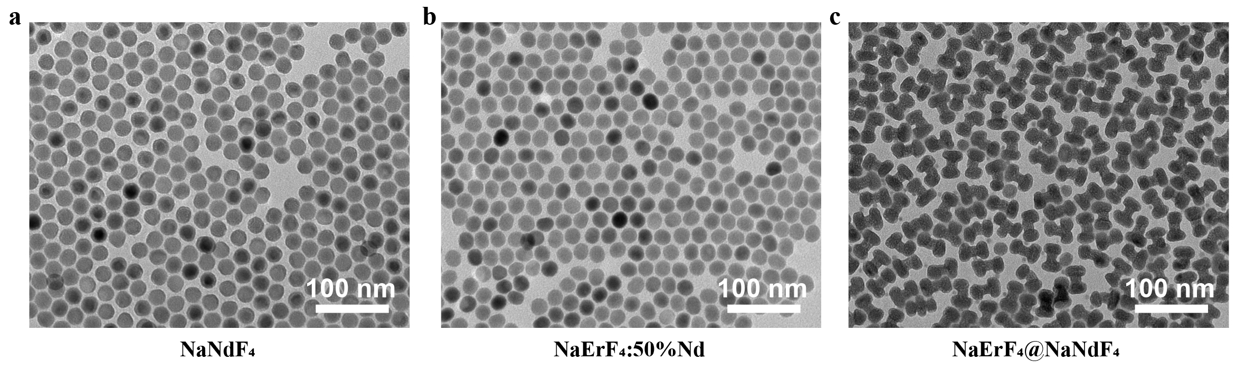
Supplementary Figure 1. (a-c) TEM images of NaNdF₄, NaErF₄:50%Nd, NaErF₄@NaNdF₄ (40.0 μmol/min) nanocrystals.

Supplementary Figure 2. (a,b) Optimized slab models of (0001) and (1000) surfaces of a hexagonal-phase NaErF₄ crystal. Yellow, dark green and grey balls denote Na, Er, and F atoms, respectively.

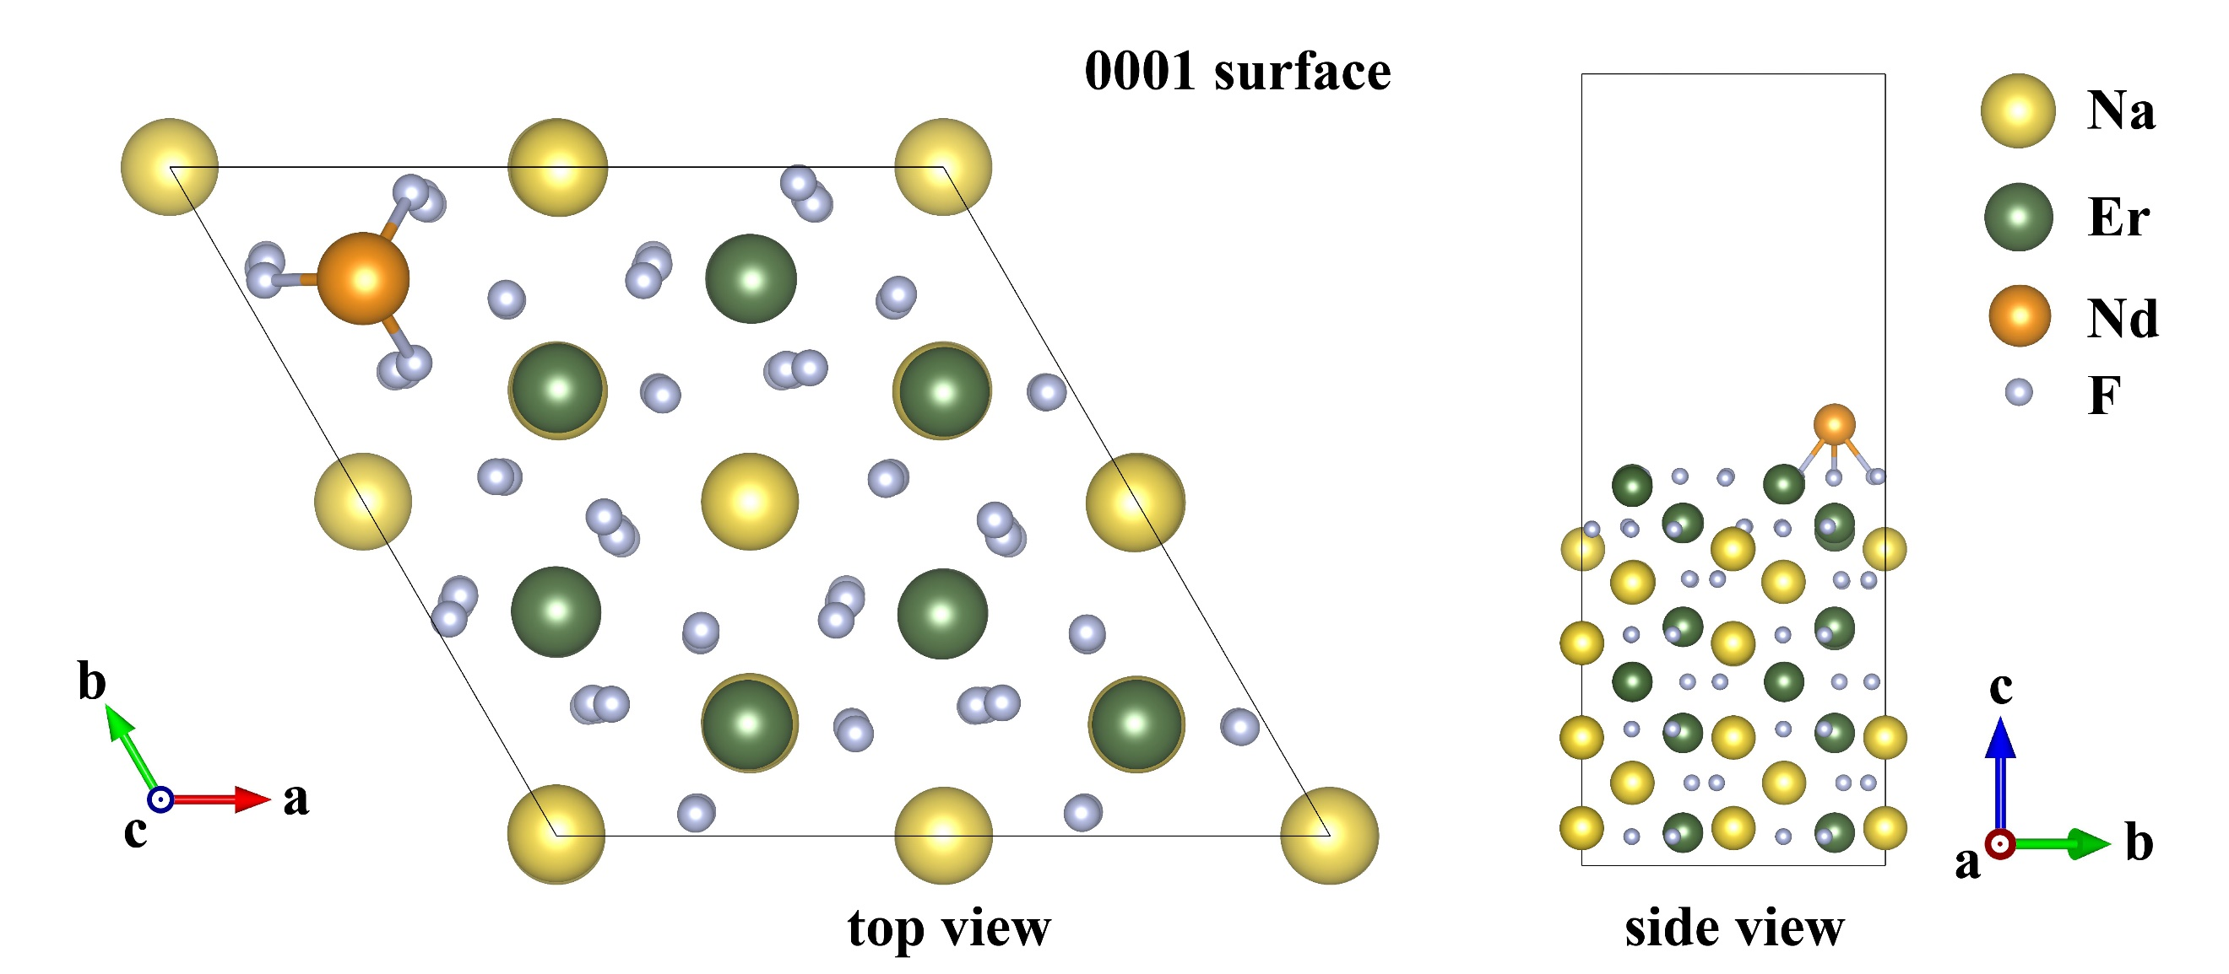
Supplementary Figure 3. Optimized atomic structure of a Nd atom adsorbed on the (0001) surface of the NaErF₄ crystal. Yellow, dark green, orange, and grey balls denote Na, Er, Nd, and F atoms, respectively.

Supplementary Figure 4. (a) Atomic structure of a Nd atom placed on top of a surface Er atom. (b) The optimized atomic structure of the Nd atom adsorbed on the (1000) surface of the NaErF₄ crystal without external strain. (c) The optimized atomic structure of the Nd atom adsorbed on the (1000) surface of the NaErF₄ crystal with external strain. Yellow, dark green, orange, and grey balls denote Na, Er, Nd, and F atoms, respectively.

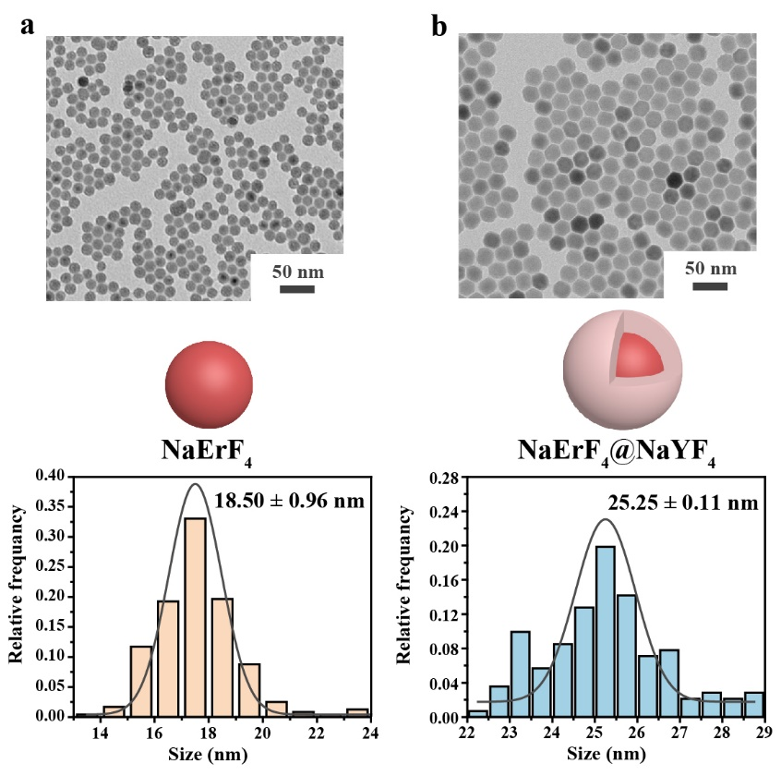
Supplementary Figure 5. (a,b) TEM images, schematic illustration and size distributions of NaErF₄ core, NaErF₄@NaYF₄ (40.0 μmol/min) core-shell nanocrystals. The core has an average size of ~18.5 nm, and the Y³⁺-based layer has a thickness of ~3.4 nm. The size distribution is fitted by a Gaussian curve (full gray line).

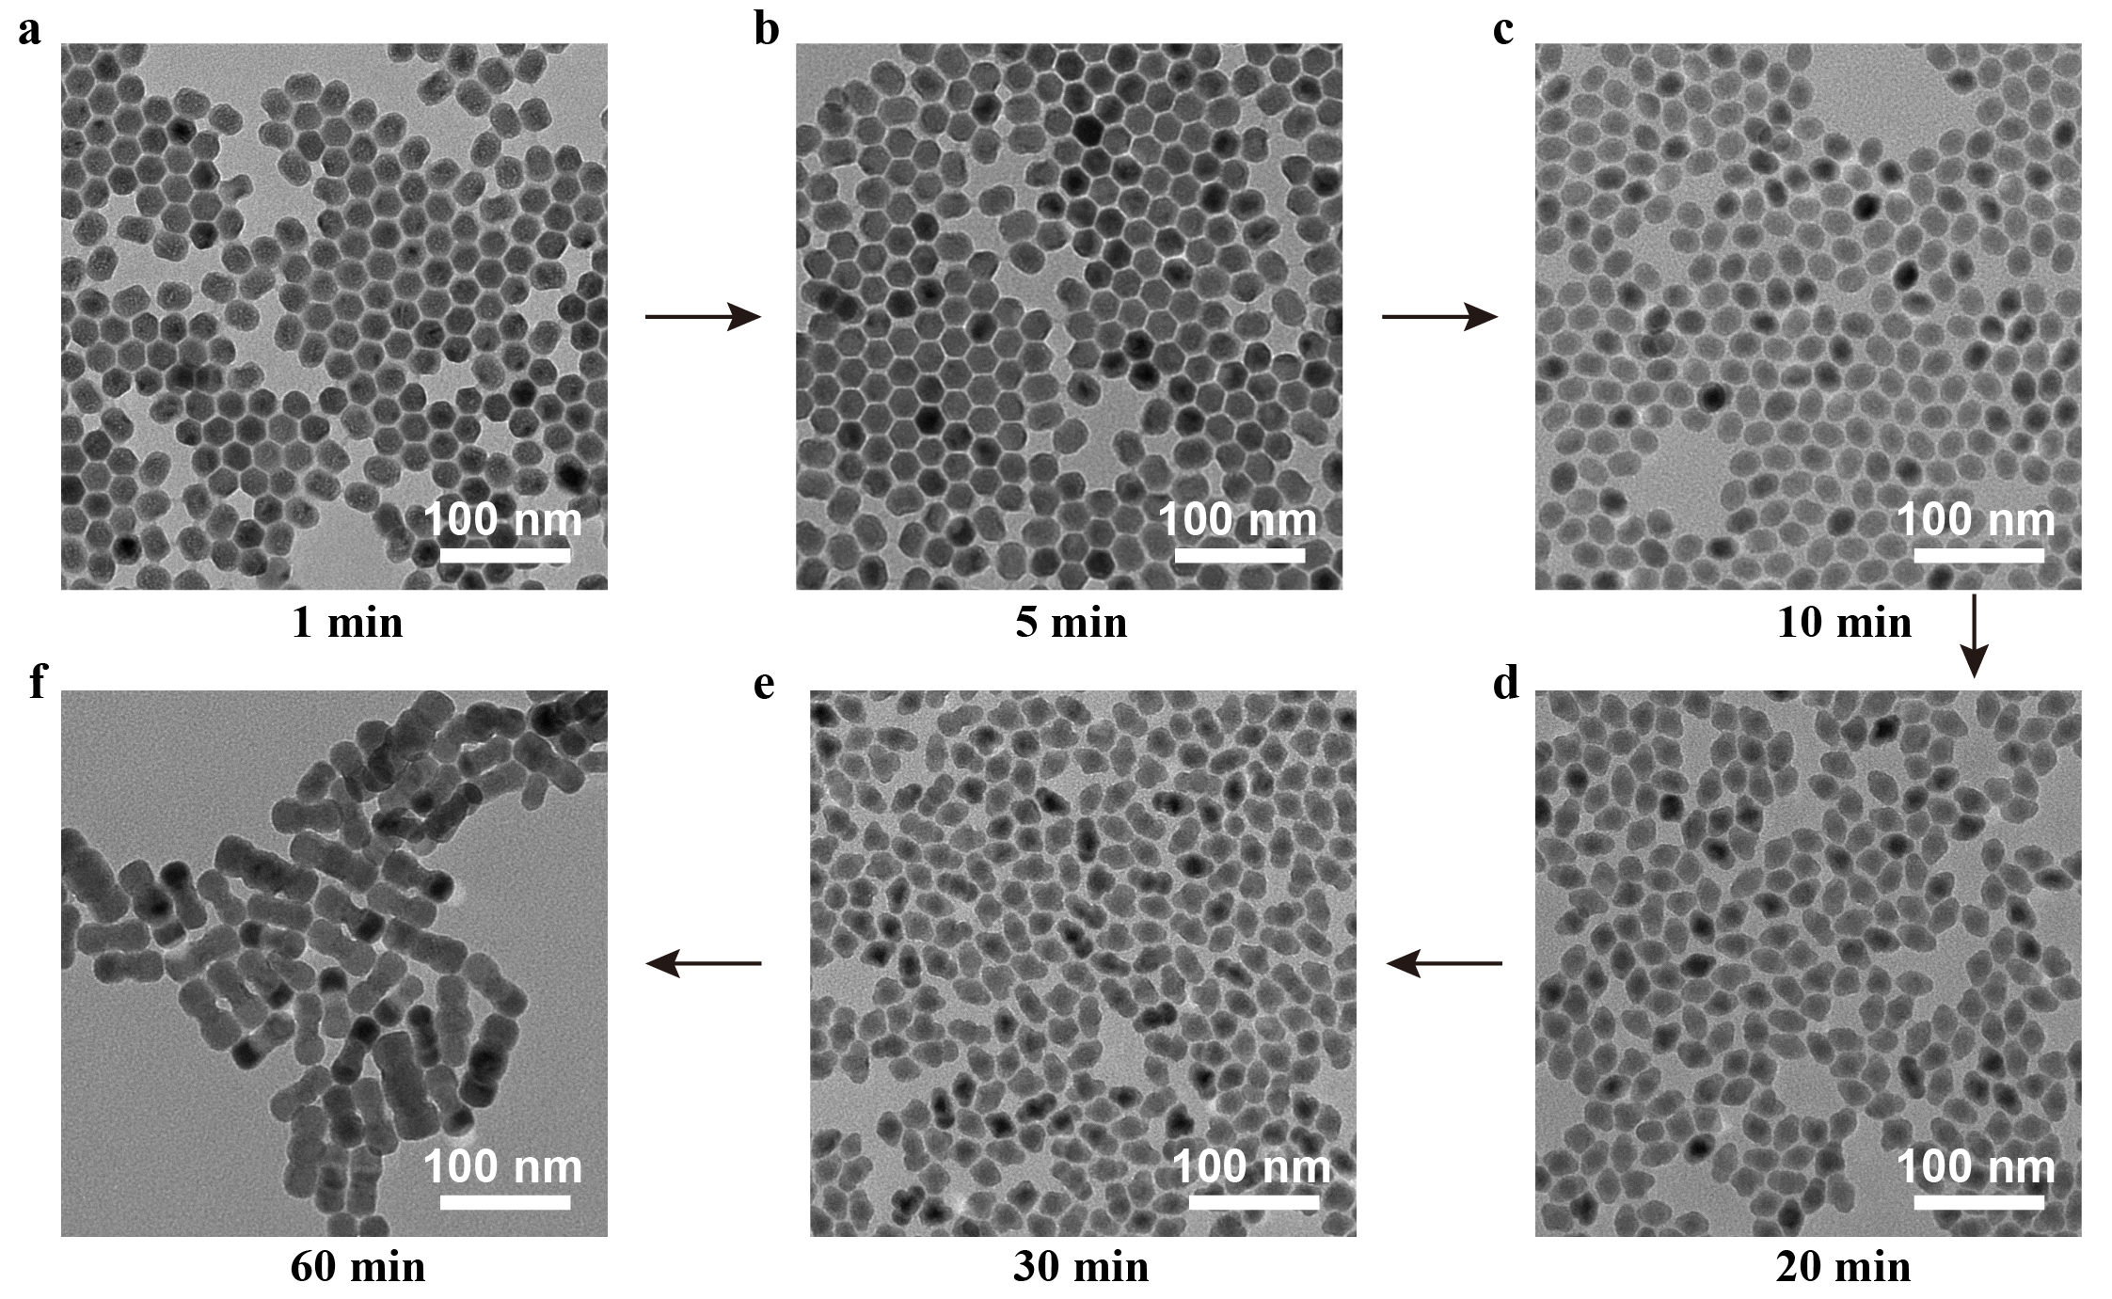
Supplementary Figure 6. TEM images of these as-synthesized NaErF₄@NaYF₄@NaNdF₄ (Injection rate 6.7 μmol/min, sampling time: 1 min-60 min) nanocrystals at 1 min (a), 5 min (b), 10 min (c), 20 min (d), 30 min (e) and 60 min (f).

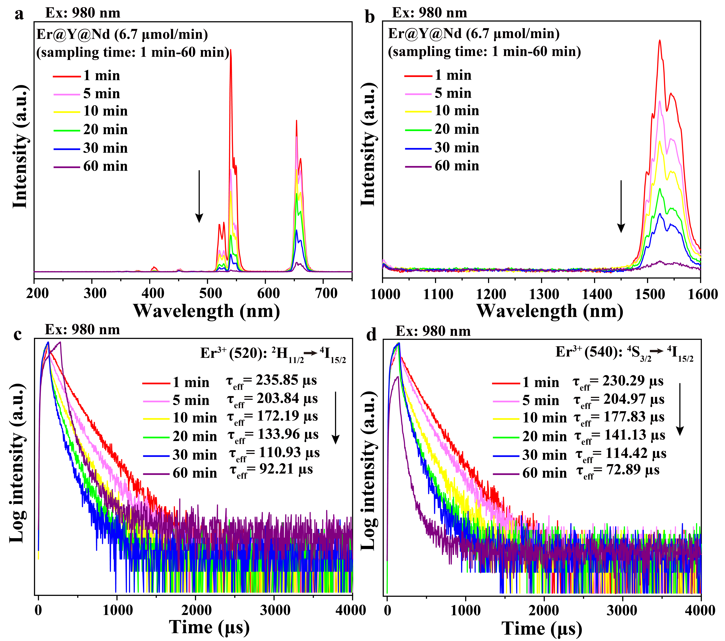
Supplementary Figure 7. Comparison of upconversion (a) and downshifting (b) emission spectra, upconversion luminescence decay curves of Er³⁺ emissions at 520 nm (c) and 540 nm (d) of these as-synthesized NaErF₄@NaYF₄@NaNdF₄ (6.7 μmol/min, sampling time: 1 min-60 min) nanocrystals under 980 nm excitation.

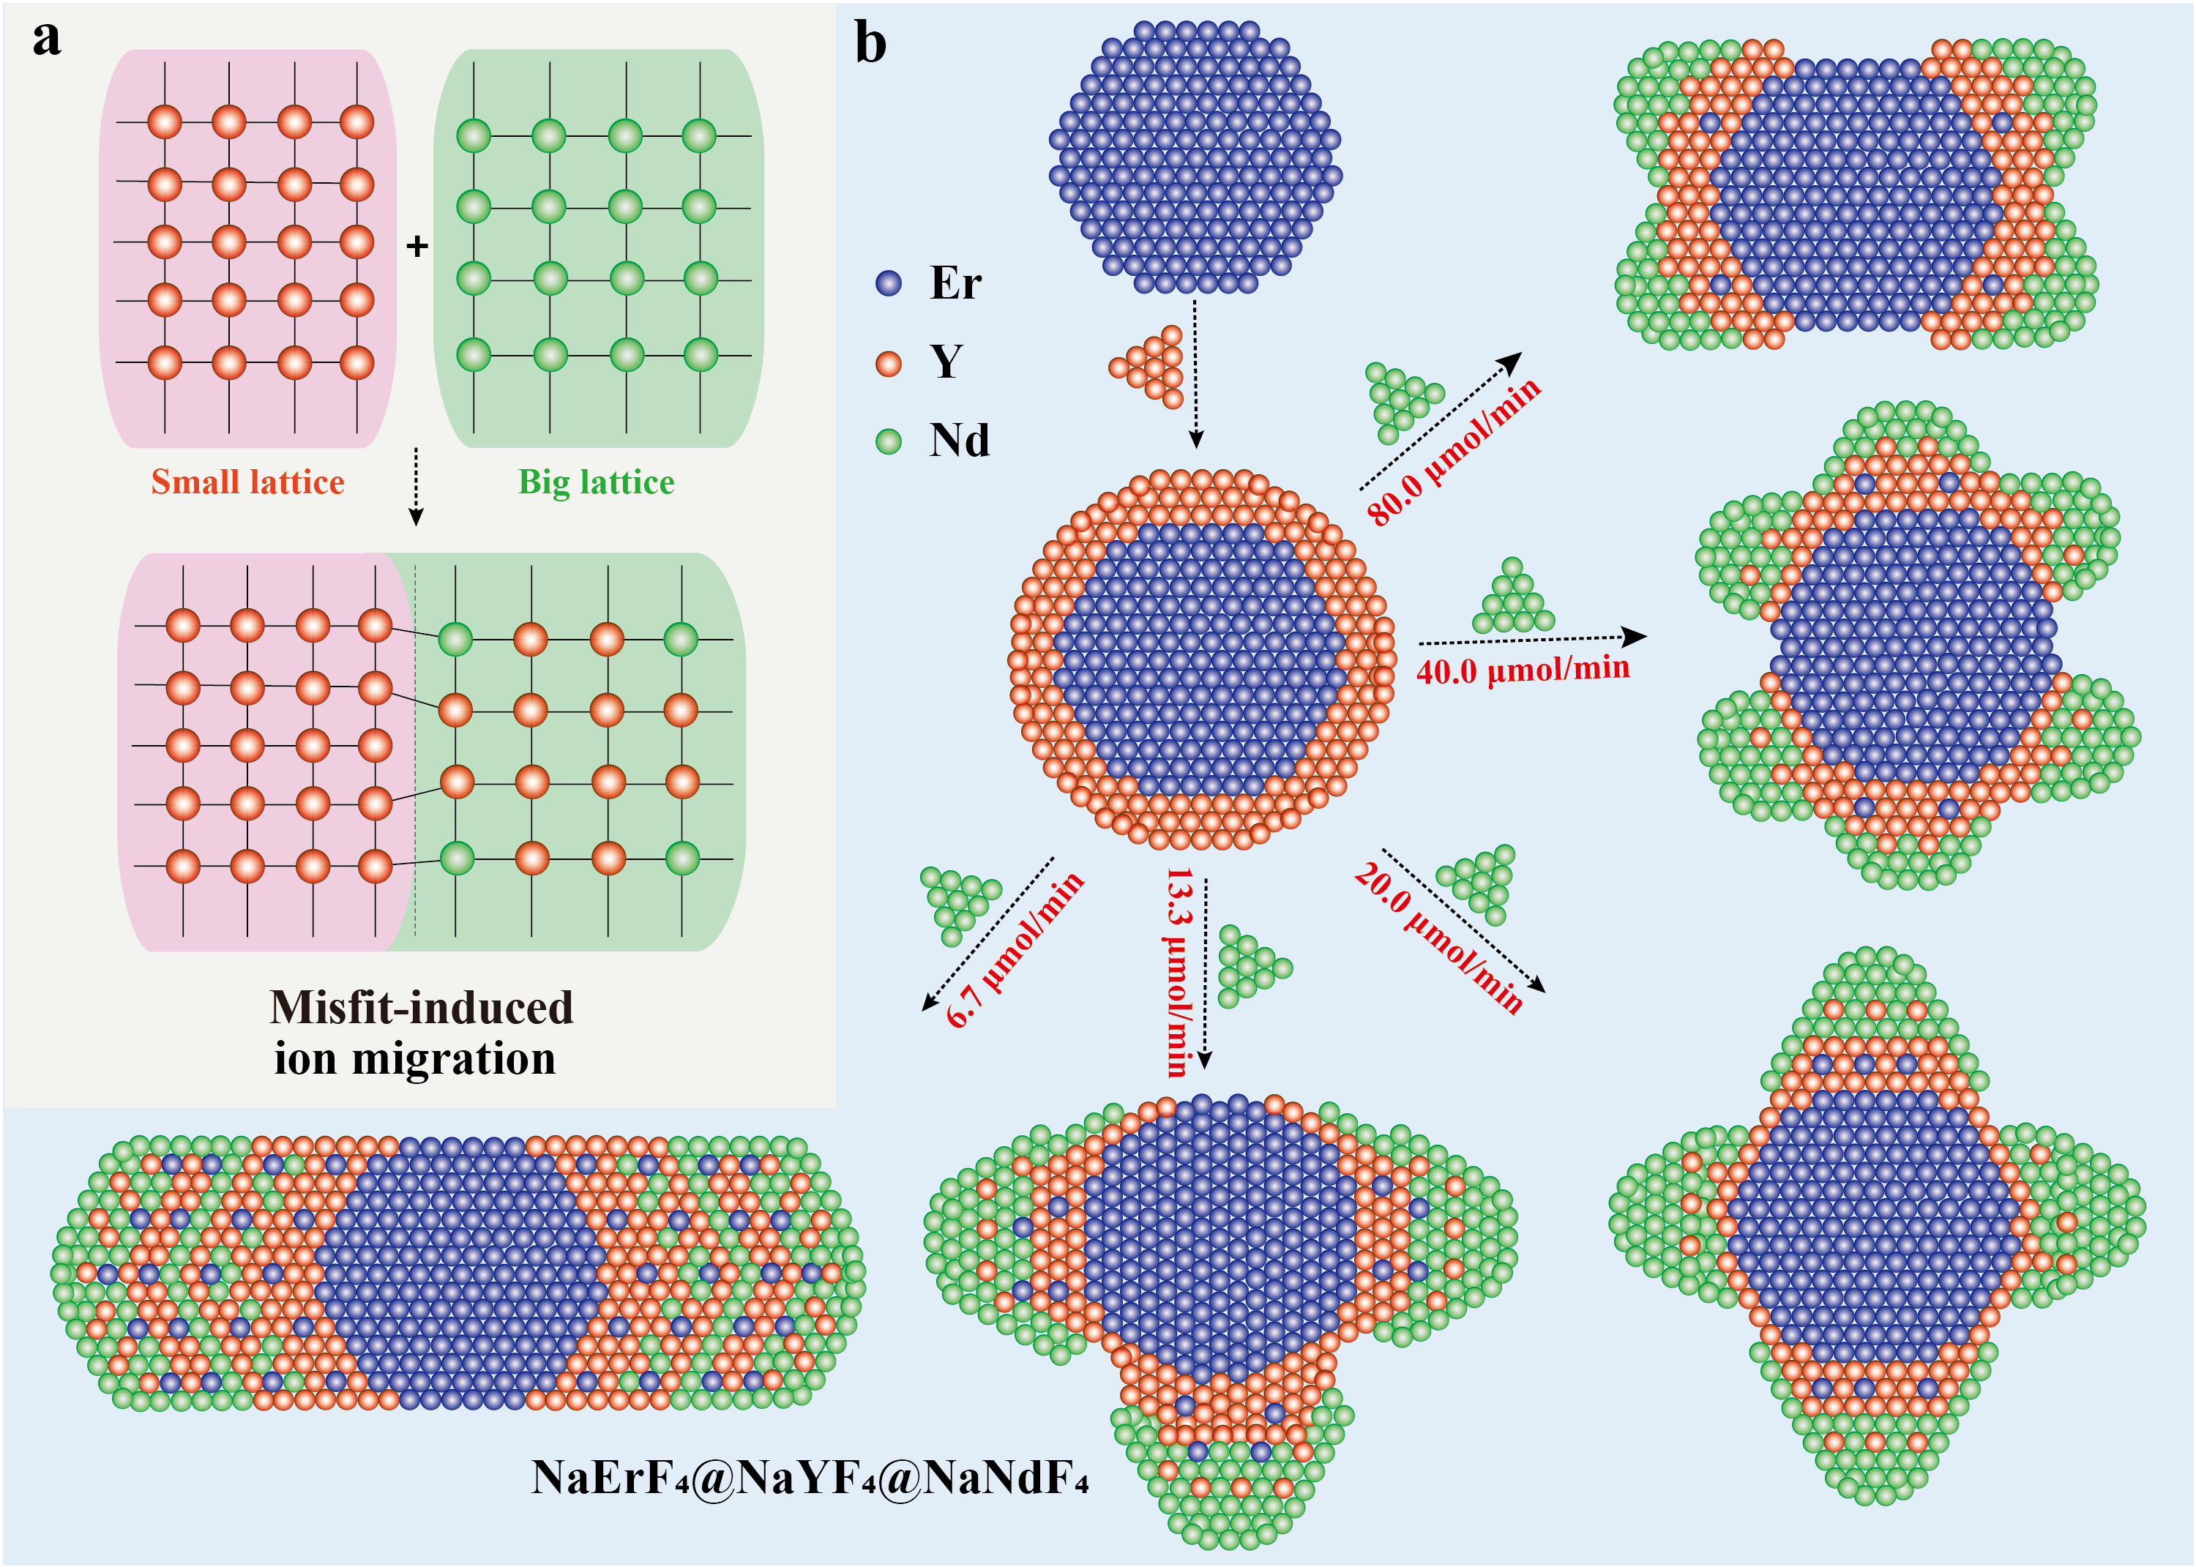
Supplementary Figure 8. Schematic illustration of misfit-induced ion migration in mismatched heteroepitaxial growth. The injection rates of the outermost Nd shell are 80.0 μmol/min, 40.0 μmol/min, 20.0 μmol/min, 13.3 μmol/min and 6.7 μmol/min, respectively (each layer contains 0.4 mmol rare earths ions). In the process of mismatched heteroepitaxial growth of NaErF₄@NaYF₄@NaNdF₄ core-multishell structure nanocrystals, the lattice relocation of Y³⁺ ions induced by the lattice mismatch of Nd³⁺ ions leads to a large amount of ion diffusion of Y³⁺ ions into the Nd³⁺ shell. With the injection rates decreases, the lattice relocation effect gradually increased, and the lattice relocation is the most obvious when the injection rate is 6.7 μmol/min.

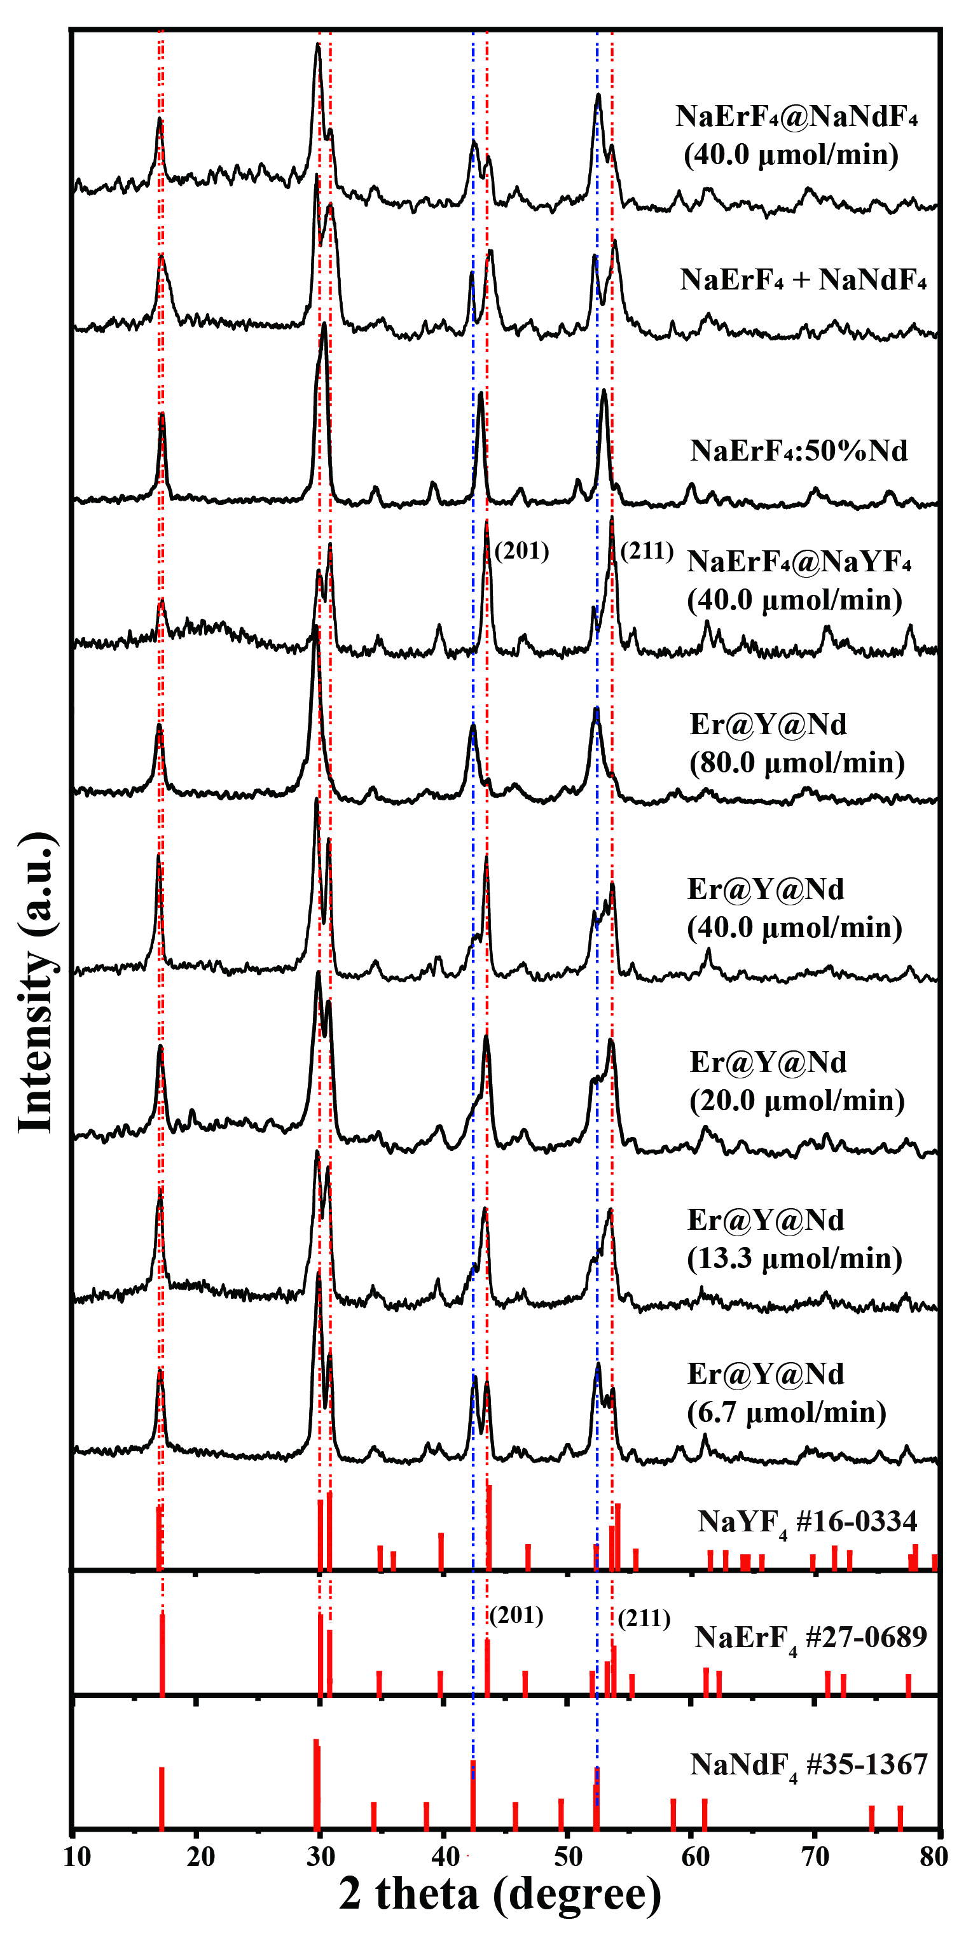
Supplementary Figure 9. XRD patterns of these as-synthesized NaErF₄@NaNdF₄ (40.0 μmol/min), NaErF₄ mix with NaNdF₄, NaErF₄:50%Nd, NaErF₄@NaYF₄ (40.0 μmol/min), NaErF₄@NaYF₄@NaNdF₄ (80.0 μmol/min, 40.0 μmol/min, 20.0 μmol/min, 13.3 μmol/min and 6.7 μmol/min) nanocrystals, indicating the hexagonal-phase of various nanocrystals.

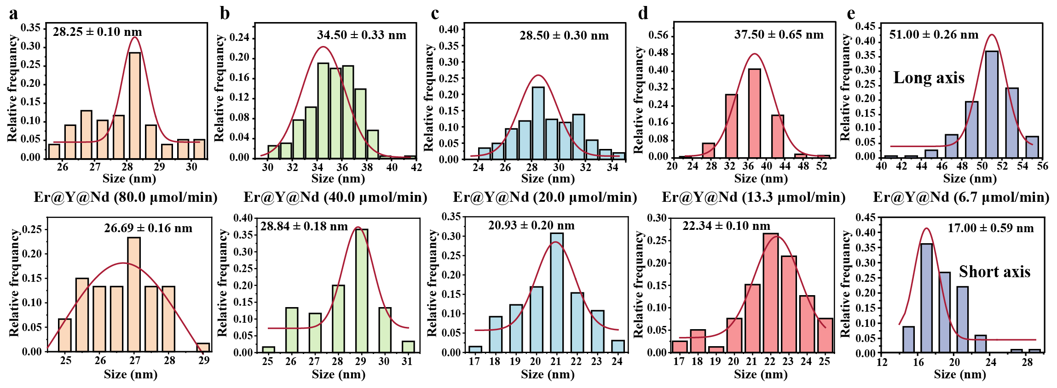
Supplementary Figure 10. Size distributions (long axis and short axis) of these as-synthesized NaErF₄@NaYF₄@NaNdF₄ nanocrystals with corresponding injection rates about 80.0 μmol/min (a), 40.0 μmol/min (b), 20.0 μmol/min (c), 13.3 μmol/min (d), 6.7 μmol/min (e). The size distribution is fitted by a Gaussian curve (full red line).

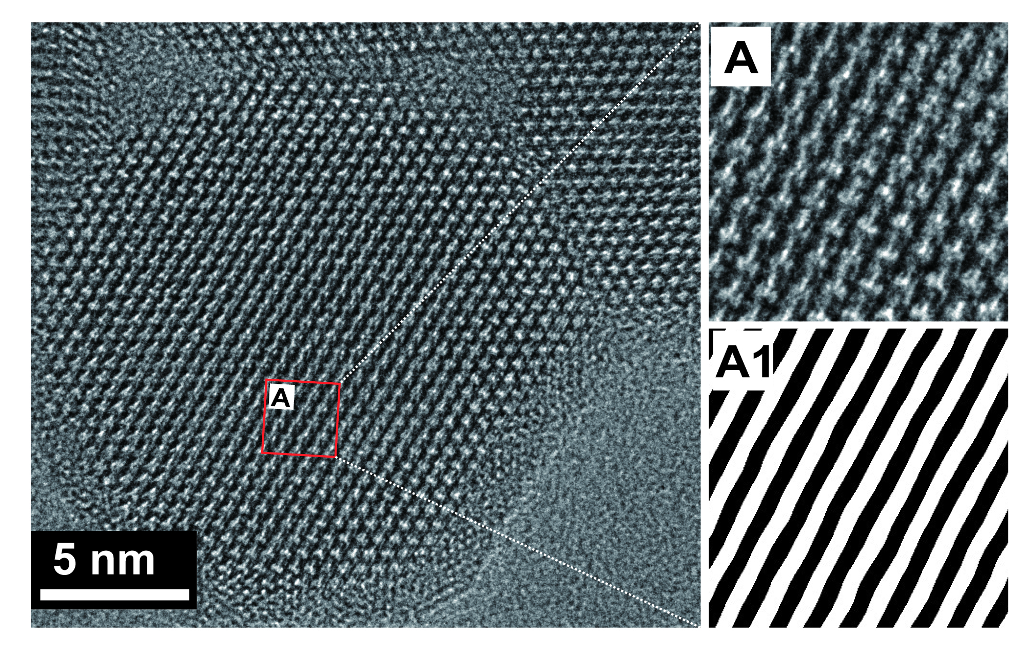
Supplementary Figure 11. HRTEM and IFFT patterns of NaErF₄@NaYF₄ nanocrystals.

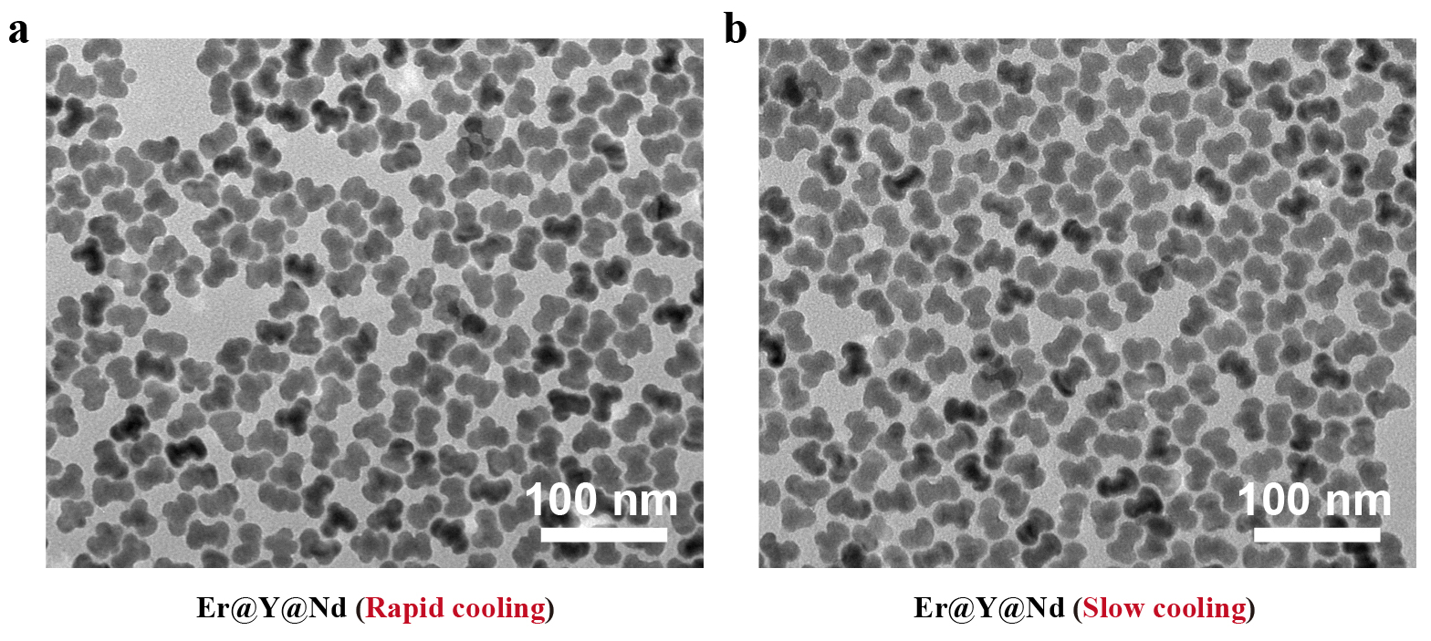
Supplementary Figure 12. TEM images of rapid cooling (a) and slow cooling (b) of the as-synthesized NaErF₄@NaYF₄@NaNdF₄ (400 μmol/min) nanocrystals.

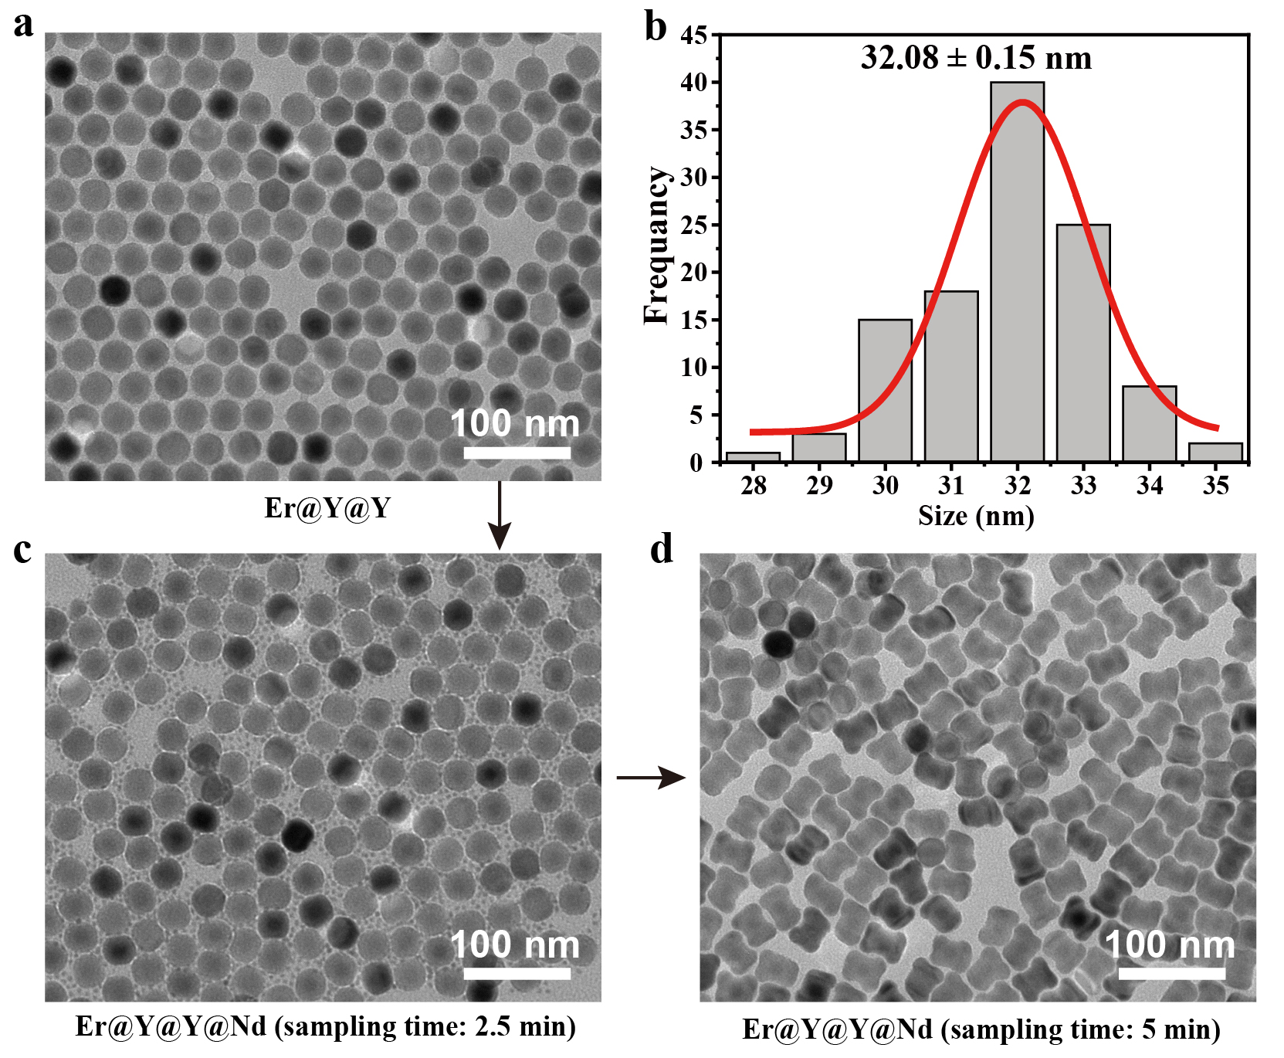
Supplementary Figure 13. TEM image (a) and size distributions (b) of the as-synthesized NaErF₄@NaYF₄@NaYF₄ (the thickness of two layer of Y = 6.8 nm) nanocrystals. TEM images of these as-synthesized NaErF₄@NaYF₄@NaYF₄@NaNdF₄ (80.0 μmol/min, the thickness of two layer of Y = 6.8 nm) nanocrystals at 2.5 min (c) and 5 min (d).

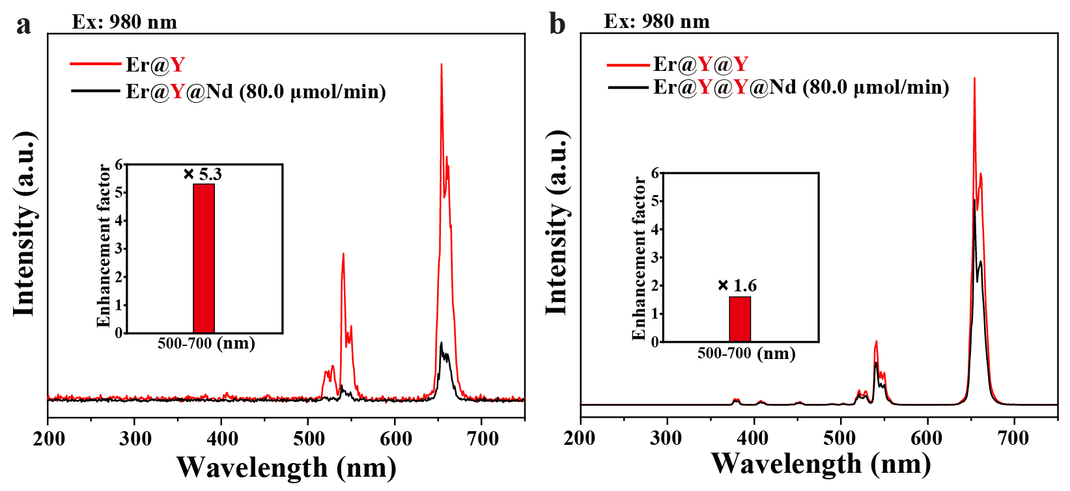
Supplementary Figure 14. (a) Comparison of upconversion emission spectra of these as-synthesized NaErF₄@NaYF₄ (the thickness of one layer of Y = 3.4 nm) and NaErF₄@NaYF₄@NaNdF₄ (80.0 μmol/min) nanocrystals, (b) Comparison of upconversion emission spectra of these as-synthesized NaErF₄@NaYF₄@NaYF₄ (the thickness of two layer of Y = 6.8 nm) and NaErF₄@NaYF₄@NaYF₄@NaNdF₄ (80.0 μmol/min) nanocrystals under 980 nm excitation. Enhancement factor of the luminescence of NaErF₄@NaYF₄ and NaErF₄@NaYF₄@NaYF₄ nanocrystals at 500-700 nm compared to the NaErF₄@NaYF₄@NaNdF₄ (80.0 μmol/min) and NaErF₄@NaYF₄@NaYF₄@NaNdF₄ (80.0 μmol/min) (Inset).

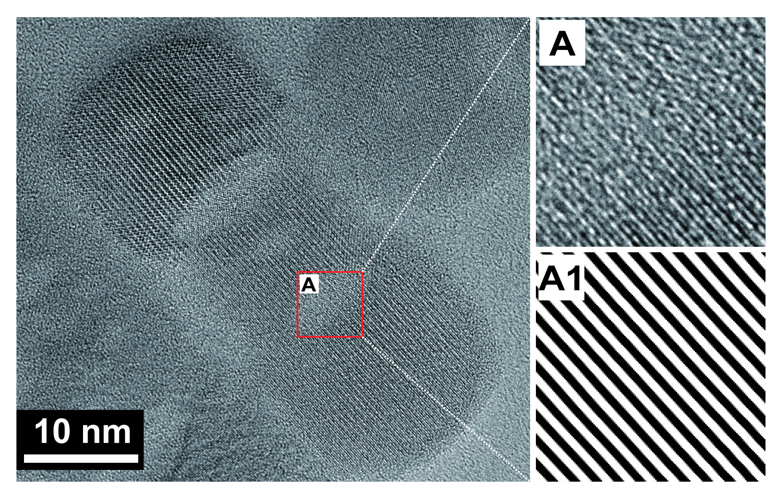
Supplementary Figure 15. HRTEM and IFFT patterns of rod NaErF₄@NaYF₄@NaNdF₄ (6.7 μmol/min) nanocrystals.

Supplementary Figure 16. EDX elemental line scan analysis of these as-synthesized NaErF₄@NaYF₄@NaNdF₄ nanocrystals with corresponding injection rates about 80.0 μmol/min (a), 40.0 μmol/min (b), 20.0 μmol/min (c), 13.3 μmol/min (d).

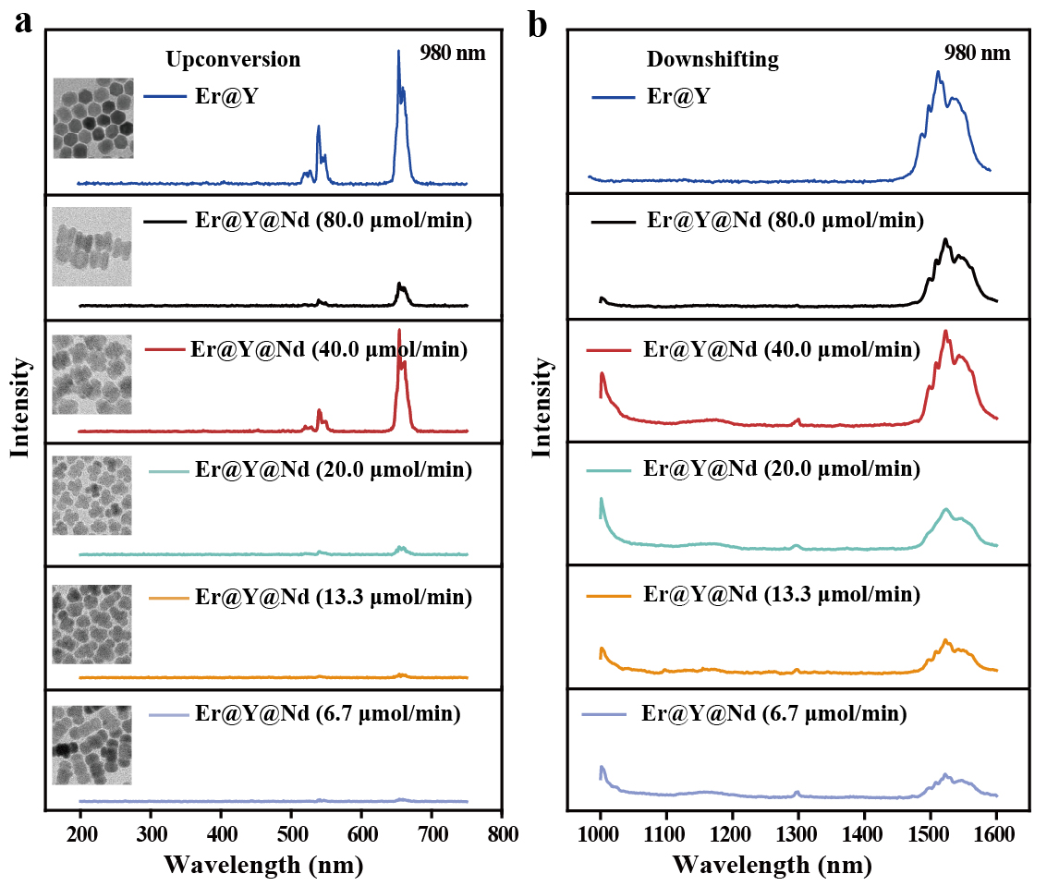
Supplementary Figure 17. Upconversion (a) and downshifting (b) emission spectra of these as-synthesized NaErF₄@NaYF₄ and NaErF₄@NaYF₄@NaNdF₄ (injection rates of 80.0 μmol/min, 40.0 μmol/min, 20.0 μmol/min, 13.3 μmol/min and 6.7 μmol/min) nanocrystals under 980 nm excitation.

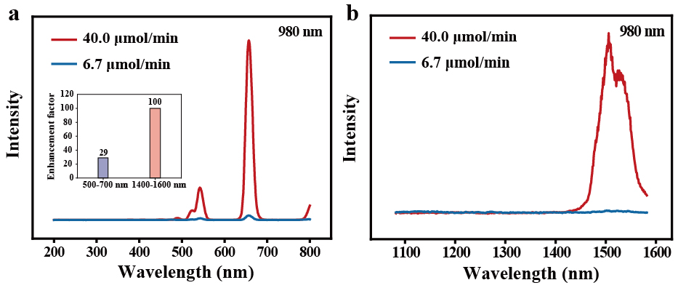
Supplementary Figure 18. Upconversion (a) and downshifting (b) emission spectra of NaErF₄@NaYF₄@NaNdF₄ (injection rates of 40.0 μmol/min and 6.7 μmol/min) nanocrystals under 980 nm excitation. Enhancement factor of the luminescence of 40.0 μmol/min at 500-700 nm, 1400-1600 nm compared to the 6.7 μmol/min (inset).

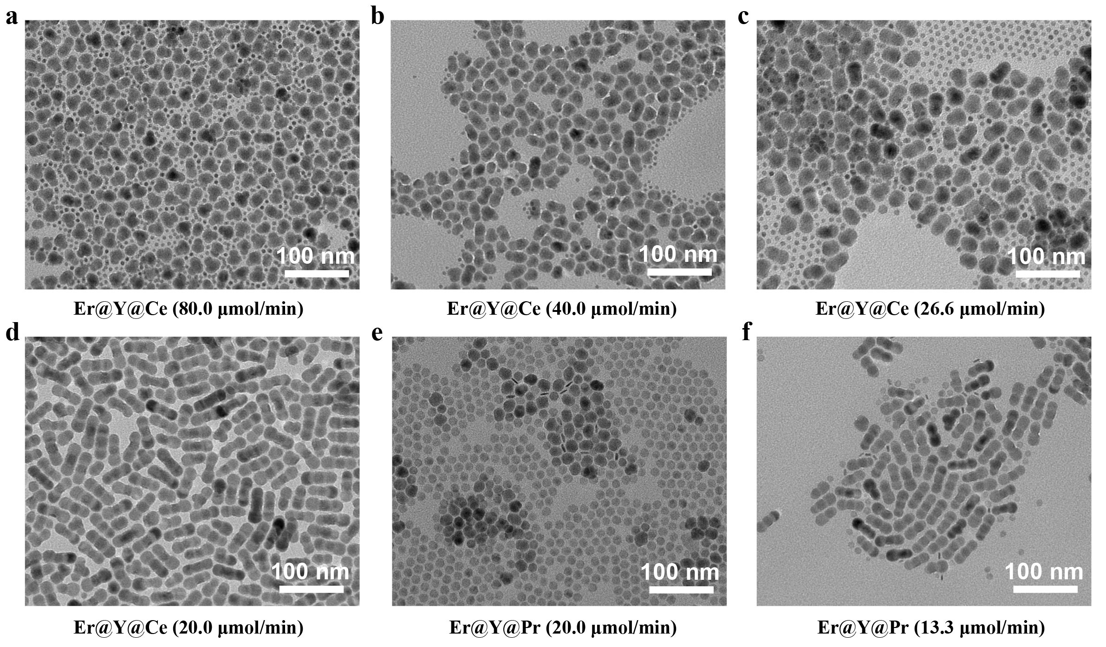
Supplementary Figure 19. TEM images of these as-synthesized NaErF₄@NaYF₄@NaCeF₄ nanocrystals with corresponding injection rates 80.0 μmol/min (a), 40.0 μmol/min (b), 26.6 μmol/min (c), and 20.0 μmol/min (d), these as-synthesized NaErF₄@NaYF₄@NaPrF₄ nanocrystals with corresponding injection rates 20.0 μmol/min (e), and 13.3 μmol/min (f).

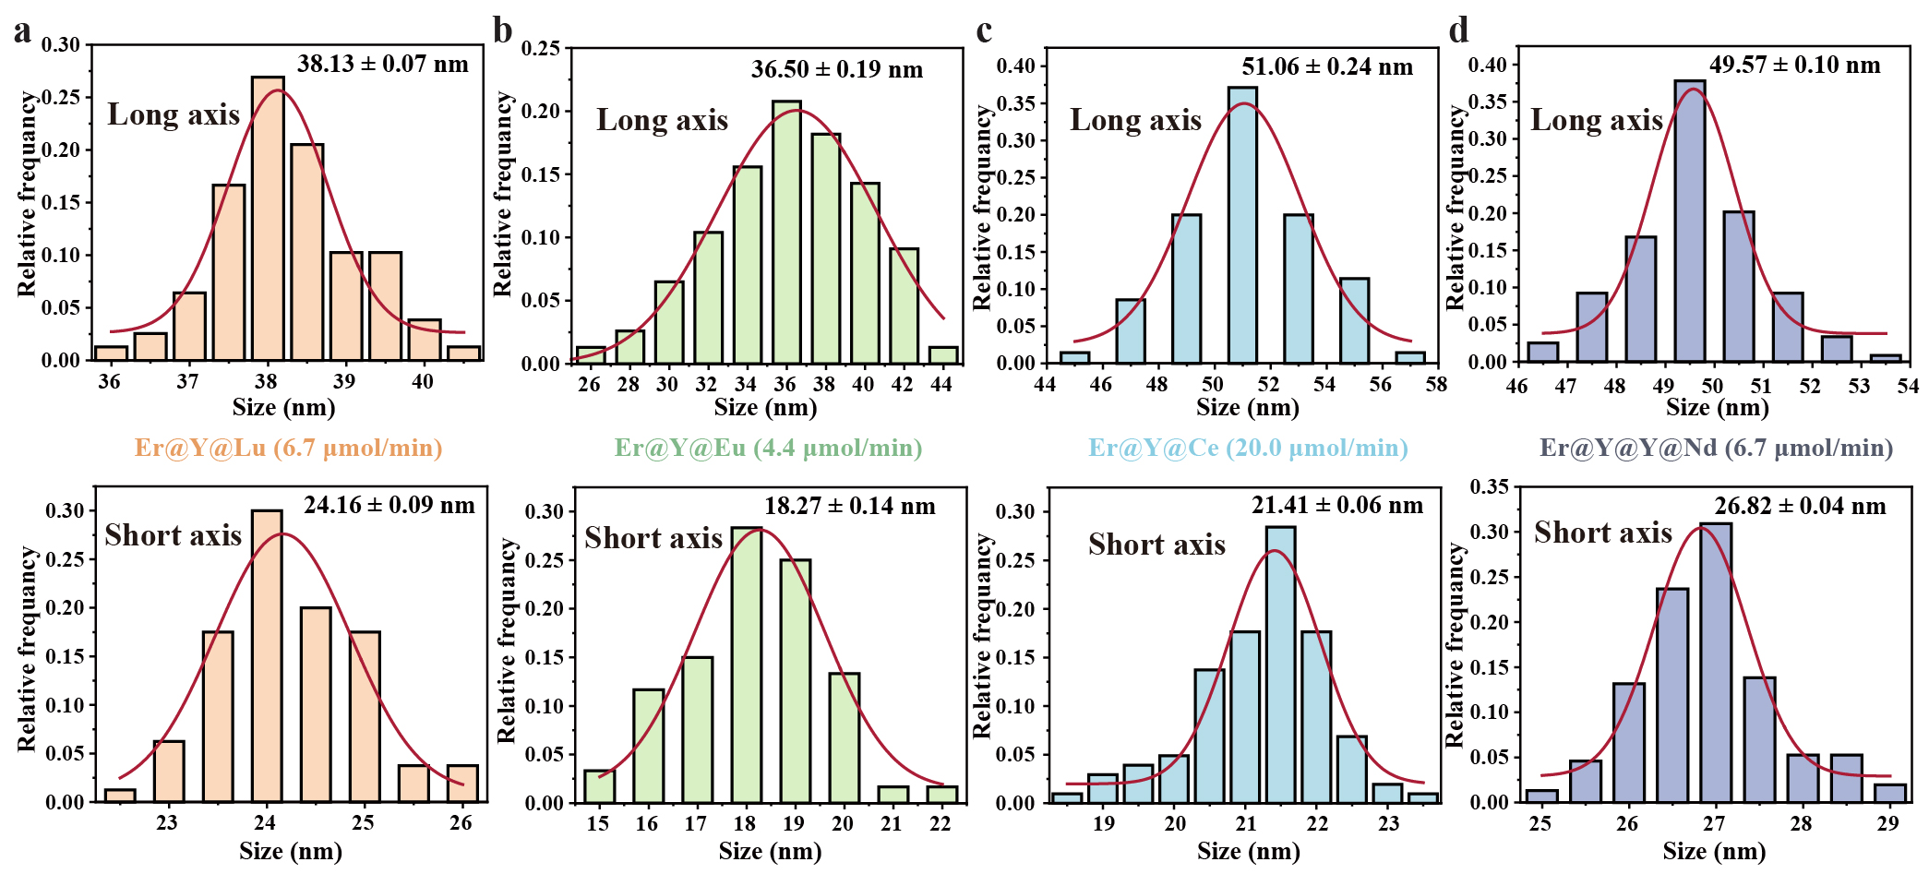
Supplementary Figure 20. Size distributions of the as-synthesized (a) NaErF₄@NaYF₄@NaLuF₄ (6.7 μmol/min), (b) NaErF₄@NaYF₄@NaEuF₄ (4.4 μmol/min), (c) NaErF₄@NaYF₄@NaCeF₄ (20.0 μmol/min), (d) NaErF₄@NaYF₄@NaYF₄@NaNdF₄ (6.7 μmol/min) nanocrystals. The size distribution is fitted by a Gaussian curve (full red line).

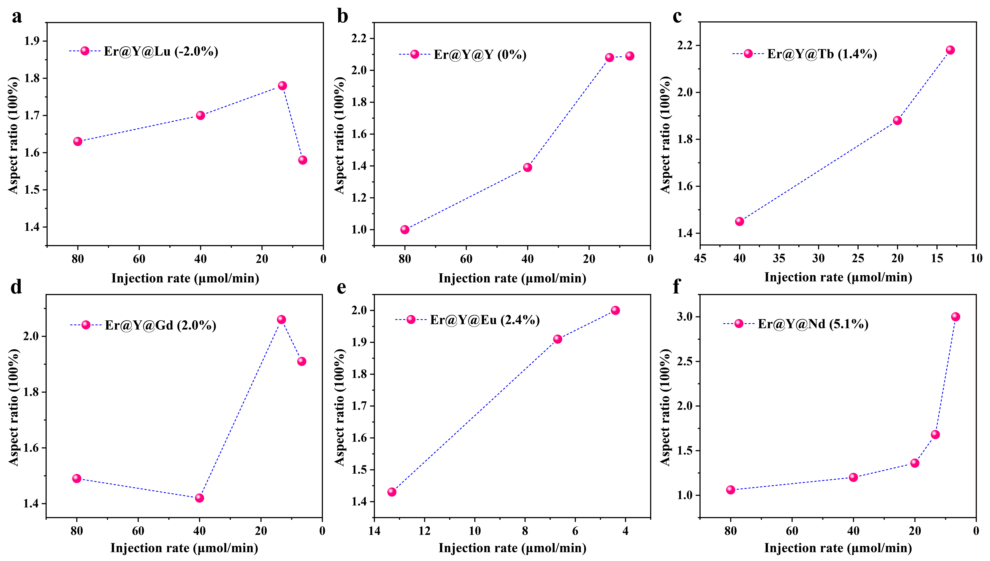
Supplementary Figure 21. Aspect ratio analysis. The ratio of long diameter to short diameter of these as-synthesized NaErF₄@NaYF₄@NaLuF₄ (a), NaErF₄@NaYF₄@NaYF₄ (b), NaErF₄@NaYF₄@NaTbF₄ (c), NaErF₄@NaYF₄@NaGdF₄ (d), NaErF₄@NaYF₄@NaEuF₄ (e) and NaErF₄@NaYF₄@NaNdF₄ (f) nanocrystals varies with injection rates.

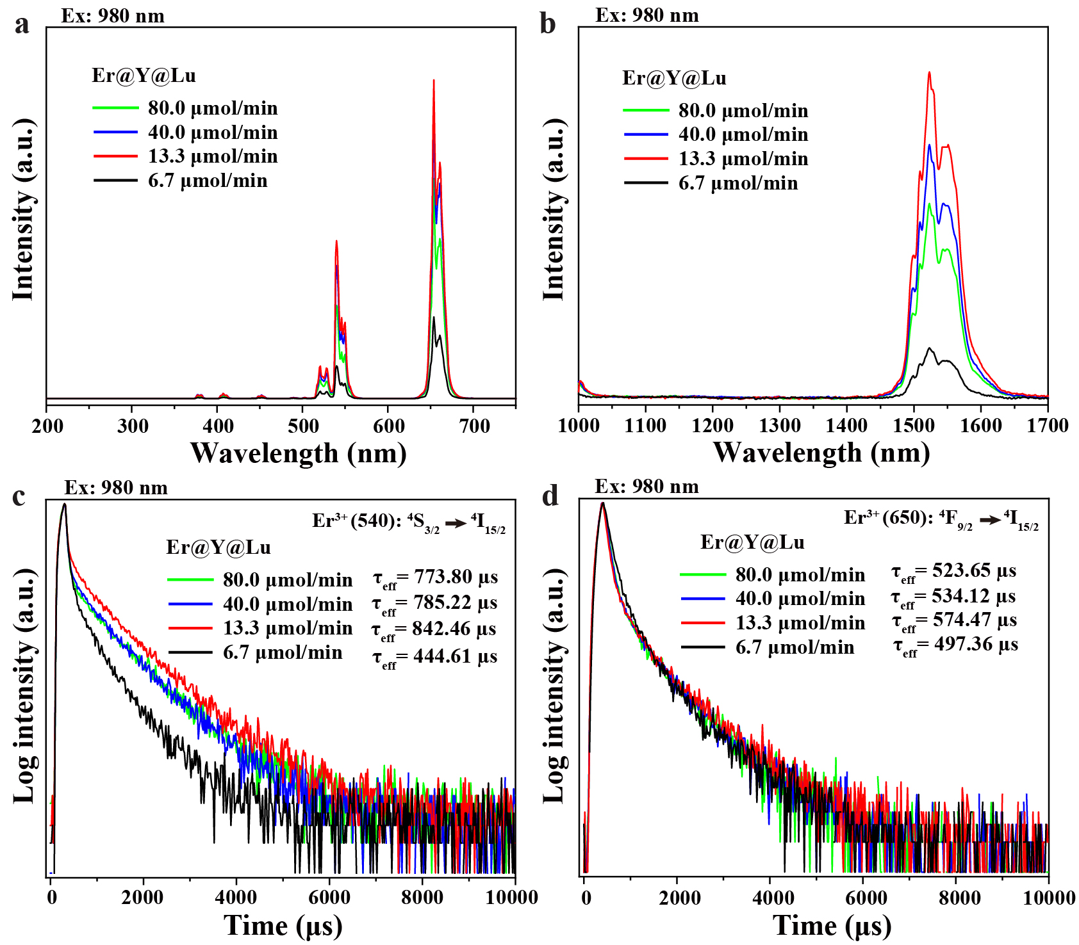
Supplementary Figure 22. Upconversion (a) and downshifting (b) emission spectra of these as-synthesized NaErF₄@NaYF₄@NaLuF₄ nanocrystals with corresponding injection rates of 80.0 μmol/min, 40.0 μmol/min, 13.3 μmol/min and 6.7 μmol/min under 980 nm excitation. Comparison of upconversion luminescence decay curves of Er³⁺ emissions at 540 nm (c) and 650 nm (d) of these NaErF₄@NaYF₄@NaLuF₄ nanocrystals.

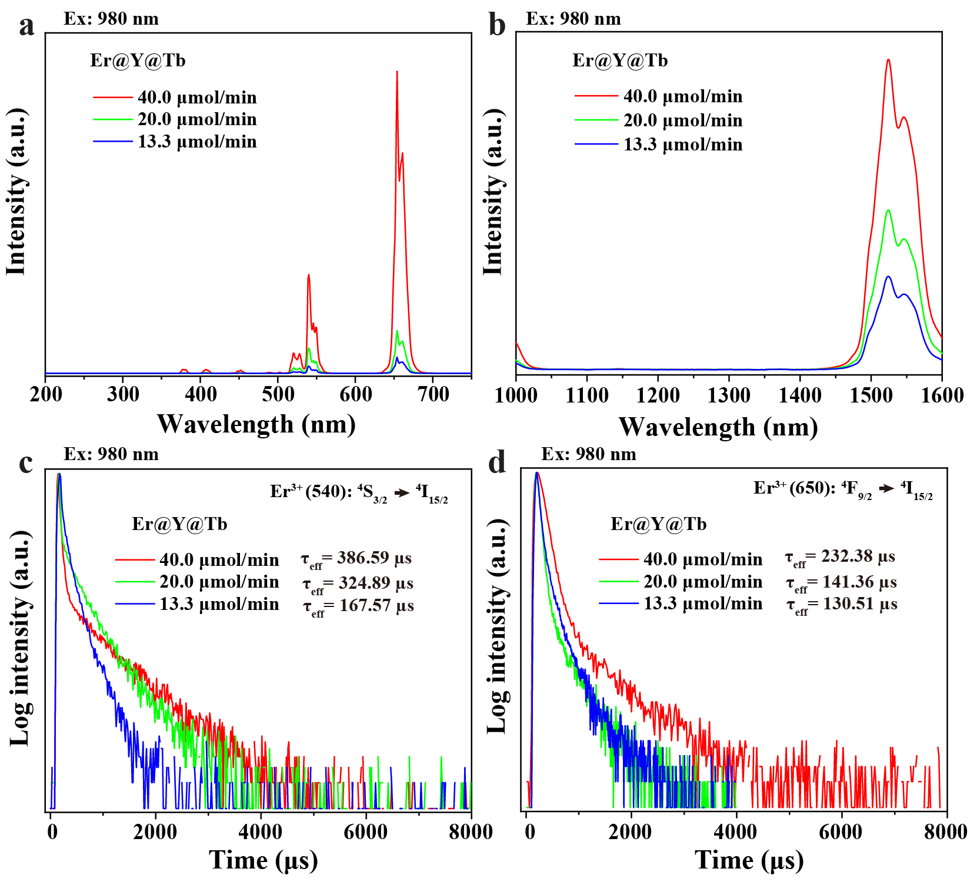
Supplementary Figure 23. Upconversion (a) and downshifting (b) emission spectra of these as-synthesized NaErF₄@NaYF₄@NaTbF₄ nanocrystals with corresponding injection rates of 40.0 μmol/min, 20.0 μmol/min, 13.3 μmol/min under 980 nm excitation. Comparison of upconversion luminescence decay curves of Er³⁺ emissions at 540 nm (c) and 650 nm (d) of these NaErF₄@NaYF₄@NaTbF₄ nanocrystals.

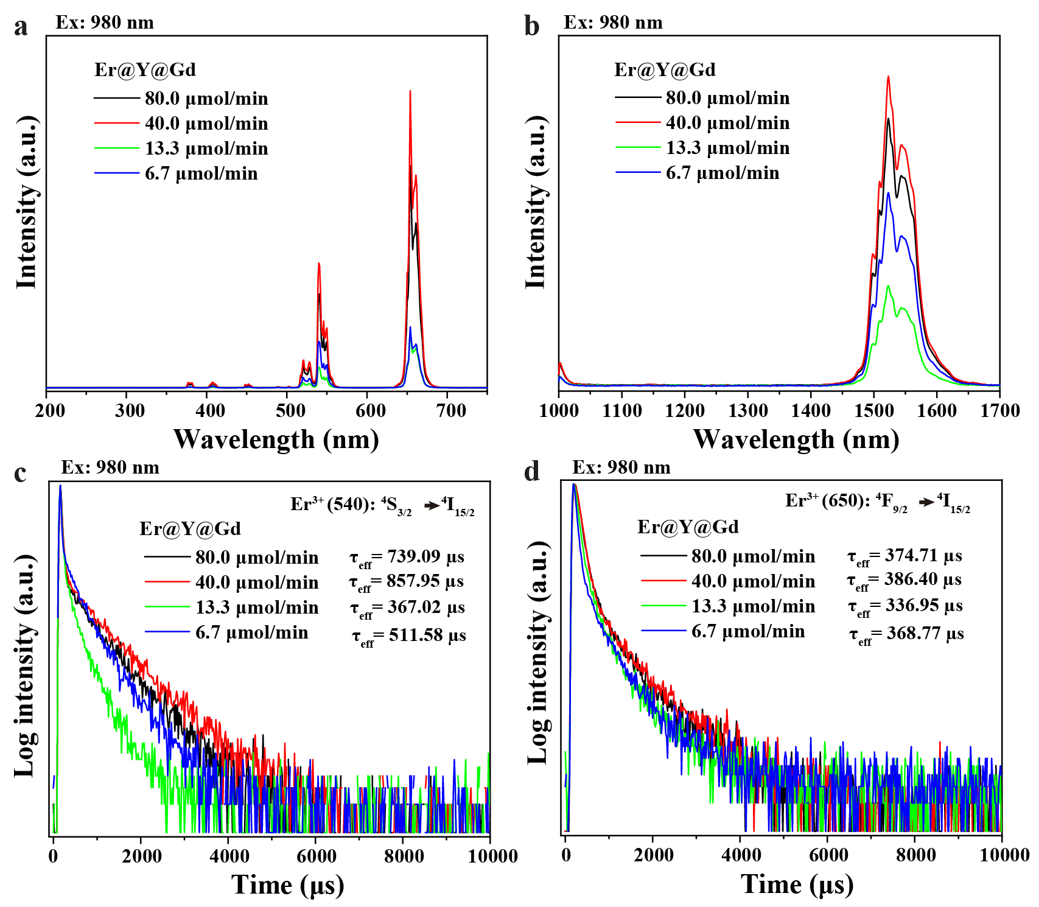
Supplementary Figure 24. Upconversion (a) and downshifting (b) emission spectra of these as-synthesized NaErF₄@NaYF₄@NaGdF₄ nanocrystals with corresponding injection rates of 80.0 μmol/min, 40.0 μmol/min, 13.3 μmol/min and 6.7 μmol/min under 980 nm excitation. Comparison of upconversion luminescence decay curves of Er³⁺ emissions at 540 nm (c) and 650 nm (d) of NaErF₄@NaYF₄@NaGdF₄ nanocrystals.

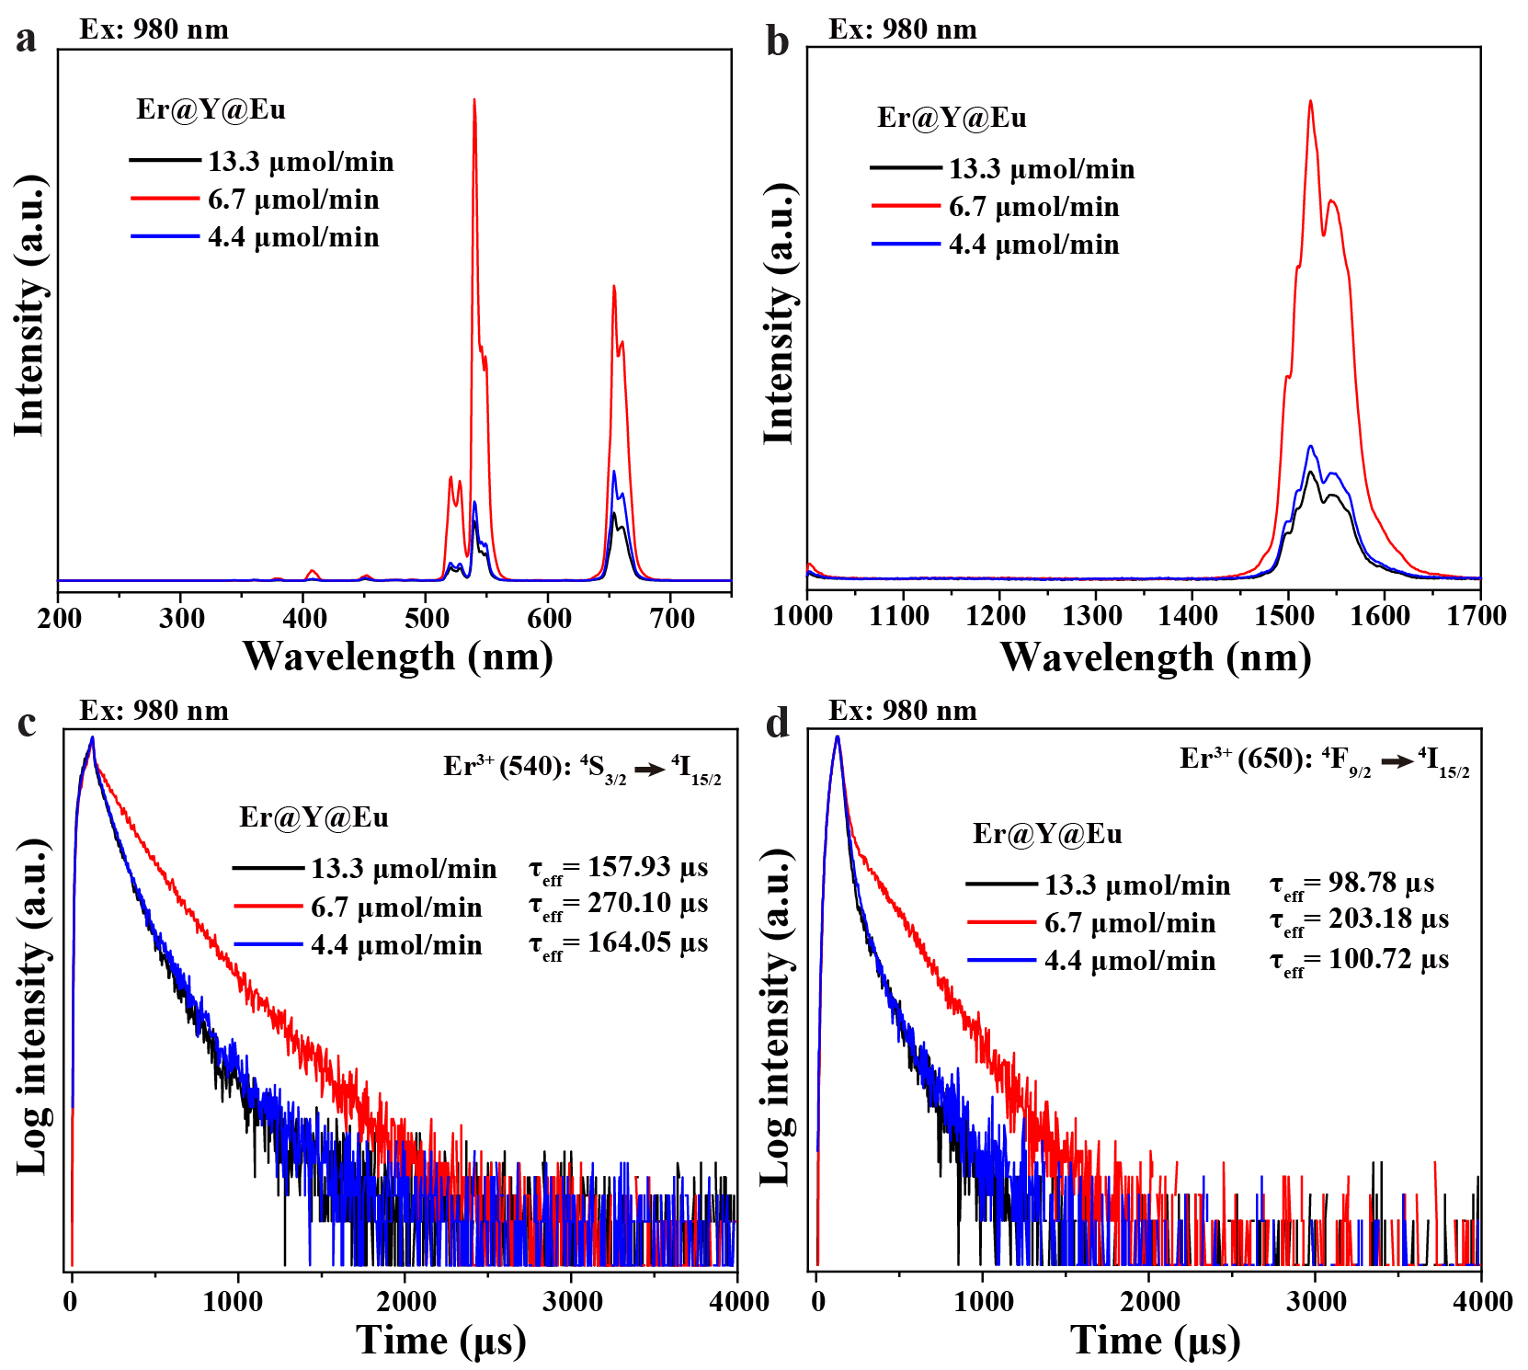
Supplementary Figure 25. Upconversion (a) and downshifting (b) emission spectra of these as-synthesized NaErF₄@NaYF₄@NaEuF₄ nanocrystals with corresponding injection rates of 13.3 μmol/min, 6.7 μmol/min, and 4.4 μmol/min under 980 nm excitation. Comparison of upconversion luminescence decay curves of Er³⁺ emissions at 540 nm (c) and 650 nm (d) of NaErF₄@NaYF₄@NaEuF₄ under 980 nm excitation.

Supplementary Table 1. DFT-calculated adsorption energies.
 | Adsorption energy without strain (eV) | Adsorption energy with strain (eV)
Nd-adsorbed on the (0001) surface  (Er₁ site) | -2.307 | -2.246
Nd-adsorbed on the (0001) surface  (hollow site) | -2.184 | -3.209
Nd-adsorbed on the (1000) surface  (Er site) | -1.911 | -3.876
Nd-adsorbed on the (1000) surface  (hollow site) | -4.158 | -6.087

Supplementary Table 2. Ionic radii of Ce³⁺, Pr³⁺, Nd³⁺, Eu³⁺, Gd³⁺, Tb³⁺, Y³⁺, Er³⁺, and Lu³⁺ ions. (Ionic radii of Ln³⁺ are for VIII coordinate species⁵).
Ions | Ce³⁺ | Pr³⁺ | Nd³⁺ | Eu³⁺ | Gd³⁺ | Tb³⁺ | Y³⁺ | Er³⁺ | Lu³⁺
Ionic Radii (Å) | 1.283 | 1.266 | 1.249 | 1.206 | 1.193 | 1.180 | 1.159 | 1.144 | 1.117

Supplementary Table 3. The crystal lattice parameters of hexagonal phase (β)-NaREF₄ crystals⁶ (NaYF₄ refers to the XRD standard card PDF16-0334).
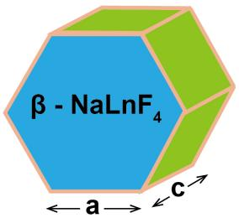  Unit Cell parameters | Crystal Host | NaLaF₄ | NaCeF₄ | NaPrF₄ | NaNdF₄ | NaSmF₄ | NaEuF₄ | NaGdF₄ | NaTbF₄
 | a & b(Å) | 6.157 | 6.131 | 6.123 | 6.100 | 6.051 | 6.044 | 6.020 | 6.008
 | C(Å) | 3.822 | 3.776 | 3.743 | 3.711 | 3.640 | 3.613 | 3.601 | 3.580
 | Year/Ref | 1966/6 | 1966/6 | 1966/6 | 1966/6 | 1966/6 | 1966/6 | 1966/6 | 1966/6
 | Crystal Host | NaHoF₄ | NaDyF₄ | NaYF₄ | NaErF₄ | NaTmF₄ | NaYbF₄ | NaLuF₄ | -
 | a & b(Å) | 5.991 | 5.985 | 5.96 | 5.959 | 5.953 | 5.929 | 5.912 | -
 | C(Å) | 3.528 | 3.554 | 3.53 | 3.514 | 3.494 | 3.471 | 3.458 | -
 | Year/Ref | 1966/6 | 1966/6 | PDF16-0334 | 1966/6 | 1966/6 | 1966/6 | 1966/6 | -

Supplementary Table 4. Summary of the lattice mismatches for crystallographic parameters c for a hexagonal phase NaREF₄ crystals. The mismatches are calculated by the conventional definition⁷ given by $\frac{Shell Lattice Parameter-Core Lattice Parameter}{Core Lattice Parameter}$.
Shell  Mismatch (%)  Core | NaCeF₄ | NaPrF₄ | NaNdF₄ | NaEuF₄ | NaGdF₄ | NaTbF₄ | NaYF₄ | NaLuF₄
NaYF₄ | 7.0 | 6.0 | 5.1 | 2.4 | 2.0 | 1.4 | 0 | -2.0
NaErF₄ | 7.5 | 6.5 | 5.6 | 2.8 | 2.5 | 1.9 | 0.5 | -1.6

Supplementary Table 5. Summary of the lattice mismatches for crystallographic parameters a & b for a hexagonal phase NaREF₄ crystals. The mismatches are calculated in the same method as in Supplementary Table 4.
Shell  Mismatch (%)  Core | NaCeF₄ | NaPrF₄ | NaNdF₄ | NaEuF₄ | NaGdF₄ | NaTbF₄ | NaYF₄ | NaLuF₄
NaYF₄ | 2.9 | 2.7 | 2.3 | 1.4 | 1.0 | 0.8 | 0 | -0.8
NaErF₄ | 2.9 | 2.8 | 2.4 | 1.4 | 1.0 | 0.8 | 0.02 | -0.8

Supplementary References
1. Kresse, G. & Furthmüller, J. Efficiency of ab-initio total energy calculations for metals and semiconductors using a plane-wave basis set. Comput. Mater. Sci. 6, 15–50 (1996).
2. Blöchl, P. E. Projector augmented-wave method. Phys. Rev. B 50, 17953–17979 (1994).
3. Perdew, J. P., Burke, K. & Ernzerhof, M. Generalized gradient approximation made simple. Phys. Rev. Lett. 77, 3865–3868 (1996).
4. Xu, H. et al. Anomalous upconversion amplification induced by surface reconstruction in lanthanide sublattices. Nat. Photonics 15, 732–737 (2021).
5. Shannon, R. D. Revised effective ionic radii and systematic studies of interatomic distances in halides and chalcogenides. Acta Cryst. A32, 751-767 (1976).
6. Thoma, R. E., Insley, H. & Hebert, G. M. The sodium fluoride-lanthanide trifluoride systems. Inorg. Chem. 5, 1222–1229 (1966).
7. Zhang, J., Tang, Y., Lee, K. & Ouyang, M. Nonepitaxial growth of hybrid core-shell nanostructures with large lattice mismatches. Science 327, 1634–1638 (2010).

