Supplementary Information
Highly efficient photosynthesis of syngas and pinacol from CO₂ and 1-phenylethanol via amine-regulated redox pathways

Xinyu Xu^{1,2}, Meiyan Guo^{1,2}, Bo Su^{1,2}, Meifang Zheng^{1,2}, Xue Feng Lu^{1,2}, Chengyang Feng³, Guigang Zhang^{1,2}, Wei Lin^{1,2,}*, Huabin Zhang³, and Sibo Wang^{1,2,}*
¹State Key Laboratory of Chemistry for NBC Hazards Protection, College of Chemistry, Fuzhou University, Fuzhou 350116, China.
²State Key Laboratory of Photocatalysis on Energy and Environment, College of Chemistry, Fuzhou University, Fuzhou 350116, P. R. China.
³KAUST Catalysis Center, Physical Sciences and Engineering Division, King Abdullah University of Science and Technology, Thuwal 23955, Saudi Arabia.
*Corresponding Author: Wei Lin; Sibo Wang
Email: wlin@fzu.edu.cn; sibowang@fzu.edu.cn

Characterizations. The crystal structures of CdS-DETA and CdS were recorded on Bruker D8 Advance instrument with Cu Kα1 radiation (k = 1.5406 Å). The morphology, structure and composition of the samples were studied by Transmission electron microscopy (TEM), high-resolution transmission electron microscopy (HRTEM), energy dispersive X-ray (EDX) element mappings and EDX linear element scans on a FEI TECNAI G2F30 S-TWIN instrument at an accelerating voltage of 300 kV. X-Ray photoelectron spectra (XPS) were examined on a Thermo Scientific ESCALAB 250 instrument with a monochromatized Al Kα line source (200 W). UV-vis diffuse reflectance spectra (DRS) were performed on a Varian Cary 500 UV-Vis-NIR spectrometer with an integrating sphere and BaSO₄ as a reflectance. The C 1s peak at 284.6 eV was referred in the data processing of all relevant elements. Gas chromatography-mass spectra (GC-MS) were taken at Thermo Trace 1300 gas chromatograph mass spectrometer and a TR-5MS column (0.25 mm × 30 m, Film: 0.25 μm). High-performance liquid chromatography mass spectra (HPLC–MS) were obtained from the central analytic mass spectrometry facilities of Fuzhou University. A gas chromatography (SHIMADZU GC 2030)-mass spectrometer (GCMS-QP2020NX) (GC-MS) was employed to detect the CO gas product generated from ¹³CO₂ isotopic experiment. In situ room temperature photoluminescence (PL) spectra and time-resolved PL spectra were acquired on an Edinburgh Analytical Instruments FI/FSTCSPC 920. The nitrogen adsorption-desorption isotherms (77 K) and CO₂ adsorption isotherms (273 K) were collected on a Micromeritics ASAP 2020 surface area and porosity analyzer. The surface functional groups and reaction intermediates during the photocatalytic CO₂ reduction reaction were examined by Fourier transform infrared spectra (FTIR) and in situ diffuse reflectance infrared Fourier transform spectra (DRIFTS) with a Nicolet Magna 670 FTIR spectrometer, respectively. The content of carbon material in the CdS-DETA sample was determined by thermogravimetric analysis/differential scanning calorimetry (TGA/DSC; STARe System) from 20 to 500°C with a ramp rate of 10°C·min⁻¹. The electrical conductivity of samples was identified by electrochemical impedance spectra (EIS). The electrochemical analysis was carried out on a SP-200 (Bio-Logic) electrochemical workstation, using the conventional three electrode cell with Pt and Ag/AgCl as the counter electrode and reference electrode, respectively. Typically, 10 mg of the samples were dispersed in the mixed solution of DMF (1 mL) and Nafion (0.1 mL) by sonication to gain a suspension. Then, the resultant slurry was spread onto the FTO glass with an area of ca. 0.25 cm². The transient photocurrent response spectra were collected in Na₂SO₄ aqueous solution (0.2 M) with a 300 W xenon lamp. Electrochemical impedance spectroscopy (EIS) measurements were carried out in Na₂SO₄ aqueous solution (0.2 M).
In situ diffuse reflectance infrared Fourier transform spectroscopy (DRIFTS) measurements were carried out on a Nicolet IS50-FTIR spectrometer (Thermo Scientific) equipped with a MCT detector and a designed reaction cell. A thin layer of the sample was loaded on the substrate that is placed in the center of the reaction cell. A N₂ (20 mL min⁻¹) flow was used to remove the gases in the cell and the adsorbed species on the catalyst surface. Then, a flowing CO₂ gas was introduced to obtain a CO₂ atmosphere for CO₂ reduction. At last, the light was turned on and the signal was collected through MCT detector during the reaction.
The AQY measurement and wavelength experiment
The AQY was measured using a closed gas circulation and evacuation system and monochromatic visible light (365±5.0 nm). Depending on the amounts of hydrogen gases produced by the photocatalytic reaction in an average of one hour, and the AQY was calculated as follows:
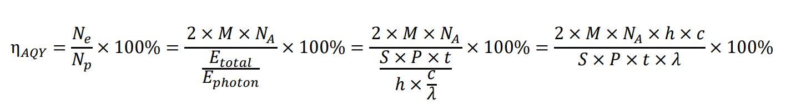
Where M is the amount of H₂ molecules (mol), N_{A} is the Avogadro constant (6.022×10²³ / mol), h is the Planck constant (6.626×10⁻³⁴ J S), c is the speed of light (3×10⁸ m/s), S is the irradiation area (cm²), P is the intensity of irradiation light (W/cm²), t is the photoreaction time (s), λ is the wavelength of the monochromatic light (m).
DFT calculations
In this work，the DFT calculations were executed utilizing the Vienna ab initio simulation package (VASP) software.¹ The computational setup encompassed the application of the projector-augmented wave (PAW) method with a plane-wave basis set, and the generalized gradient approximation (GGA) exchange-correlation functional of Perdew, Burke, and Ernzerhof (PBE).^{2,3} The DFT-D2 correction was used to account for weak interactions between intermediates and the catalyst.⁴ A plane-wave cutoff energy of 400 eV was adopted to represent the electronic wave functions accurately, with a vacuum layer of 15 Å imposed in the z-direction to prevent spurious interactions across periodic images. Relaxations were carried out in reciprocal space using a 2×2 ×1 k-point grid according to the Monkhorst-Pack scheme. The convergence criteria for total energy changes and maximum force were set to 1 × 10⁻⁵ eV and 0.03 eV/Å. The DFT+U method with a Ueff = 6.0 eV was used to process the d-bands of Cd.⁵ Furthermore, the implicit solvation model (using VASPsol) with a dielectric constant of ε is taken as 37.5 for acetonitrile.

The change of Gibbs free energy (ΔG) was computed as follows:
ΔG = ΔE + ΔE_{ZPE}- TΔS
Where ΔE is the electronic energy change from the total energy, and ΔE_{ZPE} and ΔS are the difference between the zero-point energy and entropy, respectively. T is the room temperature (298.15 K).⁶

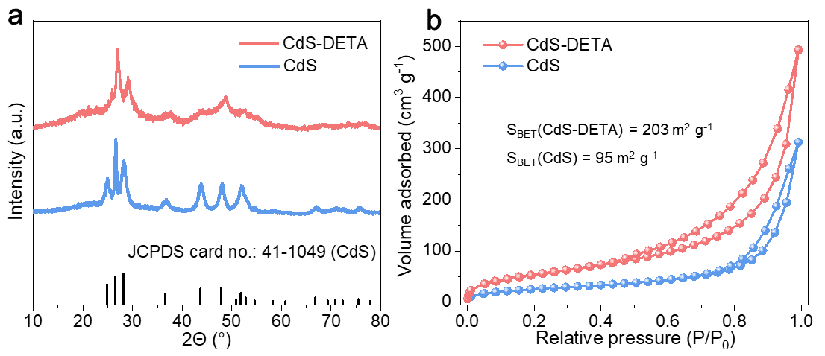
Supplementary Fig. 1. (a) XRD patterns, (b) N₂ adsorption-desorption isotherms of CdS-DETA and CdS.

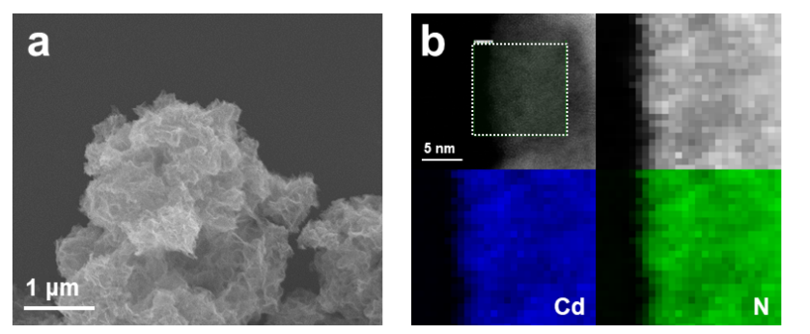
Supplementary Fig. 2. (a) SEM image of CdS-DETA, (b) atomic resolution HAADF image of CdS-DETA and the corresponding EELS maps of the green rectangle.

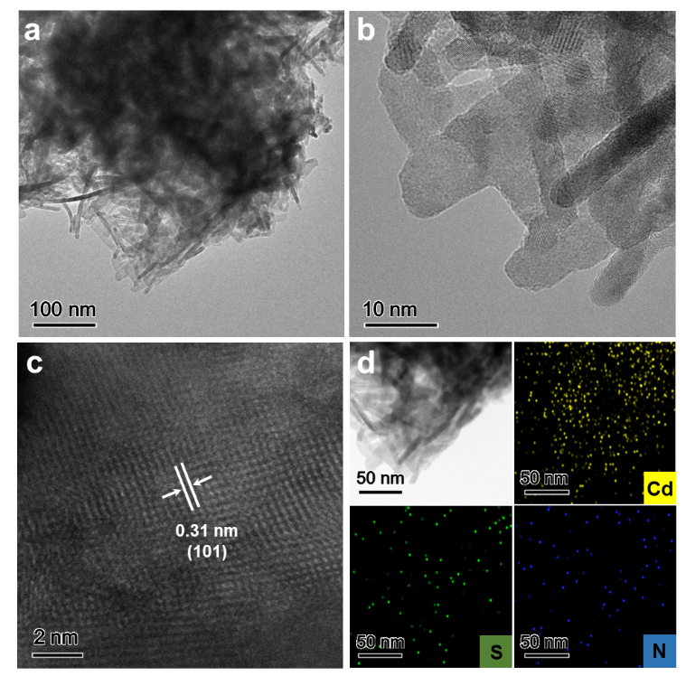
Supplementary Fig. 3. (a) TEM image, (b) HRTEM image, (c) AC-iDPC image and (d) element mappings of CdS.

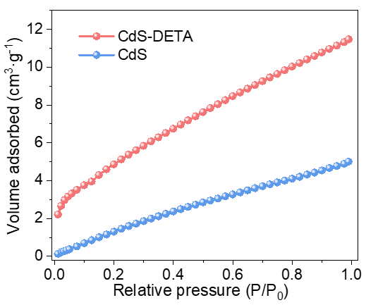
Supplementary Fig. 4. CO₂ adsorption isotherms of CdS–DETA and CdS.

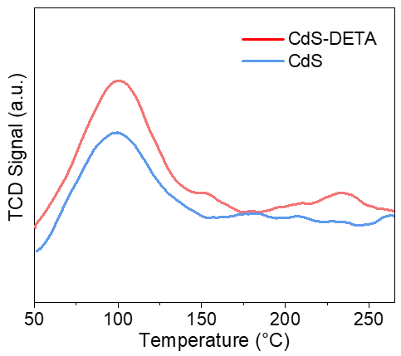
Supplementary Fig. 5. CO₂ TPD patterns of CdS–DETA and CdS.

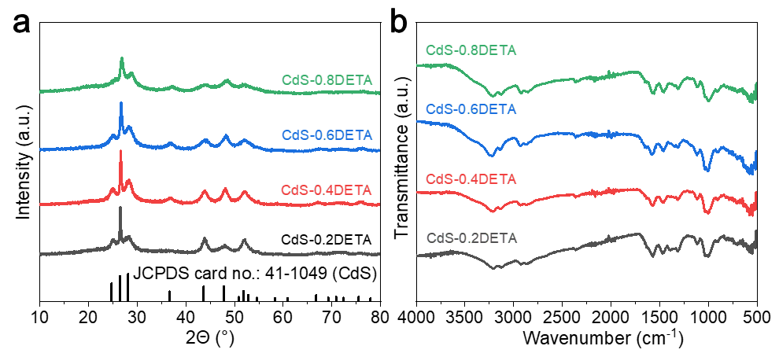
Supplementary Fig. 6. (a) XRD patterns and (b) FT-IR spectra of CdS-xDETA.

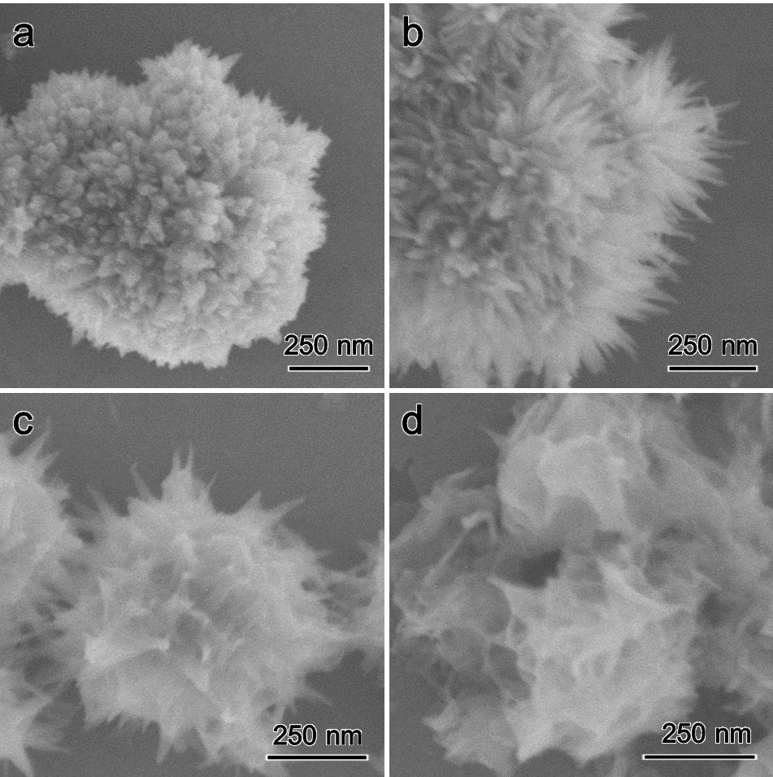
Supplementary Fig. 7. SEM images of (a) CdS-0.2DETA, (b) CdS-0.4DETA, (c) CdS-0.6DETA and (d) CdS-0.8DETA.

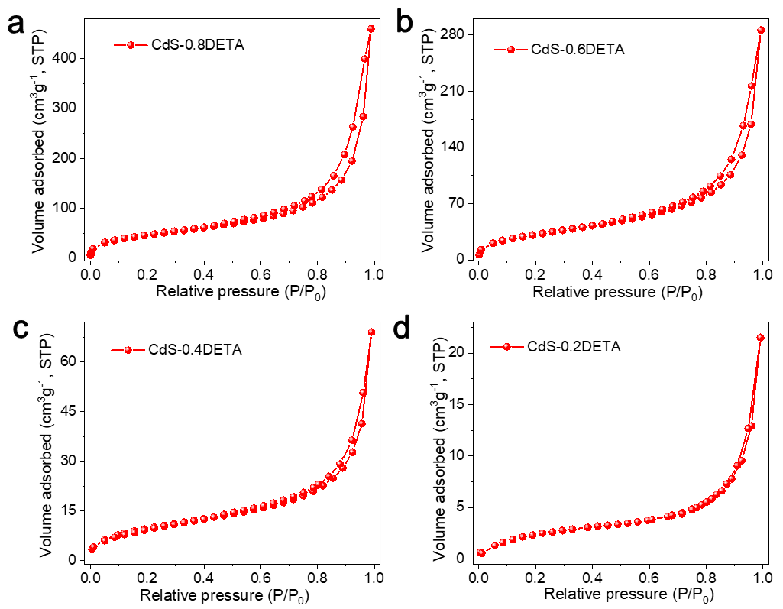
Supplementary Fig. 8. (a-d) N₂ sorption isotherms of CdS–xDETA.

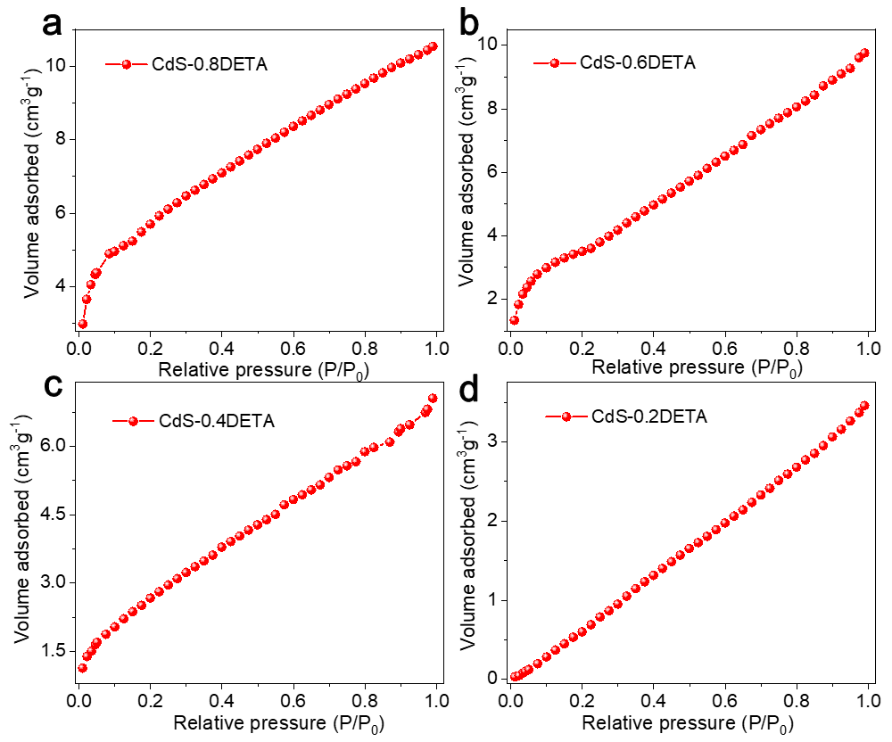
Supplementary Fig. 9. CO₂ adsorption isotherms patterns of CdS–xDETA.
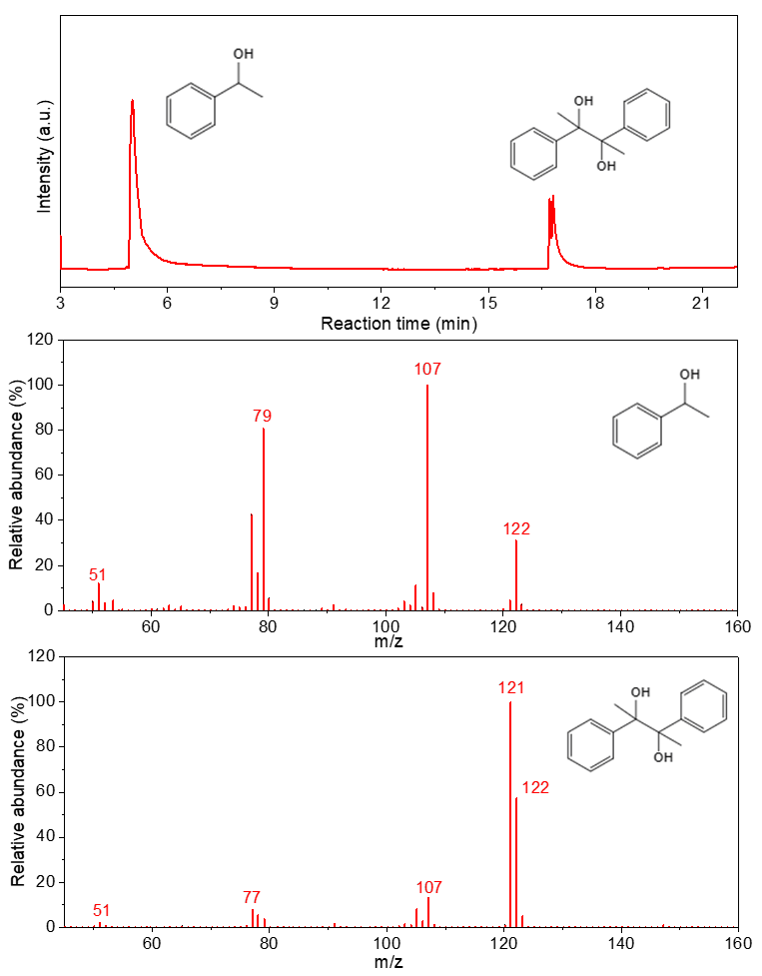
Supplementary Fig. 10. GC and mass spectra of 1-phenylethanol (feedstock) and the only obtained liquid products (pinacol).

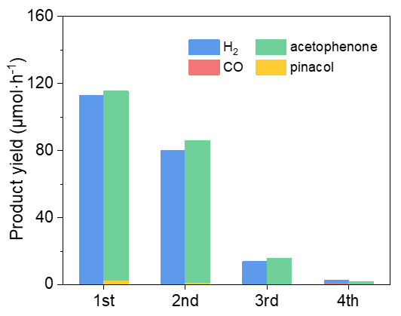
Supplementary Fig. 11. Stability tests of CdS.

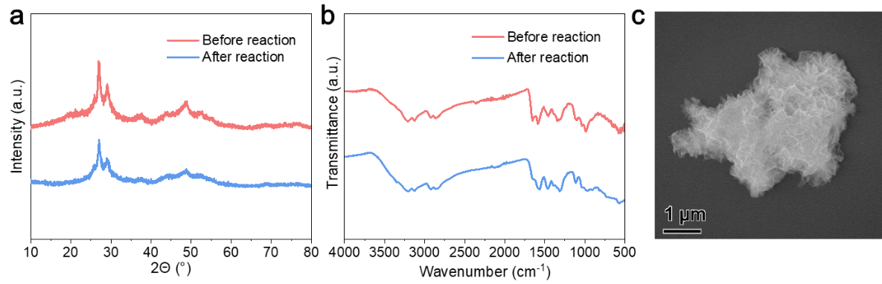
Supplementary Fig. 12. (a) XRD patterns and (b) FTIR spectra of CdS-DETA before and after reaction, (c) SEM image of CdS-DETA after reaction.

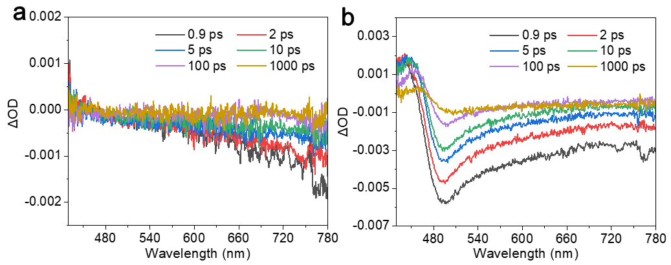
Supplementary Fig. 13. The decay signals transient absorption signals of (a) CdS-DETA and (b) CdS monitored at 732 nm.

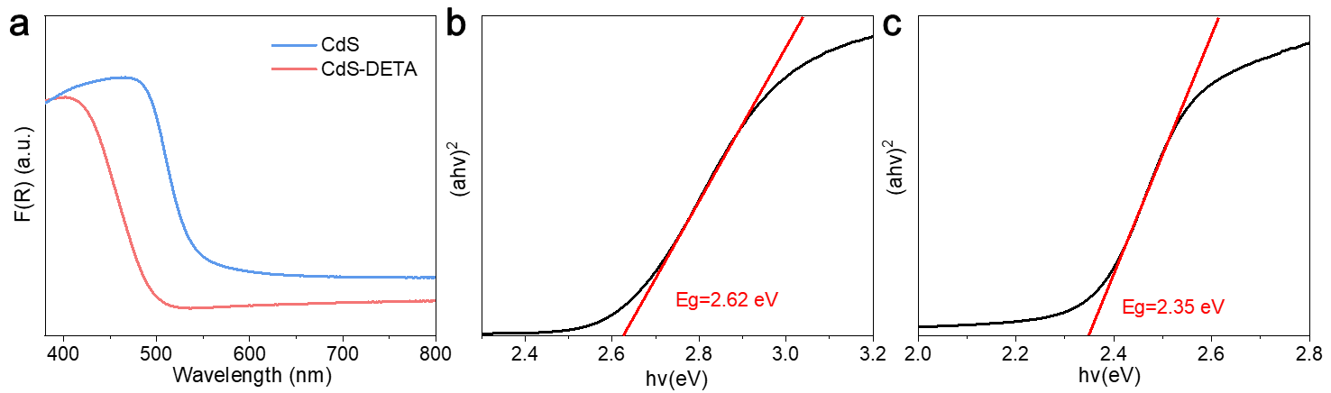
Supplementary Fig. 14. (a) DRS spectra of CdS-DETA and CdS. Tauc plots of CdS-DETA (b) and CdS (c).

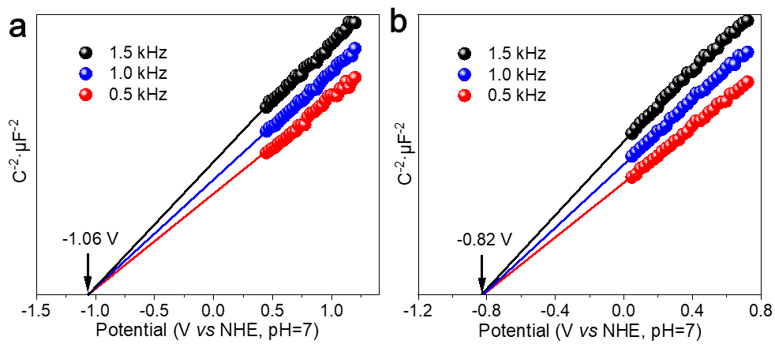
Supplementary Fig. 15. Mott-Schottky of CdS–DETA (a) and CdS (b).

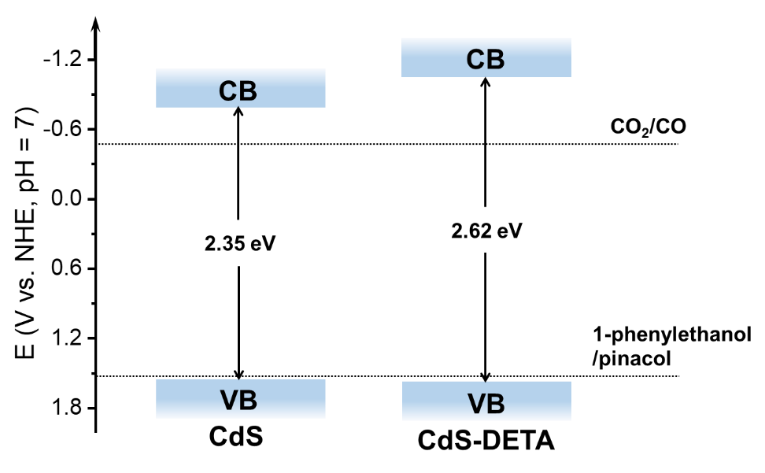
Supplementary Fig. 16. Illustration of the mechanism on CdS-DETA under simulated solar irradiation.

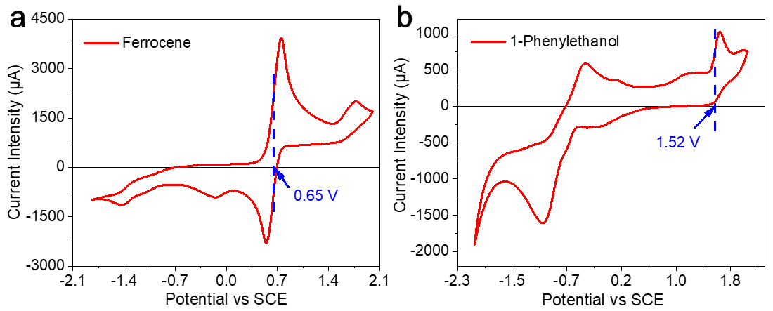
Supplementary Fig. 17. Cyclic voltammetry of (a) ferrocene as internal standard and (b) 1-phenylethanol in deaerated MeCN. The 1-phenylethanol concentration was 10 mM.
E_{ox}(1-phenylethannol) = 0.87 V vs Fc⁺/Fc
E_{ox}(1-phenylethannol) = 0.87 V + 0.4 V + 0.24 V = 1.51 V vs NHE

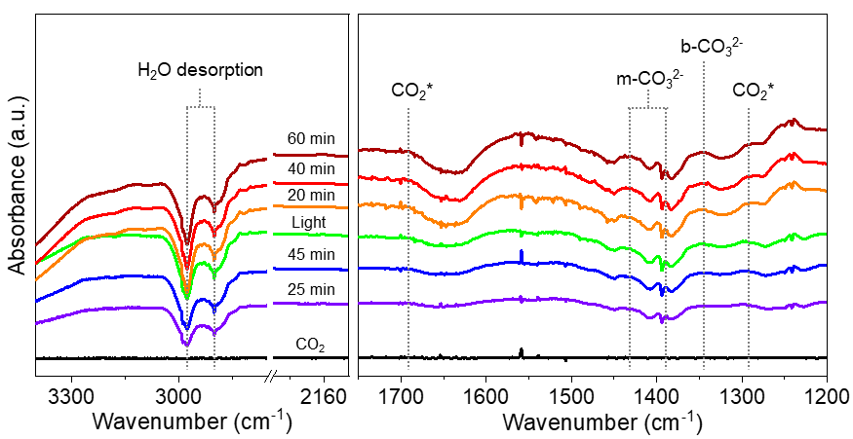
Supplementary Fig. 18. In-situ FT-IR spectra of CdS.

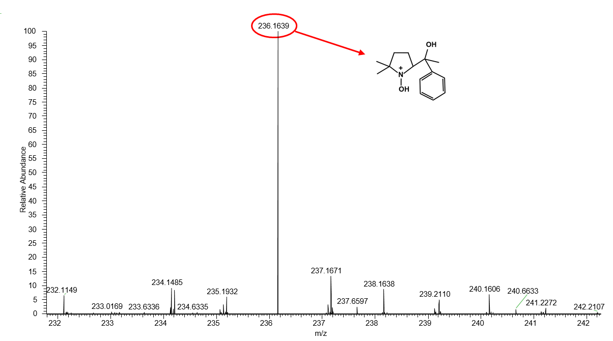
Supplementary Fig. 19. Mass spectrum (ESI, positive) of reaction system with introduction DMPO upon 12.0 h irradiation. DMPO was introduced into 10 mL photocatalytic CO₂ reduction system. After irradiation 12.0 h (λ = 395 nm), crude products were analyzed by mass spectra. The molecular weight of DMPO and intermediate Cα radical with addition of a H atom (m/z = 236.1639) was detected in themass spectrum, indicating the formation of Cα radical.

.

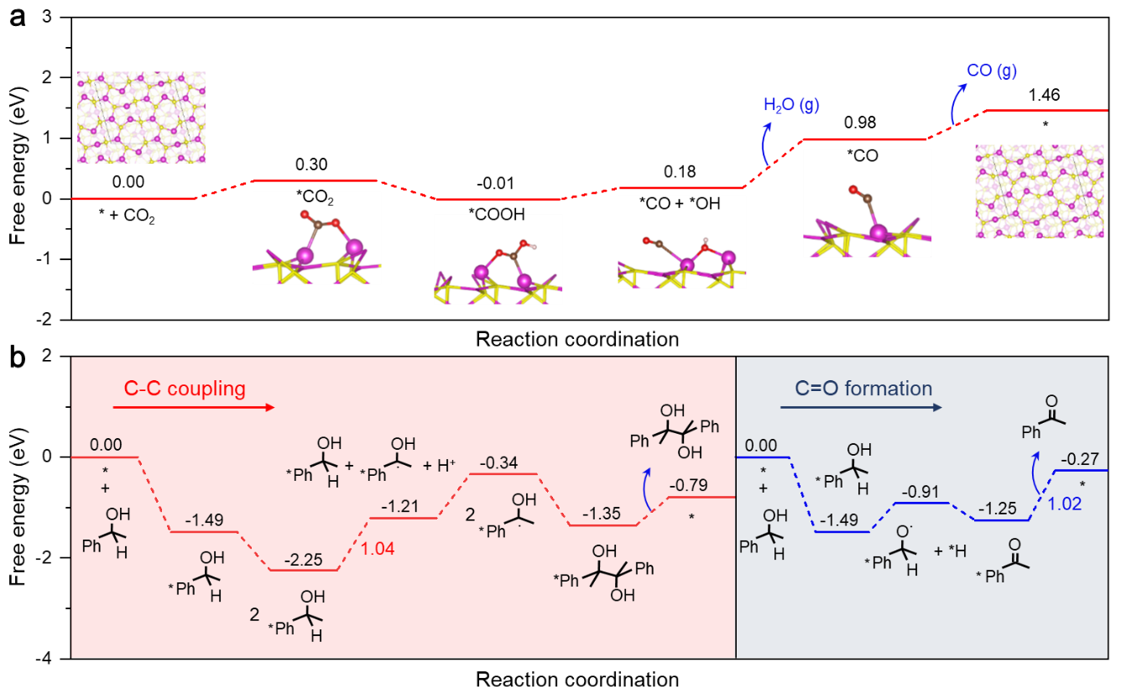
Supplementary Fig. 20. (a) Free energy diagram for the CO₂ reduction to CO on CdS (101) surface. (b) Free energy diagram for the 1-phenylethanol oxidation on CdS (101) surface. (brown, red, white, pink, and yellow atoms represent C, O, H, Cd and S atoms, respectively)

.

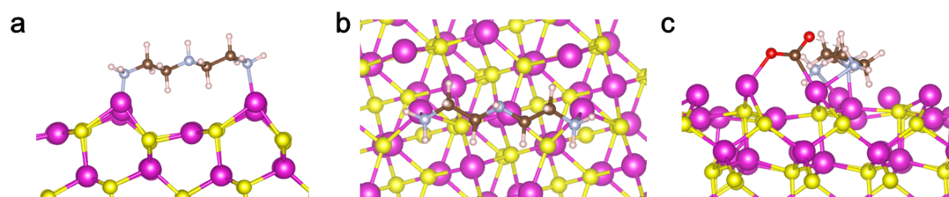
Supplementary Fig. 21. (a-b) Structural model of CdS-DETA and (c) the corresponding model of absorbing CO₂ molecular. (brown, red, white, pink, and yellow atoms represent C, O, H, Cd and S atoms, respectively)

Supplementary Table 1. EXAFS fitting parameters at the Cd K-edge for various samples（Ѕ₀²=0.90）
Sample | Shell | Nª | R(Å)^{b} | σ²(Å²)^{c} | ΔE₀ (eV)^{d} | R factor
CdS | Cd-S | 4.2 | 2.52 | 0.0065 | 4.4 | 0.0017
CdS-DETA | Cd-N | 0.3 | 2.01 | 0.0020 | 1.9 | 0.0023
CdS-DETA | Cd-S | 4.1 | 2.50 | 0.0070 | 1.9 | 0.0023
ªN: coordination numbers; ^{b}R: bond distance; ^{c}σ²: Debye-Waller factors; ^{d} ΔE₀: the inner potential correction. R factor: goodness of fit.

Supplementary Table 2. Performance comparison of photoredox systems of CO₂ reduction coupled with oxidative organic synthesis.
Catalyst | Red. Product (μmol g⁻¹ h⁻¹) | Oxi. Product (μmol g⁻¹ h⁻¹) | AQY (%) | e⁻/h⁺ | Ref.
CdS-DETA | CO: 93410 | pinacol: 110780 | 25.0 | 0.98 | This work
CdSe/CdS | CO: 27630 | pinacol: 26500 | 0.9 | 1.05 | ⁷
ZnSe QDs | CO: 5300 | hydrofuroin: n.d. | n.d. | n.d. | ⁸
Ni-CdS | CO: 1290 | 1-cyclohexyl-isoquinoline: 2580 | 1.2 | 0.50 | ⁹
3DOM CdS QD/NC | CO: 5210 | N-benzylbenzaldimine: 9820 | 2.9 | 0.59 | ¹⁰
BP-ZnIn₂S₄ | CO: 840 | N-benzylbenzaldimine: 1490 | 6.5 | 0.84 | ¹¹
CN/POM/[Re] | CO: 21.3 | benzene: 12.1  1,3-cyclohexene: 11.3 | n.d. | 0.91 | ¹²
FAPbBr₃/Bi₂WO₆ | CO: 170 | henzaldehyde: 250 | 1.2 | 0.68 | ¹³

Supplementary Table 3. BET surface area, adsorption average pore diameter and maximum CO₂ uptake of CdS-xDETA.
Catalyst | Surface area (m²·g⁻¹) | Adsorption average  pore diameter (nm) | Maximum CO₂ uptake (cm³·g⁻¹)
CdS-0.2DETA | 10 | 7.3 | 3.5
CdS-0.4DETA | 36 | 6.4 | 7.1
CdS-0.6DETA | 120 | 7.7 | 9.8
CdS-0.8DETA | 171 | 8.5 | 10.5

Supplementary Table 4. CO₂ reduction integrated with pinacol coupling reaction under irradiation
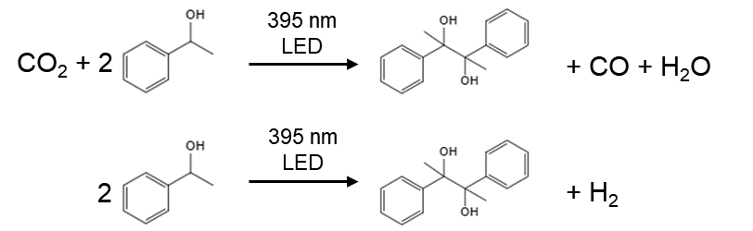
Catalyst | CO  (μmol·h⁻¹) | H₂  (μmol·h⁻¹) | Oxidation Products  (μmol·h⁻¹) | e⁻/h⁺
CdS-0.2DETA | 0.5 | 0.8 | C₁₆H₁₈O₂:1.3 | 1.00
CdS-0.4DETA | 5.2 | 4.5 | C₁₆H₁₈O₂:9.0 | 1.08
CdS-0.6DETA | 82.4 | 32.5 | C₁₆H₁₈O₂:104 | 1.10
CdS-0.8DETA | 266.3 | 38.5 | C₁₆H₁₈O₂:297.4 | 1.02
Reaction conditions: 5 mg of photocatalyst were dispersed in 11 mL of acetonitrile, then, 500 μL 1-phenylethanol were added into the solution. The solution was bubbled with CO₂ for 10 min and was irradiated with LED lamp (395 nm) for 1h at 25 °C.

References
1 Kresse, G. & Furthmüller, J. Efficient iterative schemes for ab initio total-energy calculations using a plane-wave basis set. PRB 54, 11169-11186 (1996).
2 Blöchl, P. E. Projector augmented-wave method. PRB 50, 17953-17979 (1994).
3 Perdew, J. P., Burke, K. & Ernzerhof, M. Generalized Gradient Approximation Made Simple. Phys. Rev. Lett. 77, 3865-3868 (1996).
4 Grimme, S. Semiempirical GGA-type density functional constructed with a long-range dispersion correction. J. Comput. Chem. 27, 1787-1799 (2006).
5 Gupta, S. S. & van Huis, M. A. Adsorption Study of a Water Molecule on Vacancy-Defected Nonpolar CdS Surfaces. JPC C 121, 9815-9824 (2017).
6 Luo, G., Jing, Y. & Li, Y. Rational design of dual-metal-site catalysts for electroreduction of carbon dioxide. J. Mater. Chem. A 8, 15809-15815 (2020).
7 Guo, Q. et al. Efficient and Selective CO₂ Reduction Integrated with Organic Synthesis by Solar Energy. Chem 5, 2605-2616 (2019).
8 Xin, Z.-K. et al. Reductive Carbon–Carbon Coupling on Metal Sites Regulates Photocatalytic CO₂ Reduction in Water Using ZnSe Quantum Dots. Angew. Chem. Int. Ed. 61, e202207222 (2022).
9 Qi, M.-Y. & Xu, Y.-J. Efficient and Direct Functionalization of Allylic sp C−H Bonds with Concomitant CO₂ Reduction. Angew. Chem. Int. Ed. 62, e202311731 (2023).
10 Wang, F. et al. Ordered Macroporous Carbonous Frameworks Implanted with CdS Quantum Dots for Efficient Photocatalytic CO₂ Reduction. Adv. Mater. 33, 2102690 (2021).
11 Han, C. et al. Cooperative Syngas Production and C−N Bond Formation in One Photoredox Cycle. Angew. Chem. Int. Ed. 60, 7962-7970 (2021).
12 Yu, H., Haviv, E. & Neumann, R. Visible-Light Photochemical Reduction of CO₂ to CO Coupled to Hydrocarbon Dehydrogenation. Angew. Chem. Int. Ed. 59, 6219-6223 (2020).
13 Huang, H. et al. Direct Z-Scheme Heterojunction of Semicoherent FAPbBr₃/Bi₂WO₆ Interface for Photoredox Reaction with Large Driving Force. ACS Nano 14, 16689-16697 (2020).

