Supplementary figures (From the field plot)
By: Esayas Embaye Kidane, ORCID: https://orcid.org/0000-0002-9667-2236)
This document provides supplementary information on some of the mammals found in Kafta-Sheraro National Park, as well as the threats they face.
- Some mammals of Kafta-Sheraro National Park
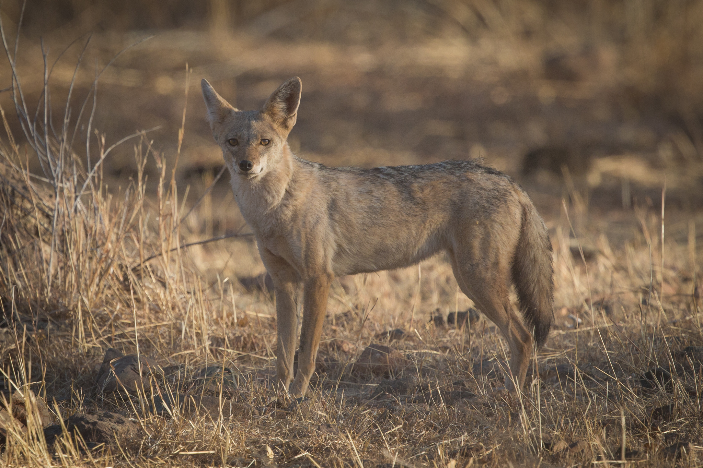  A | 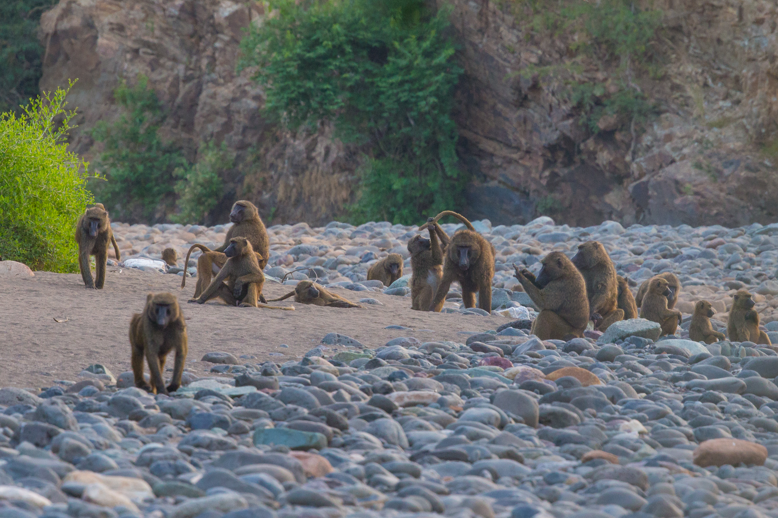  B
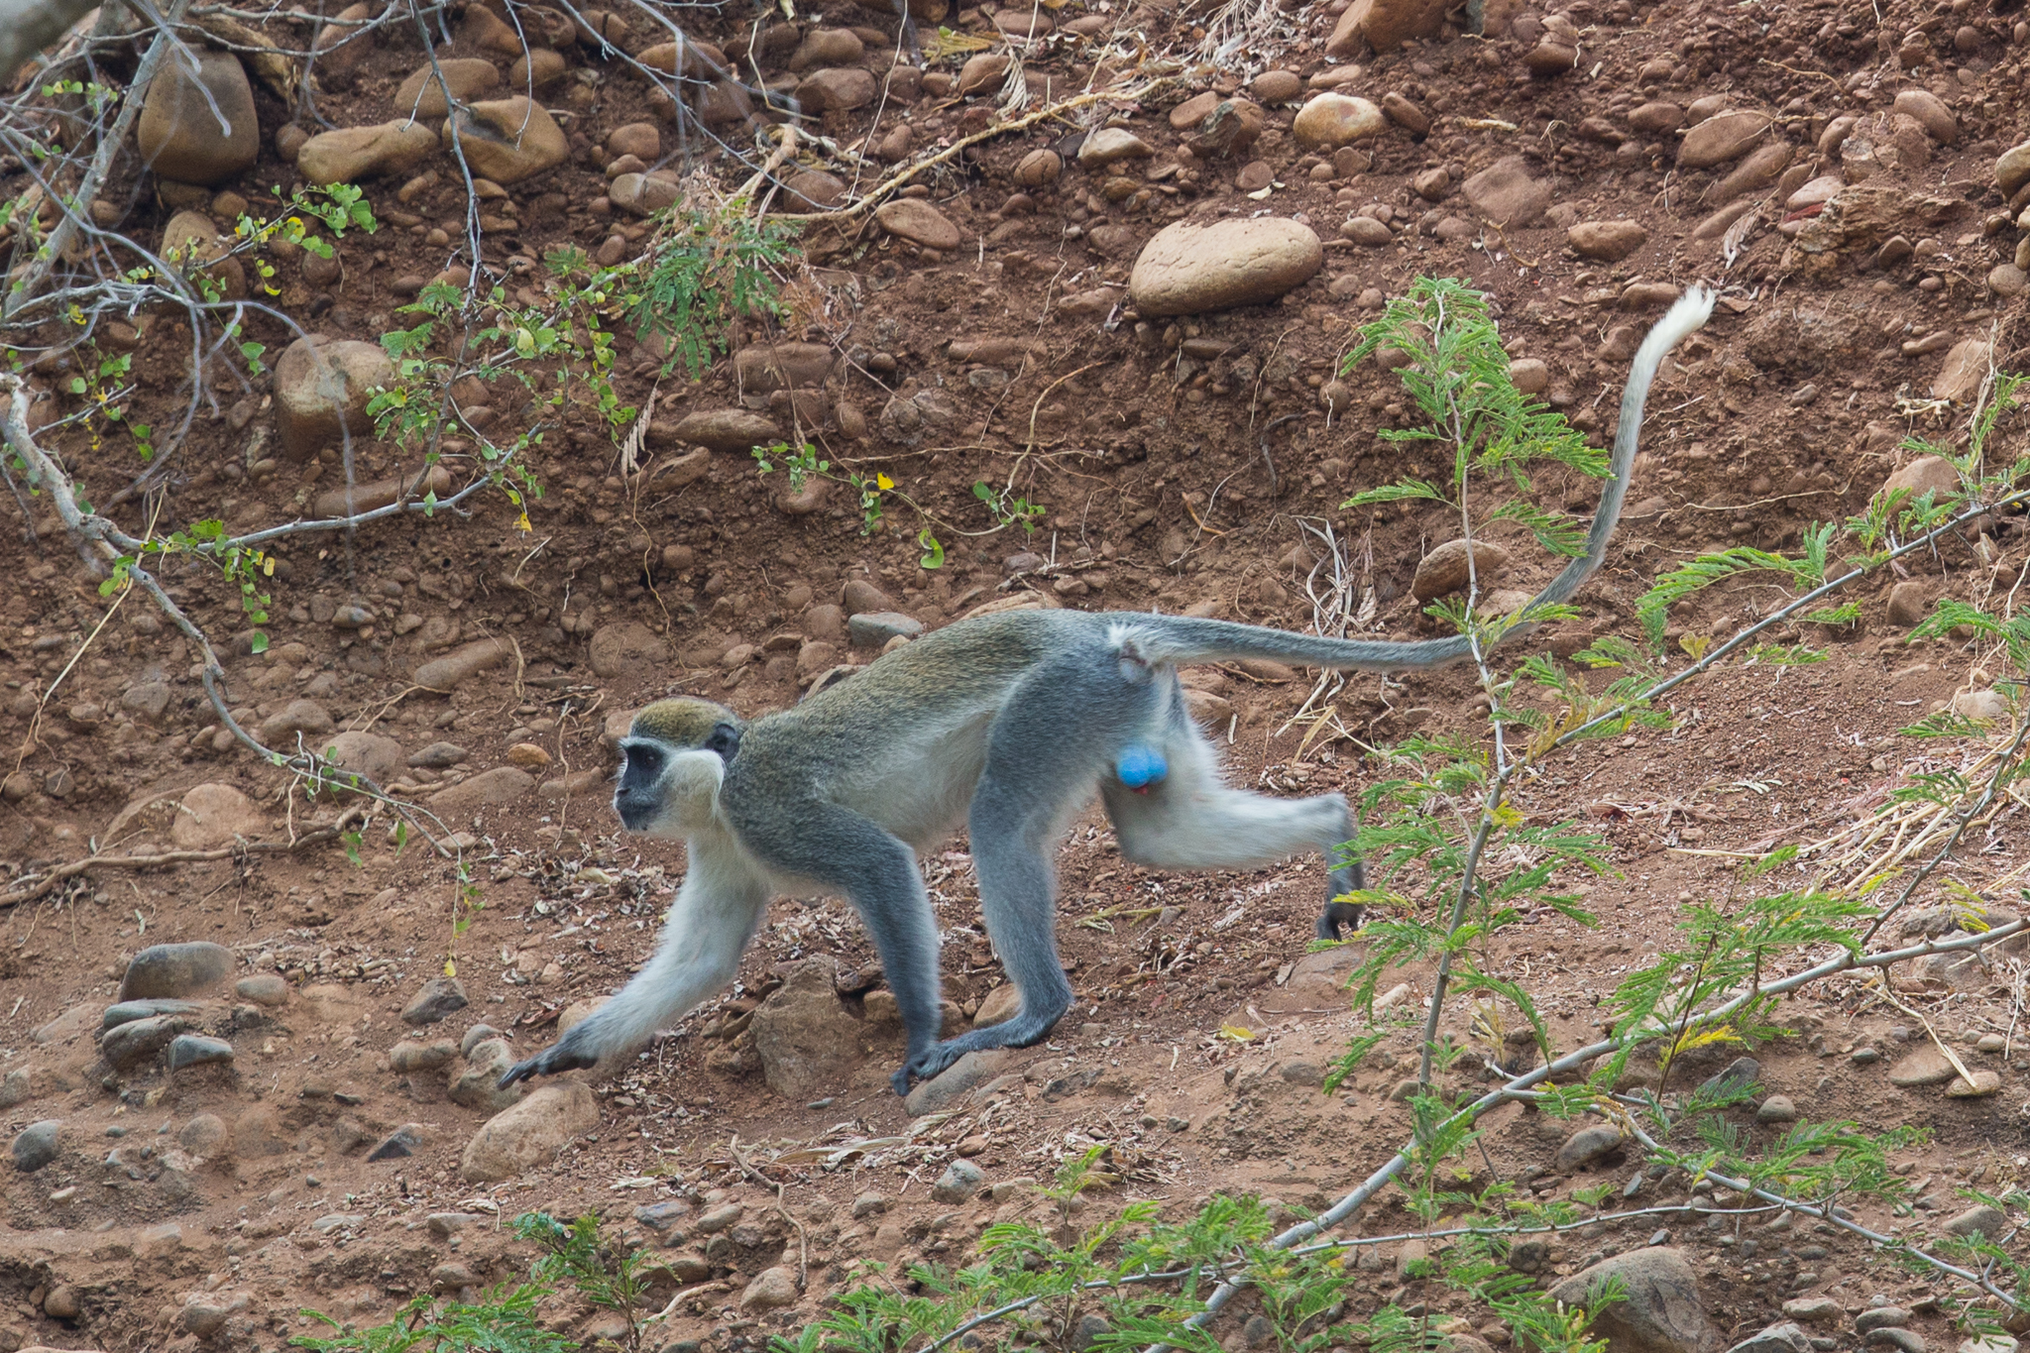  C | 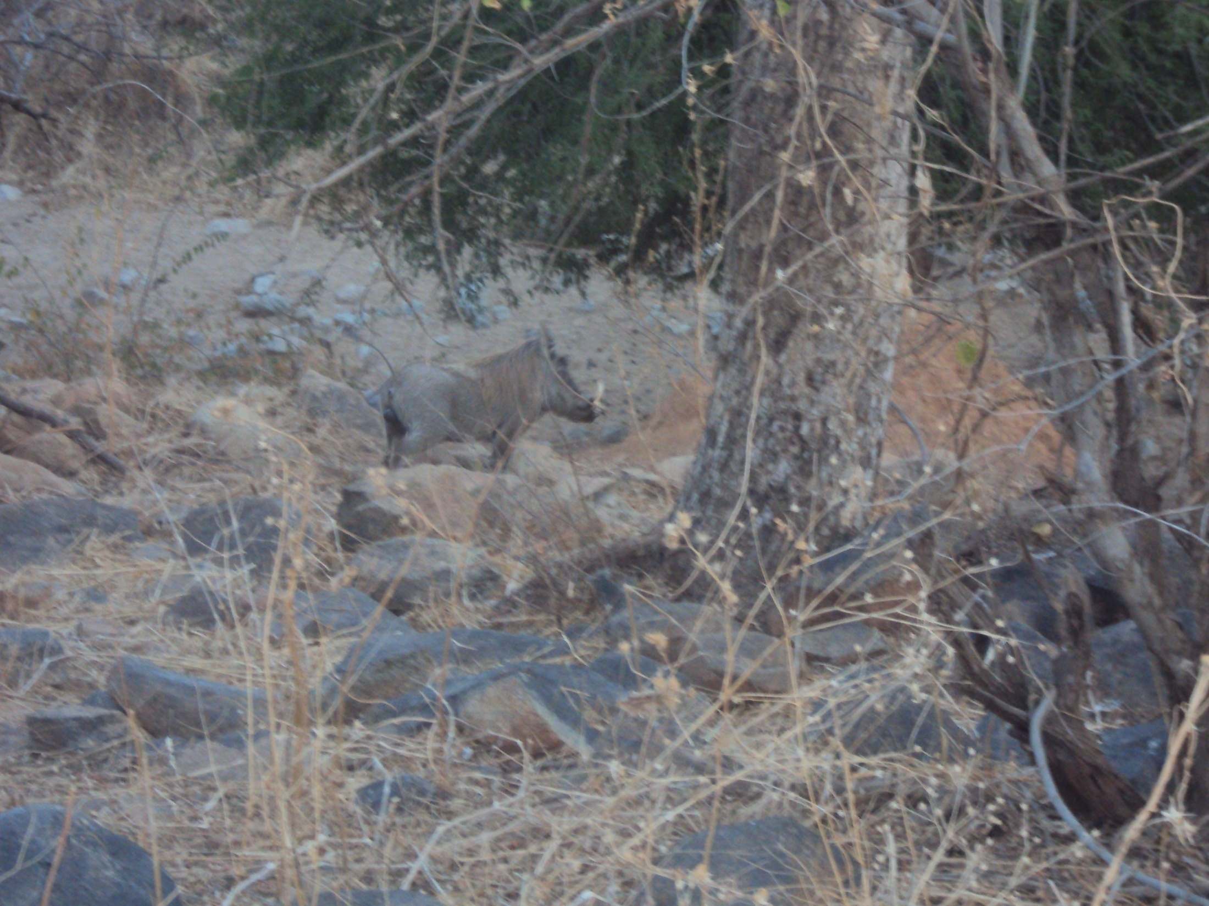  D
Plate 1: Mammals of Kafta-Sheraro National Park; (A) Canis mesomelas, (B) Papio anubis, (C) Chlorocebus aethiops, and (D) Phacochoerus africanus

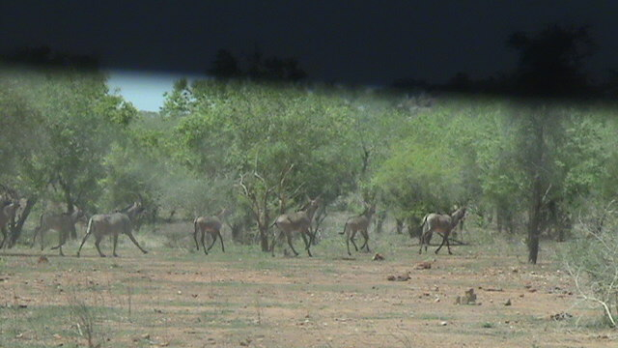  A | 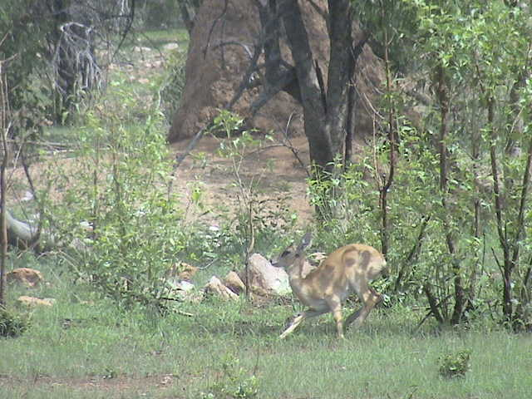  B
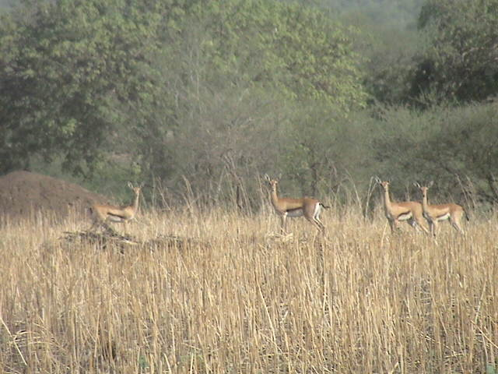  C | 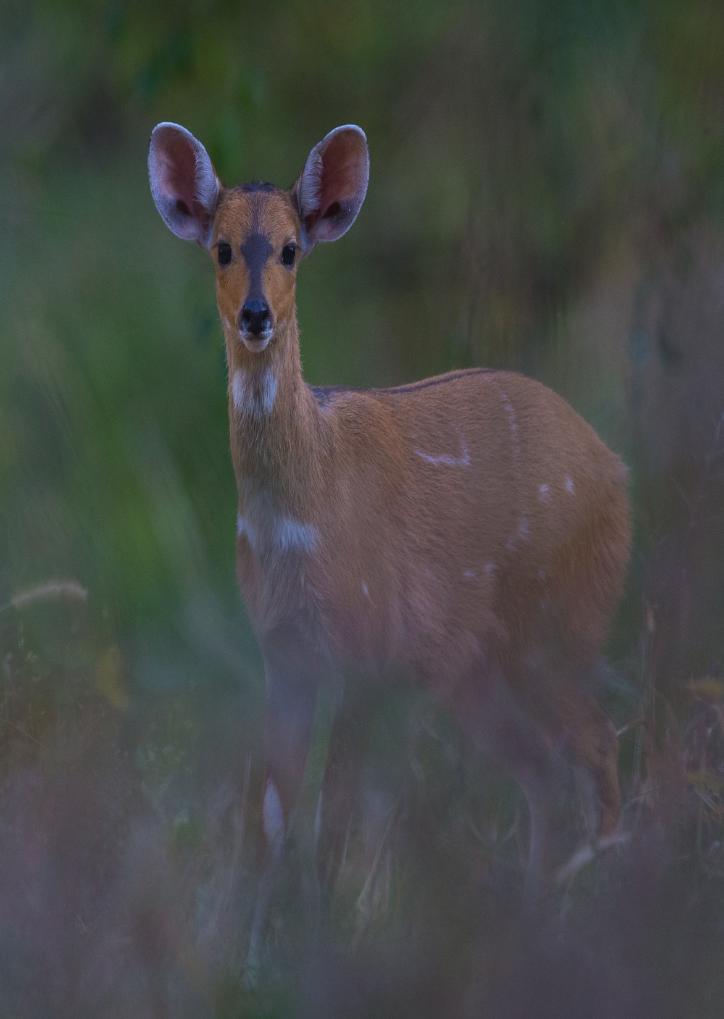  D
Plate 2: Mammals of Kafta-Sheraro National Park; (A) Hippotragus equinus, (B) Ourebia ourebi, (C) Eudorcas rufifrons, and (D) Tragelaphus skirptes

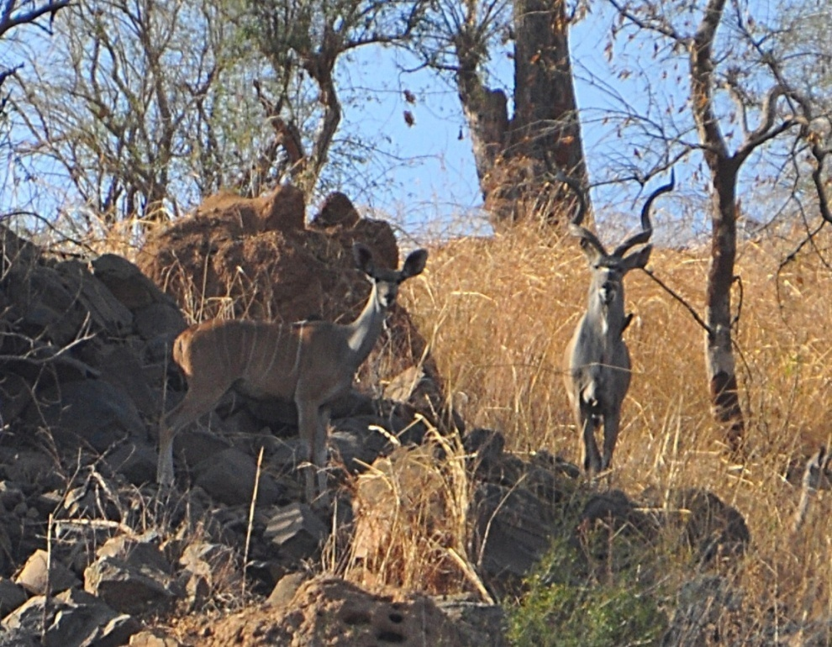  A | 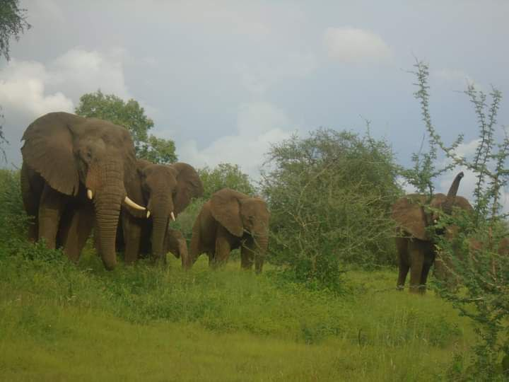  B
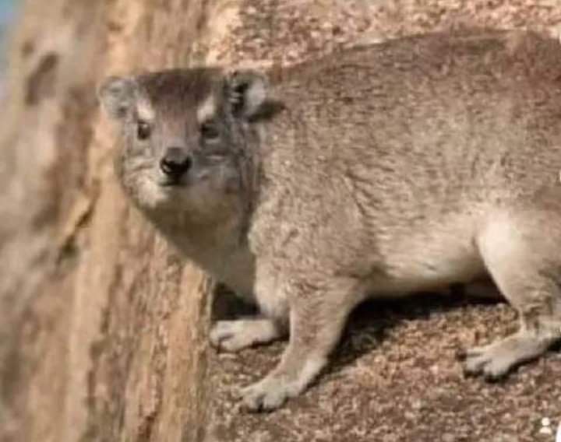  C | 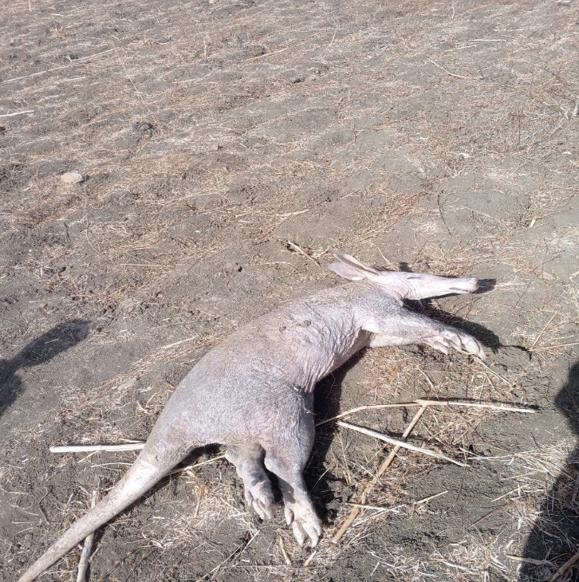  D
Plate 3: Mammals of Kafta-Sheraro National Park; (A) Tragelaphus strepsiceros, (B) Loxodonta africana, (C) Procavia capensis, and (D) Dead Orycteropus afer

- Threats of mammals of Kafta-Sheraro National Park
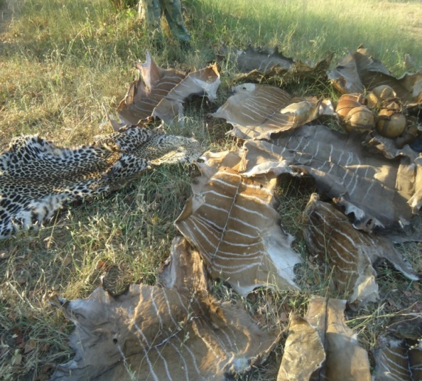  A | 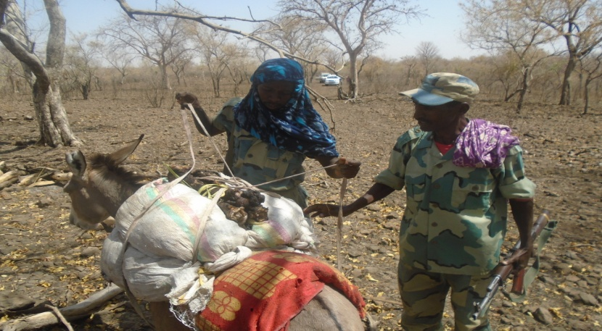  B
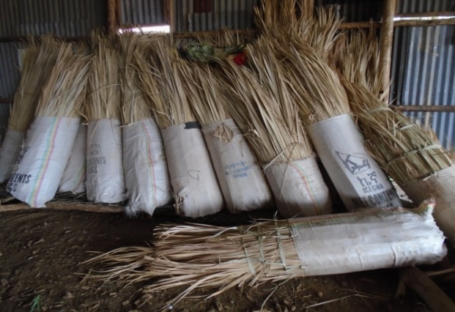  C | 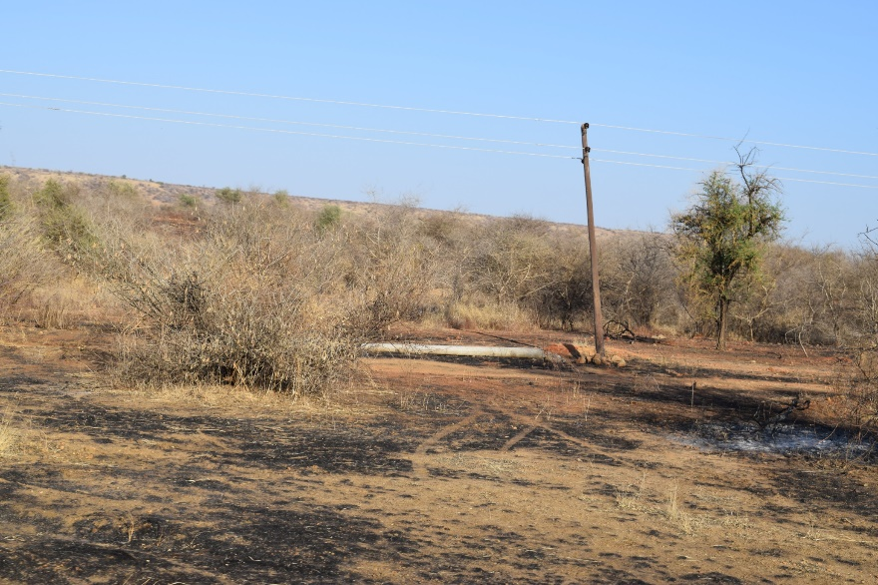  D
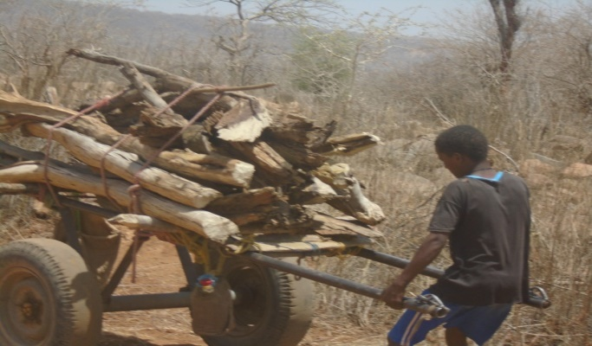  E | 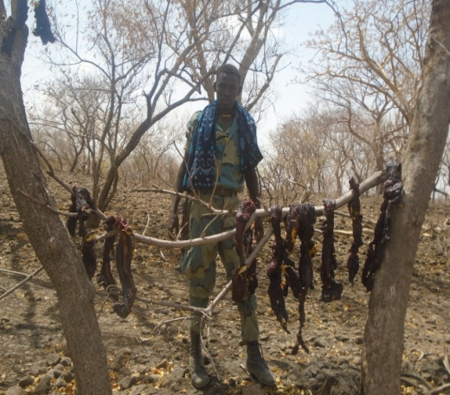  F
Plate 4: Threats of mammals of Kafta-Sheraro National Park; (A) Hunting for different purpose, (B) Agricultural expansion, (C) Collection of economical plants, (D) bush burning, (E) Firewood collection, and (F) Meat of greater kudu (illegal hunting of mammals for meat)

