Table A1. Survey information and taking frequency.
Survey type | Questions | Question number | Survey-taking frequency
Demographics | Sex | 1 | Only once (at the beginning of the study)
Demographics | Age | 1 | Only once (at the beginning of the study)
Demographics | College class year | 1 | Only once (at the beginning of the study)
Socioeconomic status | Family annual income  Parents/ Guardians employer  Number of owned cars  Number of people in home  Number of bedrooms in home | 1  1  1  1  1 | Only once (at the beginning of the study)
Daily activity | Time-diaries on different activities | 9 | Daily
Mental health | Perceived stress scale (PSS) | 4 | Weekly
Mental health | Positive and negative affect schedule (PANAS) | 1 | Weekly
Mental health | Center for Epidemiological Studies-Depression (CES-D) | 10 | Monthly
Mental health | State-Trait Anxiety | 40 | Monthly
GPA and online learning performance | Transcripts | 1 | Only once (at the end of the participation)
GPA and online learning performance | Online student engagement | 19 | Weekly

Table A2. Subjects’ Demographic and family socio-economic status distribution
Ethnicity | %
White | 56.4
Asian | 26.4
Hispanic/Latino | 10.7
Black or Africa American | 2.9
Others | 3.6
Annual income ($) | %
<10k | 1.4
10-49k | 27.9
50-99k | 10.7
100-149k | 32.1
>149k | 26.4
No. of possessed car | %
0-2 | 36.4
3-4 | 51.4
≥5 | 11.4
Home ownership | %
Own without mortgage | 32.1
Own with mortgage | 52.9
Rent | 7.9
Not sure | 7.1
Sex
Male | 30.5
Female | 68.8
School year
1st | 25
2nd | 25.7
3rd | 27.9
4th | 21.4
No. of people living in the house/apartment
1-3 | 34.3
4-6 | 63.6
6+ | 0.01
No. of the bedroom
1-2 | 11.4
3-4 | 82.1
≥5 | 5.7
Parents’ employment
Private company &Business | 74.1
Individual & Self-employment | 15.1
Government | 10.1

Table A3. Regression results of mental health on GPA and OSE
Learning | Mental health outcomes | B | SE | 95% CI | P-value
GPA | Stress | -0.02 | 0.06 | -0.14 to 0.10 | .755
GPA | Depression | -0.01 | 0.05 | -0.10 to 0.08 | .839
GPA | Anxiety | -0.07 | 0.08 | -0.26 to 0.11 | .438
Online student engagement (OSE) | Stress | -0.92 | 0.25 | -1.40 to -0.17 | <.001***
Online student engagement (OSE) | Depression | -0.34 | 0.12 | -0.51 to 0.04 | .005**
Online student engagement (OSE) | Anxiety | -0.02 | 0.05 | -0.15 to 0.11 | .772

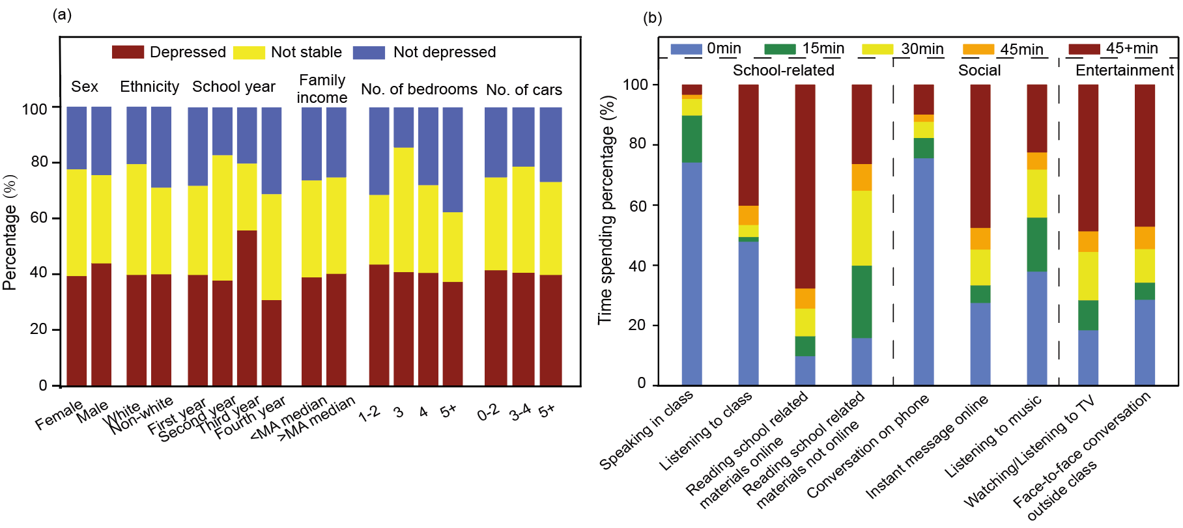
Figure A1. Participants' depression status and daily activity time use (a) Distribution of depression status among different demographic and SES groups¹ (% of total participants); (b) Distribution of time spent on daily activities (% of total weekly responses per activity, participants could contribute multiple responses)

Reference
1. U.S. Census Bureau QuickFacts: Massachusetts. https://www.census.gov/quickfacts/fact/table/MA/INC110221. Accessed April 18, 2025.

