Supplementary Material

How does the conformational landscape change on substitution in tetralin? A computational investigation with oxygen, sulphur and selenium

Asif Iqubal Middya and Abhijit Chakraborty

Department of Physics, University of Burdwan, Golapbag Campus, 713104, Burdwan, West Bengal,India

* E-mail : achakraborty.buphys@gmail.com, achakraborty@phys.buruniv.ac.in
List of Tables and Figures
Tables:
Table T1. Geometrical parameters of the optimized “twisted” configuration of isochroman in S₀. Computations are done at M06-2X/6-311G ++ (2d,3p) level.
Table T2. Geometrical parameters of the optimized configurations of isothiochroman in S₀. Computations are done at M06-2X/6-311G ++ (2d,3p) level.
Table T3. Geometrical parameters of the optimized configurations of isoselenochroman in S₀. Computations are done at M06-2X/6-311G ++ (2d,3p) level.
Table T4. :Computed frequencies (cm⁻¹) of the two conformers of isothiochroman in S₀ state and its assignments with PED analysis. Computations are performed at M06-2X/6-311G++(2d,3p) level of theory
Table T5. Computed frequencies (cm⁻¹) of isochroman in S₀ state and its assignments with PED analysis. Computations are performed at M06-2X/6-311G++(2d,3p) level of theory.
Table T6. Computed frequencies (cm⁻¹) of the two conformers of isoselenochroman in S₀ state and its assignments with PED analysis. Computations are performed at M06-2X/6-311G++(2d,3p) level of theory
Figures :
Figure F1. Comparison of observed and computed frequencies of isochroman. The observed frequencies are taken from Raman Spectrum of Ref. [32] of the main manuscript. The computations are performed at M06-2X/6-311 G++(2d,3p) level of theory
Figure F2. Different conformers and transition states (TS) along with their relative energies of isoselenochroman. Computations are performed at M06-2X/6-311G++(2d,3p) level of theory in the Ground State of the respective molecules.
Table T1. Geometrical parameters of the optimized “twisted” configuration of isochroman. Computations are done at M06-2X/6-311G ++ (2d,3p) level.
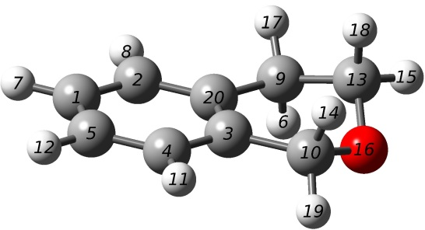

---------------------------------------------------------------------
Atom Atomic Coordinates (Angstroms)
Number Number X Y Z
---------------------------------------------------------------------
1 6 -2.536576 0.692940 0.000000
2 6 -1.338041 1.386738 -0.046143
3 6 -0.113935 -0.679644 -0.004850
4 6 -1.319250 -1.374207 0.044753
5 6 -2.527700 -0.697010 0.046234
6 1 1.381418 1.791892 -1.126452
7 1 -3.473805 1.231135 0.001430
8 1 -1.341321 2.469107 -0.078186
9 6 1.190798 1.463690 -0.102628
10 6 1.193043 -1.438840 0.014663
11 1 -1.306208 -2.456947 0.077221
12 1 -3.457460 -1.246954 0.080019
13 6 2.333402 0.568670 0.348066
14 1 1.357226 -1.852382 1.018495
15 1 3.300087 1.022992 0.144037
16 8 2.300421 -0.653844 -0.361495
17 1 1.140520 2.356563 0.521860
18 1 2.263332 0.374054 1.425266
19 1 1.152254 -2.272055 -0.685029
20 6 -0.118310 0.713221 -0.047878
--------------------------------------------------------------------
Table T2 Geometrical parameters of the optimized configurations of isothiochroman. Computations are done at M06-2X / 6-311G ++ (2d,3p) level.
(a) Bent
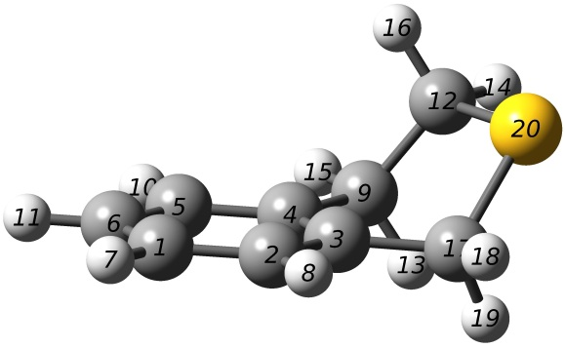
Atom Atomic Coordinates (Angstroms)
Number Number X Y Z
---------------------------------------------------------------------
1 6 2.694982 -0.832073 -0.287858
2 6 1.476890 -1.434534 -0.000319
3 6 0.363058 -0.660598 0.301132
4 6 0.465480 0.734015 0.300794
5 6 1.685045 1.329360 0.005630
6 6 2.800198 0.551619 -0.281822
7 1 3.557443 -1.440992 -0.519264
8 1 1.390217 -2.513228 -0.007676
9 6 -0.783167 1.527888 0.563522
10 1 1.762139 2.409033 -0.000788
11 1 3.745298 1.025513 -0.505907
12 6 -1.879952 1.166879 -0.442275
13 1 -1.152903 1.336382 1.573723
14 1 -2.788501 1.724901 -0.230923
15 1 -0.573639 2.594960 0.492815
16 1 -1.546587 1.406980 -1.449315
17 6 -0.963239 -1.265492 0.641919
18 1 -0.963459 -2.339855 0.477879
19 1 -1.213617 -1.083220 1.686282
20 16 -2.324429 -0.610141 -0.397974
--------------------------------------------------------------------

(b) Twisted
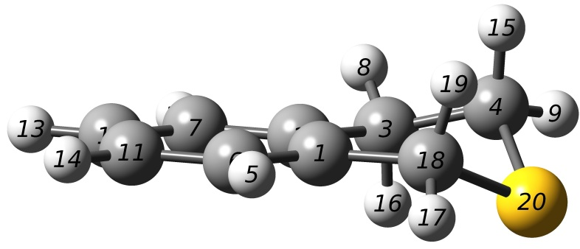
---------------------------------------------------------------------
Atom Atomic Coordinates (Angstroms)
Number Number X Y Z
---------------------------------------------------------------------
1 6 -0.370875 -0.652521 0.093753
2 6 -0.451761 0.738537 -0.004926
3 6 0.759750 1.645528 -0.042521
4 6 2.045132 1.018976 0.465101
5 1 -1.477238 -2.482120 0.165401
6 6 -1.546688 -1.403974 0.090729
7 6 -1.710941 1.331222 -0.103256
8 1 0.541120 2.540052 0.544969
9 1 2.895681 1.668992 0.276087
10 6 -2.872334 0.578832 -0.106676
11 6 -2.789696 -0.804323 -0.009464
12 1 -1.772209 2.409971 -0.178595
13 1 -3.833608 1.066476 -0.185195
14 1 -3.684995 -1.409554 -0.014262
15 1 2.000269 0.817165 1.535202
16 1 0.913772 1.974282 -1.072319
17 1 0.880643 -2.350203 -0.277329
18 6 0.930540 -1.401537 0.252863
19 1 1.109909 -1.622634 1.305984
20 16 2.386235 -0.539875 -0.399274
--------------------------------------------------------------------

Table T3. Geometrical parameters of the optimized configurations of isoselenochroman. Computations are done at M06-2X/6-311G ++ (2d,3p) level.
- Bent
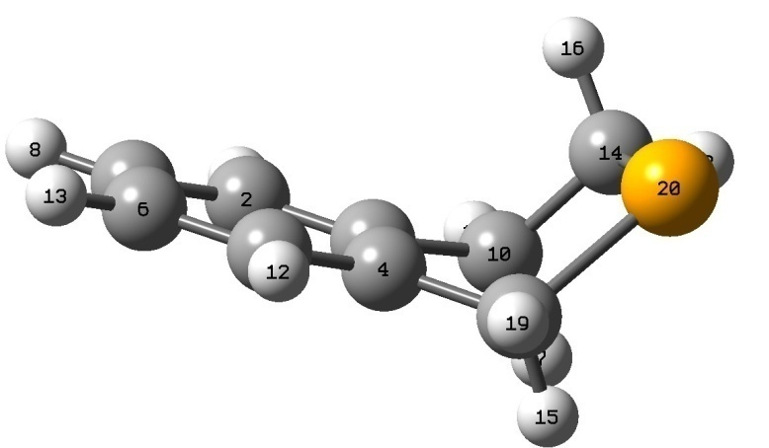
---------------------------------------------------------------------
Atom Atomic Coordinates (Angstroms)
Number Number X Y Z
---------------------------------------------------------------------
1 6 -3.272135 0.371928 0.395493
2 6 -2.246657 1.248271 0.062443
3 6 -1.004089 0.770308 -0.334721
4 6 -0.787129 -0.611615 -0.394579
5 1 -1.812557 -1.483980 -0.047411
6 6 -3.053173 -0.997218 0.343033
7 6 0.502347 1.531604 -1.661061
8 1 -4.234775 0.757458 0.699754
9 1 -2.411751 2.316843 0.113024
10 6 0.143391 1.692205 -0.641964
11 6 0.550488 -1.109365 -0.837578
12 1 -1.638191 -2.551259 -0.087052
13 1 -3.843964 -1.685063 0.606516
14 1 1.307227 1.484736 0.331134
15 1 0.754993 -0.842120 -1.871330
16 1 0.983447 1.673728 1.350391
17 1 -0.187850 2.728877 -0.577096
18 6 2.134579 2.144377 0.088300
19 1 0.632983 -2.187061 -0.734513
20 34 2.010470 -0.355265 0.259352
--------------------------------------------------------------------

b) Twisted
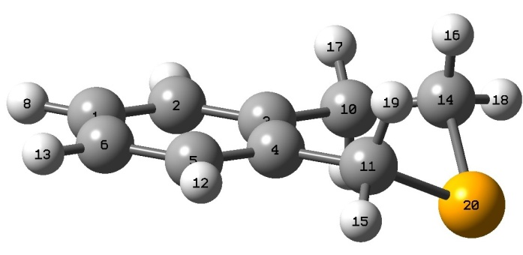

---------------------------------------------------------------------
Atom Atomic Coordinates (Angstroms)
Number Number X Y Z
---------------------------------------------------------------------
1 6 -3.371800 0.425467 -0.222882
2 6 -2.268258 1.258687 -0.170639
3 6 -0.977550 0.767972 0.037179
4 6 -0.804592 -0.612200 0.197037
5 1 -1.925436 -1.444554 0.141797
6 6 -3.198624 -0.943238 -0.065247
7 6 0.319528 2.108560 -0.991653
8 1 -4.356711 0.839121 -0.386278
9 1 -2.400114 2.326422 -0.295331
10 6 0.150036 1.784862 0.036810
11 6 0.524852 -1.278124 0.466670
12 1 -1.785894 -2.511380 0.262748
13 1 -4.045478 -1.613267 -0.106002
14 1 1.466535 1.312914 0.623022
15 1 0.537092 -2.274244 0.033268
16 1 1.384058 1.090446 1.685147
17 1 -0.188700 2.663799 0.590542
18 6 2.245492 2.057293 0.486637
19 1 0.696715 -1.378658 1.537398
20 34 2.059501 -0.321730 -0.267028
--------------------------------------------------------------------

Table T4. : Computed frequencies (cm⁻¹) of the two conformers of isothiochroman and its assignments with PED analysis. Computations are performed at M06-2X/6-311G++(2d,3p) level of theory

Mode | TWISTED | BENT | Assignmentsª
1(ν₅₄) | 125 | 76 | τ (CCCC)R1 (31) + τ(SCCC)R1 (33)  τ(CCCC)R1 (11)+ τ(SCCC)R1 (50)
2(ν₅₃) | 172 | 122 | τ (CCCC) R1 and R2 (53) +λ(CCCC) (12)  τ(CCCC)R1&R2(21)+ λ(CCCC) (17)+ τ(SCCC)R1 (12)
3(ν₅₂) | 301 | 190 | τ(HCSC)R1 (17) + λ(CCCC)(31) +τ(SCCC) (14)  λ(CCCC) (14)+ τ(CCCC)R1&R2 (18)
4(ν₅₁) | 317 | 316 | δ(CCC) (12) +τ(HCCC) (21) + τ(CCCC) (31)  ϒ(CCC)R2 (20) + τ(HCSC)R1 (12)+ τ(CCCC)R2 (20)
5(ν₅₀) | 349 | 349 | δ(CCC) R1 and R2 (66) + δ(SCC) R1 (14)  δ(CCC)R1 (10)+ δ(CCC)R1 (19)+ δ(SCC)R1 (20)+
6(ν₄₉) | 377 | 363 | ν(SC) (25) + δ (CCC) (25) + δ(SCC) (14)  δ(CCC)R1 (29) +ϒ(CCC)R2(17) + τ(CCCC)R1 (14)
7(ν₄₈) | 464 | 422 | ν(CC) (14) + δ (CCC)(36)  δ(CCC) R1&R2 (15) +δ(SCC) R1 (22)+ τ(CCCC)R1 (17)
8(ν₄₇) | 503 | 478 | τ (CCCC) (30) + ϒ (CCCC) (35)  δ(CCC)R1 (16)+ τ(CCCC)R1&R2 (38)
9(ν₄₆) | 563 | 510 | τ (HCCC) (10) + τ (CCCC) (30)  δ(CCC)R1 (26) + τ(CCCC)R1(15)
10(ν₄₅) | 622 | 588 | ν(CC) (10) +δ (CCC) (25)  δ(CCC)R2 (12) + δ(CCC)R1 (10) + τ(CCCC)R1 (14)
11(ν₄₄) | 648 | 607 | δ(CCC) (34) + δ (SCC) (20)  τ(CCCC)R1 (10) + δ(CCC)R1 (12)+ δ(CCC)R2 (14)
12(ν₄₃) | 734 | 674 | δ (CCC) (27) + τ(CCCC) (13)  ν(SC)(57)
13(ν₄₂) | 763 | 729 | δ(CCC) (29) + τ(CCCC)R2 (16)  δ(CCC)R1 (13) + τ(CCCC)R1&R2 (21)
14(ν₄₁) | 797 | 765 | τ(CCCC)R2 (54)  ν(CC)R1&R2 (63)+δ(CCC) R1(28)
15(ν₄₀) | 825 | 777 | ν(SC) R1 (41)  τ(HCCC)R1 (50)+τ(CCCC)R1(14)
16(ν₃₉) | 871 | 789 | τ(HCCC)R1 & R2 (77)  τ(HCCC)R1 (27) + τ(CCCC)R2 (15)+ ν(CCC)R1 (10)
17(ν₃₈) | 897 | 836 | ν(CC) (19) + δ(CCC) (20) + τ(HCCC) (14)  ν(CC)R2(18) + δ(CCC)R1(19)+τ(HCCC)R1 (22)
18(ν₃₇) | 958 | 875 | δ(HCS)(18) +τ(HCCC) (37)  δ(HCS)R1(15)+ ϒ(HCCC)R1(17)+τ(HCSC)R1(18)
19(ν₃₆) | 1004 | 908 | τ(HCCC)R1 & R2 (86)  τ(HCCC)R2 (63)
20(ν₃₅) | 1016 | 939 | ϒ(CCC)R2 (13) + τ(HCSC)R1 (13) + τ(HCCC)R1 (13)  ϒ(CCC)R2 (26) + τ(HCSC)R1 (14) + τ(HCCC)R1 (13)
21(ν₃₄) | 1066 | 972 | ν(CC) (58)  ν_{as}(CC)R1 (12)+ τ₁(HCCC)R1 (36)+ τ₂(HCCC)R1 (16)
22(ν₃₃) | 1097 | 983 | τ(HCCC)R1 (64)  ν_{s}(CC)R2 (18)+ τ(HCCC)R1 (42)
23(ν₃₂) | 1119 | 1017 | ν(CC) (36)  τ(HCCC)R2 (72) + τ(HCCC)R2 (11)
24(ν₃₁) | 1125 | 1028 | ν(CC) R1 (19) + τ (HCCC) (24)  ν(CC)R1 (36) + τ(HCCC)R1 (14)
25(ν₃₀) | 1129 | 1076 | τ(HCCC)R1 & R2 (56)  ν(CC)R2 (68) + δ(HCC)R2 (12)
26(ν₂₉) | 1148 | 1129 | ν(CC)R1& R2 (56)  δ(HCC)R2 (32)
27(ν₂₈) | 1210 | 1161 | ν(CC)R2 (16) +δ (HCC) R2 (27) +δ (CCC) R1 (13)  δ(HCC)R1 (23) + δ(HCS)R1 (29)
28(ν₂₇) | 1278 | 1165 | ν(CC)R1 (10) +δ (CCC) R2 (14) + δ(HCS) R1(26)  δ(HCS)R1 (37)
29(ν₂₆) | 1286 | 1182 | ν(CC)R1 (22) +δ (HCC) R2 (13)  δ(HCC)R1 (51)
30(ν₂₅) | 1292 | 1202 | ν(CC)R2 (24) +δ (CCC) R1 (11)  ϒ(HCS)R1 (34)
31(ν₂₄) | 1333 | 1222 | δ(HCS) R1 (43) + τ(HCSC) R1 (15)  ν(CC)R2 (22)+ τ(HCCC)R1 (20)
32(ν₂₃) | 1341 | 1249 | ν(CC)R1 (16)+ δ(HCC)R1 (37) +τ(HCCC)R1 (16)  ν(CC)R2 (14)+ τ(HCSC)R1 (29)
33(ν₂₂) | 1355 | 1269 | δ(HCC)R1 & R2(48)  ν(CC)R2 (16)+ τ(HCCC)R1 (39)
34(ν₂₁) | 1385 | 1316 | τ(HCSC)R1 (28)  τ(HCCC)R1 (32)
35(ν₂₀) | 1452 | 1330 | δ(HCC)R2(29) +δ(HCS)R1(13) + τ(HCCC)R1 (13)  δ(HCC)R2 (54)
36(ν₁₉) | 1468 | 1342 | δ(HCC)R2(13) + τ(HCCC)R1 (41)  δ(HCC)R2 (16) + ν(CC)R2 (43)
37(ν₁₈) | 1520 | 1366 | δ(HCC)R2(15) + τ(HCCC)R1 (53)  δ(HCC)R1 (13) + τ(HCCC)R1 (48)
38(ν₁₇) | 1596 | 1480 | δ(HCH)R1 (27) +δ(HCC)R2(26)  δ(HCH)R1 (64)+ τ(HCSC)R1 (15)
39(ν₁₆) | 1602 | 1498 | δ(HCH)R1 (53) +δ(HCC)R2(13)  δ(HCH)R1 (64)
40(ν₁₅) | 1609 | 1503 | δ(HCH)R1 (73)  δ(HCH)R2 (79)
41(ν₁₄) | 1617 | 1509 | δ(HCH)R1 (82)+ τ(HCCC)R2 (13)  ν(CC)R2 (30)+ δ(HCC)R1 (37)
42(ν₁₃) | 1649 | 1542 | δ(HCC)R1 (55)+ δ(CCC)R1 (17)  δ(HCC)R1 (40) + ν(CC)R2 (11)+ δ(CCC)R1 (24)
43(ν₁₂) | 1735 | 1659 | ν(CC)R2 (37)+ δ(CCC)R2 (30)  ν(CC)R2 (55)+ δ(CCC)R2 (28)
44(ν₁₁) | 1771 | 1685 | ν(CC)R2 (40)+ δ (CCC) R2 (10) + δ(HCC)R2 (23)  ν(CC)R2 (56)
45(ν₁₀) | 3099 | 3051 | ν (CH) R1 (97)  ν_{s} (CH)R1 (90)
46(ν₉) | 3108 | 3081 | ν (CH) R1 (93)  ν (CH)R1 (90)
47(ν₈) | 3114 | 3085 | ν (CH) R1 (93)  ν (CH)R1 (92)
48(ν₇) | 3132 | 3106 | ν (CH) R1 (99)  ν (CH)R1 (100)
49(ν₆) | 3170 | 3142 | ν_{s} (CH) (R1) (98)  ν_{s} (CH)R1 (92)
50(ν₅) | 3183 | 3143 | ν_{s} (CH) (R1) (86)  ν_{s} (CH)R1 (94)
51(ν₄) | 3231 | 3181 | ν_{as} (CH) (R2) (86)  ν_{as} (CH) (R2) (92)
52(ν₃) | 3235 | 3187 | ν_{as} (CH) (R2) (73)  ν (CH) (R2) (97)
53(ν₂) | 3258 | 3199 | ν_{as} (CH) (R2)(88)  ν_{as} (CH) (R2)(83)
54(ν₁) | 3275 | 3217 | ν_{s} (CH) (R2) (100)  ν_{s} (CH) (R2) (89)

*Calculated with M06-2X with 6-311++G (2d, 3p) basis set
ªν: Stretching ; ν_{s}: symmetric stretching; ν_{as}: asymmetric stretching;δ in-plane bending ; ϒ: out-plane bending ; τ: torsion, λ : Out of plane deformation
R1 – Saturated Ring, R2 – Unsaturated Ring,
N.B.The first line (with violet colour) in the PED analysis column of any mode correspond to the Twisted and the last one to the Bent form

Table T5.: Computed frequencies (cm⁻¹) of isochroman and its assignments with PED analysis. Computations are performed at M06-2X/6-311G++(2d,3p) level of theory.
Mode | Observedª | Computed | Assignments^{b}
1(ν₅₄) | 119 | 103 | τ (HCCC) (10) + τ(COCC) (51)
2(ν₅₃) | 166 | 151 | λ (CCCC) R1 and R2 (24) + τ(CCCC)R1 and R2 (50)
3(ν₅₂) | 269 | 263 | λ (CCCC) R1 and R2 (39) + τ(CCCC)R1 (30)
4(ν₅₁) | 338 | 338 | δ(COC) R1 (27) +δ(CCC) (22) + τ(COCC) R1 (12)
5(ν₅₀) | 347 | 346 | δ(CCC) R1 and R2 (33) + τ(HCCC) R1 (10)
6(ν₄₉) | 427 | 438 | λ(CCCC)R2 (29) +τ(CCCC)R2(32)
7(ν₄₈) | 447 | 447 | δ(CCC) R1&R2 (12) +δ(COC) R1 (26)
8(ν₄₇) | 477 | 476 | ν(CC) R1 (10) + δ(COC) R1 (11) + δ (CCC) R2 (32) + τ (COCC) R1 (13)
9(ν₄₆) | 511 | 518 | λ (CCCC) R2 (24) + τ (CCCC) R2 (32)
10(ν₄₅) | 594 | 598 | ν(CC) R2 (11) +δ (CCC) (35)
11(ν₄₄) | 654 | 657 | δ(CCC) R2 (61)
12(ν₄₃) | 715 | 733 | λ (CCCC) R2 (21) + τ (CCCC) R2 (40)
13(ν₄₂) | 745 | 760 | ν (CC) R2 (20) + δ(CCC) R2 (12) + δ(CCC) R1 (38)
14(ν₄₁) | 760 | 768 | τ (HCCC) R2 (88)
15(ν₄₀) | 829 | 835 | ν(CC) R2(12) + τ(HCCC)R1 (10)+δ(CCC) R2 (24)
16(ν₃₉) | 868 | 887 | τ(HCCC)R1 (45) + δ(CCC)R2 (12)
17(ν₃₈) | 880 | 908 | ν(OC)R1(10) + δ(CCC)R1(23)+ δ(COC)R1(11)+τ(HCCC)R1 (11)
18(ν₃₇) | 950 | 973 | τ(HCCC)R1 & R2 (86)
19(ν₃₆) |  | 974 | ν (OC) R1 (22) + δ (CCC) R2 (13) + τ(HCCC)R1 (19)
20(ν₃₅) |  | 1016 | τ(HCCC)R2 (83)
21(ν₃₄) |  | 1025 | ν(OC)R1 (14) + τ(HCCC)R1 (13)
22(ν₃₃) |  | 1038 | ν(OC)R1 (18)+ δ(COC)R1 (12)
23(ν₃₂) |  | 1075 | ν(CC) (50) + δ (HCC) R1 (11)
24(ν₃₁) |  | 1099 | δ(HCC)R1 (19) + τ(HCCC)R1 (10)
25(ν₃₀) |  | 1146 | δ(HCC)R2 (35)
26(ν₂₉) |  | 1175(S) | ν (CC) R1 (10) + ν (OC) R1 (15) + δ(HCC)R2 (11)
27(ν₂₈) |  | 1183 | ν(OC) R1 (15) + δ(HCC)R1 & R2 (44)
28(ν₂₇) |  | 1221 | ν(CC)R1 (12) +τ (HCCC) R2 (21)
29(ν₂₆) |  | 1237 | δ(HCC)R1 (27) + δ (HCO) R1 (15)
30(ν₂₅) |  | 1254 | ν (OC) R1 (11) + ν (CC) R1 (15) + δ(HCC)R2 (12)
31(ν₂₄) |  | 1274 | δ (HCO) R1 (53)
32(ν₂₃) |  | 1305 | δ(HCC)R1 & R2(42)
33(ν₂₂) |  | 1323 | ν(CC) R1 (31) + δ(HCO)R1 (27)
34(ν₂₁) |  | 1346 | ν(CC) R2 (14) + δ(HCO)R1 (45)
35(ν₂₀) |  | 1383 | τ(HCCC)R1 (29) + ν(CC)R1 (13)
36(ν₁₉) |  | 1392 | τ(HCCC)R1 (19) + τ(HCOC)R1 (41)
37(ν₁₈) |  | 1428 | δ(HCH)R1 (13) + τ(HCCC)R1 (35) + τ(HCOC)R1 (30)
38(ν₁₇) |  | 1475 | δ(HCH)R1 (88))
39(ν₁₆) |  | 1498 | δ(HCH)R1 (66)
40(ν₁₅) |  | 1505 | δ(HCH)R1 (11) +δ (HCC) R2 (34) +ν (CC) R2(15)
41(ν₁₄) |  | 1516 | δ(HCH)R1 (56)
42(ν₁₃) |  | 1549 | δ(HCC)R2 (44) + δ(CCC)R2 (18)
43(ν₁₂) |  | 1660 | ν(CC)R2 (44)+ δ(CCC)R2 (31)
44(ν₁₁) |  | 1689 | ν(CC)R2 (56)
45(ν₁₀) |  | 3014 | ν_{s} (CH)R1 (90)
46(ν₉) |  | 3021 | ν (CH)R1 (90)
47(ν₈) |  | 3058 | ν (CH)R1 (92)
48(ν₇) |  | 3106 | ν (CH)R1 (100)
49(ν₆) |  | 3110 | ν_{s} (CH)R1 (92)
50(ν₅) |  | 3132 | ν_{s} (CH)R1 (94)
51(ν₄) |  | 3171 | ν_{as} (CH) (R2) (92)
52(ν₃) |  | 3176 | ν (CH) (R2) (97)
53(ν₂) |  | 3197 | ν_{as} (CH) (R2)(99)
54(ν₁) |  | 3212 | ν_{s} (CH) (R2) (99)
ª From Reference [32] of the Main Manuscript

^{b}ν: Stretching ; ν_{s}: symmetric stretching; ν_{as}: asymmetric stretching;δ in-plane bending ϒ: out-plane bending ; τ: torsion, λ - Out of plane deformation.
R1 – Saturated Ring, R2 – Unsaturated Ring,
Table T6: Computed frequencies (cm⁻¹) of the two conformers of isoselenochroman in S₀ state and its assignments with PED analysis. Computations are performed at M06-2X/6-311G++(2d,3p) level of theory
Mode | TWISTED | BENT | Assignmentsª
1(ν₅₄) | 66 | 78 | δ (SeCC)R1 (11) + τ(HCSeC)R1 (11)+ τ(SeCCC)R1 (61)  τ (CCCC)R1 (15) + τ(SeCCC)R1 (37)+ λ(CCCC)R1(20)
2(ν₅₃) | 128 | 126 | τ (CCCC) R1 and R2 (13) + τ (CCCC) R1(14) +λ(CCCC) R1 (17)  δ (CCCC) R1 (23) +λ(CCCC) (29)
3(ν₅₂) | 246 | 180 | δ(CCC) R1 and R2 (13) +λ(CCCC) R2 (16)  τ(CCCC)R1 (18) +τ(SeCCC) (11)
4(ν₅₁) | 247 | 275 | δ(SeCC) R1 (11)+ τ (HCSeC) R1(10)  ν (SeC) R1 (11) +τ(SeCC) (39) + τ(SeCCC) R1(13)
5(ν₅₀) | 269 | 315 | ν (SeC) R1 (11) + τ (CCCC) R1(48)  δ(CCC) R1 and R2 (14) + δ(SCC) R1 (21)+ τ(SeHCC) (16)+ λ(CCCC) (12)
6(ν₄₉) | 304 | 351 | δ(SeCC) R1 (52)  δ (CCC) (32) + δ(CCC) R2 (36)
7(ν₄₈) | 419 | 413 | ν (CC) (11)+ δ(SeCC) R1 (42)  δ (CCC) R2 (21)+ δ (CCC) R2 (10)  +δ (SeCC) R1 (37)
8(ν₄₇) | 445 | 468 | τ (CCCC) R1 (15)+ τ (HCCC) R1 (51)  δ (CCC) R2 (14)+ τ (CCCC) R1 (20)+ λ(CCCC) R1 (13)
9(ν₄₆) | 508 | 510 | τ (CCCC) (24) (R1 and R2) + τ (HCCC) (43)  ν (CC) R1 (10) + δ (CCC) R2 (36)+ τ (HCCC) R2 (10)
10(ν₄₅) | 565 | 572 | δ (CCC) (R2) (12)+ δ (CCC) R2 (34)  ν(CC) R2 (14) +δ (SeCC) R1 (22)
11(ν₄₄) | 594 | 598 | τ (CCCC) R1 (34) + δ (SeCC) R1 (45)  δ(CCC) R2 (30) + δ (SeCC) R1 (36)
12(ν₄₃) | 618 | 608 | δ(CCC) R1 (15)  δ (CCC) R2 (27) + τ(SeCCC) R1 (13)+ δ(CCC) R2 (30)
13(ν₄₂) | 691 | 652 | ν(SeC) R1 (14)+ δ(CCC) (12)  τ(CCCC) R1 (21)+ τ(SeCCC) R2 (14)
14(ν₄₁) | 727 | 756 | δ (CCC) R1 (85)  δ (SeCC) R2 (50)
15(ν₄₀) | 741 | 770 | ν(SeC) R1 (85)+ δ(CCC) R1 (25)+ τ(HCCC) R2 (35)  ν(SeC) R1 (14)+ δ(CCC) (12)
16(ν₃₉) | 769 | 776 | τ(CCCC)R1 & R2 (85)  τ(HCCC)R1 & R2 (61)
17(ν₃₈) | 819 | 829 | ν(CC) R2 (10) + δ(SeCC) R1 (34)  ν(CC)R2(18) + δ(CCC)R1(19)+τ(HCCC)R1 (22)
18(ν₃₇) | 848 | 851 | δ(HCSe) R1 (20) +τ(HCCC) R2 (51)  δ(HCSe)R1(15)+ ϒ(HCCC)R1(17)+τ(HCSeC)R1(18)
19(ν₃₆) | 895 | 901 | τ(HCCC)R1 & R2 (54)  τ(HCCC)R2 (63)
20(ν₃₅) | 907 | 921 | δ(SeCC) R2(30) + τ(HCCC)R1 (14)  ϒ(CCC)R2 (26) + τ(HCSeC)R1 (12)
21(ν₃₄) | 971 | 960 | ν(CC) R1 (18)+ δ(HCSe) R1 (21)  ν_{as}(CC)R1 (10)+ τ₂(HCCC)R1 (20)
22(ν₃₃) | 987 | 978 | ν(CC) R1 (24)+ τ(SeCCC)R1 (10)  ν_{s}(CC)R2 (18)+ τ(HCCC)R1 (42)
23(ν₃₂) | 1016 | 1014 | τ(HCSeC)R1 (70)  τ(HCCC)R2 (72) + τ(HCCC)R2 (11)
24(ν₃₁) | 1039 | 1020 | ν(CC) R1 (54) + τ (SeCCC) (24)  ν(CC)R1 (36) + τ(HCCC)R1 (14)
25(ν₃₀) | 1084 | 1074 | τ(HCCC)R1 & R2 (45)+ ν(CC) R1 (65)  ν(CC)R2 (68) + δ(HCC)R2 (12)
26(ν₂₉) | 1135 | 1119 | ν_{s} (CC)R1 (35)  δ(HCC)R2 (30)
27(ν₂₈) | 1163 | 1148 | ν(CC)R2 (25) +δ (HCC) R2 (15) +δ (CCC) R1 (55)  δ(CCC)R1 (23) + δ(HCSe)R1 (35)
28(ν₂₇) | 1182 | 1159 | ν(CC)R1 (10) + δ(HCSe) R1(35)  δ(HCSe)R1 (37)+ ν(CC)R2 (54)
29(ν₂₆) | 1204 | 1181 | ν(CC)R1 (22) +δ (SeCC) R1 (13)  δ(HCC)R1 (51)
30(ν₂₅) | 1213 | 1213 | ν(CC)R2 (24) +δ (SeCC) R1 (25)  ϒ(HCSe)R1 (34)
31(ν₂₄) | 1229 | 1231 | δ(HCSe) R1 (43) + τ(HCSeC) R1 (15)  ν(CC)R2 (22)+ τ(HCCC)R1 (20)
32(ν₂₃) | 1256 | 1258 | ν(CC)R1 (18)+ δ(HCC)R1 (45) +τ(HCCC)R1 (24)  ϒ (HCSe)R1 (16)+τ (HCSeC)R1 (19)
33(ν₂₂) | 1314 | 1297 | δ(HCC)R1 & R2(35)  τ(HCSeC)R1 (18)
34(ν₂₁) | 1325 | 1328 | τ(HCSeC)R1 (35)  τ(HCCC)R1 (15)
35(ν₂₀) | 1326 | 1337 | τ (HCSe)R1(54) + τ(HCCC)R1 (13)  δ(HCC)R2 (14)
36(ν₁₉) | 1388 | 1365 | δ(CCC)R2(13) + τ(HCCC)R1 (41)  δ(HCC)R2 (16) + τ(HCCC)R1 (20)+ τ(HCCC)R1 (22)
37(ν₁₈) | 1465 | 1477 | δ(HCC)R2(16) + τ(SeCCC)R1 (65)  δ(SeCC)R1 (10) + τ(HCCC)R1 (32)
38(ν₁₇) | 1474 | 1493 | δ(HCH)R1 (27) +δ(SeCC)R2(26)  δ(HCH)R1 (46)+ δ(HCH)R1 (19)
39(ν₁₆) | 1483 | 1503 | δ(HCH)R1 (45) +δ(HCC)R2(13)  δ(HCH)R1 (15)
40(ν₁₅) | 1493 | 1506 | δ(HCH)R1 (73)  δ(HCH)R2 (46)
41(ν₁₄) | 1545 | 1539 | δ(HCH)R1 (78)+ τ(SeCCC)R1 (13)  ν(CC)R2 (12)+ δ(HCC)R1 (28)+ δ(HCH)R2 (46)
42(ν₁₃) | 1647 | 1651 | δ(HCC)R1 (55)+ δ(SeCC)R1 (35)  δ(SeCC)R1 (16) + ν(CC)R2 (25)+ δ(SeCC)R1 (12)
43(ν₁₂) | 1674 | 1678 | ν(CC)R2 (37)+ δ(CCC)R1 (28)  ν(CC)R2 (31)+ δ(CCC)R2 (25)
44(ν₁₁) | 3056 | 3062 | ν(CC)R2 (35)+ δ (SeCC) R1 (10) + δ(HCC)R2 (25)  ν(CH)R1 (40)+ ν(CH)R1 (47)
45(ν₁₀) | 3057 | 3105 | ν (CH) R1 (94)  ν_{s} (CH)R1 (16)+ ν_{s} (CH)R1 (16)+ ν_{s} (CH)R1 (90)
46(ν₉) | 3089 | 3106 | ν (CH) R1 (92)  ν (CH)R1 (92)
47(ν₈) | 3104 | 3116 | ν (CH) R1 (90)  ν (CH)R1 (94)
48(ν₇) | 3151 | 3167 | ν (CH) R1 (93)  ν (CH)R1 (100)
49(ν₆) | 3163 | 3170 | ν_{s} (CH) (R1) (92)  ν_{s} (CH)R1 (47)+ ν (CH)R1 (47)
50(ν₅) | 3189 | 3197 | ν_{s} (CH) (R1) (86)  ν_{s} (CH)R1 (92)
51(ν₄) | 3293 | 3202 | ν_{as} (CH) (R2) (86)  ν_{as} (CH) (R2) (89)
52(ν₃) | 3214 | 3204 | ν_{as} (CH) (R2) (67)  ν (CH) (R2) (99)
53(ν₂) | 3224 | 3217 | ν_{as} (CH) (R2)(88)  ν_{as} (CH) (R2)(89)
54(ν₁) | 3228 | 3230 | ν_{s} (CH) (R2) (100)  ν_{s} (CH) (R2) (95)

*Calculated with M06-2X with 6-311++G (2d, 3p) basis set
ªν: Stretching ; ν_{s}: symmetric stretching; ν_{as}: asymmetric stretching;δ in-plane bending ; ϒ: out-plane bending ; τ: torsion, λ : Out of plane deformation
R1 – Saturated Ring, R2 – Unsaturated Ring,
N.B.The first line (with violet colour) in the PED Analysis Column of any mode correspond to the Twisted Form and the last one to the Bent form
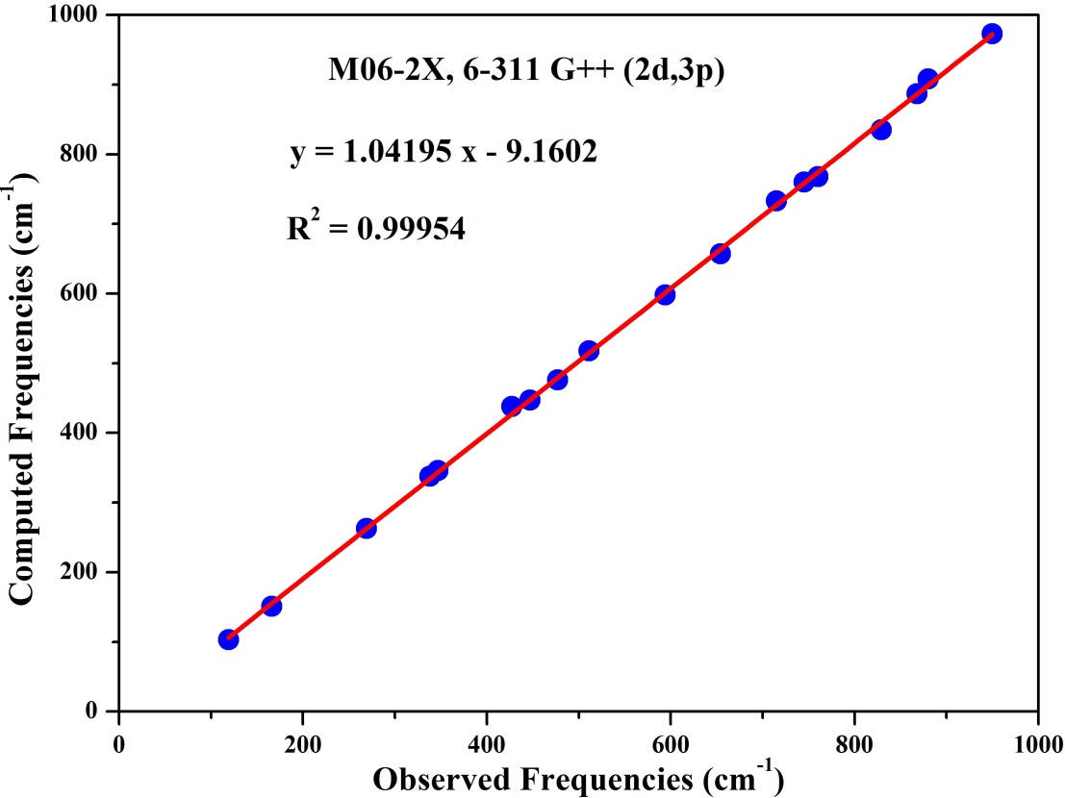

Fig. F1 Comparison of observed and computed frequencies of isochroman. The observed frequencies are taken from Raman Spectrum of Ref. [32] of the main manuscript. The computations are performed at M06-2X/6-311 G++(2d,3p) level of theory
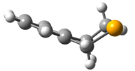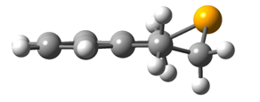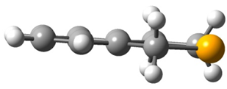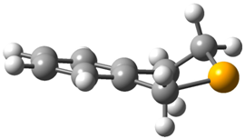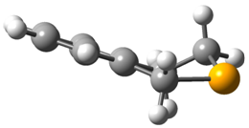
Twisted- 700 cm⁻¹

TS2 – 550 cm⁻¹
Isoselenochroman

Bent
Planar – 3900 cm⁻¹
TS1 – 1600 cm⁻¹

Fig. F2: Different conformers and transition states (TS) along with their relative energies of isoselenochroman. Computations are performed at M06-2X/6-311G ++ (2d,3p) level of theory in the Ground State of the respective molecules.

