Supplementary material

S. Ainonen, M. Paalanne, E. Ronkainen, T. Pokka, M. Honkila, E. Kajantie, N. Paalanne, T. Ruuska-Loewald. Early-Life Antibiotic Exposure and the Risk of Overweight and Obesity in Children.

Literature Review
Registers Used in the Study
National Health Insurance Register
Growth Data from Child Health Clinics and School Health Care
Finnish Medical Birth Register
Care Register of Health Care
Register of Statistics Finland
Oulu University Hospital’s and Oulaskangas Hospitals Electronic Registers
References
Supplementary Table 1. Literature review of early antibiotic exposure and weight gain in children.
Supplementary Table 2. Participant characteristics
Supplementary Table 3. Body mass index-for-age z-scores (zBMIs) at 24 months of age relation to different antibiotic exposures.
Supplementary Table 4. Cumulative antibiotic exposure and unadjusted body mass index-for-age z-scores (zBMIs) at 24 months of age compared to the control group (group 1).
Supplementary Table 5. Cumulative antibiotic exposure and adjusted body mass index-for-age z-scores (zBMIs) at 24 months of age compared to the control group (group 1).
Supplementary Table 6. Hazard ratios for overweight (including obesity) and obesity in childhood.
Supplementary Table 7. Height-for-age z-scores (zHFAs) at 24 months of age relation to different antibiotic exposures.
Supplementary Table 8. Cumulative antibiotic exposure and unadjusted height for age z-scores (zHFAs) at 24 months of age compared to the control group (group 1).
Supplementary Table 9. Cumulative antibiotic exposure and adjusted height for age z-scores (zHFAs) at 24 months of age compared to the control group (group 1).

Supplementary Figure 1. Literature review chart of maternal antibiotic exposure before beginning of pregnancy and weight gain in childhood.

Supplementary Figure 2. Literature review of antibiotic exposure during pregnancy and intrapartum antibiotic exposure and weight gain in childhood.

Supplementary Figure 3. Literature review chart of antibiotic exposure after birth and in the childhood and weight gain in childhood.

Supplementary Figure 4. Linearity assessment of continuous covariates in Cox regression analysis for antibiotic exposure before pregnancy and overweight.

Supplementary Figure 5. Linearity assessment of continuous covariates in Cox regression analysis for antibiotic exposure before pregnancy and obesity.

Supplementary Figure 6. Linearity assessment of continuous covariates in Cox regression analysis for antibiotic exposure in pregnancy and overweight.

Supplementary Figure 7. Linearity assessment of continuous covariates in Cox regression analysis for antibiotic exposure in pregnancy and obesity.

Supplementary Figure 8. Linearity assessment of continuous covariates in Cox regression analysis for perinatal antibiotic exposure and overweight.

Supplementary Figure 9. Linearity assessment of continuous covariates in Cox regression analysis for perinatal antibiotic exposure and obesity.

Supplementary Figure 10. Linearity assessment of continuous covariates in Cox regression analysis for antibiotic exposure in the first 24 months of life and overweight.

Supplementary Figure 11. Linearity assessment of continuous covariates in Cox regression analysis for antibiotic exposure in the first 24 months of life and obesity.

Supplementary Figure 12. Log-log curves to test proportional hazard assumption in childhood overweight analyses adjusted for birth year and sex.

Supplementary Figure 13. Log-log curves to test proportional hazard assumption in childhood obesity analyses adjusted for birth year and sex.

Supplementary Figure 14. Log-log curves to test proportional hazard assumption in childhood overweight analyses adjusted for all covariates.

Supplementary Figure 15. Log-log curves to test proportional hazard assumption in childhood obesity analyses adjusted for all covariates.

Supplementary Figure 16. Cumulative incidences of childhood overweight in children exposed to early antibiotics compared to unexposed ones.

Supplementary Figure 17. Cumulative incidences of childhood obesity in children exposed to early antibiotics compared to unexposed ones.

Supplementary Figure 18. Mean differences of height-for-age z-scores (zHFAs) at 24 months of age between those exposed to antibiotics and those not to.

Supplementary Figure 19. Cumulative antibiotic exposure and height-for-age z-scores (zHFAs) at 24 months of age.

Literature Review

We conducted three separate literature searches in Medline database exploring the timing of the antibiotic exposure and subsequent weight gain, overweight and obesity in childhood using Covidence systematic review software. Search strategy was planned with skilled informatician. We chose to exclude studies of preterm newborns and studies performed in low resource setting due to the highly diverging clinical practices of antibiotic use and environments influencing children’s growth.

First, we searched articles concerning maternal antibiotic exposure prior to pregnancy (eFigure 1). We used keywords "anti-bacterial agents", antibiotic*, antimicrobial*, child*, infant* , adolescen*, overweight or obes*, growth, "body mass index", "body size", height or weight, "body fat", "body constitution", skinfold, before adj3 pregnan*, prece* adj3 pregnan*, prior adj3 pregnan*, "pre-pregnan.*" We found 184 studies, of which none explored maternal antibiotic exposure prior to pregnancy and later growth or weight gain in childhood. However, we found one article during another literature search, studying antibiotic exposure three months before pregnancy, which found no association with BMI z-score or obesity at 4 years of age.¹

Second, we searched articles concerning antibiotic exposure during pregnancy prior to child’s birth, including antibiotic exposure during pregnancy and intrapartum antibiotic exposure (eFigure 2). Search terms included keywords: fetal, pregnan*, fetus*, "in utero", intrauterine, unborn, intrapartum, perinatal, antenatal, prenatal, delivery, labor, parturition, antibiotic*, antimicrobial*, overweight, obes*, growth, "body mass index", "body size", height, weight, "body fat", "body constitution", skinfold, child*, infant*, adolescen*. We screened 1694 studies based on the search, of which 28 studies fulfilled the inclusion criteria, and 3 studies were added based on another literature search. In total of 23 studies focused on antibiotic exposure during birth and 12 studies focused on intrapartum antibiotic exposure.

All studies concerning intrapartum antibiotic exposure were observational. There were two meta-analysis concerning prenatal antibiotic exposure, which both included only one original study exploring intrapartum antibiotic exposure. ^{2,3} In four original studies no association with intrapartum antibiotic exposure and increased body-mass-index (BMI) was found.^{4–7} Three studies reported association between intrapartum antibiotic exposure and higher weight especially in infancy, but these associations were not seen in older children. ^{8–10} Three cohort studies of 9539, 156 381, and 126 547 vaginally delivered children reported association between group B Streptococcal intrapartum antibiotic prophylaxis and increased BMI or weight gain in childhood. ^{11–13}

Four meta-analyses explored antibiotic exposure during pregnancy and weight gain in childhood^{2,3,14,15}, one reporting association to increased risk of later obesity or overweight¹⁴. Three meta-analyses did not found association between antibiotic exposure during the pregnancy^{2,3,15}, however two of them reported associations especially concerning antibiotic exposure during the second trimester of pregnancy and later overweight and obesity in childhood.^{3,15} In six studies no association was found with antibiotic exposure during pregnancy and weight gain in childhood, and one study of 150 699 children reported found associations disappearing in twin and sibling analyses. ^{1,7,16–20} Controversially, eleven studies observed associations between antibiotic exposure during pregnancy and later overweight or obesity ^{12,21–30}, some of the studies especially reporting found associations with antibiotic exposures in the 2nd or 3rd trimester^{12,21,26–29}, to broad-spectrum antibiotics²², to repeated antibiotic courses²⁸, or in the female population^{23,27}.

Third, we searched articles concerning antibiotic exposure after birth and later in the childhood using following keywords: postnatal, neonatal, newborn, premature, preterm, child*,infant*, adolescen*, "Anti-Bacterial Agents", antibiotic*, antimicrobial*, overweight, obes*, growth, “body mass index”, “body size”, height, weight, “body fat”, “body constitution” and skinfold. We found 9847 studies, of which 55 were included in the literature review (eFigure 3). Only one of the studies was randomized clinical trial, in which, 607, 2 to 71 months old children with vesicoureteral reflux, were randomized to receive trimethoprim-sulfamethoxazole prophylaxis or placebo daily for 2 years.³¹ No difference was seen in weight gain, overweight or obesity during the first 24 months between the two groups.³¹ Additionally, nine observational studies did not find association between early antibiotic exposure in childhood and later weight gain or growth^{32–40}, and in one found associations disappeared in sibling and twin analysis.¹ Three studies suggested that reported relationship between antibiotic exposure in infancy and later weight gain is confounded by infection. ^{34,35,41} One study reported association to increased childhood BMI in boys, but not in girls.⁴² In total 33 observational studies reported associations between antibiotic exposure in early childhood and later increase in children’s later weight.^{4,5,7,16,24,41,43–69} Furthermore, nine meta-analyses had consistent findings, all reporting association with antibiotic exposure in infancy or childhood and later body weight. ^{2,14,15,70–75}
Registers Used in the Study

National Health Insurance Register
Data on mothers’ and children’s systemic antimicrobial purchases, as well as children’s growth hormone treatment, was obtained from Dispensations reimbursable under the National Health Insurance register, which is a national register maintained by Social Insurance Institution of Finland and has been collecting data on reimbursed drug purchases from the pharmacies since the year 1993.⁷⁶ In Finland, systemic antimicrobials and growth hormones are partially or fully reimbursed, by Social Insurance Institution of Finland.

Growth Data from Child Health Clinics and School Health Care
Growth data used from outcome variables was collected from child health clinics and school health care, from Lifecare patient information system, provided by technology company, Tietoevry Finland Oy.

Finnish Medical Birth Register
Study population was identified using Finnish Medical Birth register, which includes data of all births (gestational age > 22 weeks and birth weight > 500 grams) in Finland since the year 1987.⁷⁷ Additionally, data on maternal covariates, including maternal age, parity, pre-pregnancy BMI, gestational diabetes, hypertensive disorders of pregnancy, mother’s highest occupational status, gestational age, child’s birth year and child’s birth weight were retrieved. Finnish Medical Birth Register is controlled by the Finnish Institute for Health and Welfare, and information of the births are gathered from maternity hospitals and other national registers maintained by the Finnish Institute for Health and Welfare. Internal and external validation studies have been evaluated register data’s quality to be generally good.^{78,79}

Care Register of Health Care

Covariate data on mother’s autoimmune disease diagnosis, asthma diagnosis and maternal mental or neurodevelopmental disease diagnosis and data on children’s congenital anomalies was retrieved from the Care Register of Health Care, which is controlled by the Finnish Institute for Health and Welfare using the corresponding ICD-10 codes.⁸⁰ Data on mother’s diagnosis codes was obtained from two years prior to the child’s birth, to the end of the follow-up time, December 31st of 2019. The Care Register of Health Care includes data of the inpatient and specialized outpatient care in different health centers, hospitals, and other institutions in Finland since the year 1969. Systematic review of external validation studies has been evaluated the quality of the Care Register of Health Care to be good, with 75-99% positive predictive value.⁸¹

Register of Statistics Finland
Covariate data of mother’s highest occupational status and highest education level were obtained data from Statistics Finland. Statistics Finland has been established in 1865, and it provides reliable statistics of Finnish society.⁸²

Oulu University Hospital’s and Oulaskangas Hospital’s Electronic Registers
Oulu University Hospital’s and Oulaskangas hospital’s digital delivery record (CSAM iPana, CSAM Finland Oy, Oulu, Finland) was used to obtain data on intrapartum antibiotic exposure, prolonged rupture of the membranes, birth weight, smoking during the pregnancy and maternal prepregnancy BMI. Digital delivery record is a structured electronic register, which was adopted in 2007 in Oulu University Hospital and Oulaskangas hospital. Data on postnatal antibiotic exposure was obtained from hospitals’ intensive care information record (Centricity Critical Care Clinisoft, GE Healthcare Europe, Helsinki, Finland) and further completed manually from individual electronic medical records if required.

References

1. Leong KSW, McLay J, Derraik JGB, et al. Associations of Prenatal and Childhood Antibiotic Exposure With Obesity at Age 4 Years. JAMA Netw Open. 2020;3(1):e1919681. doi:10.1001/jamanetworkopen.2019.19681
2. Srivastava A, Chau K, Kwon H, Guo Q, Johnston BC. Early and frequent exposure to antibiotics in children and the risk of obesity: systematic review and meta-analysis of observational studies. F1000Res. 2020;9:711. doi:10.12688/f1000research.24553.1
3. Solans M, Barceló MA, Morales-Suárez-Varela M, Moya A, Saez M. Prenatal exposure to antibiotics and risk of childhood overweight or obesity: A systematic review and meta-analysis. Obesity Reviews. 2022;23(S1). doi:10.1111/obr.13382
4. Awujoola A, Torga AP, Abdul Ghayum MA, et al. Neonatal Ampicillin/Gentamicin Exposure and the Risk of Childhood Obesity in South Bronx Pediatric Population. Am J Perinatol. Published online September 15, 2023. doi:10.1055/s-0043-1774315
5. Bridgman SL, Azad MB, Persaud RR, et al. Impact of maternal pre‐pregnancy overweight on infant overweight at 1 year of age: associations and sex‐specific differences. Pediatr Obes. 2018;13(10):579-589. doi:10.1111/ijpo.12291
6. Metz TD, McKinney J, Allshouse AA, Knierim SD, Carey JC, Heyborne KD. Exposure to group B Streptococcal antibiotic prophylaxis and early childhood body mass index in a vaginal birth cohort. The Journal of Maternal-Fetal & Neonatal Medicine. 2020;33(19). doi:10.1080/14767058.2019.1571575
7. Poulsen MN, Pollak J, Bailey‐Davis L, Hirsch AG, Glass TA, Schwartz BS. Associations of prenatal and childhood antibiotic use with child body mass index at age 3 years. Obesity. 2017;25(2):438-444. doi:10.1002/oby.21719
8. Gardemeister S, Skogberg K, Saisto T, et al. Cross-sectional study of the proportion of antibiotic use during childbirth in full-term deliveries in Finland. BMC Pregnancy Childbirth. 2023;23(1):50. doi:10.1186/s12884-023-05368-0
9. Hutton EK, Simioni JC, Thabane L, et al. Associations of intrapartum antibiotics and growth, atopy, gastrointestinal and sleep outcomes at one year of age. Pediatr Res. Published online February 18, 2023. doi:10.1038/s41390-023-02525-1
10. Klancic T, Black AM, Reimer RA. Influence of antibiotics given during labour and birth on body mass index z scores in children in the All Our Families pregnancy cohort. Pediatr Obes. Published online August 19, 2021. doi:10.1111/ijpo.12847
11. Mukhopadhyay S, Bryan M, Dhudasia MB, et al. Intrapartum group B Streptococcal prophylaxis and childhood weight gain. Arch Dis Child Fetal Neonatal Ed. 2021;106(6):649-656. doi:10.1136/archdischild-2020-320638
12. Koebnick C, Sidell MA, Getahun D, et al. Intrapartum Antibiotic Exposure and Body Mass Index in Children. Clinical Infectious Diseases. 2021;73(4). doi:10.1093/cid/ciab053
13. Sidell MA, Getahun D, Tartof SY, et al. Higher body mass index after intrapartum antibiotic exposure in children persists over 10‐years. Pediatr Obes. 2023;18(7). doi:10.1111/ijpo.13035
14. Chagas AP, da Silva NG, Ribeiro CM, Amato AA. Early-life exposure to antibiotics and excess body weight in childhood and adolescence: A systematic review and meta-analysis. Obes Res Clin Pract. 2023;17(4):318-334. doi:10.1016/j.orcp.2023.07.001
15. Wan S, Guo M, Zhang T, et al. Impact of Exposure to Antibiotics During Pregnancy and Infancy on Childhood Obesity: A Systematic Review and Meta‐Analysis. Obesity. 2020;28(4):793-802. doi:10.1002/oby.22747
16. Figueiredo RA de O, Kajantie E, Neuvonen PJ, Rounge TB, Weiderpass E, Viljakainen H. Lifetime antimicrobial use is associated with weight status in early adolescence—A register‐based cohort study. Pediatr Obes. 2021;16(3). doi:10.1111/ijpo.12727
17. Gofin R, Palti H, Adler B. Bacteriuria in pregnancy and growth and development of the infants. Early Hum Dev. 1984;9(4):341-346. doi:10.1016/0378-3782(84)90078-1
18. Heerman WJ, Daley MF, Boone-Heinonen J, et al. Maternal antibiotic use during pregnancy and childhood obesity at age 5 years. Int J Obes. 2019;43(6):1202-1209. doi:10.1038/s41366-018-0316-6
19. Isaevska E, Popovic M, Pizzi C, et al. Maternal antibiotic use and vaginal infections in the third trimester of pregnancy and the risk of obesity in preschool children. Pediatr Obes. 2020;15(8). doi:10.1111/ijpo.12632
20. Li DK, Chen H, Ferber J, Odouli R. Maternal infection and antibiotic use in pregnancy and the risk of childhood obesity in offspring: a birth cohort study. Int J Obes. 2020;44(4):771-780. doi:10.1038/s41366-019-0501-2
21. Cassidy-Bushrow AE, Burmeister C, Havstad S, et al. Prenatal antimicrobial use and early-childhood body mass index. Int J Obes. 2018;42(1):1-7. doi:10.1038/ijo.2017.205
22. Jess T, Morgen CS, Harpsøe MC, et al. Antibiotic use during pregnancy and childhood overweight: A population-based nationwide cohort study. Sci Rep. 2019;9(1):11528. doi:10.1038/s41598-019-48065-9
23. Lin M, Song H, Liu W, et al. Sex-specific associations between prenatal antibiotics exposure and offspring’s body mass index. Int J Obes. 2020;44(10):2044-2051. doi:10.1038/s41366-020-0629-0
24. Margetaki K, Stratakis N, Roumeliotaki T, et al. Prenatal and infant antibiotic exposure and childhood growth, obesity and cardiovascular risk factors: The Rhea mother-child cohort study, Crete, Greece. Pediatr Obes. 2022;17(1):e12843. doi:10.1111/ijpo.12843
25. Mor A, Antonsen S, Kahlert J, et al. Prenatal exposure to systemic antibacterials and overweight and obesity in Danish schoolchildren: a prevalence study. Int J Obes (Lond). 2015;39(10):1450-1455. doi:10.1038/ijo.2015.129
26. Mueller NT, Whyatt R, Hoepner L, et al. Prenatal exposure to antibiotics, cesarean section and risk of childhood obesity. Int J Obes. 2015;39(4):665-670. doi:10.1038/ijo.2014.180
27. Sakurai K, Yamamoto M, Eguchi A, Takatani R, Watanabe M, Mori C. Association between maternal antibiotic exposure during pregnancy and childhood obesity in the Japan Environment and Children’s Study. Pediatr Obes. 2022;17(11). doi:10.1111/ijpo.12956
28. Wang B, Liu J, Zhang Y, et al. Prenatal Exposure to Antibiotics and Risk of Childhood Obesity in a Multicenter Cohort Study. Am J Epidemiol. 2018;187(10):2159-2167. doi:10.1093/aje/kwy122
29. Zhang M, Differding MK, Benjamin-Neelon SE, Østbye T, Hoyo C, Mueller NT. Association of prenatal antibiotics with measures of infant adiposity and the gut microbiome. Ann Clin Microbiol Antimicrob. 2019;18(1):18. doi:10.1186/s12941-019-0318-9
30. Zhuang C, Liao X, Fu M, et al. Association between the use of antibiotics during pregnancy and obesity in 5-year-old children. Transl Pediatr. 2021;10(6):1686-1691. doi:10.21037/tp-21-220
31. Edmonson MB, Eickhoff JC. Weight Gain and Obesity in Infants and Young Children Exposed to Prolonged Antibiotic Prophylaxis. JAMA Pediatr. 2017;171(2):150-156. doi:10.1001/jamapediatrics.2016.3349
32. Campbell S, Tracey E, Fagan R, et al. Childhood infection, antibiotic exposure and subsequent metabolic risk in adolescent and young adult Aboriginal Australians: practical implications. Aust J Prim Health. 2019;25(6):555-563. doi:10.1071/PY18110
33. Contopoulos-Ioannidis DG, Ley C, Wang W, et al. Effect of long-term antibiotic use on weight in adolescents with acne. J Antimicrob Chemother. 2016;71(4):1098-1105. doi:10.1093/jac/dkv455
34. Li DK, Chen H, Ferber J, Odouli R. Infection and antibiotic use in infancy and risk of childhood obesity: a longitudinal birth cohort study. Lancet Diabetes Endocrinol. 2017;5(1):18-25. doi:10.1016/S2213-8587(16)30281-9
35. Ohler AM, Braddock A. Infections and antibiotic use in early life, and obesity in early childhood: a mediation analysis. Int J Obes (Lond). 2022;46(9):1608-1614. doi:10.1038/s41366-022-01155-7
36. Prins-van Ginkel AC, Wijga AH, Bruijning-Verhagen PCJ, et al. Early childhood infections and body mass index in adolescence. Int J Obes (Lond). 2021;45(5):1143-1151. doi:10.1038/s41366-021-00806-5
37. Sejersen TS, Vinding RK, Stokholm J, et al. Antibiotic exposure in infancy and development of BMI and body composition in childhood. EClinicalMedicine. 2019;17:100209. doi:10.1016/j.eclinm.2019.10.020
38. Gürpinar A, Balkan E, Kiliç N, Kiriştioǧlu I, Doǧruyol H. The Effects of a Fluoroquinolone on the Growth and Development of Infants. Journal of International Medical Research. 1997;25(5):302-306. doi:10.1177/030006059702500508
39. Korpela K, Zijlmans MAC, Kuitunen M, et al. Childhood BMI in relation to microbiota in infancy and lifetime antibiotic use. Microbiome. 2017;5(1):26. doi:10.1186/s40168-017-0245-y
40. Murphy R, Thompson JM, Mitchell EA. Early antibiotic exposure and body mass index in children born small for gestational age. Acta Paediatr. 2013;102(9). doi:10.1111/apa.12307
41. Block JP, Bailey LC, Gillman MW, et al. Early Antibiotic Exposure and Weight Outcomes in Young Children. Pediatrics. 2018;142(6). doi:10.1542/peds.2018-0290
42. Murphy R, Stewart AW, Braithwaite I, Beasley R, Hancox RJ, Mitchell EA. Antibiotic treatment during infancy and increased body mass index in boys: an international cross-sectional study. Int J Obes. 2014;38(8):1115-1119. doi:10.1038/ijo.2013.218
43. Ajslev TA, Andersen CS, Gamborg M, Sørensen TIA, Jess T. Childhood overweight after establishment of the gut microbiota: the role of delivery mode, pre-pregnancy weight and early administration of antibiotics. Int J Obes. 2011;35(4):522-529. doi:10.1038/ijo.2011.27
44. Aris IM, Lin PID, Rifas-Shiman SL, et al. Association of Early Antibiotic Exposure With Childhood Body Mass Index Trajectory Milestones. JAMA Netw Open. 2021;4(7):e2116581. doi:10.1001/jamanetworkopen.2021.16581
45. Aversa Z, Atkinson EJ, Schafer MJ, et al. Association of Infant Antibiotic Exposure With Childhood Health Outcomes. Mayo Clin Proc. 2021;96(1):66-77. doi:10.1016/j.mayocp.2020.07.019
46. Azad MB, Bridgman SL, Becker AB, Kozyrskyj AL. Infant antibiotic exposure and the development of childhood overweight and central adiposity. Int J Obes. 2014;38(10):1290-1298. doi:10.1038/ijo.2014.119
47. Bailey LC, Forrest CB, Zhang P, Richards TM, Livshits A, DeRusso PA. Association of Antibiotics in Infancy With Early Childhood Obesity. JAMA Pediatr. 2014;168(11):1063. doi:10.1001/jamapediatrics.2014.1539
48. Bailey LC, Bryan M, Maltenfort M, et al. Antibiotics prior to age 2 years have limited association with preschool growth trajectory. Int J Obes. 2022;46(4):843-850. doi:10.1038/s41366-021-01023-w
49. Chelimo C, Camargo Jr CA, Morton SMB, Grant CC. Association of Repeated Antibiotic Exposure Up to Age 4 Years With Body Mass at Age 4.5 Years. JAMA Netw Open. 2020;3(1):e1917577-e1917577. doi:10.1001/jamanetworkopen.2019.17577
50. Chen LW, Xu J, Soh SE, et al. Implication of gut microbiota in the association between infant antibiotic exposure and childhood obesity and adiposity accumulation. Int J Obes. 2020;44(7):1508-1520. doi:10.1038/s41366-020-0572-0
51. Dawson-Hahn EE, Rhee KE. The association between antibiotics in the first year of life and child growth trajectory. BMC Pediatr. 2019;19(1):23. doi:10.1186/s12887-018-1363-9
52. Gerber JS, Bryan M, Ross RK, et al. Antibiotic Exposure During the First 6 Months of Life and Weight Gain During Childhood. JAMA. 2016;315(12):1258. doi:10.1001/jama.2016.2395
53. Kamphorst K, Oosterloo BC, Vlieger AM, et al. Antibiotic Treatment in the First Week of Life Impacts the Growth Trajectory in the First Year of Life in Term Infants. J Pediatr Gastroenterol Nutr. 2019;69(1):131-136. doi:10.1097/MPG.0000000000002360
54. Kelly D, Kelly A, O’Dowd T, Hayes CB. Antibiotic use in early childhood and risk of obesity: longitudinal analysis of a national cohort. World Journal of Pediatrics. 2019;15(4):390-397. doi:10.1007/s12519-018-00223-1
55. Kwak JH, Lee SW, Lee JE, et al. Association of Antibiotic Use during the First 6 Months of Life with Body Mass of Children. Antibiotics. 2022;11(4):507. doi:10.3390/antibiotics11040507
56. Li P, Chang X, Chen X, et al. Early-life antibiotic exposure increases the risk of childhood overweight and obesity in relation to dysbiosis of gut microbiota: a birth cohort study. Ann Clin Microbiol Antimicrob. 2022;21(1):46. doi:10.1186/s12941-022-00535-1
57. Mbakwa CA, Scheres L, Penders J, Mommers M, Thijs C, Arts ICW. Early Life Antibiotic Exposure and Weight Development in Children. J Pediatr. 2016;176:105-113.e2. doi:10.1016/j.jpeds.2016.06.015
58. Mitchell EA, Stewart AW, Braithwaite I, et al. Factors associated with body mass index in children and adolescents: An international cross-sectional study. PLoS One. 2018;13(5):e0196221. doi:10.1371/journal.pone.0196221
59. Park YJ, Chang J, Lee G, Son JS, Park SM. Association of class number, cumulative exposure, and earlier initiation of antibiotics during the first two-years of life with subsequent childhood obesity. Metabolism. 2020;112:154348. doi:10.1016/j.metabol.2020.154348
60. Rifas-Shiman SL, Bailey LC, Lunsford D, et al. Early Life Antibiotic Prescriptions and Weight Outcomes in Children 10 Years of Age. Acad Pediatr. 2021;21(2):297-303. doi:10.1016/j.acap.2020.10.016
61. Saari A, Virta LJ, Sankilampi U, Dunkel L, Saxen H. Antibiotic exposure in infancy and risk of being overweight in the first 24 months of life. Pediatrics. 2015;135(4):617-626. doi:10.1542/peds.2014-3407
62. Schwartz BS, Pollak J, Bailey-Davis L, et al. Antibiotic use and childhood body mass index trajectory. Int J Obes. 2016;40(4):615-621. doi:10.1038/ijo.2015.218
63. Stark CM, Susi A, Emerick J, Nylund CM. Antibiotic and acid-suppression medications during early childhood are associated with obesity. Gut. 2019;68(1):62-69. doi:10.1136/gutjnl-2017-314971
64. Tian J, Liu H, Guo H, Han W, Ding H, Chen T. Application of antibiotics before 3 years of age increases the risk of childhood overweight and obesity. Exp Ther Med. 2020;21(1):56. doi:10.3892/etm.2020.9488
65. Trasande L, Blustein J, Liu M, Corwin E, Cox LM, Blaser MJ. Infant antibiotic exposures and early-life body mass. Int J Obes. 2013;37(1):16-23. doi:10.1038/ijo.2012.132
66. Uzan-Yulzari A, Turta O, Belogolovski A, et al. Neonatal antibiotic exposure impairs child growth during the first six years of life by perturbing intestinal microbial colonization. Nat Commun. 2021;12(1):443. doi:10.1038/s41467-020-20495-4
67. Ville AP, Heyman MB, Medrano R, Wojcicki JM. Early Antibiotic Exposure and Risk of Childhood Obesity in Latinos. Childhood Obesity. 2017;13(3):231-235. doi:10.1089/chi.2016.0235
68. Guidos PJ, Arlen AM, Leong T, Bonnett MA, Cooper CS. Impact of continuous low-dose antibiotic prophylaxis on growth in children with vesicoureteral reflux. J Pediatr Urol. 2018;14(4):325.e1-325.e7. doi:10.1016/j.jpurol.2018.07.007
69. Scott FI, Horton DB, Mamtani R, et al. Administration of Antibiotics to Children Before Age 2 Years Increases Risk for Childhood Obesity. Gastroenterology. 2016;151(1):120-129.e5. doi:10.1053/j.gastro.2016.03.006
70. Aghaali M, Hashemi-Nazari SS. Association between early antibiotic exposure and risk of childhood weight gain and obesity: a systematic review and meta-analysis. J Pediatr Endocrinol Metab. 2019;32(5):439-445. doi:10.1515/jpem-2018-0437
71. Duong QA, Pittet LF, Curtis N, Zimmermann P. Antibiotic exposure and adverse long-term health outcomes in children: A systematic review and meta-analysis. Journal of Infection. 2022;85(3):213-300. doi:10.1016/j.jinf.2022.01.005
72. Meng X, Zhu Y, Di H, et al. Dose-response association of early-life antibiotic exposure and subsequent overweight or obesity in children: A meta-analysis of prospective studies. Obesity Reviews. 2021;22(11). doi:10.1111/obr.13321
73. Miller SA, Wu RKS, Oremus M. The association between antibiotic use in infancy and childhood overweight or obesity: a systematic review and meta-analysis. Obes Rev. 2018;19(11):1463-1475. doi:10.1111/obr.12717
74. Rasmussen SH, Shrestha S, Bjerregaard LG, et al. Antibiotic exposure in early life and childhood overweight and obesity: A systematic review and meta-analysis. Diabetes Obes Metab. 2018;20(6):1508-1514. doi:10.1111/dom.13230
75. Shao X, Ding X, Wang B, et al. Antibiotic exposure in early life increases risk of childhood obesity: A systematic review and meta-analysis. Front Endocrinol (Lausanne). 2017;8(JUL). doi:10.3389/fendo.2017.00170
76. Social Insurance Institution of Finland. Dispensations reimbursable under the National Health Insurance Scheme register. Accessed December 12, 2022. https://aineistokatalogi.fi/catalog/studies/ff551f4e-6842-4732-962d-74499a339c46/datasets/0644617c-0bac-44a8-a15d-1724fe10e371
77. Finnish Institute for Health and Welfare. Medical Birth Register. https://thl.fi/en/web/thlfi-en/statistics-and-data/data-and-services/register-descriptions/newborns.
78. Gissler M, Shelley J. Quality of data on subsequent events in a routine Medical Birth Register. Med Inform Internet Med. 2002;27(1):33-38. doi:10.1080/14639230110119234
79. Teperi J. Multi method approach to the assessment of data quality in the Finnish medical birth registry. J Epidemiol Community Health (1978). 1993;47(3):242-247. doi:10.1136/jech.47.3.242
80. Finnish Institute for Health and Welfare. Care Register for Health Care. https://thl.fi/en/web/thlfi-en/statistics-and-data/data-and-services/register-descriptions/care-register-for-health-care.
81. Sund R. Quality of the Finnish Hospital Discharge Register: A systematic review. Scand J Public Health. 2012;40(6):505-515. doi:10.1177/1403494812456637
82. Statistics Finland. About us: Statistics Finland. Accessed December 12, 2022. https://www.stat.fi/org/index_en.html

Supplementary Table 1. submitted in a separate word form.

Supplementary Table 2. submitted in an excel form.

Supplementary Table 3. Body mass index-for-age z-scores (zBMIs) at 24 months of age relation to different antibiotic exposures.
 | Antibiotic exposure one year before beginning of pregnancy | Antibiotic exposure during pregnancy | Antibiotic exposure in the 1st trimester of pregnancy | Antibiotic exposure in the 2nd trimester of pregnancy | Antibiotic exposure in the 3rd trimester of pregnancy | Perinatal antibiotic exposure | Childhood antibiotic exposure in the first 24 months of life | Childhood antibiotic exposure in the first 6 months of life | Childhood antibiotic exposure in the first 6 to 24 months of life
Unadjusted modelª
No. | 11 271 | 7888 | 2952 | 3577 | 2489 | 6197 | 19 541 | 4379 | 18 895
Mean zBMI, (SD), kg/m2 | 0.091 (0.010) | 0.083 (0.012) | 0.099 (0.020) | 0.092 (0.018) | 0.087 (0.022) | 0.078 (0.014) | 0.119 (0.016) | 0.121 (0.016) | 0.097 (0.008)
Mean difference^{b} of zBMI (SD), kg/m² | 0.039 (0.013) | 0.022 (0.014) | 0.036 (0.021) | 0.028 (0.019) | 0.022 (0.023) | 0.013 (0.016) | 0.083 (0.014) | 0.061 (0.018) | 0.084 (0.013)
95% CI of mean difference^{b} of zBMI | 0.013 to 0.064 | -0.006 to 0.050 | -0.005 to 0.077 | -0.009 to 0.066 | -0.022 to 0.066 | -0.017 to 0.044 | 0.056 to 0.110 | 0.026 to 0.096 | 0.057 to 0.110
Adjusted model^{c}
No. | 11 045 | 7698 | 2881 | 3487 | 2430 | 6077 | 19 087 | 4266 | 18 453
Mean zBMI, (SD), kg/m2 | 0.082 (0.010) | 0.068 (0.012) | 0.084 (0.020) | 0.075 (0.018) | 0.061 (0.021) | 0.068 (0.015) | 0.093 (0.008) | 0.110 (0.016) | 0.095 (0.008)
Mean difference^{b} of zBMI (SD), kg/m² | 0.019 (0.013) | -0.004 (0.014) | 0.015 (0.021) | 0.005 (0.019) | -0.011 (0.022) | -0.003 (0.017) | 0.067 (0.014) | 0.046 (0.018) | 0.069 (0.013)
95% CI of mean difference^{b} of zBMI | -0.007 to 0.044 | -0.031 to 0.024 | -0.026 to 0.055 | -0.032 to 0.043 | -0.055 to 0.033 | -0.036 to 0.030 | 0.041 to 0.094 | 0.011 to 0.081 | 0.042 to 0.095
Abbreviations: CI, Confidence of Interval
ªAnalyses were adjusted for child’s birth year and sex.
^{b}Mean difference was calculated between those exposed and unexposed to antibiotics in question.
^{c}Analyses were adjusted for maternal age, parity, prepregnancy BMI, gestational diabetes, hypertensive disorders of pregnancy, smoking during pregnancy, prolonged rupture of the membranes, mother’s highest education level, mother’s highest occupational status, maternal asthma diagnosis, maternal autoimmune disease diagnosis, and maternal mental or neurodevelopmental disease diagnosis, gestational age, child’s birth year, sex and birth weight.

Supplementary Table 4. Cumulative antibiotic exposure and unadjusted body mass index-for-age z-scores (zBMIs) at 24 months of age compared to the control group (group 1).ª

No. | Mutually exclusive antibiotic exposure groups. |  |  |  | Mean zBMI, (SD) | Mean difference of zBMI (SD) | 95 % CI of mean difference of zBMI | n (%)
 | Antibiotic exposure before beginning of the pregnancy | Antibiotic exposure during pregnancy | Perinatal antibiotic exposure | Childhood antibiotic exposure in the first 24 months of life
1 | No | No | No | No | 0.005 (0.016) | control | control | 4248 (15)
2 | Yes | No | No | No | 0.047 (0.027) | 0.048 (0.031) | -0.014 – 0.110 | 1623 (5.6)
3 | No | Yes | No | No | -0.057 (0.038) | -0.056 (0.041) | -0.137 – 0.025 | 808 (2.8)
4 | No | No | Yes | No | -0.033 (0.030) | -0.032 (0.037) | -0.104 – 0.040 | 1084 (3.7)
5 | No | No | No | Yes | 0.076 (0.013) | 0.077 (0.021) | 0.035 – 0.118 | 6904 (24)
6 | Yes | No | Yes | No | 0.008 (0.048) | 0.009 (0.051) | -0.091 – 0.109 | 498 (1.7)
7 | Yes | No | No | Yes | 0.106 (0.017) | 0.107 (0.024) | 0.061 – 0.154 | 3975 (14)
8 | No | Yes | No | Yes | 0.095 (0.024) | 0.097 (0.029) | 0.040 – 0.153 | 2107 (7.3)
9 | Yes | Yes | No | No | 0.116 (0.041) | 0.117 (0.045) | 0.029 – 0.204 | 674 (2.3)
10 | No | Yes | Yes | No | 0.096 (0.067) | 0.097 (0.069) | -0.039 – 0.233 | 255 (0.88)
11 | No | No | Yes | Yes | 0.114 (0.026) | 0.115 (0.031) | 0.054 – 0.175 | 1699 (5.9)
12 | Yes | Yes | Yes | No | 0.068 (0.068) | 0.069 (0.070) | -0.069 – 0.207 | 249 (0.86)
13 | Yes | Yes | No | Yes | 0.095 (0.022) | 0.096 (0.027) | 0.043 – 0.150 | 2444 (8.4)
14 | Yes | No | Yes | Yes | 0.108 (0.033) | 0.109 (0.037) | 0.037 – 0.182 | 1062 (3.7)
15 | No | Yes | Yes | Yes | 0.122 (0.039) | 0.123 (0.047) | 0.031 – 0.214 | 605 (2.1)
16 | Yes | Yes | Yes | Yes | 0.109 (0.039) | 0.110 (0.043) | 0.026 – 0.194 | 745 (2.6)
Abbreviations: CI, confidence of interval
ªMutually exclusive antibiotic exposure groups were compared to the control group, with no antibiotic exposure before or during pregnancy, in the perinatal period or in the first 24 months of life. Analyses were adjusted for child’s birth year and sex assigned at birth.
^{b}Grey color indicates antibiotic exposure.

Supplementary Table 5. Cumulative antibiotic exposure and adjusted body mass index-for-age z-scores (zBMIs) at 24 months of age compared to the control group (group 1).ª
No. | Mutually exclusive antibiotic exposure groups^{b} |  |  |  | Mean zBMI, (SD) | Mean difference of zBMI (SD) | 95 % CI of mean difference of zBMI | n (%)
 | Antibiotic exposure one year before beginning of the pregnancy | Antibiotic exposure during pregnancy | Perinatal antibiotic exposure | Childhood antibiotic exposure in the first 24 months of life
1 | No | No | No | No | 0.026 (0.016) | control | control | 4177 (15)
2 | Yes | No | No | No | 0.055 (0.026) | 0.029 (0.031) | -0.032 to 0.090 | 1599 (5.6)
3 | No | Yes | No | No | -0.059 (0.038) | -0.085 (0.041) | -0.165 to -0.004 | 788 (2.8)
4 | No | No | Yes | No | -0.020 (0.033) | -0.045 (0.037) | -0.117 to 0.027 | 1064 (3.8)
5 | No | No | No | Yes | 0.089 (0.013) | 0.064 (0.021) | 0.023 to 0.105 | 6722 (24)
6 | Yes | No | Yes | No | 0.011 (0.048) | -0.014 (0.051) | -0.114 to 0.085 | 492 (1.7)
7 | Yes | No | No | Yes | 0.110 (0.017) | 0.085 (0.024) | 0.038 to 0.131 | 3895 (14)
8 | No | Yes | No | Yes | 0.091 (0.023) | 0.066 (0.029) | 0.010 to 0.122 | 2052 (7.2)
9 | Yes | Yes | No | No | 0.110 (0.041) | 0.085 (0.044) | -0.002 to 0.171 | 662 (2.3)
10 | No | Yes | Yes | No | 0.083 (0.068) | 0.057 (0.070) | -0.079 to 0.194 | 245 (0.86)
11 | No | No | Yes | Yes | 0.110 (0.026) | 0.085 (0.031) | 0.023 to 0.146 | 1664 (5.9)
12 | Yes | Yes | Yes | No | 0.045 (0.069) | 0.020 (0.071) | -0.118 to 0.158 | 240 (0.85)
13 | Yes | Yes | No | Yes | 0.068 (0.022) | 0.042 (0.027) | -0.011 to 0.096 | 2382 (8.4)
14 | Yes | No | Yes | Yes | 0.081 (0.033) | 0.055 (0.037) | -0.018 to 0.128 | 1044 (3.7)
15 | No | Yes | Yes | Yes | 0.111 (0.043) | 0.085 (0.047) | -0.006 to 0.177 | 598 (2.1)
16 | Yes | Yes | Yes | Yes | 0.076 (0.039) | 0.051 (0.043) | -0.033 to 0.135 | 730 (2.6)
Abbreviations: CI, confidence of interval
ªMutually exclusive antibiotic exposure groups were compared to the control group, with no antibiotic exposure before or during pregnancy, in the perinatal period or in the first 24 months of life. Analyses were adjusted for maternal age, parity, prepregnancy BMI, gestational diabetes, hypertensive disorders of pregnancy, smoking during pregnancy, prolonged rupture of the membranes, mother’s highest education level, mother’s highest occupational status, maternal asthma diagnosis, maternal autoimmune disease diagnosis, maternal mental or neurodevelopmental disease diagnosis, gestational age, child’s birth year, sex and birth weight.
^{b}Grey color indicates antibiotic exposure.

Supplementary Table 6. Hazard ratios for overweight (including obesity) and obesity in childhood.
Characteristic | Antibiotic exposure one year before beginning of pregnancy | Antibiotic exposure during pregnancy | Perinatal antibiotic exposure | Childhood antibiotic exposure in the first 24 months of life
Unadjusted analysesª
Cases with overweight, No. | 10 710 | 10 710 | 10 709 | 10 710
Hazard ratio of overweight (95 % CI) | 1.07 (1.03 to 1.12) | 1.04 (0.99 to 1.08) | 1.07 (1.03 to 1.13) | 1.08 (1.04 to 1.13)
Cases with obesity, No. | 2726 | 2726 | 2726 | 2726
Hazard ratio of obesity (95 % CI) | 1.11 (1.03 to 1.20) | 1.12 (1.03 to 1.22) | 1.12 (1.02 to 1.23) | 1.18 (1.08 to 1.28)
Adjusted analyses^{b}
Cases with overweight, No. | 10 622 | 10 622 | 10 621 | 10 622
Hazard ratio of overweight (95 % CI) | 1.04 (1.001 to 1.08) | 1.00 (0.95 to 1.04) | 1.01 (0.96 to 1.07) | 1.09 (1.04 to 1.13)
Cases with obesity, No. | 2700 | 2700 | 2700 | 2700
Hazard ratio of obesity (95 % CI) | 1.05 (0.97 to 1.14) | 1.02 (0.94 to 1.11) | 1.03 (0.93 to 1.15) | 1.20 (1.10 to 1.31)
ªAnalyses were adjusted for birth year and sex.
^{b}Analyses were adjusted for maternal age, parity, prepregnancy BMI, gestational diabetes, hypertensive disorders of pregnancy, smoking during pregnancy, prolonged rupture of the membranes, mother’s highest education level, mother’s highest occupational status, maternal asthma diagnosis, maternal autoimmune disease diagnosis, maternal mental or neurodevelopmental disease diagnosis, gestational age, child’s birth year, sex and birth weight.

Supplementary Table 7. Height-for-age z-scores (zHFAs) at 24 months of age relation to different antibiotic exposures.
 | Antibiotic exposure one year before beginning of pregnancy | Antibiotic exposure during pregnancy | Antibiotic exposure in the 1st trimester of pregnancy | Antibiotic exposure in the 2nd trimester of pregnancy | Antibiotic exposure in the 3rd trimester of pregnancy | Perinatal antibiotic exposure | Childhood antibiotic exposure in the first 24 months of life | Childhood antibiotic exposure in the first 6 months of life | Childhood antibiotic exposure in the first 6 to 24 months of life
Unadjusted modelª
No. | 11 271 | 7888 | 2952 | 3577 | 2489 | 6197 | 19 541 | 4379 | 18 895
Mean zHFA, (SD), kg/m2 | -0.354 (0.01) | -0.343 (0.011) | -0.326 (0.019) | -0.346 (0.017) | -0.341 (0.020) | -0.343 (0.013) | -0.361 (0.007) | -0.387 (0.015) | -0.359 (0.007)
Mean difference^{b} of zHFA (SD), kg/m² | 0.026 (0.012) | 0.037 (0.013) | 0.049 (0.020) | 0.027 (0.018) | 0.032 (0.021) | 0.034 (0.015) | 0.028 (0.013) | -0.020 (0.017) | 0.030 (0.013)
95% CI of mean difference of zHFA | 0.002 to 0.050 | 0.011 to 0.063 | 0.010 to 0.088 | -0.008 to 0.063 | -0.010 to 0.073 | 0.005 to 0.063 | 0.003 to 0.054 | -0.053 to 0.012 | 0.005 to 0.055
Adjusted model^{c}
No. | 11 045 | 7698 | 2881 | 3487 | 2430 | 6077 | 19 087 | 4266 | 18 453
Mean zHFA, (SD), kg/m2 | -0.352 (0.010) | -0.343 (0.011) | -0.324 (0.019) | -0.346 (0.017) | -0.350 (0.020) | -0.351 (0.014) | -0.354 (0.007) | -0.359 (0.015) | -0.353 (0.007)
Mean difference^{b} of zHFA (SD), kg/m² | 0.027 (0.012) | 0.036 (0.013) | 0.050 (0.020) | 0.026 (0.018) | 0.020 (0.021) | 0.023 (0.016) | 0.045 (0.013) | 0.011 (0.017) | 0.045 (0.013)
95% CI of mean difference of zHFA | 0.004 to 0.051 | 0.009 to 0.062 | 0.011 to 0.088 | -0.010 to 0.061 | -0.022 to 0.061 | -0.008 to 0.054 | 0.020 to 0.070 | -0.022 to 0.044 | 0.020 to 0.070
Abbreviations: CI, Confidence of Interval
ªAnalyses were adjusted for child’s birth year and sex.
^{b}Mean difference was calculated between those exposed and unexposed to antibiotics in question.
^{c}Analyses were adjusted for maternal age, parity, prepregnancy BMI, gestational diabetes, hypertensive disorders of pregnancy, smoking during pregnancy, prolonged rupture of the membranes, mother’s highest education level, mother’s highest occupational status, maternal asthma diagnosis, maternal autoimmune disease diagnosis, maternal mental or neurodevelopmental disease diagnosis, gestational age, child’s birth year, sex and birth weight.

Supplementary Table 8. Cumulative antibiotic exposure and unadjusted height for age z-scores (zHFAs) at 24 months of age compared to the control group (group 1).ª
No. | Mutually exclusive antibiotic exposure groups^{b} |  |  |  | Mean zHFA, (SD) | Mean difference of zHFA (SD) | 95 % CI of mean difference of zHFA | n (%)
 | Antibiotic exposure before beginning of the pregnancy | Antibiotic exposure during pregnancy | Perinatal antibiotic exposure | Childhood antibiotic exposure in the first 24 months of life
1 | No | No | No | No | -0.413 (0.016) | control | control | 4817 (15)
2 | Yes | No | No | No | -0.411 (0.025) | 0.003 (0.030) | -0.055 to 0.061 | 1838 (5.8)
3 | No | Yes | No | No | -0.398 (0.036) | 0.016 (0.039) | -0.061 to 0.092 | 913 (2.9)
4 | No | No | Yes | No | -0.396 (0.031) | 0.017 (0.035) | -0.051 to 0.085 | 1329 (4.2)
5 | No | No | No | Yes | -0.377 (0.012) | 0.036 (0.020) | -0.003 to 0.075 | 7291 (23)
6 | Yes | No | Yes | No | -0.301 (0.046) | 0.113 (0.048) | 0.018 to 0.207 | 602 (1.9)
7 | Yes | No | No | Yes | -0.362 (0.016) | 0.051 (0.022) | 0.007 to 0.095 | 4204 (13)
8 | No | Yes | No | Yes | -0.337 (0.022) | 0.076 (0.027) | 0.023 to 0.130 | 2220 (7.0)
9 | Yes | Yes | No | No | -0.282 (0.039) | 0.132 (0.042) | 0.049 to 0.214 | 747 (2.4)
10 | No | Yes | Yes | No | -0.280 (0.064) | 0.133 (0.066) | 0.005 to 0.262 | 307 (1.0)
11 | No | No | Yes | Yes | -0.366 (0.025) | 0.047 (0.029) | -0.010 to 0.105 | 1900 (6.0)
12 | Yes | Yes | Yes | No | -0.323 (0.064) | 0.090 (0.066) | -0.040 to 0.220 | 292 (0.9)
13 | Yes | Yes | No | Yes | -0.367 (0.021) | 0.047 (0.026) | -0.004 to 0.097 | 2574 (8.1)
14 | Yes | No | Yes | Yes | -0.321 (0.031) | 0.092 (0.035) | 0.024 to 0.160 | 1189 (3.8)
15 | No | Yes | Yes | Yes | -0.346 (0.041) | 0.068 (0.044) | -0.019 to 0.154 | 658 (2.1)
16 | Yes | Yes | Yes | Yes | -0.301 (0.016) | 0.112 (0.040) | 0.033 to 0.191 | 781 (2.5)
Abbreviations: CI, confidence of interval
ªMutually exclusive antibiotic exposure groups were compared to the control group, with no antibiotic exposure before or during pregnancy, in the perinatal period or in the first 24 months of life. Analyses were adjusted for child’s birth year and sex assigned at birth.
^{b}Grey color indicates antibiotic exposure.

Supplementary Table 9. Cumulative antibiotic exposure and adjusted height for age z-scores (zHFAs) at 24 months of age compared to the control group (group 1).ª

No. | Mutually exclusive antibiotic exposure groups^{b} |  |  |  | Mean zHFA, (SD) | Mean difference of zHFA (SD) | 95 % CI of mean difference of zHFA | n (%)
 | Antibiotic exposure before beginning of the pregnancy | Antibiotic exposure during pregnancy | Perinatal antibiotic exposure | Childhood antibiotic exposure in the first 24 months of life
1 | No | No | No | No | -0.423 (0.016) | control | control | 4177 (15)
2 | Yes | No | No | No | -0.419 (0.025) | 0.004 (0.029) | -0.053 – 0.062 | 1599 (5.6)
3 | No | Yes | No | No | -0.395 (0.036) | 0.028 (0.039) | -0.048 – 0.104 | 788 (2.8)
4 | No | No | Yes | No | -0.407 (0.031) | 0.016 (0.035) | -0.052 – 0.084 | 1064 (3.8)
5 | No | No | No | Yes | -0.368 (0.012) | 0.055 (0.020) | 0.016 – 0.094 | 6722 (24)
6 | Yes | No | Yes | No | -0.315 (0.045) | 0.108 (0.048) | 0.014 – 0.202 | 492 (1.7)
7 | Yes | No | No | Yes | -0.345 (0.016) | 0.078 (0.022) | 0.034 – 0.121 | 3895 (14)
8 | No | Yes | No | Yes | -0.332 (0.022) | 0.091 (0.027) | 0.038 – 0.144 | 2052 (7.2)
9 | Yes | Yes | No | No | -0.298 (0.039) | 0.125 (0.042) | 0.044 – 0.207 | 662 (2.3)
10 | No | Yes | Yes | No | -0.314 (0.064) | 0.109 (0.066) | -0.020 – 0.237 | 245 (0.86)
11 | No | No | Yes | Yes | -0.373 (0.025) | 0.050 (0.030) | -0.008 – 0.108 | 1664 (5.9)
12 | Yes | Yes | Yes | No | -0.348 (0.065) | 0.075 (0.067) | -0.056 – 0.205 | 240 (0.85)
13 | Yes | Yes | No | Yes | -0.363 (0.021) | 0.060 (0.026) | 0.009 – 0.110 | 2382 (8.4)
14 | Yes | No | Yes | Yes | -0.336 (0.031) | 0.087 (0.035) | 0.018 – 0.156 | 1044 (3.7)
15 | No | Yes | Yes | Yes | -0.339 (0.041) | 0.084 (0.044) | -0.002 – 0.170 | 598 (2.1)
16 | Yes | Yes | Yes | Yes | -0.294 (0.037) | 0.130 (0.040) | 0.050 – 0.209 | 730 (2.6)
Abbreviations: CI, confidence of interval
ªMutually exclusive antibiotic exposure groups were compared to the control group, with no antibiotic exposure before or during pregnancy, in the perinatal period or in the first 24 months of life. Analyses were adjusted for maternal age, parity, prepregnancy BMI, gestational diabetes, hypertensive disorders of pregnancy, smoking during pregnancy, prolonged rupture of the membranes, mother’s highest education level, mother’s highest occupational status, maternal asthma diagnosis, maternal autoimmune disease diagnosis, maternal mental or neurodevelopmental disease diagnosis, gestational age, child’s birth year, sex and birth weight.
^{b}Grey color indicates antibiotic exposure.

Supplementary Figure 1. Literature review chart of maternal antibiotic exposure before beginning of pregnancy and weight gain in childhood.

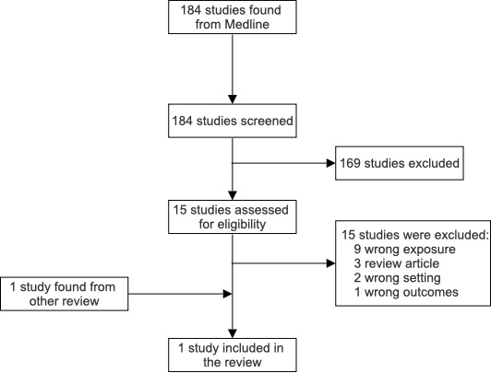

Supplementary Figure 2. Literature review of antibiotic exposure during pregnancy and intrapartum antibiotic exposure and weight gain in childhood.

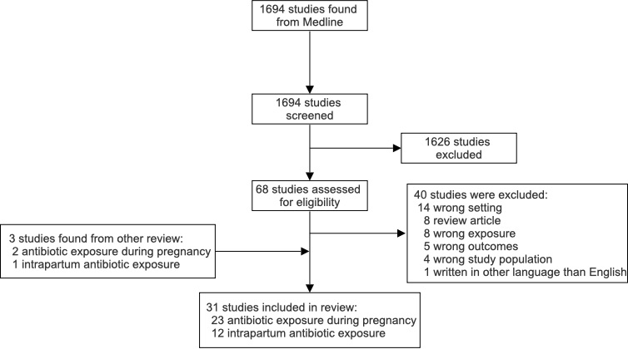

Supplementary Figure 3. Literature review chart of antibiotic exposure after birth and in the childhood and weight gain in childhood.

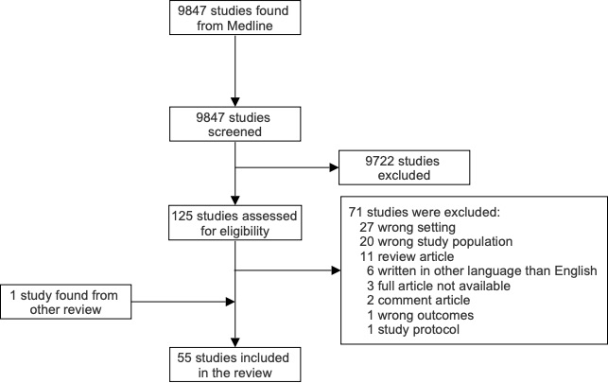

Supplementary Figure 4. Linearity assessment of continuous covariates in Cox regression analysis for antibiotic exposure before pregnancy and overweight.
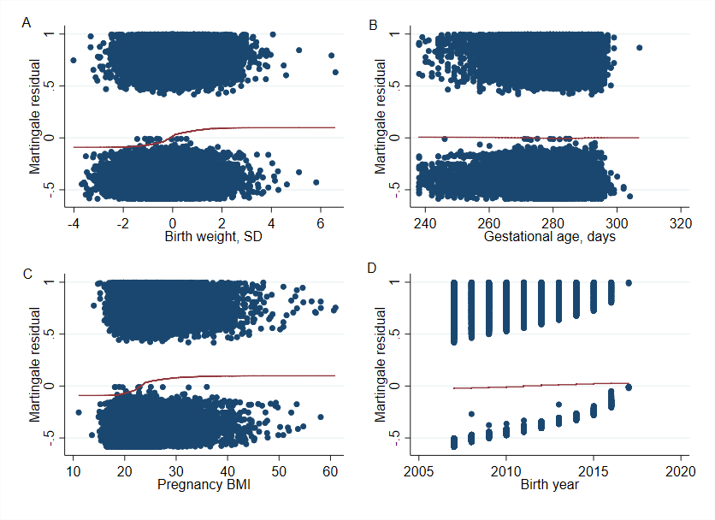

Supplementary Figure 5. Linearity assessment of continuous covariates in Cox regression analysis for antibiotic exposure before pregnancy and obesity.
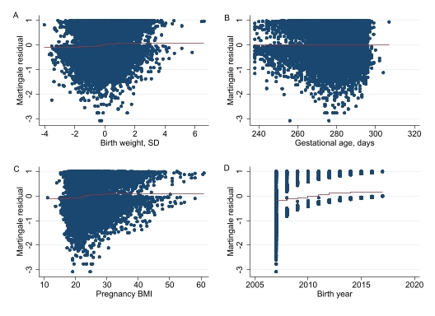

Supplementary Figure 6. Linearity assessment of continuous covariates in Cox regression analysis for antibiotic exposure in pregnancy and overweight.
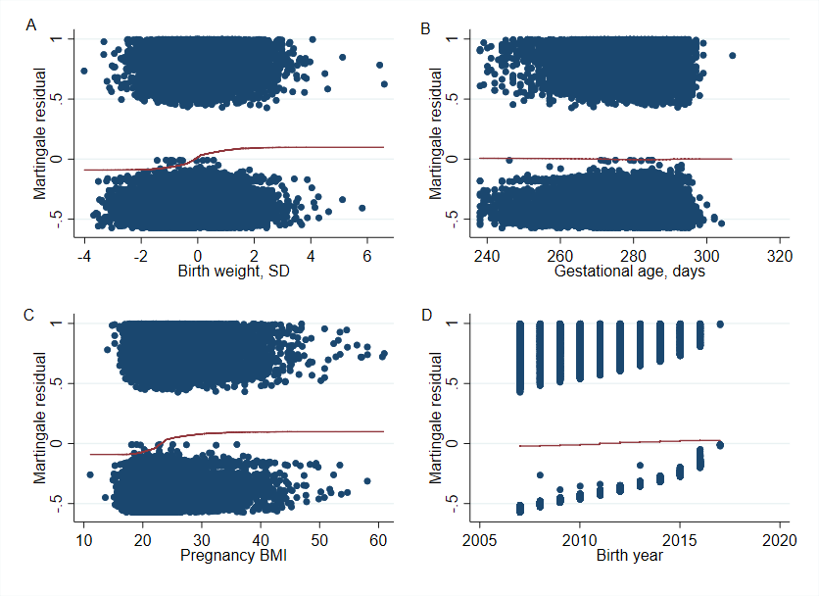

Supplementary Figure 7. Linearity assessment of continuous covariates in Cox regression analysis for antibiotic exposure in pregnancy and obesity.
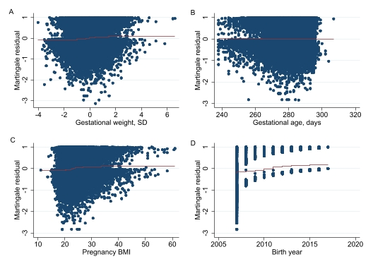

Supplementary Figure 8. Linearity assessment of continuous covariates in Cox regression analysis for perinatal antibiotic exposure and overweight.
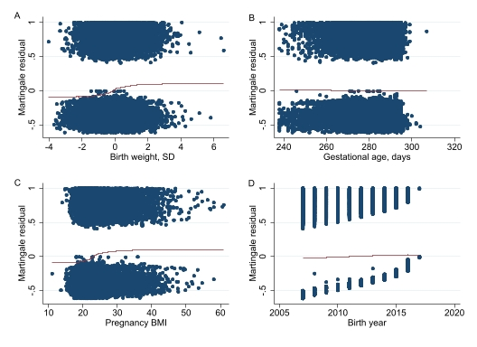

Supplementary Figure 9. Linearity assessment of continuous covariates in Cox regression analysis for perinatal antibiotic exposure and obesity.

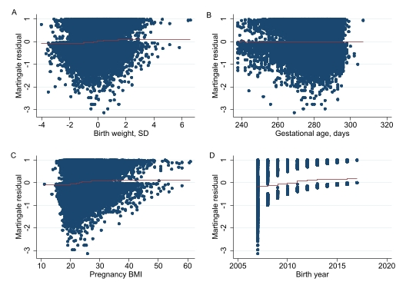

Supplementary Figure 10. Linearity assessment of continuous covariates in Cox regression analysis for antibiotic exposure in the first 24 months of life and overweight.
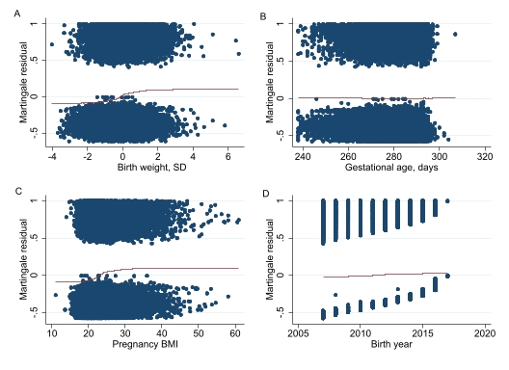

Supplementary Figure 11. Linearity assessment of continuous covariates in Cox regression analysis for antibiotic exposure in the first 24 months of life and obesity.

Supplementary Figure 12. Log-log curves to test proportional hazard assumption in childhood overweight analyses adjusted for birth year and sex.
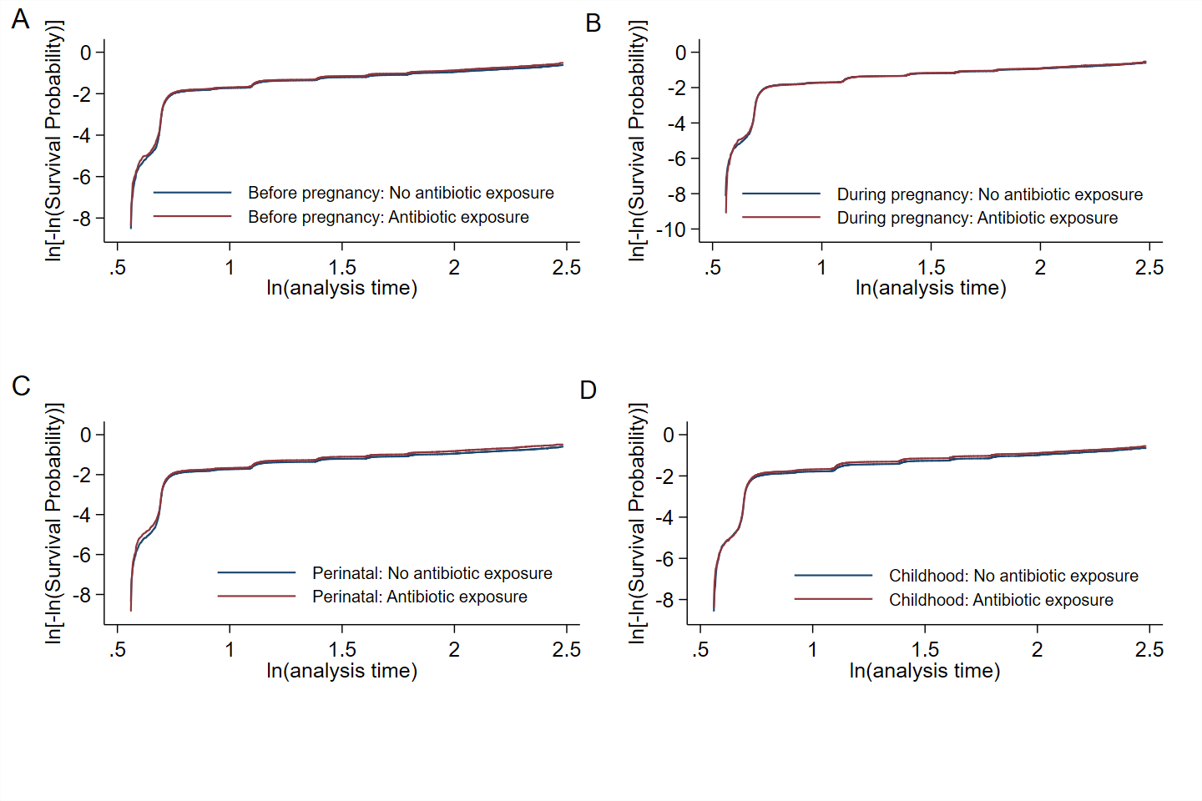

Supplementary Figure 13. Log-log curves to test proportional hazard assumption in childhood obesity analyses adjusted for birth year and sex.
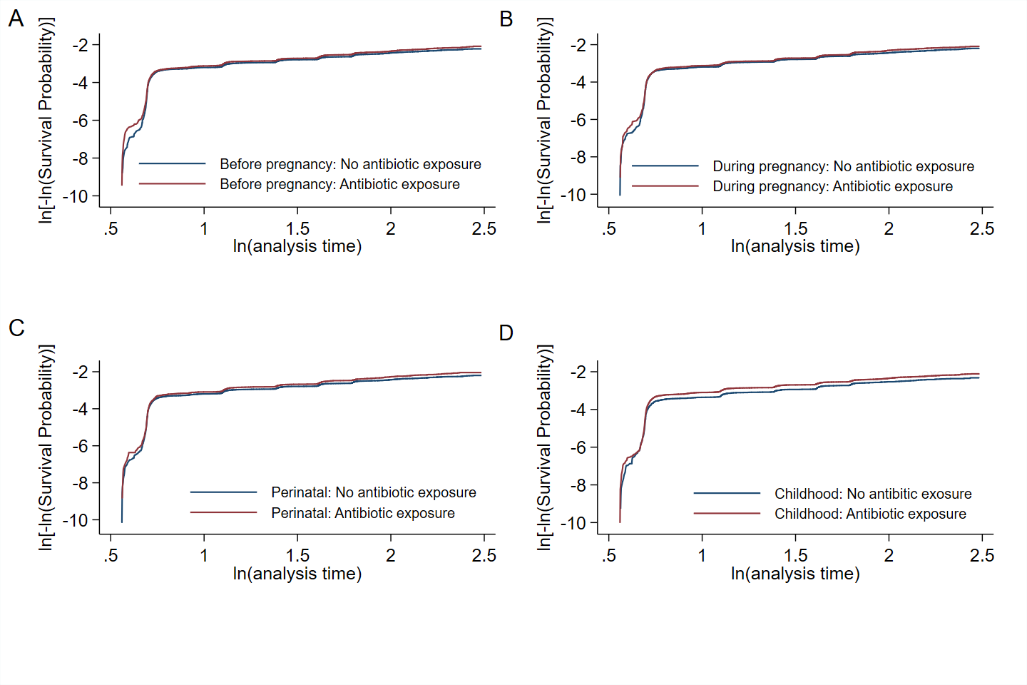
Supplementary Figure 14. Log-log curves to test proportional hazard assumption in childhood overweight analyses adjusted for all covariates.
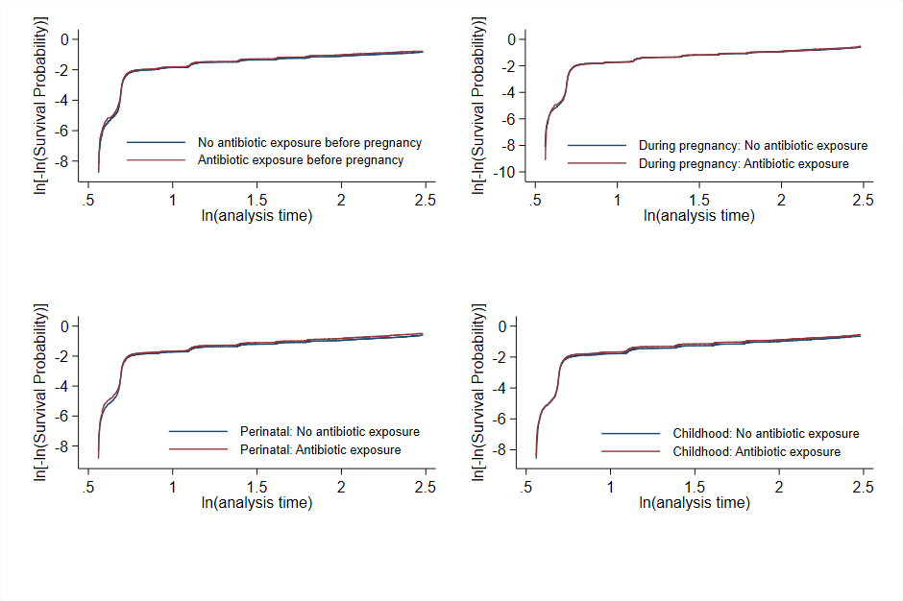

Supplementary Figure 15. Log-log curves to test proportional hazard assumption in childhood obesity analyses adjusted for all covariates.
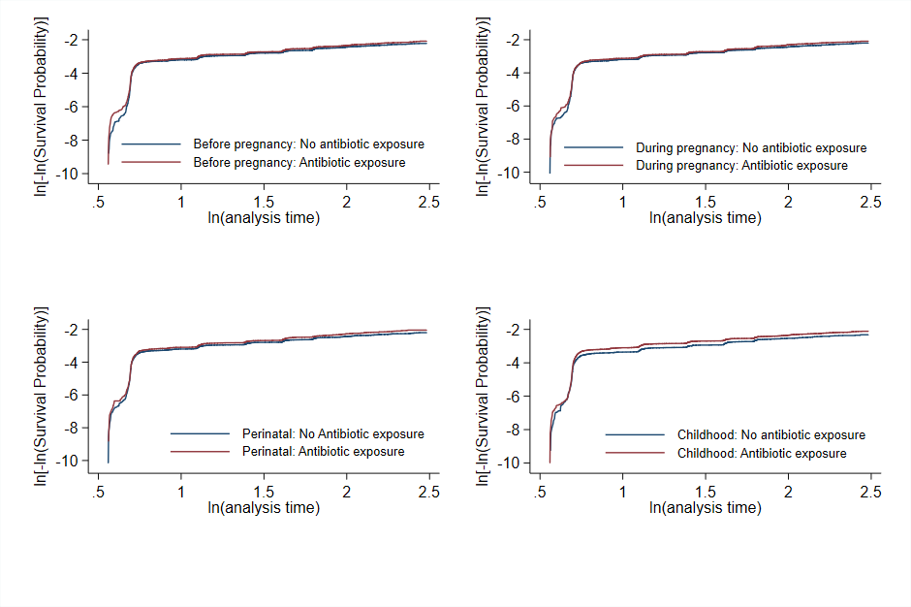

Supplementary Figure 16. Cumulative antibiotic exposure and body mass index-for-age Z-Scores (zBMIs) at 24 months of age between children exposed to antibiotics and those unexposed (children with no antibiotic exposure at any time). Analyses were adjusted for all covariates.

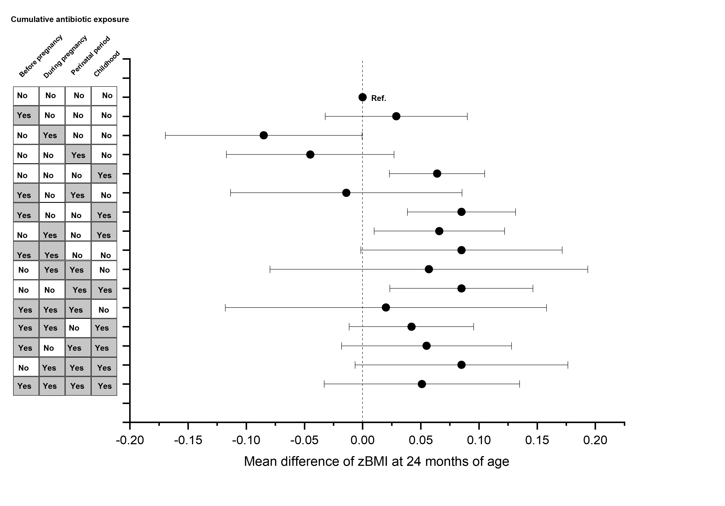

Supplementary Figure 17. Cumulative incidences of childhood overweight in children exposed to early antibiotics compared to unexposed ones. Analyses were adjusted for child’s birth year and sex.

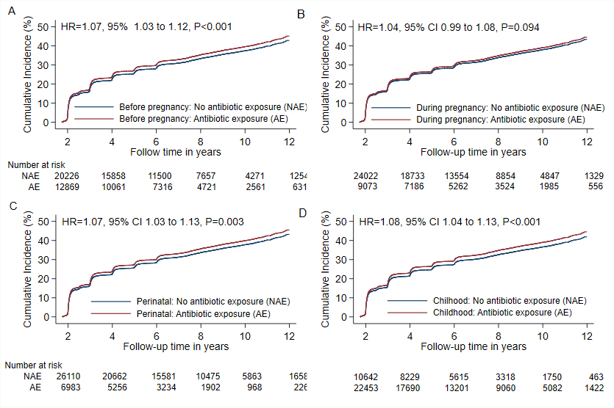

Supplementary Figure 18. Cumulative incidences of childhood obesity in children exposed to early antibiotics compared to unexposed ones. Analyses were adjusted for child’s birth year and sex.
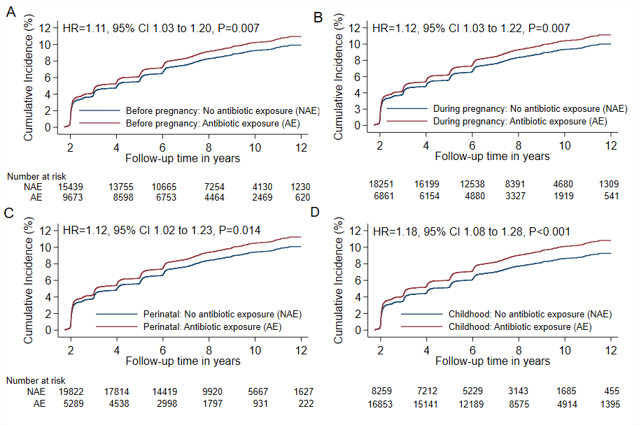

Supplementary Figure 19. Mean differences of height-for-age z-scores (zHFAs) at 24 months of age between those exposed to antibiotics and those not to. Analyses were adjusted for all covariates.

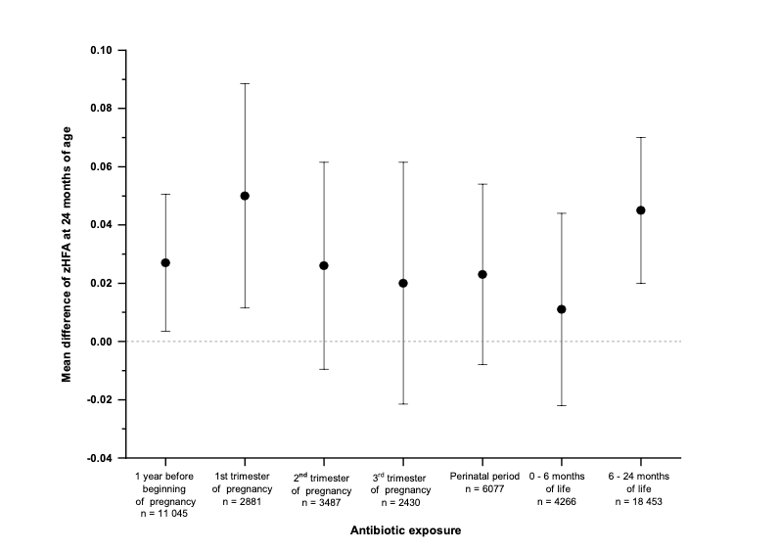

Supplementary Figure 20. Cumulative antibiotic exposure and height-for-age z-scores (zHFAs) at 24 months of age between children exposed to antibiotics and those unexposed (children with no antibiotic exposure at any time). Analyses were adjusted for all covariates.

