Mapping greenhouse gas emissions from global croplands circa 2020
Supplementary Information

Peiyu Cao¹, Franco Bilotto¹, Carlos Gonzalez Fischer¹, Nathaniel D. Mueller², Kimberly M. Carlson³, James S. Gerber^{4,5}, Pete Smith⁶, Francesco N. Tubiello⁷, Paul C. West^{5,8}, Liangzhi You⁹, and Mario Herrero¹

¹ Department of Global Development, College of Agriculture and Life Sciences, and Cornell Atkinson Center for Sustainability, Cornell University, Ithaca, New York 14853, USA.
² Department of Ecosystem Science and Sustainability and Department of Soil and Crop Sciences, Colorado State University, Fort Collins, Colorado 80521, USA.
³ Department of Environmental Studies, New York University, New York, New York 10003, USA.
⁴ Institute on the Environment, University of Minnesota, St. Paul, Minnesota 55108, USA.
⁵ Project Drawdown.
⁶ Institute of Biological & Environmental Sciences, University of Aberdeen, Cruickshank Building, St Machar Drive, Aberdeen, AB24 3UU, UK.
⁷ Statistics Division, Food and Agriculture Organization of the United Nations, Via Terme di Caracalla, Rome 00153, Italy.
⁸ Department of Applied Economics, University of Minnesota, St. Paul, Minnesota 55108, USA.
⁹ International Food Policy Research Institute, Washington, DC 20005, USA.

Supplementary Method

1 World Bank regions

Supplementary Figure 1. World Bank regions.

2 Workflow of development for input drivers

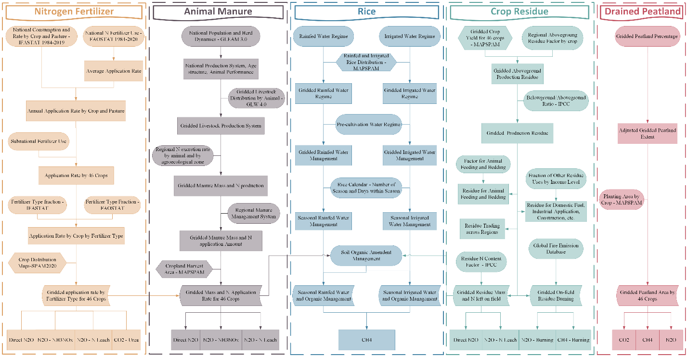
Supplementary Figure 2. Diagram for developing input drivers.

3 Climate zones

Supplementary Figure 3. Climate zone based on the decision tree in Figure 3A.5.2 of IPCC 2019 Refinement¹.

4 Runoff

Supplementary Figure 4. Overland runoff (a) and subsurface runoff (b) in 2020. Daily runoffs were sourced from the Land Data Assimilation System by NASA² and were accumulated to annual runoff. The annual overland and subsurface runoff that less than 10 kg m⁻² were ruled out.

5 Irrigation
Supplementary Figure 5. Cropland that receives irrigation. The map is the product of the percentage of area equipped for irrigation (> 5%) and the percentage of area actually irrigated. Data are sourced from FAO Global Map of Irrigation Areas version 5.

6 Cropland and managed grassland

Supplementary Table 1. Crop categories by SPAM 2020 and FAO.
SPAM 2020 Crop | FAO Crop
Wheat | Wheat
Rice | Rice
Maize | Maize
Barley | Barley
Pearl Millet | Millet
Small Millet | Millet
Sorghum | Sorghum
Other Cereals | Other Cereals; Teff; Rye; Oats; Buckwheat; Quinoa; Fonio; Triticale; Canary Seed; Mixed Grain; Cereals n.e.c.
Potato | Potato
Sweet Potato | Sweet Potato
Yams | Yam
Cassava | Cassava
Other Roots | Yautia; Taro; Edible roots and tubers with high starch or inulin content, n.e.c., fresh
Bean | Beans, Dry
Chickpea | Chickpea
Cowpea | Cowpea
Pigeon Pea | Pigeon Pea
Lentil | Lentils
Other Pulses | Broad beans and horse beans, dry; Peas, dry; Bambara beans, dry; Vetches; Lupins; Other pulses n.e.c.
Soybean | Soybean
Groundnut | Groundnut, With Shell
Coconut | Coconut
Oil Palm | Oil Palm Fruit
Sunflower | Sunflower Seed
Rapeseed | Rapeseed, Mustard; Mustard seed
Sesame Seed | Sesame Seed
Other Oil Crops | Olives; Linseed; Karite nuts (sheanuts); Castor oil seeds; Tung nuts; Safflower seed; Poppy seed; Melonseed; Hempseed; Other oil seeds, n.e.c.
Sugarcane | Sugar Cane
Sugarbeet | Sugarbeet
Cotton | Seed Cotton
Other Fibre Crop | Other Fibres; Abaca, manila hemp, raw; True hemp, raw or retted; Jute, raw or retted; Kenaf, and other textile bast fibres, raw or retted; Ramie, raw or retted; Sisal, raw; Agave fibres, raw, n.e.c.; Other fibre crops, raw, n.e.c.
Arabica Coffee | Coffee, Green
Robusta Coffee | Coffee, Green
Cocoa | Cocoa, Beans
Tea | Tea
Tobacco | Tobacco, Unmanufactured
Banana | Banana
Plantain | Plantain
Citrus | Citrus Fruit, Total
Other Tropical Fruit | Papayas; Watermelons; Cantaloupes and other melons; Figs; Mangoes, guavas and mangosteens; Avocados; Pineapples; Dates; Persimmons; Cashewapple; Other tropical fruits, n.e.c.
Temperate Fruit | Apples; Pears; Quinces; Apricots; Sour cherries; Cherries; Peaches and nectarines; Plums and sloes; Other stone fruits; Other pome fruits; Strawberries; Raspberries; Gooseberries; Currants; Blueberries; Cranberries; Other berries and fruits of the genus vaccinium n.e.c.; Grapes; Kiwi fruit; Other fruits, n.e.c.
Tomato | Tomatoes
Onion | Onions and shallots, green
Other Vegetables | Cabbages; Artichokes; Asparagus; Lettuce and chicory; Spinach; Cauliflowers and broccoli;  Pumpkins, squash and gourds; Cucumbers and gherkins; Eggplants (aubergines)  Chillies and peppers, green (Capsicum spp. and Pimenta spp.); Green garlic; Leeks and other alliaceous vegetables; Other beans, green; Peas, green;  Broad beans and horse beans, green; String beans;  Carrots and turnips; Okra; Green corn (maize); Cabbages And Other Brassicas; Chicory roots; Locust beans (carobs); Other vegetables, fresh n.e.c.
Rubber | Natural rubber in primary forms
Rest of Crops | Other sugar crops n.e.c.; All Individual Other Crops (e.g., Spices, Tree Nuts, Other Sugar Crops, Mate,); Cashew nuts, in shell; Chestnuts, in shell; Almonds, in shell; Walnuts, in shell; Pistachios, in shell; Kola nuts  Hazelnuts, in shell; Areca nuts; Other nuts (excluding wild edible nuts and groundnuts), in shell, n.e.c.; Maté leaves; Hop cones; Pepper (Piper spp.), raw; Chillies and peppers, dry (Capsicum spp., Pimenta spp.), raw; Vanilla, raw; Cinnamon and cinnamon-tree flowers, raw; Cloves (whole stems), raw; Nutmeg, mace, cardamoms, raw; Anise, badian, coriander, cumin, caraway, fennel and juniper berries, raw; Ginger, raw; Other stimulant, spice and aromatic crops, n.e.c.; Peppermint, spearmint; Pyrethrum, dried flowers; All Individual Other Crops (e.g., Spices, Tree Nuts, Other Sugar Crops, Mate, Rubber)

7 Synthetic nitrogen fertilizer development

Supplementary table 2. Countries with sub-national fertilizer consumption information. All fertilizer includes nitrogen, phosphorus, and potassium.
Country | Type | Source
Argentia | All | https://fertilizar.org.ar/estadisticas/
Australia | N | https://www.abs.gov.au/statistics/industry/agriculture/land-management-and-farming-australia
Austria | N | https://ec.europa.eu/eurostat/databrowser/view/aei_fm_usefert/default/table?lang=en&category=agr.aei.aei_nut
Belarus | N | https://dataportal.belstat.gov.by/
Brazil | N | https://sidra.ibge.gov.br/Tabela/770
Cambodia | All | https://www.nis.gov.kh/index.php/km/2-uncategorised/142-cambodia-agriculture-survey
Canada | N | https://www150.statcan.gc.ca/t1/tbl1/en/tv.action?pid=3210038901
China | N | https://data.stats.gov.cn/easyquery.htm?cn=E0103; Yu, et al³
Czechia | N | https://ec.europa.eu/eurostat/databrowser/view/aei_fm_usefert/default/table?lang=en&category=agr.aei.aei_nut
Egypt | All | https://censusinfo.capmas.gov.eg/Metadata-en-v4.2/index.php/catalog/287
Finland | N | https://ec.europa.eu/eurostat/databrowser/view/aei_fm_usefert/default/table?lang=en&category=agr.aei.aei_nut
France | N | https://ec.europa.eu/eurostat/databrowser/view/aei_fm_usefert/default/table?lang=en&category=agr.aei.aei_nut
Germany | N | https://www.bmel-statistik.de/landwirtschaft/tabellen-zur-landwirtschaft#c8273
India | N | https://www.indiastat.com/data/agriculture/consumption-of-fertiliser-nurtients
Indonesia | All | https://sensus.bps.go.id/topik/tabular/st2023/231/98808/0
Iran | N | https://irandataportal.syr.edu/socio-economic-data/statistical-yearbook
Italy | N | http://dati.istat.it/Index.aspx?QueryId=23965&lang=en#
Japan | N | http://www.jaf.gr.jp/gaiyou.html#toukei
Lithuania | N | https://ec.europa.eu/eurostat/databrowser/view/aei_fm_usefert/default/table?lang=en&category=agr.aei.aei_nut
Mexico | All | https://www.economia.gob.mx/datamexico/en/profile/product/mineral-or-chemical-fertilizers-with-all-three-elements-exc-in-tablets-or-similar-forms-or-in-packages-with-a-gross-weight-of-10-kg-nitrogen-phosphorus-and-potassium
New Zealand | N | https://www.stats.govt.nz/indicators/fertilisers-nitrogen-and-phosphorus/
Norway | N | https://ec.europa.eu/eurostat/databrowser/view/aei_fm_usefert/default/table?lang=en&category=agr.aei.aei_nut
Pakistan | N | https://www.pbs.gov.pk/sites/default/files/other/yearbooks/Pakistan_Statistical_Year_Book_2022.pdf
Philippines | N | https://openstat.psa.gov.ph/PXWeb/pxweb/en/DB/DB__2E__CS/0052E4ECFU0.px/?rxid=bdf9d8da-96f1-4100-ae09-18cb3eaeb313
Poland | N | https://ec.europa.eu/eurostat/databrowser/view/aei_fm_usefert/default/table?lang=en&category=agr.aei.aei_nut
Romania | N | https://ec.europa.eu/eurostat/databrowser/view/aei_fm_usefert/default/table?lang=en&category=agr.aei.aei_nut
Russia | All | https://eng.rosstat.gov.ru/territorial
Slovakia | N | https://ec.europa.eu/eurostat/databrowser/view/aei_fm_usefert/default/table?lang=en&category=agr.aei.aei_nut
Slovenia | N | https://ec.europa.eu/eurostat/databrowser/view/aei_fm_usefert/default/table?lang=en&category=agr.aei.aei_nut
South Africa | N | https://www.fertasa.co.za/fertilizer-information/historic-sales-data/
South Korea | N | https://kosis.kr/statHtml/statHtml.do?orgId=101&tblId=DT_1EA1511&vw_cd=MT_ETITLE&list_id=F1E1&scrId=&language=en&seqNo=&lang_mode=en&obj_var_id=&itm_id=&conn_path=MT_ETITLE&path=%252Feng%252FstatisticsList%252FstatisticsListIndex.do
Spain | N | https://ec.europa.eu/eurostat/databrowser/view/aei_fm_usefert/default/table?lang=en&category=agr.aei.aei_nut
Sweden | N | https://ec.europa.eu/eurostat/databrowser/view/aei_fm_usefert/default/table?lang=en&category=agr.aei.aei_nut
Thailand | All | https://www.nso.go.th/public/e-book/Indicators-Environment/Environment-Indicators-Thailand-2555/152-153/
Turkey | N | https://ec.europa.eu/eurostat/databrowser/view/aei_fm_usefert/default/table?lang=en&category=agr.aei.aei_nut
Uganda | N | https://www.ubos.org/?pagename=explore-publications&p_id=2
Ukraine | N | https://ukrstat.gov.ua/operativ/operativ2018/sg/vmod/arch_vmodsg_e.htm
United Kingdom | N | https://www.gov.uk/government/collections/fertiliser-usage
United States | N | NuGIS⁴; Cao, et al⁵
Zambia | All | https://zambia.opendataforafrica.org/ZMCRFCSD2016/crop-forecast-survey-data-of-zambia-2015

Supplementary Figure 6. Availability of sub-national nitrogen fertilizer data.

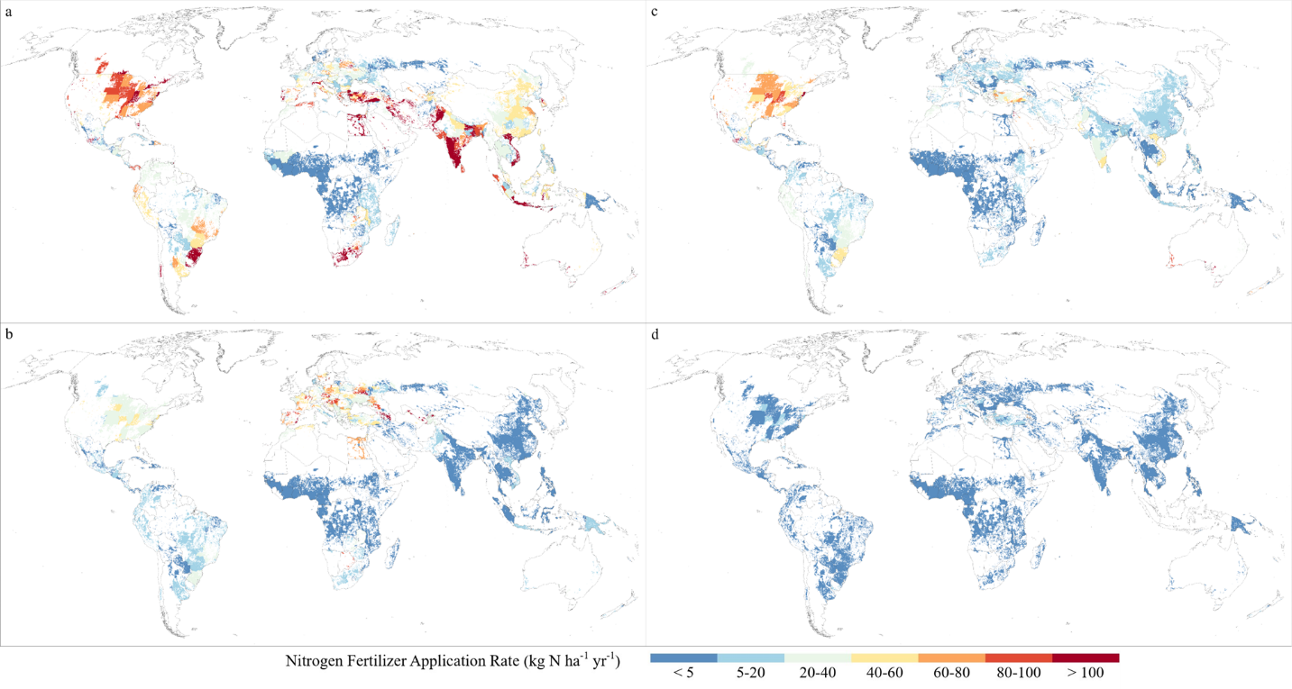
Supplementary Figure 7. Example of nitrogen fertilizer use for maize by urea (a), NH₄⁺-NO₃⁻-N (b), NH₄⁺-N (c), and NO₃⁻-N (d).

8 Rice cultivation

Supplementary table 3.
Rice system | Water regime | Definition
Irrigated | Continuously flooded | Standing water throughout growing season and may have the end-season drainage
Irrigated | Intermittently flooded – single aeration | A single drainage event in addition to end-season drainage
Irrigated | Intermittently flooded – multiple aeration | Multiple drainage events without flooded conditions in addition to end-season drainage
Rainfed | Upland | Never flooded for a significant period of time
Rainfed | Regular rainfed | Water level may rise up to 50 cm
Rainfed | Drought prone | Drought periods occur
Rainfed | Deep water | Water level rises to > 50 cm for a significant period of time

Supplementary table 4. Rainfed rice system information (proportion of different managements) for 85 countries.
Country | Upland | Deep water | Drought prone | Regular rainfed | Year
Afghanistan | 0.00 | 0.00 | 0.00 | 1.00 | 2000
Algeria | 0.50 | 0.00 | 0.50 | 0.00 | 2013
Angola | 0.41 | 0.00 | 0.00 | 0.59 | 2013
Argentina | 0.00 | 0.00 | 0.00 | 1.00 | 2000
Australia | 0.00 | 0.00 | 0.00 | 1.00 | 2000
Bangladesh | 0.12 | 0.25 | 0.33 | 0.29 | 2000
Benin | 0.31 | 0.00 | 0.00 | 0.69 | 2013
Bhutan | 0.17 | 0.02 | 0.81 | 0.00 | 2000
Bolivia | 0.98 | 0.00 | 0.01 | 0.01 | 2000
Brazil | 0.98 | 0.00 | 0.02 | 0.00 | 2010
Burkina Faso | 0.21 | 0.00 | 0.01 | 0.78 | 2013
Burundi | 0.15 | 0.00 | 0.00 | 0.85 | 2013
Cameroon | 0.75 | 0.00 | 0.22 | 0.02 | 2013
Cambodia | 0.02 | 0.06 | 0.84 | 0.08 | 2016
Central African Republic | 0.86 | 0.00 | 0.00 | 0.14 | 2013
Chad | 0.56 | 0.00 | 0.43 | 0.01 | 2013
China | 0.29 | 0.00 | 0.57 | 0.14 | 2000
Colombia | 0.14 | 0.00 | 0.03 | 0.84 | 2000
Comoros | 0.40 | 0.00 | 0.00 | 0.60 | 2013
Congo | 0.52 | 0.00 | 0.44 | 0.04 | 2013
Côte d’Ivoire | 0.66 | 0.00 | 0.32 | 0.02 | 2013
Cuba | 0.04 | 0.00 | 0.04 | 0.92 | 2000
Dominican Republic | 0.14 | 0.00 | 0.14 | 0.71 | 2000
Congo DRC | 0.83 | 0.00 | 0.17 | 0.00 | 2013
Ecuador | 0.57 | 0.00 | 0.43 | 0.00 | 2018
Egypt | 0.20 | 0.00 | 0.00 | 0.80 | 2013
Eswatini | 0.52 | 0.00 | 0.48 | 0.00 | 2013
Ethiopia | 0.56 | 0.00 | 0.44 | 0.00 | 2013
France | 0.00 | 0.00 | 0.00 | 1.00 | 2000
Gabon | 0.52 | 0.00 | 0.00 | 0.48 | 2013
Gambia | 0.37 | 0.14 | 0.00 | 0.49 | 2020
Ghana | 0.07 | 0.00 | 0.92 | 0.01 | 2013
Greece | 0.00 | 0.00 | 0.00 | 1.00 | 2000
Guinea | 0.84 | 0.05 | 0.00 | 0.11 | 2013
Guinea-Bissau | 0.39 | 0.11 | 0.00 | 0.50 | 2013
Guyana | 0.14 | 0.00 | 0.14 | 0.71 | 2000
India | 0.24 | 0.06 | 0.6 | 0.1 | 2014
Indonesia | 0.20 | 0.40 | 0.29 | 0.11 | 2000
Iran | 0.00 | 0.00 | 0.00 | 1.00 | 2000
Italy | 0.00 | 0.00 | 0.00 | 1.00 | 2000
Japan | 0.00 | 0.00 | 0.00 | 1.00 | 2000
Kenya | 0.50 | 0.00 | 0.50 | 0.00 | 2013
Laos | 0.12 | 0.00 | 0.88 | 0.00 | 2019
Liberia | 0.82 | 0.00 | 0.18 | 0.00 | 2013
Madagascar | 0.12 | 0.04 | 0.82 | 0.02 | 2013
Malawi | 0.25 | 0.00 | 0.75 | 0.00 | 2013
Malaysia | 0.36 | 0.00 | 0.58 | 0.06 | 2000
Mali | 0.35 | 0.00 | 0.27 | 0.38 | 2019
Mauritania | 0.26 | 0.00 | 0.74 | 0.00 | 2013
Mauritius | 0.54 | 0.00 | 0.46 | 0.00 | 2013
Mexico | 0.91 | 0.00 | 0.05 | 0.05 | 2000
Morocco | 0.11 | 0.78 | 0.11 | 0.00 | 2013
Mozambique | 0.33 | 0.00 | 0.66 | 0.01 | 2013
Myanmar | 0.05 | 0.13 | 0.67 | 0.15 | 2000
Nepal | 0.11 | 0.01 | 0.62 | 0.25 | 2000
Nicaragua | 0.97 | 0.00 | 0.02 | 0.02 | 2019
Niger | 0.08 | 0.44 | 0.00 | 0.48 | 2013
Nigeria | 0.30 | 0.00 | 0.00 | 0.70 | 2013
North Korea | 0.04 | 0.00 | 0.88 | 0.08 | 2000
Pakistan | 0.00 | 0.00 | 1.00 | 0.00 | 2000
Paraguay | 0.95 | 0.00 | 0.02 | 0.02 | 2000
Panama | 0.00 | 0.00 | 0.00 | 1.00 | 2017
Peru | 0.51 | 0.00 | 0.46 | 0.03 | 2000
Philippines | 0.06 | 0.00 | 0.68 | 0.26 | 2000
Portugal | 0.00 | 0.00 | 0.00 | 1.00 | 2000
Russian Federation | 0.00 | 0.00 | 1.00 | 0.00 | 2000
Rwanda | 0.00 | 0.00 | 1.00 | 0.00 | 2013
Senegal | 0.18 | 0.28 | 0.00 | 0.54 | 2013
Sierra Leone | 0.49 | 0.07 | 0.00 | 0.44 | 2013
Somalia | 0.59 | 0.06 | 0.35 | 0.00 | 2013
South Africa | 0.17 | 0.00 | 0.83 | 0.00 | 2013
South Korea | 0.10 | 0.00 | 0.86 | 0.05 | 2000
Spain | 0.00 | 0.00 | 1.00 | 0.00 | 2000
Sri Lanka | 0.03 | 0.00 | 0.93 | 0.03 | 2000
Tanzania | 0.05 | 0.00 | 0.00 | 0.95 | 2013
Thailand | 0.02 | 0.04 | 0.74 | 0.20 | 2000
Togo | 0.13 | 0.00 | 0.00 | 0.87 | 2013
Turkey | 0.00 | 0.00 | 1.00 | 0.00 | 2000
Uganda | 0.48 | 0.00 | 0.00 | 0.52 | 2013
United States | 0.00 | 0.00 | 0.00 | 1.00 | 2000
Uruguay | 0.00 | 0.00 | 0.00 | 1.00 | 2000
Venezuela | 0.33 | 0.00 | 0.33 | 0.33 | 2000
Vietnam | 0.35 | 0.00 | 0.00 | 0.65 | 2016
Zambia | 0.28 | 0.00 | 0.72 | 0.00 | 2013
Zimbabwe | 0.27 | 0.00 | 0.73 | 0.00 | 2013
Sources: FAO⁶, UNFCCC⁷, Ref⁸, Ref⁹.

Supplementary Figure 8. Availability of rainfed rice system information (in red). Countries shaded in grey indicate those where irrigated rice is cultivated but detailed system information is lacking. Countries in white do not report any rice.

Supplementary Table 5. Irrigated rice system information (proportion of different management practices) for 35 countries.
Country | Continuously flooded | Single aeration | Multiple aeration | Year
Afghanistan | 0.34 | 0.33 | 0.33 | 2017
Argentina | 1 | 0 | 0 | 2019
Bangladesh | 0.04 | 0 | 0.96 | 1998
Belize | 1 | 0 | 0 | 2019
Brazil | 0.75 | 0.25 | 0.33 | 2019
Cambodia | 1 | 0 | 0 | 2015
Chile | 1 | 0 | 0 | 2019
China | 0.2 | 0 | 0.8 | 2002
Colombia | 0.34 | 0.33 | 0.33 | 2019
Costa Rica | 1 | 0 | 0 | 2019
Côte d’Ivoire | 1 | 0 | 0 | 2019
El Salvador | 1 | 0 | 0 | 2019
Ghana | 0 | 1 | 0 | 2019
Honduras | 1 | 0 | 0 | 2019
India | 0.35 | 0.37 | 0.28 | 2016
Indonesia | 0.43 | 0.22 | 0.35 | 1998
Japan | 0.35 | 0 | 0.65 | 2011
Malaysia | 1 | 0 | 0 | 2019
Mali | 1 | 0 | 0 | 2019
Mauritania | 1 | 0 | 0 | 2010
Mexico | 1 | 0 | 0 | 2019
Myanmar | 0 | 0 | 1 | 1998
Nicaragua | 1 | 0 | 0 | 2019
North Macedonia | 1 | 0 | 0 | 2019
Pakistan | 0 | 1 | 0 | 2019
Panama | 0 | 0 | 1 | 2019
Philippines | 1 | 0 | 0 | 1998
Rwanda | 0 | 0 | 1 | 2019
Somalia | 0 | 0 | 1 | 2019
South Korea | 0.15 | 0 | 0.85 | 2019
Thailand | 1 | 0 | 0 | 1998
Uganda | 1 | 0 | 0 | 2019
Uruguay | 1 | 0 | 0 | 2019
United States | 0.98 | 0 | 0.02 | 2019
Vietnam | 0.64 | 0.35 | 0.01 | 2016
Sources: FAO⁶, UNFCCC⁷, Ref⁸, Ref¹⁰.

Supplementary Figure 9. Availability of irrigated rice system information (in red). Countries shaded in grey indicate those where irrigated rice is cultivated but detailed system information is lacking. Countries in white do not report any rice.

9 Peatland

Supplementary Figure 10. Extent of peatland (grey) and the drained peatland (red).

10 Crop energy conversion factors

Supplementary Table 6. Crop energy content table.
SPAM 2020 Crop | Calorie (kcal per 100 grams)
Wheat | 334
Rice | 280
Maize | 356
Barley | 332
Pearl Millet | 340
Small Millet | 340
Sorghum | 343
Other Cereals | 340
Potato | 67
Sweet Potato | 92
Yams | 101
Cassava | 109
Other Roots | 91
Bean | 341
Chickpea | 358
Cowpea | 342
Pigeon Pea | 343
Lentil | 346
Other Pulses | 340
Soybean | 335
Groundnut | 567
Coconut | 184
Oil Palm | 514
Sunflower | 308
Rapeseed | 484
Sesame Seed | 573
Other Oil Crops | 387
Sugarcane | 30
Sugarbeet | 70
Cotton | 0
Other Fibre Crop | 0
Arabica Coffee | 47
Robusta Coffee | 47
Cocoa | 414
Tea | 40
Tobacco | 0
Banana | 60
Plantain | 75
Citrus | 26
Other Tropical Fruit | 41
Temperate Fruit | 45
Tomato | 17
Onion | 24
Other Vegetables | 22
Rubber | 0
Rest of Crops | 367

Supplementary Results

1 Global N inputs
In 2020, we estimated that the global cropland received 103, 19, and 37 Tg N yr⁻¹ of synthetic fertilizer, animal manure, and crop residue inputs, respectively (Supplementary Table 7). Our estimates allign well with those reported by FAOSTAT¹¹ and Ref¹². Note that FAOSTAT report encompassed both cropland and grassland, whereas our estimates excluded grassland inputs, resulting in lower values. In addition, we accounted for the herd dynamics and age structurein national animal populations, recognizing that younger animals produce less manure than adults. Ref¹² estimated the uses of fertilizer and manure for cropland during the 2010s, which are comparable to our results considering the increasing application rate over the past decade.
Alligning to global and national N fertilizer datasets ^{3,5,12–14}, our N fertilizer map represents high application intensity (> 70 kg N ha⁻¹ yr⁻¹) in the Midwest US, southern Brazil, Europe, Eygpt, South Africa, southern India, and central and eastern China (Supplementary Figure 10a). The Caribbean, north of South America, Southeast Asia, and Oceania received intermediate N fertilizer (35-70 kg N ha⁻¹ yr⁻¹). Meanwhile, high manure inputs (> 35 kg N ha⁻¹ yr⁻¹) were found in vast area across all regions where animal desity was high¹⁵ (Supplementary Figure 10b). However, the application rates of manure were generally lower than those of fertilizer and crop residue. Hotspots of crop residue N were concentrated in tropical areas, exceeding 70 kg N ha⁻¹ yr⁻¹ (Supplementary Figure 10c). Additionally, the eastern Europe, northern India, northwest of China, Japan, and northern Midwest US incorporated high rate of crop residue N.
Cereals (excluding rice) received the highest N inputs (63 Tg N yr⁻¹) (Supplementary Figure 11a), with fertilizer as the major contributor (45 Tg N yr⁻¹). Rice and Sugar & Fiber used similar total N inputs (23 Tg yr⁻¹ and 22 Tg N yr⁻¹, respectively), while rice consumed more fertilizer (17 Tg N yr⁻¹) and Sugar & Fiber received equal amount from fertilizer and crop residue. The remaining six crop groups consumed 51 Tg N yr⁻¹ in total, with individual group inputs ranging from 11 to 5 Tg N yr⁻¹. Although the total N inputs are similar across these groups, the contributions of the three inputs differred. Fruits and Oil Crops predominantly used fertilizer, whereas Vegetables and Other received inputs solely from fertilizer and manure.
Regionally, Asia is the dominant N consumer with 81 Tg N yr⁻¹ (Supplementary Figure 11b), followed by Europe (26 Tg N yr⁻¹), Latin America (20 Tg N yr⁻¹), and North America (19 Tg N yr⁻¹), while Africa received the least N inputs (14 Tg N yr⁻¹). Fertilizer is the main N input in all regions except Sub-Saharan Africa, where crop residue was the most important N input.
Overall, cropland N inputs that account for all three input sources were attributed to fertilizer and crop residue. Regions such as the Midwest US, southern Brazil, Europe, India, and China consumed high N inputs over 250 kg N ha⁻¹ yr⁻¹, whereas the Central Africa and Central Asia received less than 80 kg N ha⁻¹ yr⁻¹ N inputs (Supplementary Figure 11c).

Supplementary Table 7. Global nitrogen inputs to cropland (Tg N yr⁻¹).
Inputs | This study  2020 | FAOSTAT¹¹  2020 | Ref¹²  2010s | Ref¹⁵  2014
Synthetic fertilizer | 103 | 110 | 97
Animal manure | 19 | 27 | 22 | 24.5
Crop residue | 37 | 38
Total | 159 | 175

Supplementary Figure 11. Global synthetic nitrogen fertilizer application (a), animal manure N application (b), and crop residue N incorporation (c).

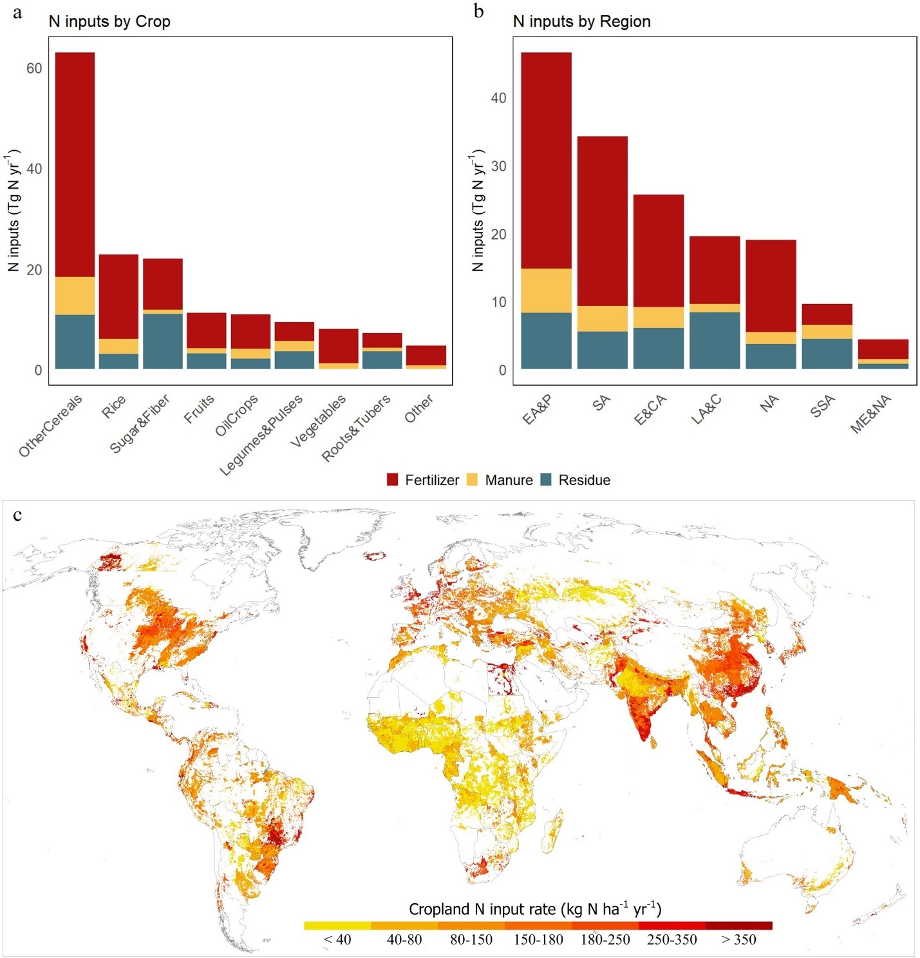
Supplementary Figure 12. Nitrogen use of synthetic fertilizer, manure, and crop residue by crop groups (a), by regions (b), and by grid distribution (c). The cropland N input rate is summed rate of three N inputs in (c). EA&P refers to East Asia & Pacific, SA refers to South Asia, E&CA refers to Europe & Central Asia, LA&C refers to Latin America & Caribbean, NA refers to North America, SSA refers to Sub-Saharan Africa, ME&NA refers to Middle East & North Africa.

2 Rice paddy
Upland rice was relatively prevalent in Latin America and Caribbean, and Africa, while less representive in Southeast Asia (Supplementary Figure 12a), which is consistent with the previous study¹⁶. Regular rainfed rice was primarily cultivated in parts of Southesat Asia and Africa, and a few countries such as Canada, Colombia, Argentia, Japan, and Austrilia (Supplementary Figure 12b). Drought prone rice represented the most common system in Central Asia and was widely adopted in East and Southeast Asia, alog with several African countries (Supplementary Figure 12c). In contrast, Deep water rice occurred only in a limited number of tropical countries with lower adoption rates (Supplementary Figure 12d).
Continuously flooded rice was practiced widely across most regions except for some countries in Asia (Supplementary Figure 13a). The multiple aeration rice system was extensively adopted in Asian countries such as Japan, South Korea, and China. In contrast, Single aeration rice was adopted in a few countries such as Vienam, Indonesia, India, Colombia, and Brazil at relatively low rate (< 40%) (Supplementary Figure 13c).
We compiled rice system information for 85 rainfed rice and 35 irrigated rice countries (Supplementary Table 4 & 5), representing the most comprehensive global dataset on rice water regime management to our knowledge. However, data availability varies across regions and time periods. In addition, the sub-national information is essential for large countries to better capture of spatial heterogeneity of rice water regime systems.

Supplementary Figure 13. Global share of rainfed rice system: Upland rice (a), Regular rainfed (b), Drought prone (c), and Deep water (d).

Supplementary Figure 14. Global share of irrigated rice water regime system: Continuously flooded (a), Single aeration (b), and Multiple aeration (c).

3 Peatland area
Globally and regionally, the estimated peatland area differs significantly among studies (Supplementary Table 8). In this study, the peatland area derived from Peat-ML is 3.8 Mkm², which falls within the range of 3.3-4.9 Mkm² reported in global peatland studies. Based on the area of organic soils (histosols), Ref^{17,18} estimated a relatively lower peatland area compared to other studies that multiple factors (e.g. meta-analysis and biophysical indices) and experts knowledge were combined to generate peatland extent. Meanwhile, Peat-ML estimates remained consistently within the published peatland area ranges, with the North America and Europe fall into the lower end while the rest regions fall into the higher end. In addition, we compared the national peatland area against five datasets (Supplementary Figure 14). Peat-ML alligns well with Ref¹⁹ for the tropical regions and Global Peatland Map 2.0²⁰ for top peatland countries across regions. Overall, there is general well agreement between Peat-ML and the rest three datasets, especially when compared with FAO¹¹ and Ref¹⁷. However, large discrepancies observed across different datasets can introduce substantial uncertainties to GHG emissions estimates for peatland.
We estimated that 0.2 M km² of peatland is drained for crop cultivation, accounting for 5.2% of peatland (Supplementary Table 8). This drained peatland area is 19% smaller than that by Ref¹⁸ and 45% larger than that of Ref¹⁷. The comparisons to these two datasets show a large disagreement across countries (Supplementary Figure 15).

Supplementary Table 8. Global peatland area and drained peatland area for cultivation (Thousand km²). Ref^{21,22} split Russian Federation into Asia and Europe.
Regions | This study | Ref¹⁸ | Ref¹⁷ | Ref²³ | Ref²¹ | Ref²² | Ref²⁴ | Ref²⁰
North America | 1264 | 1312 | 1320 | 1710 | 1735 | 1860 | 1339 | 1582
Asia | 402 | 259 | 272 | 338 | 1119 | 1523 | 284 | 425
Europe | 1507 | 1502 | 1535 | 1785 | 957 | 617 | 1868 | 1773
Africa | 248 | 72 | 53 | 50 | 58 | 59 | 187 | 390
South America | 363 | 100 | 110 | 86 | 102 | 191 | 486 | 634
Oceania | 45 | 45 | 20 | 0.2 | 14 | 8 | 69 | 73
Total | 3843 | 3289 | 3310 | 3970 | 3985 | 4258 | 4232 | 4878
Drainage rate | 5.2% | 7.5% | 4.1%
Drained Area | 199 | 247 | 137

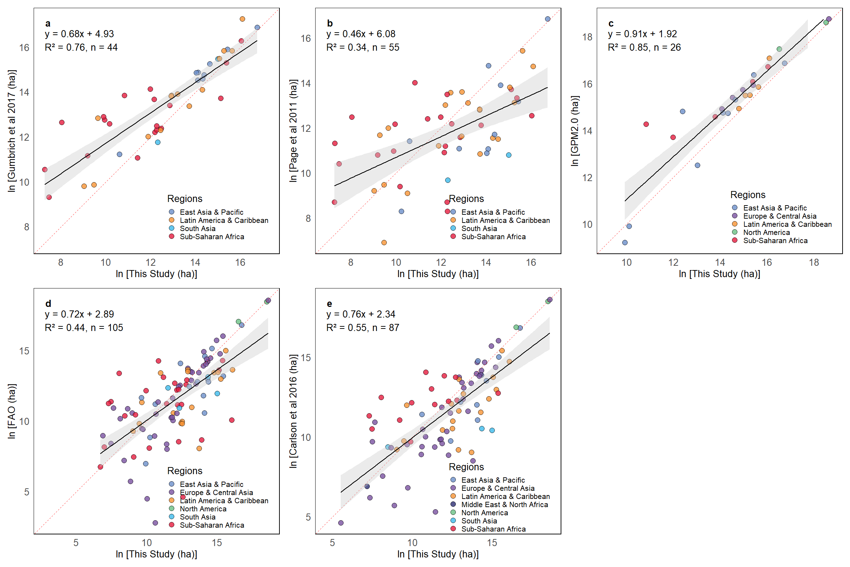
Supplementary Figure 15. Comparison of peatland area between this study and different datasets. Dots present countries.

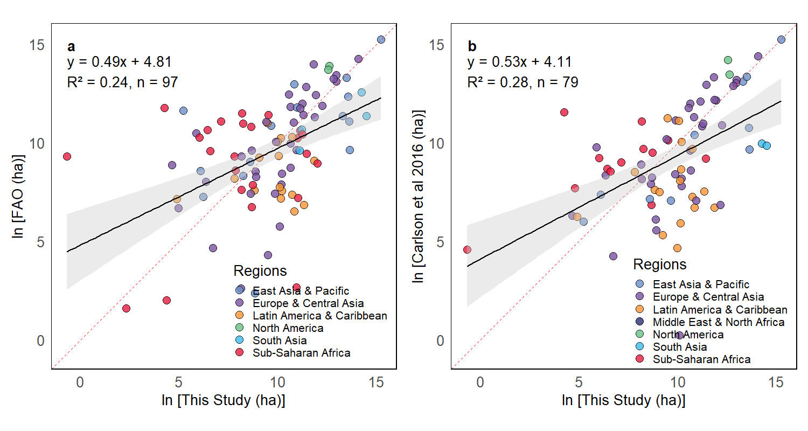
Supplementary Figure 16. Comparison of drained peatland between this study and different datasets. Individual dots represent countries, colors represent regions.

4 N₂O emissions from nitrogen fertilizer

We estimated 1.33 Tg N₂0 yr⁻¹ direct emission, 0.15 Tg N₂0 yr⁻¹ indirect emission from volatilization, and 0.3 Tg N₂0 yr⁻¹ indirect emission from runoff emissions from synthetic N fertilizer in 2020 using IPCC 2019 emissions factors (Supplementary Table 10). The total N₂O emission from these three sources for N fertilizer was 1.78 Tg N₂0 yr⁻¹. Our estimate is lower than that by FAO, who reported 1.76 Tg N₂0 yr⁻¹ direct emission and 2.28 Tg N₂0 yr⁻¹ total emission. Compared to the statistical model and process-based model, our estimate is also lower. The difference could be attributed to the scope, data source, and estimation approach. We separated fertilizer use into cropland and managed grassland, which led to a lower fertilizer input. The process-based model accounts for a greater scope that includes soil mineralization from previous nutrient accumulation and N deposition effect. Additionally, the estimation approach contributed to the variety. By using the same data source, our estimates of direct and indirect emission usings IPCC 2019 were lower that those by IPCC 2006 (Supplementary Table 8). Significant spatial discrepancies were revealed in the comparison between two approaches (Supplementary Figure 16-18), which was observed in a previous study²⁵. In the IPCC 2019, the disaggregated emission factor (EF) for direct N₂O emission from fertilizer is 0.016 kg N₂O-N per kg N in wet climate, which is three times greater than that in dry climate. This difference enhances the N₂O estimation in wet climate (e.g. Eastern US, Southern China, and Southeast Asia) while weakens it in dry climate (e.g. Midwest US, Central Asia, and Eastern Europe) (Supplementary Figure 16a). In contrast, a universal EF, 0.01 kg N₂O-N per kg N, is recommended in IPCC 2006, resulting in the same spatial pattern as the fertilizer use intensity (Supplementary Figure 16b). For example, the N₂O emission hotspots were found in the Midwest US, Southern Brazil, Europe, Southern India, and Central and Eastern China, where the intensive N fertilizer have been used. Similarly, The spatial differences between IPCC 2019 and IPCC 2006 were found for the indirect N₂O emission from fertilizer volatilization (Supplementary Figure 17). The EF for wet climate (0.014 kg N₂O-N per kg N) is about three times greater than that for dry climate (0.015 kg N₂O-N per kg N) in IPCC 2019 while keeping constant in IPCC 2006 for both climate zones. The spatial indirect N₂O emissions from fertilizer runoff also revealed a significant change from IPCC 2006 to IPCC 2019 (Supplementary Figure 18). The IPCC 2019 suggested the indirect N₂O emissions from runoff only occur in wet climate or the dry climate where irrigation happens with a higher EF. The IPCC 2006 assumed that the emissions occurred as long as runoff or leach generated with a lower EF. As a result, we assigned the higher N₂O emission rates on fewer grid cells using IPCC 2019 compared to the estimation using IPCC 2006.

Supplementary Table 10. Global N₂O (Tg N₂O yr⁻¹) emission from synthetic N fertilizer.
Year | N₂O | Direct N₂O | Indirect N₂O volatilization | Indirect N₂O runoff | Method | Source
2020 | 1.94 | 1.44 | 0.16 | 0.34 | IPCC 2006 | This study
2020 | 1.78 | 1.33 | 0.15 | 0.3 | IPCC 2019 | This study
2020 | 2.28 | 1.76 | 0.52 |  | IPCC 2006 | Ref²⁶
2000 |  | 1.57 |  |  | Statistical model | Ref²⁷
2007-2016 |  | 3.14 |  |  | Process-based model | Ref²⁸

Supplementary Figure 17. Direct N₂O emissions from synthetic nitrogen fertilizer using IPCC 2019 (a) and IPCC 2006 (b).

Supplementary Figure 18. Indirect N₂O emissions from synthetic nitrogen fertilizer volatilization using IPCC 2019 (a) and IPCC 2006 (b).

Supplementary Figure 19. Indirect N₂O emissions from synthetic nitrogen fertilizer runoff using IPCC 2019 (a) and IPCC 2006 (b).

5 N₂O emissions from manure application

Using IPCC 2019, the manure application to cropland released 0.27 Tg N₂O yr⁻¹ in 2020 globally, which included 0.16 from direct emission, and 0.06 Tg N₂O yr⁻¹ through volatilization and runoff respectively (Supplementary Table 11). Our estimates using IPCC 2019 were 25% less than those using IPCC 2006, which was mainly due to the difference in direct emissions. IPCC 2019 suggested 0.006 and 0.005 kg N₂O-N per kg N for wet and dry climate, which are about half of the EF (0.01 kg N₂O-N per kg N) in IPCC 2006. Same as the factors that impact emissions from N fertilizer, the large difference in EF between wet and dry climate in IPCC 2019 substantially altered the spatial pattern of N₂O emissions from manure, especially for the indirect emissions through volatilization and runoff (Supplementary Figure 19-21). The emissions through volatilization in the wet climate were largely intensified in the tropical area following IPCC 2019 (Supplementary Figure 20a). Meanwhile, the dry climate areas in the Midwest US and Europe had little N₂O emissions through runoff with IPCC 2019 approach (Supplementary Figure 21a).
Our estimated manure N₂O emission was also smaller than the FAO estimates, by which IPCC 2006 approach was adopted. A recent study following IPCC 2019 estimated 1.09 Tg N₂O yr⁻¹ total N₂O emission from manure application, which is close to the estimate by the process-based models. In addition to the effects of different approaches, our estimated manure application was smaller because we considered the age dynamics of animal herd as mentioned above.

Supplementary Table 11. Global N₂O (Tg N₂O yr⁻¹) emission from manure application.
Year | N₂O | Direct N₂O | Indirect N₂O volatilization | Indirect N₂O runoff | Method | Source
2020 | 0.36 | 0.27 | 0.03 | 0.07 | IPCC 2006 | This study
2020 | 0.27 | 0.16 | 0.06 | 0.06 | IPCC 2019 | This study
2020 | 0.53 | 0.39 | 0.14 |  | IPCC 2006 | Ref²⁶
2020 | 1.09 |  |  |  | IPCC 2019 | Ref²⁹
2007-2016 |  | 0.94 |  |  | Process-based model | Ref²⁸

Supplementary Figure 20. Direct N₂O emissions from manure application using IPCC 2019 (a) and IPCC 2006 (b).

Supplementary Figure 21. Indirect N₂O emissions from manure application volatilization using IPCC 2019 (a) and IPCC 2006 (b).

Supplementary Figure 22. Indirect N₂O emissions from manure application runoff using IPCC 2019 (a) and IPCC 2006 (b).

6 N₂O emission from crop residue incorporation

We estimated 0.32 Tg N₂O yr⁻¹ direct N₂O emission and 0.11 Tg N₂O yr⁻¹ indirect N₂O emission, totaled 0.43 N₂O emission from crop residue incorporation using IPCC 2019 approach (Supplementary Table 12). The EFs for crop residue were the same as manure application, resulting in a greater emission using IPCC 2006. The spatial N2O emissions also show large discrepancies between IPCC 2006 and IPCC2019 (Supplementary Figure 22-23). Our estimated N₂O emissions using the same IPCC 2006 approach are highly aligned with that by FAO.

Supplementary Table 12. Global N₂O (Tg N₂O yr⁻¹) emission from crop residue incorporation.
Year | N₂O | Direct N₂O | Indirect N₂O runoff | Method | Source
2020 | 0.68 | 0.55 | 0.13 | IPCC 2006 | This study
2020 | 0.43 | 0.32 | 0.11 | IPCC 2019 | This study
2020 | 0.65 | 0.55 | 0.10 | IPCC 2006 | Ref²⁶

Supplementary Figure 23. Direct N₂O emissions from crop residue incorporation using IPCC 2019 (a) and IPCC 2006 (b).

Supplementary Figure 24. Indirect N₂O emissions from crop residue incorporation runoff using IPCC 2019 (a) and IPCC 2006 (b).

7 CH₄ emission from rice paddy

Rice paddy emitted 35 Tg CH₄ yr⁻¹ globally in 2020 under both IPCC 2006 and IPCC2019 approaches (Supplementary Table 13). The spatial characteristics of rice CH₄ emissions also proved marginal changes between these two approaches (Supplementary Figure 24). In IPCC 2019, the global EF in IPCC 2006 was disaggregated into seven regions. Meanwhile, the scaling factos of water regime, pre-cultivation water management, and organic amendment were updated from IPCC 2006. These changes have little impacts on rice paddy CH₄ emissions estimation. Our estimates are lower than those by FAO and USEPA, while fall into the estimation range of various approachs in the Global Methane Budget. The water management information we collected for rainfed rice and irrigated rice covered most of rice countries, which advanced the estimation of CH₄ emissions. In addition, our harmonized gridded crop residue and manure application enhanced the scaling factor of organic amendment.

Supplementary Table 13. Global CH₄ emission from rice paddy
Year | CH₄ (Tg CH₄ yr⁻¹) | Method | Source
2020 | 35 | IPCC 2006 | This study
2020 | 35 | IPCC 2019 | This study
2020 | 22 | IPCC 2006 | Ref²⁶
2020 | 32 (29-37) | IPCC approach, process-based model | Ref³⁰
2020 | 25 | IPCC 2006 | Ref³¹

Supplementary Figure 25. CH₄ emissions from rice paddy using IPCC 2019 (a) and IPCC 2006 (b).

8 GHGs emission from drained peatland

In 2020, the peatlands drained for cultivation emitted 0.25 Tg N₂O, 1.01 Tg CH₄, and 838 Tg CO₂. Compared to previous studies, which used the IPCC 2006 approach, our estimated N₂O is close to their estimates but higher than their CO₂ emissions (Supplementary Table 14). The IPCC 2013 supplement to 2006 not only updated the EF for N₂O and CO₂, but also suggested the EF for CH₄ emissions, which was not inlcuded in IPCC 2006. Moreover, the difference could be attributed to the peatland data and the drained peatland area mentioned above.

Supplementary Table 14. Global N₂O (Tg N₂O yr⁻¹), CH₄ (Tg CH₄ yr⁻¹), and CO₂ (Tg CO₂ yr⁻¹) emissions from drained peatland.
Year | N₂O | CH₄ | CO₂ | Method | Source
2020 | 0.25 | 1.01 | 838 | IPCC 2013 | This study
2020 | 0.21 |  | 477 | IPCC 2006 | Ref²⁶
2019 | 0.28 |  | 676 | IPCC 2006 | Ref¹⁸

9 GHGs emission from crop residue on-site burning

Supplementary Table 15. Global N₂O (Tg N₂O yr⁻¹) and CH₄ (Tg CH₄ yr⁻¹) emissions from crop residue on-site burning.
Year | N₂O | CH₄ | Method | Source
2020 | 0.01 | 0.39 | IPCC 2006 | This study
2020 | 0.02 | 0.84 | IPCC 2006 | Ref²⁶

10 Comparison of GHG emissions and inputs to 2000 by Ref¹⁷

Supplementary Table 16. GHG emissions from different sources by this study and Ref¹⁷
Source | Carlson et al¹⁷  (2000) | This Study  (2020) | Change
N₂O-Fertilizer + Manure | 415 | 559 | 35%
CH₄-Rice | 927 | 940 | 1%
GHG-Peatland | 632 | 934 | 48%
Total | 1975 | 2434 | 23%

Supplementary Table 17. Inputs used for estimating GHG emissions by this study and Ref¹⁷.
Inputs | Carlson et al¹⁷  (2000) | This study  (2020) | Change
Peatland area (km2) | 3.31 * 10^6 | 3.86 * 10^6 | 17%
Drained Peatland area (km2) | 1.37 * 10^5 | 1.99 * 10^5 | 45%
Synthetic N fertilizer (Tg yr-1) | 79 | 103 | 30%
Manure N (Tg yr-1) | 7.4 | 19.1 | 158%
Fertilizer + Manure | 86.4 | 122.1 | 41%
Cropland harvest area (km2) | 1.45 * 10^7 | 1.44 * 10^7 | -1%
Energy production (M kcal) | 1.36 * 10^10 | 2.06 * 10^10

11 Comparison of GHG emissions for individual source by country to FAO
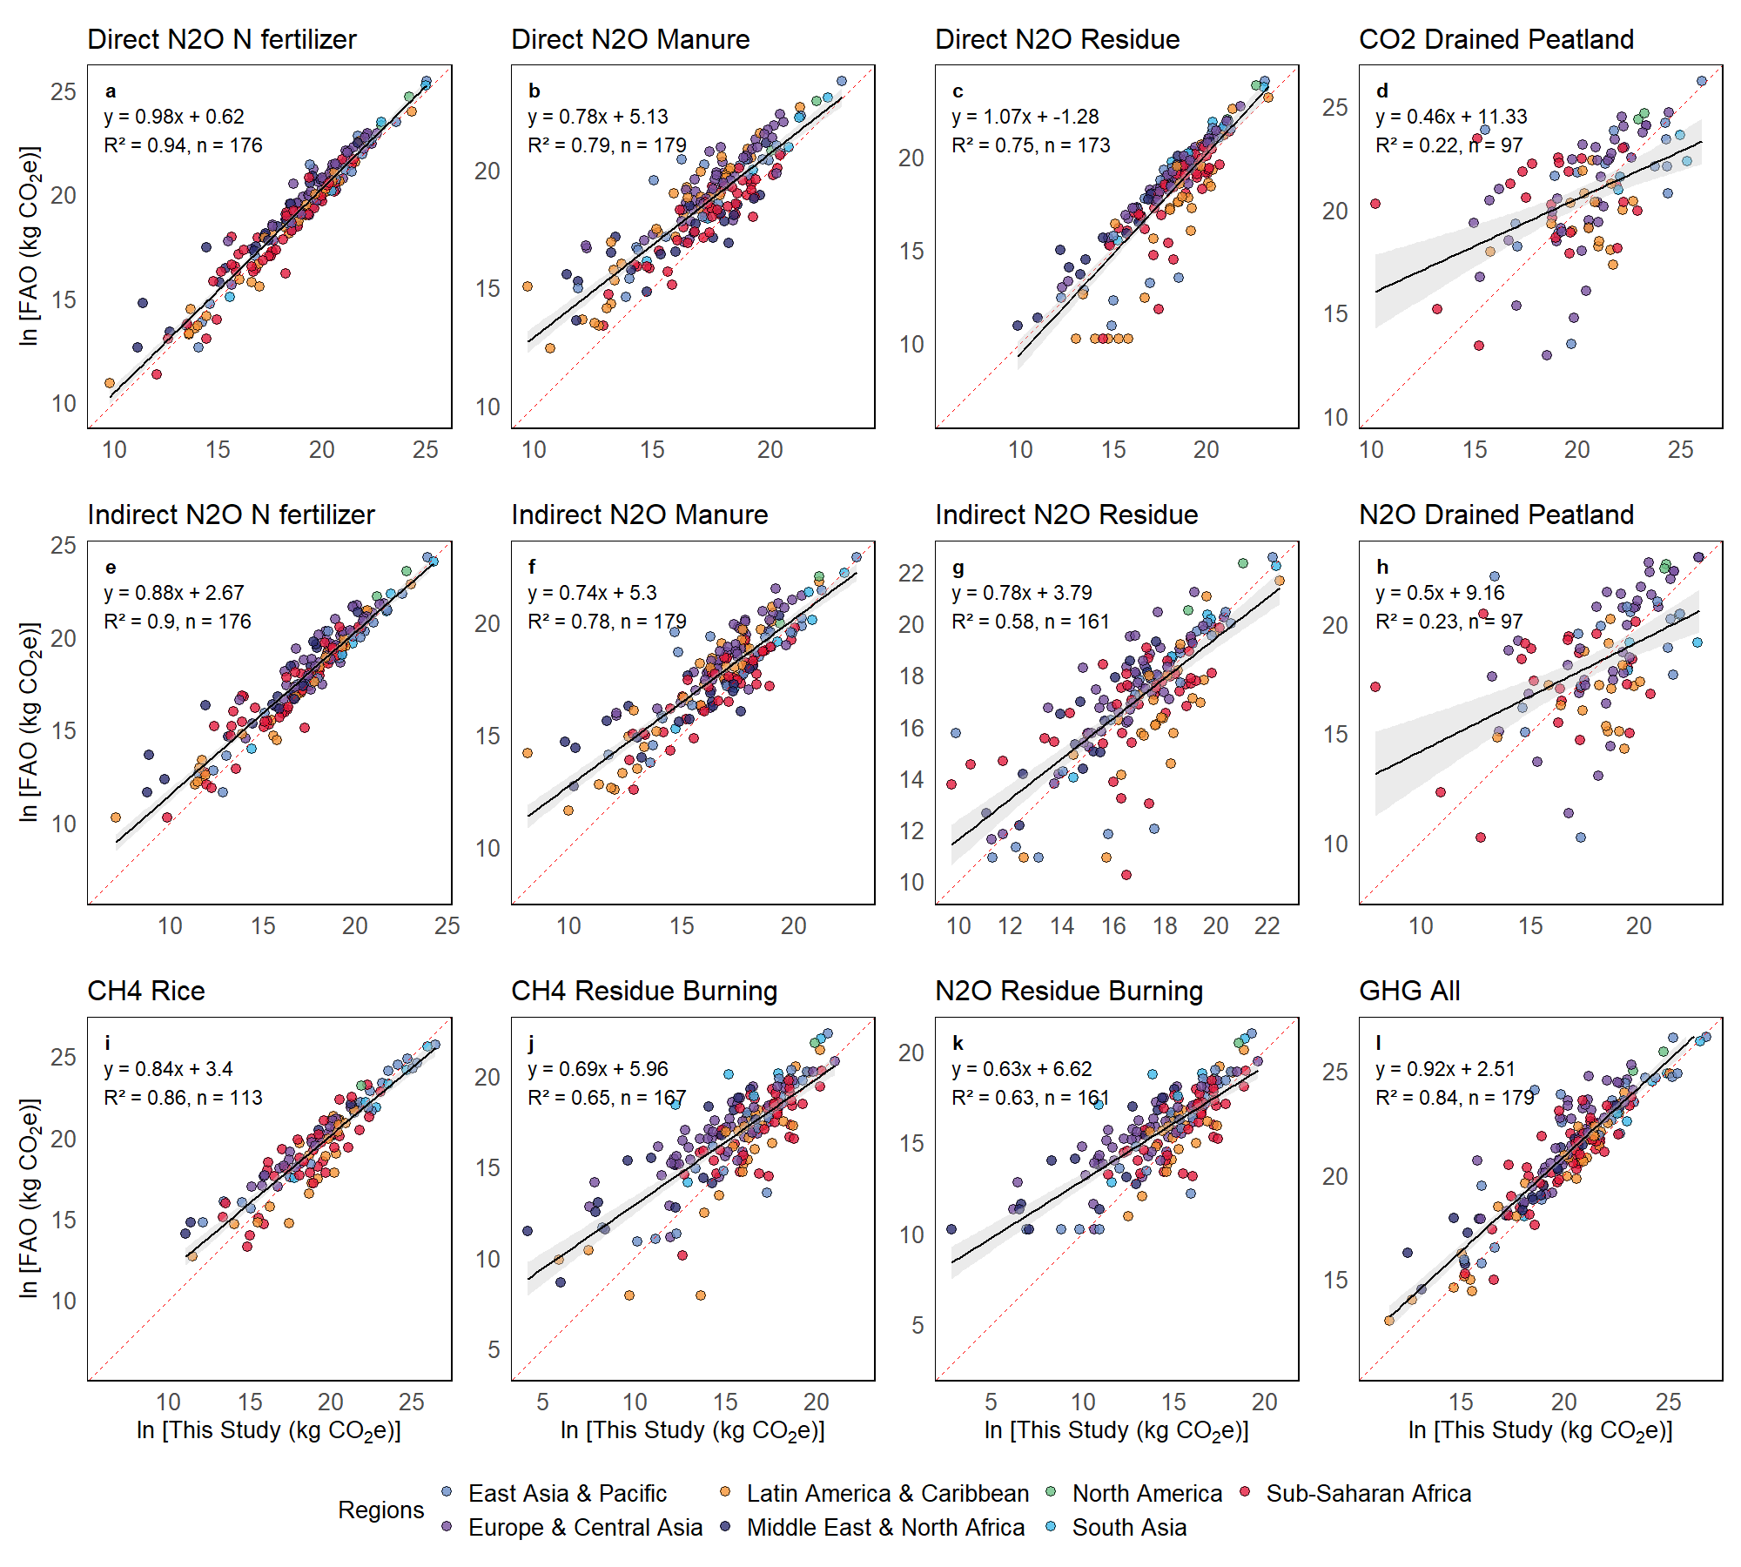
Supplementary Figure 26. Comparison of GHG emissions across individuel sources between this study and FAO. Dots present countries.

12 Crop-specific GHG emissions and emission intensity

Supplementary Figure 27. GHG emissions (a) and emission intensity (b) for rice.

Supplementary Figure 28. GHG emissions (a) and emission intensity (b) for maize.

Supplementary Figure 29. GHG emissions (a) and emission intensity (b) for vegetables.

Supplementary Figure 30. GHG emissions (a) and emission intensity (b) for sugarcane.

Supplementary Figure 31. GHG emissions (a) and emission intensity (b) for soybean.

Reference
1. IPCC 2019. 2019 Refinement to the 2006 IPCC Guidelines for National Greenhouse Gas Inventories. (2019).
2. Hydrological Sciences Laboratory - NASA. Land Data Assimilation System. (2025).
3. Yu, Z., Liu, J. & Kattel, G. Historical nitrogen fertilizer use in China from 1952 to 2018. Earth Syst. Sci. Data 14, 5179–5194 (2022).
4. The Fertilizer Institute. Nutrient Use Geographic Information System. (2025).
5. Cao, P., Lu, C. & Yu, Z. Historical nitrogen fertilizer use in agricultural ecosystems of the contiguous United States during 1850–2015: application rate, timing, and fertilizer types. Earth Syst. Sci. Data 10, 969–984 (2018).
6. FAO. FAO Rice Information. The Secretariat of the International Rice Commission, Crop and Grassland Service, Plant Production and Protection Division, Agriculture Department, FAO (2002).
7. United Nations Framework Convention on Climate Change. National communications and Biennial Reports. (2025).
8. Huke, R. E. & Huke, E. H. Rice Area by Type of Culture: South, Southeast, and East Asia. (Int. Rice Res. Inst., 1997).
9. Diagne, A., Amovin-Assagba, E., Futakuchi, K. & Wopereis, M. C. S. Estimation of cultivated area, number of farming households and yield for major rice-growing environments in Africa. in Realizing Africa’s rice promise 35–45 (CABI Wallingford UK, 2013).
10. Leon, A., Kohyama, K., Yagi, K., Takata, Y. & Obara, H. The effects of current water management practices on methane emissions in Japanese rice cultivation. Mitig Adapt Strateg Glob Chang 22, 85–98 (2017).
11. FAO. (Food and Agriculture Organization of the United Nations), FAOSTAT, available at: http://www.fao.org/faostat/en/ #data/RF, last access: 15 March 2024. (2024).
12. Tian, H. et al. History of anthropogenic Nitrogen inputs (HaNi) to the terrestrial biosphere: a 5 arcmin resolution annual dataset from 1860 to 2019. Earth Syst. Sci. Data 14, 4551–4568 (2022).
13. Lu, C. & Tian, H. Global nitrogen and phosphorus fertilizer use for agriculture production in the past half century: shifted hot spots and nutrient imbalance. Earth Syst. Sci. Data 9, 181–192 (2017).
14. Bora, K. Spatial patterns of fertilizer use and imbalances: Evidence from rice cultivation in India. Environmental Challenges 7, 100452 (2022).
15. Zhang, B. et al. Global manure nitrogen production and application in cropland during 1860–2014: a 5 arcmin gridded global dataset for Earth system modeling. Earth Syst. Sci. Data 9, 667–678 (2017).
16. Saito, K., Asai, H., Zhao, D., Laborte, A. G. & Grenier, C. Progress in varietal improvement for increasing upland rice productivity in the tropics. Plant Prod Sci 21, 145–158 (2018).
17. Carlson, K. M. et al. Greenhouse gas emissions intensity of global croplands. Nat Clim Chang 7, 63–68 (2017).
18. Conchedda, G. & Tubiello, F. N. Drainage of organic soils and GHG emissions: validation with country data. Earth Syst. Sci. Data 12, 3113–3137 (2020).
19. Gumbricht, T. et al. An expert system model for mapping tropical wetlands and peatlands reveals South America as the largest contributor. Glob Chang Biol 23, 3581–3599 (2017).
20. United Nations Environment Programme. Global Peatlands Assessment: The State of the World’s Peatlands. https://wedocs.unep.org/bitstream/handle/20.500.11822/41222/peatland_assessment.pdf?sequence=1&isAllowed=y (2022) doi:https://doi.org/10.59117/20.500.11822/41222.
21. Lappalainen, E. Global peat resources. (1996).
22. Joosten, H. & Clarke, D. Wise use of mires and peatlands. International mire conservation group and international peat society 304, (2002).
23. Waite, S. The Global Status of Peatlands and their Role in Carbon Cycling. A report for Friends of the Earth by the Wetland Ecosystem Research Group, Department of Geography, University of Exeter, C.P. Immirzi and E. Maltby with R. S. Clymo (Friends of the Earth, London, 1992, ISBN 1 85750 105 5, 145 pp., SB £17). Oryx 27, 127–127 (1993).
24. Xu, J., Morris, P. J., Liu, J. & Holden, J. PEATMAP: Refining estimates of global peatland distribution based on a meta-analysis. Catena (Amst) 160, 134–140 (2018).
25. Hergoualc’h, K. et al. Improved accuracy and reduced uncertainty in greenhouse gas inventories by refining the IPCC emission factor for direct N2O emissions from nitrogen inputs to managed soils. Glob Chang Biol 27, 6536–6550 (2021).
26. FAO. Greenhouse gas emissions from agrifood systems – Global, regional and country trends, 2000–2022. FAOSTAT Analytical Brief Series, No. 94. Rome. (2024).
27. Cui, X. et al. Global mapping of crop-specific emission factors highlights hotspots of nitrous oxide mitigation. Nat Food 2, 886–893 (2021).
28. Tian, H. et al. Global soil nitrous oxide emissions since the preindustrial era estimated by an ensemble of terrestrial biosphere models: Magnitude, attribution, and uncertainty. Glob Chang Biol 25, 640–659 (2019).
29. Zhang, L. et al. Global nitrous oxide emissions from livestock manure during 1890–2020: An IPCC tier 2 inventory. Glob Chang Biol 30, e17303 (2024).
30. Saunois, M. et al. Global Methane Budget 2000-2020. Earth Syst. Sci. Data Discuss. 2024, 1–147 (2024).
31. EPA. Global Non-CO2 Greenhouse Gas Emission Projections & Mitigation: 2015-2050. United States Environmental Protection Agency Office of Atmospheric Programs (6207A) Washington, DC 20005 (2019).

