Table 1. Physical and chemical characteristics of samples.
Variables |  |  | El-Hamoul |  |  | Seidy Salem
 |  |  | Site 4 | Site 9 | Site 10 | Site 6 | Site 7 | Site 8 | Site 13
Physical analysis of the soil | Sand % |  | 7.23 | 6.65 | 7.26 | 8.34 | 7.58 | 9.53 | 9.53
Physical analysis of the soil | Silt % |  | 32.43 | 34.95 | 31.76 | 32.67 | 31.88 | 31.72 | 31.88
Physical analysis of the soil | Clay% |  | 60.34 | 58.40 | 60.98 | 58.99 | 60.54 | 58.75 | 58.59
Physical analysis of the soil | Texture |  | Clay | Clay | Clay | Clay | Clay | Clay | Clay
Soil pH |  |  | 7.93 | 7.87 | 7.82 | 7.98 | 8.01 | 8.11 | 7.90
EC, dS.m⁻¹ |  |  | 15.93 | 7.75 | 10.87 | 13.94 | 6.32 | 10.27 | 15.13
Soluble cations,  meq/100g |  | Mg⁺² | 34.43 | 23.92 | 20.95 | 22.07 | 15.04 | 20.5 | 33.43
 |  | Ca⁺² | 33.50 | 21.44 | 17.20 | 21.33 | 12.06 | 15.15 | 33.1
 |  | Na⁺ | 90.50 | 30.60 | 69.25 | 95.50 | 34.90 | 65.75 | 88.50
 |  | K⁺ | 1.50 | 1.54 | 1.50 | 0.50 | 1.68 | 1.50 | 1.52
Soluble anions,  meq/100g |  | So₄⁻² | 69.14 | 43.58 | 34.02 | 43.07 | 31.03 | 32.52 | 69.78
 |  | HCO₃ | 4.69 | 3.12 | 6.88 | 3.13 | 3.76 | 6.25 | 4.39
 |  | CO₂⁻⁻ | -- | -- | -- | -- | -- | -- | --
 |  | Cl⁻ | 86.10 | 31.80 | 68.00 | 93.20 | 28.84 | 64.13 | 86.70

Table 2. Methanolic extract components of N. calcicola
N | Compound Name | CSBC | RT | Area % | M F | MW
1 | p-xylene ( benzene, 1,4-dimethyl) | 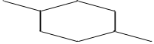 | 4.06 | 8.25 | C₈H₁₀ | 106
2 | 1,3,4,7-tetraphenyl,thieno [3,4-c]pyridine, | 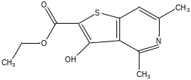 | 4.63 | 2.07 | C₃₁H₂₁NS | 439
3 | (o-Xylene) benzene, 1,2-dimethyle - | 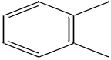 | 4.70 | 1.15 | C₈H₁₀ | 106
4 | Propenone, 1-(2-benzyloxyphenyl)-3-(3 methoxyphenyl)- | 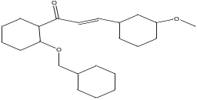 | 4.79 | 2.28 | C₂₃H₂₀O₃ | 344
5 | 9-octadecenoic acid, (2-phenyl-1,3-dioxolan-4-yl)methylester, trans | 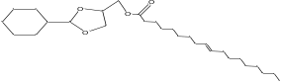 | 7.31 | 1.20 | C₂₈H₄₄O₄ | 444
6 | Diethyl 4-[(trimethylsilyl)oxy]-3,5,6,7,8,8a-hexahydro-1,2-cinnolinedicarboxylate | 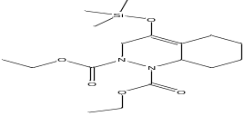 | 9.94 | 1.47 | C₁₇H₃₀N₂O₅S | 370
7 | Cycloheptasiloxane, tetradecamethyl- | 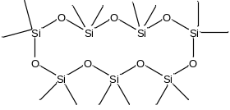 | 10.3 | 3.02 | C₁₄H₄₂O₇Si₇ | 518
8 | Androstane-11,17-dione,3-[(trimethylsilyl)oxy]-,7-[O (phenylmethyl)oxime],(3à,5à) | 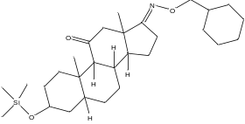 | 11.51 | 0.57 | C₂₉H₄₃NO₃Si | 481
9 | Trimethylsilyl-methoxy-2-(2-oxo-2-((trimethylsilyl)oxy)ethoxy) benzoate | 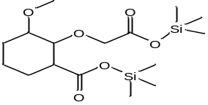 | 12.37 | 1.01 | C₁₆H₂₆O₆Si₂, | 370
10 | Cyclooctasiloxane, hexadecamethyl- | 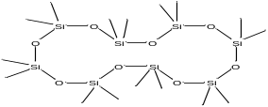 | 12.87 | 3.58 | C₁₆H₄₈O₈Si₈ | 592
11 | 2,5-Dimethoxy-3,6 dinitrobenzylidenediformamide | 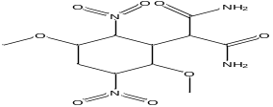 | 14.60 | 1.37 | C₁₁H₁₂N₄O₈ | 328
12 | Cyclononasiloxane, octadecamethyl- | 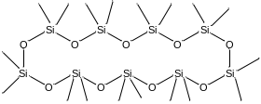 | 15.14 | 1.29 | C₁₈H₅₄O₉Si₉ | 666
13 | Biphenyl-2,2',6,6'-tetracarboxylic acid, tetramethyl ester | 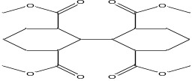 | 16.63 | 0.96 | C₂₀H₁₈O₈ | 386
14 | 4H-1- benzopyran -4-one,2-(3,4dihydroxyphenyl)-6,8- Di-á-D-glucopyranosyl -5,7-dihydroxy- | 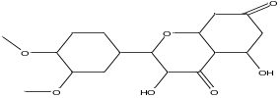 | 17.10 | 0.57 | C₁₈H₁₆O₇ | 344
15 | glycine, N-[(3à,5á,7à,12à)-24-oxo-3,7,12-tris [(trimethyl silyl)oxy]cholan-24-yl]-, methyl ester, Methyl glycocholate, 3TMS derivative | 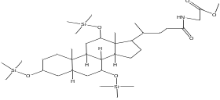 | 18.51 | 1.03 | C₃₆H₆₉NO₆Si₃ | 695
16 | Propanoic acid, 2-(3-acetoxy-4,4,14 trimethylandrost 8-en-17-yl)- | 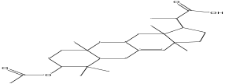 | 18.91 | 0.66 | C₂₇H₄₂O₄ | 430
17 | Bufa-20,22-dienolide,3,14-dihydroxy-, (3á,5á)- | 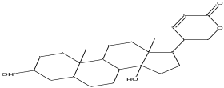 | 20.26 | 0.81 | C₂₄H₃₄O₄ | 386
18 | 1H-purin -6-amine, (2-fluorophenyl)methyl]- | 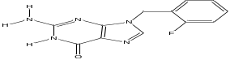 | 20.58 | 0.55 | C₁₂H₁₀FN₅ | 243
19 | 4-Methoxyphenoxyformamide, N-methyl-N-[4-(1-pyrrolidinyl)-2-butynyl]- | 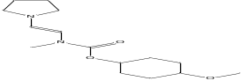 | 21.04 | 0.89 | C₁₇H₂₂N₂O₃ | 302
20 | Retinol, acetate (vitamin A) | 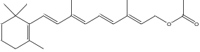 | 21.44 | 0.48 | C₂₂H₃₂O₂ | 328
21 | Hexadecanoic acid, methyl ester (Palmitic acid, methyl ester) | 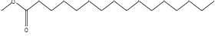 | 21.73 | 6.92 | C₁₇H₃₄O₂ | 270
22 | Oxiraneundecanoic acid, 3-pentyl-, methyl ester, trans- | 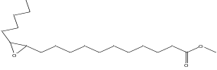 | 21.88 | 3.34 | C₁₉H₃₆O₃ | 312
23 | Bistrimethyl N-acetyl eicosasphinga -4,11-dienine | 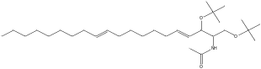 | 22.14 | 0.88 | C₂₈H₅₇NO₃S₂ | 511
24 | Rhodopin | 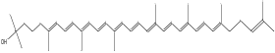 | 23.09 | 1.08 | C₄₀H₅₈O | 554
25 | 5à-Pregn-16-en-20-one, á,12à-dihydroxy-, diacetate (1  2-(Acetyloxy)-20-oxopregn-16-en-3-yl acetate | 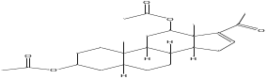 | 23.41 | 0.67 | C₂₅H₃₆O₅ | 416
26 | 2-(3-acetoxy4,4,10,13,14-penta methyl-2,3,4,5,6,7,10,11,12,13,14, 15,16,17-tetradecahydro-1H-cyclo pent [a]phenanthren -17-yl)-propioni | 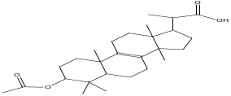 | 23.63 | 1.47 | C₂₇H₄₂O₄ | 592
27 | 9-octadecenoic acid (Z)-, methyl ester (Oleic acid) | 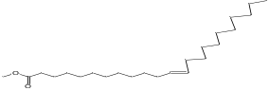 | 24.18 | 19.48 | C₁₉H₃₆O₂ | 296
28 | 12,15-Octadecadienoic acid,  Methylester | 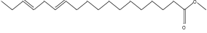 | 24.40 | 9.04 | C₁₉H₃₄O | 294
29 | 2,4,7,14-Tetramethyl-4-vinyl-tricyclo[5.4.3.0(1,8)] tetradecan-6-ol | 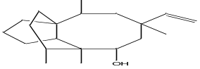 | 24.57 | 1.56 | C₂₀H₃₄O | 290
30 | Cyclopropaneoctanoic acid, 2-[(2-pentylcyclopropyl)methyl]-, methyl ester, trans,trans- | 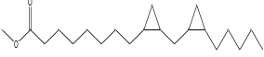 | 24.86 | 0.37 | C₂₁H₃₈O₂ | 322
31 | 9,12-octadecadienoic acid (Z,Z)-, 2,3-bis [(trimethylsilyl)oxy] propyl ester | 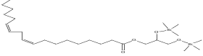 | 25.05 | 1.08 | C₂₇H₅₄O₄Si₂ | 498
32 | Cyclopropanebutanoic acid,2-[[2-[[2-[(2 pentylcyclopropyl) methyl],methyl ester | 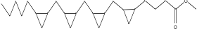 | 25.46 | 1.64 | C₂₅H₄₂O₂ | 374
33 | 7,10-Octadecadienoic acid, methyl ester | 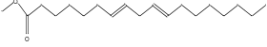 | 25.91 | 2.14 | C₁₉H₃₄O₂ | 294
34 | 1,9-Dioxa-5-thianonane,3,7-bis (9-borabicyclo[3.3.1]non-9-yloxy)-1,9-diphenyl- | 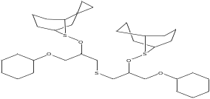 | 26.23 | 0.34 | C₃₄H₄₈B₂O₄S | 574
35 | SILKONFETT SE30 (Grevels) | ------------------------ | 26.40 | 0.92 | N/A | 0
36 | 1-Heptatriacotanol |  | 26.73 | 0.74 | C₃₇H₇₆O | 536
37 | Beclomethasone  (Pregna-1,4-diene-3,20-dione, 9-chloro-11,17,21-trihydroxy-16-methyl) | 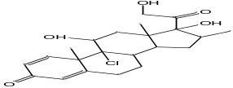 | 27.55 | 0.35 | C₂₂H₂₉ClO₅ | 408
38 | methyle ((24-oxo-3,7,12-tris[(trimmethylsilyl)oxy]cholan -24-yl)amino)acetate # | 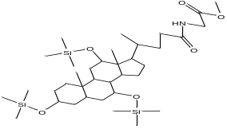 | 27.69 | 0.71 | C₂₈H₅₇NO₃Si₂ | 511
39 | 9,12,15-octadecatrienoic acid acid, 2,3-bis[(trimethylsilyl)oxy]propyl ester, (Z,Z,Z)- | 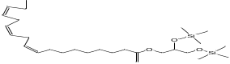 | 28.93 | 1.69 | C₂₇H₅₂O₄Si₂ | 496
40 | 2-hydroxy-3-[(9E)-9octadecenoyloxy]propyl(9E)-9-octadecenoate ((Z,Z)-1,3-dioctadecenoyl glycerol) | 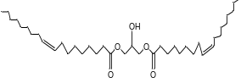 | 29.65 | 0.60 | C₃₉H₇₂O₅ | 620
41 | di-n-octyl phthalate (1 ,2-Benzenedicarboxylic acid, dioctyl ester) | 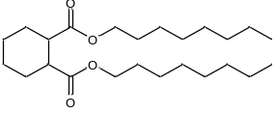 | 30.73 | 3.51 | C₂₄H₃₈O₄ | 390
42 | Ethyl iso-allocholate (Ethyl 3,7,12-trihydroxycholan-24-oate) | 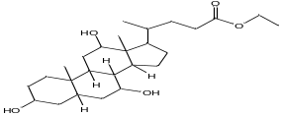 | 31.03 | 0.69 | C₂₆H₄₄O₅ | 436
43 | Ursodeoxycholic acid(Cholan-24-oic acid, 3,7-dihydroxy) | 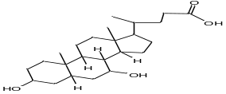 | 31.81 | 0.92 | C₂₄H₄₀O₄ | 392
44 | 9,12,15-Octadecatrienoic acid,2-phenyl-1,3-dioxan-2-yl ester,(Z,Z,Z)- | 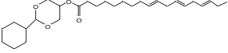 | 31.91 | 2.82 | C₂₈H₄₀O₄ | 440
45 | 2,3-Dimethoxy-5-methyl-6-dekaisoprenyl-chinon | 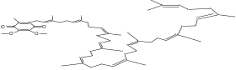 | 32.21 | 0.55 | C₅₉H₉₀O₄ | 862
46 | psi.,.psi.-Carotene,1,1',2,2'-tetrahydro-1,1'-dimethoxy (Lycopene) | 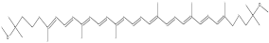 | 32.92 | 1.13 | C₄₂H₆₄O₂ | 600
47 | 2-Methylcortisol (11,17,21-Trihydroxy-2-methylpregn-4-ene-3,20-dione) | 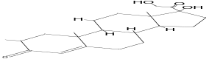 | 33.07 | 1.29 | C₂₂H₃₂O₅ | 376
48 | cis-2-phenyl -1,3-dioxolane -4-methyloctadec 9, 12, 15 trienoate | 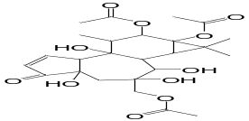 | 33.19 | 0.49 | C₂₈H₄₀O₄ | 440
49 | Milbemycin B,,28-anhydro-15-chloro-25-isopropyl  13-dehydro-5-O-demethyl-4-methyl- | 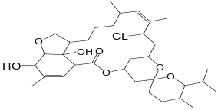 | 34.78 | 0.33 | C₃₃H₄₇ClO₇ | 590

Table 3. Methanolic extract components of Nostoc linkia

N | Compound Name | CSBC | RT | Area % | M F | MW
1 | Thieno(3,4-C)pyridine,1,3,4,7tetraphenyl | 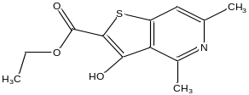 | 4.06 | 4.86 | C₃₁H₂₁NS | 439
2 | á-Hydroxyquebrachamine | 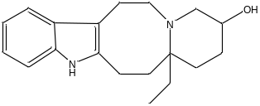 | 9.92 | 1.02 | C₁₉H₂₆N₂O | 298
3 | 5à-Pregn-16-en-20-one,á,12à-dihydroxy-, diacetate | 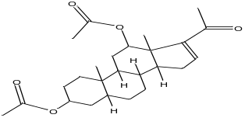 | 12.38 | o.83 | C₂₅H₃₆O₅ | 416
4 | Cyclooctasiloxane, hexadecamethyl- | 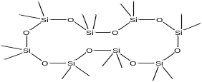 | 12.87 | 1.14 | C₁₆H₄₈O₈Si₈ | 592
5 | 3,6,2',3'-Tetramethoxyflavone | 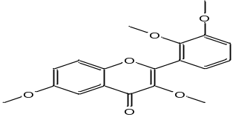 | 14.60 | 0.83 | C₁₉H₁₈O₆ | 342
6 | Cyclononasiloxane, octadecamethyl- | 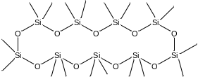 | 15.13 | 1.02 | C₁₈H₅₄O₉Si₉ | 666
7 | Trimethylsilyl 3-methoxy-2-(2-oxo-2-((trimethylsilyl)oxy)ethoxy)benzoate | 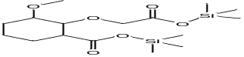 | 16.63 | 0.63 | C₁₆H₂₆O₆Si₂ | 370
8 | celidoniol, deoxy (Nonacosane) |  | 16.73 | 1.92 | C₂₉H₆₀ | 408
9 | Glycine, N-[(3à,5á)-24-oxo-3-[(trimethylsilyl) oxy]cholan-24-yl]-, methyl ester | 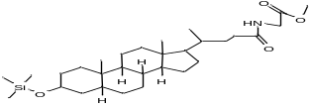 | 17.10 | 0.43 | C₃₀H₅₃NO₄Si | 519
10 | octacosane (AI3-52615) |  | 17.24 | 4.89 | C₂₈H₅₈ | 394
11 | 1-chlorooctadecane |  | 17.67 | 1.28 | C₁₈H₃₇Cl | 288
12 | Dihydromorphine, 2TMS derivative (Dihydromorphine , di(trimehylsilyl) ether) | 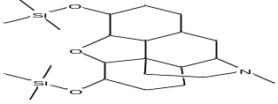 | 18.51 | 0.82 | C₂₃H₃₇NO₃Si₂ | 431
13 | Propanoic acid,2-(3-acetoxy-4,4,14-trimethylandrost 8-en-17-yl)- | 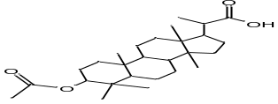 | 18.91 | 0.64 | C₂₇H₄₂O₄ | 430
14 | Dodecyl cis-9,10-epoxyoctadecanoate | 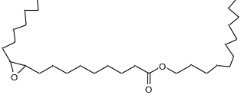 | 20.26 | 0.91 | C₃₀H₅₈O₃ | 466
15 | Palmitic acid, 2-(tetradecyloxy)ethyl ester | 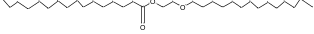 | 20.33 | 0.98 | C₃₂H₆₄O₃ | 496
16 | Bistrimethylsilyl N-acetyleicosasphinga -4,11-dienine |  | 20.58 | 0.60 | C₂₈H₅₇NO₃Si₂ | 511
17 | 9-hexadecenoic acid ,methyl ester, (Z) | 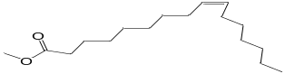 | 21.61 | 24.10 | C₁₇H₃₄O₂ | 270
18 | pentadecanoic acid, 14methyl-methyl ester | 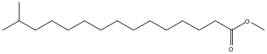 | 21.89 | 1.31 | C₁₇H₃₄O₂ | 270
19 | 9,12-octadecadienoic acid (Z,Z),2,3-bis[(trimethylsilyl)oxy]propyl ester | 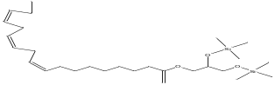 | 22.14 | 0.62 | C₂₇H₅₄O₄Si₂ | 498
20 | Cyclopropaneoctanoic acid, 2-octyl-,methyl ester | 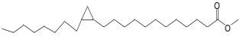 | 23.11 | 1.33 | C₂₀H₃₈O₂ | 310
21 | 4H-1-benzopyran -4-one, 2-(3,4-di-methoxyphenyl)-3,5-dihydroxy-7-methoxy -(3',4',7-trimethylquercetin) | 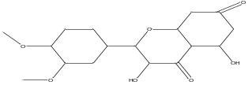 | 23.41 | 0.57 | C₁₈H₁₆O₇ | 344
22 | 1H-purin-6-amine,(2-fluorophenyl) methyl | 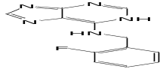 | 23.63 | 0.92 | C₁₂H₁₀FN₅ | 243
23 | 10-Octadecenoic acid, methyl ester | 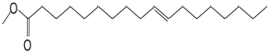 | 24.18 | 27.67 | C₁₉H₃₆O₂ | 296
24 | 12,15-Octadecadienoic acid, methyl ester | 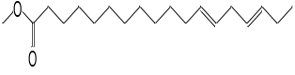 | 24.41 | 10.16 | C₁₉H₃₄O₂ | 294
25 | Linoleic acid ethyl ester | 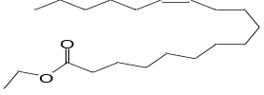 | 24.85 | 0.36 | C₂₀H₃₆O₂ | 308
26 | 9,12,15-octadecatrienoicacid,2,3-bis[(trimethylsilyl)oxy]  propylester,(Z,Z,Z)-(Linolenic-acid) | 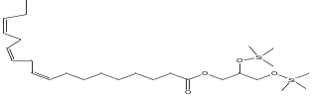 | 25.05 | 0.66 | C₂₇H₅₂O₄Si₂ | 496
27 | 9,12- Octadecadienoic acid(Z,Z)-,methyl ester | 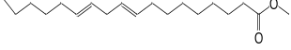 | 25.47 | 1.01 | C₂₀H₃₆O₂, | 308
28 | 8,11-Octadecadienoic acid, methyl ester | 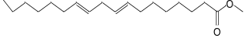 | 25.56 | 1.41 | C₁₉H₃₄O₂ | 294
29 | 10,13-octadecadienoic acid,methyl ester | 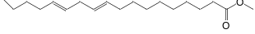 | 25.95 | 2.98 | C₁₉H₃₄O₂ | 294
30 | 1,9-Dioxa-5-thianonane,3,7-bis(9 bor abicyclo [3.3.1]non-9-yloxy)-1,9-diphenyl- | 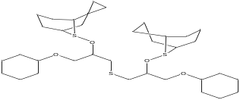 | 26.23 | 0.38 | C₃₄H₄₈B₂O₄S | 574
31 | methyl glycocholate, 3TMS derivative , glycine, N-[(3à,5á,7à,12à)-24-oxo-3,7,12-tris [(trimethyl silyl)oxy]cholan-24-yl]-, methyl ester, | 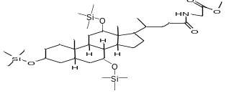 | 26.40 | 0.58 | C₃₆H₆₉NO₆Si₃ | 695
32 | methyl-9,9,10,10-D4 octadecanoate | 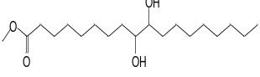 | 28.94 | 1.16 | C₁₉H₃₄D₄O₂ | 302
33 | Cyclopropanedecanoic acid à-(Acetyloxy)-2-hexyl-,methyl ester | 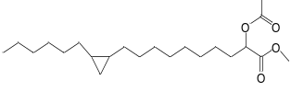 | 30.74 | 0.78 | C₂₂H₄₀O₄ | 368
34 | psi.,.psi.-carotene -16-ol (Lycoxanthin) | 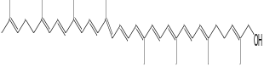 | 42.82 | 0.74 | C₄₀H₅₆O | 552
35 | Cyclotrisiloxane, hexaphenyl- (Diphenylsiloxane cyclic trimer) | 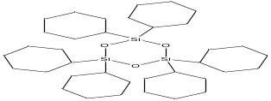 | 44.80 | 0.47 | C₃₆H₃₀O₃Si₃ | 594

Table 4. The effect of the Nostoc spp. on infected tomato plants with Fusarium after 50 days

Cyanobacterial isolates | Plant height(cm) | Fresh weight(g) | Dry weight(g)
Control (without any addition) | 14.17 | 10.56 | 0.90
Control (with Fusarium only) | 14.67 | 5.76 | 0.67
N. calcicola (extract) | 14.00 | 7.82 | 0.67
N. calcicola (culture) | 14.40 | 7.97 | 0.70
N. linkia (extract) | 13.87 | 7.72 | 0.73
N. linkia (culture) | 13.50 | 8.08 | 0.73
LSD
p<0.05 | 0.012 |  | 0.019
p<0.01 |  | 0.000
Each value is an average of three replicates. One-way ANOVA tests were performed to determine significant differences among the treatments and correlation coefficients were analyzed using SPSS version 22.

Table 5. Plant height (cm) and dry weight (g) of tomato after 100 days

Cyanobacterial isolates | Plant height(cm) | Dry weight(g)
Control (without any addition) | 28.00 | 27.35
Control (with Fusarium only) | 23.33 | 18.47
N. calcicola (extract) | 28.33 | 26.73
N. calcicola (culture) | 29.33 | 26.84
N. linkia (extract) | 28.00 | 27.83
N. linkia (culture) | 30.33 | 34.27
LSD
p<0.05 | 0.015
p<0.01 |  | 0.000

Each value is an average of three replicates. One-way ANOVA tests were performed to determine significant differences among the treatments and correlation coefficients were analyzed using SPSS version 22.

