Uncovering the Unexpected Role of Proteasome Activator PA200 in Regulating Immunoproteasome Expression and Activity
Supplementary Figures

Dušan Živković^{1,2,}*, Fatme Mourtada³, Angelique Sanchez Dafun^{1,2} , Ayse Seda Yazgili^{4,}**, Marijke Jansma^{5,6}, Przemysław Grygier^{7,8}, Michał Rawski⁹, Anna Czarna⁷, Stefan Bohn^{6,10}, Krzysztof M. Zak⁵, Norbert Reiling¹¹, Linda Zemke¹¹, Kai Guo³, Jürgen Behr¹², Odile Burlet-Schiltz^{1,2}, Grzegorz M. Popowicz^{5,6#}, Julien Marcoux^{1,2,#,§}, Silke Meiners^{3,4,13,#,§}, Marie-Pierre Bousquet^{1,2,#,§}

¹ Institut de Pharmacologie et de Biologie Structurale (IPBS), Université de Toulouse, CNRS, Université Toulouse (UT), Toulouse, France.
² Infrastructure Nationale de Protéomique, ProFI, UAR 2048, Toulouse, France.
³ Research Center Borstel/Leibniz Lung Center, RG Immunology and Cell Biology, Airway Research Center North (ARCN), Member of the German Center for Lung Research (DZL), Parkallee 1-40, 23845, Borstel, Germany
⁴ Comprehensive Pneumology Center (CPC), University Hospital of the Ludwig -Maximilians-University (LMU) and Helmholtz Center Munich, Member of the German Center for Lung Research (DZL), Max-Lebsche Platz 31, 81377, Munich, Germany
⁵ Molecular Targets and Therapeutics Center, Institute of Structural Biology, Helmholtz Munich, Neuherberg, Germany
⁶ TUM School of Natural Sciences, Department of Bioscience, Bayerisches NMR Zentrum, Technical University of Munich, Garching, Germany
⁷ Malopolska Centre of Biotechnology, Jagiellonian University, Gronostajowa 7a, Krakow 30-387, Poland
⁸ Doctoral School of Exact and Natural Sciences, Jagiellonian University, Lojasiewicza 11, Krakow 30-348, Poland
⁹ National Synchrotron Radiation Centre SOLARIS, Jagiellonian University, Kraków, Poland
¹⁰ Cryo-Electron Microscopy Platform and Institute of Structural Biology, Helmholtz Munich; Ingolstädter Landstraße 1, 85764 Neuherberg, Germany
¹¹ Research Center Borstel/Leibniz Lung Center, RG Microbial Interface Biology, Parkallee 1-40, 23845, Borstel, Germany, German Center for Infection Research (DZIF), Partner Site Hamburg-Lübeck-Borstel-Riems, 23845 Borstel, Germany
¹² Department of Medicine V, LMU University Hospital, LMU Munich, Member of the German Center for Lung Research (DZL), Marchioninistr. 15, 81377, Munich, Germany
¹³ Institute of Experimental Medicine, Christian-Albrechts University Kiel, Kiel, Germany

*Present Address: University of Oxford, Department of Biology, South Parks Road, Oxford OX1 3RB, United Kingdom.
**Present Address: The CRUK Scotland Institute, Garscube Estate, Switchback Road, Bearsden, Glasgow, G61 1BD, United Kingdom
§ these authors contributed equally
# to whom correspondence should be addressed

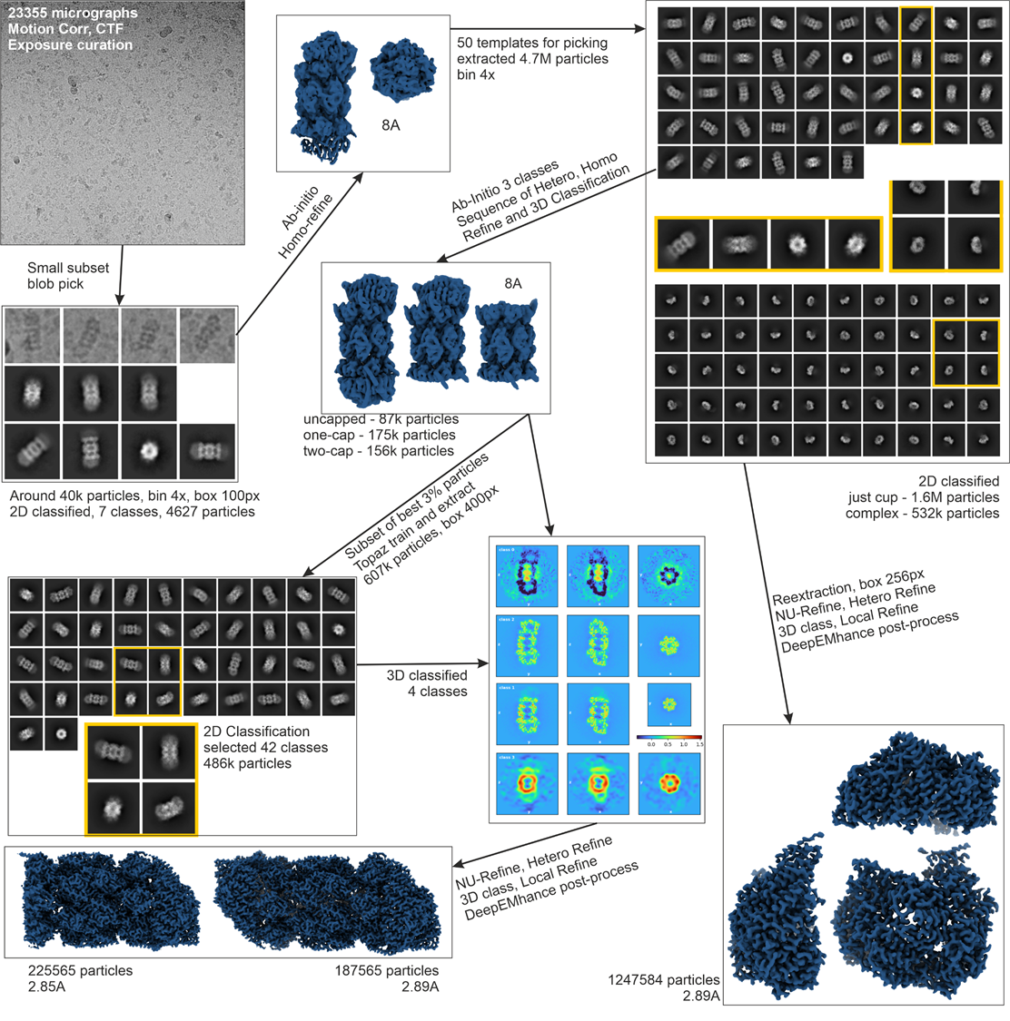
Figure S1. Cryo-EM data processing and 3D classification pipeline.

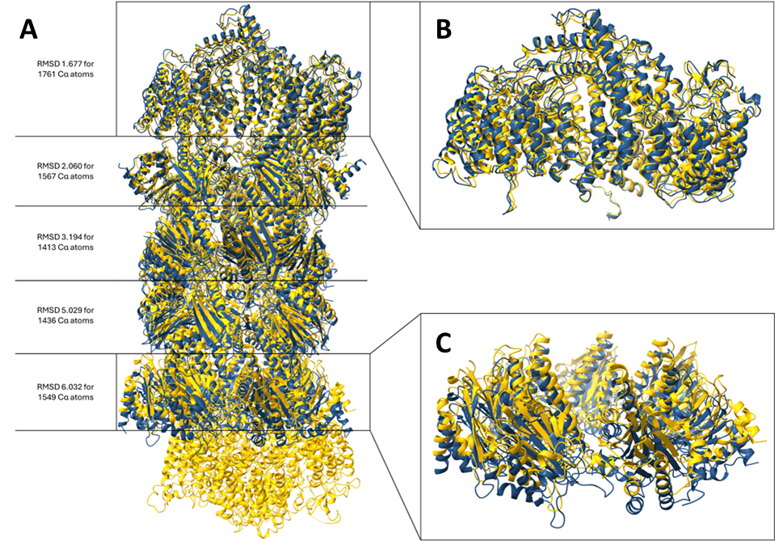
Figure S2. (A) Structure of the singly-capped i20S-PA200 complex (in blue) overlaid onto the doubly-capped s20S-PA200 complex (in yellow). The misalignment of the domains far away from the aligned PA200 molecule (B) is evident in (C).

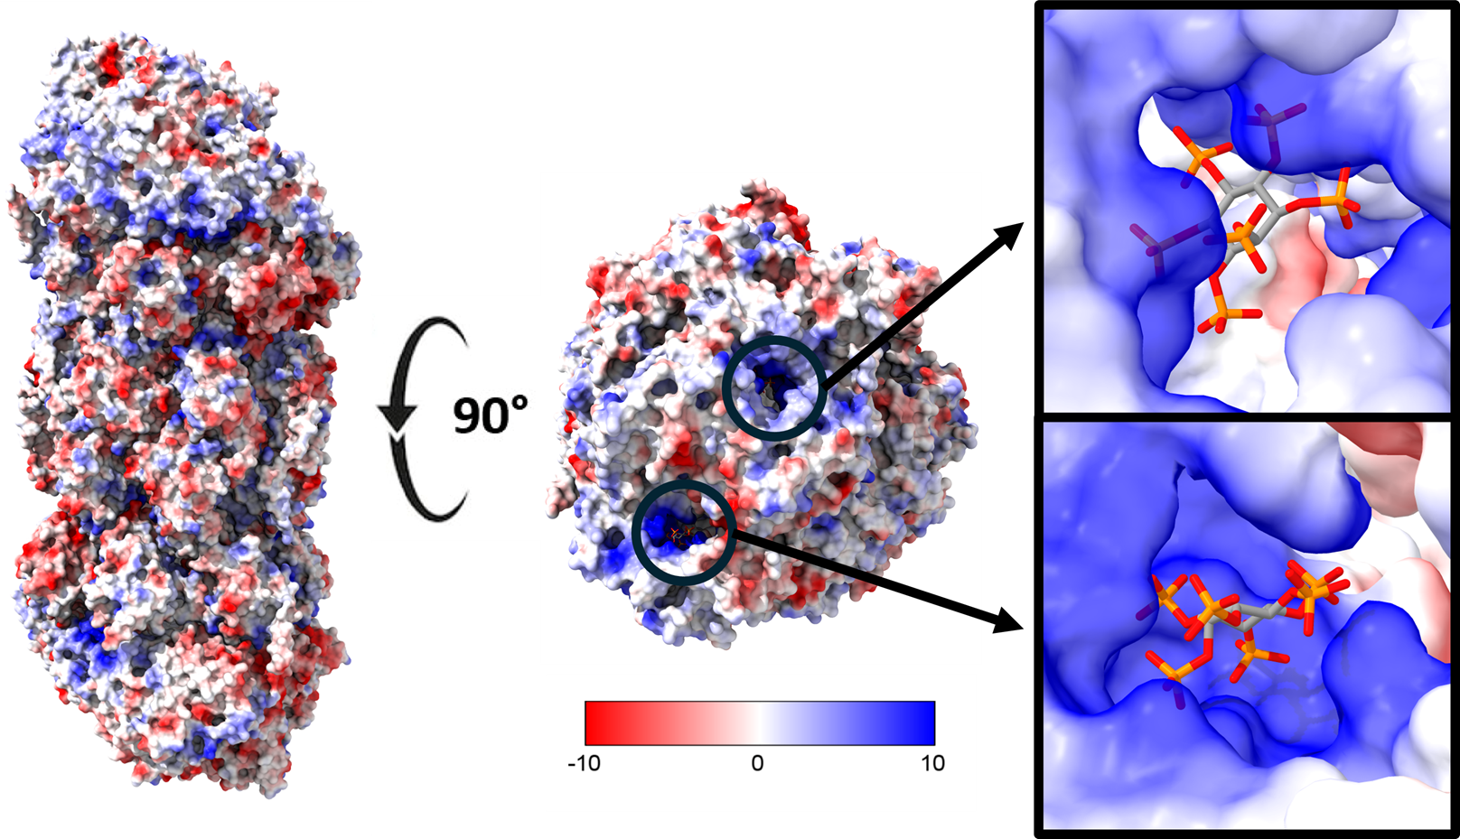
Figure S3. Phytic acid binds to the i20S-PA200 complex. Front and top views of the singly-capped i20S-PA200 complex showing the binding of two IP6 molecules in the positively charged grooves.
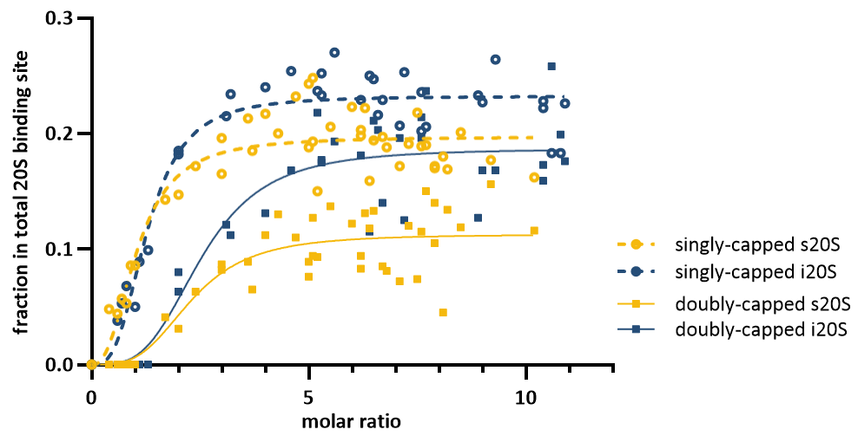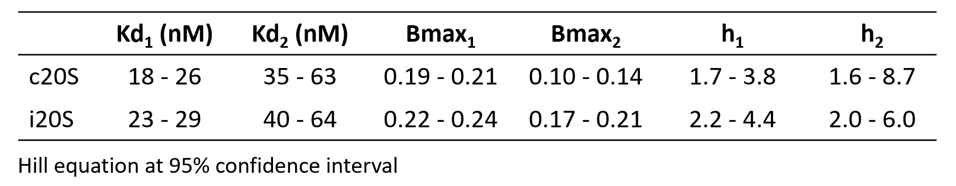
Figure S4: i20S-PA200 doubly-capped particles are preferentially formed compared to s20S-PA200 complexes. Titrations of PA200 to either s20S and i20S showed that the higher occupancy of the i20S is mainly due to a higher population of doubly-capped complexes.

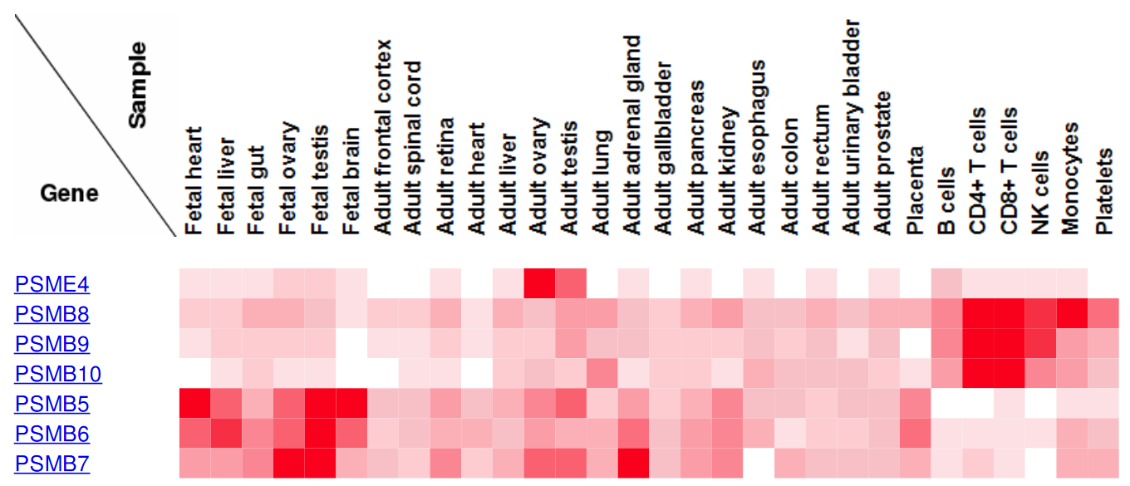
Figure S5: Mapping of the protein expression of PA200 (PSME4) and the catalytic subunits of the i20S (β1i, β2i and β5i, i.e. PSMB8-10, respectively) and s20S (β1, β2 and β5, i.e. PSMB5-7, respectively). Data was retrieved from³³.

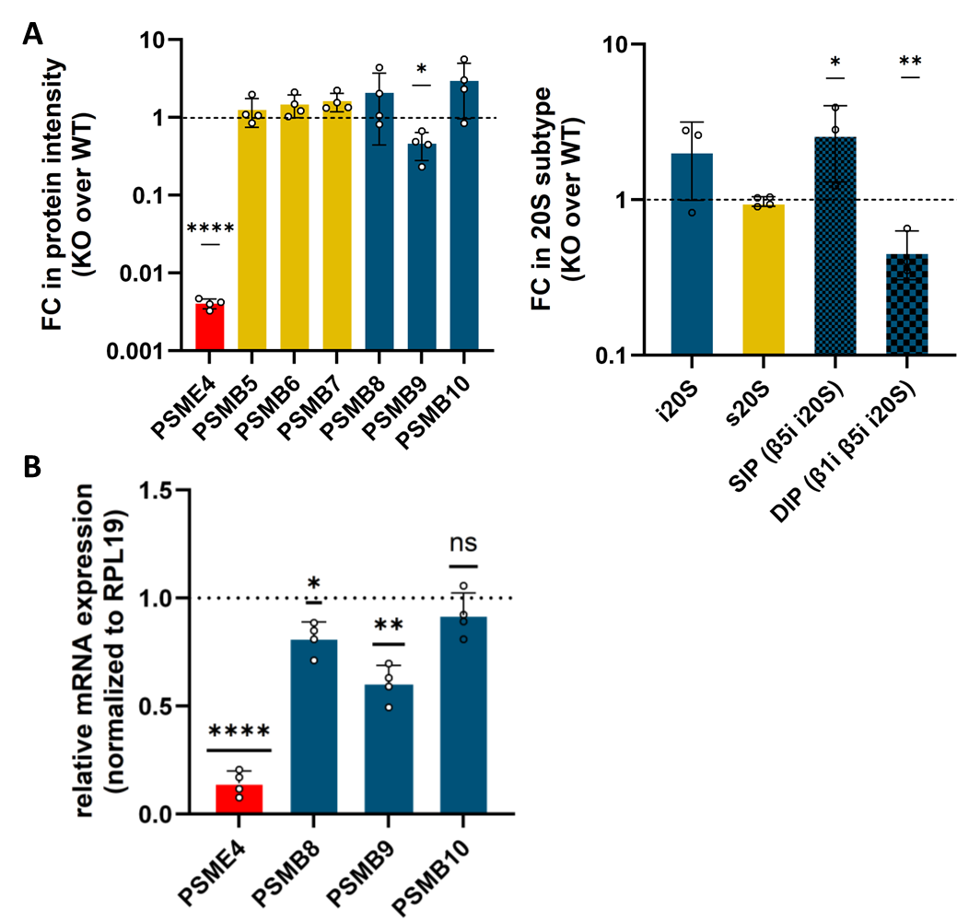
Figure S6: Depletion of PA200 reduces i20S expression and changes the composition of 20S subtypes in lung cancer cells. A) Two different WT and PA200 KO clones of A549 and H1299 were used for proteasome immunopurification using the MCP21 antibody. The expression of PA200 and catalytic 20S subunits were quantified by LC MS/MS. For each protein, the log10-fold change of the intensities in PA200 KO over WT was calculated. In this data set, the stoichiometry of each 20S subtype was calculated (as in³⁸) and for each 20S subtype, the fold change of the stoichiometry in the PA200 KO over WT was calculated. Bars show quantification of expression relative to average WT levels set to 1 (two-sided paired t-test). *: p<0.05, **: p<0.01. B) PA200 was depleted in A549 cells by siRNA-mediated silencing for 72 hr. RNA expression of PSME4 (PA200) and the i20S catalytic subunits PSMB8-10 was analyzed by RTqPCR. RPL19 was used as a housekeeping gene, and the bars indicate mRNA levels normalized to control siRNA transfected cells using the 2^{-∆∆ct} formula. (one-sample t-test, n=4, *: p<0.05, **: p<0.01, ****: p<0.0001).

