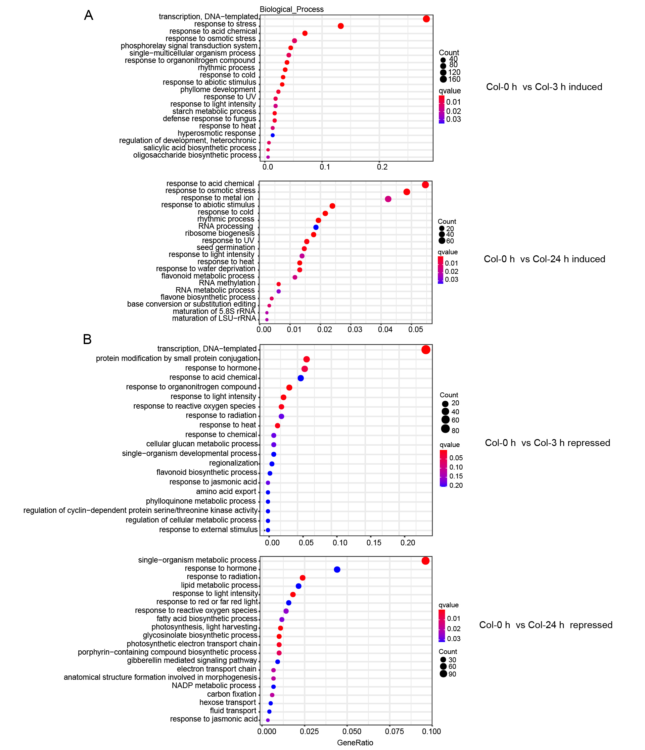
Supplementary Figure 1. GO enrichment analysis of DEGs in Col before and after cold treatment at 3 h and 24 h. The enrichment analysis of up-regulated at 3 h and 24 h (A), down-regulated 3 h and 24 h (B).

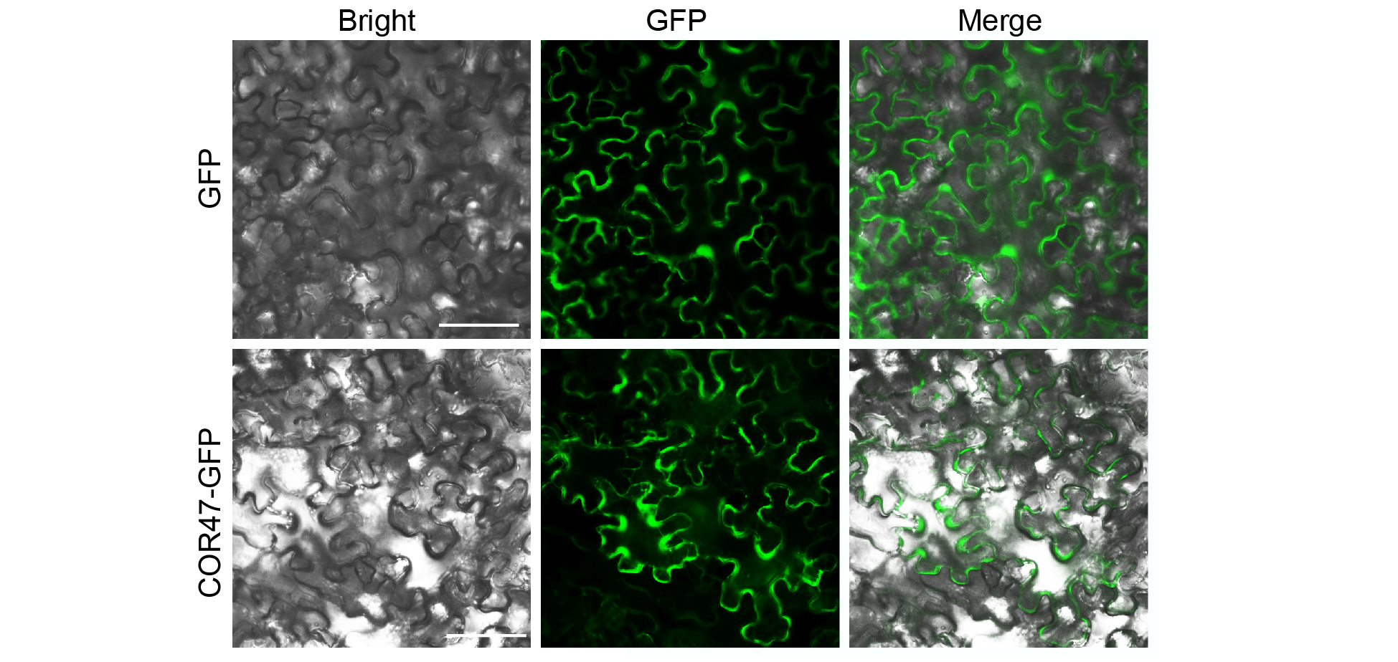
Supplementary Figure 2. COR47 protein is localized in the cytoplasm. Subcellular localization of free-GFP (upper panel) or COR47-GFP (lower panel) in tobacco epidermal cells. Scale bars, 40 µm.

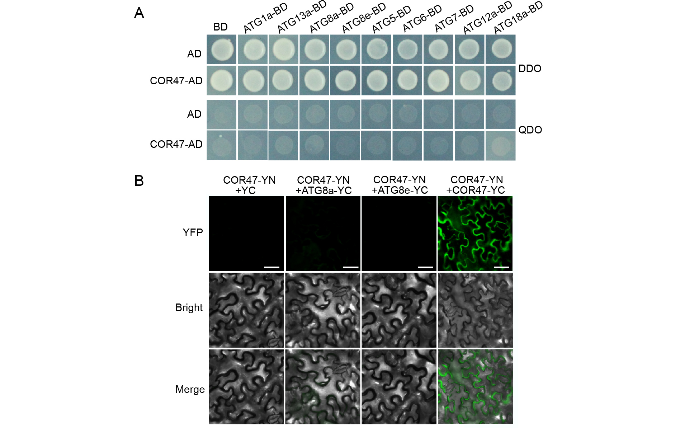
Supplementary Figure 3. COR47 does not directly interact with core autophagy proteins. (A) No interaction between COR47 and ATGs (ATG8a, ATG8e, ATG1a, ATG13a, ATG5, ATG6, ATG7, ATG12a, or ATG18a) in yeast two-hybrid (Y2H) assays. DDO, SD medium lacking Trp and Leu; QDO, SD medium lacking Trp, Leu, His, and Ade. (B) No interaction between COR47 and ATG8a/ATG8e in bimolecular fluorescence complementation (BiFC) assays. Scale bars, 40 µm.

Supplementary Table 1. Primers used for the qRT-PCR analysis in this study.
Primer Name | Sequence (5'-3')
qCBF1-F | GCATGTCTCAACTTCGCTGA
qCBF1-R | ATCGTCTCCTCCATGTCCAG
qCBF2-F | TGACGTGTCCTTATGGAGCTA
qCBF2-R | CTGCACTCAAAAACATTTGCA
qCBF3-F | GATGACGACGTATCGTTATGGA
qCBF3-R | TACACTCGTTTCTCAGTTTTACAAAC
qCOR15a-F | GCTTCAGATTTCGTGACGGATAAAAC
qCOR15a-R | GCAAAACATTAAAGAATGTGACGGTG
qCOR47-F | CAGTGTCGGAGAGTGTGGTG
qCOR47-R | ACAGCTGGTGAATCCTCTGC
qGols3-F | GGAGTGGTTGGTCTGGCTAA
qGols3-R | TTGGTTATCCGGTGGGTAAA
qDDF1-F | GTGCGGGAAGGAGAGTGTTT
qDDF1-R | GTCGGTTCTCTGACTTCGCA
qZAT12-F | TGAAAACGTCGTCGCATCCT
qZAT12-R | AAGCCACTCTCTTCCCACTG
qB1L-F | CGCGACGGTATCGAACAGAT
qB1L-R | AGAGCTTTCTTAGCTCGCCG
qCHS-F | TCAAGCGCATGTGCGACAA
qCHS-R | ACTTCGACCACCACGATGTC
qDFR-F | GCTCTCTCCTATCACTCGGAAC
qDFR-R | GAGCGTTGCATAAGTCGTCC
qANS-F | TGCAAACGATCAAGCCACTG
qANS-R | ACTCACTCGTTGCTTCTATGT
qATG5-F | ACTGATACCATGTGAAGGAG
qATG5-R | GTATAGGCATCAAGATCACC
qATG7-F | GAAGATTGTCTAGGTCGTGG
qATG7-R | CCTGCTTTCTCTTGTATCGG
qATG13a-F | TCTCGTGGTCGTACTCGTGAG
qATG13a-R | TATCGTTTGAAATCGGATGGAC
qATG13b-F | GCAGGAGGTCAAGCAGTAATAAG
qATG13b-R | AACCGATAAGCAAAGTCTACCA
qATG8a-F | CGAATCGCAATGGCTAAGAGTT
qATG8a-R | CATCAATGCAGCAGTTGGAGG
qATG8e-F | ACCTTGTGCCATCAGACCTAAC
qATG8e-R | AGCCATCTTCGTCTTTCTTATCC

