Supporting Information
Exploring the Interaction Between Particle Cracking and Expansion in NMC811 Using an Electro-Chemo-Mechanical Model

VINIT NAGDA ^{a, *}, HENRIK EKSTRÖM ^{b, c}, ARTEM KULACHENKO ª
ª Department of Engineering Mechanics, KTH Royal Institute of Technology, Stockholm
^{b} Department of Chemical Engineering, KTH Royal Institute of Technology, Stockholm
^{c} COMSOL AB, Sweden
* Corresponding author: nagda@kth.se

Construction of Particle Structure
To understand the mechanical degradation processes occurring within NMC811 active particle, the presented study utilizes a computational model based on realistic particle morphology. The geometry of the active particle was derived directly from electrode microstructures previously reconstructed using X-ray computed tomography (CT) imaging [1].
From the reconstructed microstructure, a single active particle with an approximate radius of 10 microns was randomly selected as the subject for detailed modelling, illustrated in Figure S1.a). The particle is explicitly modelled as a secondary NMC particle, consisting of agglomerated primary particles to represent a polycrystalline structure.
a)
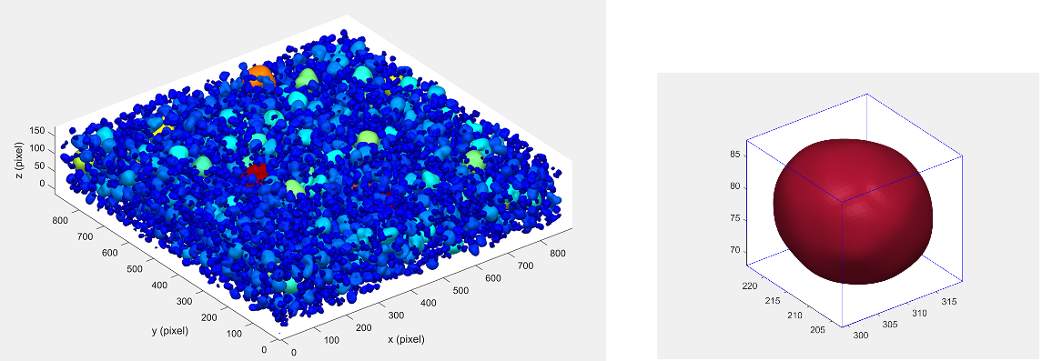

b)  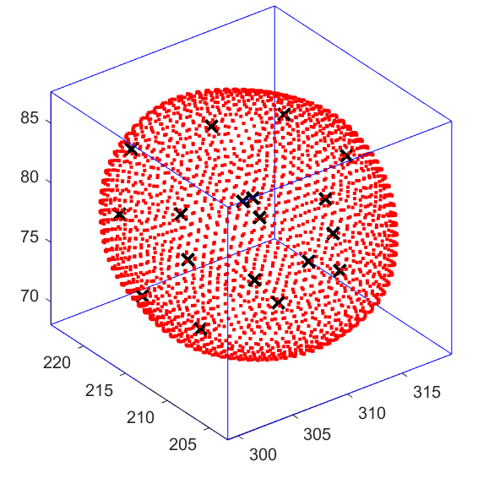 | c)  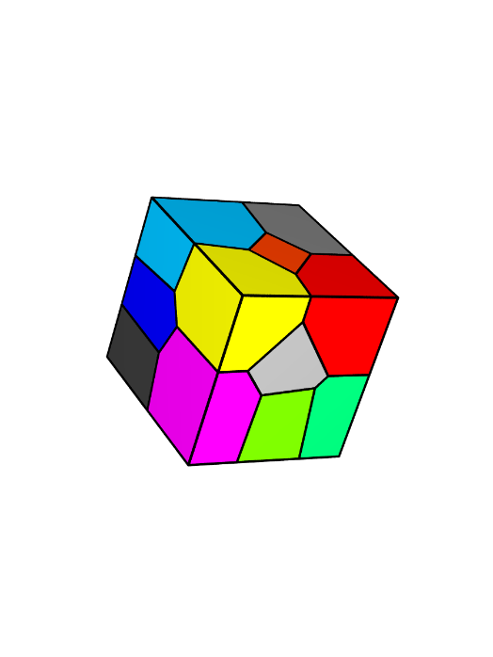 | d)  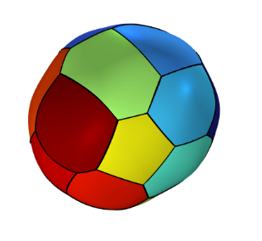
Figure S1. a) Particle of radius 10 microns randomly selected from the reconstructed electrode microstructure. b) Seed points (x) obtained from the sphere packing in the bounding box. c) Laguerre tessellations generated from the seed points and their corresponding weights. d) Polycrystalline particle structure with random grain orientation obtained from cropping the tessellations to particle shape.
The construction of this representative polycrystalline structure involved several steps:
- Bounding Box Definition: Initially, a bounding box was established around the complex three-dimensional shape of the selected secondary particle.
- Sphere Packing: Spheres, with radii matching the desired size of the primary particles, were packed without overlap within this bounding box.
- Laguerre Tessellation: The centres these packed spheres were then employed as seed points (see Figure S1.b)) and weights were normalised based on the distance from the boundary of particle surface, to generate Laguerre tessellations in Neper [2], filling the bounding box, as illustrated in Figure S1.c).
Shape Conformation: Finally, the generated tessellations were precisely cropped to match the external geometry of the selected active particle, resulting in the final model of the polycrystalline secondary NMC particle, see Figure S1.d).

Solution scheme
The order and shape of the test function for all the solution field variables are linear. A segregated solution approach is employed to solve the coupled field equations. This approach sequentially and iteratively solves each field variable, simplifying the handling of complex equations. Within each segregated step, the PARADISO ("PARallel Direct Solver") solver in COMSOL is used to solve the linearised system of algebraic equations. After each iteration, the convergence of the complete system of equations is evaluated. Furthermore, the time stepping was handled using a backwards Euler method for time integration.

References
1. Nagda, V., A. Kulachenko, and S.B. Lindström, Image-based 3D characterization and reconstruction of heterogeneous battery electrode microstructure. Computational materials science, 2023. 223: p. 112139.
2. Quey, R., P.R. Dawson, and F. Barbe, Large-scale 3D random polycrystals for the finite element method: Generation, meshing and remeshing. Computer Methods in Applied Mechanics and Engineering, 2011. 200(17-20): p. 1729-1745.

