Supplementary Document

SEDIST: Spatially Enhanced Domain Identification through Spatial Transcriptomics
Abdullah Al Sakib¹, Fahad Rahman¹, Riasat Azim^{1,*}, Fahim Hafiz¹,Shabrina Airen Esha¹, Umme Aimon Bristy¹.
¹Department of Computer Science and Engineering, United International University, Dhaka 1212, Bangladesh.
*Riasat Azim. Tel: +8801796619200; Email: riasat@cse.uiu.ac.bd

Supplementary Equations

SSCL is modeled by utilizing binary cross-entropy (BCE). The contrastive loss has the following formal definition as shown in equation S1:

$$A_{1}=\sum_{i=1}^{N_{\text{spot }}}{\left(E_{\left(X,A\right)}\left[\log{Φ\left(p_{i},q_{i}\right)}\right]\right) }$$
$$B_{1}=E_{\left(X^{'},A^{'}\right)}\left[\log\left(1-Φ\left(p_{i}^{'},q_{i}\right)\right)\right]$$
$$L_{SSCL}=-\frac{1}{2N_{\text{spot }}}\left(A_{1}+B_{1}\right) (S1)$$
Where $Φ\left(⋅\right)$dual neural network discriminator $D:R^{d}×R^{d}→R$that separates the positive pairs from the negative pairs. $Φ(p_{i},q_{i})$ indicates the probability score that the positive pair $(p_{i},q_{i})$ has been given. Since the original graph $G$ and the modified graph $G^{'}$ have the same topological structure, symmetric contrastive loss is adopted for the modified $L_{SSCL}$ corrupt graph in order to improve the stability and balance of the model as mentioned in equation S2:
$$A_{2}=\sum_{i=1}^{N_{\text{spot }}}{\left(E_{\left(X^{'},A^{'}\right)}\left[\log{Φ\left(p_{i}^{'},q_{i}^{'}\right)}\right]\right)}$$
$$B_{2}=E_{\left(X,A\right)}\left[\log\left(1-Φ\left(p_{i},q_{i}^{'}\right)\right)\right]$$
$$L_{SSCL}=-\frac{1}{2N_{\text{spot }}}\left(A_{2}+B_{2}\right) (S2)$$

Supplementary Tables

Table S1. ARI Comparison of SEDIST, GraphST, DeepST, ConST, GRAS4T, GAAEST, MNMST, SpaGCN and SpaceFlow for all ST Datasets slices used in this study.
Method | SEDIST | GraphST | DeepST | ConST | GRAS4T | GAAEST | MNMST | SpaGCN | SpaceFlow
Dataset Slices | ARI | ARI | ARI | ARI | ARI | ARI | ARI | ARI | ARI
151507 | 0.4361 | 0.4254 | 0.5529 | 0.26 | 0.5096 | 0.4321 | 0.5203 | 0.43 | 0.31
151508 | 0.4894 | 0.4511 | 0.4675 | 0.37 | 0.4701 | 0.3591 | 0.4734 | 0.38 | 0.26
151509 | 0.4837 | 0.4482 | 0.5128 | 0.42 | 0.3516 | 0.4321 | 0.4756 | 0.37 | 0.21
151510 | 0.6244 | 0.5004 | 0.3048 | 0.33 | 0.4179 | 0.4525 | 0.3627 | 0.4 | 0.21
151669 | 0.4426 | 0.4356 | 0.2959 | 0.3 | 0.2727 | 0.3812 | 0.4601 | 0.3 | 0.2
151670 | 0.6244 | 0.5004 | 0.3048 | 0.23 | 0.2818 | 0.4338 | 0.3829 | 0.21 | 0.17
151671 | 0.5926 | 0.5768 | 0.373 | 0.38 | 0.4857 | 0.6226 | 0.4923 | 0.38 | 0.26
151672 | 0.6273 | 0.5733 | 0.4512 | 0.38 | 0.4331 | 0.6415 | 0.5738 | 0.51 | 0.28
*151673 | 0.6466 | 0.6123 | 0.5855 | 0.51 | 0.2735 | 0.5097 | 0.6012 | 0.4557 | 0.35
151674 | 0.5993 | 0.5561 | 0.4575 | 0.45 | 0.3655 | 0.4722 | 0.5361 | 0.41 | 0.34
151675 | 0.5366 | 0.4816 | 0.5112 | 0.44 | 0.3367 | 0.3917 | 0.5572 | 0.39 | 0.25
151676 | 0.5366 | 0.5458 | 0.5623 | 0.39 | 0.3577 | 0.3373 | 0.4798 | 0.32 | 0.29

Table S2. Description of ST datasets used in this study.
Platform | Tissue | Slice | Spots | Related Figures | Reference
10x Visium | Human  dorsolateral prefrontal  cortex (DLPFC) | 151507 | 4,226 | Fig. 2C | [1]
10x Visium | Human  dorsolateral prefrontal  cortex (DLPFC) | 151508 | 4,384 | Fig. 2D | [1]
10x Visium | Human  dorsolateral prefrontal  cortex (DLPFC) | 151509 | 4,789 | Fig. 2E | [1]
10x Visium | Human  dorsolateral prefrontal  cortex (DLPFC) | 151510 | 3,498 | Fig. 2F | [1]
10x Visium | Human  dorsolateral prefrontal  cortex (DLPFC) | 151669 | 3,661 | Fig. 2G | [1]
10x Visium | Human  dorsolateral prefrontal  cortex (DLPFC) | 151670 | 3,498 | Fig. 2H | [1]
10x Visium | Human  dorsolateral prefrontal  cortex (DLPFC) | 151671 | 4,110 | Fig. 2I | [1]
10x Visium | Human  dorsolateral prefrontal  cortex (DLPFC) | 151672 | 4,015 | Fig. 2J | [1]
10x Visium | Human  dorsolateral prefrontal  cortex (DLPFC) | 151673 | 3,639 | Fig. 2B,Fig. 2K, Fig.4 | [1]
10x Visium | Human  dorsolateral prefrontal  cortex (DLPFC) | 151674 | 3,673 | Fig. 2L | [1]
10x Visium | Human  dorsolateral prefrontal  cortex (DLPFC) | 151675 | 3,592 | Fig. 2M | [1]
10x Visium | Human  dorsolateral prefrontal  cortex (DLPFC) | 151676 | 3,460 | Fig. 2N | [1]
10x Visium | Human Breast Cancer (BRCA) | Block A Section 1 | 3,798 | Fig. 5 | [2]

Supplementary Figures

Figure S1. Visualization of Gene Expression and Spatial Architecture on the 151673 slices of the DLPFC dataset.
-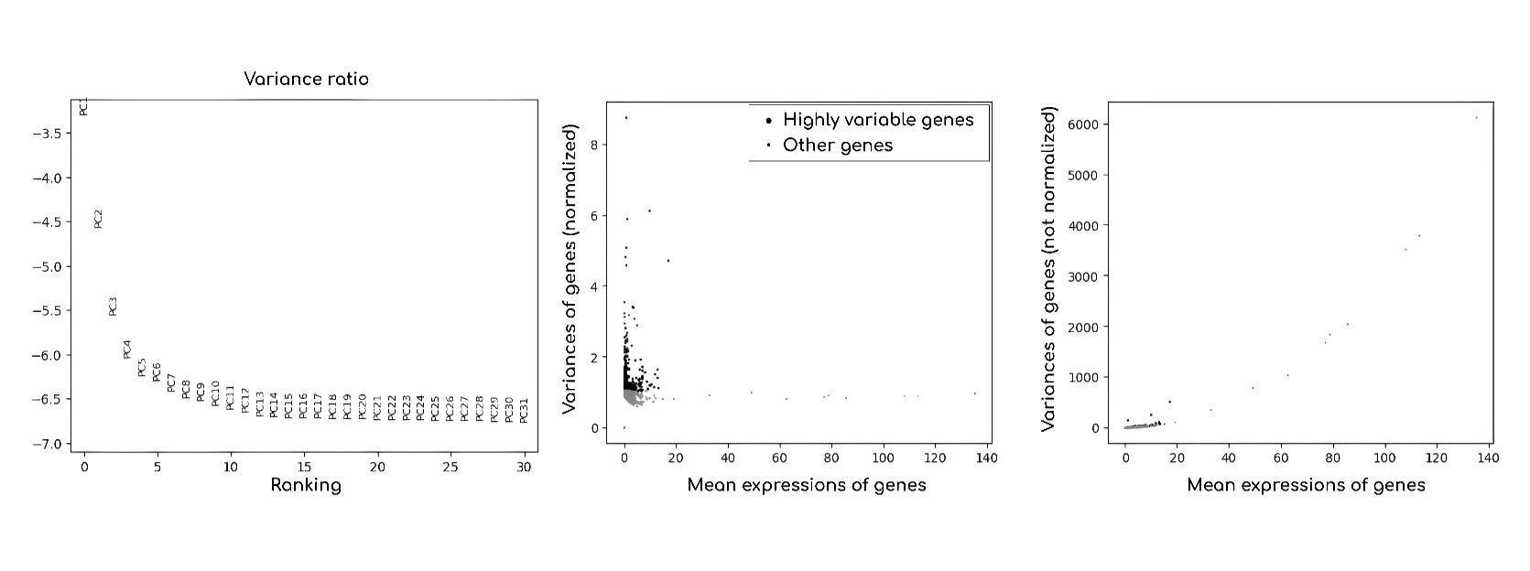
Figure S1. Visualization of Gene Expression and Spatial Architecture using SEDIST. Visualization of Feature Amounts in PCA and Comparison of Normalized and Non-Normalized Gene Expression.

Figure S2. Visualization of top 5 Spatially Variable Genes on each cluster in the 151673 slices of DLPFC dataset.
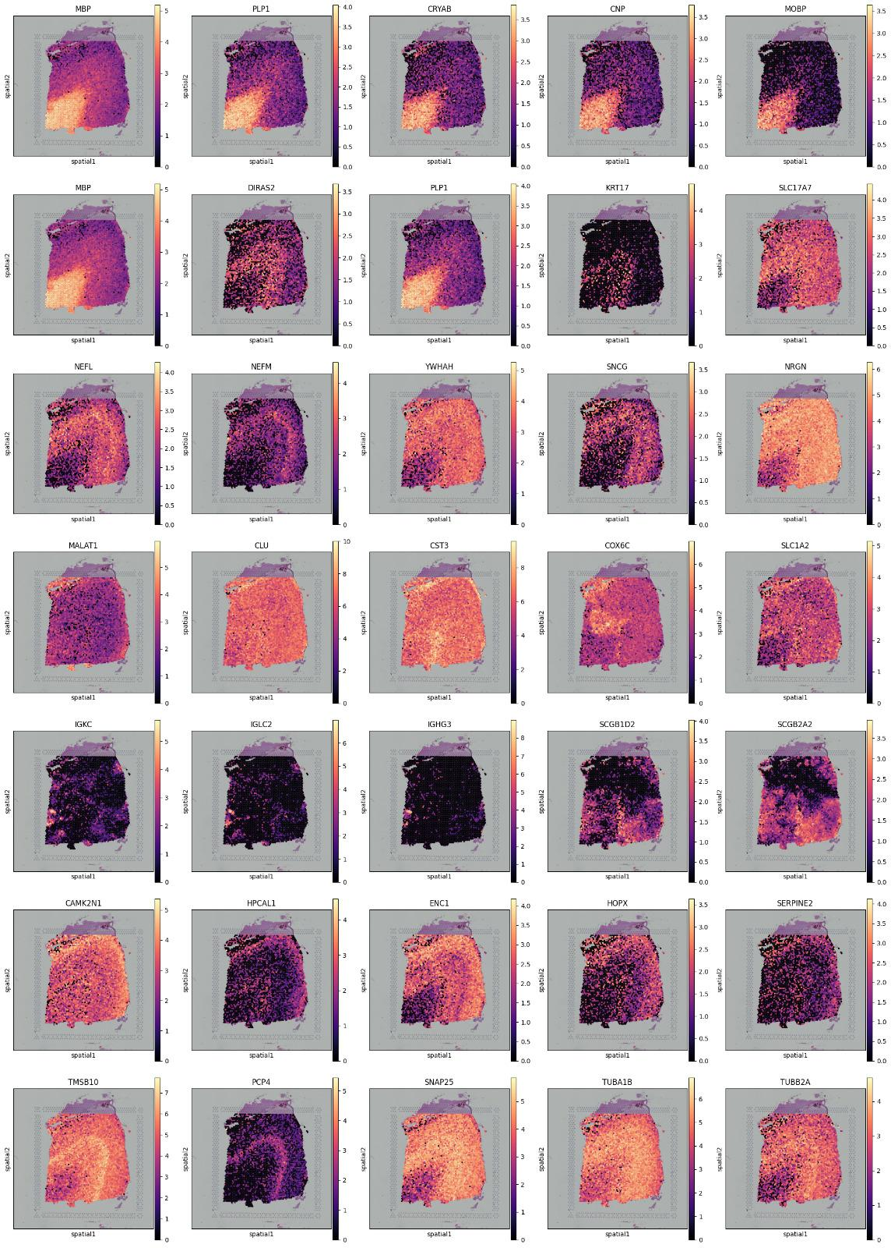
Figure S2. Visualization of Spatially Variable Gene Expression

Figure S3. Visualization of top 20 Expressed Genes by percentage of total counts in the slice 151673 of DLPFC dataset.
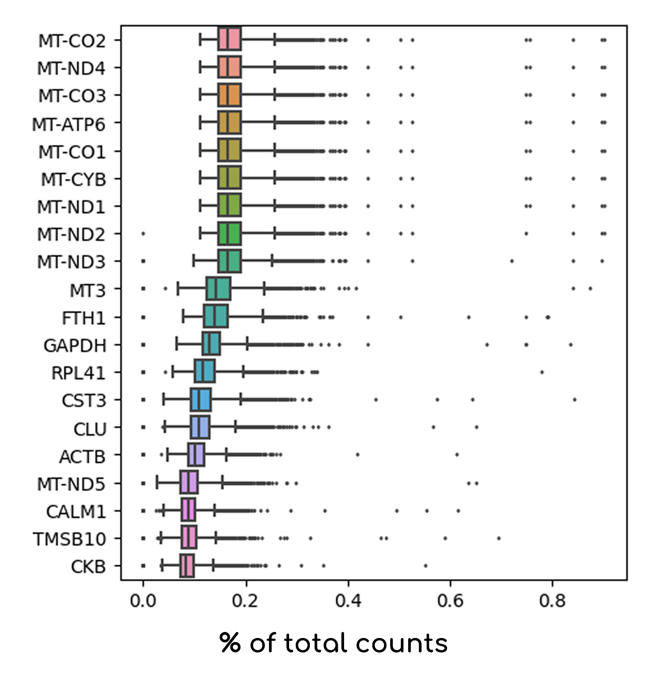
Figure S3. SEDIST’s proficiency in identifying the top 20 genes within individual cells is demonstrated.

References
1. Maynard, K. R. et al. Transcriptome-scale spatial gene expression in the human dorsolateral prefrontal cortex. Nat. Neurosci. 24, 425–436 (2021).
2. 10x Genomics. Human breast cancer block A, section 1-1 (Standard 1.1.0). 10x Genomics. Retrieved December, 2024,from https://www.10xgenomics.com/datasets/human-breast-cancer-block-a-section-1-1-standard-1-1-0

