Supplementary Table 1 Percentage of each regimen pattern
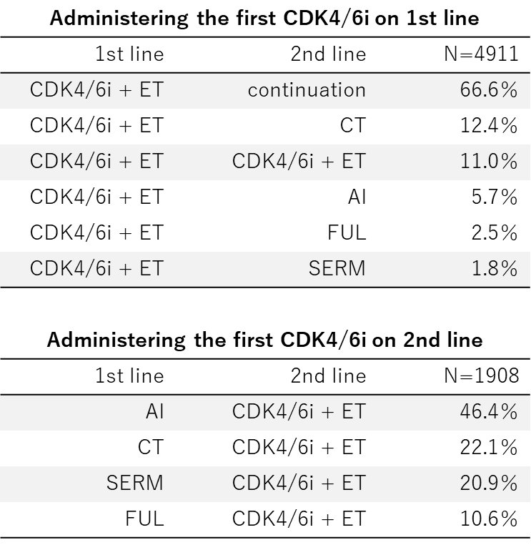

Supplementary Figure 1 Patterns of regimens in group A
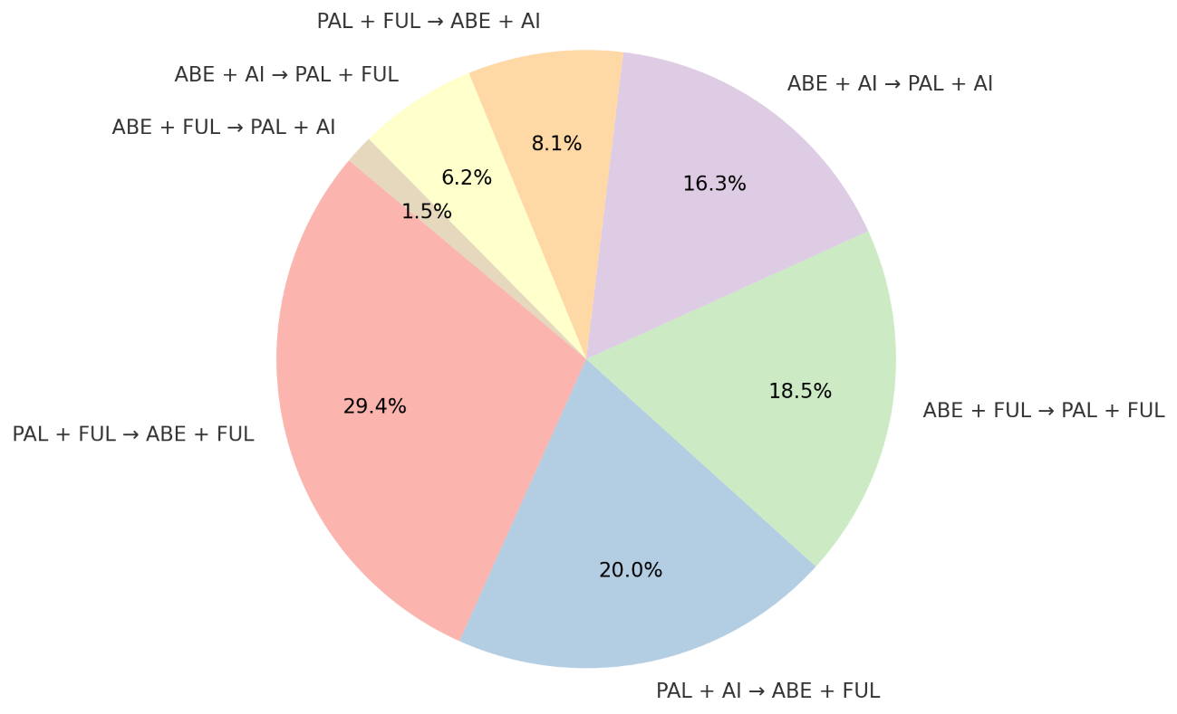
A pie chart illustrates the distribution of combined ET used with CDK4/6i and the sequencing of Abemaciclib and Palbociclib when switching CDK4/6i in group A patients. Combined ET is categorized as either Fulvestrant (FUL) or aromatase inhibitor (AI).

Supplementary Figure 2 Total TTD of first- and second-line in group A and B
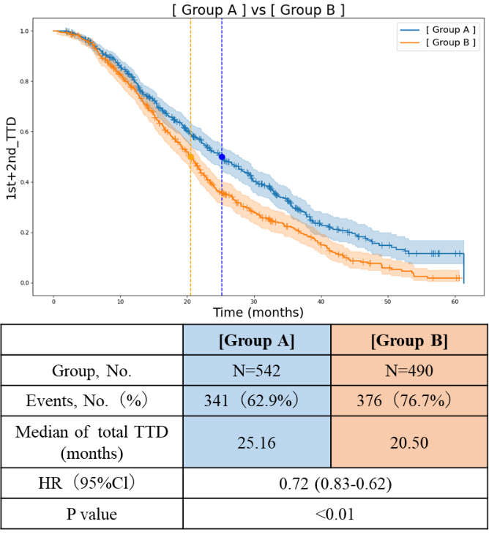
Kaplan-Meier estimates of total TTD of first- and second-line are shown for group A and B.

Supplementary Figure 3a Second-line TTD on the order of palbociclib (PAL) and abemaciclib (ABE)
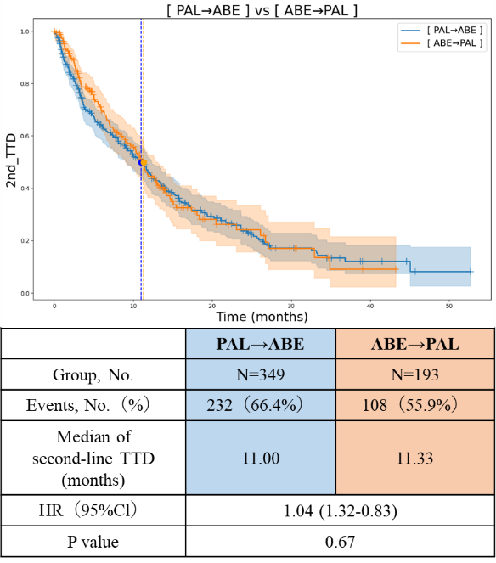
Supplementary Figure 3b Total TTD of first- and second-line on the order of palbociclib (PAL) and abemaciclib (ABE)
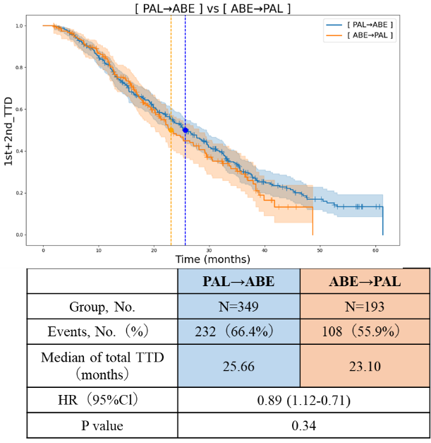
Kaplan-Meier estimates of TTD are shown for group A patients who switched from palbociclib to abemaciclib (PAL→ABE) and those who switched from abemaciclib to palbociclib (ABE→PAL). Supplementary Figure 3a shows second-line TTD, while Supplementary Figure 3b shows total TTD of first- and second-line.
Supplementary Table 2 Sub-analysis in group A
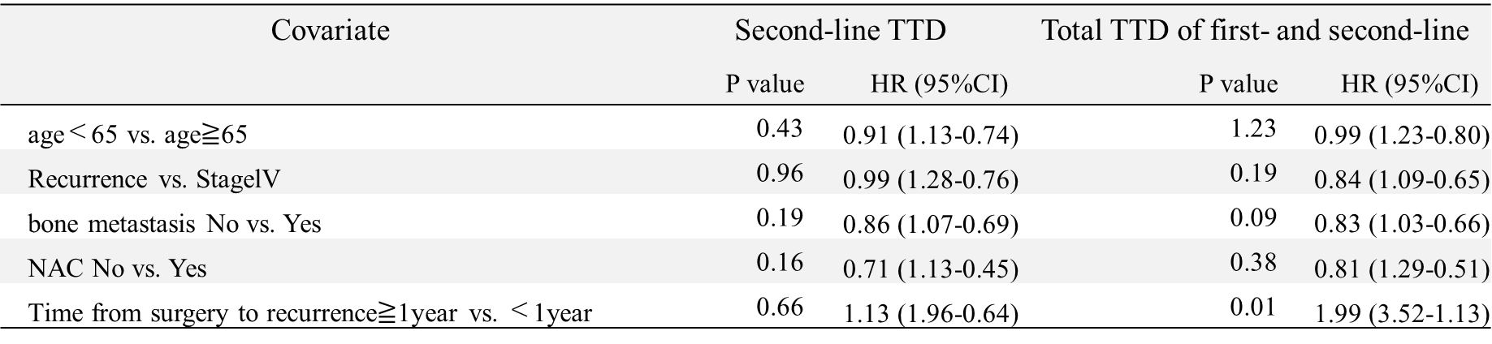

Supplementary Figure 4 Total TTD of first- and second-line in group A and C
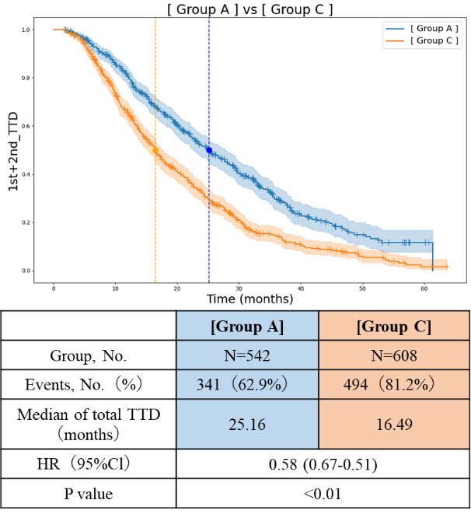
Kaplan-Meier estimates of total TTD of first- and second-line are shown for group A and C.

