Supplementary Figures and Tables

A Molecular Velcro Self-Healing Cement
Chao Zeng, Zihao Li, Trent R. Graham, Manh-Thuong Nguyen, R. S. Quin Miller, William Chrisler, Tamas Varga, Lan Li, and Carlos A. Fernandez*

Table S1. Mixture proportion of cement samples.
 | Control cement | Cement + bPEI/PAA/PEO
Type I/II cement (g) | 210 | 210
Silica fume (g) | 90 | 90
Water or solution (g) | 113.4 | 113.4

Table S2. Chemical composition and physical properties of cement Type I/II.
Component | CaO | SiO₂ | Al₂O₃ | SO₃ | Fe₂O₃ | MgO | Na₂O | Others
Mass (%) | 63.7 | 20.1 | 4.7 | 3.1 | 3.5 | 0.7 | 0.5 | 3.7
C₃S* |  | C₂S* |  | C₃A* |  | C₄AF* |  | Others
53 |  | 18 |  | 7 |  | 11 |  | 11
Symbol * denotes the mineral compounds with notation: S = SiO₂, A = Al₂O₃, C = CaO, F = Fe₂O₃.

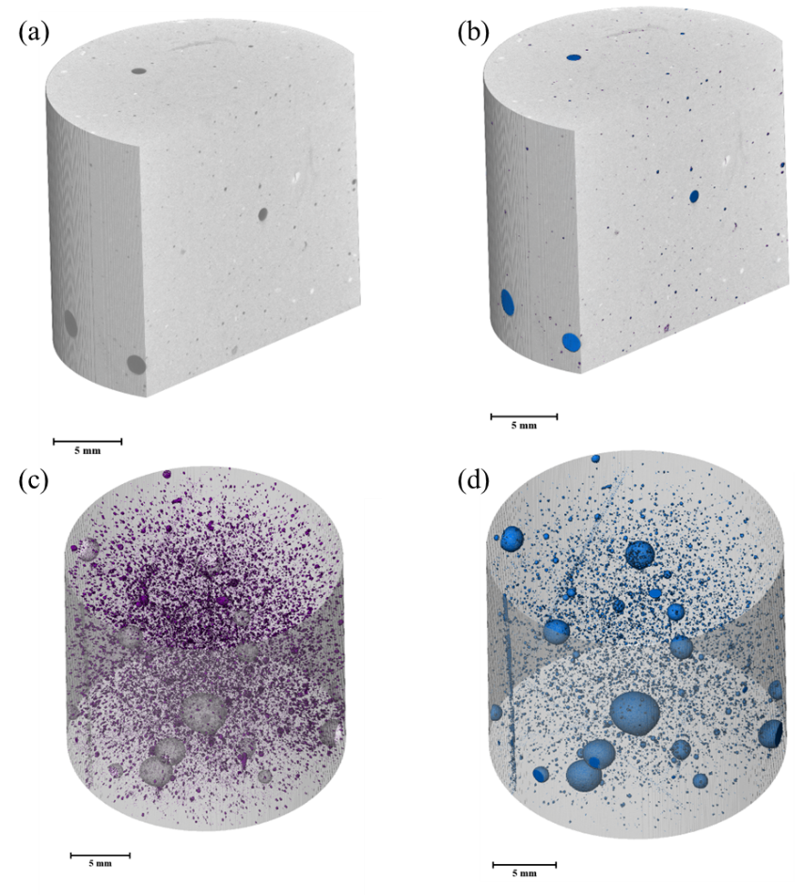
Figure S1. X-ray computed tomography (XCT) of polymer cement sample: (a) grayscale 3D geometry; (b) colorized 3D geometry to distinguish pore (blue) and polymer (purple); (c) polymer distribution (purple) in the scanned geometry; (d) pore distribution (blue) in the scanned geometry. In the original grayscale geometry (a), the pore is identified as medium gray, indicating water in the pores. The air voids are usually identified as very dark in grayscale images. The total porosity is 1.01%, and the volume percentage of polymer is 0.13%. Total pore volume is 87.34 mm³ and total polymer volume is 11.86 mm³. The voxel resolution is 0.013 mm.

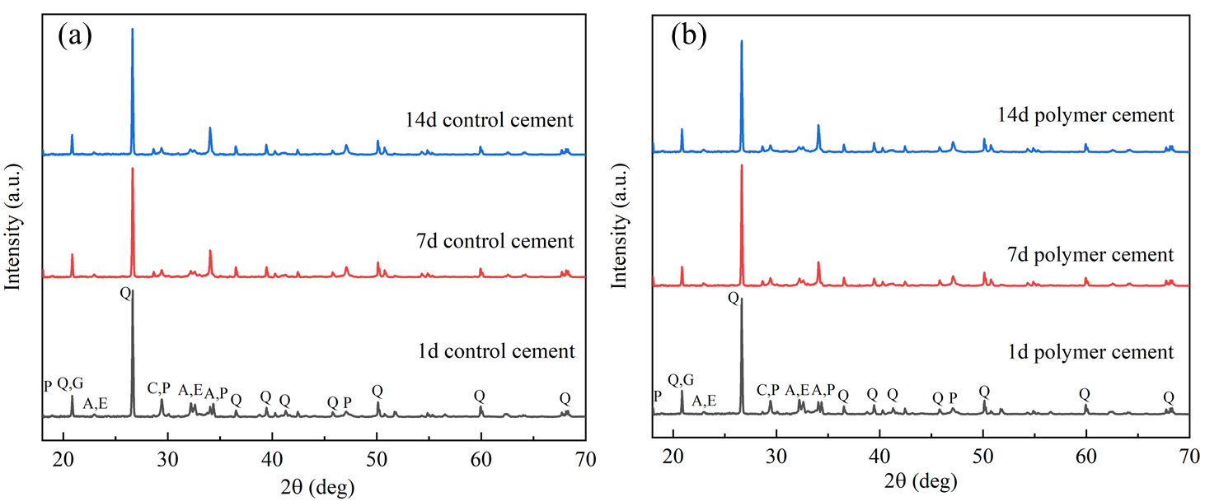
Figure S2. Powder X-Ray Diffraction (XRD) analysis of both (a) control cement and (b) polymer cement at curing time of 1 day, 7 days and 14 days. The Phases identified in XRD are listed: Q: quartz, C: calcite, P: portlandite, G: gypsum, A: alite, E: ettringite. The background signal is subtracted and only the signals from crystalline minerals are presented.

Table S3. Proportion of identified crystal minerals in both control cement and polymer cement by Powder-XRD.
Minerals | Control cement (wt %) |  |  | Polymer cement (wt %)
Minerals | 24h | 7 days | 14 days | 24h | 7 days | 14 days
Quartz | 52.28 | 58.48 | 53.17 | 53.22 | 58.47 | 50.88
Calcite | 6.58 | 0.91 | 0.65 | 1.22 | 1.14 | 0.7
Portlandite | 10.62 | 22.47 | 21.3 | 11.32 | 22.5 | 21.97
Gypsum | 0.39 | 0.36 | 0.37 | 2.89 | 0.18 | 0.34
Alite | 30.14 | 15.91 | 10.72 | 31.36 | 16.64 | 11.53
Ettringite | / | 1.87 | 13.78 | / | 2.06 | 14.58

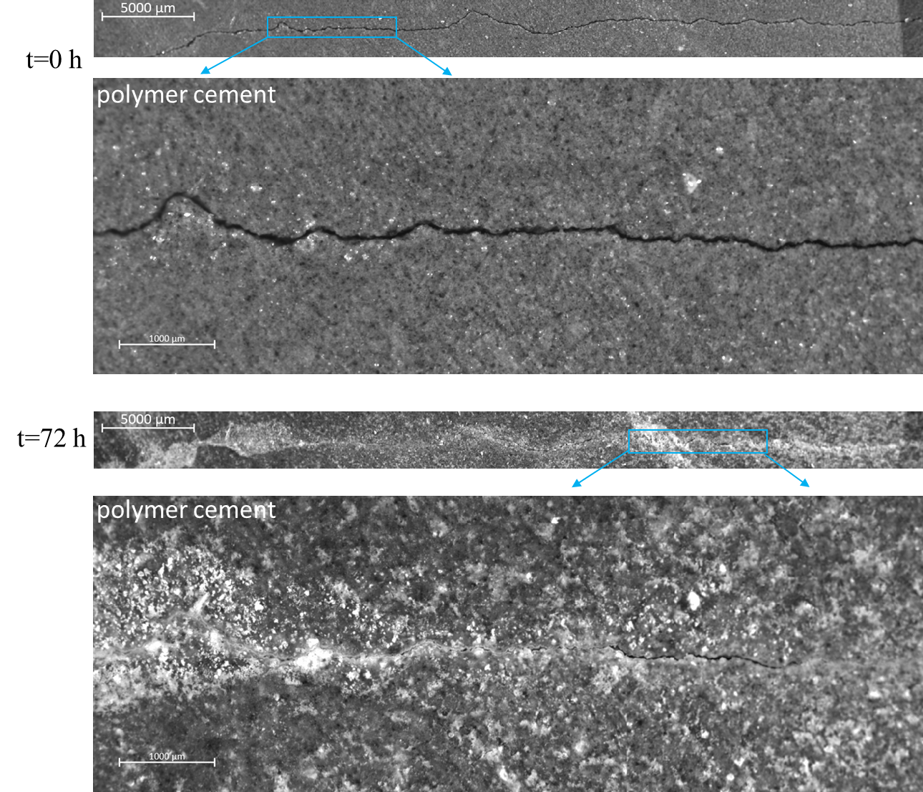
Figure S3. Optical microscopy observation of crack healing for polymer cement in curing time of three days. It shows the magnified images from Fig. 3 in the main text. After 3 days, the crack face is filled with bright white color in the left-hand side, indicating the self-healing induced by polymer. The healing process of cracked polymer cement refers to supplementary video SV2.

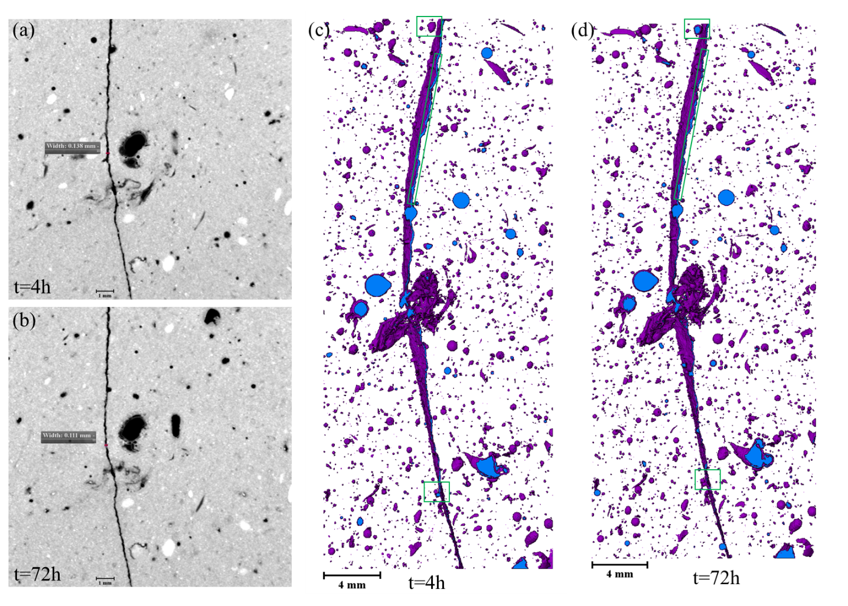
Figure S4. XCT observation of healing process for cracked polymer cement. The observed region of interest is 16.2×3.5×38.8 mm. The slice images with crack width measurement: (a) after 4 hours of cracking and (b) after 72 hours of cracking. The 2D projection of spatial distribution of pores (blue) and polymer (purple): (c) after 4 hours of cracking and (d) after 72 hours of cracking. Before cracking, the polymer is randomly distributed in matrix as Fig. S1c. After cracking, polymer quickly migrates to crack face during the first hours and then gradually migrates afterwards. The migration of polymer can be indicated by the comparison of the marked regions in (c) and (d).

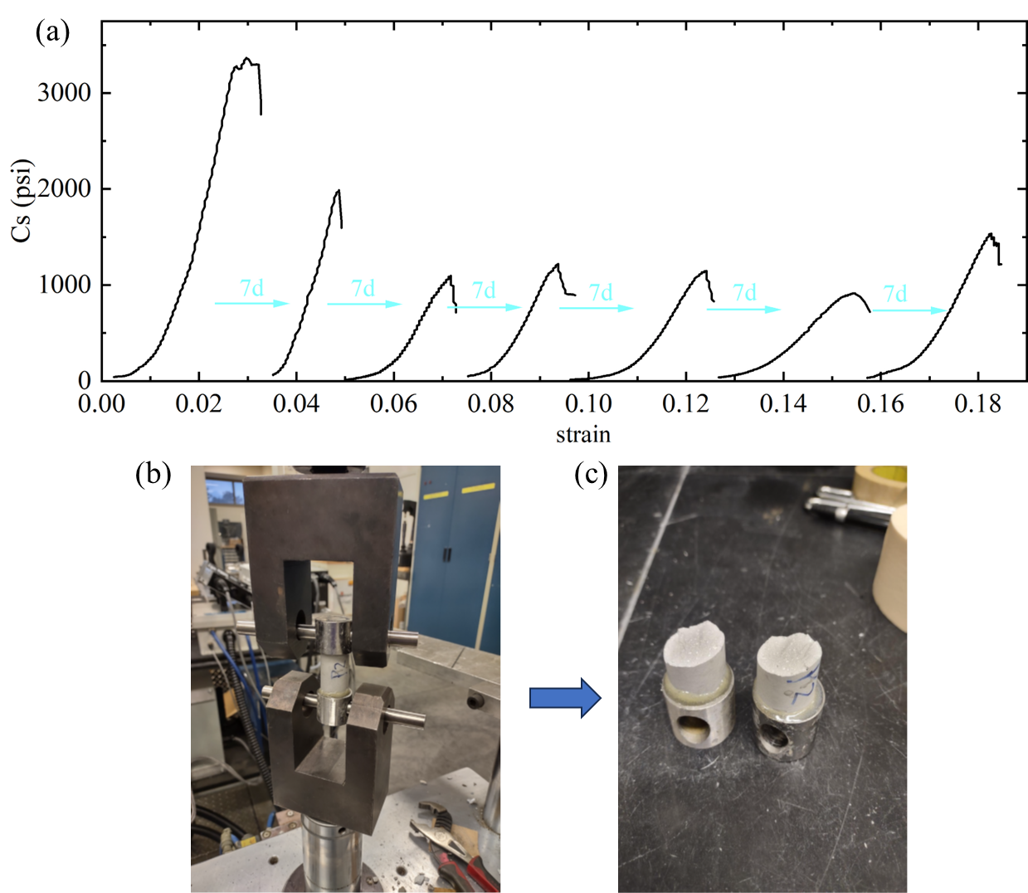
Figure S5. (a) The compressive stress-strain curves for one typical polymer cement sample. (b) The loading frame with cylinder sample setup. (c) The cement sample after tensile failure. The loading termination is at 20% drop of compressive stress after the peak value for compression test, as shown in (a).

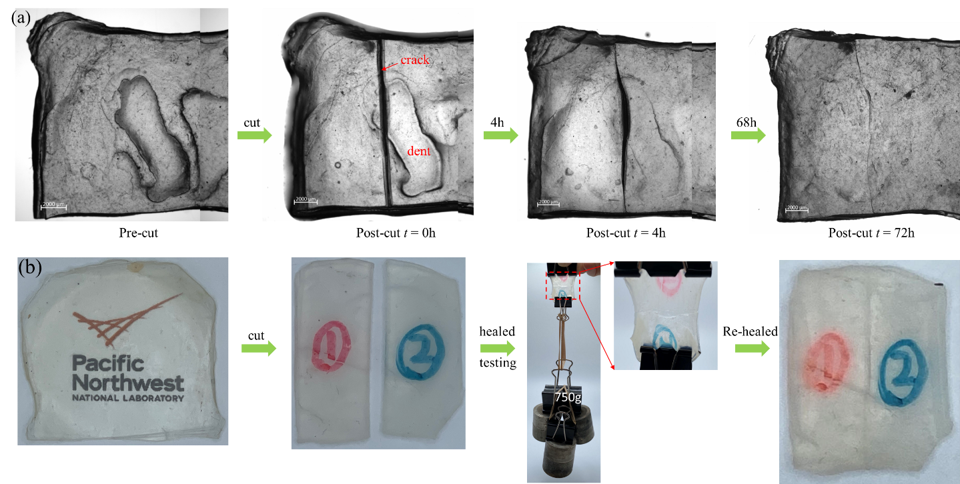
Figure S6. The demonstration of healing capability of pure polymer: (a) healing of cracked polymer in 72 hours by optical microscopy, (b) multiple healing cycles by naked eye observation. The polymer healing process is shown in supplementary video SV3.

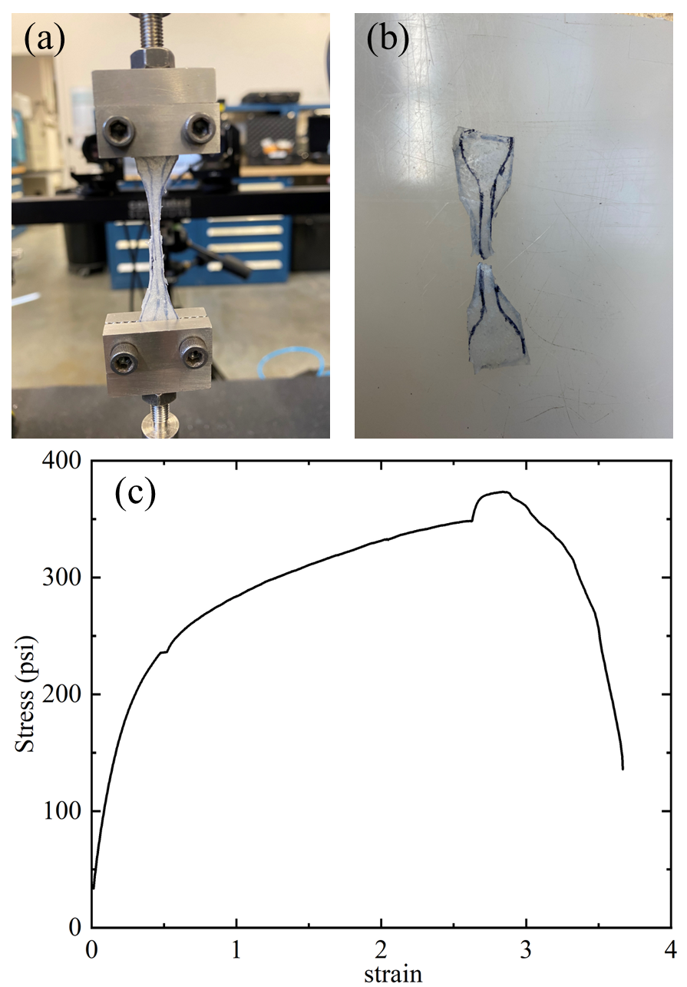
Figure S7. Pulling test of pure polymer to test its tensile strength. (a) polymer in pulling, (b) polymer after testing, (c) strain-strain curve. The dog-bone shape of sample has gauge dimension: thickness 1.5 mm and width 5.28 mm. The large strain demonstrates its high stretchability.

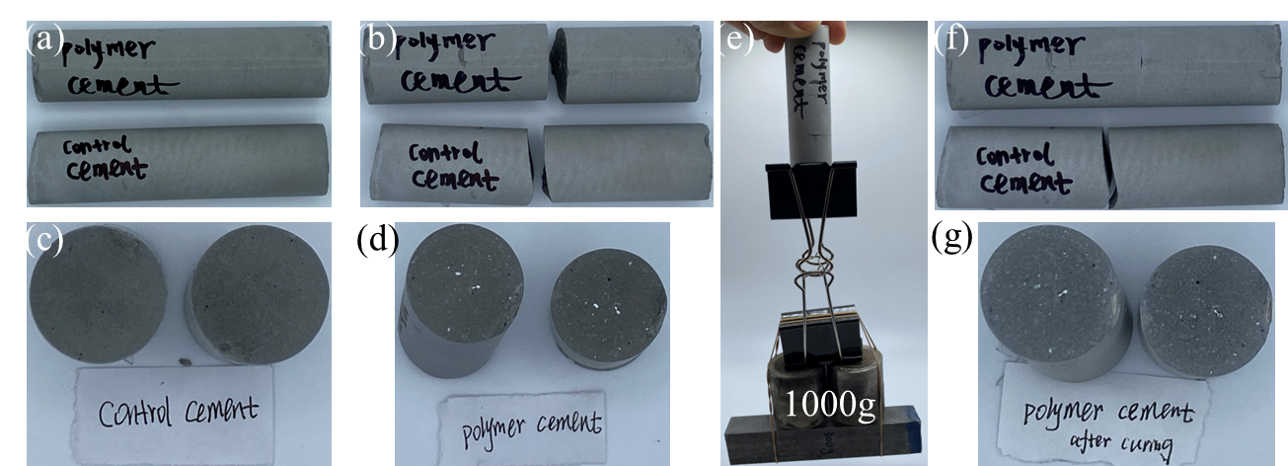
Figure S8. Demonstration of healing capability of polymer cement. (a) pre-cut samples, (b) post-cut samples t = 0h, (c) crack faces of control cement, (d) crack faces of polymer cement, (e) loading of samples by weight scale, (f) re-healed cracks for polymer cement, (g) re-healed crack faces of polymer cement. The bright white particles at cracked faces for polymer cement are polymer. Visual demonstration of self-healing performance for cement samples refers to supplementary videos SV5~SV7.

Table S4. Line shape parameters used to fit the solid state ¹³C MAS NMR spectra.
Sample | Peak position [ppm] | FWHM [Hz] | Relative signal intensity [%]ª | Assignment
PAA-only | 182 | 353 | 65 | PAA-PAA complexes
PAA-only | 178 | 418 | 35 | unassociated PAA
PAA+bPEI+PEO | 183 | 313 | 21 | PAA-PAA complexes
PAA+bPEI+PEO | 179 | 494 | 54 | unassociated PAA and/or PAA-bPEI complexes
PAA+bPEI+PEO | 176 | 317 | 25 | PAA-PEO complexes and/or PAA-bPEI complexes
control cement | 168 | 483 | 100 | carbonate
1x cured | 187 | 355 | 39 | PAA-cement
1x cured | 169 | 247 | 61 | carbonate
4x cured | 188 | 319 | 67 | PAA-cement
4x cured | 169 | 522 | 33 | carbonate
Physical mixture | 186 | 327 | 100 | PAA-cement
a. Note that the relative signal intensity in cross polarization NMR studies is influenced by transfer efficiencies, which are often non-equivalent.

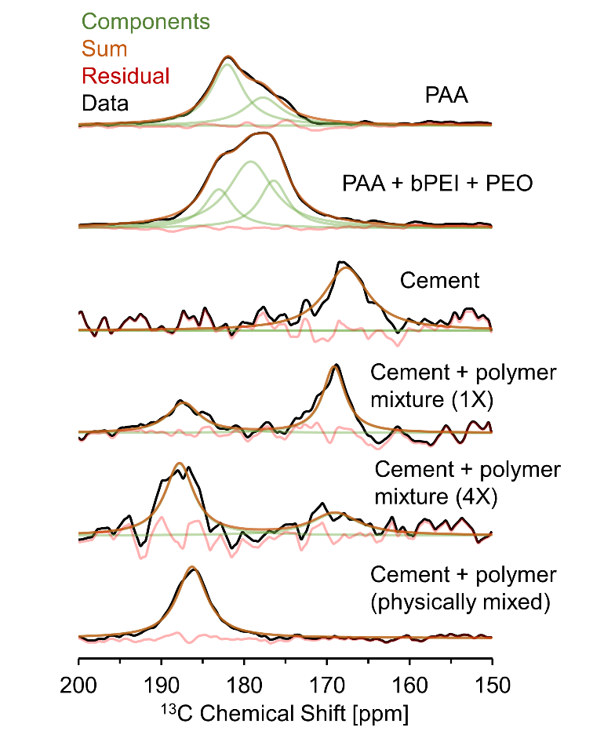
Figure S9. Deconvolutions of the carbonyl region of solid ¹³C cross polarization MAS NMR spectra.

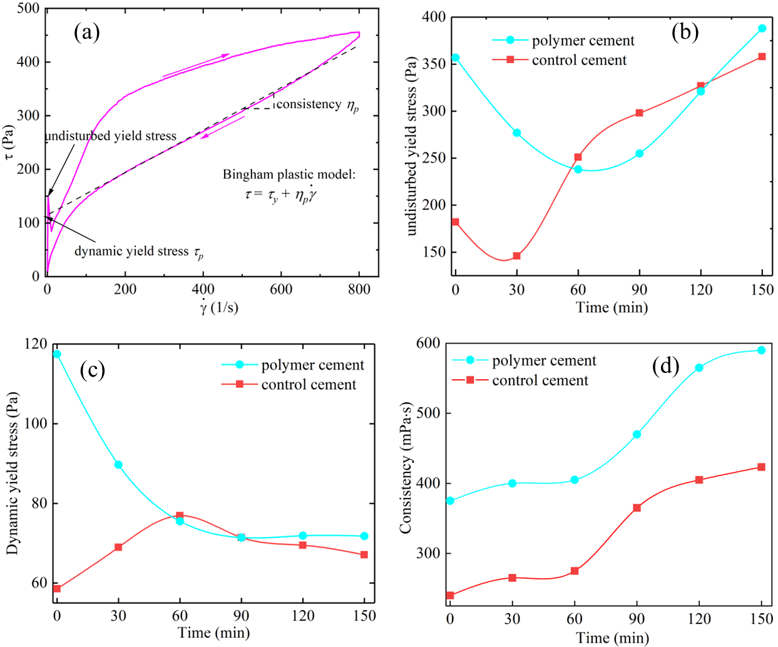
Figure S10. (a) A typical rheology curve with annotation of key rheological parameters. The comparison of rheological parameters: (b) undisturbed yield stress, (c) dynamic yield s tress, and (d) consistency, with respect to curing time since slurry preparation.

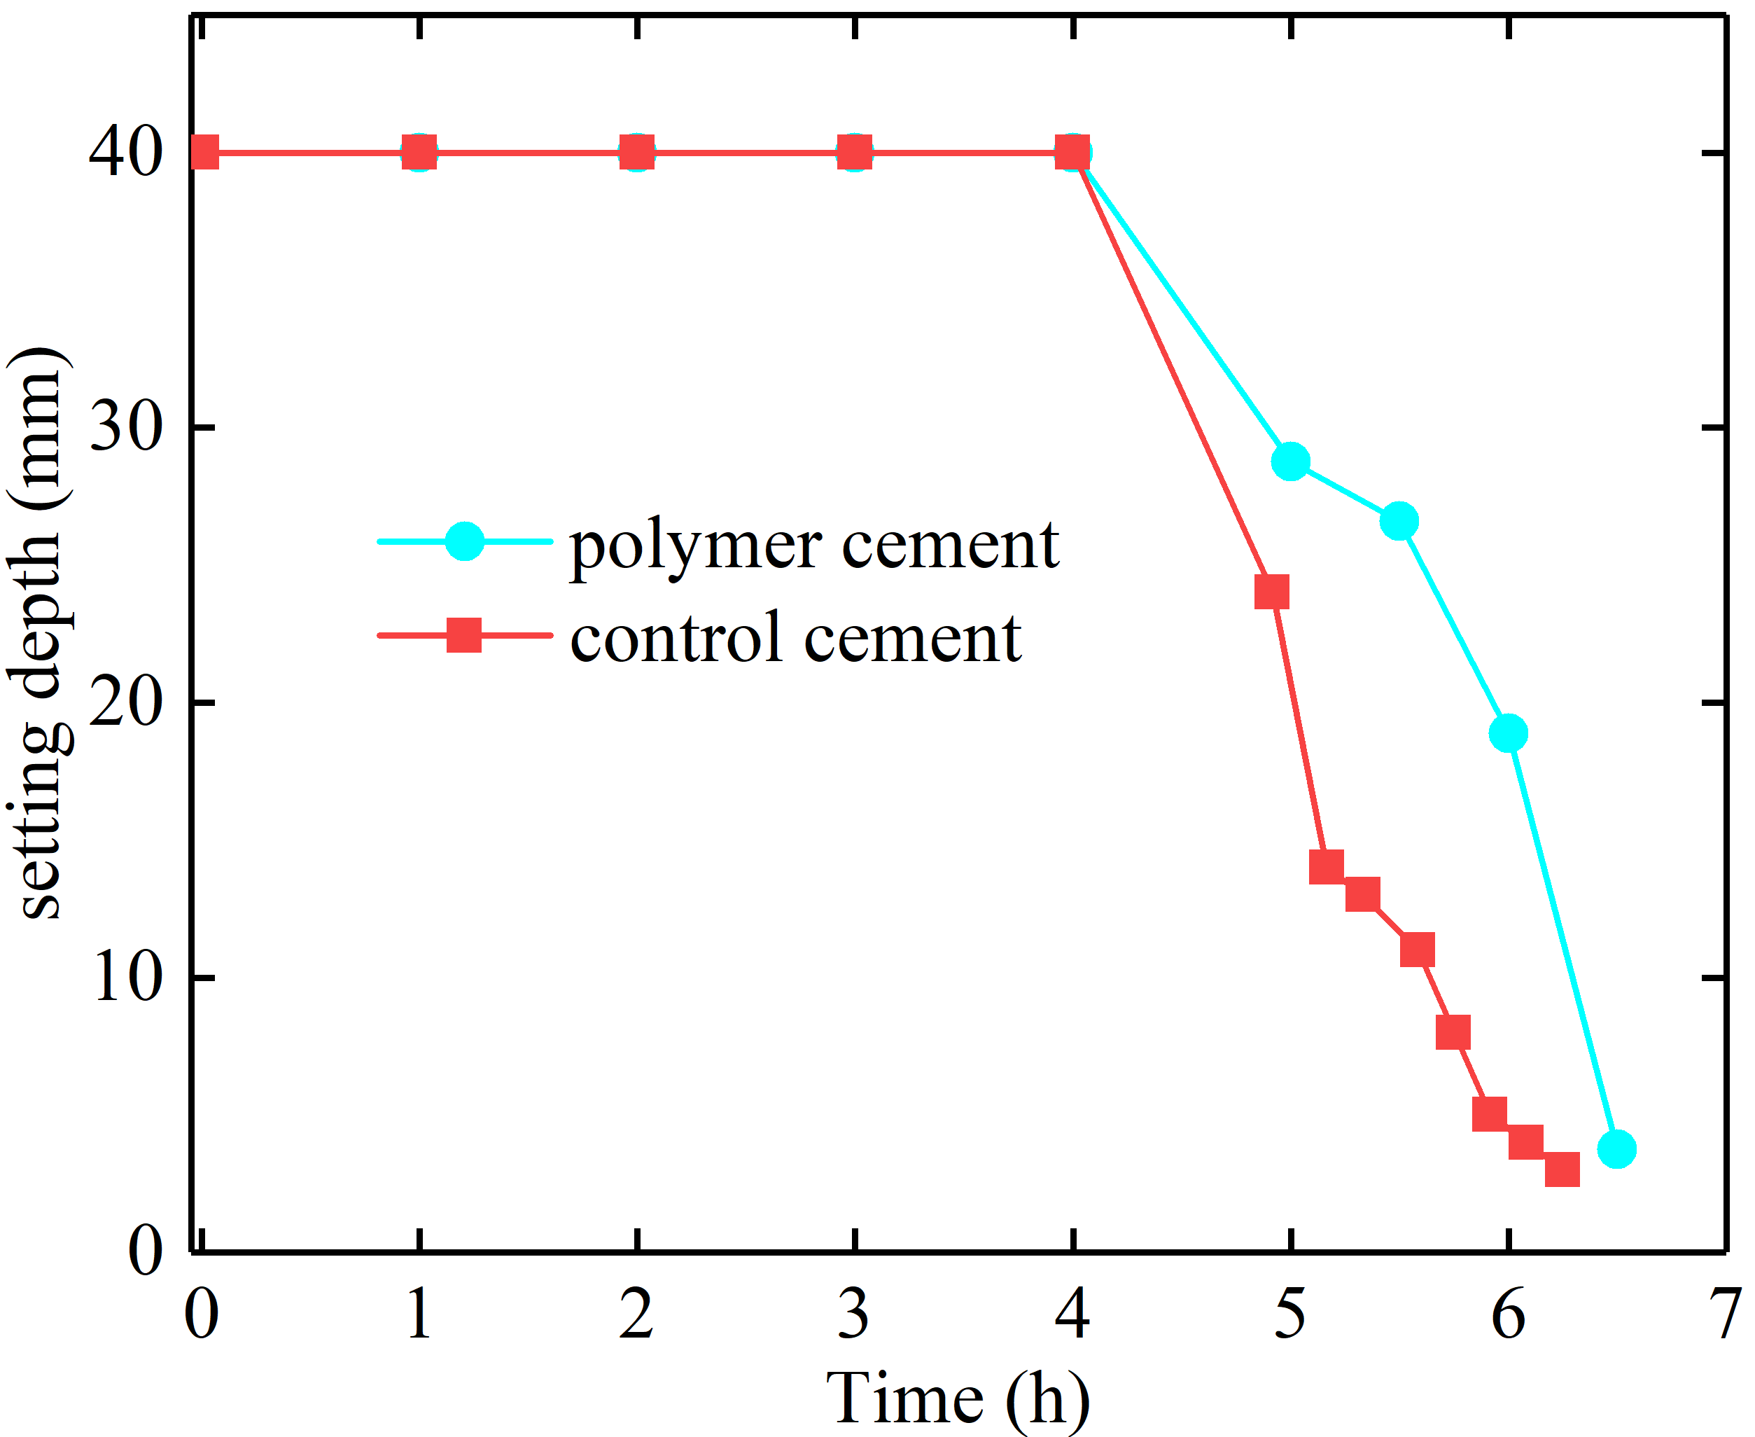
Figure S11. Initial and final setting time of cement samples by Vicat needle test.

