Carbon defects enhanced TEMPO redox cycles enabled high-efficiency urotropine electrosynthesis

Shiyun Li, Guangsheng Liu, Chuhao Liu, Yifan Fu, Yixuan Fu, Yifei Xu, Chengyu Li, Xueqiang Zhang*, Bingjun Xu*, Wanlu Li* and Mufan Li*

Contents
Supplementary Figure 1. 4
Supplementary Figure 2. 5
Supplementary Figure 3. 6
Supplementary Figure 4. 7
Supplementary Figure 5. 8
Supplementary Figure 6. 9
Supplementary Figure 7. 10
Supplementary Figure 8. 11
Supplementary Figure 9. 12
Supplementary Figure 10. 13
Supplementary Figure 11. 14
Supplementary Figure 12. 15
Supplementary Figure 13. 16
Supplementary Figure 14. 17
Supplementary Figure 15. 18
Supplementary Figure 16. 19
Supplementary Figure 17. 20
Supplementary Figure 18. 21
Supplementary Figure 19. 22
Supplementary Figure 20. 23
Supplementary Figure 21. 24
Supplementary Figure 22. 25
Supplementary Figure 23. 26
Supplementary Figure 24. 27
Supplementary Figure 25. 28
Supplementary Figure 26. 29
Supplementary Figure 27. 30
Supplementary Figure 28. 31
Supplementary Figure 29. 32
Supplementary Figure 30. 33
Supplementary Figure 31. 34
Supplementary Figure 32. 35
Supplementary Figure 33. 36
Supplementary Figure 34. 37
Supplementary Figure 35. 38
Supplementary Figure 36. 39
Supplementary Figure 37. 40
Supplementary Figure 38. 41
Supplementary Figure 39. 42
Supplementary Figure 40. 43
Supplementary Figure 41. 44
Supplementary Figure 42. 45
Supplementary Figure 43. 46
Supplementary Figure 44. 47
Supplementary Figure 45. 48
Supplementary Figure 46. 49
Supplementary Figure 47. 50
Supplementary Figure 48. 51
Supplementary Figure 49. 52
Supplementary Figure 50. 53
Supplementary Figure 51. 54
Supplementary Figure 52. 55
Supplementary Figure 53. 56
Supplementary Table 1. 57
Supplementary Table 2. 58
Supplementary Table 3. 59
Supplementary Table 4. 60
Supplementary Table 5. 61
Supplementary Table 6. 62
Supplementary Table 7. 63
Supplementary Table 8. 64
Supplementary Table 9. 65
Supplementary Note 1. 66
Supplementary Note 2. 67
Supplementary Note 3. 68
Supplementary Note 4. 70
Supplementary Note 5. 71
Supplementary Note 6. 72
Supplementary Note 7. 76
References 77

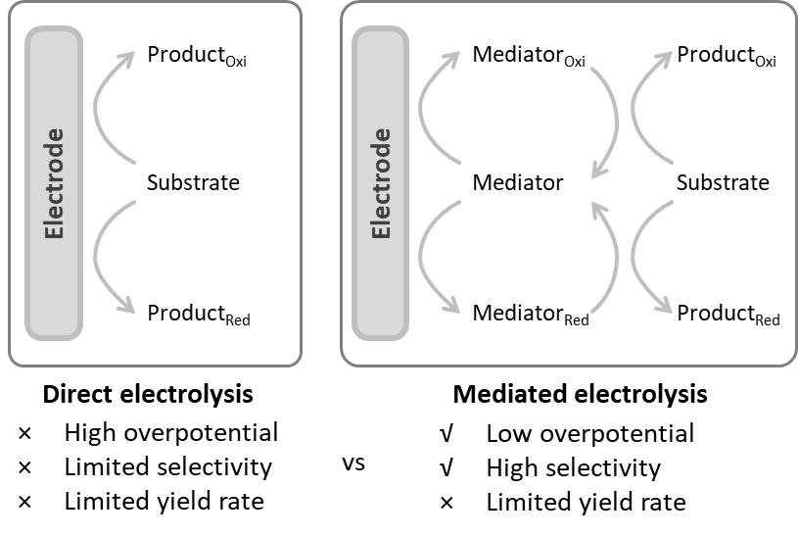
Supplementary Figure 1. Direct and mediated electrolysis.

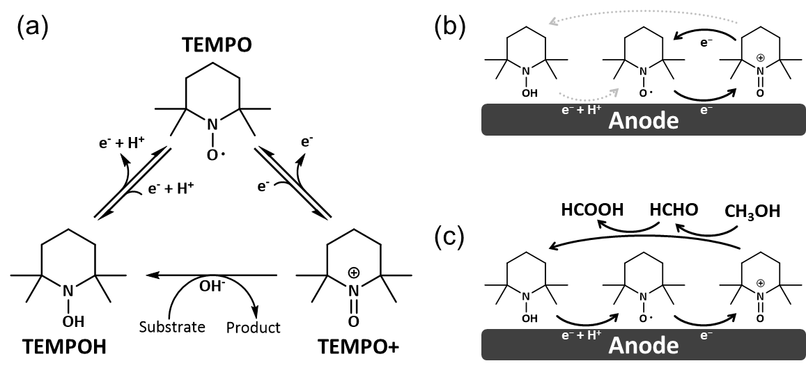
Supplementary Figure 2. (a) Diagram of TEMPO redox cycles¹. (b) The electrochemical process. In CV experiments without substrate, TEMPO is oxidized to TEMPO+ and subsequently reduced back to TEMPO. (c) The electrochemical-chemical process. In CV experiments with the substrate, TEMPO is oxidized to TEMPO+. The oxidative TEMPO+ rapidly oxidizes the substrate (methanol in this work), yielding oxidation products (formaldehyde or even formic acid) and TEMPOH. As TEMPO+ is consumed, a significant decrease in the reduction peak is observed in the subsequent negative sweep of the CV experiment. Furthermore, TEMPOH continues to be oxidized on the electrode surface to regenerate TEMPO, thus establishing the TEMPO redox cycles.

Supplementary Figure 3. Comparison of the optimal electrocatalytic partial current density and Faraday efficiency (FE) in this work with reported values in the literature involving electrosynthesis of N-containing molecules (see Supplementary Table 6 for more details).

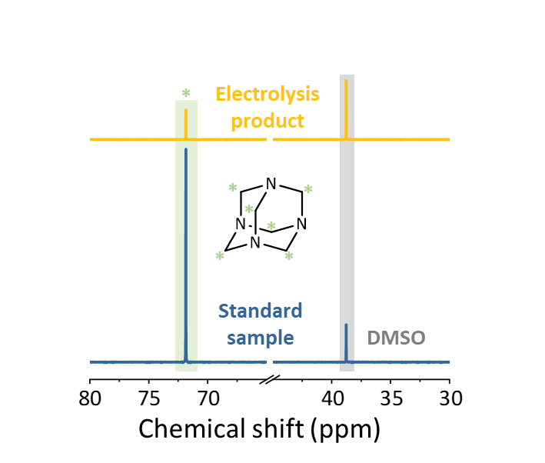
Supplementary Figure 4. The ¹³C nuclear magnetic resonance (NMR) signals of the products isolated from the electrolyte correspond exactly to those of the standard urotropine.

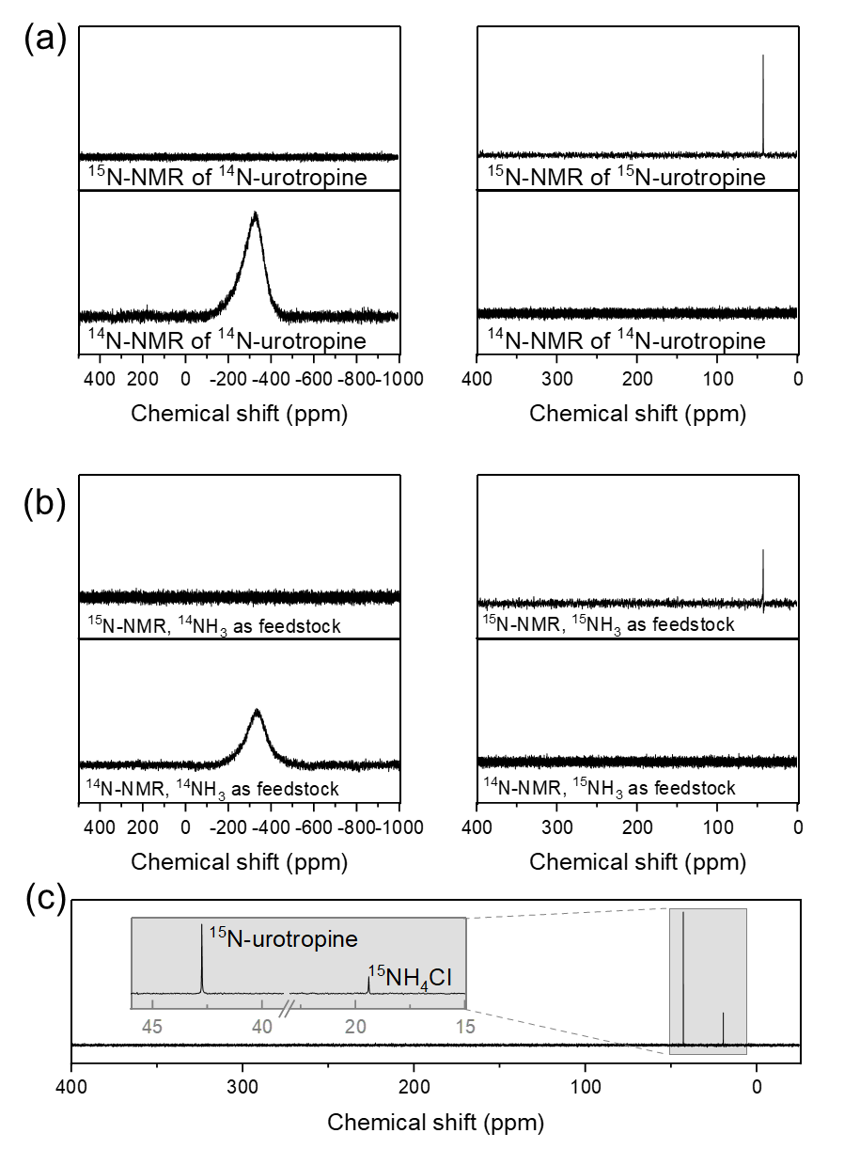
Supplementary Figure 5. (a) Urotropine labeled with ¹⁴N and ¹⁵N was characterized using ¹⁴N NMR and ¹⁵N NMR, respectively, to obtain standard spectra. (b) Electrolysis products were obtained using ammonia labeled with ¹⁴N and ¹⁵N, and then ¹⁴N NMR and ¹⁵N NMR tests were performed on the two products, respectively. The results showed that the nitrogen in the urotropine products originated from ammonia. (c) ¹⁵N NMR testing was conducted on ¹⁵N-urotropine and ¹⁵NH₄Cl, revealing chemical shifts of 42.7 for ¹⁵N-urotropine and 19.4 for ¹⁵NH₄Cl. In the NMR analysis, all samples were dissolved in D₂O.

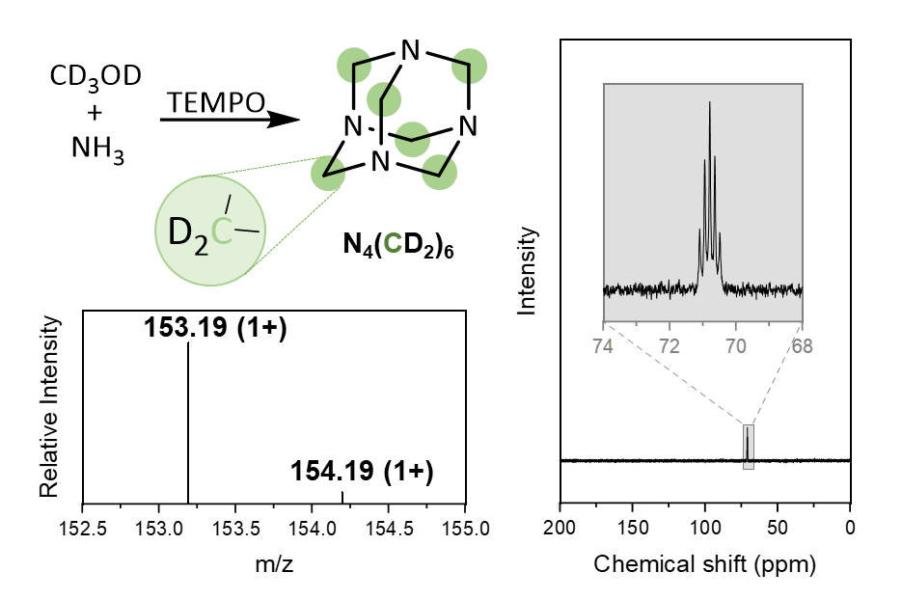
Supplementary Figure 6. NMR and high-resolution Fourier transform mass spectra (HRFTMS) of the electrolysis product using deuterated methanol and ammonia as feedstocks.

The cleavage of the ¹³C nucleus absorption peak by two deuterium nuclei, which are directly attached, is seen in the NMR spectra. The corresponding HRFTMS signals were subsequently obtained in our characterization of the product.

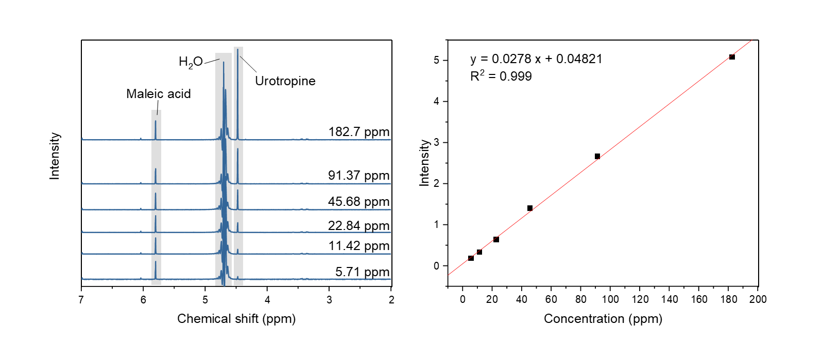
Supplementary Figure 7. Quantitative analysis of urotropine using NMR, where the ratio of the peak area of urotropine to the internal standard maleic acid varies linearly with the concentration of urotropine.

Supplementary Figure 8. Under a constant current of 100 mA, the total amount of urotropine increases linearly over time.

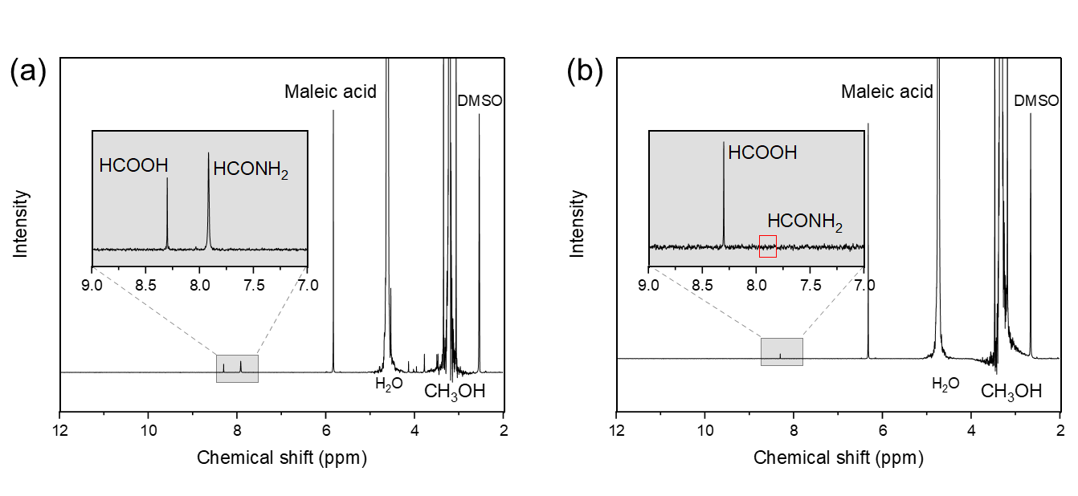
Supplementary Figure 9. (a) In the absence of TEMPO, a significant amount of formamide (~7.9 ppm) was detected after electrolysis of the system. (b) Upon adding TEMPO and electrolyzing under the same conditions, almost no formamide was detected in the electrolyte.

Supplementary Figure 10. CV control experiments on the oxidative capability of the electrode (rGO) and TEMPO+ toward ammonia.

Notably, the addition of ammonia did not induce any change in the current while TEMPO was added, indicating that TEMPO+ does not undergo the TEMPO redox cycle due to the oxidation of NH₃. Additionally, within the potential range, the electrode rGO exhibits negligible oxidative capability toward NH₃, as well. Furthermore, GC (N₂, Supplementary Fig. 11) and colorimetric methods (nitrates and nitrites, Supplementary Fig. 12 and 13) to quantify possible products of NH₃ oxidation with the addition of both TEMPO and NH₃. Analysis of the gaseous products in the reaction by GC did not detect N₂, a common product of NH₃ oxidation. Moreover, we quantitatively analyzed the electrolyte for the presence of nitrates and nitrites, two possible oxidation products of NH₃. Based on the experimental results, neither of these products was detected. These findings collectively demonstrate that NH₃ is relatively inert in our electrolysis system and does not contribute to electron loss or the formation of other byproducts.

Supplementary Figure 11. Analysis of the gaseous components in the hexamine electrosynthesis system was conducted using GC.

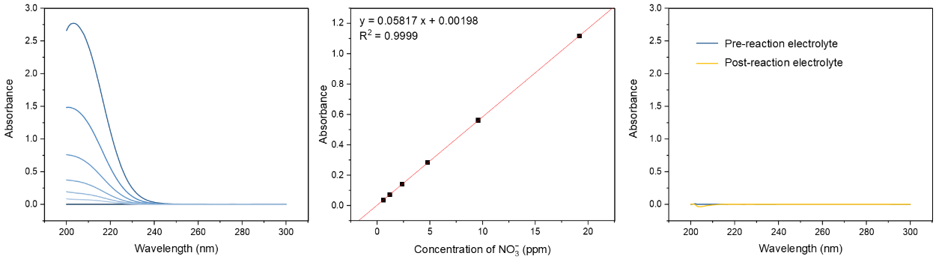
Supplementary Figure 12. Analysis of nitrate components in the electrolyte from the oxidation of ammonia by TEMPO UV-Vis spectrophotometry.

The detection of nitrate and nitrite was performed using a previously reported method². Specifically, for nitrate detection: 0.1 mL of 1 M HCl and 10 μL of a 0.8 wt% sulfamic acid solution were added to 5 mL of electrolyte diluted to within the detection limit. The mixture was allowed to react at room temperature for 30 minutes, after which the absorbance was measured in the 200–300 nm range using the UV-Vis spectrophotometer. The absorbance used for quantification was calculated as A = A_{220nm} − A_{275nm}, subtracting the absorbance at 275 nm from that at 220 nm. For nitrite detection: 0.1 mL of a chromogenic reagent was added to 5 mL of electrolyte diluted to within the detection limit. The mixture was reacted at room temperature for 30 minutes, and the absorbance was measured in the 400–650 nm range using a UV-Vis spectrophotometer, with the absorbance at 540 nm used for quantitative analysis. The chromogenic reagent was prepared by dissolving 8.0 g of p-aminobenzenesulfonamide, 0.4 g of N-(1-naphthyl)ethylenediamine dihydrochloride, and 20 mL of concentrated phosphoric acid in 100 mL of water, followed by ultrasonication.

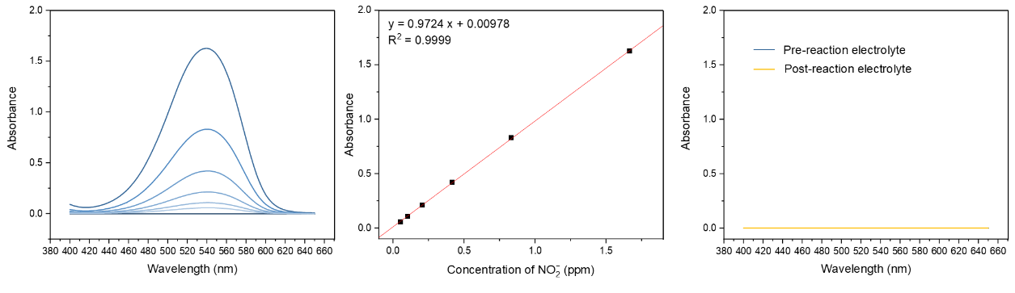
Supplementary Figure 13. Analysis of nitrite components in the electrolyte from the oxidation of ammonia by TEMPO UV-Vis spectrophotometry.

Supplementary Figure 14. The FE of formamide in the products, when using a Pt electrode in an electrolyte containing TEMPO, was measured under conditions with and without stirring.

Supplementary Figure 15. FE distribution of products when ammonia was added after electrolysis.

Electrolysis was conducted in a system without ammonia, after which ammonia water was added dropwise to the obtained electrolyte, and the products in the electrolyte were then tested. Formamide was not detected in the products, indicating that the formation of formamide involves an direct oxidation process on electrode of C-N coupling intermediates (aminomethanol). Comparing scenarios where ammonia was present in the electrolyte from the start versus added later, we found that the FE of formic acid was higher when ammonia was added later. This result also indicates that the presence of ammonia in the electrolyte helps to reduce the over-oxidation of formaldehyde, thereby enhancing the FE of urotropine. On the other hand, this result also supports that the TEMPO+ species can hardly oxidize aminomethanol, thus, the formamide detected in the urotropine electrosynthesis is mainly contributed by directly electrode oxidation.

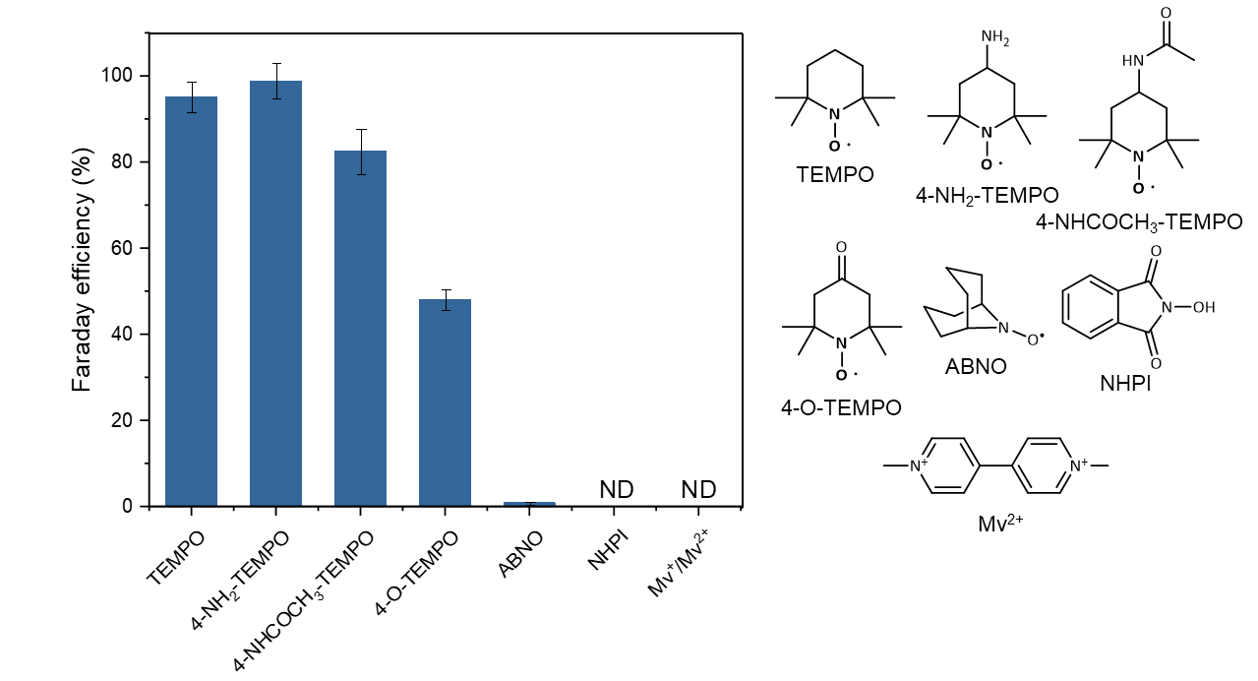
Supplementary Figure 16. FE of urotropine using different TEMPO derives and other molecular mediators. The structures corresponding to these molecules are also listed alongside.

4-NH₂-TEMPO has a urotropine FE similar to TEMPO but at a higher price than the purveyor. The solubility of 4-NHCOCH₃-TEMPO and 4-O-TEMPO is slightly poorer, which may have impacted their oxidation efficiency. ABNO is almost insoluble in water, making it difficult to achieve a significant FE. NHPI and Mv²⁺ both have good water solubility, but no urotropine was detected in the system. Therefore, considering both selectivity and cost, TEMPO remains our preferred molecular mediator.

Supplementary Figure 17. FE of urotropine and current density of urotropine varies with the concentration of TEMPO at 1.5 V.

The current density increased linearly with increasing concentration of TEMPO, indicating that the sites on the electrode surface for TEMPO oxidation were not saturated. Meanwhile, the FE of urotropine decreased slightly when the concentration of TEMPO was lower, which could be attributed to the loss of product due to the direct oxidation of part of the formaldehyde generated near the electrode surface. Due to solubility limitations, the highest TEMPO concentration we tested was 50 mM.

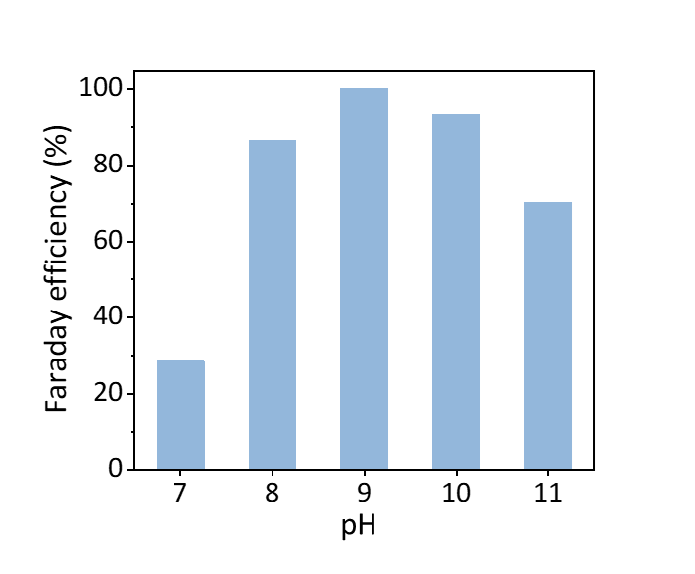
Supplementary Figure 18. The FE of urotropine varies with the pH of the electrolyte.

The volcano-shaped curve indicates that pH has two or more influences on FE. On the one hand, higher pH accelerates the alcohol oxidation rate of TEMPO+³ and enhances the nucleophilic attacking ability of ammonium. On the other hand, both ammonia and methanol would be oxidized directly (Supplementary Fig. 51), and TEMPO+ forms electrochemically inert ions⁴ (Supplementary Fig. 52) in strongly alkaline environments.

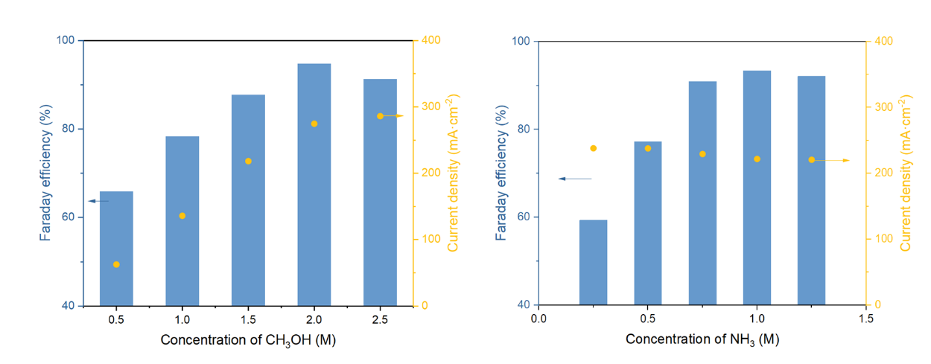
Supplementary Figure 19. FE of urotropine and current density of urotropine varies with the concentration of methanol and ammonia, respectively, at 1.5 V.

With a low concentration of methanol, the TEMPO+ produced by electrooxidation could not be consumed in a timely manner, so the rate of TEMPO redox cycles rate was suppressed, and the current density was limited. When the methanol concentration is too high (>2 M), the current density no longer changes, but the FE decreases slightly. This may be due to the partial direct oxidation of methanol as well as the peroxidation of formaldehyde. However, for ammonia, the level of concentration does not change the current density. This result is natural, considering that the current density is only related to the TEMPO redox cycles. When a small amount of ammonia was added, the formaldehyde produced in the electrolyte could not be consumed in time; the TEMPO+, as well as the anode, oxidizes the formaldehyde to obtain formic acid, which reduces the selectivity of the urotropine.
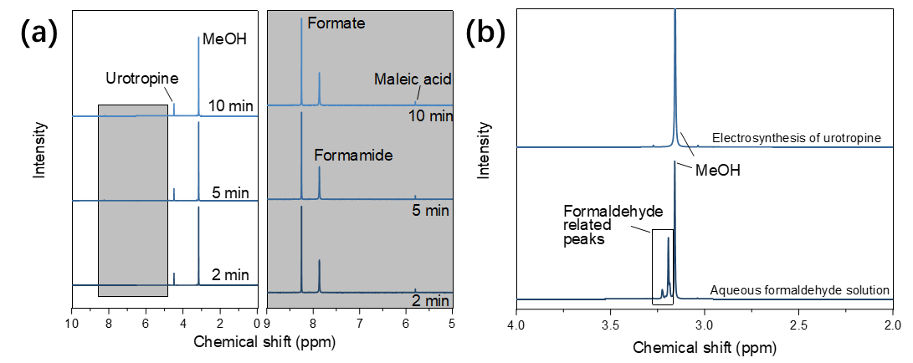
Supplementary Figure 20. (a) Results of NMR testing conducted immediately after the urotropine electrosynthesis system. (b) Comparison of NMR results between the electrolyte from urotropine production and a standard aqueous formaldehyde solution.

The main byproducts detected in the electrosynthesis of urotropine were formamide and formic acid (Supplementary Fig. 9). Among them, formic acid, in addition to being a direct oxidation product of formaldehyde, may also result from the Cannizzaro disproportionation of formaldehyde, thus belonging to non-Faradaic processes. We conducted the experiment in which the post-reaction electrolyte was rapidly transferred to the NMR spectrometer for analysis as quickly as possible. The peak area of formic acid did not increase at 2 minutes, 5 minutes, and 10 minutes after the reaction. This indicates that the Cannizzaro disproportionation of formaldehyde ceased within at least 2 minutes after the electrochemical reaction stopped. Similarly, no peaks related to formaldehyde were observed in the NMR spectrum at the 2-minute, suggesting the concentration of formaldehyde is sufficiently low, making Cannizzaro disproportionation unlikely to produce substantial formic acid. Based on the above discussion, we conclude that non-Faradaic processes do not affect our estimation of the FE or the carbon balance of the products.

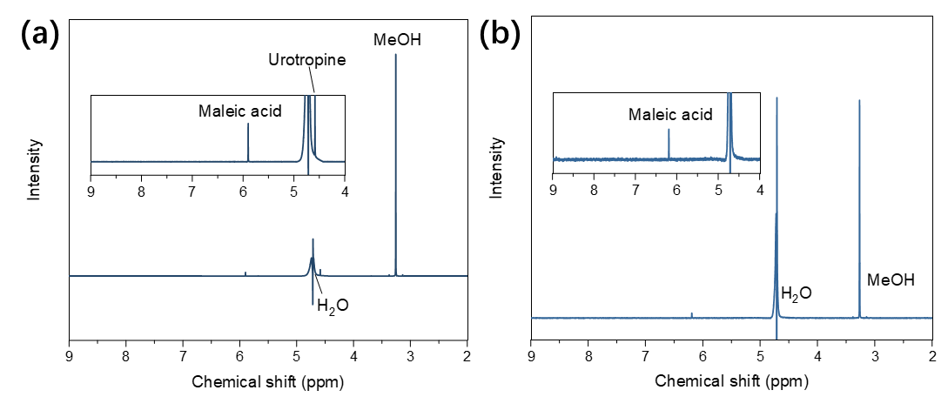
Supplementary Figure 21. (a) Characterization of the substance distribution in the electrolyte on the counter electrode side using NMR. (b) Characterization of substances adsorbed on the ion exchange membrane using NMR.

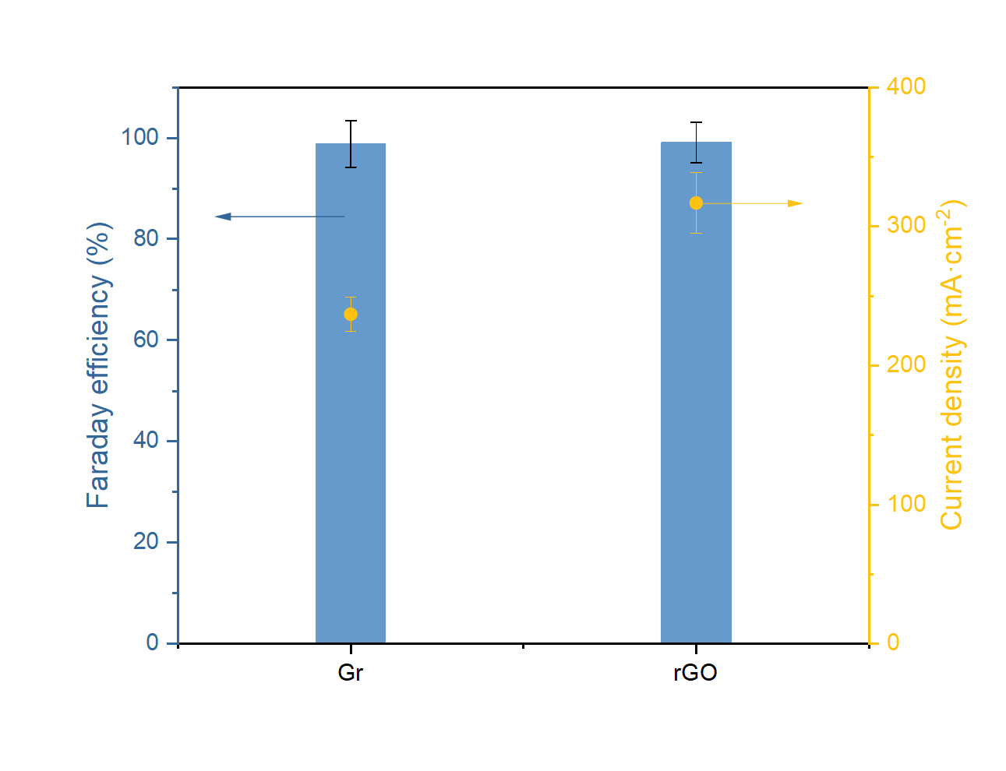
Supplementary Figure 22. Comparison of current and urotropine FE between Gr and rGO under the same electrolysis conditions.

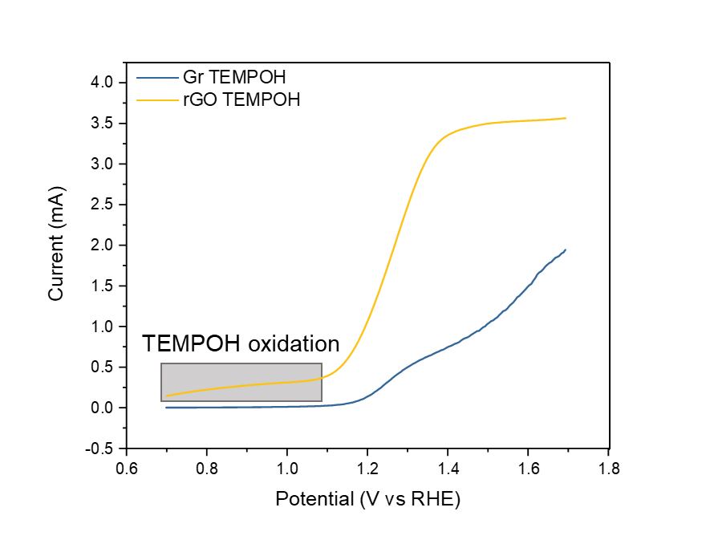
Supplementary Figure 23. LSV curves of oxidized TEMPOH in the presence of methanol using a rotating disk electrode (RDE).

Considering that during actual electrolysis, the concentration of TEMPO in solution decreases while the concentration of TEMPOH increases, TEMPO in the solution was replaced with TEMPOH to probe the oxidizing ability of the two carbon materials. We found that rGO has a significantly larger oxidation current relative to Gr. Also, we noted that rGO shows oxidation currents at lower overpotentials, whereas Gr does not show a significant increase in current until it reaches the oxidation potential of TEMPO. This may indicate that the difference in activity between the two in electrolysis stems from their difference in TEMPOH oxidizing ability.

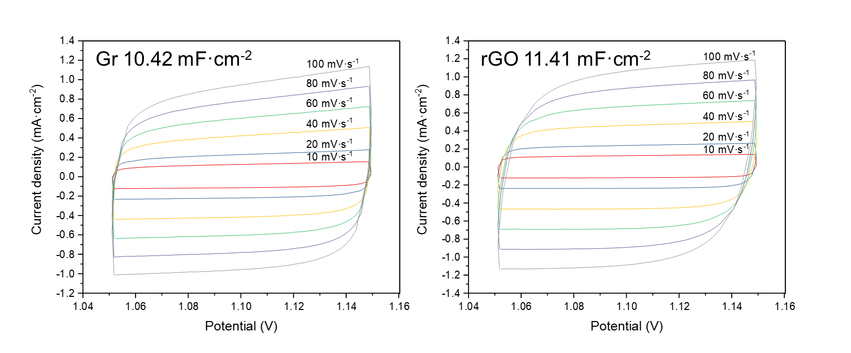
Supplementary Figure 24. The double-layer capacitance of Gr and rGO obtained at different scan rates.

Supplementary Figure 25. In situ surface-enhanced infrared absorption spectroscopy (SEIRAS) spectra of TEMPOH oxidation on rGO.

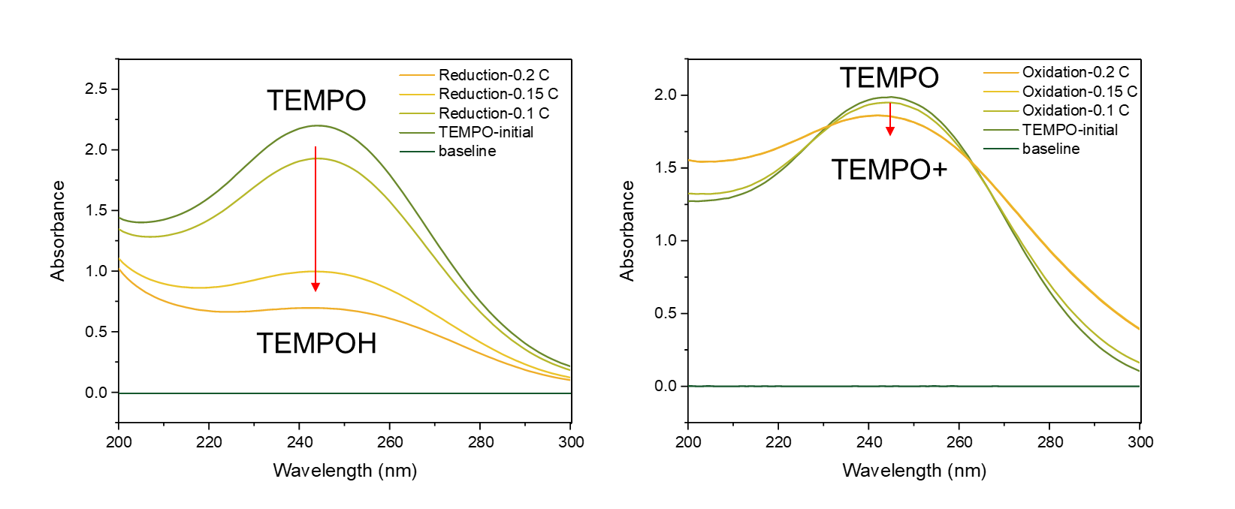
Supplementary Figure 26. In situ UV-vis detection of the electrochemical conversion of TEMPO to TEMPOH and TEMPO+. During the conversion of TEMPO to TEMPOH, the absorption peak at 244 nm significantly decreases. In contrast, the same amount of TEMPO converting to TEMPO+ shows less of a decrease at 244 nm but an increase in absorbance around 290 nm. By utilizing the different absorbances of TEMPO+ and TEMPOH at 244 nm, we can qualitatively analyze the concentration changes of TEMPO/TEMPO+/TEMPOH during the electrochemical reaction process. Note that all the electrolyte here are methanol-free to avoid the interference from chemical reaction between TEMPO+ and methanol, which would consume TEMPO+ and yield TEMPOH.

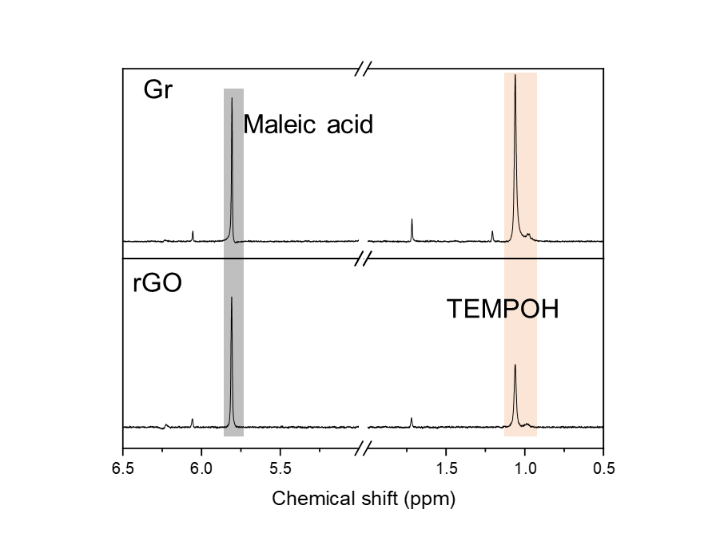
Supplementary Figure 27. ¹H NMR spectrum of verifying the concentration of TEMPOH. Under the same electrolysis conditions, the concentration of TEMPOH in the electrolyte is lower with the rGO electrode than with the Gr electrode.

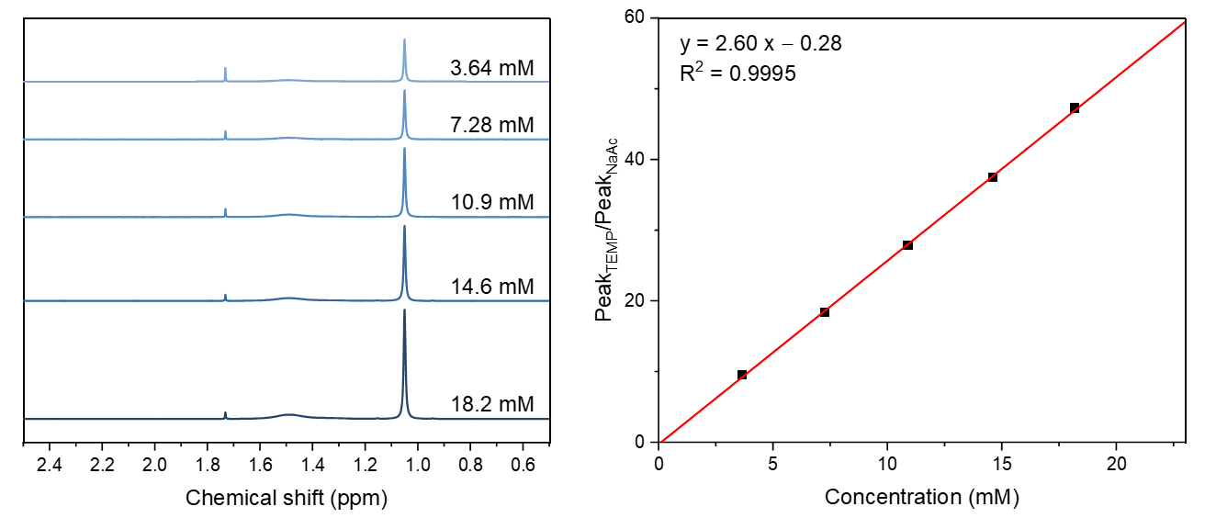
Supplementary Figure 28. Quantitative analysis of TEMPOH using NMR, where the ratio of the peak area of TEMPOH (~1.1 ppm) to the internal standard NaAc (~1.75 ppm) varies linearly with the concentration of urotropine.

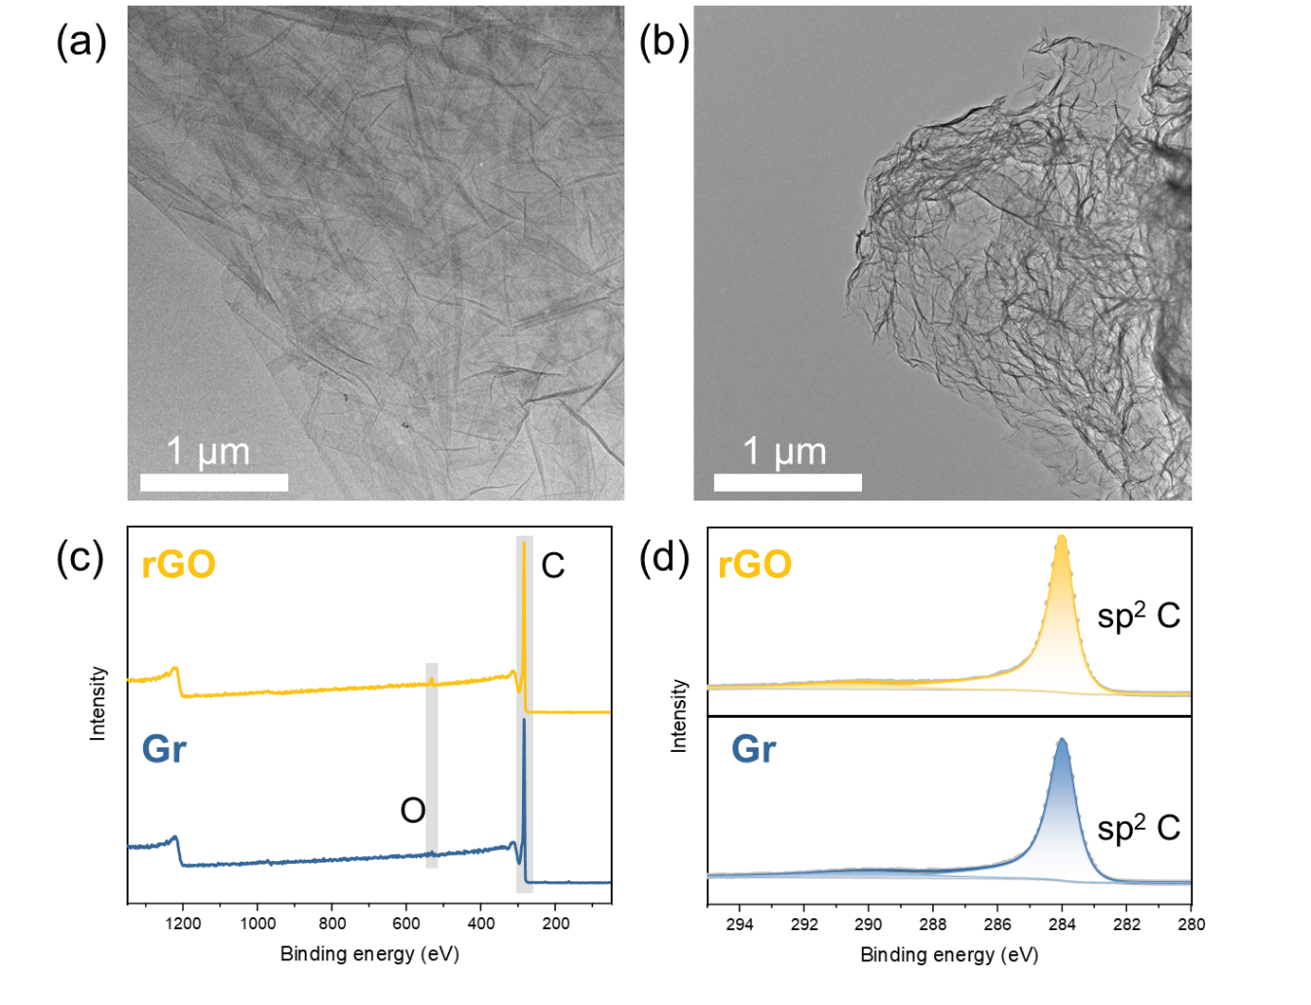
Supplementary Figure 29. (a,b) Transmission electron microscopy (TEM) and (c,d) X-ray photoelectron spectroscopy (XPS) of Gr and rGO.

In TEM images, Gr and rGO exhibit similar morphologies, showing partially overlapping thin layers. Further analysis using XPS on the surface valence states of both materials reveals a high degree of similarity. Figure c shows that the main component of both structures is carbon, with very small amounts of oxygen present. In the C1s XPS spectra, both carbon materials display characteristic peaks of sp² hybrid C.

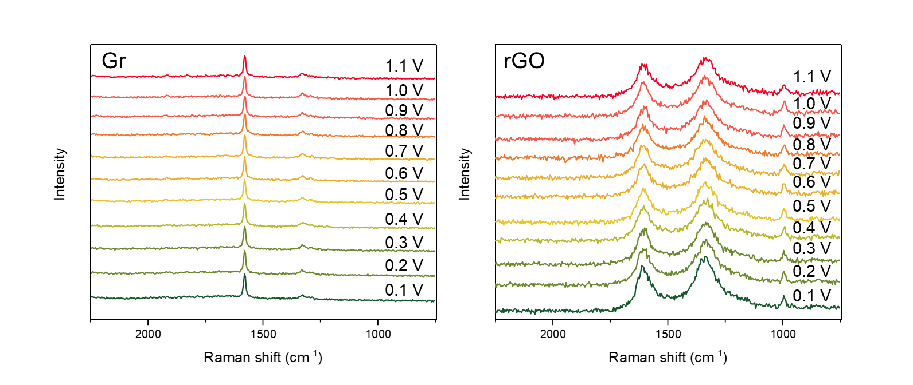
Supplementary Figure 30. In situ Raman spectroscopy study of Gr and rGO in the electrosynthesis of urotropine.

The D and G peaks of both Gr and rGO do not show significant changes, indicating that the structures of both remained stable during the reaction process. The peak in 1000 cm⁻¹ is attributed to phosphate in the electrolyte.

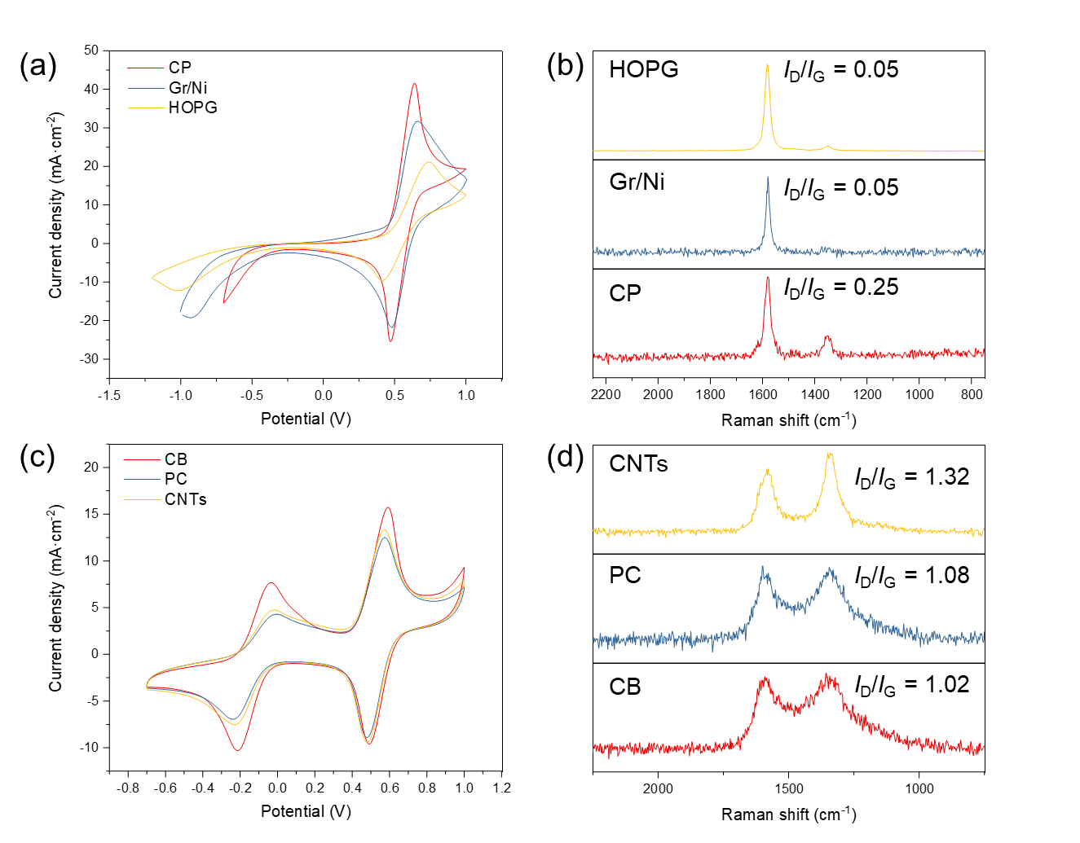
Supplementary Figure 31. (a,c) CV curves of carbon materials without (a) and with (c) TEMPOH oxidation activity. (b,d) Raman spectra of carbon materials without (b) and with (d) TEMPOH oxidation activity.

In this figure, CP stands for hydrophilic carbon paper. Gr/Ni represents a few-layer graphene grown on a Ni film using the CVD method. HOPG refers to highly oriented pyrolytic graphite, which has a high surface crystallinity and a high exposure rate of graphene layers. CB stands for carbon black, commercially known as Vulcan XC-72. PC denotes porous carbon, a carbon material with a porous structure. CNTs represent multiwall carbon nanotubes with an inner diameter of about 70 nm and a length of about 10 μm. All these materials are commercial products and were not further purified after purchase. Carbon materials with a high I_{D}/I_{G} ratio exhibit good TEMPOH oxidation activity, while materials with poor TEMPOH oxidation activity have a lower D peak. This result demonstrates the correlation between the D peak in Raman spectra and the TEMPOH oxidation activity of carbon materials. CV curves here were recorded without iR compensation.

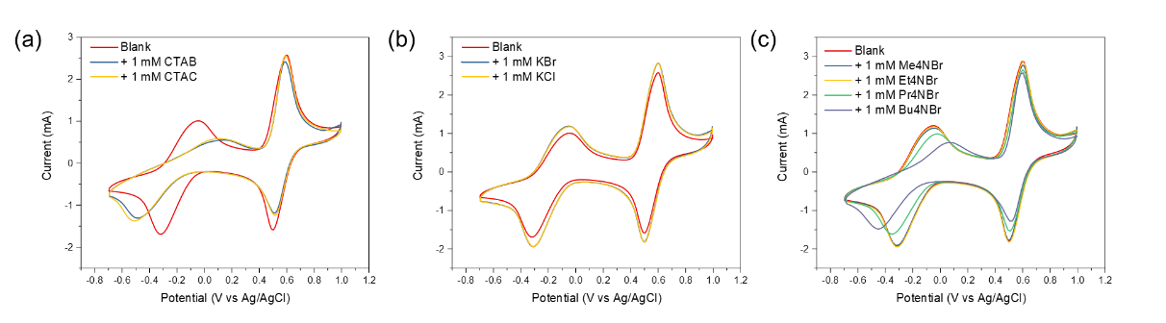
Supplementary Figure 32. Catalytic activities inhibition using surfactants. (a) Influence of adding 1 mM CTAB and CTAC. (b) Control experiments using 1 mM KBr and KCl. (c) Effect of different sizes of cationic surfactants.

By adding 1 mM surfactants into the electrolyte containing 20 mM TEMPOH, we noticed that both TEMPOH oxidation and TEMPO reduction were significantly inhibited while TEMPO/TEMPO+ interconversion remain unchanged. Peaks of TEMPOH/TEMPO redox pair were shifted by more than 100 mV, but those of TEMPO/TEMPO+ remained unchange. Control experiments using corresponding concentration of KBr and KCl showed negligible change in peaks, thus ruling out the possibility that anion participate the inhibition process. Test using different size of cations further validate the conclusion that cationic surfactants indeed hinder the adsorption of TEMPOH on the rGO surface but little impact the oxidation of TEMPO. Different influence for TEMPOH and TEMPO oxidation on the same electrode (rGO) indicate that they undergo different pathway or have different mechanism. Given that TEMPO oxidation has same oxidation performance in almost all the carbon materials despite with or without carbon defects, we believe the TEMPO oxidation on electrode is an outer-sphere (OS) process, which is consistent with our findings that its oxidation is not affect by surfactants.

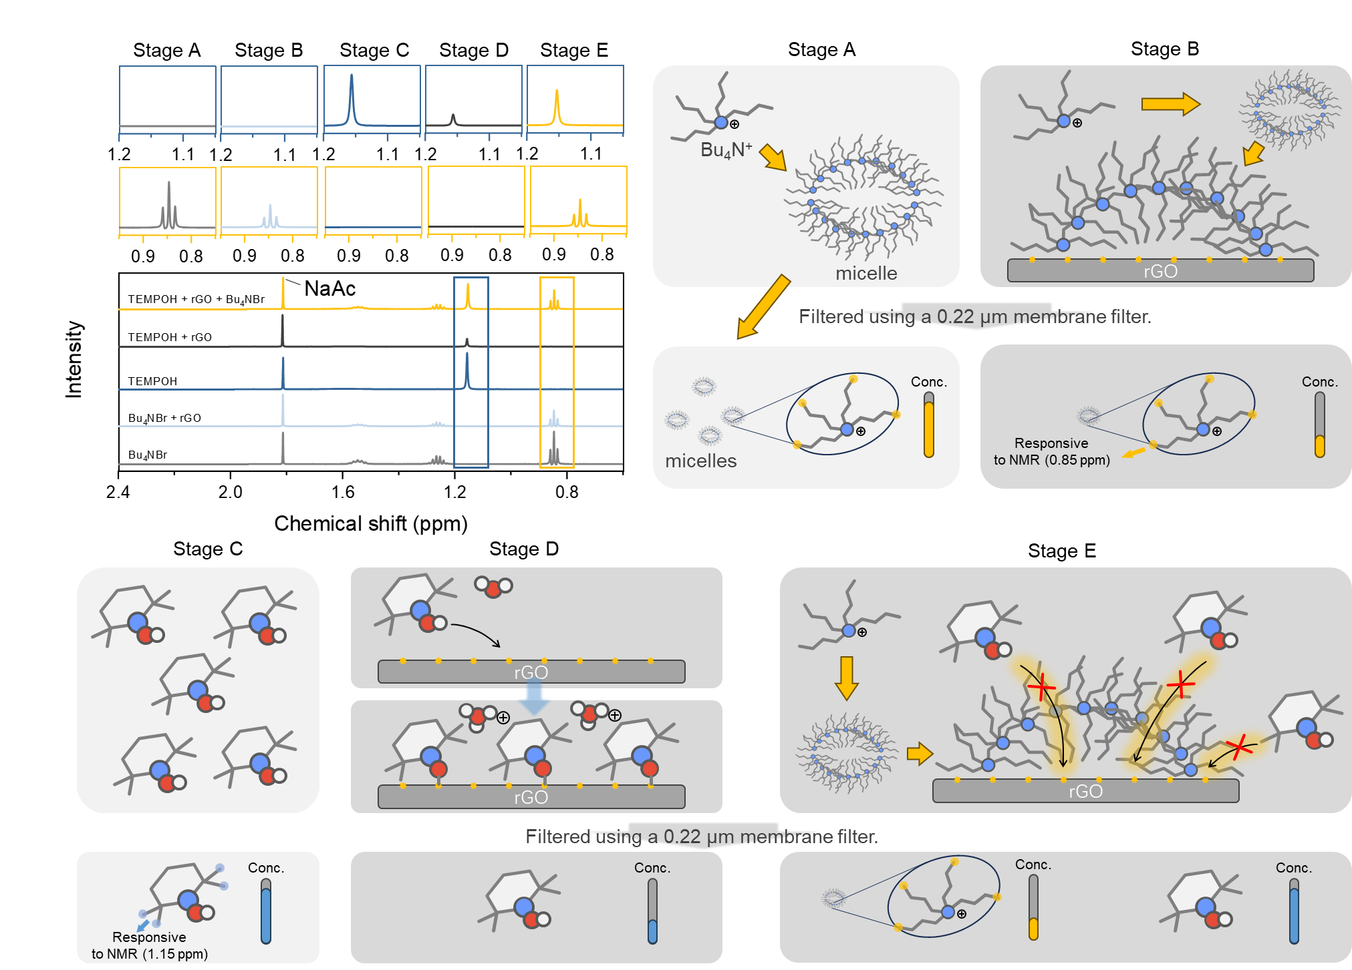
Supplementary Figure 33. Detection of TEMPOH and Bu₄NBr adsorption on carbon defects using NMR and related cartoon schemes.

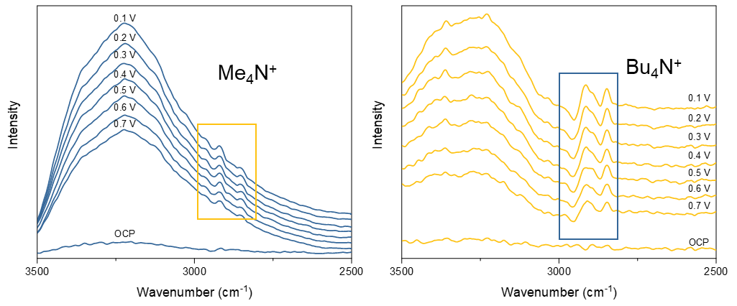
Supplementary Figure 34. In situ SEIRAS spectra of rGO decorated electrode in an PBS buffer (without TEMPO or MeOH) electrolyte with Me₄NBr and Bu₄NBr, respectively.

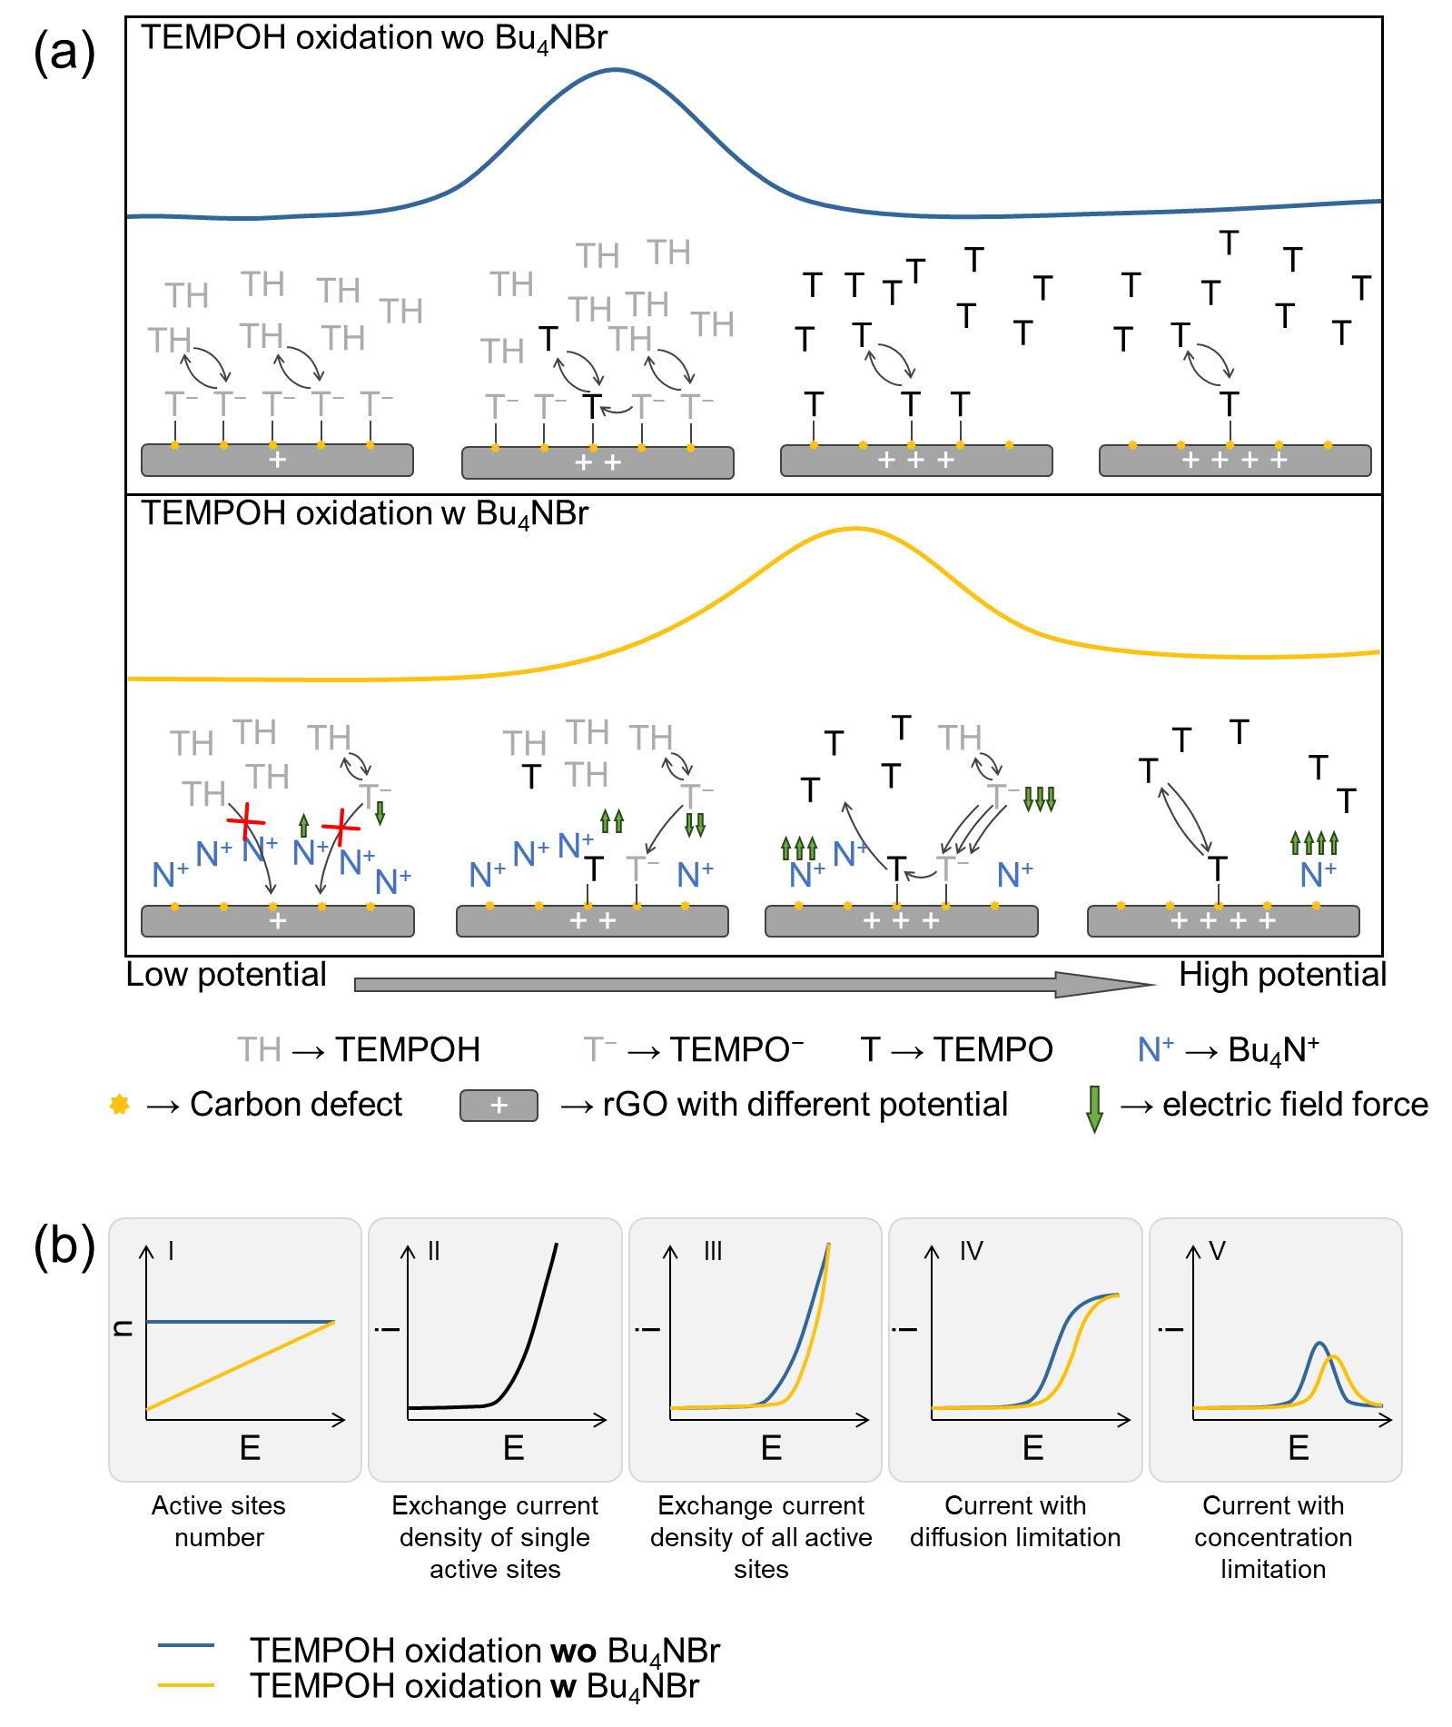
Supplementary Figure 35. (a) Schematic of the catalytic activities inhibition with surfactants. (b) Derivation of the relationship between the shift in the TEMPOH oxidation peak position and changes in the number of active sites.
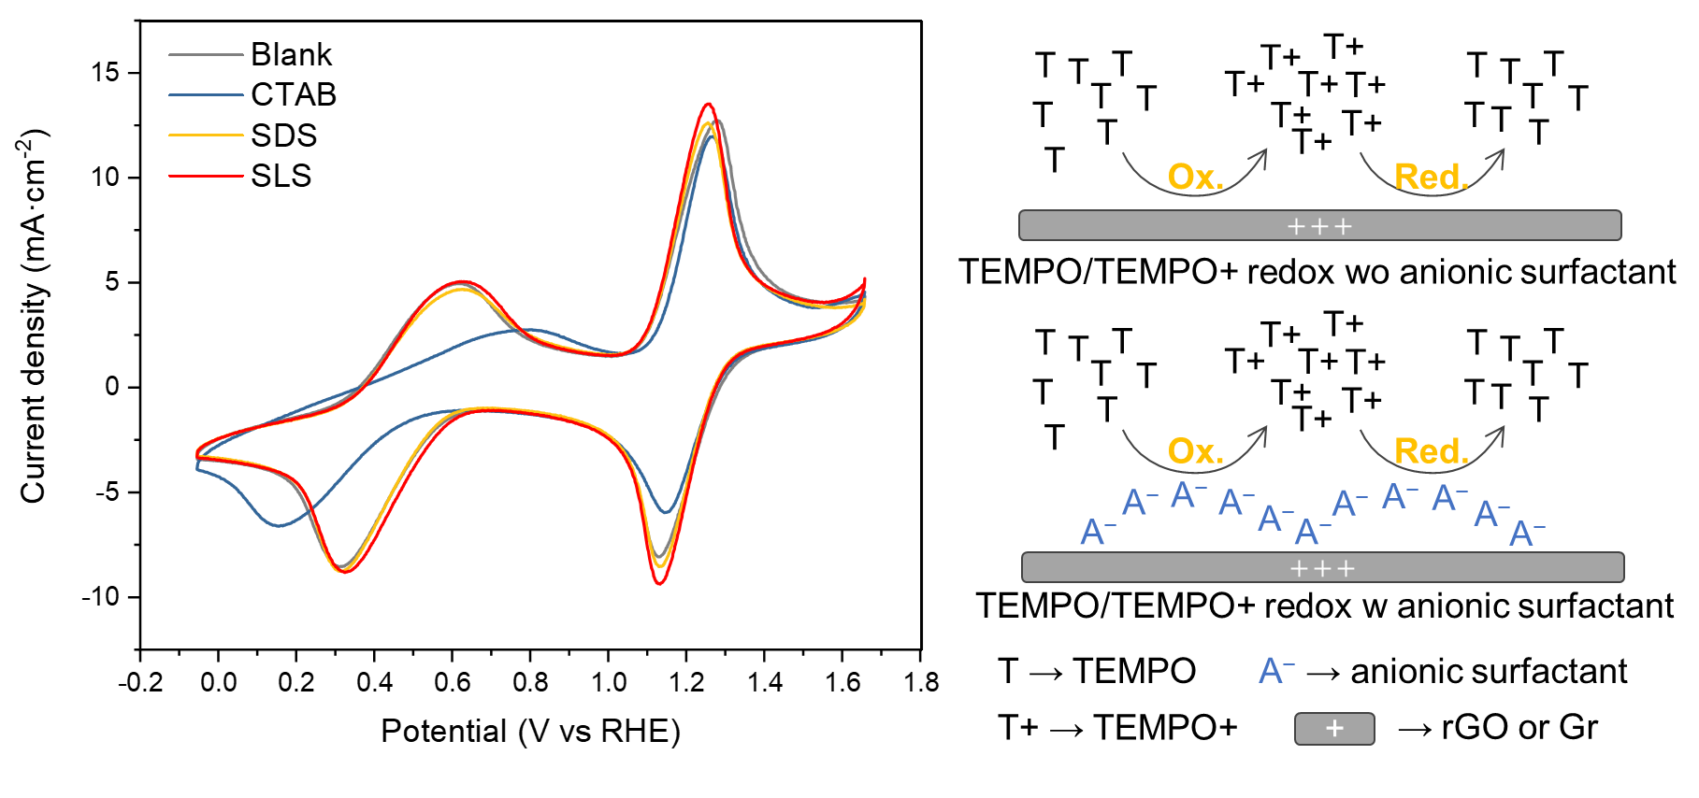
Supplementary Figure 36. Catalytic activities inhibition using surfactants.

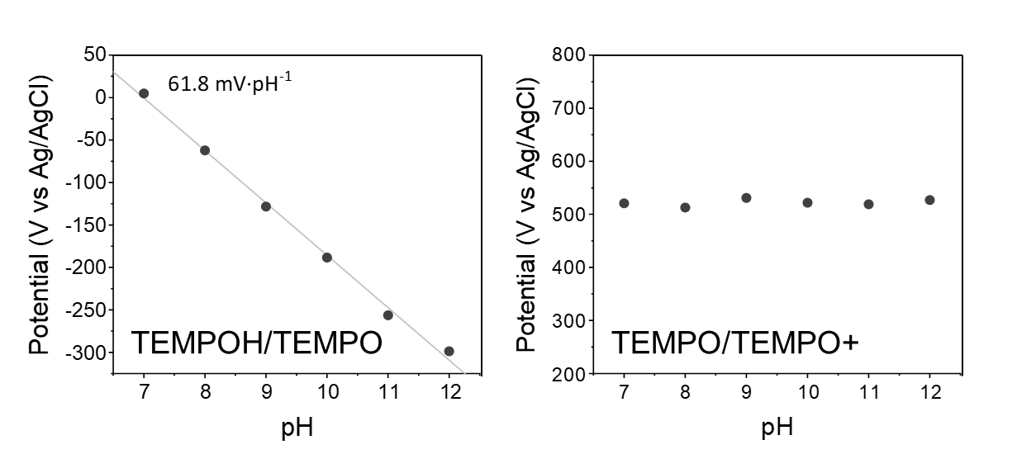
Supplementary Figure 37. Equilibrium positions of TEMPOH/TEMPO and TEMPO/TEMPO+ redox peaks vary with pH.

In this figure, the equilibrium positions of the TEMPOH/TEMPO redox peaks shift linearly with pH changes, with a slope of 61.8 mV per pH unit, which is close to the theoretical value of 59 mV^{5,6} per pH unit for a single-electron proton-coupled transfer process. The TEMPO to TEMPO+ redox potential does not change with pH, which is consistent with the fact that the TEMPO/TEMPO+ redox pair involves the transfer of only one electron^{5,6}.

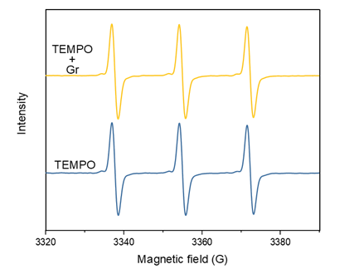
Supplementary Figure 38. Detection of TEMPO adsorption on Gr using EPR.

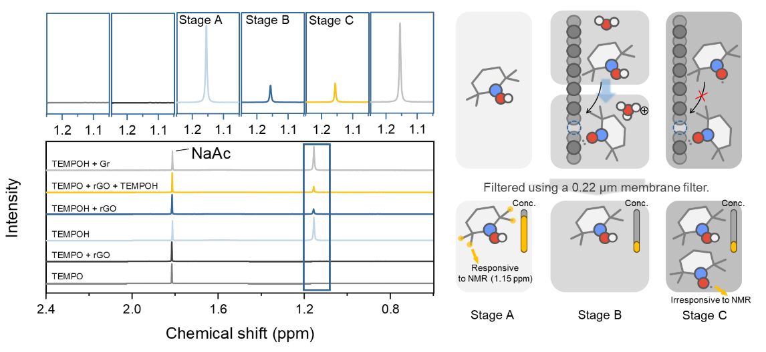
Supplementary Figure 39. Detection of TEMPO and TEMPOH adsorption on carbon defects using NMR.

It is evident that TEMPO, due to the influence of unpaired electrons in its structure, does not exhibit normal peak signals in NMR, whereas TEMPOH shows a sharp peak. Additionally, when a certain amount of rGO was added to the TEMPOH solution, the corresponding NMR signal for TEMPOH significantly decreased. In contrast, adding an equivalent amount of Gr did not cause noticeable changes. These results demonstrate that TEMPOH can effectively adsorb onto carbon defects, consistent with the findings from the EPR experiments. Furthermore, when TEMPO was added to the TEMPOH solution followed by rGO, the concentration of TEMPOH in the solution did not change significantly compared to the case without TEMPO. This indicates that TEMPO does not interfere with the adsorption of TEMPOH on carbon defects, meaning the adsorption strength between TEMPO and carbon defects is weaker than that of TEMPOH. Once again, this result aligns with our EPR findings and is fully consistent with the adsorption energy differences obtained from our DFT calculations.

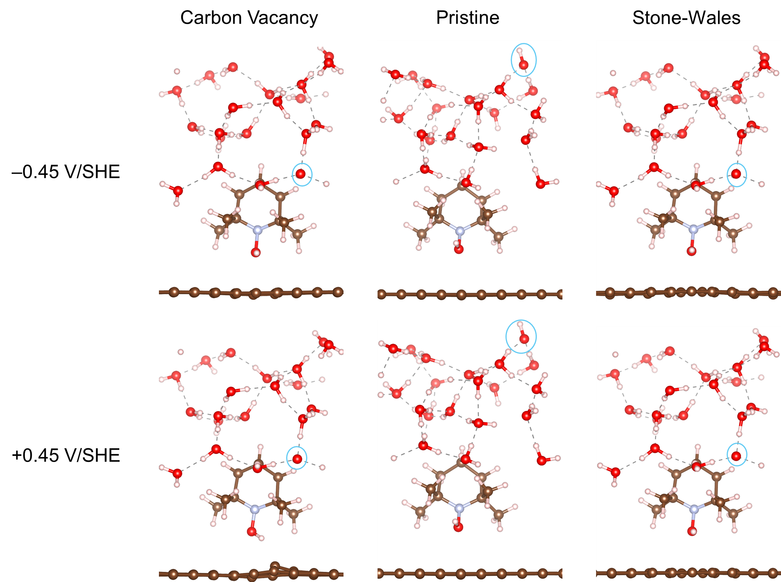
Supplementary Figure 40. TEMPOH on pristine graphene and defected graphene under potential of −0.45 V and +0.45 V. OH⁻ groups in the solvent have been circled by blue lines.

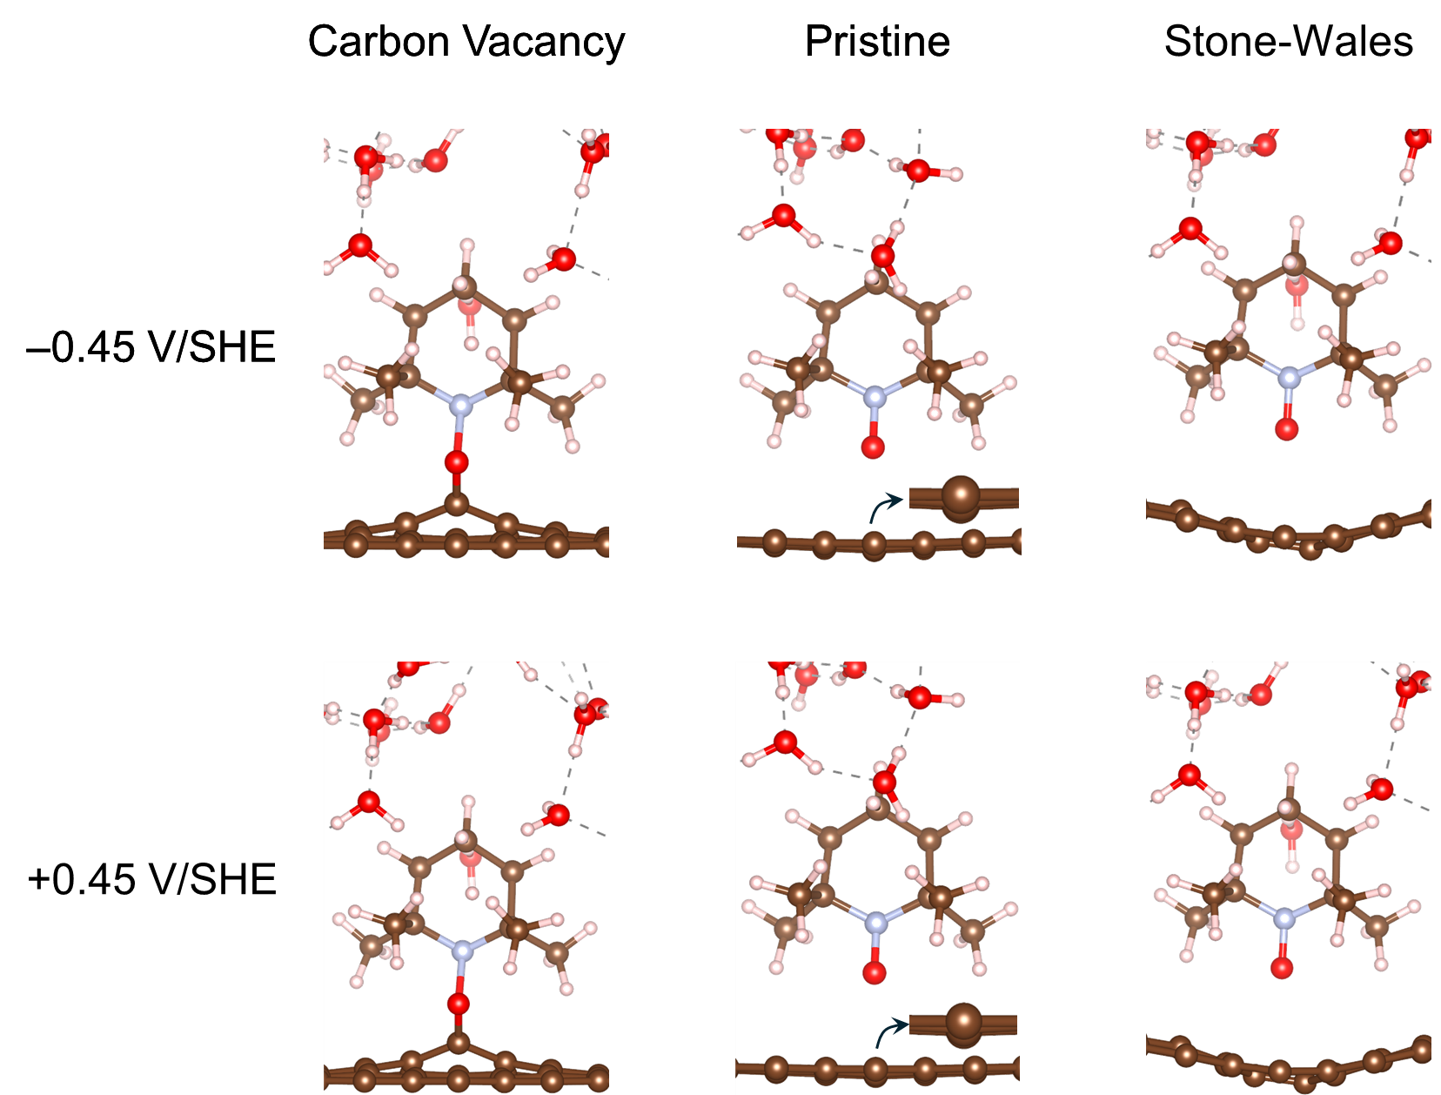
Supplementary Figure 41. Structures of TEMPO* on pristine graphene and defected graphene under potential of −0.45 V and +0.45 V.

Specifically, we calculated the interaction energies of TEMPO positioned at two distinct distances from the graphene surface—2.28 Å and 2.76 Å—corresponding to adsorbed and dissolved states, respectively. Our results indicate that the closer configuration (2.28 Å) exhibits higher energy (approximately 0.14 eV higher) compared to the more distant configuration (2.76 Å). This reveals that TEMPO adsorption on pristine graphene is energetically unfavorable. Structural analysis further shows that, upon approaching TEMPO, carbon atoms in the graphene layer are displaced downward, clearly evidencing a repulsive interaction between TEMPO and pristine graphene. Subsequently, we expanded our investigation to the oxidation behavior of TEMPOH on graphene surfaces with structural defects, specifically the Stone–Wales defect and the carbon vacancy defect. For graphene containing a Stone–Wales defect, the interaction pattern resembles that of the pristine graphene case. When TEMPOH approach the Stone–Wales defect site, significant wrinkling and concave deformation beneath TEMPO are observed, indicating structural instability. Therefore, graphene with a Stone–Wales defect does not appear to facilitate the oxidation of TEMPOH. In contrast, graphene featuring a carbon vacancy defect shows distinctly different interactions. TEMPOH can favorably adsorb onto carbon atoms adjacent to the vacancy site, suggesting that such defect sites may stabilize TEMPO adsorption and potentially promote TEMPOH oxidation.

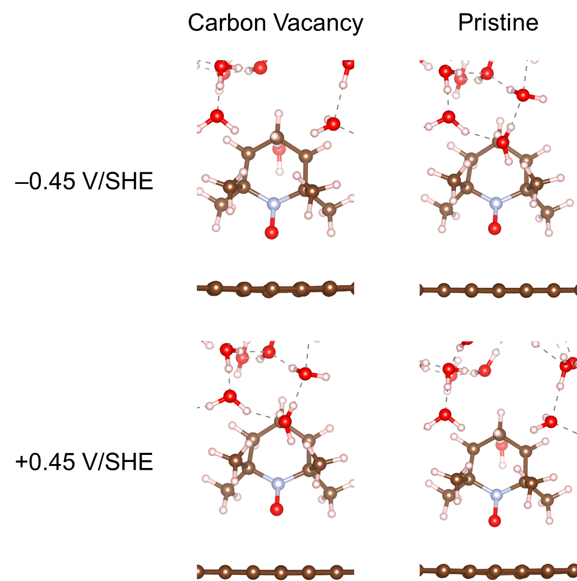
Supplementary Figure 42. Structures of TEMPO in the solvent on pristine graphene and defected graphene under potential of −0.45 V and +0.45 V.

Supplementary Figure 43. LSV curves of the HER at the cathode in electrolytes with varying methanol concentrations.

As the penetration of methanol through ion exchange membranes is a common and difficult-to-avoid issue^{7,8}, we tested the influence of MeOH to the HER on cathode. The results indicate that even in 2 M MeOH, the HER performance at the cathode is not affected. This is consistent with previous reports^{9,10}. Although N117 cannot block the penetration of alcohols, its structure maintains relatively long-term stability in methanol aqueous solutions (40 h¹¹, 40 h¹², and 100 h¹³), that is, the ion exchange membrane can withstand certain methanol concentrations without structural degradation. Based on the above discussion, employing a Nafion N117 ion-exchange membrane for urotropine production ensures the stable operation of the reaction system.

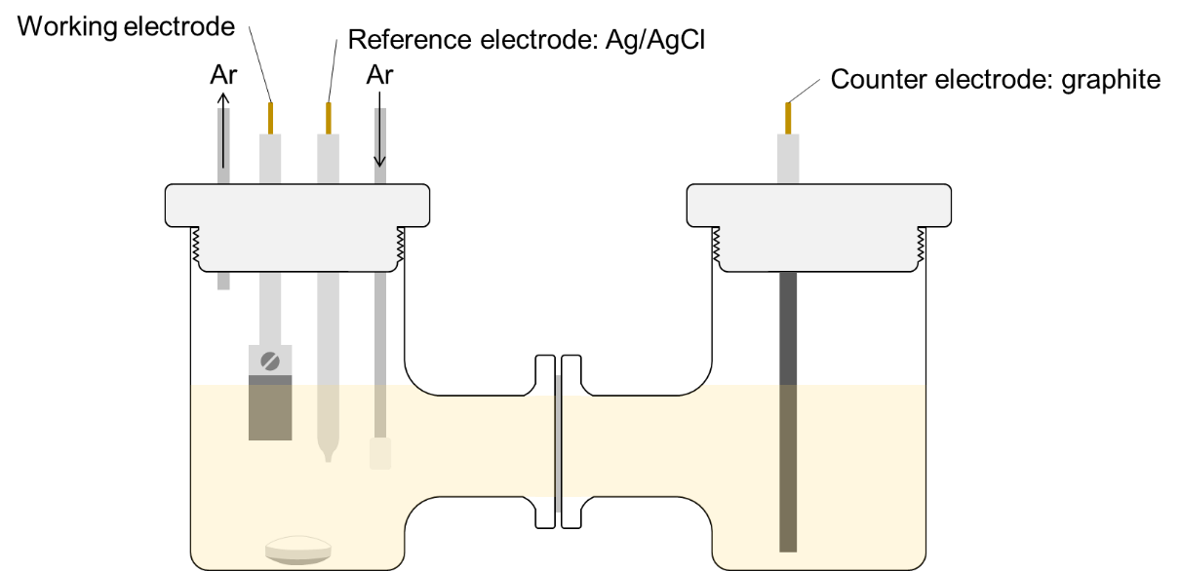
Supplementary Figure 44. Diagram of H-cell used in this work.

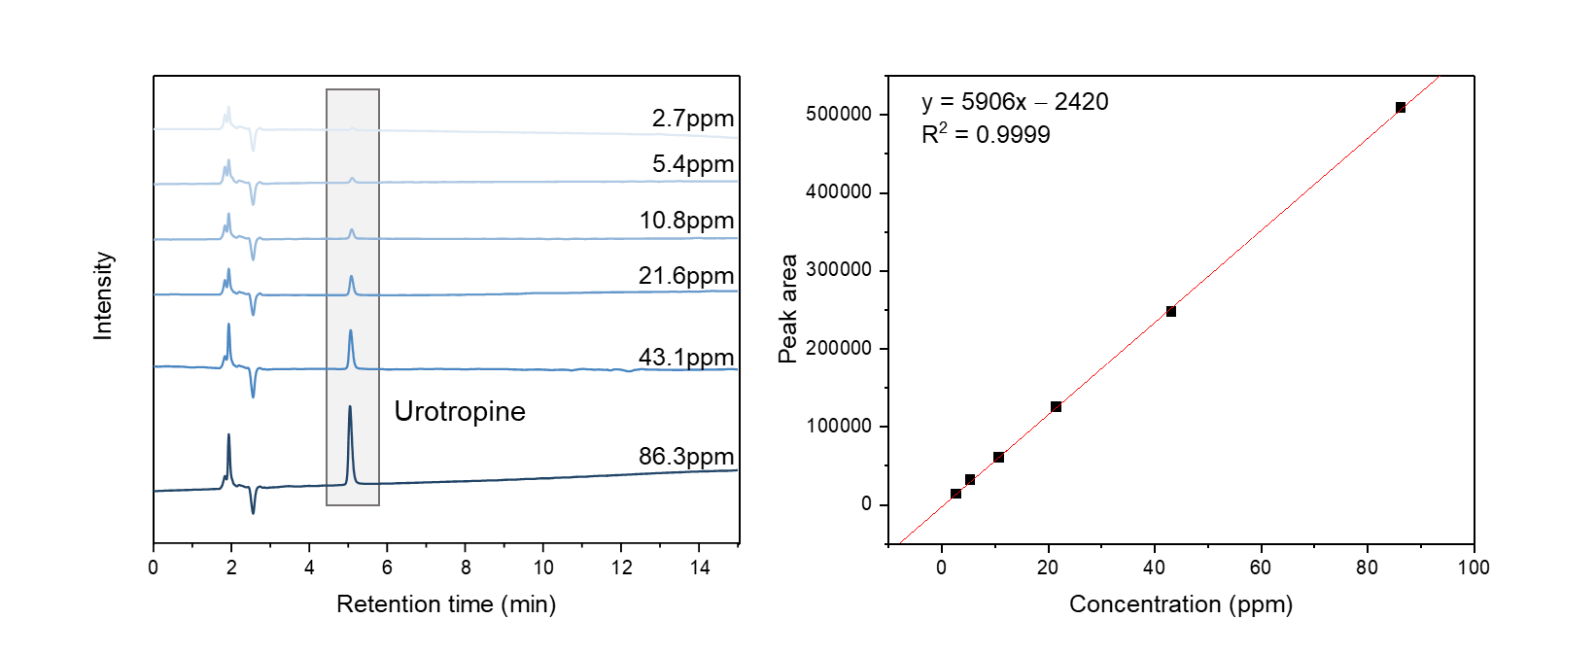
Supplementary Figure 45. Quantitative analysis of urotropine using high-performance liquid chromatography (HPLC).

Supplementary Figure 46. Comparison of quantitative results of urotropine using ¹H NMR and HPLC.

The quantitative results from ¹H NMR and HPLC showed good consistency, with the HPLC results being slightly lower than those from NMR. This discrepancy may be due to minor product loss during the evaporation and redissolution processes during the pretreatment of HPLC samples.

Supplementary Figure 47. HPLC spectra of electrolyte before and after the urotropine electrosynthesis. No containment from pure electrolyte was detected.

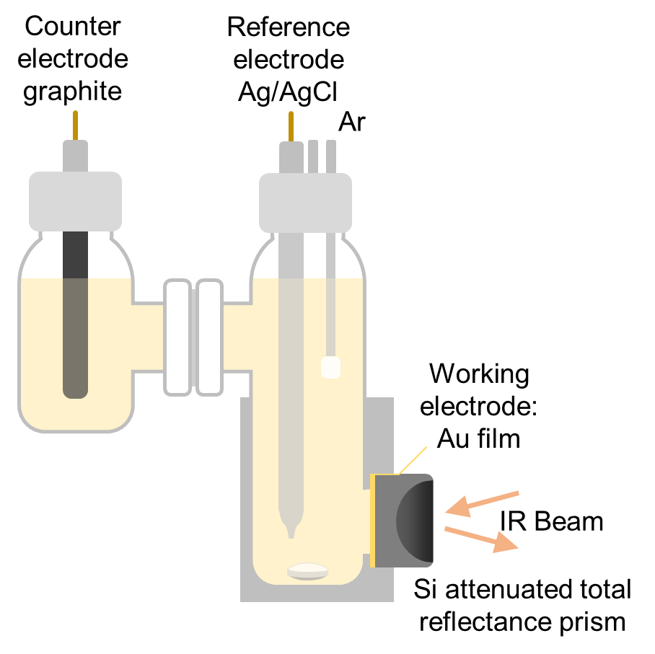
Supplementary Figure 48. Schematic of the setup of in situ SEIRAS.

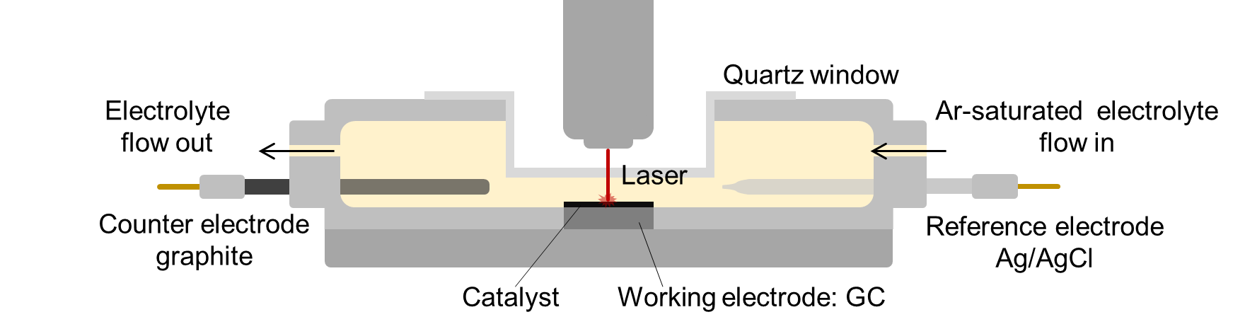
Supplementary Figure 49. Schematic of the setup of in situ Raman spectroscopy.

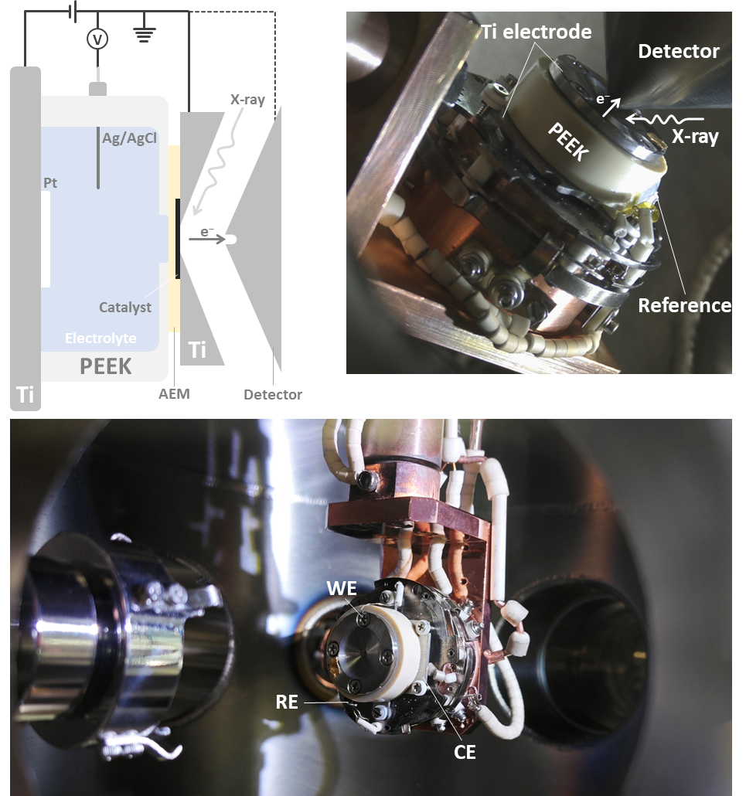
Supplementary Figure 50. Schematic of the in situ near ambient pressure X-ray photoelectron spectroscopy (NAP-XPS) testing apparatus and photos of the actual detection cell.

According to our experience, the Nafion N117 proton exchange membrane lacks sufficient strength, and is difficult to maintain the airtight structure of the electrolytic cell in the high vacuum environment where the in situ detection cell is located. In contrast, the Fumasep FAA-3-PK-75 exhibits excellent structural strength, effectively withstanding the pressure difference across the membrane caused by the high vacuum environment, thereby providing better stability for our tests. Furthermore, prolonged exposure to the vacuum environment can cause water evaporation (as evidenced by the H₂O(g) signal observed in Fig. 4b). The use of a high-concentration (0.5 M) electrolyte may lead to salt precipitation during extended testing due to gradual water loss. This could result in severe issues such as circuit interruption or even membrane damage, thus employing a lower-concentration (0.1 M) electrolyte helps mitigate the potential risks associated with water loss.

Supplementary Figure 51. At a pH of 13, linear sweep voltammetry (LSV) curves of KOH, KOH + NH₄Cl, and KOH + CH₃OH, respectively.

Supplementary Figure 52. Under strongly alkaline conditions with a pH greater than 12, TEMPO+ binds with hydroxide ions, becoming electrochemically inert.

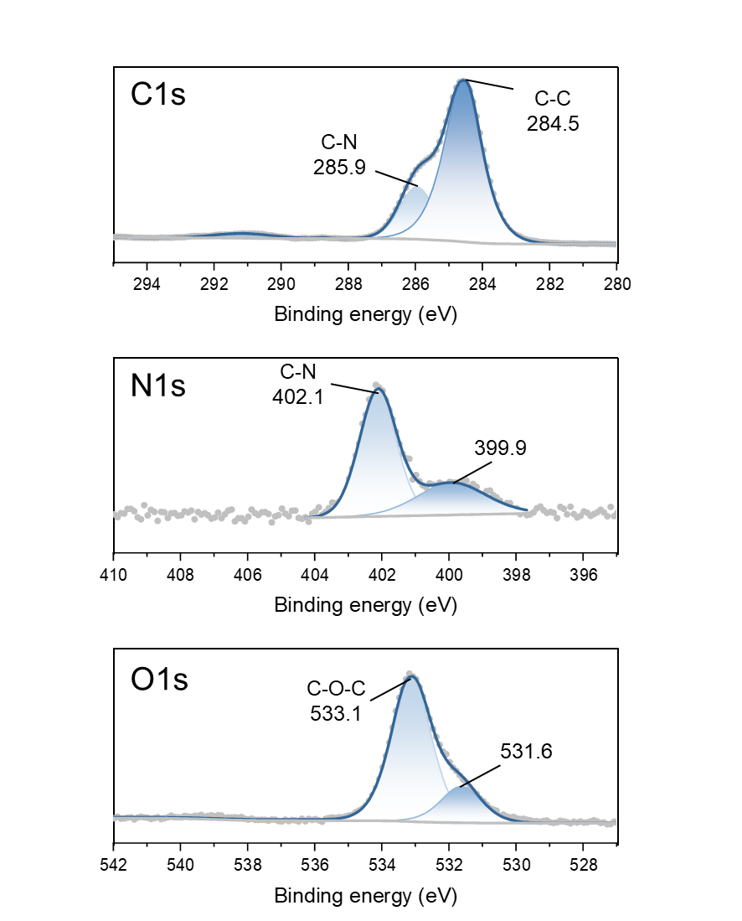
Supplementary Figure 53. XPS of commercial Fumasep FAA-3 anion exchange membrane (AEM).

The O1s signal at 531.6 eV for O-N in main text Fig. 4b decreased into a non-zero value is attributed to be a minor quantity of residue oxygen signal from the AEM.

Supplementary Table 1. Detailed HRFTMS data of urotropine with different deuterated nuclei.
Product | m/z  in experiment | Relative intensity/% | m/z  in theory | Relative intensity/%
Urotropine  N₄(CH₂)₆ | 141.11397 | 100 | 141.113473 | 100
Urotropine  N₄(CH₂)₆ | 142.11748 | 4.664 | 142.116893 | 6.639
Urotropine  N₄(CH₂)₆ | 143.12080 | 0.107 | 143.120336 | 0.185
¹⁵N-Urotropine  ¹⁵N₄(CH₂)₆ | 145.10225 | 100 | 145.101612 | 100
¹⁵N-Urotropine  ¹⁵N₄(CH₂)₆ | 146.10560 | 6.353 | 146.105033 | 6.639
¹⁵N-Urotropine  ¹⁵N₄(CH₂)₆ | 147.11035 | 1.414 | 147.108475 | 0.185
D-Urotropine  N₄(CD₂)₆ | 153.18912 | 100 | 153.188794 | 100
D-Urotropine  N₄(CD₂)₆ | 154.19133 | 7.897 | 154.190993 | 7.962
D-Urotropine  N₄(CD₂)₆ | 155.19139 | 1.264 | 155.193300 | 0.271

Supplementary Table 2. FE of electrodes in urotropine electrosynthesis.
Electrode |  | FE/%
Without TEMPO | Au | <5
Without TEMPO | Co | <5
Without TEMPO | Cu | <5
Without TEMPO | Zn | <5
Without TEMPO | Ti | <5
Without TEMPO | CP | 12
Without TEMPO | HOPG | 10
With TEMPO | Au | 54
With TEMPO | Co | 47
With TEMPO | Cu | 7.2
With TEMPO | Zn | <5
With TEMPO | Ti | 37
With TEMPO | CP | 85
With TEMPO | HOPG | 87

Both Cu and Zn dissolved partially after electrolysis, leading to a significantly lower FE. This may be attributed to the fact that transition metal ions are readily attacked by ammonia, forming more stable complex ions, thereby promoting the dissolution of the electrode and consuming a significant number of electrons.

Supplementary Table 3. Quantitative results of substances before and after electrolysis.
 |  | MeOH  mmol | Urotropine  mmol | Formate  mmol | Formamide  mmol | HCHO  mM
Before electrolysis | Working | 199.8 | 0 | 0 | 0 | 0
Before electrolysis | Counter | 0 | 0 | 0 | 0 | 0
Before electrolysis | Membrane | 0 | 0 | 0 | 0 | 0
After electrolysis | Working | 194.0 | 0.693 | 0.025 | 0.008 | 0
After electrolysis | Counter | 1.2 | 0.0023 | 0 | 0 | 0
After electrolysis | Membrane | 0.11 | 0 | 0 | 0 | 0

The electrolyte from the counter electrode side after the reaction was analyzed using NMR (Supplementary Fig. 21a) to quantify the loss of the main reactants and products (methanol and urotropine) due to membrane crossover. To detect substances adsorbed on the membrane, we soaked the ion exchange membrane, which was cut into pieces after the reaction, in approximately 0.5 mL of pure water and then stirred overnight. The leachate was then analyzed using NMR to determine the content of adsorbed substances (Supplementary Fig. 21b). The NMR results indicate that methanol, urotropine and trace formate crossed over to the counter electrode side through the membrane, while the membrane itself adsorbed a small amount of methanol without significant retention of urotropine. Based on the above discussion, we summarized the carbon balance in the urotropine production system, and the results are presented in Supplementary Table 3. The calculated carbon balance within the electrosynthesis of urotropine is 94.0%, as detailed below:
Carbon balance
= (6 × n_{Utrotropine} + n_{Formate} + n_{Formamide}) / n_{MeOH_consumed}
= (6 × (0.693 + 0.0023) + 0.025 + 0.008) × 100% / (199.8 – 194.0 – 1.2 – 0.11)
= 94.0%

Supplementary Table 4. Bader charge for each component under −0.45 and +0.45 V
Potential  Vs. SHE | Systems | Component | Charge |e‒|
Potential  Vs. SHE | Systems | Component | rGOª | PG^{b} | SW^{c}
−0.45 | TEMPOH | graphene | −0.11 | −0.01 | −0.02
−0.45 | TEMPOH | TEMPO | 0.18 | 0.07 | 0.10
−0.45 | TEMPOH | Solvent | −0.97 | −0.99 | −0.97
−0.45 | TEMPO* | graphene | 0.19 | −0.07 | −0.04
−0.45 | TEMPO* | TEMPO | −0.56 | 0.00 | −0.01
−0.45 | TEMPO* | Solvent | −0.02 | 0.00 | −0.01
−0.45 | TEMPO | graphene | −0.40 | 0.01 | /
−0.45 | TEMPO | TEMPO | −0.01 | 0.02 | /
−0.45 | TEMPO | Solvent | −0.02 | −0.01 | /
+0.45 | TEMPOH | graphene | 0.20 | 0.22 | 0.07
+0.45 | TEMPOH | TEMPO | 0.26 | 0.22 | 0.00
+0.45 | TEMPOH | Solvent | −0.96 | −0.98 | −0.01
+0.45 | TEMPO* | graphene | 0.67 | 0.08 | 0.18
+0.45 | TEMPO* | TEMPO | −0.54 | 0.10 | 0.32
+0.45 | TEMPO* | Solvent | −0.02 | 0.00 | −0.96
+0.45 | TEMPO | graphene | 0.12 | 0.08 | /
+0.45 | TEMPO | TEMPO | 0.01 | 0.09 | /
+0.45 | TEMPO | Solvent | −0.01 | 0.00 | /
- rGO represents the graphene with carbon vacancy
- PG represents the pristine graphene
- SW represents the graphene with Stone-Wales defect

Supplementary Table 5. Reaction results of substrate scope exploration.
No | C-source | N-source | Product | FE/% | i/mA·cm⁻²
1 | MeOH | NH₃ |  | 99 | 500
2 | EtOH | NH₃ |  | 70 | 320
3 | n-PrOH | NH₃ |  | 62 | 200
4 | i-PrOH | NH₃ |  | ND | 50
5 | n-BuOH | NH₃ |  | ND | 50
6 | BnOH | NH₃ |  | ND | 50
7 | i-PrOH | / |  | <5 | 230
8 | n-BuOH | / |  | 73 | 50
9 | BnOH | / |  | 43 | 25
 |  |  |  | 15 | 150
10 | BnOH | PhNH₂ |  | 62 | 25
 |  |  |  | <5 | 150
11 | BnOH | MeNH₂ |  | 43 | 25
 |  |  |  | <5 | 150

Supplementary Table 6. Details of partial current density and FE in the reported literature.
No | Product | Electrode | Feedstock | FE/% | Partial current density  mA·cm⁻² | Ref.
1 | Urea | Anode | CO + NH₃ | 50 | 5.4ª | ¹⁴
2 | Urea | Cathode | CO₂ + N₂ | 8.92 | 0.11^{b} | ¹⁵
3 | Urea | Cathode | CO₂ + N₂ | 12.55 | 0.29ª | ¹⁶
4 | Urea | Cathode | CO₂ + N₂ | 20.66 | 0.47ª | ¹⁷
5 | Urea | Cathode | CO₂ + NO₃⁻ | 16.5 | 0.48ª | ¹⁸
6 | Urea | Cathode | CO₂ + NO₃⁻ | 53.4 | 0.38ª | ¹⁹
7 | Urea | Cathode | CO₂ + NO₃⁻ | 70.1 | 0.7ª | ²⁰
8 | Formamide | Anode | CH₃OH + NH₃ | 40.39 | 40.39^{b} | ²¹
9 | Formamide | Anode | CH₃OH + NH₃ | 22.63 | 22.6ª | ²²
10 | Formamide | Anode | EG^{f} + NH₃ | 43.2 | 43.2^{b} | ²³
11 | Formamide | Anode | CH₃OH + NH₃ | 33.5 | 40.2^{b} | ²⁴
12 | Formamide | Cathode | CO + NO₂⁻ | 45.65 | 5.32ª | ²⁵
13 | Formamide | Cathode | HCOOH + NO₂⁻ | 29.7 | 11.3ª | ²⁶
14 | DMF^{d} | Cathode | CO₂ + DMA^{e} | 19.6^{c} | 19.6^{c} | ²⁷
15 | Methanamine | Cathode | CO₂ + NO₃⁻ | 13 | 3.4 | ²⁸
a. These data were calculated based on the given total product yield (e.g., mg·h-1·mgcat-1) and catalyst loading (e.g., mg_{cat}·cm⁻²).
b. These data were calculated based on the provided total current density (e.g., mA·cm⁻²) and FE.
c. Data collected from Fig. 3c in the ref.
d. DMF is short for N,N-Dimethylformamide.
e. DMA is short for N-Methylmethanamine.
f. EG is short for ethylene glycol.

Supplementary Table 7. Parameters for life-cycle assessment of urotropine electrosynthesis.
Items |  | Units | Value | Reference
Input | Ammonia | kg | 0.54 | This work
Input | Methanol | kg | 1.52 | This work
Input | Electricityª | kWh | 3.90 | This work
Input | TEMPO^{b} | kg | 0.0004 | Ecoinvent 3.10 database
Output | Methanol | kg | 0.00003 | Ecoinvent 3.10 database
Output | Formaldehyde | kg | 0.00002 | Ecoinvent 3.10 database
Output | urotropine | kg | 1
- Given that the current density of 0.5 A·cm⁻², the FE = 99%, and the flow cell potential of 1.7 V (after iR compensation to evaluate the best flow cell performance).
- TEMPO is assumed to be replaced by organic chemicals reported in Ecoinvent 3.10 database.

Supplementary Table 8. Parameters for life-cycle assessment of urotropine industrial production.
Items |  | Units | Value
Input | Air | kg | 4.375
Input | Waterª | kg | 189.4
Input | Ammonia | kg | 0.6625
Input | Methanol | kg | 2
Input | Diesel | kg | 0.156
Input | Electricity | kWh | 0.1875
Output | Carbon dioxide^{b} | kg | 0.183
Output | Carbon monoxide | g | 0.006
Output | Oxygen | g | 0.0008
Output | Hydrocarbons | g | 0.001
Output | Nitrogen oxides | g | 0.007
Output | Sulfur oxides | g | 0.0002
- The water discussed here and mentioned in Fig. 5d refers to the cooling water required for cooling the high-temperature products during industrial production processes.
- Data in this table comes from reference²⁹ except for this item. The CO₂ emission here is calculated by the fact that there is 0.156 kg of diesel in the input.

Supplementary Table 9. Details of partial current density and FE in the reported literature.
Total costs | Capital costs | Electrolyser equipment
Total costs | Capital costs | Separation equipment
Total costs | Operating costs | Electricity
Total costs | Operating costs | Separation
Total costs | Operating costs | Operation
Total costs | Operating costs | Materials
Total costs | Operating costs | Catalyst
Total profit | Urotropine
Total profit | Hydrogen

Supplementary Note 1. Supplementary discussion on the in situ SEIRAS experiments.

As the acquisition time for a single spectrum exceeds 2 minutes (128 scans), we employed a mixed solution of TEMPOH and TEMPO to prevent variations in reaction conditions due to differences in the naturally accumulated TEMPOH concentrations on different electrodes during the reaction process. This approach ensures consistent substrate reaction conditions across all potentials, thereby enhancing the reproducibility of the data.

Supplementary Note 2. Description of rotating ring-disk electrode experiment.

The diagram scheme of the rotating ring-disk electrode experiment is shown in main text Fig. 3h. Briefly, we performed CV on the disk while conducting chronoamperometry (CA) on the ring. The species produced on the disk rapidly diffuse to the peripheral ring electrode due to the rapid rotation of the electrode, and these species may undergo electrochemical reactions on the ring, allowing us to detect them. By applying different ring potentials, we were able to collect signals of different intermediates, allowing for rapid electrochemical monitoring of intermediates generated at various disk potentials.

Supplementary Note 3. Supplementary discussion on the surfactants experiments.

We employed NMR to investigate the adsorption strength of both Bu₄NBr and TEMPOH (Supplementary Fig. 33) to identify the adsorption sites of cationic surfactants on rGO. In the NMR spectra, we successfully observed the peak of Bu₄NBr (Supplementary Fig. 33, Stage A), and upon the addition of rGO, the intensity of this peak significantly decreased, indicating that Bu₄N⁺ can adsorb onto the rGO surface (Supplementary Fig. 33, Stage B). Stages C and D are repetitions of the previous NMR experiments confirming the adsorption strength relationship between TEMPOH and TEMPO, serving here as controls. In Stage E, we introduced TEMPOH into a solution already containing adsorbed Bu₄NBr on rGO, and the peak intensity of TEMPOH did not decrease. This suggests that the adsorption of Bu₄NBr on the rGO surface inhibits the adsorption of TEMPOH. Literature reports³⁰⁻³² indicate that the adsorption mode of alkylammonium cationic surfactants on graphite layers adopts a hemimicelle state (depicted in Supplementary Fig. 33, Stage B). The graphite used in these studies was HOPG, which lacks carbon defect sites on its surface. This suggests that the adsorption of alkylammonium cations on the rGO surface is not site-specific (i.e., it does not distinguish between pristine surfaces and defect sites) but rather occurs across the entire rGO surface (encompassing both pristine areas and defect sites). Consequently, TEMPOH cannot adsorb onto the electrode surface due to the coverage of defect sites (Supplementary Fig. 33, Stage E), thereby hindering its oxidation.

Subsequently, we aimed to determine the reason for the shift of the TEMPOH oxidation peak in CV. In situ SEIRAS tests were conducted with both Me₄NBr and Bu₄NBr (Supplementary Fig. 34). Vibrational peaks around 2900 cm⁻¹ are observed, corresponding to C-H bonds, within the potential range (0.1−0.7 V) where TEMPOH is able to be oxidized to TEMPO. This indicates that cationic surfactants can adsorb onto the electrode surface within this potential range. Based on the trend of the C-H bond absorption peak (Supplementary Fig. 34), the surfactants coverage decreases as the potential increases. Since only defect sites are active for TEMPOH oxidation, we focus our discussion on the interactions between cationic surfactants covering defect sites, TEMPOH, and carbon defects (Supplementary Fig. 35a). At a low potential (Supplementary Fig. 35a, +), the Bu₄NBr coverage is high, and the normal oxidation potential of TEMPOH has not yet been reached, resulting in no current generation. As the potential increases (Supplementary Fig. 35a, ++), it reaches the normal oxidation potential of TEMPOH, at which point the Bu₄NBr coverage remains relatively high, thus a suppressed current is observed (Supplementary Fig. 32). With a further increase in potential (Supplementary Fig. 35a, +++), the Bu₄NBr coverage decreases, allowing oxidation of TEMPOH and a marked increase in current. At an even higher potential (Supplementary Fig. 35a, ++++), the Bu₄NBr coverage is further reduced, but the current decreases due to the depletion of TEMPOH at the electrode surface. Between the +++ and ++++ potential range, the depletion of TEMPOH results in an initial increase followed by a decrease in current, manifesting as the so-called TEMPOH oxidation peak. While when no surfactants were involved, the TMEPOH oxidation peak should be observed between the ++ and +++ potential range in Supplementary Fig. 35a.

From the perspective of the number of active sites varying with potential, we can also explain this process by examining the relationship between current and potential (Supplementary Fig. 35b). First, we recognize that as the potential increases, the number of cationic surfactants covering defect sites decreases, meaning the number of active sites increases with rising potential. For simplicity, this relationship is depicted as linear in the schematic (Supplementary Fig. 35b, I). If we assume that each active site, when uncovered, exhibits the same TEMPOH oxidation activity (i.e., the exchange current density of individual sites is equal, as is shown in Supplementary Fig. 35b, II), the total exchange current density of covered surface is determined and obviously differed (i.e., the overall TEMPOH oxidation activity differs, Supplementary Fig. 35b, III) with the uncovered one. Moreover, under diffusion considerations, we can derive approximate i-E curves for two scenarios (with and without Bu₄NBr) (Supplementary Fig. 35b, IV). The limiting diffusion currents are comparable in both cases at high potential, but the current rise in the carbon surface with Bu₄NBr is slower compared to the one without Bu₄NBr. When further accounting for the depletion of the finite amount of TEMPOH at the electrode surface (Supplementary Fig. 35b, V), the electrode with Bu₄NBr depletes surface TEMPOH later than the one without Bu₄NBr, resulting in a positive shift of the current inflection point, that is the TEMPOH oxidation peak.

Both aspects of this discussion (Supplementary Fig. 35) demonstrate that the partial coverage of rGO by surfactants, modulated by potential, can influence the position of the oxidation peak solely by hindering defect sites.

Regarding the influence on the OS reaction process of TEMPO, considering that the adsorption of cationic surfactants on the electrode surface may decrease at higher electrode potentials (i.e., TEMPO oxidation), we supplemented experiments with anionic surfactants (Supplementary Fig. 36), specifically sodium dodecyl sulfate (SDS) and sodium lauroyl sarcosinate (SLS). Significant adsorption of anionic surfactants on graphene layers has been documented³¹, and under positive potentials, the adsorption of anionic surfactants becomes more pronounced due to their negative charge. The results (Supplementary Fig. 36) demonstrate that the adsorption of ionic surfactants has no obvious effect on the redox processes of TEMPO/TEMPO+. This finding indicates that the oxidation of TEMPO and the reduction of TEMPO+ are insensitive to the electrode surface state and do not require adsorption, consistent with the characteristics of a typical OS reaction³³. Besides, this result suggests that the electron transfer involved in the oxidation of TEMPO and the reduction of TEMPO+ occurs relatively easily, taking place at a distance from the electrode surface equivalent to at least the length of one anionic surfactant molecule.

Supplementary Note 4. Supplementary discussion on in-situ NAP-XPS results.

X-ray photoelectron spectroscopy (XPS) was chosen due to its high sensitivity to the oxidation states of the catalyst surface, as the interaction between adsorbates and the reactive sites can induce changes in the oxidation state of catalysts³⁴. Based on the TEMPOH oxidation potential range provided in Fig. 3a (i.e., 0 to 0.6 V), electrochemical in situ NAP-XPS spectra were collected using rGO as the electrode at open-circuit potential (OCP) and within the corresponding reaction range.

The assignments of the other peaks are as follows: (i) C1s. Peaks above 290 eV are attributed to K2p³⁵ and C-F_{x}³⁶. The peaks at 284.5 eV and 285.9 eV corresponds to C-C and C-N, respectively, from the AEM (Supplementary Fig. 53), while the peak at 282.6 eV is attributed to the C-S bond in the Nafion³⁷. (ii) N1s. The peak at 405.1 eV is attributed to gaseous TMEPOH³⁸⁻⁴⁰, as isolated molecules typically have a few electronvolts higher than the adsorbed ones³⁴. As signal at 400.1 decreased into a non-zero value with the increasing potential, the residue signal was attributed to the residual signals from the AEM (Supplementary Fig. 53). Signal at 402.5 eV was also attributed to AEM. (iii) O1s. The peak in O1s at 534.6 eV is attributed to gaseous water volatilized from the AEM into the chamber⁴¹. The peak at 533.1 eV is attributed to molecular H₂O⁴² and residual C-O-C signal from the AEM. The signal at 529.9 eV is attributed to P=O⁴³, originating from phosphate ions adsorbed on the electrode surface⁴⁴.

Supplementary Note 5. Life-cycle assessment

Electrosynthesis performance conducted in a flow cell with a rGO electrode in this work is compared with conventional thermal catalytic process for producing urotropine. The functional unit is one kg of urotropine in our analysis, and the global warming potential (GWP) is defined by the equal mass (kg) of CO₂ released into the air in the life cycle of producing 1 kg of urotropine. Urotropine industrial production data comes from reference²⁹, and the electrocatalytic parameters are provided in this work. Detailed data is listed in Supplementary Table 7 and 8. Besides the production process, two different electricity sources are considered: the US grid or the weighted average of different renewable energy of the US grid, considering that the present electricity grid is still powered largely by consuming fossil fuel (https://www.eia.gov/energyexplained/electricity/electricity-in-the-us.php).

Notably, the GWP of producing urotropine electrochemically is more intensive than that of conventional production if the current electrical grid provides electricity (Main text Fig. 5d). On the one hand since the synthesis of ammonia and methanol still relies on existing chemical systems, GHG emissions from feedstock will not be reduced even electrochemical process is adapted. On the other hand, a larger increase in GHG emissions comes from the electricity consumption for the electrochemical cell, consistent with the fact that about 60% of the energy in the US grid comes from non-renewable energy sources (https://www.eia.gov/energyexplained/electricity/electricity-in-the-us.php). Luckily, when replacing the electricity grid with renewable electricity (data are derived from the weighted average of renewable energy sources currently utilized in the US grid), there is a significant GWP reduction. Besides, recent reports^{45,46} have shown that both methanol and ammonia have the potential to be produced by electrochemical methods so that in the future, it is expected that low or even negative GHP of urotropine production can be realized using methanol and ammonia obtained by carbon capture-based electrochemical reduction of CO₂ and nitrate reduction in nitrate-enriched wastewater as feedstock.

Supplementary Note 6. Techno-economic analysis.

Detailed analytic items, which are used to calculate the total plant gate levelized cost and total benefit of sustainable urotropine electrosynthesis with units of US$ per ton of urotropin, are described in Supplementary Table 9. The costs are divided into two parts, namely, the capital costs and the operating costs. Capital costs mainly refer to the electrolyzer and solid-liquid separation equipment costs. Operating costs mainly include five components: electricity, catalyst, product separation, plant operation, and material.

Below is a detailed description of the assumptions made:
- The cost of the electrolyzer is assumed to be 10000 $·m^{-2,} and the lifetime of the plant is assumed to be 10 years.
- Separations equipment capital costs will be set as 10 % of the electrolyzer capital costs.
- The price of electricity is considered to be 0.03 $·kWh⁻¹, based on recently published work²¹.
- The price of catalyst TEMPO is considered to be 2 $·kg⁻¹ based on the estimate from Pagliaro, et al.⁴⁷
- The ratio of catalyst and reactant is about to be constant and then set as 5%; that is, for every 1000 g of methanol, 5 g of TEMPO is added.
- Considering the catalyst could be degraded in manufacturing, the daily loss rate of TEMPO is set as 5%.
- Separation costs are set as 30% of electricity costs.
- Operation costs are set as 10% of the capital costs, and the operating time is 80% of a day, which is 19.2 hours per day.
- The FE to urotropine is 99%, the total cell operating voltage is 1.7 V, and the operating current density is 500 mA cm⁻², based on the case where the optimized condition of the flow cell is performed in this work.
- Theoretically, the plant will convert 400 tons of MeOH and 141.8 tons of liquid NH₃ to 291.8 tons of urotropin per day. Assuming that 99% of the starting MeOH and liquid NH₃ eventually convert to urotropine, 288.8 tons of urotropin yield per day.
- As for material costs, the price of MeOH, liquid NH_{3,} and urotropine is assumed to be 400 $·ton⁻¹, 500 $·ton⁻¹, and 1500 $·ton⁻¹, respectively.
- The price of hydrogen is set at $1900 per ton. The FE for hydrogen production is set as 100 %.

Calculation details are given below.
1.Material costs
Material costs
= (Cost of MeOH × Mass of MeOH needed per day + Cost of liquid NH₃ × Mass of liquid NH₃ needed per day) / (Mass of urotropine yielded in a day)
= (400(ton)×400($·ton⁻¹)+141.8(ton)×500($·ton⁻¹))/(288.8(ton))
= 799.5 $·ton⁻¹
2.Electricity costs
Firstly, we calculate the total charge needed to oxidize 400 tons of MeOH per day.
Total charge
= (Mass of MeOH × Conversion rate of MeOH × F × n₁) / (Molar mass of MeOH × FE)
= (400(ton)×1000×1000×0.99×F×2) / (32.04(g·mol⁻¹)×0.99)
= 2.41 × 10¹² C
Where F is the Faraday’s constant and n₁ takes the value 2 since methanol oxidation to formaldehyde is a two-electron transfer process. Then we calculate the current needed to maintain:
Current
= (Total charge) / (Producing time in a day)
= (2.41×10¹²(C)) / (19.2(h)×60×60)
= 3.49 × 10⁷ A
The corresponding power:
Power
= Current × Voltage
= 3.49×10⁷(A)×1.5(V)
= 5.93 × 10⁷ W
= 5.93 × 10⁴ kW
The energy consume per day can be depicted as follows:
Energy consume per day
= Power × Producing time in a day
= 5.93×10⁴(kW)×19.2(h)
= 1.14 × 10⁶ kWh
Finally, the daily electricity cost normalized by the mass of urotropine produced can be calculated:
Electricity cost per day
= (Energy consume per day × price of electricity) / (Mass of urotropine yielded in a day)
= (1.14×10⁶(kWh)×0.03($·kWh⁻¹))/(288.8(ton))
= 118.4 $·ton⁻¹
3.Separation costs
The separation costs are set as 30% of electricity costs. Hence:
Separation costs
= Electricity cost per day × 0.3
= 118.2($·ton⁻¹)×0.3
= 35.5 $·ton⁻¹
4.Catalyst costs
The mass of catalyst TEMPO needed in production is:
Mass of TEMPO
= Mass of MeOH ×Conversion rate of MeOH × 0.05
= 400(ton)×0.05
= 20 ton
Considering the consumption, we need the mass of TEMPO added in a year:
Added mass of TEMPO
= Mass of TEMPO × Daily loss rate × 365
= 20(ton)×0.05×365
= 365 ton
Then, we calculate the catalyst cost per ton of urotropine on average in a year:
Catalyst cost
= ((Mass of TEMPO + Added mass of TEMPO) × Price of catalyst) / (Mass of urotropine yielded in a day × 365)
= ((20(ton)+365(ton))×1000(kg·ton⁻¹)×300($·kg⁻¹))/(288.8(ton)×365)
= 7.3 $·ton⁻¹
5.Capital costs
Firstly, we calculate the electrolyzer cost. The area of the electrolyzer can be calculated as follows:
Area of electrolyzer
= Current / Current density
= (3.49×10⁷(A))/(500(mA·cm⁻²)×0.001×10000)
= 6.97 × 10³ m²
The cost of the electrolyzer is assumed to be $10000 per m², so the electrolyzer cost can be calculated as follows:
Cost of electrolyzer
= Area of electrolyzer × costs of electrolyser
= 6.97×10³(m²)×10000($·m⁻²)
= 6.97 × 10⁷ $
Separation equipment capital costs will be set at 10 % of the electrolyzer capital costs. So, the capital costs can be calculated as follows:
Cost of separation equipment
= Cost of electrolyser × 0.1
= 6.97×10⁷($)×0.1
= 6.97 × 10⁶ $
As a result, the capital costs component can be calculated as follows:
Capital costs
= (Cost of separations equipment + Cost of electrolyser) / (Lifetime of plant × Mass of urotropine yielded in a day)
= (6.97×10⁶($)+6.97×10⁷($))/(10×365×288.8 (ton))
= 72.7 $·ton⁻¹
6.Operation costs
Operation costs are set as 10% of the capital costs. So, the operation costs can be calculated as follows:
Operation cost
= Capital costs × 0.1
= 72.7($·ton⁻¹)×0.1
= 7.3 $·ton⁻¹
7.The total costs:
Total costs
= Operation cost + Capital costs + Catalyst cost + Separation costs + Electricity costs + Material costs
= (7.3+72.7+7.3+35.5+118.4+799.5)($·ton⁻¹)
= 1040.7 $·ton⁻¹
8.Urotropine profit:
The daily profit can be calculated based on the market price of sodium glycolate.
Profit per ton of urotropine
= Price of urotropine − Total costs
= (1500−1040.7)($·ton⁻¹)
= 459.3 $·ton⁻¹
9.The total profits:
The FE for hydrogen production is set as 100 %. Then, the mass of hydrogen can be calculated as:
Mass of hydrogen produced per day
= (Total charge × Molar mass of hydrogen) / (n₂ × F)
= (2.41×10¹²(C)×2(g·mol⁻¹))/(96485(C·mol⁻¹)×2)
= 2.50 × 10⁷ g
= 25 ton
The profit of hydrogen can be calculated as follows:
Profit from hydrogen per ton of urotropine
= (Mass of hydrogen produced per day × Price of hydrogen) / Mass of urotropine yielded in a day
= (25(ton)×1900($·ton⁻¹))/(288.8(ton))
= 164.5 $·ton⁻¹
Thus, the total can be calculated by adding the hydrogen and urotropine profit:
Total profits
= Profit from hydrogen per ton of urotropine + Profit per ton of urotropine
= (459.3+164.5)($·ton⁻¹)
= 623.8 $·ton⁻¹

Supplementary Note 7. Substrate scope exploration.

For acetaldehyde and aldehydes with longer aliphatic chains, the reaction with ammonia yielded trimeric products⁴⁸, shown in the above table. We successfully obtained the corresponding trimeric products with substrates of ethanol (EtOH) and n-propanol (n-PrOH). However, we failed to isolate the corresponding products when n-butanol (n-BuOH), IPA, and benzyl alcohol (BnOH) were used as substrates. In a control experiment without ammonia, we found that IPA could not be oxidized by TEMPO+ to acetone due to the steric hindrance of the secondary alcohol⁴⁹. For benzyl alcohol, we did obtain a certain amount of benzaldehyde (Item 9 in the table). This result suggests that the failure to obtain trimeric products from benzaldehyde and ammonia is more likely due to the steric hindrance of the benzyl group impeding further imine polymerization. A similar phenomenon was observed in experiments with n-BuOH, that is, n-BuOH was able to be oxidized by TEMPO+, but the resulting n-butyraldehyde had difficulty forming the trimeric molecule, which could be unstable in the test condition⁴⁸. It should be noted that for n-butanol, due to its low solubility, the current density needed to be correspondingly reduced to avoid overoxidation.

Considering that amine compounds exhibit similar reactivity with aldehydes, experiments were conducted on the co-electrolysis of aliphatic alcohols and aliphatic amines in TEMPO electrolytes. However, control experiments showed that primary amines are easily oxidized by TEMPO+. To avoid overoxidation of the aliphatic amines, aliphatic alcohols were first electrolyzed, and then aliphatic amines were added post-electrolysis. Compared with the standard sample of aliphatic amines, new peaks appeared in the NMR spectrum, which we believe correspond to the imines. However, the product could not effectively be isolated, which is likely because the aliphatic imines obtained in aqueous solution are unstable, easily hydrolyzing or polymerizing, thus hindering product identification. Considering that the conjugation and steric hindrance of the benzene ring to the C=N bond can stabilize the imine structure, we performed coupling reactions using benzyl alcohol and benzyl amine as the carbon and nitrogen sources, respectively. Using commercially available standard samples, we were able to perform quantitative analysis on two combinations (Items 10 and 11). The quantitative results showed that at low current density, we could obtain the imine product with good FE, while it decreased dramatically at higher current density. This result is partly due to the low solubility of benzyl alcohol, which leads to a relatively high content of TEMPO+, making benzyl alcohol prone to overoxidation at high current density (Item 9). Additionally, the direct oxidation of amine compounds by TEMPO+ also consumes a portion of the electron.

These substrate scope exploration experiments demonstrated that the carbon defects accelerated TEMPO redox cycles designed in this study effectively promote various carbon-nitrogen coupling reactions. Imines, as important intermediate structures, are widely used in the total synthesis of natural products, polymer synthesis, and other fields. The carbon defects enhanced TEMPO redox process will find broader applications in electrosynthesis with subtle electrolysis system design.

References
1 Yamauchi, Y., Maeda, H. & Ohmori, H. Amperometric detection of alcohols and carbohydrates coupled with their electrocatalytic oxidation by 2,2,6,6-tetramethylpiperidinyl-1-oxy (TEMPO). Chemical & Pharmaceutical Bulletin 44, 1021-1025 (1996).
2 Chen, F.-Y. et al. Efficient conversion of low-concentration nitrate sources into ammonia on a Ru-dispersed Cu nanowire electrocatalyst. Nature Nanotechnology 17, 759-767 (2022).
3 Green, R. A., Hill-Cousins, J. T., Brown, R. C., Pletcher, D. & Leach, S. G. A voltammetric study of the 2, 2, 6, 6-tetramethylpiperidin-1-oxyl (TEMPO) mediated oxidation of benzyl alcohol in tert-butanol/water. Electrochimica Acta 113, 550-556 (2013).
4 Fish, J. R., Swarts, S. G., Sevilla, M. D. & Malinski, T. Electrochemistry and spectroelectrochemistry of nitroxyl free radicals. Journal of Physical Chemistry 92, 3745-3751 (1988).
5 Hickey, D. P. et al. Predicting electrocatalytic properties: modeling structure–activity relationships of nitroxyl radicals. Journal of the American Chemical Society 137, 16179-16186 (2015).
6 Nutting, J. E., Rafiee, M. & Stahl, S. S. Tetramethylpiperidine N-Oxyl (TEMPO), Phthalimide N-Oxyl (PINO), and Related N-Oxyl Species: Electrochemical Properties and Their Use in Electrocatalytic Reactions. Chemical Reviews 118, 4834-4885 (2018).
7 Choi, W. C., Kim, J. D. & Woo, S. I. Modification of proton conducting membrane for reducing methanol crossover in a direct-methanol fuel cell. Journal of Power Sources 96, 411-414 (2001).
8 Ling, J. & Savadogo, O. Comparison of methanol crossover among four types of Nafion membranes. Journal of the Electrochemical Society 151, A1604-A1610 (2004).
9 Pei, A. et al. Methanol-Enhanced Low-Cell-Voltage Hydrogen Generation at Industrial-Grade Current Density by Triadic Active Sites of Pt1-Pd n -(Ni,Co)(OH) x. Journal of the American Chemical Society 147, 3185-3194 (2025).
10 Zhao, B. et al. Anode-cathode interchangeable strategy for in situ reviving electrocatalysts' critical active sites for highly stable methanol upgrading and hydrogen evolution reactions. Applied Catalysis B-Environment and Energy 305 (2022).
11 Wei, X. F., Li, Y., Chen, L. S. & Shi, J. L. Formic Acid Electro-Synthesis by Concurrent Cathodic CO2 Reduction and Anodic CH3OH Oxidation. Angewandte Chemie-International Edition 60, 3148-3155 (2021).
12 Hao, S., Cong, M., Xu, H., Ding, X. & Gao, Y. Bismuth-Based Electrocatalysts for Identical Value-Added Formic Acid Through Coupling CO<sub>2</sub> Reduction and Methanol Oxidation. Small 20 (2024).
13 Xia, Q. et al. Methanol-Facilitated Surface Reconstruction Catalysts for Near 200% Faradaic Efficiency in a Coupled System. Advanced Functional Materials 34 (2024).
14 Xiong, H. et al. Urea synthesis via electrocatalytic oxidative coupling of CO with NH3 on Pt. Nature Catalysis, 1-11 (2024).
15 Chen, C. et al. Coupling N2 and CO2 in H2O to synthesize urea under ambient conditions. Nature chemistry 12, 717-724 (2020).
16 Yuan, M. et al. Unveiling electrochemical urea synthesis by co‐activation of CO₂ and N₂ with Mott–Schottky heterostructure catalysts. Angewandte Chemie 133, 11005-11013 (2021).
17 Yuan, M. et al. Highly selective electroreduction of N₂ and CO₂ to urea over artificial frustrated Lewis pairs. Energy & Environmental Science 14, 6605-6615 (2021).
18 Geng, J. et al. Ambient electrosynthesis of urea with nitrate and carbon dioxide over iron‐based dual‐sites. Angewandte Chemie International Edition 62, e202210958 (2023).
19 Lv, C. et al. Selective electrocatalytic synthesis of urea with nitrate and carbon dioxide. Nature Sustainability 4, 868-876 (2021).
20 Zhao, Y. et al. Efficient urea electrosynthesis from carbon dioxide and nitrate via alternating Cu–W bimetallic C–N coupling sites. Nature Communications 14, 4491 (2023).
21 Meng, N. et al. Electrosynthesis of formamide from methanol and ammonia under ambient conditions. Nature Communications 13, 5452 (2022).
22 Zhu, J. et al. Formamide Electrosynthesis from Methanol and Ammonia in Water over Pr-Doped MnO2. JACS Au 3, 2987-2992 (2023).
23 Shi, Q. et al. Electrocatalytic upgrading of plastic and biomass‐derived polyols to formamide under ambient conditions. Angewandte Chemie, e202407580 (2024).
24 Shao, J. et al. Scalable Electrosynthesis of formamide through C− N coupling at the industrially relevant current density of 120 mA cm− 2. Angewandte Chemie 134, e202213009 (2022).
25 Lan, J. et al. Efficient electrosynthesis of formamide from carbon monoxide and nitrite on a Ru-dispersed Cu nanocluster catalyst. Nature Communications 14, 2870 (2023).
26 Guo, C. et al. Electrochemical upgrading of formic acid to formamide via coupling nitrite co-reduction. Journal of the American Chemical Society 144, 16006-16011 (2022).
27 Fan, Y. et al. Electrochemical synthesis of formamide by C–N coupling with amine and CO2 with a high faradaic efficiency of 37.5%. Chem (2024).
28 Wu, Y., Jiang, Z., Lin, Z., Liang, Y. & Wang, H. Direct electrosynthesis of methylamine from carbon dioxide and nitrate. Nature Sustainability 4, 725-730 (2021).
29 Taghizadeh Isini, L., Dehghani Ghanatghestani, M., Kargari, N. & Ghasemi, S. Environmental Impacts of Formalin and Hexamine Production Units Using Life Cycle Assessment: A Case Study in the Gameron Petro Industry Complex, Iran. Journal of Advances in Environmental Health Research 10, 173-186 (2022).
30 Atkin, R., Craig, V. S. J., Wanless, E. J. & Biggs, S. Mechanism of cationic surfactant adsorption at the solid-aqueous interface. Advances in Colloid and Interface Science 103, 219-304 (2003).
31 Warr, G. G. Surfactant adsorbed layer structure at solid/solution interfaces: impact and implications of AFM imaging studies. Current Opinion in Colloid & Interface Science 5, 88-94 (2000).
32 Manne, S. & Gaub, H. E. MOLECULAR-ORGANIZATION OF SURFACTANTS AT SOLID-LIQUID INTERFACES. Science 270, 1480-1482 (1995).
33 McCreery, R. L. Advanced carbon electrode materials for molecular electrochemistry. Chemical Reviews 108, 2646-2687 (2008).
34 Nguyen, L., Tao, F. F., Tang, Y., Doug, J. & Bao, X. J. Understanding Catalyst Surfaces during Catalysis through Near Ambient Pressure X-ray Photoelectron Spectroscopy. Chemical Reviews 119, 6822-6905 (2019).
35 Chang, F. et al. Potassium hydride-intercalated graphite as an efficient heterogeneous catalyst for ammonia synthesis. Nature Catalysis 5, 222-230 (2022).
36 Chen, F. D. et al. Blocking the sulfonate group in Nafion to unlock platinum's activity in membrane electrode assemblies. Nature Catalysis 6, 392-401 (2023).
37 Wang, R. J. et al. High rate lithium slurry flow batteries enabled by an ionic exchange Nafion composite membrane incorporated with LLZTO fillers. Nano Energy 108 (2023).
38 Du, X. Z. et al. A theoretical library of N1s core binding energies of polynitrogen molecules and ions in the gas phase. Physical Chemistry Chemical Physics 24, 8196-8207 (2022).
39 Ou, Y., Zhang, Y., Xiong, Y. F., Hu, Z. F. & Dong, L. J. Three-dimensional porous radical polymer/reduced graphene oxide composite with two-electron redox reactions as high-performance cathode for lithium-ion batteries. European Polymer Journal 143 (2021).
40 Zhang, C. Y. et al. A Radical Mediator Layer on Composite Solid Polymer Electrolyte for Uniform Lithium Deposition. Small (2024).
41 Zhang, X. et al. A stable low-temperature H2-production catalyst by crowding Pt on α-MoC. Nature 589, 396-+ (2021).
42 Zhang, X. Q. & Ptasinska, S. Distinct and dramatic water dissociation on GaP(111) tracked by near-ambient pressure X-ray photoelectron spectroscopy. Physical Chemistry Chemical Physics 17, 3909-3918 (2015).
43 Morgan, W. E., Stec, W. J. & Vanwazer, J. R. INNER-ORBITAL PHOTOELECTRON SPECTROSCOPY OF ALKALI-METAL HALIDES, PERCHLORATES, PHOSPHATES, AND PYROPHOSPHATES. Journal of the American Chemical Society 95, 751-755 (1973).
44 Luo, X. et al. Adsorption of phosphate in water using one-step synthesized zirconium-loaded reduced graphene oxide. Scientific Reports 6 (2016).
45 Wu, Y., Jiang, Z., Lu, X., Liang, Y. & Wang, H. Domino electroreduction of CO2 to methanol on a molecular catalyst. Nature 575, 639-642 (2019).
46 Chen, F.-Y. et al. Efficient conversion of low-concentration nitrate sources into ammonia on a Ru-dispersed Cu nanowire electrocatalyst. Nature nanotechnology 17, 759-767 (2022).
47 Ciriminna, R., Ghahremani, M., Karimi, B. & Pagliaro, M. Electrochemical alcohol oxidation mediated by TEMPO‐like nitroxyl radicals. ChemistryOpen 6, 5-10 (2017).
48 Nielsen, A. T. et al. Structure and chemistry of the aldehyde ammonias. 1-Amino-1-alkanols, 2, 4, 6-trialkyl-1, 3, 5-hexahydrotriazines, and N, N-dialkylidene-1, 1-diaminoalkanes. The Journal of Organic Chemistry 38, 3288-3295 (1973).
49 Rafiee, M., Karimi, B. & Alizadeh, S. Mechanistic Study of the Electrocatalytic Oxidation of Alcohols by TEMPO and NHPI. ChemElectroChem 1, 455-462 (2014).

