Supplementary materials

Table1 Comparison of ORR, DCR, and PFS in Patients with and without Concomitant Medications
Group | ORR (%) | P | DCR (%) | P | mPFS (months) | P
Antibacterial agents | 12.3 | 0.002 | 28.7 | <0.001 | 4.8 | <0.001
Without-Antibacterial agents | 21.9 |  | 64.8 |  | 11.6
GCs | 16.6 | 0.088 | 50 | 0.001 | 6 | <0.001
Without-GCs | 22.2 |  | 67.2 |  | 15
PPI | 16.4 | 0.117 | 42.9 | <0.001 | 5.7 | <0.001
Without-PPI | 21.7 |  | 66.5 |  | 13.4
NSAIDs | 9.1 | 0.003 | 25.9 | <0.001 | 4.5 | <0.001
Without-NSAIDs | 20.4 |  | 56.7 |  | 8.5
Antihistamines | 19.5 | 0.516 | 48 | 0.191 | 6.1 | <0.001
Without-Antihistamines | 17.5 |  | 53.3 |  | 8.1
Anticoagulants | 18.2 | 0.184 | 43 | 0.005 | 5.6 | <0.001
Without-Anticoagulants | 18.4 |  | 54.9 |  | 8.5
Opioids | 14.2 | <0.001 | 34.6 | <0.001 | 5.6 | <0.001
Without-Opioids | 20.7 |  | 56.8 |  | 10
Antihypertensives | 17.7 | 0.809 | 38.6 | 0.165 | 6.5 | 0.168
Without-Antihypertensives | 13.7 |  | 46.4 |  | 5.5
Sedative-hypnotics | 16.9 | 0.222 | 53.1 | 0.197 | 7.1 | 0.067
Without-Sedative-hypnotics | 20.8 |  | 47.9 |  | 7.8
β2-adrenergic receptor agonists | 16.7 | 0.521 | 41.5 | 0.099 | 5.5 | 0.066
Without-β2-adrenergic receptor agonists | 18.6 |  | 52.3 |  | 7.7
Muscarinic receptor agonists | 23.4 | 0.264 | 7.8 | 0.267 | 10 | 0.489
Without-Muscarinic receptor agonists | 17.7 |  | 50.5 |  | 7.3
Antidiabetics | 9.5 | 0.031 | 49.2 | 0.465 | 6 | 0.791
Without-Antidiabetics | 23.8 |  | 42.9 |  | 6.3
Statins | 12.1 | 0.084 | 50.5 | 0.875 | 8.3 | 0.981
Without-Statins | 19.4 |  | 51.4 |  | 7.2
Aspirin | 29.3 | 0.003 | 63 | 0.014 | 11.2 | 0.004
Without-Aspirin | 16.5 |  | 49.3 |  | 7
Clopidogrel | 18.4 | 0.968 | 49.5 | 0.704 | 6.4 | 0.282
Without-Clopidogrel | 18.3 |  | 51.6 |  | 7.7

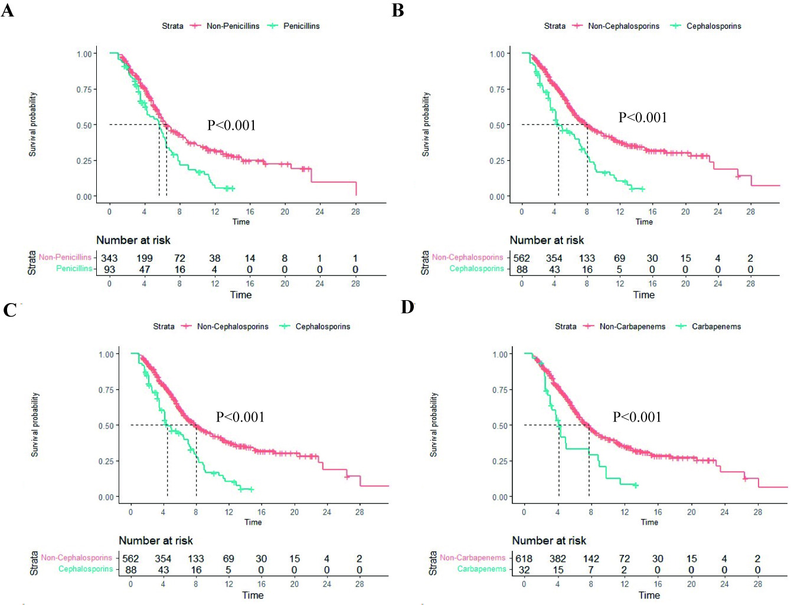
Fig 1: Kaplan-Meier survival curves of PFS in patients treated with different classes of antimicrobial agents; (A) Penicillin class: 5.1 vs 8.5 months; [HR], 2.319; 95% CI 1.790-3.005; (B) Cephalosporin class: 4.5 vs 8.0 months; [HR], 2.155; 95% CI 1.635-2.839; (C) Quinolone class: 5.3 vs 8.3 months; [HR], 2.035; 95% CI 1.602-2.586; (D) Carbapenem class: 4.1 vs 7.7 months; [HR], 2.155; 95% CI 1.431-3.247.

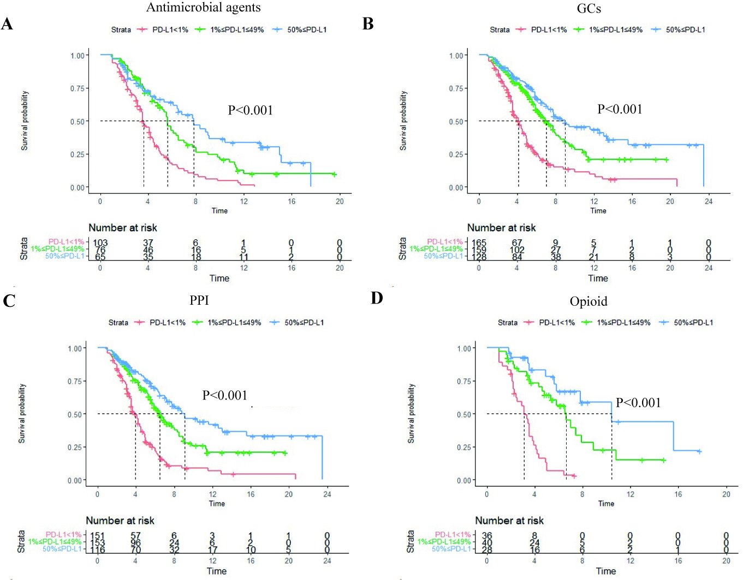
Fig 2: Kaplan-Meier survival curves of PFS in patients with different PD-L1 expression receiving antimicrobial agents, glucocorticoid, proton pump inhibitors, and opioids; (A) antimicrobial agents: 3.6 vs 5.6 vs 7.8 months; P<0.001; (B) Glucocorticoid: 4.1 vs 7.0 vs 9.0 months; P<0.001; (C) Proton pump inhibitors: 3.9 vs 6.5 vs 9.1 months; P<0.001; (D) Opioids: 3.1 vs 6.6 vs 10.4 months; P<0.001.

