Supplemental Figures and Tables:

Supplemental Figure 1: The Age-Standardized Incidence Rate (ASIR) (Sup. Fig 1A), Age-Standardized Death Rate (ASDR) (Sup. Fig 1B), and Age-Standardized Disability-Adjusted Life Years Rate (ASDALYR) (Sup. Fig 1C) of Tuberculosis (TB) in 1990 and 2021 across Socio-Demographic Index (SDI) regions per 100,000 population

Sup. Fig 1A:
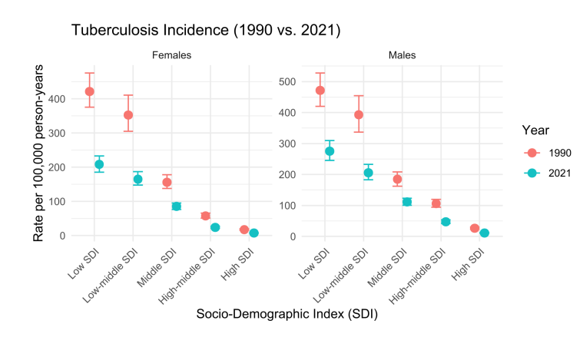
Sup. Fig 1B:

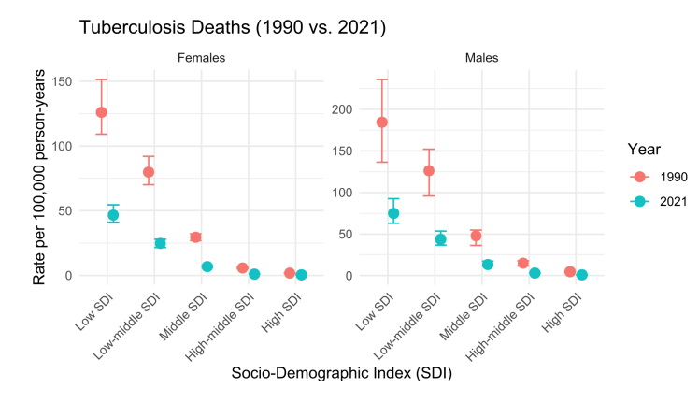

Sup. Fig 1C:
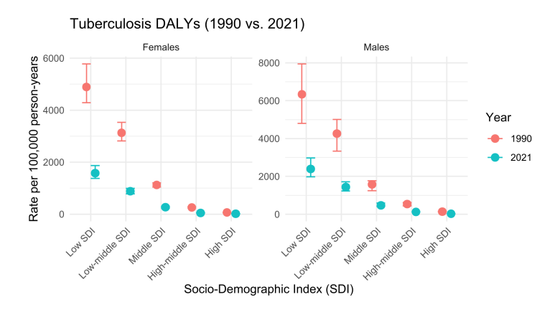

Supplemental Figure 2: Annual percentage changes (APC) of age-standardized incidence rate (ASIR) and age-standardized death rate (ASDR) of tuberculosis (TB) from 1990 to 2021 in Global, Socio-demographic Index (SDI) regions, and 21 Global Burden of Disease (GBD) regions per 100,000 population.
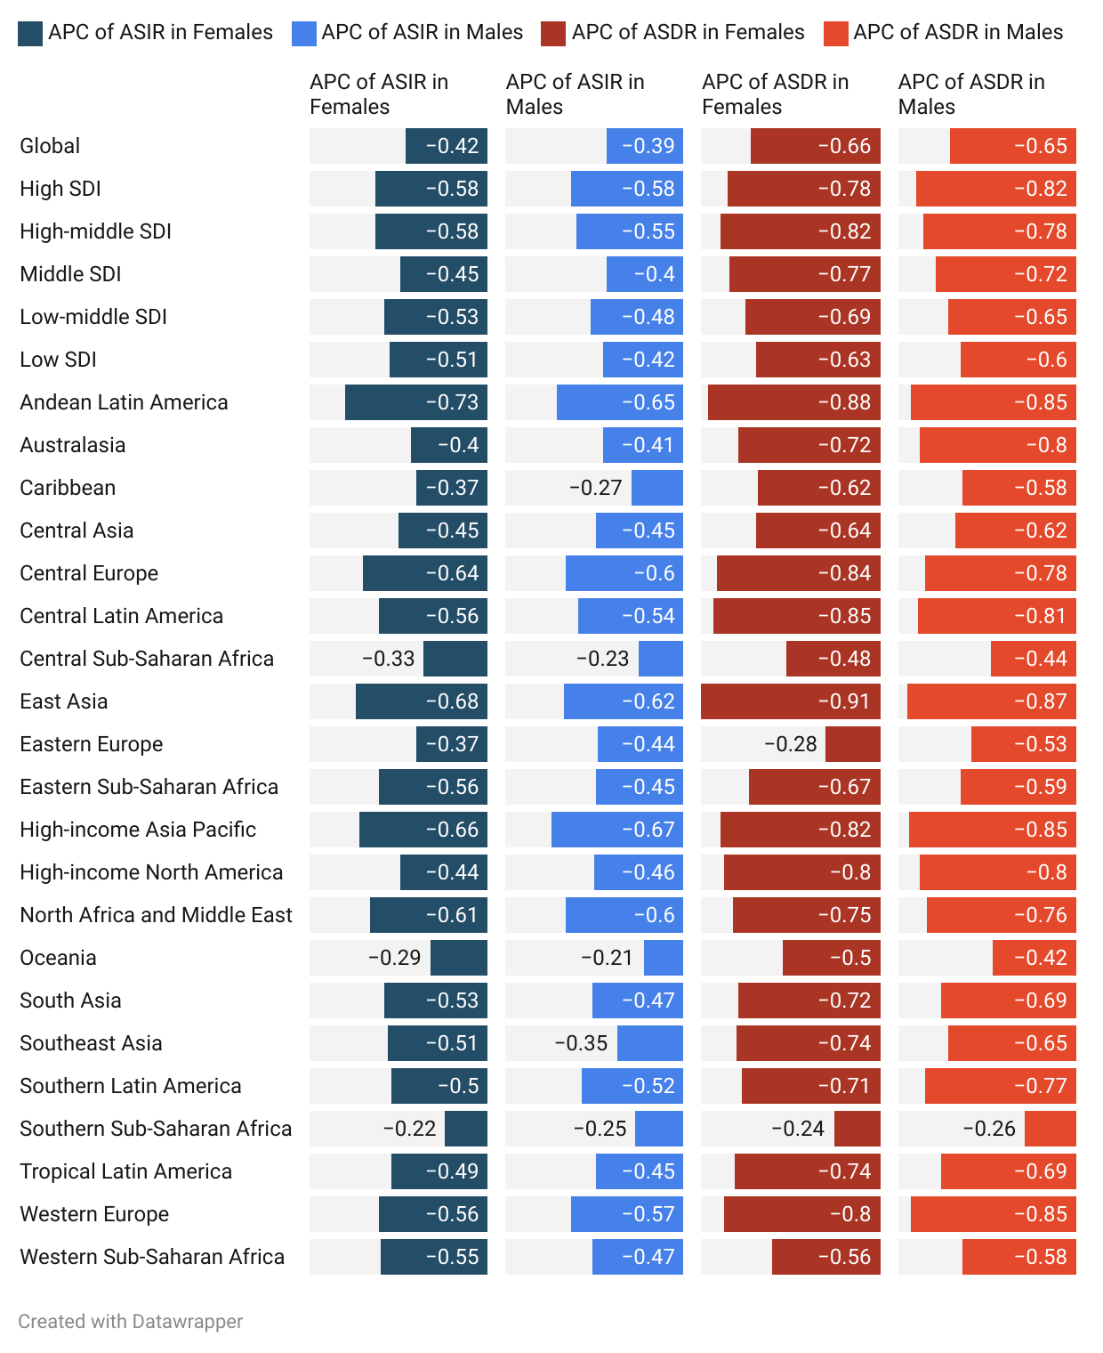

Supplemental Figure 3:
Trends in the impact of risk factors on tuberculosis (TB)-related deaths (Sup. Fig 3A) and disability-adjusted life years (DALYs) (Sup. Fig 3B) from 1990 to 2021.

Sup. Fig 3A:

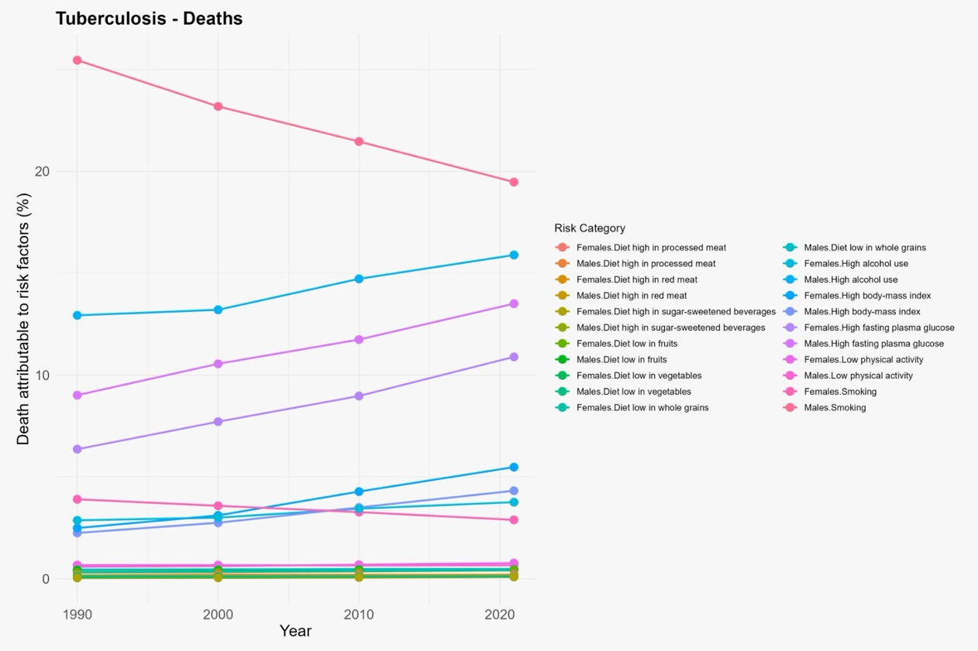

Sup. Fig 3B:

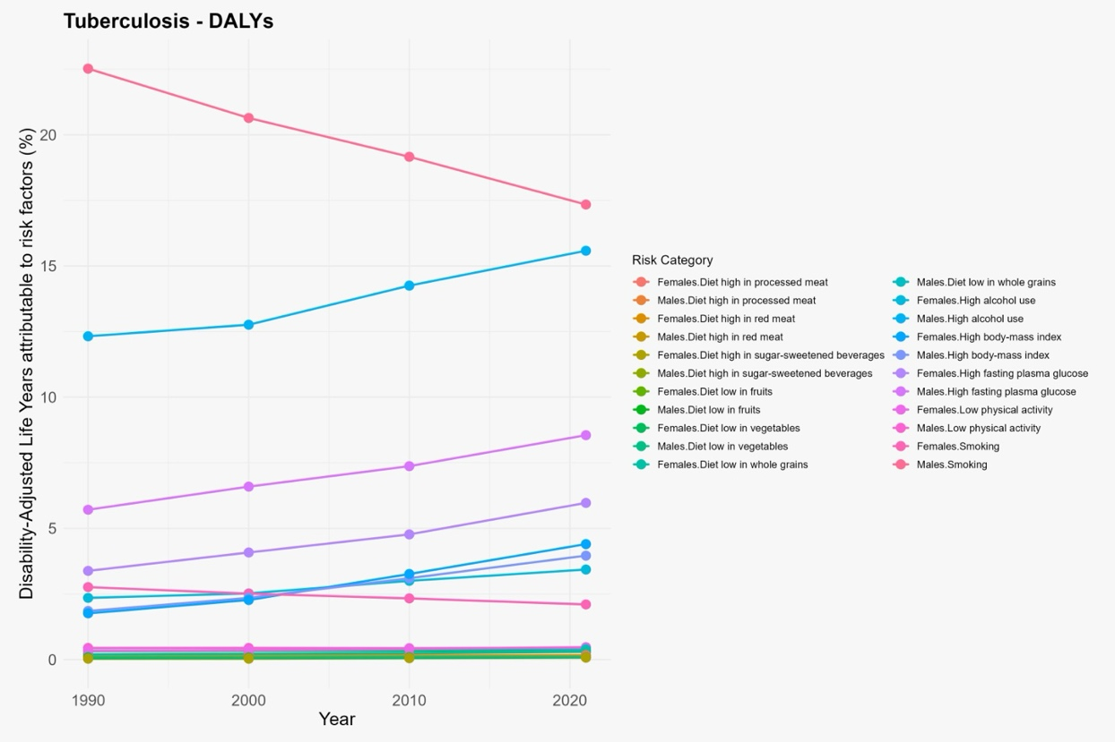

Supplemental Table 1: The Age-Standardized Incidence Rate (ASIR) and Age-Standardized Death Rate (ASDR) of Tuberculosis (TB) for the Socio-Demographic Index (SDI) regions in 1990 and 2021 per 100,000 population.

Location | Male ASIR 1990 (95% UI) | Female ASIR 1990 (95% UI) | Male ASIR 2021 (95% UI) | Female ASIR 2021 (95% UI) | Male ASDR 1990 (95% UI) | Female ASDR 1990 (95% UI) | Male ASDR 2021 (95% UI) | Female ASDR 2021 (95% UI)
High SDI | 26.59 (23.69–29.81) | 17.40 (15.45–19.67) | 11.16 (9.83–12.78) | 7.35 (6.41–8.55) | 4.87 (4.56–5.19) | 1.76 (1.62–1.86) | 0.89 (0.80–1.02) | 0.38 (0.32–0.43)
High-income Asia Pacific | 58.40 (52.21–65.08) | 35.43 (31.71–39.28) | 19.02 (16.32–21.81) | 12.20 (10.38–14.19) | 11.64 (10.51–13.72) | 3.77 (3.37–4.17) | 1.69 (1.46–1.94) | 0.68 (0.52–0.78)
High-income North America | 5.16 (4.39–6.05) | 3.38 (2.90–3.96) | 2.79 (2.41–3.29) | 1.88 (1.60–2.22) | 1.05 (1.00–1.09) | 0.48 (0.44–0.50) | 0.21 (0.20–0.22) | 0.10 (0.09–0.10)
High-middle SDI | 105.71 (94.23–119.45) | 57.78 (50.69–65.93) | 47.21 (42.01–53.68) | 24.30 (21.45–27.57) | 14.83 (11.71–17.74) | 5.83 (5.16–6.48) | 3.24 (2.80–3.90) | 1.06 (0.96–1.20)
Low SDI | 471.26 (420.03–527.24) | 421.32 (375.70–475.34) | 275.46 (245.14–309.35) | 208.13 (185.30–232.70) | 184.46 (136.22–235.54) | 126.13 (109.13–151.28) | 74.65 (62.96–92.50) | 46.62 (41.02–54.59)
Low-middle SDI | 392.43 (336.80–453.95) | 353.05 (305.17–411.05) | 206.02 (183.36–232.30) | 165.29 (147.42–186.78) | 126.12 (95.97–151.87) | 79.94 (70.13–91.89) | 43.79 (36.86–53.34) | 24.79 (21.46–27.83)
Middle SDI | 184.62 (162.51–208.71) | 156.23 (137.55–178.38) | 111.47 (100.66–122.89) | 85.76 (76.40–95.18) | 47.65 (36.21–54.84) | 29.37 (26.87–32.08) | 13.46 (11.55–17.22) | 6.65 (6.04–7.48)

