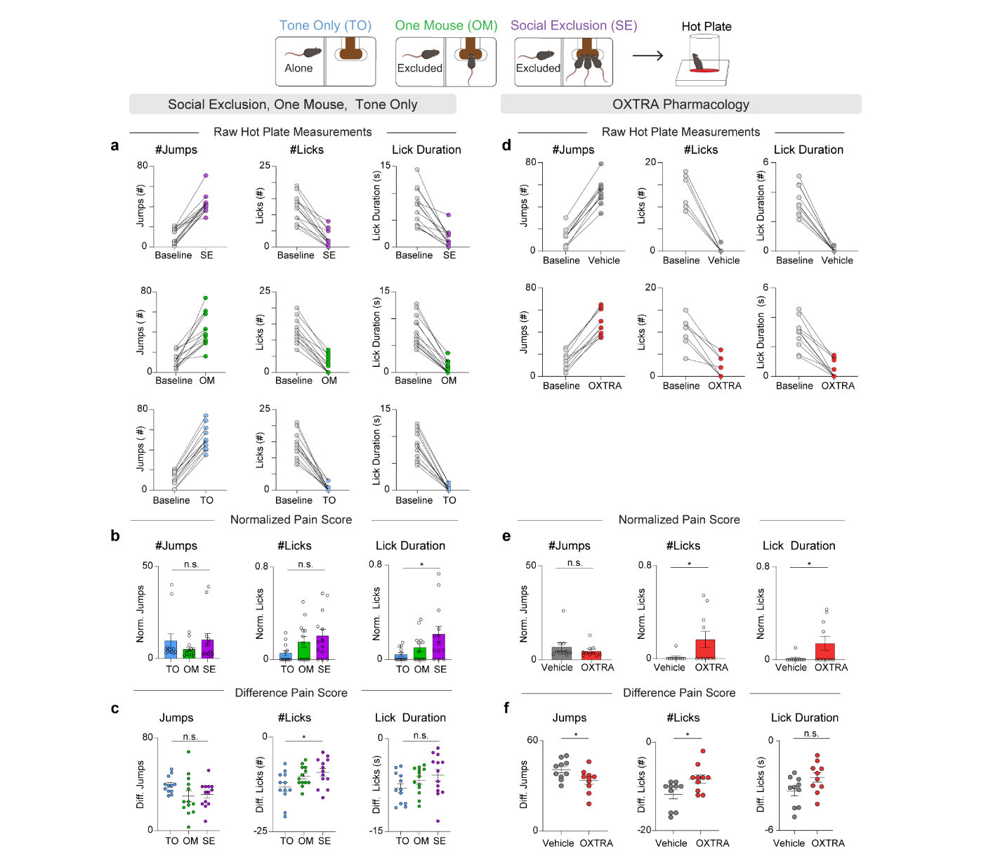
Extended Data Fig. 1. Comparison of different hot plate metrics between experiments.
a, Baseline measurements taken before and after SE/OM/TO. These raw values for number of jumps and licks, and lick duration were used to calculate both the normalized pain score and the difference pain score in b and c. b, Animals engage in more affective behaviors with increasing intensity of social condition. Normalized number of jumps during SE/OM/TO (n = 38, One-Way ANOVA F_{(2, 35)} = 0.90, p = 0.41). Normalized number of licks during SE/OM/TO (n = 38, One-Way ANOVA, F_{(2, 35)} = 2.76, p = 0.08). Normalized lick duration during SE/OM/TO. (n = 38, One-Way ANOVA, F_{(2, 35)} = 3.84, *p = 0.031, Tukey’s multiple comparisons test SE vs OM p = 0.15, SE vs TO *p = 0.03, OM vs TO p = 0.35). c, Animals engage in more affective behaviors with increasing intensity of social condition. Difference Score for number of jumps After-Before exposure to the SE/OM/TO (n = 38, One-Way ANOVA F_{(2, 35)} = 2.09, p = 0.14). Difference score for number of licks After-Before SE/OM/TO (n = 38, One-Way ANOVA, F_{(2, 35)} = 3.85, *p = 0.03, Tukey’s multiple comparisons test, SE vs OM p = 0.72, SE vs TO *p = 0.028, OM vs TO p = 0.14). Difference score for lick duration After-Before SE/OM/TO (n = 38, One-Way ANOVA F_{(2, 35)} = 1.83, p = 0.18). d, Baseline measurements taken before and after SE with intra-aIC OXTRA pharmacology. These raw values for number of jumps and licks and lick duration were used to calculate both the normalized pain score and difference pain score in e and f. e, Animals have enhanced affective responses to hot plate with oxytocin receptor antagonist (OXTRA), L-368,899 hydrochloride at a concentration of 5μg/μl and 200nl per hemisphere into the aIC. Normalized number of jumps during OXTRA pharmacology experiments (n = 20 two-tailed unpaired t-test, p = 0.38, t₁₈ = 0.91). Normalized number of licks during OXTRA pharmacology experiments (n = 20, two-tailed unpaired t-test *p = 0.048, t₁₈ = 2.12). Normalized lick duration during OXTRA pharmacology experiments (n = 20, two-tailed unpaired t-test *p = 0.045, t₁₈ = 2.16). f, Animals jump less and lick more following SE with OXTRA administration. Difference score for number of jumps After-Before exposure to the SE condition paired with intra-aIC OXTRA or vehicle. (n = 20 two-tailed unpaired t-test *p = 0.04, t₁₈ = 2.25) Difference score for number of licks upon intra-aIC OXTRA administration. (n = 20, two-tailed unpaired t-test *p = 0.02, t₁₈ = 2.49). Difference score for lick duration After-Before exposure to the SE condition paired with intra-aIC OXTRA or vehicle. (n = 20, two-tailed unpaired t-test p = 0.06, t₁₈ = 2.04).

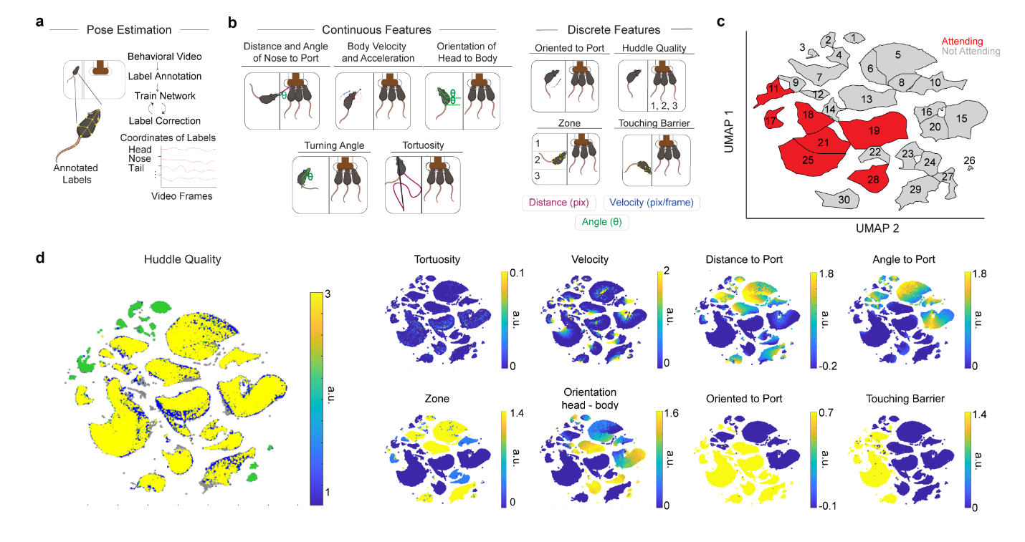Extended Data Fig. 2. Distinct clusters are discovered through UMAP and DBSCAN.
a, Mice poses were estimated using SLEAP. b, The SLEAP model was iteratively trained using discrete features that were extracted as behavioral features. Tortuosity describes the path that the animal takes over 1s. Orientation to port is either classified as 0 or 1, depending on angle to port. Huddle Quality is classified as the number of mice at the port at any time (1, 2, 3). Zone is classified as the zone that the excluded mouse is in (1, 2, 3). Touching Barrier is classified as 0 or 1, depending on the distance to the barrier. Colors indicate different metrics, including distance in pixels, velocity, and angle. c, DBSCAN clusters on the UMAP. Each cluster is labeled, and colors indicate whether that cluster was manually selected to be an “Attending” cluster or an “Not Attending” cluster. d, Features were mapped onto UMAP to identify how clusters were influenced by each behavioral feature.
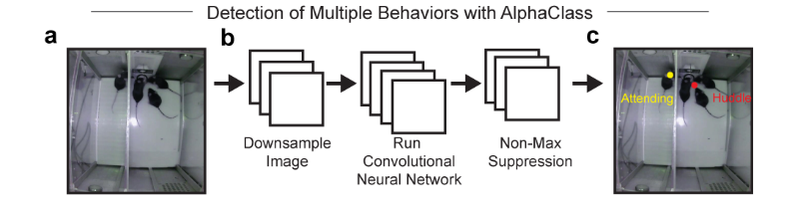
Extended Data Fig. 3. AlphaClass Architecture
a, Model architecture for AlphaClass. AlphaClass is a 2-D behavioral estimate method that primarily uses keypoint detection to estimate behaviors in single images. b, For training, AlphaClass receives images as input and extracts features through a downsampling method with a convolutional neural network (CNN). Then, non-max suppression is used to remove any faulty detections or low-confidence detections. c, The final results are behavioral labels predicted on novel video data. Example of final behaviors used for analysis during Social Exclusion. “Attending” frames were quantified when the excluded mouse was labeled as “Attending”.

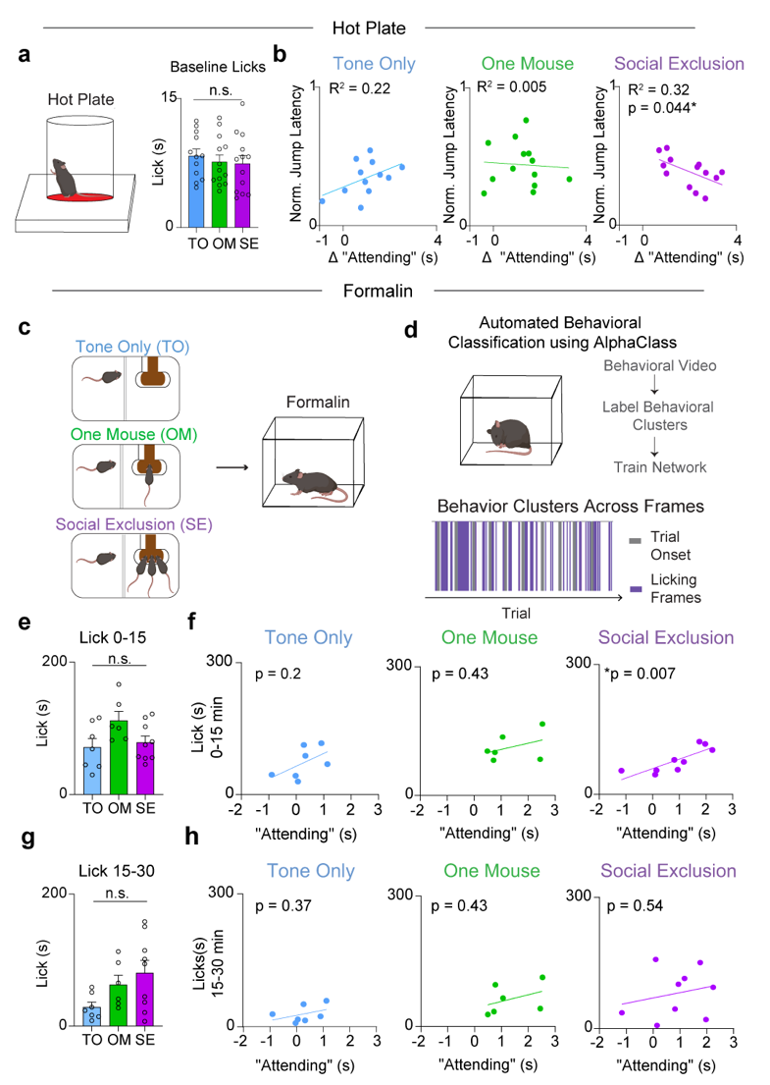
Extended Data Fig. 4. Social Exclusion “Attending” behavior is correlated with physical pain.
a, Baseline measurements for each mouse on the hot plate. The paradigm group that each animal is placed in is the future social paradigm that that animal will experience. (n = 38, One-Way ANOVA, F_{(2, 35)} = 0.33, p = 0.72). b, Correlation between “Attending” frames and behavioral responses to Physical Pain. TO (n = 12, Linear Regression R² = 0.22, p = 0.1226), OM (n = 13, Linear Regression R² = 0.005, p = 0.82), SE (n = 13, Linear Regression R² = 0.32, p = 0.04) c, Mice underwent one of three behavioral conditions (SE/OM/TO) and then were injected with formalin into the right hindpaw. d, AlphaClass was used to quantify lick duration and bouts. e, Lick duration after formalin injection during the first phase. There is no difference between duration of licks during the first phase after formalin injection. (n = 23, One-Way ANOVA, F_{(2,19)} = 0.20. p = 0.82). f, Correlation between licks during the first phase after formalin injection, and “Attending” behavior. Mice that exhibit more “Attending” behavior during Social Exclusion lick more after formalin injection. TO (n = 7, Linear Regression, R² = 0.30, p = 0.20). OM (n = 6, Linear Regression R² = 0.16, p = 0.43). SE (n = 9, Linear Regression, R² = 0.67, *p = 0.007). g, Lick duration after formalin injection during the second phase. There is no difference between groups (n = 23, One-Way ANOVA, F_{(2, 19)} = 3.8, p = 0.07). h, Correlation between licks during the second phase after formalin injection and “Attending” behavior. There is no correlation in any of the behavioral conditions. TO (n = 7, Linear Regression R² = 0.16, p = 0.37). OM (n = 6, Linear Regression R² =0.16, p =0.43). SE (n = 9, Linear Regression R² = 0.06, p = 0.54).

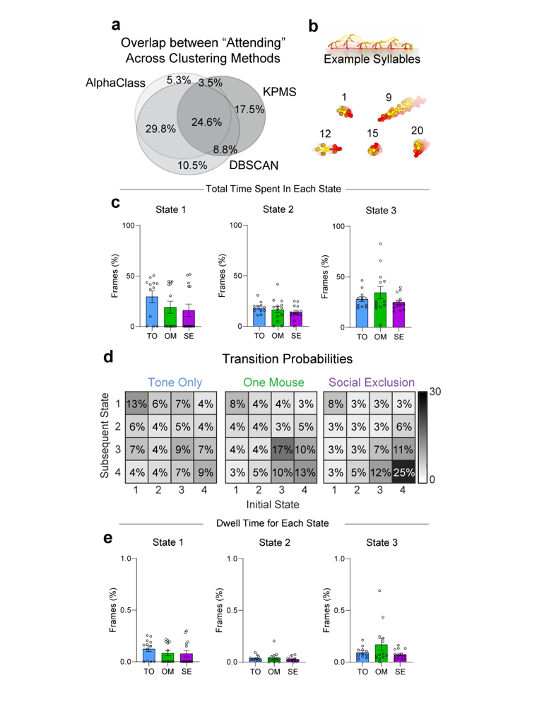
Extended Data Fig. 5. Additional behavioral metrics for other hidden states during the “FOMO” task.
a, Venn Diagram displaying percentage of overlapping frames across the three supervised and unsupervised behavioral classification methods used. b, Example syllables generated using KeypointMoseq (KPMS) that are present in the FOMO task. A total of 87 syllables were generated using all frames from the Social Exclusion, One Mouse, and Tone Only paradigms with n = 39. c, Duration spent in each hidden state between social conditions. Besides State 4, there is no difference for all states between conditions. (n = 39, One-Way ANOVA, State 1 F_{(2, 36)} = 0.11, p = 0.27, State 2 F_{(2, 36)} = 2.18, p = 0.43. State 3 F_{(2, 36)} = 3.58, p = 0.23). d, Transition Probabilities between each of the four behavioral states. Transitions are grouped over all animals per condition and normalized across the entire matrix. e, Dwell Time for each hidden state per social condition. Besides State 4, there is no difference between behavioral conditions for each state. (n = 39, One-Way ANOVA, State 1 F_{(2, 36)} = 0.02, p = 0.49. State 2 F_{(2, 36)} = 1.03, p = 0.53, State 3 F_{(2, 36)} = 2.93, p = 0.12). Error bars around the mean indicates s.e.m.
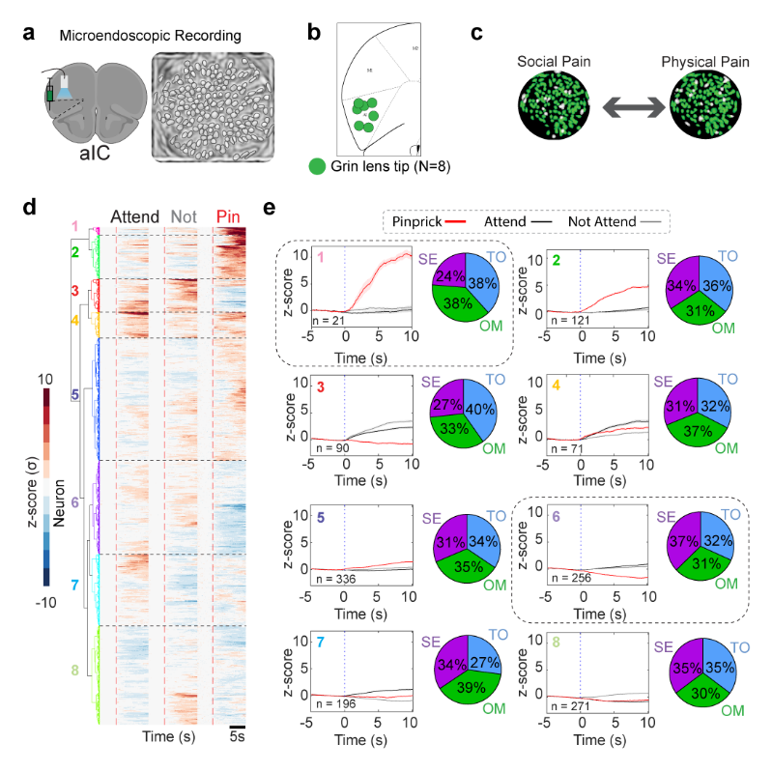
Extended Data Fig. 6. Social Exclusion causes distinct responses to pinprick.
a, Schematic of viral strategy for cellular resolution calcium imaging of anterior insular cortex (aIC) cells. Example image of contours extracted using constrained non-negative matrix factorization for microendoscopic data (CNMF-e). Each outline represents one neuron. b, Location of GRIN lens (0.5 mm x 0.67 mm) implant within the aIC for all animals used across both social and discrimination single unit analysis. c, Example output from cell registration to coregister and track the same cells across social and physical pain stimuli. d, Neuron responses are separated into clusters using hierarchical clustering. Heatmaps for aIC ΔF/F0 responses to “Attending” and “Not Attending” trials during the Social Exclusion, One Mouse, and Tone Only paradigms, as well as during pinprick stimuli applied after each social condition. Social trials are aligned to trial onset. At trial onset, the cue is played, and the switchable glass wall turns transparent. Pain trials are aligned to stimulus application onset. Neurons are co-registered per social condition and physical pain stimuli application. Colors indicate clusters obtained using hierarchical clustering. e, Response amplitude for aIC cells during “Attending”, “Not Attending”, and pinprick trials for each specific cluster. Cluster colors are matched with heatmap cluster (d). Pie charts depict the percentage of neurons that belong to each social condition.

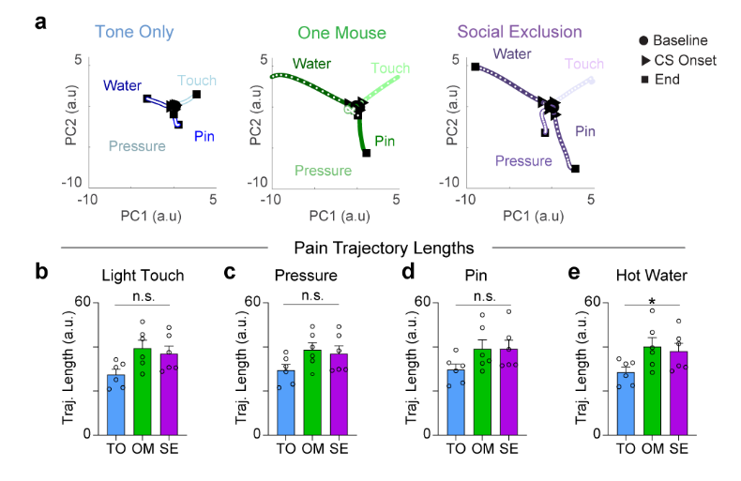
Extended Data Fig. 7. Neural trajectories from aIC neural population responses to physical pain stimuli.
a, Sample neural trajectories for one representative animal. Responses to light touch, pressure, pinprick, and hot water are shown and graded by color to match the stimulus intensity. b,c,d,e, Quantification of trajectory lengths. b, Touch: Repeated Measures One-Way ANOVA, n = 6, F_{(1.6, 8.2)} = 4.6, p = 0.051. c, Pressure: Repeated Measures One-Way ANOVA, n = 6, F_{(1.5, 7.2)} = 2.74, p = 0.136. d, Pin: Repeated Measures One-Way ANOVA, n = 6, F_{(1.7, 8.5)} = 3.1, p = 0.098. e, Water: Repeated Measures One-Way ANOVA, n = 6, F_{(1.9, 9.4)} = 4.3, *p = 0.049.
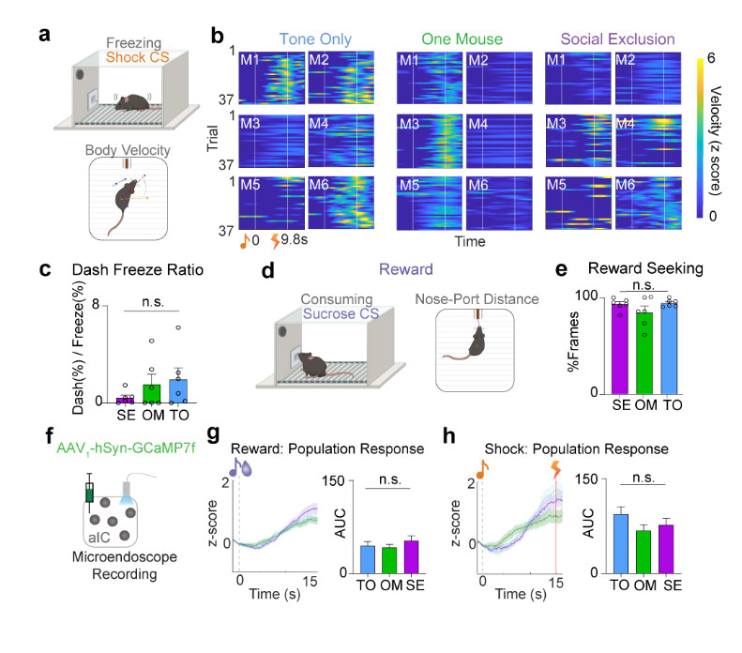
Extended Data Fig. 8. Social Exclusion only changes encoding of conditioned cues, not behavioral responses to reward and shock.
a, Quantification of freezing behavior during shock trials using body velocity. Velocity was z-scored for each animal separately across its three sessions. b, Heatmaps showing normalized mouse velocity for 37 shock trials (n = 6). Cue onset and shock onset are marked at 0s and 9.8s respectively. c, Ratio of dash/freezing behavior for each animal across social conditions in the 0-15s post-CS onset (Repeated Measure One-way ANOVA, F_{(1.1, 5.4)} = 0.89. p = 0.39). d, Quantification of reward seeking behavior during reward trials using nose-port distance. A threshold was set for all animals for distance to the port to determine number of reward frames. e, Percentage of frames under the nose-port distance threshold to quantify reward seeking. There is no difference in reward seeking behavior across social conditions (Repeated Measures One-way ANOVA, F _{(1.4, 6.8)} = 1.39, p = 0.30) f, Viral strategy for labeling aIC neurons with a calcium indicator to record activity during the discrimination assay. g,h, Average population neural activity for both reward (g) and shock trials (h). All responsive neurons were determined using rank-sum for each neuron. Final responsive neurons were averaged for a population response to both trial types. g, There is no difference in the average z-score responses to reward trials after the three social conditions. (n = 6, One-Way ANOVA reward: F _{(2,278)} = 0.76, p = 0.47. h, There is no difference in responses to shock. (n = 6, One-Way ANOVA shock: F _{(2,228)} = 1.59, p = 0.21). Error bars and solid shaded regions around the mean indicates s.e.m.

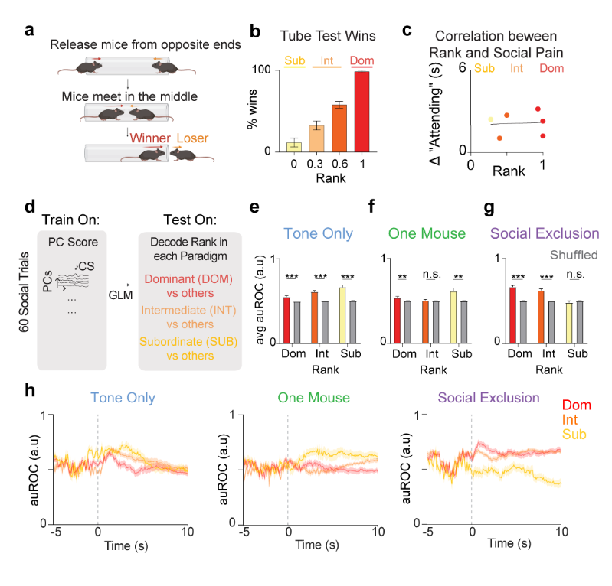
Extended Data Fig. 9 aIC rank encoding dynamically shifts based on FOMO Task Condition.
a, Tube test schematic to determine rank. Mice are tested in a round robin fashion. b, Rank is determined by overall percentage of wins during the four days of testing (n = 16, One-Way ANOVA, F_{(3,12)} = 71.62, ***p<0.0001. Tukey’s multiple comparisons test. Rank 1 vs 2, ***p=0.0001, Rank 1 vs 3 ***p<0.0001, Rank 1 vs 4, ***p<0.0001. Rank 2 vs 3, **p = 0.0075, Rank 2 vs 4, ***p<0.0001, Rank 3 vs 4 *p = 0.026). c, Correlation between Social Rank and “Attending” frames. There is no relationship between social rank and the amount of “Attending” behaviors exhibited (n = 6, Pearson’s Correlation, R² = 0.005, p = 0.89). d, Decoding schematic using a generalized linear model to test if rank information is represented in neural responses to 60 social trials. The number of PCs required to explain 90% of the variance was used in this analysis, and decoding was done with 10-fold cross validation. e, Area under the ROC (auROC) for each rank in the Tone Only paradigm. All ranks are decodable during Tone Only (n = 6, Two-Way ANOVA, Main effect Rank F_{(2, 354)} = 38.3, ***p<0.0001, Shuffled Control F_{(1, 354)} = 358, ***p<0.0001, Rank x Shuffled Control F_{(2, 354)} = 31.58, ***p<0.0001. Tukey’s multiple comparisons test. Dom vs Dom Shuffled ***p<0.0001. Int vs Int Shuffled ***p<0.0001. Sub vs Sub Shuffled ***p<0.0001. Tukey’s multiple comparisons test. Sub vs Int ***p<0.0001, Sub vs Dom ***p<0.0001, Int vs Dom ***p<0.0001). f, Area under the ROC (auROC) for each rank in the One Mouse paradigm. Only Dominants and Subordinates are decodable during One Mouse within the aIC (n = 6, Two-Way ANOVA, Main effect Rank F_{(2, 354)} = 24.85, ***p<0.0001, Shuffled Control F_{(1,354)} = 63.8, ***p<0.0001, Rank x Shuffled Control F_{(2, 354)} = 24.1, ***p<0.0001. Tukey’s multiple comparisons test. Dom vs Dom shuffled **p = 0.009. Int vs Int shuffled p = 0.86. Sub vs Sub shuffled ***p<0.0001. Tukey’s multiple comparisons test Dom vs Sub ***p<0.0001. Dom vs Int p = 0.15. Int vs Sub ***p<0.0001. g, Area under the ROC (auROC) for each rank in the Social Exclusion paradigm. Only Dominants and Intermediates are decodable during Social Exclusion within the aIC. (n = 6, Two-Way ANOVA, Main effect Rank F_{(2, 354)} = 97.94, ***p<0.0001, Shuffled Control F_{(1,354)} = 257.5, ***p<0.0001, Rank x Shuffled Control F_{(2, 354)} = 97.3, ***p<0.0001. Tukey’s multiple comparisons test. Dom vs Dom shuffled ***p < 0.0001. Int vs Int shuffled ***p<0.0001. Sub vs Sub shuffled p = 0.17. Tukey’s multiple comparisons test Dom vs Sub ***p<0.0001. Dom vs Int **p = 0.004. Int vs Sub ***p<0.0001. h, Decoding performance of rank displayed in 100 ms bins for each social condition. Error bars and solid shaded regions around the mean indicates s.e.m.
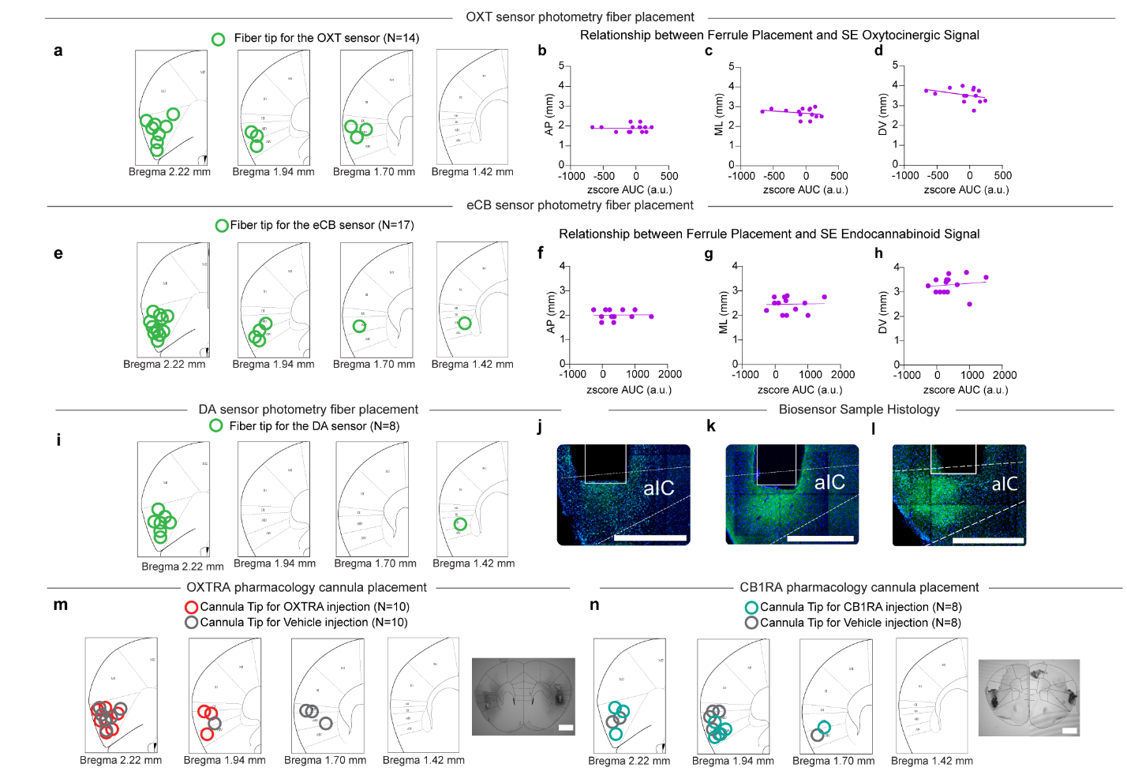
Extended Data Fig. 10. Biosensor and Pharmacology Verification.
a, Histological verification of ferrule placement for the oxytocin sensor experimental cohort. Each green dot marks the tip of the ferrule for each animal. One animal was excluded due to lack of expression. b-d, Correlation between the oxytocinergic signal during Social Exclusion, and placement of ferrule. Anterior-posterior (AP), Medial-lateral (ML), Dorsal-ventral (DV). b, Correlation with anterior-posterior coordinates R² = 0.0002, p = 0.96. c, Correlation with medial-lateral coordinates R² = 0.07, p = 0.37. d, Correlation with dorsal ventral coordinates R² = 0.12. p = 0.23. e, Histological verification of ferrule placement for the endocannabinoid sensor experimental cohort. Each green dot marks the tip for each animal. 3 animals were excluded for light leak. 7 animals were excluded for lack of expression. f-h, Correlation between the endocannabinoid signal during Social Exclusion and placement of ferrule. f, Correlation with anterior-posterior coordinates R² = 0.0003, p = 0.95, g, Correlation with medial-lateral coordinates R² = 0.001, p = 0.91. (h) Correlation with dorsal-ventral coordinates R² = 0.017, p = 0.66. i, Histological verification of ferrule placement for the dopamine sensor experimental cohort. No animals were excluded. j, Example histology image of GRAB_{OXT1.0} sensor expression. Scale Bar 500 µm. k, Example histology image of GRAB_{eCB2.0} sensor expression. Scale Bar 500 µm. l, Example histology image of GRAB_{DA3h} sensor expression. Scale Bar 500 µm. m, Histological verification of cannula placement for the OXTRA pharmacology experiments. 3 animals were excluded based on cannula placement. Colors indicate whether the animal received an OXTR antagonist or Vehicle Injection. Scale Bar 1000 µm. n, Histological verification of cannula placement for the CB1R agonist pharmacology experiments. No animals were excluded based on cannula placement. Scale Bar 1000 µm.

