Supplementary Material

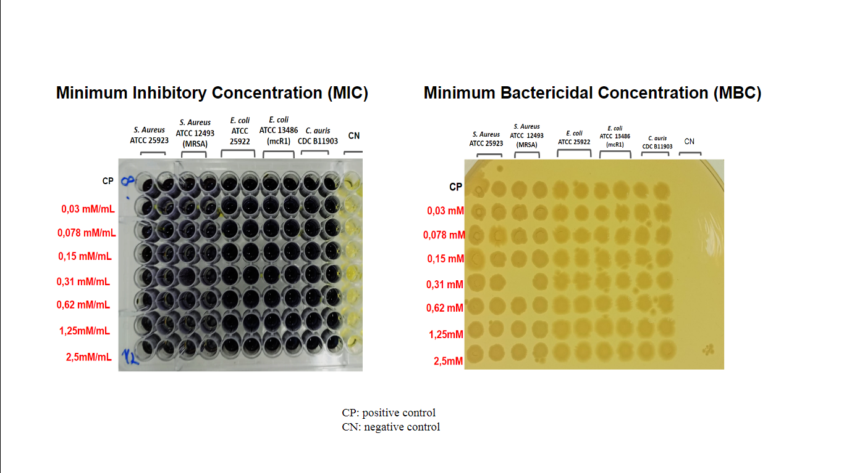
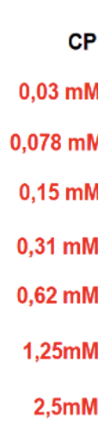
Figure S1 – Determination of MIC and MBC of AE for susceptible and multiresistant bacterial strains and C. auris.

Figure S2 - Photodynamic activity of AE to planktonic cells under different conditions of light in triplicates.

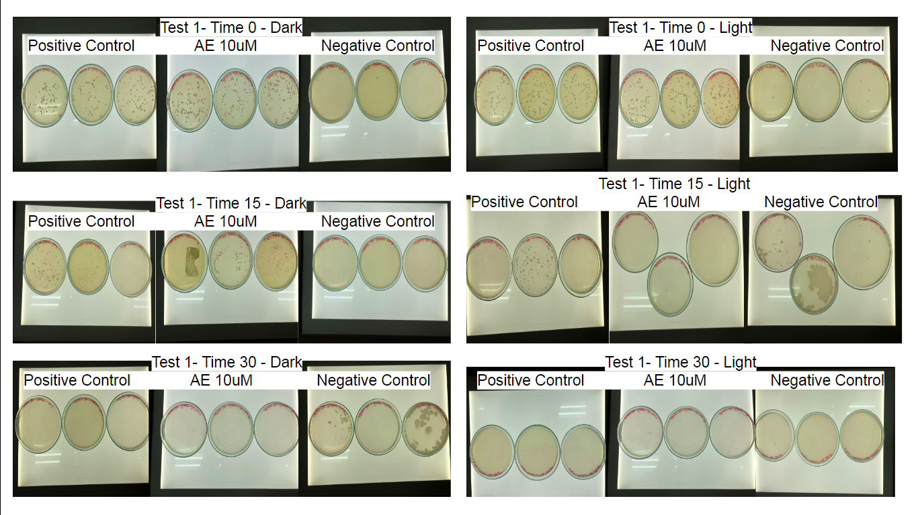
Triplicate 1

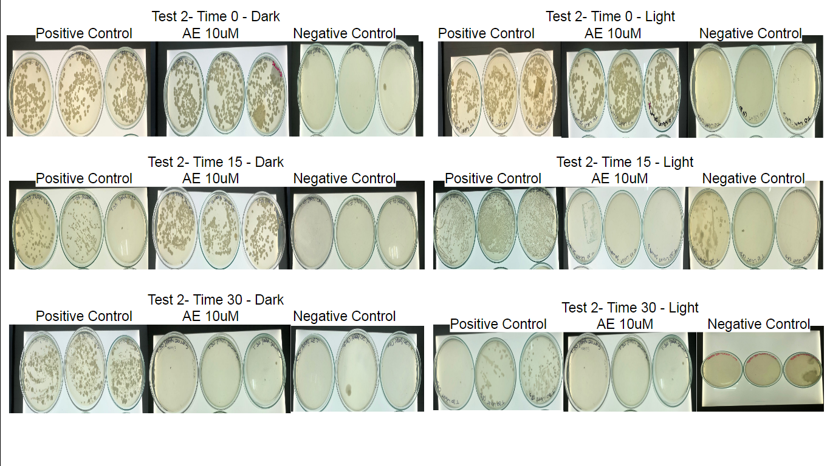
Triplicate 2

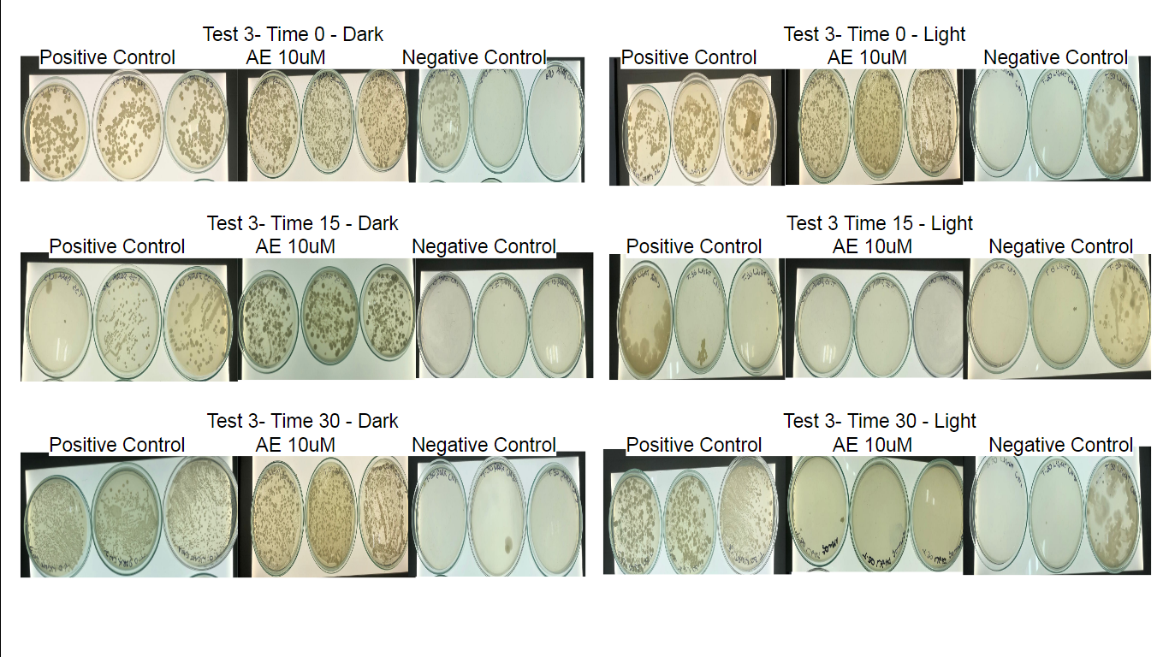
Triplicate 3

