Variantscape: Using Large Language Models to Build a Comprehensive Landscape of Cancer Variants

Supplementary material

*Marie Wosny^{1,2}, Maximilian Boesch^{3,4}, Tobias Peres³, Thibault Niederhauser¹, Martin Früh³, Christian Rothermundt⁵, Janna Hastings^{1,2,6}

¹School of Medicine, University of St.Gallen (HSG), St Gallen, Switzerland
²Institute for Implementation Science in Health Care, University of Zurich (UZH), Zurich, Switzerland
³HOCH Health Ostschweiz, Kantonsspital St.Gallen, Universitäres Lehr- und Forschungsspital, Department of Medical Oncology and Hematology, St.Gallen, Switzerland
⁴HOCH Health Ostschweiz, Kantonsspital St.Gallen, Universitäres Lehr- und Forschungsspital, Lung Center, St.Gallen, Switzerland
⁵Department of Medical Oncology and Cancer Center, Luzerner Kantonsspital (LUKS), Lucerne, Switzerland
⁶Swiss Institute of Bioinformatics (SIB), Lausanne, Switzerland

*Corresponding author: mariejohanna.wosny@unisg.ch

Table of supplementary information
Supplementary information 1: Workflow of computational LLM-based variant extraction and analysis pipeline. 3
Supplementary information 2.: Performance evaluation of cancer type extraction. 3
Supplementary information 3: Performance evaluation of treatment extraction. 3
Supplementary information 4: Performance evaluation of large language model prompts for study design classification. 4
Supplementary information 5: Performance evaluation of large language model prompts for variant-treatment relationship classification. 4
Supplementary information 6: Temporal analysis of biomedical publications (2014-2024) from OpenAlex: yearly, monthly, and weekly trends. 6
Supplementary information 7: Distribution of the number of gene mentions per biomedical publication. 7
Supplementary information 8: Distribution of study design types across 199,726 articles classified by LLaMA-3.3-70b and the ‘General Classifier’. 7
Supplementary information 9: Distribution of the most frequently mentioned specific treatments identified in the 126,195 articles (40.87%) containing treatments of the total 308,748 publications screened. 8
Supplementary information 10: Top 20 most frequent mentions of variants of 16,508 articles containing variants extracted by LLaMA-3.3-70b. 8
Supplementary information 11: Variant-associated extraction of Oncomine genes. 9
Supplementary information 12: Progressive merging ad filtering of datasets from 307,748 detected articles with Oncomine gene mentions, to 7,524 (2.4%) of articles which contain all predefined conditions, including variants. 10
Supplementary information 13: Most mentioned treatment types in the final analysis dataset of 7,524 articles. 10
Supplementary information 14: Most mentioned cancer types in the final analysis dataset of 7,524 articles. 11
Supplementary information 15: Heatmap illustrating co-associations of variants and cancers. 12
Supplementary information 16: Heatmap illustrating co-associations of cancers and treatments. 13

Supplementary information 1: Workflow of computational LLM-based variant extraction and analysis pipeline.
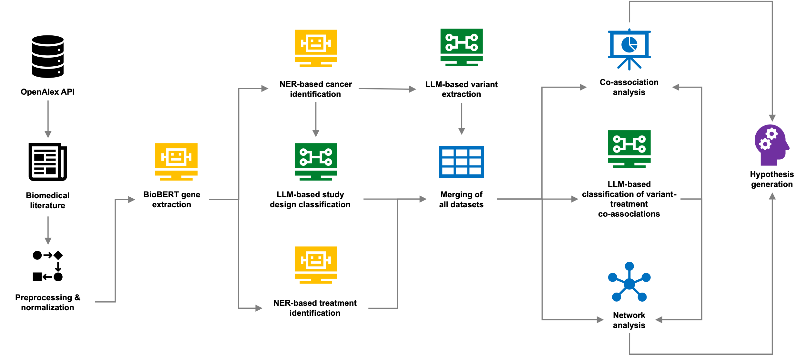

Supplementary information 2.: Performance evaluation of cancer type extraction.
Approach/model | Precision | Recall | Accuracy | F1 Score
SciSpaCy en_ner_bionlp13cg_md and en_ner_bc5cdr_md combined | 1 | 0.80 | 0.80 | 0.89
SciSpaCy en_ner_bionlp13cg_md | 1 | 0.72 | 0.72 | 0.84
SciSpaCy en_ner_bc5cdr_md | 1 | 0.77 | 0.77 | 0.87

Supplementary information 3: Performance evaluation of treatment extraction.
Approach/model | Precision | Recall | Accuracy | F1 Score
Ontology-guided NER | 0.96 | 0.95 | 0.95 | 0.95
SciSpaCy en_ner_bionlp13cg_md and en_ner_bc5cdr_md | 0.44 | 0.32 | 0.58 | 0.37
BioBERT alvaroalon2/biobert_chemical_ner | 0.71 | 0.68 | 0.70 | 0.70

Supplementary information 4: Performance evaluation of large language model prompts for study design classification.
Prompt number | Prompt Text | Precision | Recall | Accuracy | F1 Score
Prompt1 | INSTRUCTION: You are a helpful classifier. You are given the abstract of a scientific, biomedical publication and you have to select the correct of the possible categories. The topic of the classification is '[TOPIC]'. The allowed categories are '[CATEGORIES]'. QUESTION: The abstract to be classified is '[TEXT]'. ANSWER: The correct category for this abstract is "". | 0.93 | 0.92 | 0.92 | 0.92
Prompt2 | INSTRUCTION: You are a classifier for biomedical abstracts. Classify the given abstract under one of the predefined categories. CONTEXT: The classification topic is '[TOPIC]'. Allowed categories: [CATEGORIES]. QUESTION: The abstract to be classified is '[TEXT]'. REQUIREMENTS: - Select only one category from the list. - Do not create new categories. ANSWER: The correct category for this abstract is "". | 0.92 | 0.91 | 0.91 | 0.91
Prompt3 | INSTRUCTION: You are a classifier for biomedical abstracts. Classify the given abstract under one of the predefined categories. Topic: '[TOPIC]'. Allowed categories: [CATEGORIES]. Abstract: '[TEXT]'. Select only one category. Do not create new categories. ANSWER: The correct category is "". | 0.93 | 0.92 | 0.92 | 0.92
Prompt4 | INSTRUCTION: You are a helpful classifier. You are given the abstract of a scientific, biomedical publication and you have to select the correct of the possible study categories. The topic of the classification is '[TOPIC]'. The allowed categories are '[CATEGORIES]'. QUESTION: The abstract to be classified is '[TEXT]'. ANSWER: The correct category for this abstract is "". | 0.92 | 0.91 | 0.91 | 0.91

Supplementary information 5: Performance evaluation of large language model prompts for variant-treatment relationship classification.
Prompt number | Prompt Text | Precision | Recall | Accuracy | F1 Score
Prompt1 | You are a biomedical research assistant analyzing the relationship between genetic variants and treatments based on scientific publications. Read the following title and abstract carefully, then evaluate each of the variant-treatment pairs listed. For each pair, classify the relationship described in the abstract using only one of the following labels: - Sensitive - Resistant - Diagnostic - Unrelated - Unknown Respond **only** with the list of pairs and their labels, in this format: <variant> + <treatment> : <label> | 0.48 | 0.35 | 0.35 | 0.33
Prompt2 | You are analyzing biomedical literature to extract clinical relationships between gene variants and drugs. Using the information from the title and abstract, determine whether each of the following variant-treatment pairs has a meaningful clinical association. Label each pair using one of the following categories: Sensitive, Resistant, Diagnostic, Unrelated, Unknown. Format your output as follows: <variant> + <treatment> : <label> | 0.87 | 0.84 | 0.84 | 0.85
Prompt3 | Carefully analyze the title and abstract of the following biomedical paper. Then evaluate the relationship between the listed variant-treatment pairs. Use only these labels: Sensitive, Resistant, Diagnostic, Unrelated, Unknown. Respond strictly in this format: <variant> + <treatment> : <label> | 0.63 | 0.5 | 0.5 | 0.51

Supplementary information 6: Temporal analysis of biomedical publications (2014-2024) from OpenAlex: yearly, monthly, and weekly trends.
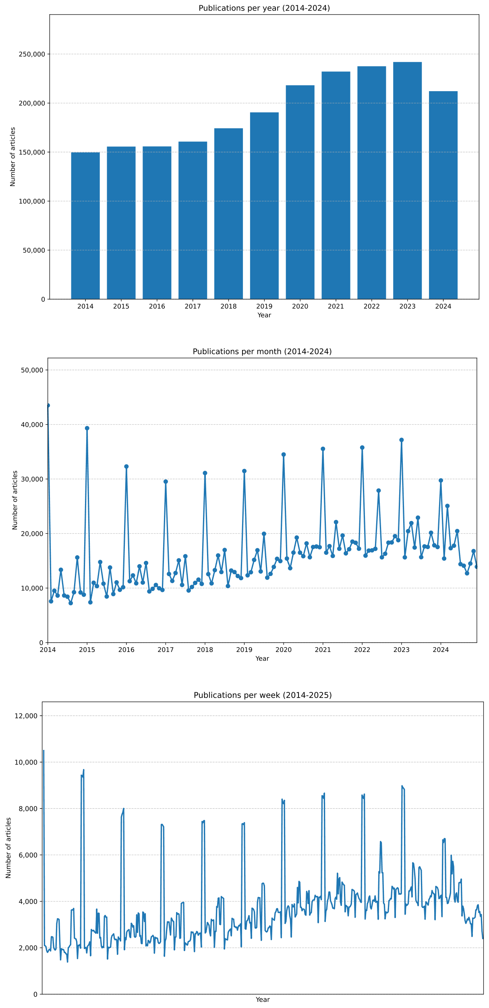
Supplementary information 7: Distribution of the number of gene mentions per biomedical publication.
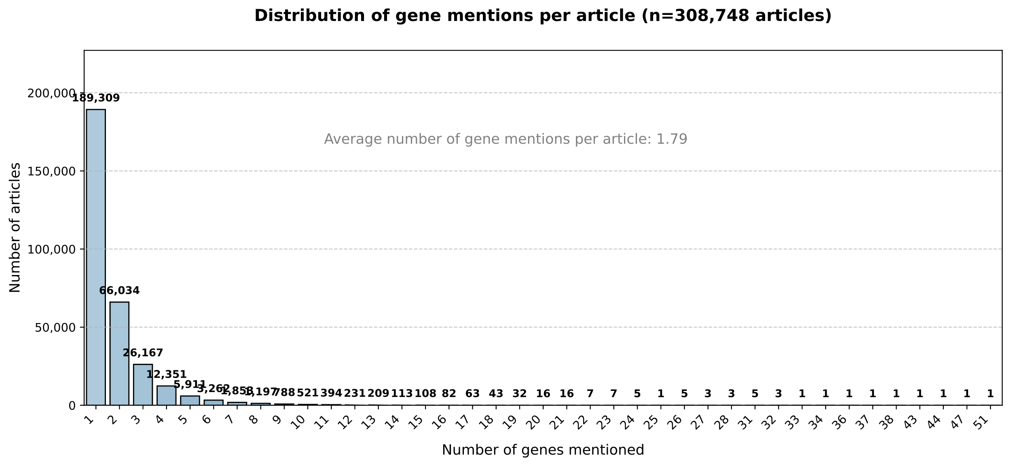
Supplementary information 8: Distribution of study design types across 199,726 articles classified by LLaMA-3.3-70b and the ‘General Classifier’.
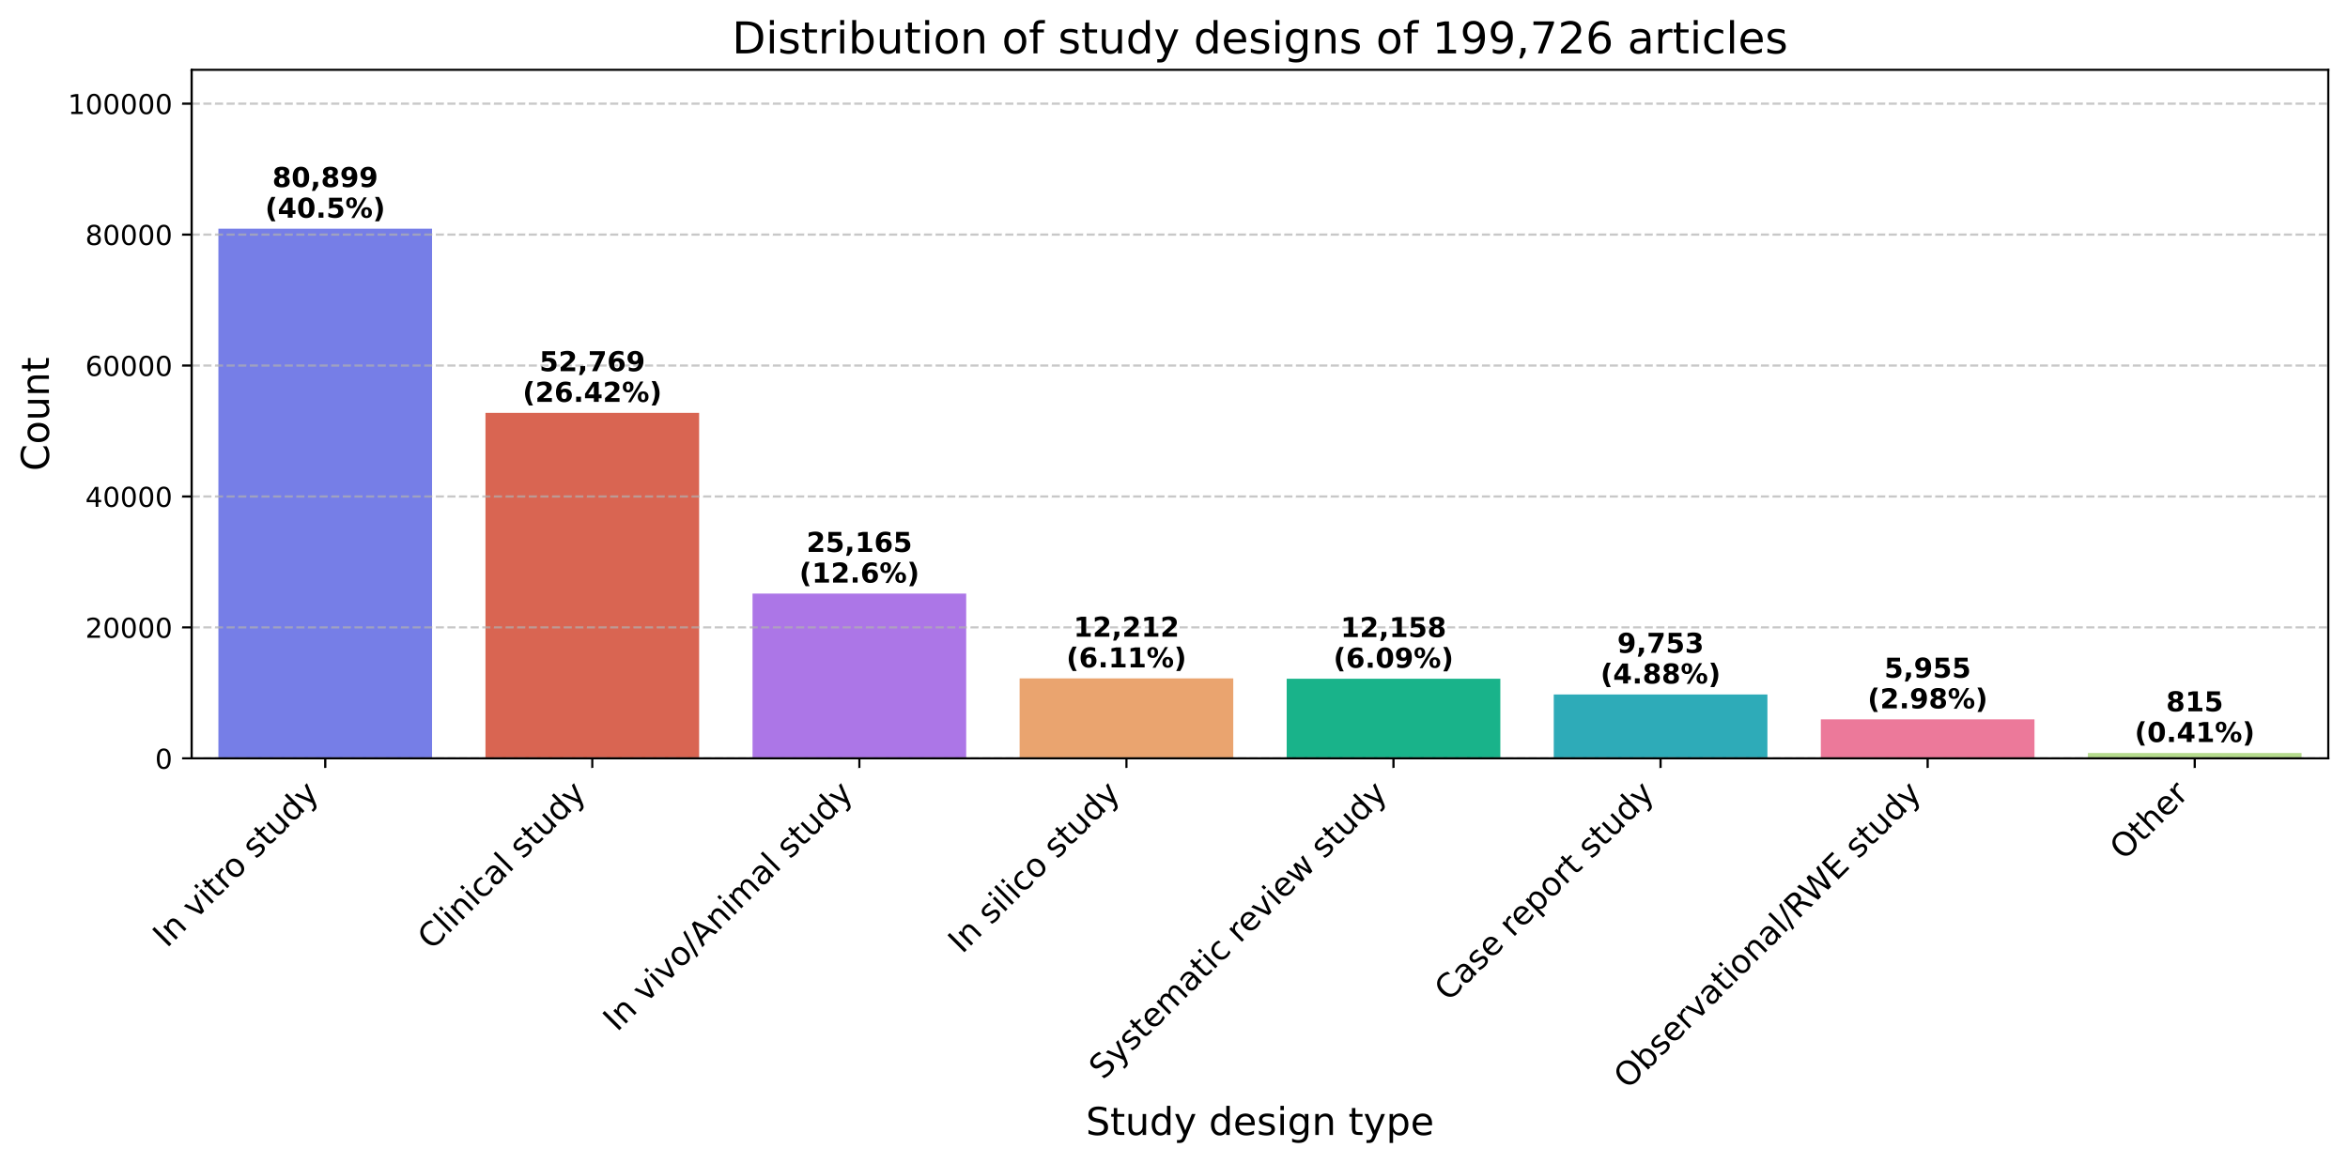

Supplementary information 9: Distribution of the most frequently mentioned specific treatments identified in the 126,195 articles (40.87%) containing treatments of the total 308,748 publications screened.
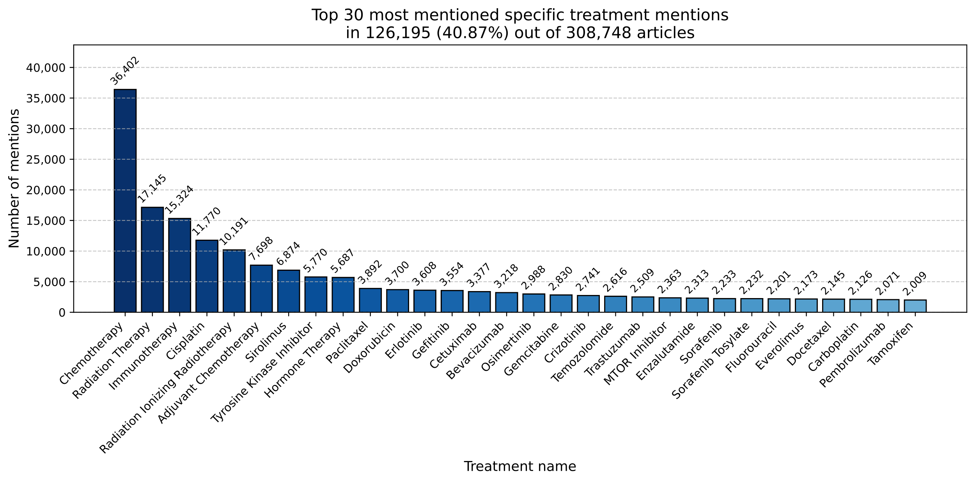

Supplementary information 10: Top 20 most frequent mentions of variants of 16,508 articles containing variants extracted by LLaMA-3.3-70b.
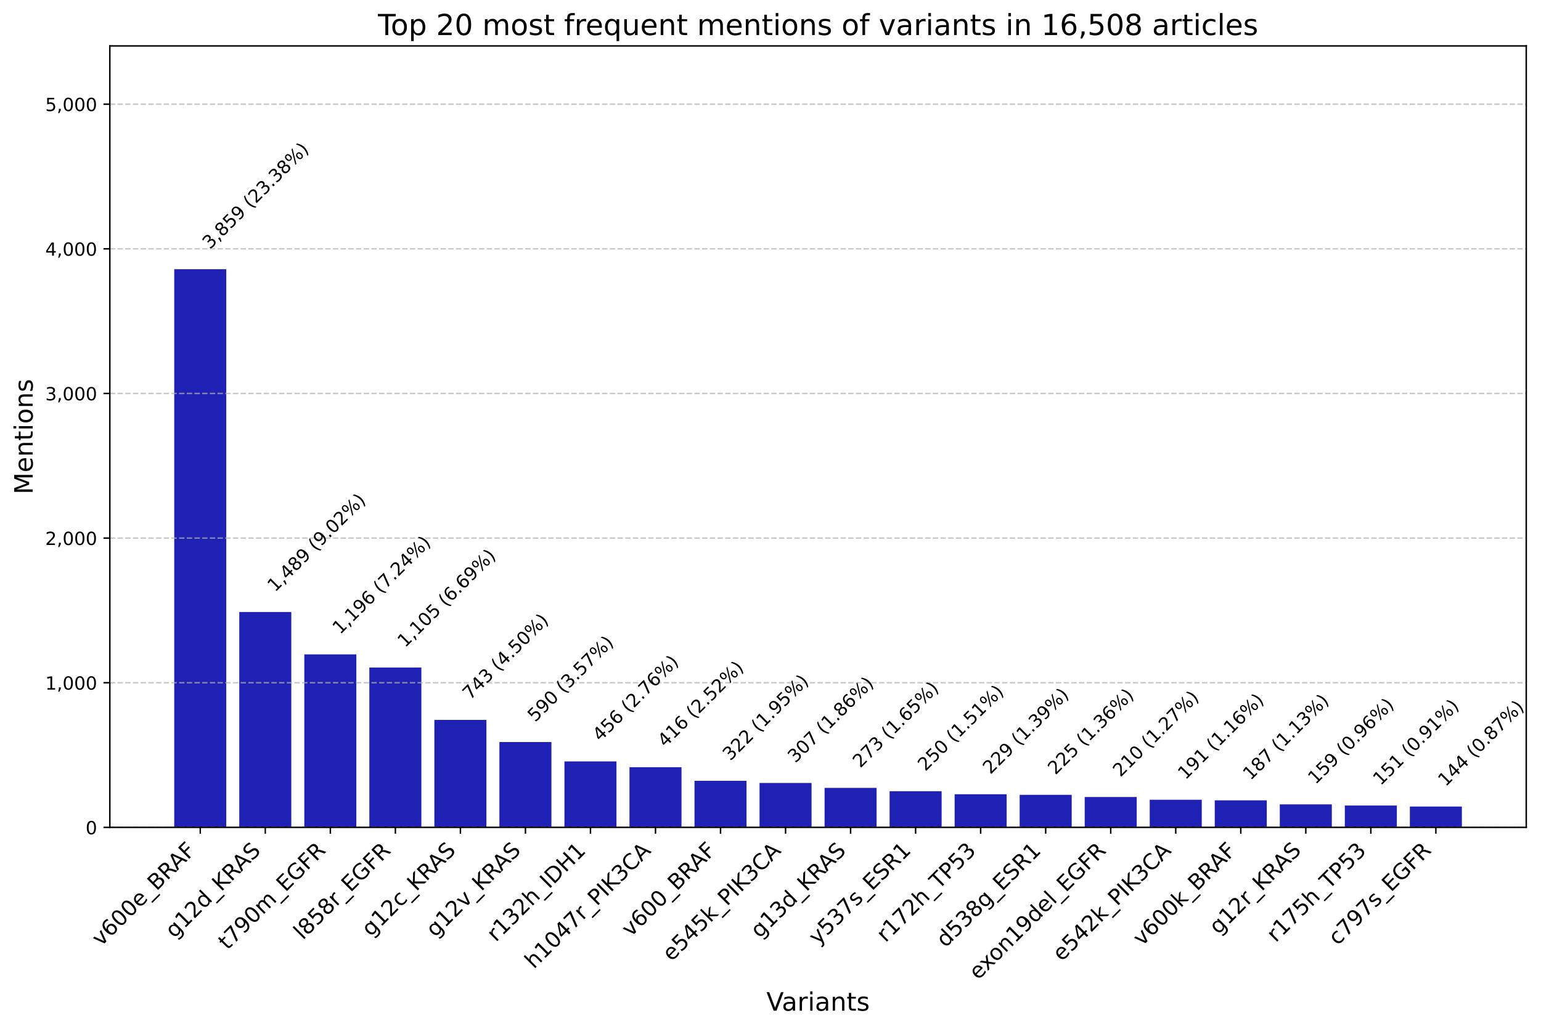
Supplementary information 11: Variant-associated extraction of Oncomine genes.
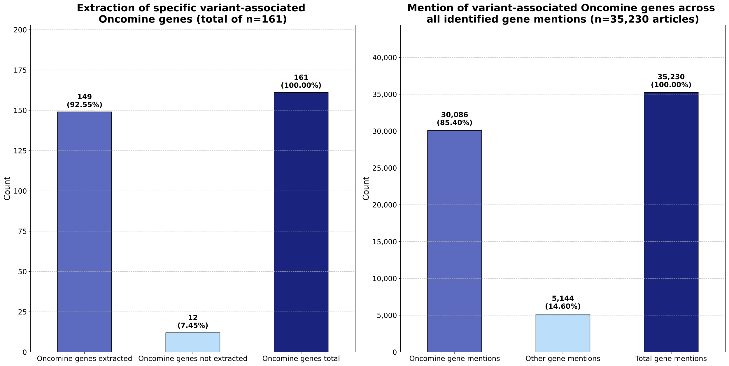

- Variant-associated Oncomine genes not extracted:
ETV5, FGF19, FGF3, FGR, MAGOH, MYB, MYBL1, MYCL, NUTM1, RHEB, RSPO2, RSPO3.
- Variant-associated Oncomine extracted:
AKT1, AKT2, AKT3, ALK, AR, ARAF, ARID1A, ATM, ATR, ATRX, AXL, BAP1, BRAF, BRCA1, BRCA2, BTK, CBL, CCND1, CCND2, CCND3, CCNE1, CDK12, CDK2, CDK4, CDK6, CDKN1B, CDKN2A, CDKN2B, CHEK1, CHEK2, CREBBP, CSF1R, CTNNB1, DDR2, EGFR, ERBB2, ERBB3, ERBB4, ERCC2, ERG, ESR1, ETV1, ETV4, EZH2, FANCA, FANCD2, FANCI, FBXW7, FGFR1, FGFR2, FGFR3, FGFR4, FLT3, FOXL2, GATA2, GNA11, GNAQ, GNAS, H3F3A, HIST1H3B, HNF1A, HRAS, IDH1, IDH2, IGF1R, JAK1, JAK2, JAK3, KDR, KIT, KNSTRN, KRAS, MAP2K1, MAP2K2, MAP2K4, MAPK1, MAX, MDM2, MDM4, MED12, MET, MLH1, MRE11, MSH2, MSH6, MTOR, MYC, MYCN, MYD88, NBN, NF1, NF2, NFE2L2, NOTCH1, NOTCH2, NOTCH3, NOTCH4, NRAS, NRG1, NTRK1, NTRK2, NTRK3, PALB2, PDGFRA, PDGFRB, PIK3CA, PIK3CB, PIK3R1, PMS2, POLE, PPARG, PPP2R1A, PRKACA, PRKACB, PTCH1, PTEN, PTPN11, RAC1, RAD50, RAD51, RAD51B, RAD51C, RAD51D, RAF1, RB1, RELA, RET, RHOA, RICTOR, RNF43, ROS1, SETD2, SF3B1, SLX4, SMAD4, SMARCA4, SMARCB1, SMO, SPOP, SRC, STAT3, STK11, TERT, TOP1, TP53, TSC1, TSC2, U2AF1, XPO1.
Supplementary information 12: Progressive merging ad filtering of datasets from 307,748 detected articles with Oncomine gene mentions, to 7,524 (2.4%) of articles which contain all predefined conditions, including variants.
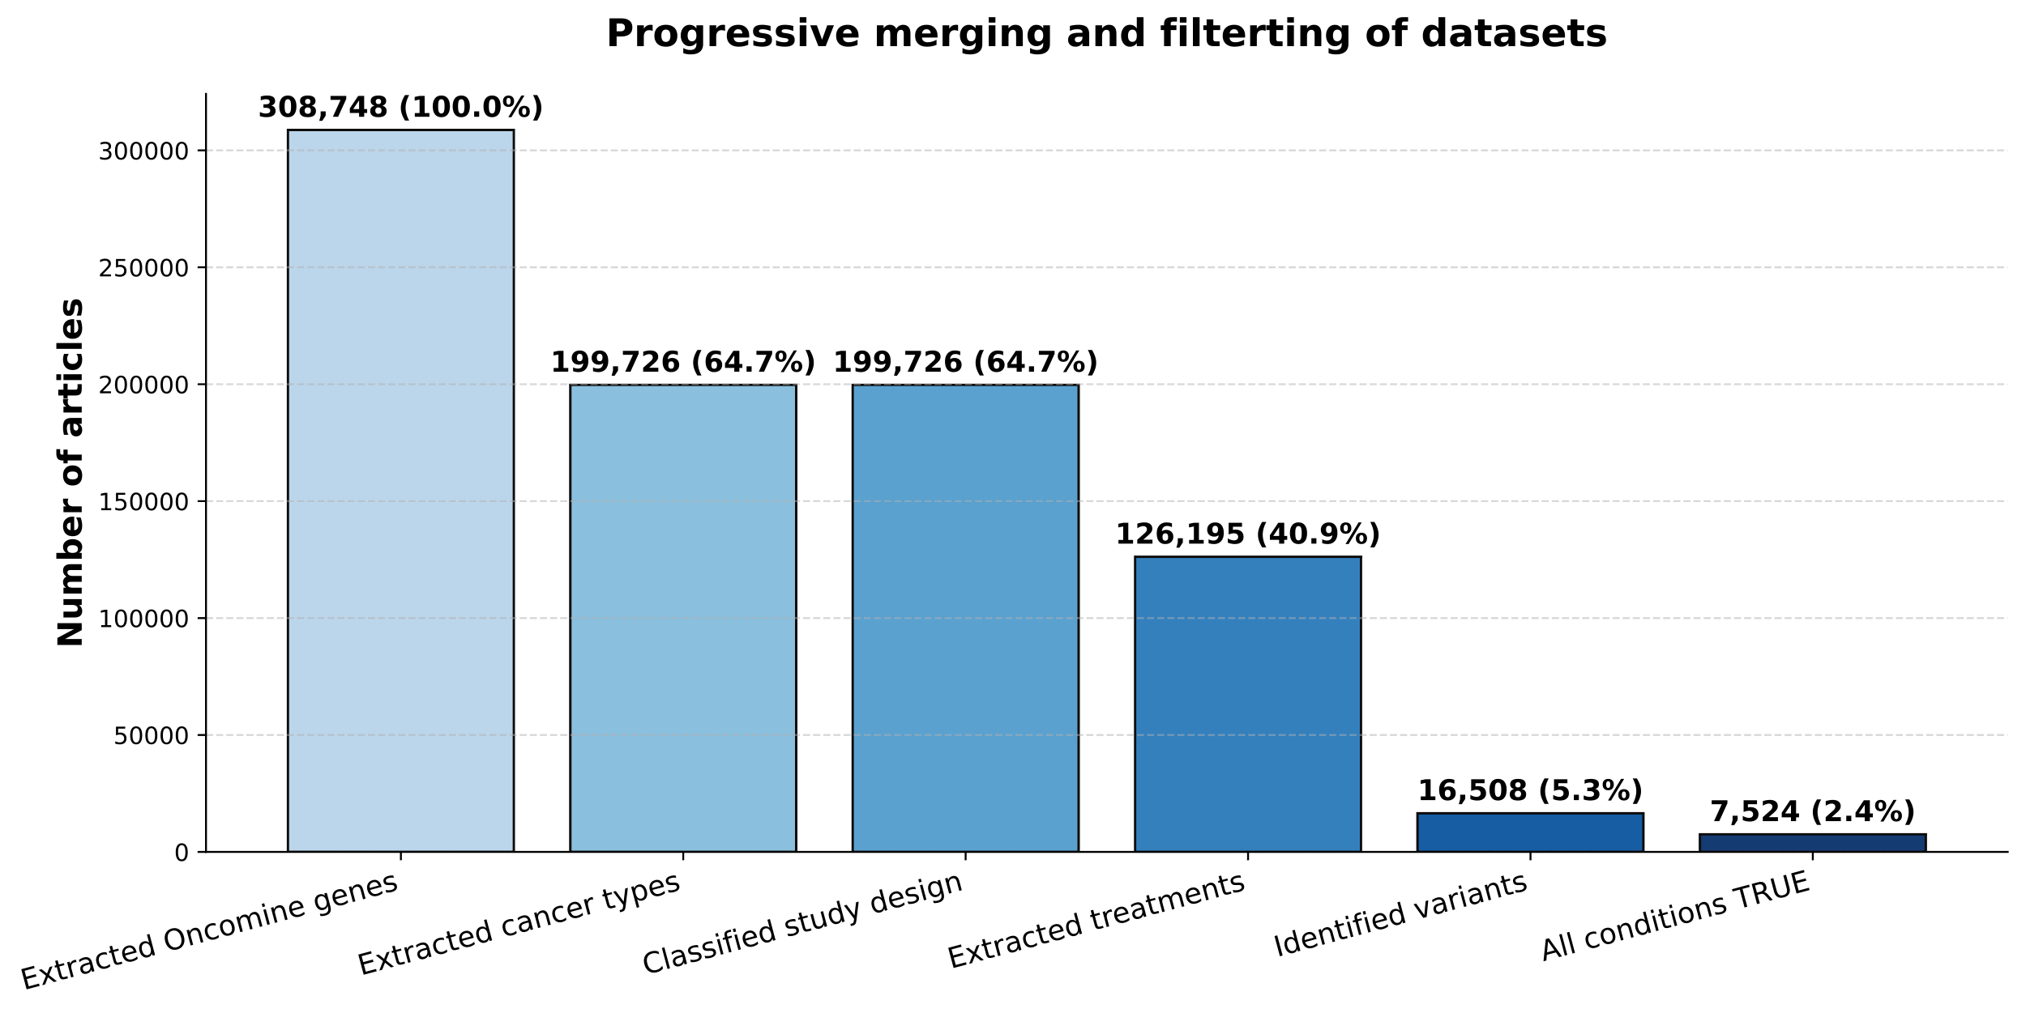

Supplementary information 13: Most mentioned treatment types in the final analysis dataset of 7,524 articles.
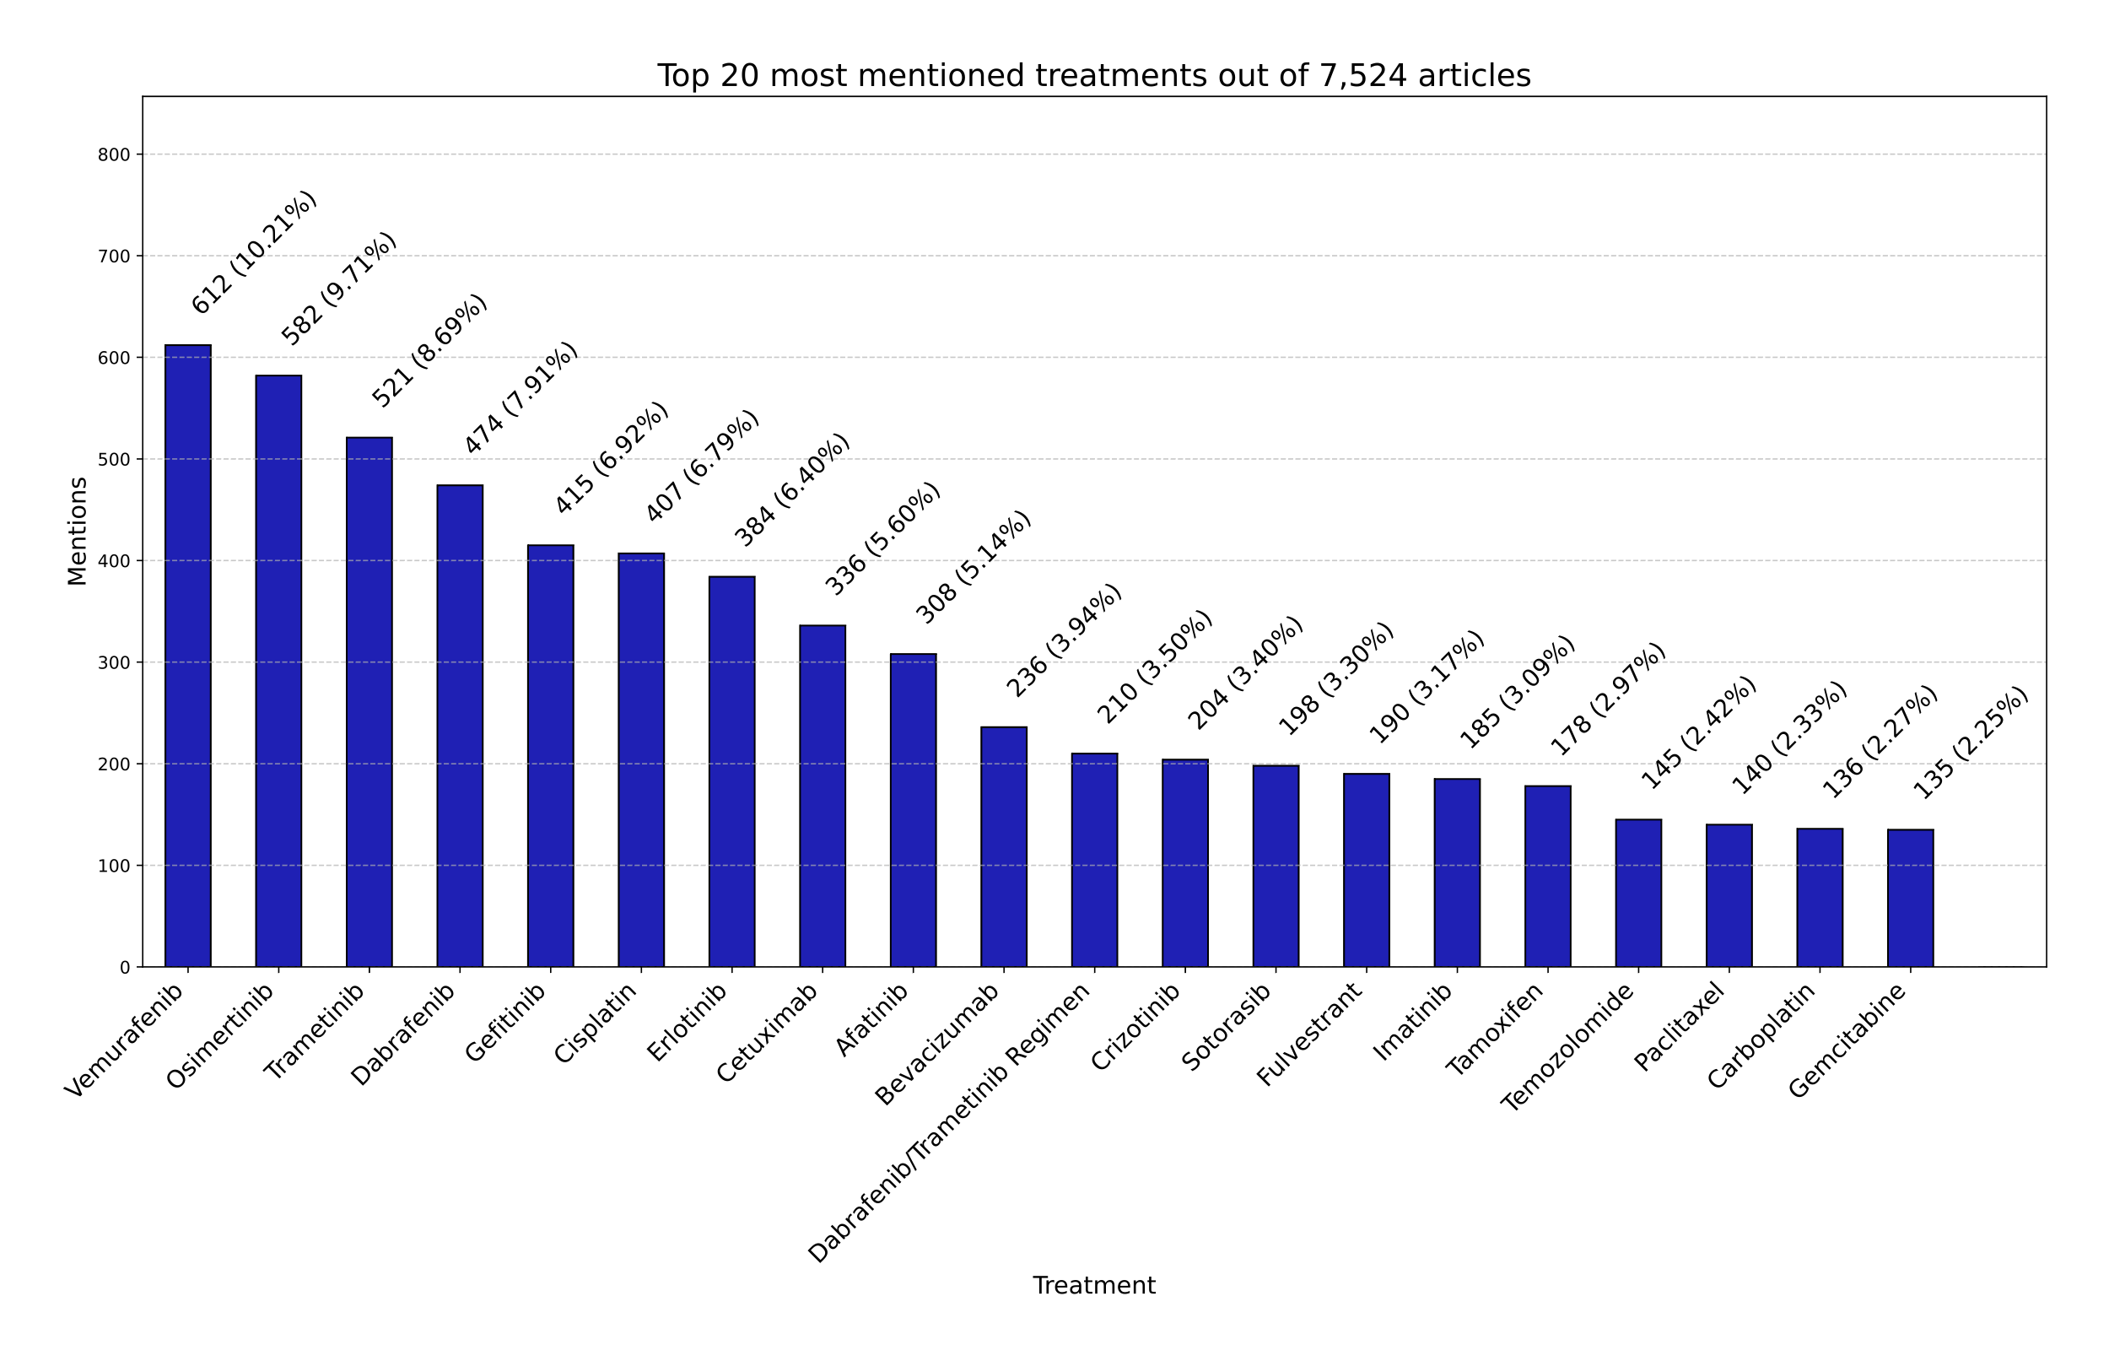

Supplementary information 14: Most mentioned cancer types in the final analysis dataset of 7,524 articles.
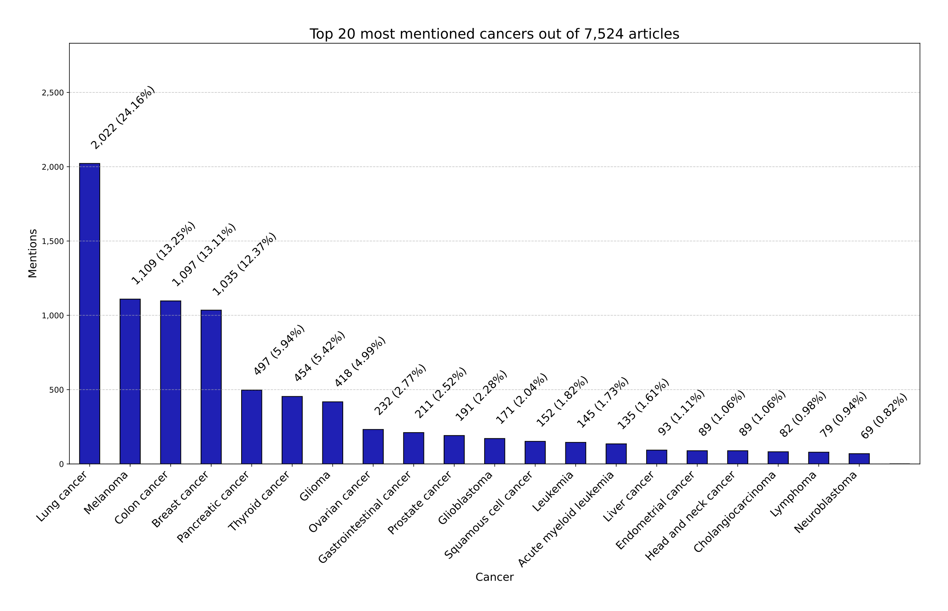

Supplementary information 15: Heatmap illustrating co-associations of variants and cancers.
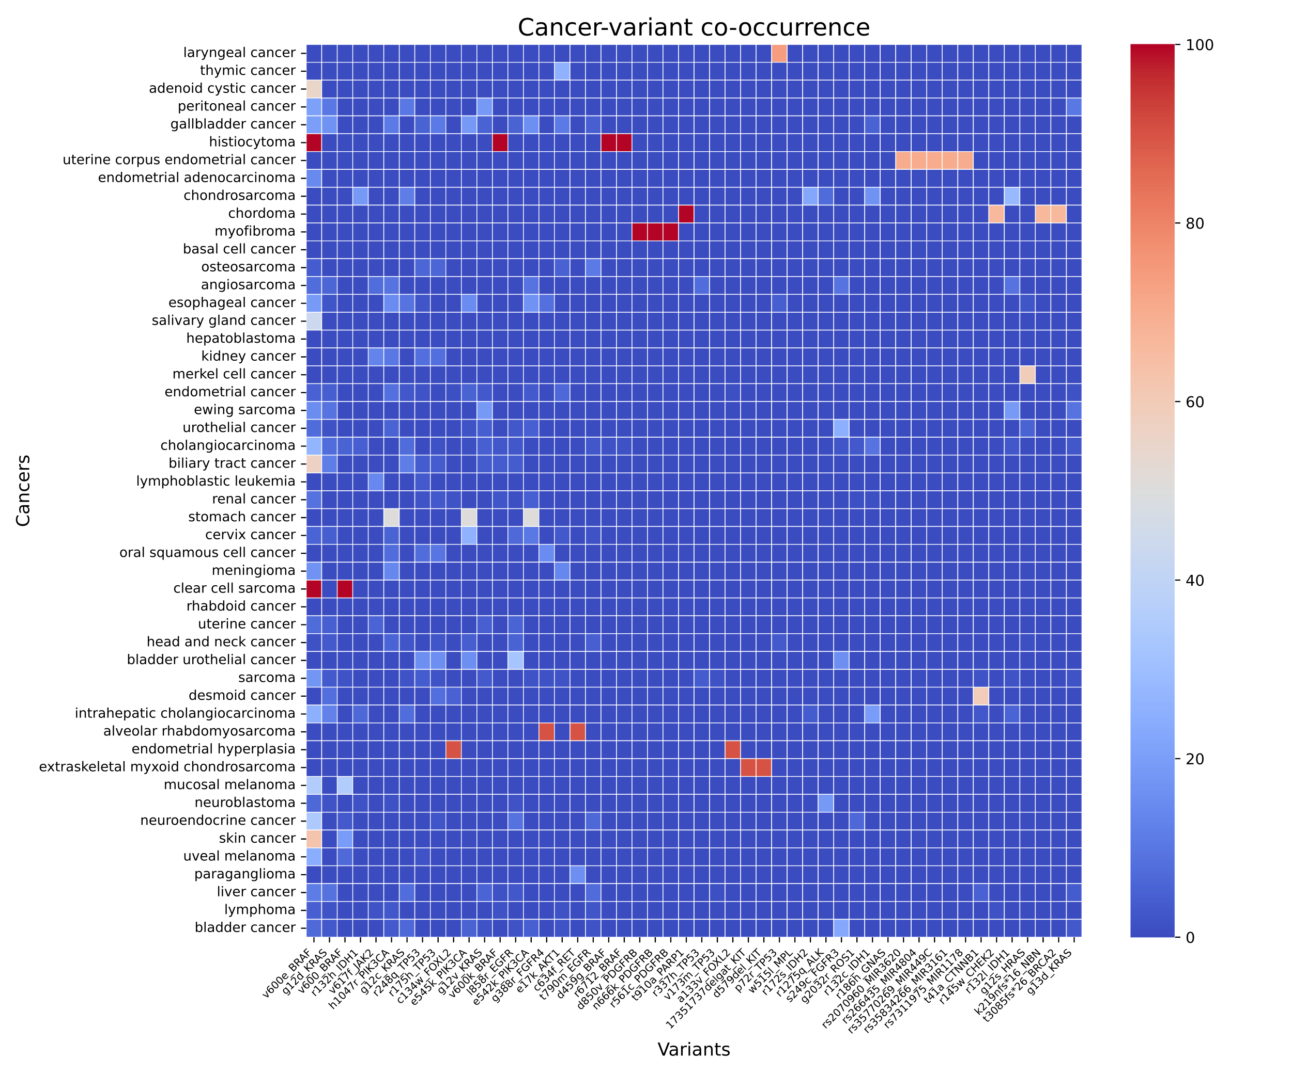

Supplementary information 16: Heatmap illustrating co-associations of cancers and treatments.
