Correlations regarding the primary analyses: HRV indices, executive function scores and manipulations checks.
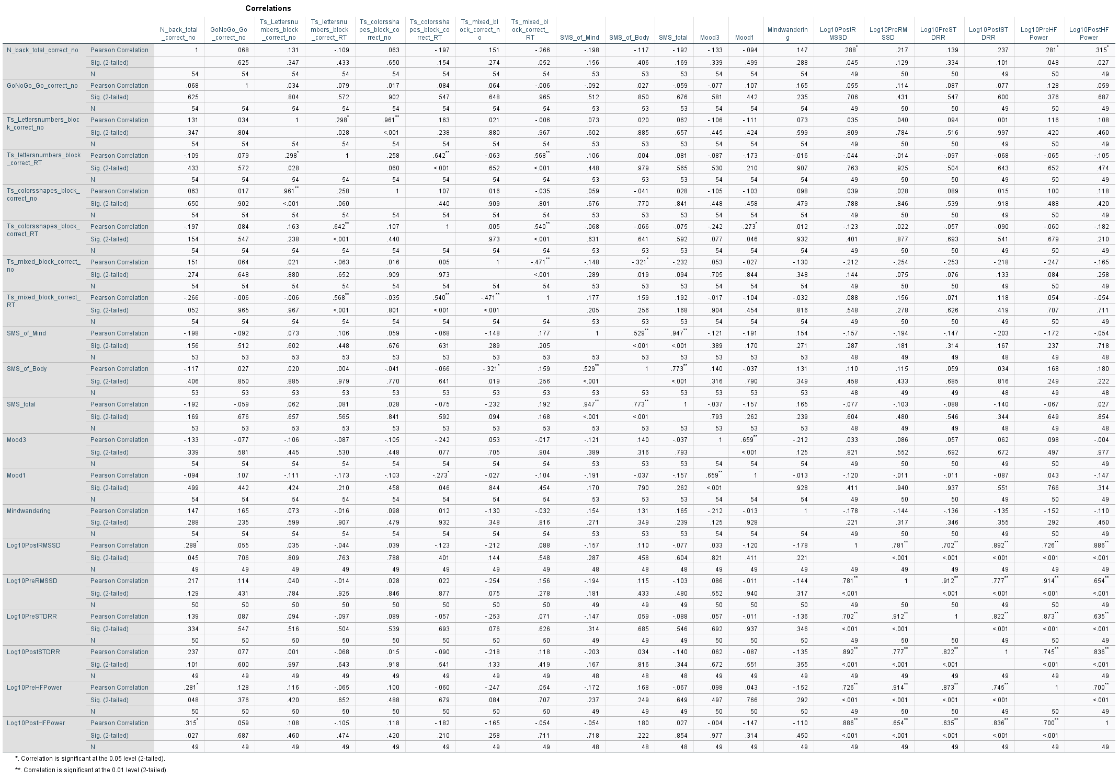

Correlations regarding the secondary analyses: executive function scores, manipulation checks and state scores.
