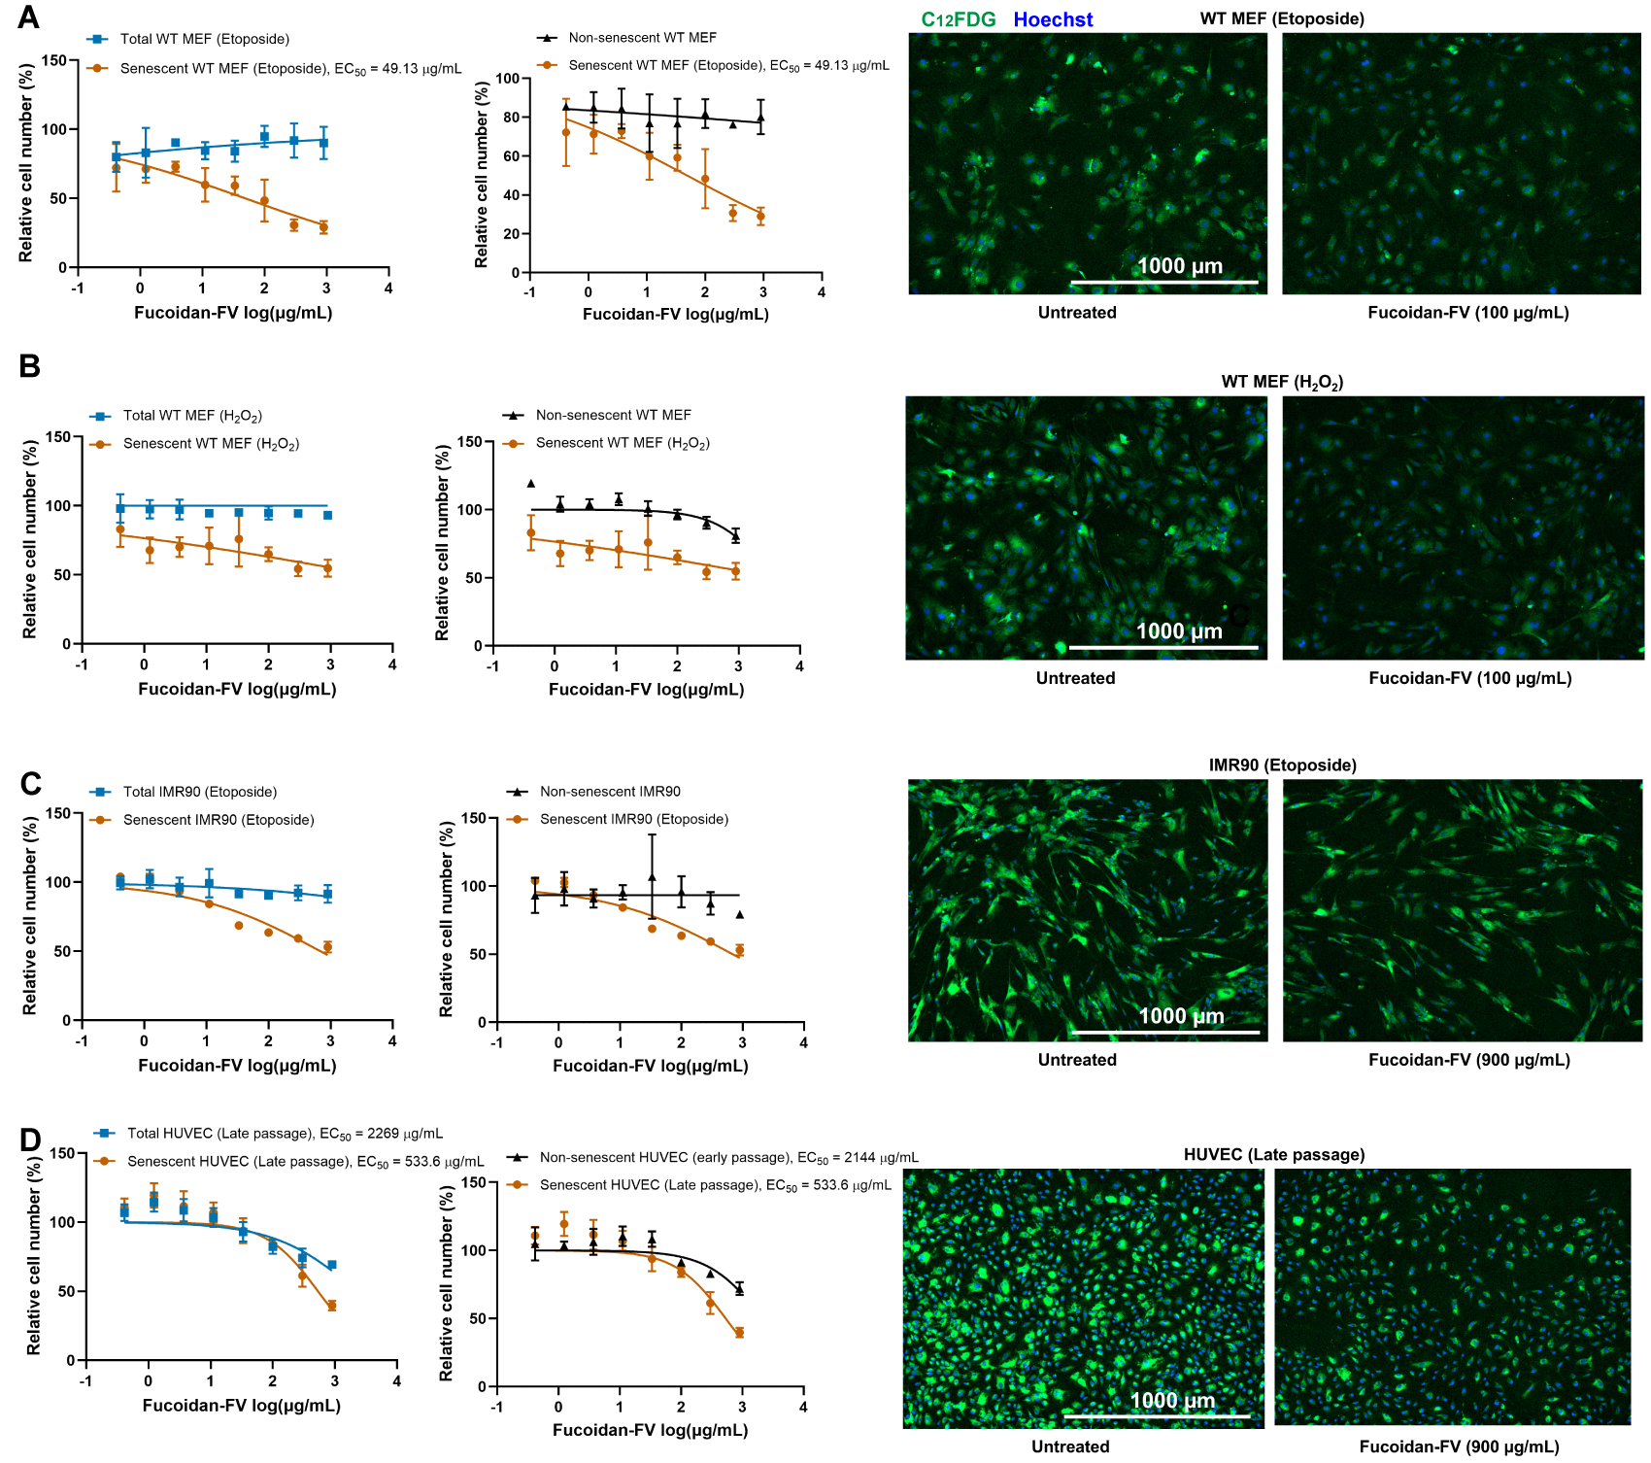
Supplementary Figure S1. Senotherapeutic activity of Fucoidan-FV in various senescent cell models, related to Figure 1.
Fucoidan-FV reduced senescence detected by staining with C₁₂FDG for SA-β-gal activity in (A) senescent WT MEFs induced by hydrogen peroxide, (B) senescent WT MEFs induced by etoposide, (C) senescent IMR90 induced by etoposide, (D) senescent HUVECs induced by proliferative passaging. Representative images were captured using Cytation 1 at 4X magnification. Blue fluorescence indicates Hoechst 33324-stained nuclei and green fluorescence marks C₁₂FDG-stained SA-β-gal positive senescent cells.
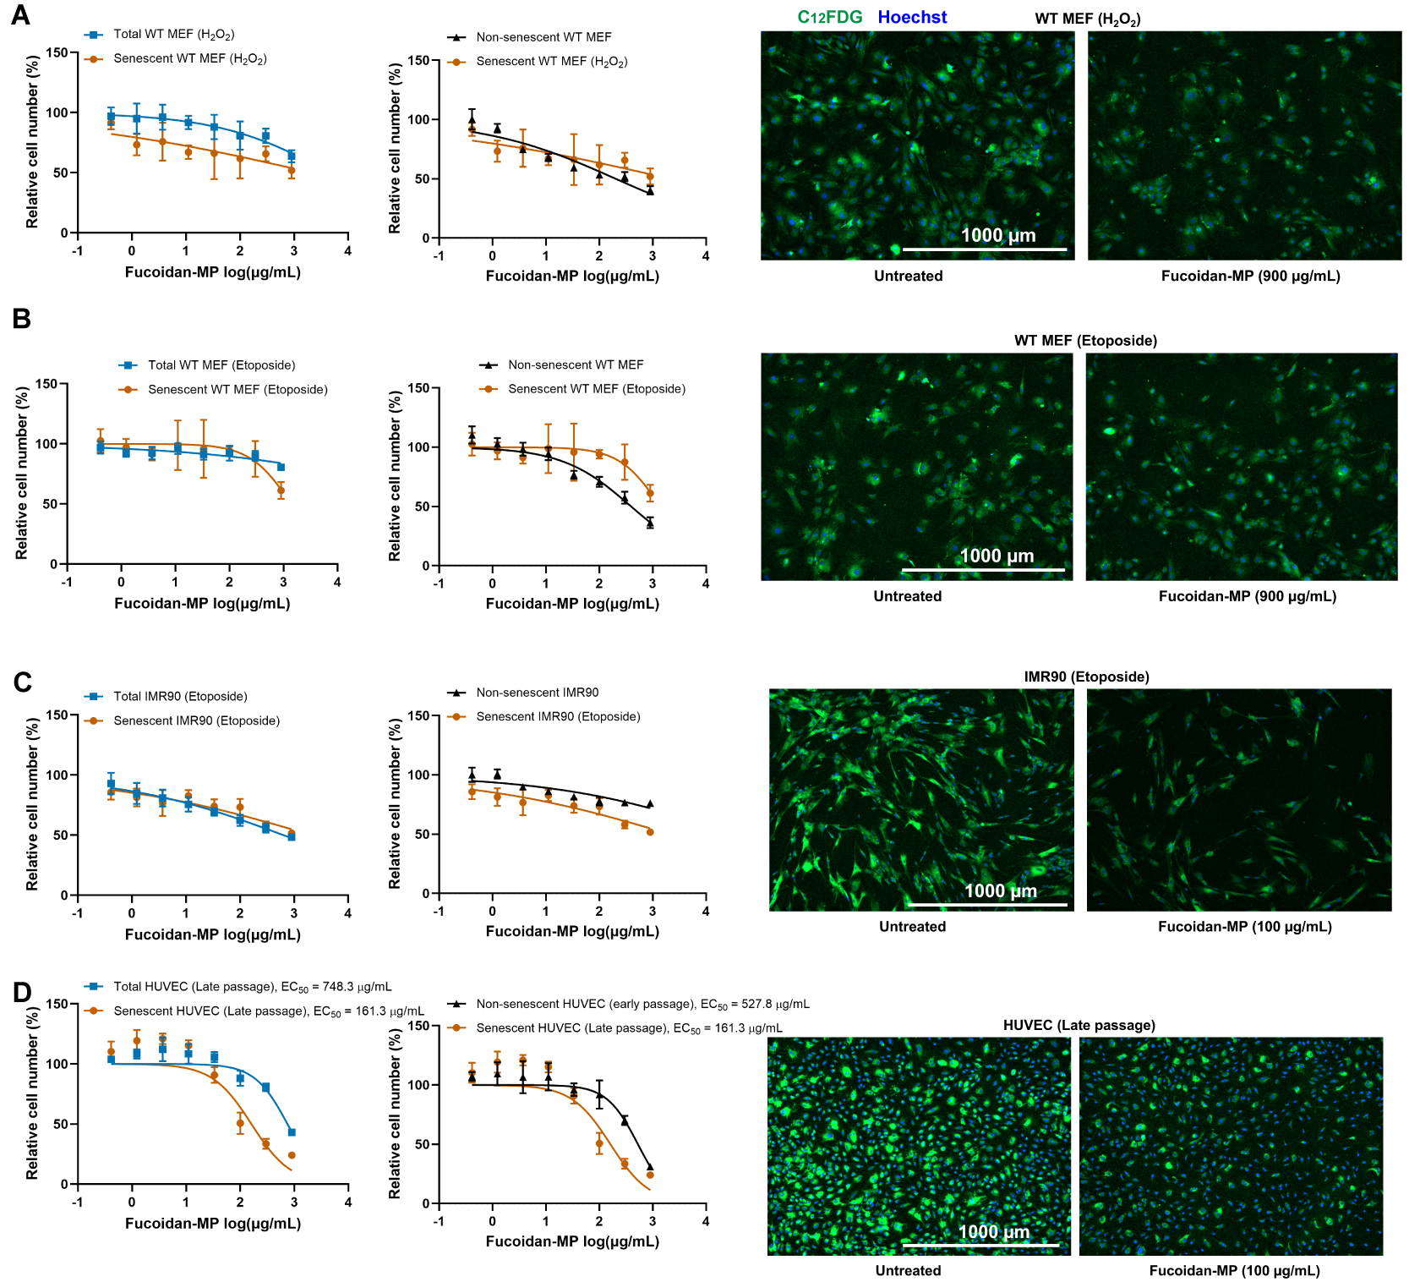Supplementary Figure S2. Senotherapeutic activity of Fucoidan-MP in various senescent cell models, related to Figure 1.
Fucoidan-MP reduced senescence detected by staining with C₁₂FDG for SA-β-gal activity in (A) senescent WT MEFs induced by hydrogen peroxide, (B) senescent WT MEFs induced by etoposide, (C) senescent IMR90 induced by etoposide, (D) senescent HUVECs induced by proliferative passaging. Representative images were captured using Cytation 1 at 4X magnification. Blue fluorescence indicates Hoechst 33324-stained nuclei and green fluorescence marks C₁₂FDG-stained SA-β-gal positive senescent cells.
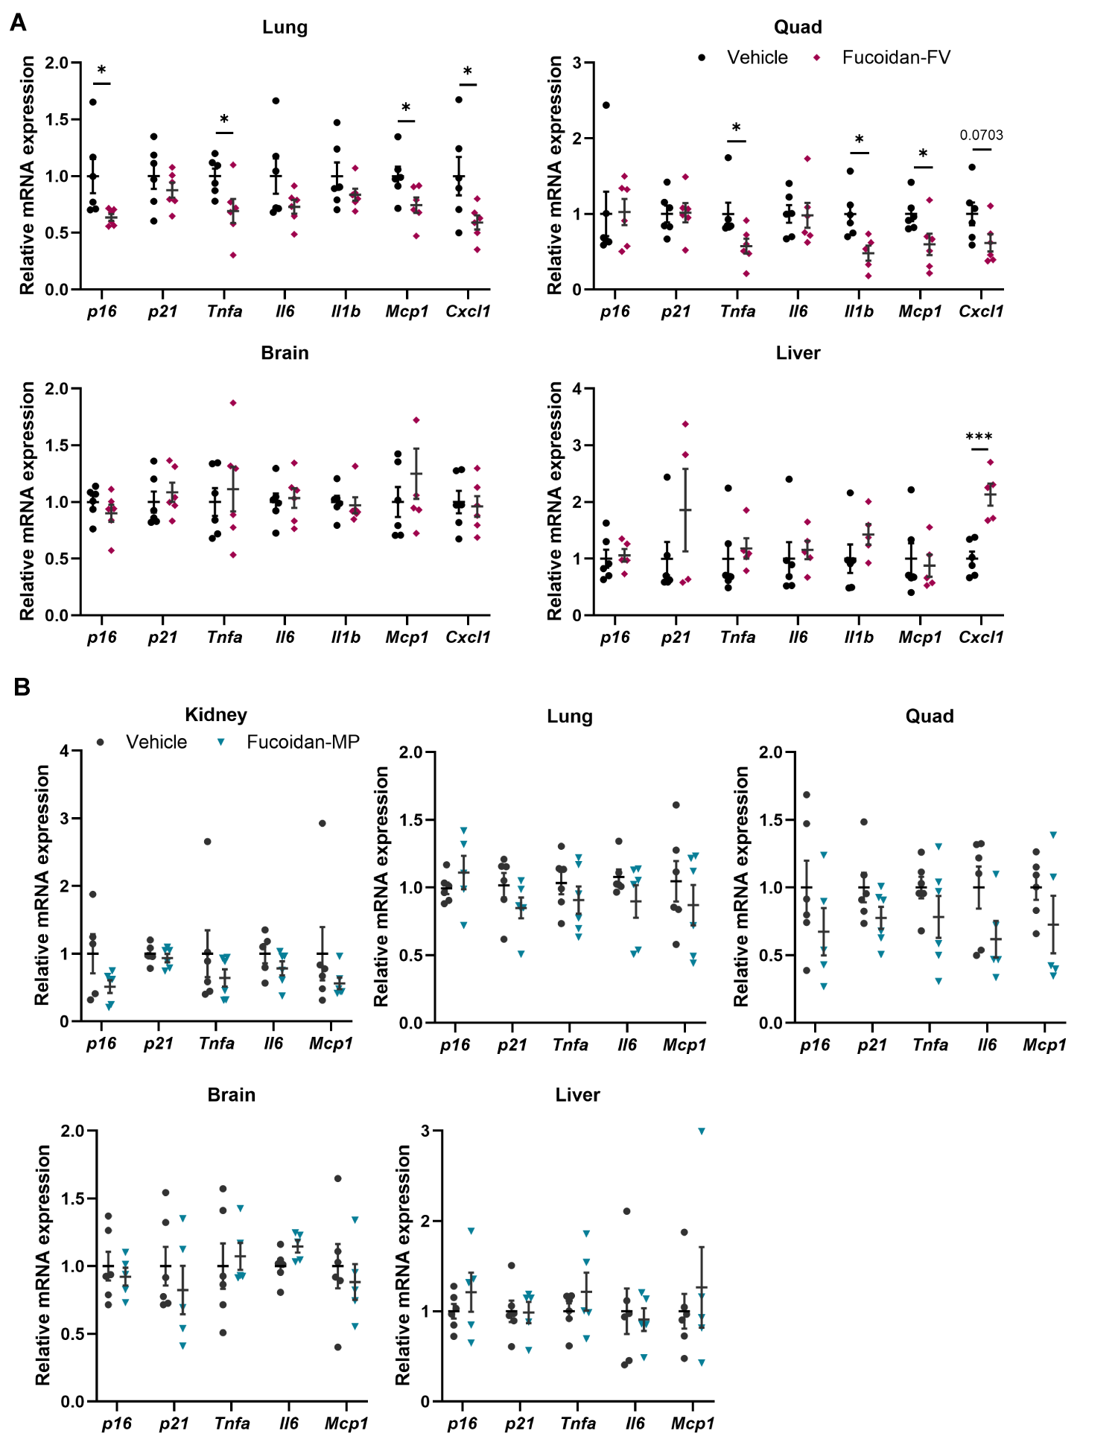
Supplementary Figure S3. Senotherapeutic effects of Fucoidan-FV and Fucoidan-MP in aged WT C57BL/6 mice, related to Figure 2.
(A) The effects of Fucoidan-FV on reducing senescence markers across different tissues in WT C57BL/6 mice aged 32 months. Error bars represent SEM for n = 6. (B) The effects of Fucoidan-MP on reducing senescence across different tissues in WT C57BL/6 mice aged 32 months. Error bars represent SEM for n = 6.
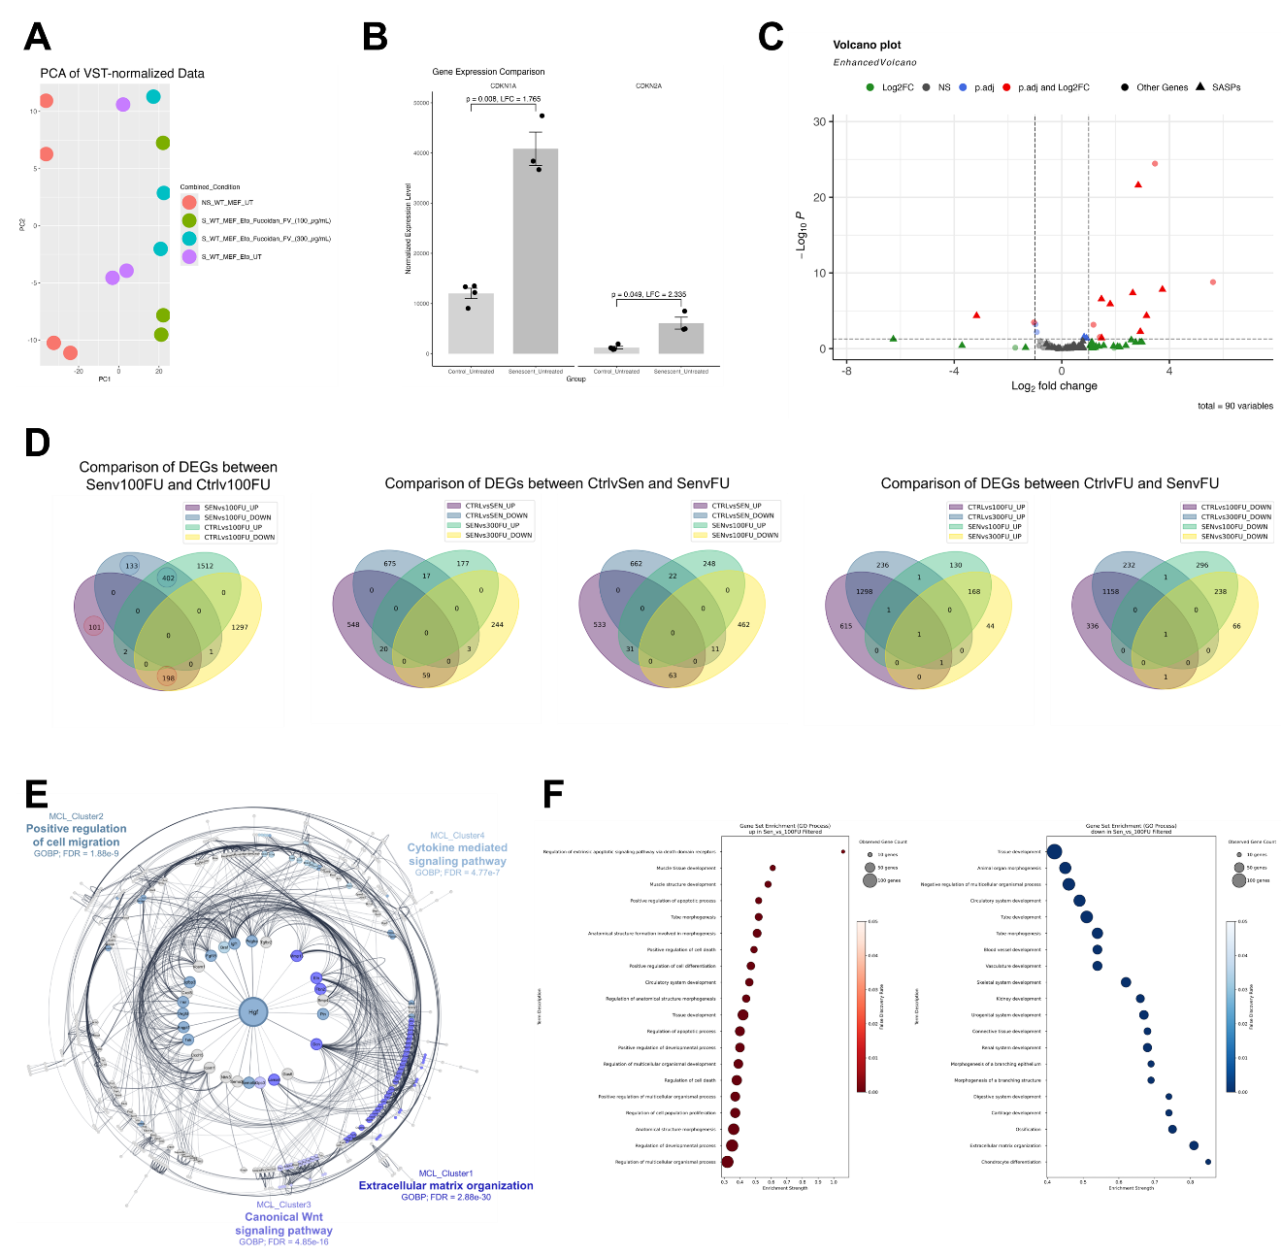

Supplementary Figure S4. Transcriptional changes in senescent MEFs and additional RNA-Seq analysis, related to Figure 4.
(A) Principal component analysis plot for RNA-Seq data obtained from untreated (UT) or Fucoidan-FV treated non-senescent (NS/CTRL) and senescent (Sen/Eto) WT MEFs. (B) Normalized expression of CDKN1A and CDKN2A in UT NS and UT Sen MEFs; n = 3 per group. (C) Volcano plot highlighting differentially expressed SASP genes between UT NS and UT Sen MEF; cutoffs at |log₂FC|=1 and -log₁₀padj = 1.3. (D) Venn diagrams for comparisons among different treatment groups. (E) Radial interaction network diagram of filtered downregulated DEGs in UT Sen vs 100 µg/mL Fucoidan-FV treated MEFs. Node size corresponds to degree centrality in network topology; edge width corresponds to undirected confidence of interaction between nodes. Top 4 MCL clusters are annotated with colored nodes and labeled with the highest enriched GO term. (F) Top 20 GO biological processes (GOBP) pathways overrepresented by filtered up- and downregulated DEGs in UT Sen vs 100 µg/mL Fucoidan-FV treated MEFs.

