Supplementary Material
This material has been provided by the authors to give readers additional information about their work. Supplement to:
Américo Agostinho, Etienne Chalot, Daniel Teixeira, Davide Bosetti, Niccolò Buetti, Gaud Catho, Stephan Harbarth, Mohamed Abbas. Semi-automated surveillance of surgical site infections: development of machine learning models and comparison with a rule-based classification model.

Table of Contents
Supplementary Tables 2
Supplementary Table 1. 2
Supplementary Table 2. 3
Supplementary Table 3. 4
Supplementary Figures 6
Supplementary Fig. 1. 6
Supplementary Fig. 2. 7
Supplementary Fig. 3. 8

Supplementary Tables
Supplementary Table 1. Hyperparameters grid search
Model | Type | Hyperparameters | Grid search
Naïve Bayes | L | - assumption: Bernoulli  - Laplace smoothing=1 | - assumption=[Bernoulli, Gaussian]  - Laplace smoothing=[0, 0.5, 1, 2]
Logistic regression | L | - penalty=L2 ,  - penalty parameter =1 | - penalty=[L1, L2, L1&L2]  - penalty parameter=[0.1, 0.5, 1, 2, 5]
Dense neural network | NL | - loss=binary cross-entropy ,  - learning rate= 1e-4  - optimizer= adam,  - hidden layers= 2  - neurones =64  - activation=ReLu ,  - dropout layer=0.3,  - output layer activation = sigmoid | - learning rate= [1e-5, 1e-4, 1e-3, 1e-2]  - optimizer=[sgd, adam],  - hidden layers=[2, 3, 4, 5]  - neurones =[16, 32, 64, 128, 256]  - activation=[sigmoid, tanh, ReLu] ,  - dropout layer=[0, 0.1, 0.3, 0.5],
Random forest | NL | - max depth=3 - min samples leaf=4 | - max depth=[None, 1, 2, 3, 4, 5]  - min samples leaf=[1, 2, 3, 4, 5]
Discriminant analysis | NL | - regularization parameter=0 | - regularization parameter=[0, 0.1, 0.5, 1, 2, 5]
Support vector machine | NL | - kernel=radial basis function  - regularization parameter=1 | - kernel= [linear, poly, rbf, sigmoid]  - regularization parameter=[0.1, 0.5, 1, 2, 5]
XGBoost | NL | - learning rate=0.1,  - minimum loss reduction=0,  - L2 regularization=3  - L1 regularization=1,  - max depth=3 | - learning rate=[0.001, 0.01, 0.1, 03]  - minimum loss reduction= [0, 1, 3, 5, 10],  - L2 regularization=[0, 0.1, 1, 3, 10]  - L1 regularization=[0, 0.1, 1, 3, 10],  - max depth=[3, 5, 7, 10]

Supplementary Table 2. Model performance in the cross-validation test sets
Model | Negative predictive value (95%CI) | Workload reduction (95%CI) | Sensitivity (95%CI) | Specificity (95%CI) | AUC (95%CI) | MCC (95%CI)
Naive Bayes | 0.996 (0.995-0.997) | 0.907 (0.897-0.917) | 0.871 (0.846-0.897) | 0.932 (0.924-0.94) | 0.966 (0.963-0.969) | 0.477 (0.427-0.527)
Dense neural network | 0.989 (0.985-0.993) | 0.928 (0.921-0.935) | 0.641 (0.555-0.728) | 0.944 (0.938-0.95) | 0.918 (0.885-0.951) | 0.367 (0.319-0.414)
Random forest | 0.974 (0.968-0.979) | 0.991 (0.988-0.993) | 0.156 (0.124-0.188) | 0.995 (0.993-0.998) | 0.937 (0.913-0.961) | 0.28 (0.212-0.347)
Support vector classifier | 0.973 (0.966-0.981) | 0.993 (0.992-0.995) | 0.159 (0.099-0.218) | 0.998 (0.996-1.0) | 0.938 (0.909-0.968) | 0.319 (0.213-0.426)
Quadratic discriminant analysis | 0.987 (0.982-0.991) | 0.925 (0.916-0.933) | 0.61 (0.552-0.668) | 0.941 (0.934-0.948) | 0.938 (0.92-0.957) | 0.356 (0.336-0.375)
XGBoost classifier | 0.978 (0.973-0.983) | 0.984 (0.981-0.987) | 0.314 (0.249-0.378) | 0.993 (0.99-0.996) | 0.959 (0.95-0.968) | 0.419 (0.325-0.514)
AUC, area under the receiver-operating characteristic curve; MCC, Matthew’s correlation coefficient; NPV, negative predictive value.

Supplementary Table 3. Model performance in the validation dataset across the probability prediction threshold.
Model | Threshold | NPV | WR | Sensitivity | Specificity | AUC | MCC
Naive Bayes | 0 | 0 | 0 | 1 | 0 | 0.968 | 0
Naive Bayes | 0.1 | 0.999 | 0.883 | 0.95 | 0.905 | 0.968 | 0.419
Naive Bayes | 0.2 | 0.999 | 0.892 | 0.95 | 0.914 | 0.968 | 0.438
Naive Bayes | 0.3 | 0.997 | 0.902 | 0.9 | 0.923 | 0.968 | 0.436
Naive Bayes | 0.4 | 0.997 | 0.911 | 0.9 | 0.932 | 0.968 | 0.46
Naive Bayes | 0.5 | 0.997 | 0.916 | 0.9 | 0.937 | 0.968 | 0.475
Naive Bayes | 0.6 | 0.997 | 0.92 | 0.9 | 0.941 | 0.968 | 0.488
Naive Bayes | 0.7 | 0.997 | 0.922 | 0.9 | 0.944 | 0.968 | 0.497
Naive Bayes | 0.8 | 0.995 | 0.929 | 0.8 | 0.948 | 0.968 | 0.458
Naive Bayes | 0.9 | 0.993 | 0.939 | 0.75 | 0.957 | 0.968 | 0.465
Naive Bayes | 1 | 0.975 | 1 | 0 | 1 | 0.968 | 0
Dense neural network | 0 | 0 | 0 | 1 | 0 | 0.924 | 0
Dense neural network | 0.1 | 0.998 | 0.571 | 0.95 | 0.584 | 0.924 | 0.17
Dense neural network | 0.2 | 0.997 | 0.764 | 0.9 | 0.781 | 0.924 | 0.252
Dense neural network | 0.3 | 0.997 | 0.826 | 0.9 | 0.845 | 0.924 | 0.309
Dense neural network | 0.4 | 0.996 | 0.868 | 0.85 | 0.887 | 0.924 | 0.342
Dense neural network | 0.5 | 0.996 | 0.901 | 0.85 | 0.92 | 0.924 | 0.406
Dense neural network | 0.6 | 0.996 | 0.921 | 0.85 | 0.941 | 0.924 | 0.462
Dense neural network | 0.7 | 0.996 | 0.94 | 0.85 | 0.961 | 0.924 | 0.539
Dense neural network | 0.8 | 0.993 | 0.954 | 0.75 | 0.973 | 0.924 | 0.544
Dense neural network | 0.9 | 0.983 | 0.978 | 0.35 | 0.987 | 0.924 | 0.365
Dense neural network | 1 | 0.975 | 1 | 0 | 1 | 0.924 | 0
Quadratic discriminant analysis | 0 | 0 | 0 | 1 | 0 | 0.916 | 0
Quadratic discriminant analysis | 0.1 | 0.997 | 0.877 | 0.9 | 0.897 | 0.916 | 0.382
Quadratic discriminant analysis | 0.2 | 0.997 | 0.881 | 0.9 | 0.901 | 0.916 | 0.389
Quadratic discriminant analysis | 0.3 | 0.997 | 0.886 | 0.9 | 0.906 | 0.916 | 0.399
Quadratic discriminant analysis | 0.4 | 0.997 | 0.888 | 0.9 | 0.909 | 0.916 | 0.404
Quadratic discriminant analysis | 0.5 | 0.997 | 0.889 | 0.9 | 0.91 | 0.916 | 0.407
Quadratic discriminant analysis | 0.6 | 0.996 | 0.893 | 0.85 | 0.913 | 0.916 | 0.389
Quadratic discriminant analysis | 0.7 | 0.996 | 0.895 | 0.85 | 0.914 | 0.916 | 0.391
Quadratic discriminant analysis | 0.8 | 0.996 | 0.895 | 0.85 | 0.914 | 0.916 | 0.391
Quadratic discriminant analysis | 0.9 | 0.994 | 0.9 | 0.8 | 0.918 | 0.916 | 0.376
Quadratic discriminant analysis | 1 | 0.991 | 0.936 | 0.65 | 0.952 | 0.916 | 0.388
Random forest | 0 | 0 | 0 | 1 | 0 | 0.957 | 0
Random forest | 0.1 | 0.997 | 0.912 | 0.9 | 0.934 | 0.957 | 0.464
Random forest | 0.2 | 0.993 | 0.948 | 0.75 | 0.966 | 0.957 | 0.507
Random forest | 0.3 | 0.988 | 0.963 | 0.55 | 0.977 | 0.957 | 0.44
Random forest | 0.4 | 0.984 | 0.975 | 0.4 | 0.984 | 0.957 | 0.384
Random forest | 0.5 | 0.981 | 0.985 | 0.25 | 0.991 | 0.957 | 0.309
Random forest | 0.6 | 0.98 | 0.994 | 0.2 | 0.999 | 0.957 | 0.394
Random forest | 0.7 | 0.977 | 0.996 | 0.1 | 0.999 | 0.957 | 0.252
Random forest | 0.8 | 0.975 | 1 | 0 | 1 | 0.957 | 0
Random forest | 0.9 | 0.975 | 1 | 0 | 1 | 0.957 | 0
Random forest | 1 | 0.975 | 1 | 0 | 1 | 0.957 | 0
Support vector classifier | 0 | 0 | 0 | 1 | 0 | 0.908 | 0
Support vector classifier | 0.1 | 0.992 | 0.95 | 0.7 | 0.967 | 0.908 | 0.484
Support vector classifier | 0.2 | 0.988 | 0.964 | 0.55 | 0.978 | 0.908 | 0.448
Support vector classifier | 0.3 | 0.986 | 0.97 | 0.45 | 0.98 | 0.908 | 0.394
Support vector classifier | 0.4 | 0.983 | 0.973 | 0.35 | 0.982 | 0.908 | 0.324
Support vector classifier | 0.5 | 0.981 | 0.981 | 0.25 | 0.987 | 0.908 | 0.273
Support vector classifier | 0.6 | 0.981 | 0.982 | 0.25 | 0.988 | 0.908 | 0.284
Support vector classifier | 0.7 | 0.978 | 0.986 | 0.15 | 0.99 | 0.908 | 0.187
Support vector classifier | 0.8 | 0.978 | 0.989 | 0.15 | 0.992 | 0.908 | 0.21
Support vector classifier | 0.9 | 0.978 | 0.994 | 0.15 | 0.997 | 0.908 | 0.292
Support vector classifier | 1 | 0.975 | 1 | 0 | 1 | 0.908 | 0
XGBC classifier | 0 | 0 | 0 | 1 | 0 | 0.951 | 0
XGBC classifier | 0.1 | 0.993 | 0.944 | 0.75 | 0.962 | 0.951 | 0.488
XGBC classifier | 0.2 | 0.989 | 0.958 | 0.6 | 0.973 | 0.951 | 0.45
XGBC classifier | 0.3 | 0.988 | 0.963 | 0.55 | 0.977 | 0.951 | 0.44
XGBC classifier | 0.4 | 0.987 | 0.968 | 0.5 | 0.98 | 0.951 | 0.431
XGBC classifier | 0.5 | 0.984 | 0.972 | 0.4 | 0.982 | 0.951 | 0.364
XGBC classifier | 0.6 | 0.982 | 0.981 | 0.3 | 0.988 | 0.951 | 0.332
XGBC classifier | 0.7 | 0.979 | 0.99 | 0.2 | 0.995 | 0.951 | 0.306
XGBC classifier | 0.8 | 0.977 | 0.996 | 0.1 | 0.999 | 0.951 | 0.252
XGBC classifier | 0.9 | 0.975 | 0.999 | 0 | 0.999 | 0.951 | 0
XGBC classifier | 1 | 0.975 | 1 | 0 | 1 | 0.951 | 0
AUROC: area under the receiver-operating characteristic curve; MCC: Matthew’s correlation coefficient; NPV: negative predictive value; WR: workload reduction.

Supplementary Figures
Supplementary Fig. 1. Illustration of the rule-based model. This model classifies patients as positive for SSI if any of the following criteria are met: ≥5 days of postoperative antibiotics, ≥1 re-admission, ≥2 positive cultures, or ≥1 infectious disease consultation.

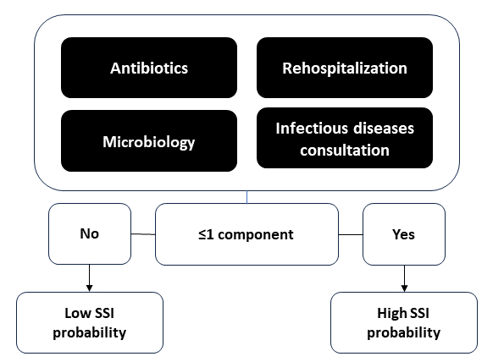

Supplementary Fig. 2. Receiver operating characteristic of the Naïve Bayes model (Bernoulli assumption).
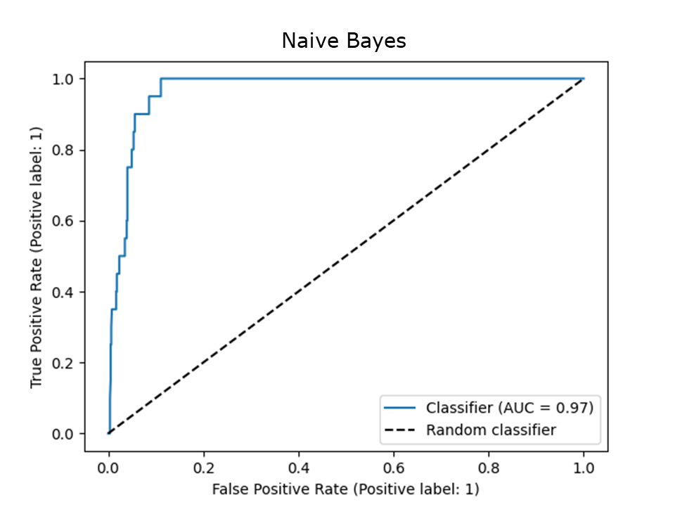

Supplementary Fig. 3. Receiver operating characteristic for the dense neural network model.
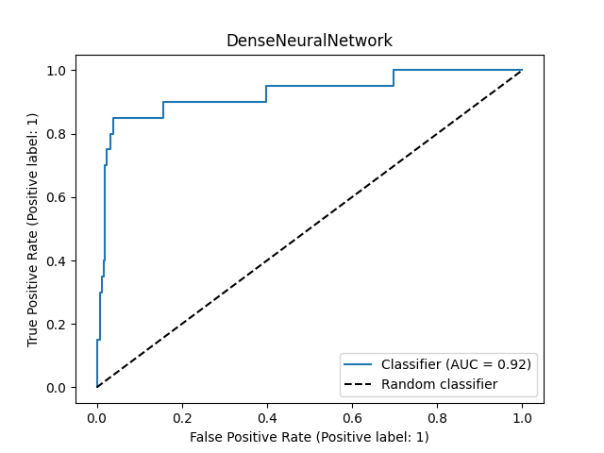

Supplementary Fig. 4. Model performance in the validation dataset across feature restrictions (point estimates and 95%CI).
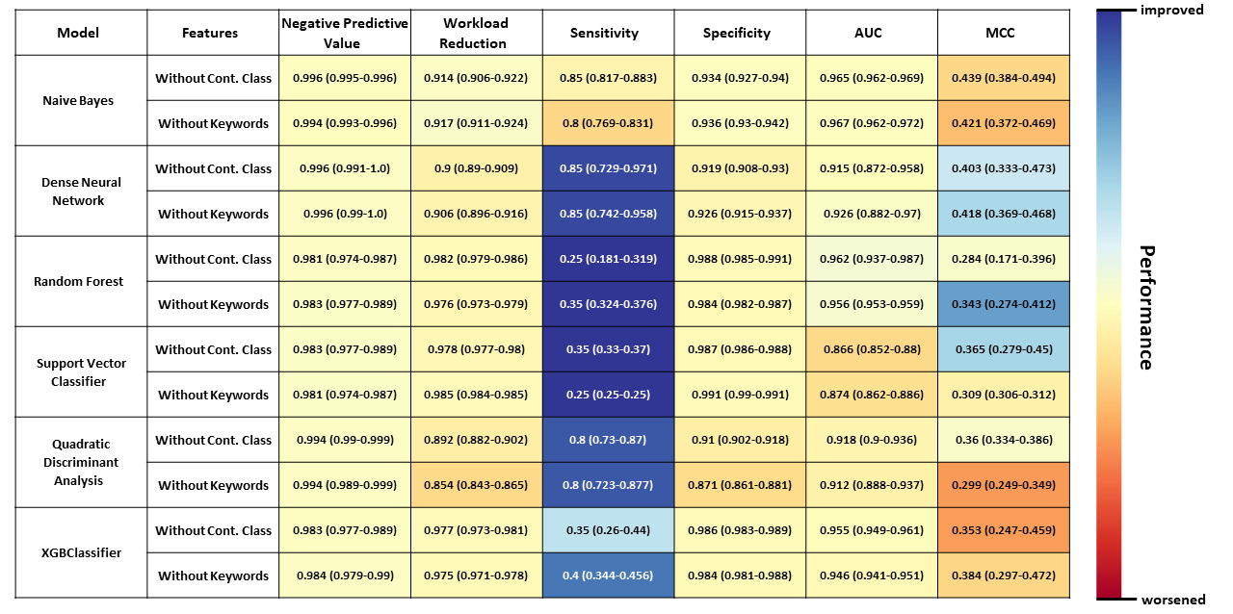
AUC, area under the receiver-operating characteristic curve; MCC, Mathew’s correlation coefficient; NPV, negative predictive value.

