Supplementary Materials for
Microbial Signature of Ocean-Going Syndrome

The supplementary figures include:
Figure S1. Comparison of individual perturbations in the gut microbiome between ‘symptomless’ and ‘symptom’ crew members for 24 indicators (symptoms)
Figure S2. Co-occurrence networks of the OGS and non-OGS at beginning (day 1) and end (day 135) of the voyage

The additional tables include:
Table S1. Definitions of the 24 indicators in the questionnaire
Table S2. Annotation for microbial species in the co-occurrence network
Table S3. The important score of the 27 microbial species and functions used in the Random Forest model

Reference

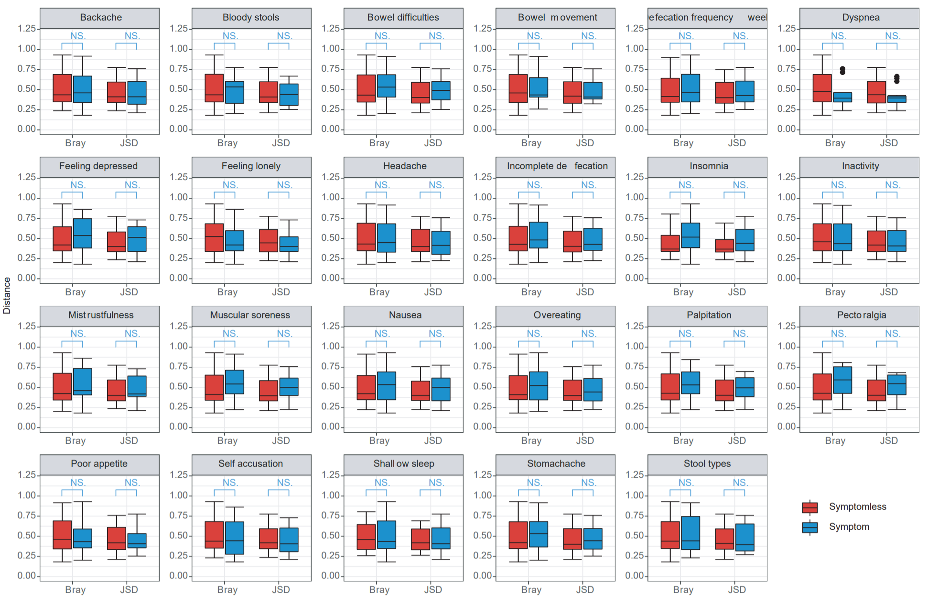
Figure S1. Comparison of individual perturbations in the gut microbiome between ‘symptomless’ and ‘symptom’ crew members for 24 indicators (symptoms). Individual perturbations (n=77) in the gut microbiome measured by BC and rJSD were first grouped according to whether they were ‘symptomless’ or ‘symptom’ for each individual health indicator (symptom), and then compared with each other using Wilcoxon test.

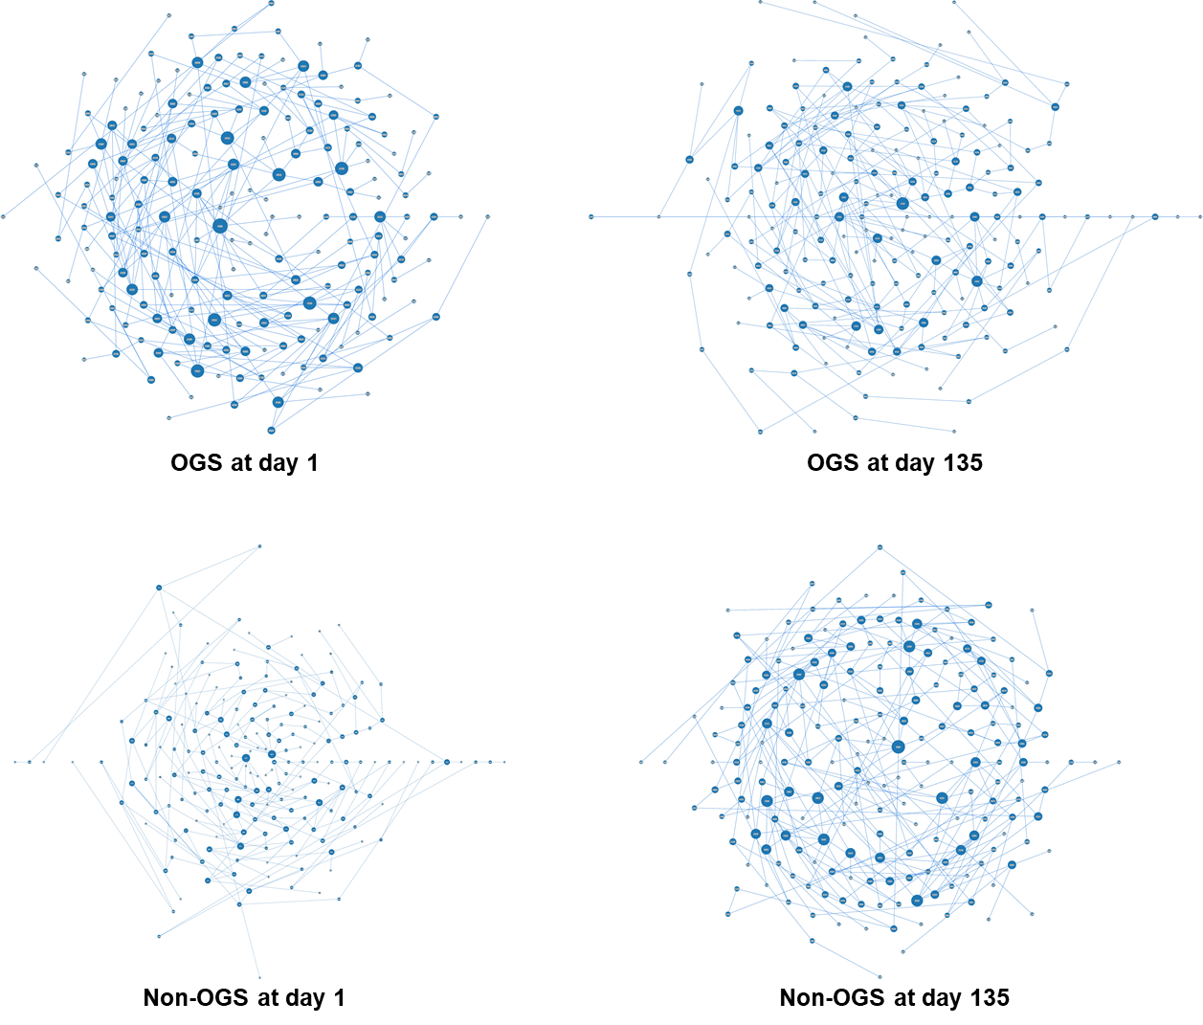
Figure S2. Co-occurrence networks of the OGS and non-OGS at beginning (day 1) and end (day 135) of the voyage.

Table S1 Definitions of the 24 indicators in the questionnaire
Indicator | Definition
Body mass index (BMI) | The BMI is defined as the body mass divided by the square of the body height ¹.
Backache | Back pain, also known as backache, is pain felt in the back ².
Headache | It is usually confined to the upper part of the head, including the upper edge of the eyebrow arch, the helix and the pain above the line connecting the external occipital protuberance ³.
Stomachache | Stomach pain refers to the pain in the epigastric part of the upper abdomen, above the connection line between the lower edges of ribs on both sides and near the heart socket under the xiphoid process ⁴.
Pectoralgia | Pectoralgia is a subjective feeling, feeling chest pain, severe pain, dull pain, stuffy pain or oppressive feeling ⁵.
Muscular soreness | Pain or tenderness in one or more muscles which can involve any area of the body.
Dyspnea | Dyspnea is a combination of subjective feeling and objective signs. Subjectively, breathing is laborious, objectively, the number of breaths increases, the movement is fast and the range increases ⁶.
Palpitation | Palpitation includes palpitation and palpitation, which is a kind of uncomfortable feeling or palpitation of conscious heart beating ⁷.
Insomnia | Insomnia is medically defined as being unable to fall asleep or remain asleep, resulting in insufficient sleep ⁸.
Shallow sleep | Difficulty in falling asleep, decreased sleep quality and sleep time.
Over-eating | Overeating means taking a huge amount of food in a very short time ⁹.
Nausea | Nausea is a kind of gastric discomfort that can cause vomiting impulse ¹⁰.
Inactivity | People's mental and physical abilities are not as good as before, and will feel tired when they engage in daily activities ¹¹.
Poor appetite | Lack of appetite or lack the desire to eat ¹².
Feelings of loneliness | Loneliness is an unpleasant emotional response to perceived isolation ¹³.
Depression | Depression (mood), a state of low mood and aversion to activity ¹⁴.
Self-accusation | Self-accusation is a cognitive process in which an individual attributes the occurrence of a stressful event to oneself ¹⁵.
Mistrustfulness | Mistrustfulness is an individual's distrust of other people's words, promises and statements ¹⁶.
Stool type | Type 1: Separate hard lumps (like nuts), or sausage-shaped (but lumpy); Type 2: Like a sausage but with cracks on its surface (can be black);Type 3: Like a sausage or snake, smooth and soft (average stool) Type 4: Soft blobs with clear cut edges; Type 5: A mushy stool or watery (diarrhoea) ¹⁷.
Bloody stools | The color of the stool is bright red, dark red or tar like (black stool) ¹⁸.
Incomplete defecation | This term is a feeling of incomplete defecation. When defecating, even if the intestinal contents have been emptied, they still want to be discharged.
Bowel difficulties | The defecation was laborious, painful and prolonged.
Bowel movement | Want to defecate but can't row out, or squat down for a long time to row out ¹⁹.
Defecation frequency (weekly) | Frequency of defecation per week. The normal frequency of bowel movements in adults is between three per day and three per week ²⁰.

Table S2. Annotation for microbial species in the co-occurrence network.
Nodes ID | Species name (annotation in mOTUs2) | Nodes ID | Species name (annotation in mOTUs2)
S0004 | Clostridiales species incertae sedis [meta_mOTU_v25_13280] | S0716 | Coprobacter fastidiosus [ref_mOTU_v25_03667]
S0008 | Faecalibacterium prausnitzii [ref_mOTU_v25_06109] | S0720 | Ruminococcaceae species incertae sedis [meta_mOTU_v25_13151]
S0019 | Bacteroides cellulosilyticus/fragilis [ref_mOTU_v25_01597] | S0723 | Eubacterium sp. CAG:180 [ref_mOTU_v25_07675]
S0030 | Bacteroides plebeius [ref_mOTU_v25_05069] | S0727 | [Ruminococcus] torques [ref_mOTU_v25_03703]
S0032 | Clostridiales species incertae sedis [meta_mOTU_v25_13006] | S0735 | Dorea longicatena [ref_mOTU_v25_03692]
S0033 | Clostridiales species incertae sedis [meta_mOTU_v25_12707] | S0736 | Clostridiales species incertae sedis [meta_mOTU_v25_12434]
S0052 | Ruminococcus bicirculans [ref_mOTU_v25_02792] | S0749 | Bacteroides coprocola [ref_mOTU_v25_11279]
S0060 | Coprococcus eutactus [ref_mOTU_v25_02378] | S0752 | [Eubacterium] hallii [ref_mOTU_v25_03632]
S0082 | Proteobacteria sp. [ref_mOTU_v25_00095] | S0754 | Dorea longicatena [ref_mOTU_v25_03693]
S0085 | Clostridiales species incertae sedis [meta_mOTU_v25_13168] | S0756 | Bacteroides coprophilus [ref_mOTU_v25_04094]
S0093 | Clostridiales species incertae sedis [meta_mOTU_v25_12253] | S0761 | Faecalibacterium prausnitzii [ref_mOTU_v25_06108]
S0094 | Firmicutes sp. [ref_mOTU_v25_03629] | S0763 | Clostridium sp. CAG:127 [meta_mOTU_v25_12306]
S0100 | Clostridiales species incertae sedis [meta_mOTU_v25_12356] | S0766 | Bacteroides finegoldii [ref_mOTU_v25_03474]
S0103 | Sutterella sp. CAG:351 [meta_mOTU_v25_13411] | S0769 | Prevotella sp. CAG:279 [meta_mOTU_v25_12279]
S0114 | Blautia obeum/wexlerae [ref_mOTU_v25_02154] | S0770 | Roseburia inulinivorans [ref_mOTU_v25_00860]
S0115 | Clostridium sp. AT4 [meta_mOTU_v25_12609] | S0772 | Firmicutes sp. [ref_mOTU_v25_02374]
S0116 | Paraprevotella xylaniphila [ref_mOTU_v25_03699] | S0777 | Roseburia sp. CAG:303 [meta_mOTU_v25_12911]
S0117 | Pasteurellaceae species incertae sedis [meta_mOTU_v25_13253] | S0781 | Eubacterium sp. CAG:156 [ref_mOTU_v25_07673]
S0124 | Clostridiales species incertae sedis [meta_mOTU_v25_12252] | S0785 | Clostridiales species incertae sedis [meta_mOTU_v25_12265]
S0127 | Bifidobacterium pseudocatenulatum [ref_mOTU_v25_02700] | S0792 | Prevotella stercorea [ref_mOTU_v25_00717]
S0129 | [Ruminococcus] gnavus [ref_mOTU_v25_01594] | S0794 | Clostridium sp. CAG:492 [meta_mOTU_v25_12462]
S0134 | Ruminococcaceae species incertae sedis [meta_mOTU_v25_12664] | S0804 | Oscillibacter sp. 57_20 [meta_mOTU_v25_12282]
S0144 | Paraprevotella clara [ref_mOTU_v25_03698] | S0812 | Roseburia sp. 40_7 [meta_mOTU_v25_12352]
S0146 | Eubacterium species incertae sedis [meta_mOTU_v25_12474] | S0814 | [Clostridium] clostridioforme/bolteae [ref_mOTU_v25_03442]
S0148 | Bacteroides massiliensis [ref_mOTU_v25_02135] | S0837 | Clostridiales species incertae sedis [meta_mOTU_v25_12301]
S0151 | Clostridiales species incertae sedis [meta_mOTU_v25_12873] | S0840 | Firmicutes bacterium CAG:227 [ref_mOTU_v25_07734]
S0155 | Ruminococcaceae species incertae sedis [meta_mOTU_v25_12259] | S0842 | Roseburia sp. [ref_mOTU_v25_03650]
S0156 | Clostridiales species incertae sedis [meta_mOTU_v25_12452] | S0850 | Clostridiales species incertae sedis [meta_mOTU_v25_12361]
S0164 | uncultured Butyricicoccus sp. [ref_mOTU_v25_07314] | S0853 | Ruminococcaceae species incertae sedis [meta_mOTU_v25_12239]
S0167 | Clostridium sp. CAG:217 [meta_mOTU_v25_12270] | S0867 | Clostridiales species incertae sedis [meta_mOTU_v25_12288]
S0191 | [Ruminococcus] torques [ref_mOTU_v25_03659] | S0868 | Clostridiales species incertae sedis [meta_mOTU_v25_12229]
S0197 | Butyricicoccus species incertae sedis [meta_mOTU_v25_12336] | S0874 | Veillonella parvula [ref_mOTU_v25_01938]
S0198 | Streptococcus sp. [ref_mOTU_v25_00283] | S0881 | Clostridiales species incertae sedis [meta_mOTU_v25_13200]
S0204 | Oscillibacter sp. [ref_mOTU_v25_03341] | S0883 | Odoribacter splanchnicus [ref_mOTU_v25_03697]
S0207 | Prevotella species incertae sedis [meta_mOTU_v25_12332] | S0890 | Holdemanella biformis [meta_mOTU_v25_12329]
S0211 | Clostridiales species incertae sedis [meta_mOTU_v25_12522] | S0899 | Bacteria sp. [ref_mOTU_v25_00077]
S0214 | Bifidobacterium adolescentis [ref_mOTU_v25_02703] | S0907 | Bacteroides stercoris [ref_mOTU_v25_01579]
S0229 | Clostridiales species incertae sedis [meta_mOTU_v25_12251] | S0916 | Clostridiales species incertae sedis [meta_mOTU_v25_12476]
S0236 | Enterobacteriaceae sp. [ref_mOTU_v25_00096] | S0924 | Alistipes putredinis [ref_mOTU_v25_03683]
S0240 | Eubacterium sp. CAG:38 [ref_mOTU_v25_07679] | S0932 | Clostridiales species incertae sedis [meta_mOTU_v25_13187]
S0247 | Ruminococcus sp. CAG:177 [meta_mOTU_v25_12400] | S0939 | Haemophilus influenzae/parainfluenzae [ref_mOTU_v25_01068]
S0253 | Holdemanella biformis [ref_mOTU_v25_11382] | S0952 | Roseburia species incertae sedis [meta_mOTU_v25_12366]
S0255 | Bacteroides caccae [ref_mOTU_v25_03473] | S0959 | Bifidobacterium ruminantium [ref_mOTU_v25_02702]
S0257 | Eubacterium sp. CAG:274 [meta_mOTU_v25_12688] | S0967 | Blautia massiliensis [ref_mOTU_v25_03342]
S0262 | Eubacterium ramulus [ref_mOTU_v25_03570] | S0970 | Clostridiales species incertae sedis [meta_mOTU_v25_14166]
S0264 | Alistipes finegoldii [ref_mOTU_v25_03682] | S0971 | Clostridium species incertae sedis [meta_mOTU_v25_12350]
S0269 | Flavonifractor plautii [ref_mOTU_v25_02971] | S0972 | uncultured Flavonifractor sp. [ref_mOTU_v25_07315]
S0271 | Acinetobacter sp. [ref_mOTU_v25_03673] | S0973 | Flavonifractor plautii [ref_mOTU_v25_05238]
S0272 | Firmicutes sp. [ref_mOTU_v25_03641] | S0974 | Alistipes shahii [ref_mOTU_v25_01014]
S0274 | Bacteroidales species incertae sedis [meta_mOTU_v25_13286] | S0981 | Bacteroides faecis/thetaiotaomicron [ref_mOTU_v25_01657]
S0277 | Butyricicoccus species incertae sedis [meta_mOTU_v25_12617] | S0994 | Bacteroides salyersiae [ref_mOTU_v25_02140]
S0279 | Bifidobacterium longum [ref_mOTU_v25_01099] | S1006 | Bacteroides fragilis [ref_mOTU_v25_01598]
S0287 | Ruminococcus lactaris [ref_mOTU_v25_01595] | S1016 | Clostridiales species incertae sedis [meta_mOTU_v25_13390]
S0303 | Clostridium sp. CAG:230 [ref_mOTU_v25_07616] | S1018 | Clostridiales species incertae sedis [meta_mOTU_v25_12463]
S0305 | Clostridiales species incertae sedis [meta_mOTU_v25_12631] | S1019 | Clostridium sp. CAG:7 [ref_mOTU_v25_07647]
S0306 | Blautia obeum [ref_mOTU_v25_05140] | S1021 | Collinsella aerofaciens [ref_mOTU_v25_03626]
S0308 | Clostridium sp. [ref_mOTU_v25_03622] | S1023 | Sutterella wadsworthensis [ref_mOTU_v25_04772]
S0310 | Burkholderiales species incertae sedis [meta_mOTU_v25_12785] | S1034 | Eubacterium ventriosum [ref_mOTU_v25_11151]
S0321 | Lachnospiraceae species incertae sedis [meta_mOTU_v25_12240] | S1043 | Roseburia intestinalis [ref_mOTU_v25_03702]
S0327 | Clostridium species incertae sedis [meta_mOTU_v25_12399] | S1047 | Clostridium sp. CAG:138 [meta_mOTU_v25_12233]
S0344 | Eubacterium sp. CAG:202 [meta_mOTU_v25_12308] | S1052 | Prevotella sp. CAG:520 [ref_mOTU_v25_00718]
S0357 | Roseburia hominis [ref_mOTU_v25_00861] | S1053 | Alistipes ihumii [ref_mOTU_v25_07379]
S0363 | Oscillibacter sp. [ref_mOTU_v25_04664] | S1059 | Clostridiales species incertae sedis [meta_mOTU_v25_12411]
S0367 | Clostridium sp. CAG:58 [ref_mOTU_v25_07640] | S1065 | Clostridiales sp. [ref_mOTU_v25_03634]
S0389 | Faecalibacterium species incertae sedis [meta_mOTU_v25_12303] | S1066 | Clostridiales species incertae sedis [meta_mOTU_v25_12653]
S0400 | Faecalibacterium species incertae sedis [meta_mOTU_v25_12325] | S1067 | Bacteroides caecimuris [ref_mOTU_v25_03476]
S0401 | Streptococcus parasanguinis [ref_mOTU_v25_00312] | S1069 | Clostridiales species incertae sedis [meta_mOTU_v25_12554]
S0403 | Clostridiales species incertae sedis [meta_mOTU_v25_12742] | S1070 | Ruminococcaceae species incertae sedis [meta_mOTU_v25_12264]
S0406 | Romboutsia timonensis [ref_mOTU_v25_09389] | S1075 | Clostridiales species incertae sedis [meta_mOTU_v25_12635]
S0421 | Ruminococcus callidus [ref_mOTU_v25_11153] | S1078 | Bacteroidales species incertae sedis [meta_mOTU_v25_13098]
S0433 | Coprococcus catus [ref_mOTU_v25_11851] | S1082 | Clostridium sp. CAG:302 [meta_mOTU_v25_12499]
S0436 | Clostridiales species incertae sedis [meta_mOTU_v25_13377] | S1091 | Firmicutes species incertae sedis [meta_mOTU_v25_12231]
S0437 | Eubacterium species incertae sedis [meta_mOTU_v25_12314] | S1092 | Ruminococcus sp. CAG:254 [meta_mOTU_v25_12276]
S0440 | Clostridiales species incertae sedis [meta_mOTU_v25_12473] | S1102 | Clostridiales species incertae sedis [meta_mOTU_v25_14118]
S0448 | Streptococcus sp. [ref_mOTU_v25_01350] | S1114 | Fusobacterium mortiferum [ref_mOTU_v25_11278]
S0450 | Clostridium sp. CAG:299 [ref_mOTU_v25_07619] | S1122 | Firmicutes bacterium CAG:102 [ref_mOTU_v25_07726]
S0452 | Faecalibacterium prausnitzii [ref_mOTU_v25_06110] | S1123 | Parabacteroides merdae [ref_mOTU_v25_05401]
S0488 | Parabacteroides distasonis [ref_mOTU_v25_03640] | S1142 | Clostridiales species incertae sedis [meta_mOTU_v25_12309]
S0489 | Alistipes obesi [ref_mOTU_v25_06695] | S1145 | Firmicutes bacterium CAG:114 [ref_mOTU_v25_07728]
S0493 | Clostridiales species incertae sedis [meta_mOTU_v25_12563] | S1149 | Ruminococcus bromii [ref_mOTU_v25_00853]
S0512 | [Clostridium] leptum [ref_mOTU_v25_03688] | S1159 | Clostridiales sp. [ref_mOTU_v25_03658]
S0519 | Anaerostipes hadrus [ref_mOTU_v25_00857] | S1160 | Ruminococcus species incertae sedis [meta_mOTU_v25_12766]
S0520 | Blautia obeum [ref_mOTU_v25_05139] | S1161 | Bacteroides dorei/vulgatus [ref_mOTU_v25_02367]
S0526 | Sutterella wadsworthensis [ref_mOTU_v25_03066] | S1167 | Faecalibacterium species incertae sedis [meta_mOTU_v25_12403]
S0548 | [Eubacterium] eligens [ref_mOTU_v25_02376] | S1168 | Bacteroides intestinalis [ref_mOTU_v25_02809]
S0551 | Allisonella histaminiformans [ref_mOTU_v25_10689] | S1186 | Clostridium species incertae sedis [meta_mOTU_v25_12324]
S0562 | Clostridiales species incertae sedis [meta_mOTU_v25_13227] | S1187 | Clostridiales species incertae sedis [meta_mOTU_v25_12786]
S0572 | Clostridium sp. [ref_mOTU_v25_03680] | S1190 | Bacteroidales species incertae sedis [meta_mOTU_v25_12262]
S0578 | Coprococcus sp. [ref_mOTU_v25_01683] | S1191 | Clostridiales species incertae sedis [meta_mOTU_v25_12674]
S0585 | Alistipes finegoldii/onderdonkii [ref_mOTU_v25_03069] | S1193 | unclassified
S0588 | Barnesiella intestinihominis [ref_mOTU_v25_03595] | S1194 | Clostridiales sp. [ref_mOTU_v25_03605]
S0590 | Dialister sp. CAG:357 [meta_mOTU_v25_12661] | S1208 | Oscillibacter sp. 57_20 [meta_mOTU_v25_12610]
S0596 | Eubacterium sp. [ref_mOTU_v25_03633] | S1209 | Faecalibacterium sp. [ref_mOTU_v25_03636]
S0602 | Blautia hansenii [ref_mOTU_v25_03670] | S1215 | Coprococcus comes [ref_mOTU_v25_03690]
S0606 | Clostridium species incertae sedis [meta_mOTU_v25_12762] | S1225 | [Eubacterium] eligens [ref_mOTU_v25_02375]
S0610 | Clostridium species incertae sedis [meta_mOTU_v25_12640] | S1227 | Dorea formicigenerans [ref_mOTU_v25_03668]
S0615 | Bacteroides eggerthii [ref_mOTU_v25_01577] | S1232 | Clostridiales species incertae sedis [meta_mOTU_v25_12556]
S0622 | Ruminococcaceae species incertae sedis [meta_mOTU_v25_12286] | S1243 | Ruthenibacterium lactatiformans [ref_mOTU_v25_04716]
S0653 | Enterobacterales sp. [ref_mOTU_v25_00085] | S1248 | Clostridiales species incertae sedis [meta_mOTU_v25_12437]
S0657 | [Eubacterium] rectale [ref_mOTU_v25_03657] | S1257 | Clostridiales species incertae sedis [meta_mOTU_v25_12284]
S0663 | Clostridiales species incertae sedis [meta_mOTU_v25_12776] | S1259 | bacterium LF-3 [ref_mOTU_v25_03628]
S0677 | Clostridiales species incertae sedis [meta_mOTU_v25_13012] | S1264 | Anaerostipes hadrus [ref_mOTU_v25_00856]
S0679 | Bacteroides sp. [ref_mOTU_v25_03475] | S1265 | Phascolarctobacterium succinatutens [ref_mOTU_v25_03700]
S0681 | Faecalibacterium prausnitzii [ref_mOTU_v25_06112] | S1267 | Eubacterium species incertae sedis [meta_mOTU_v25_12260]
S0684 | Bacteroides rodentium/uniformis [ref_mOTU_v25_00855] | S1276 | Ruminococcus sp. [ref_mOTU_v25_03681]
S0698 | Clostridiales species incertae sedis [meta_mOTU_v25_13863] | S1277 | Oscillibacter species incertae sedis [meta_mOTU_v25_12353]
S0699 | Prevotella copri [ref_mOTU_v25_03701] | S1287 | Bacteroides sp. [ref_mOTU_v25_02810]
S0703 | Bilophila wadsworthia [ref_mOTU_v25_04300] | S1289 | [Ruminococcus] torques [ref_mOTU_v25_03660]
S0709 | Bifidobacterium bifidum [ref_mOTU_v25_03116] | S1293 | Firmicutes species incertae sedis [meta_mOTU_v25_12744]
S0710 | Parasutterella excrementihominis [ref_mOTU_v25_03674] | S1294 | Megamonas funiformis/rupellensis [ref_mOTU_v25_02318]
S0711 | Clostridium species incertae sedis [meta_mOTU_v25_12234]

Table S3. The important score of the 27 microbial species and functions used in the Random Forest model.
ID | Name | Importance | Mean for those with ocean-going syndrome | mean for the 'symptomless' group
K00620 | Metabolism; Amino acid metabolism; Arginine biosynthesis | 0.01006 | 0.000636 | 0.000716
K00800 | Metabolism; Amino acid metabolism; Phenylalanine, tyrosine and tryptophan biosynthesis | 0.006301 | 0.000545 | 0.0006
K01703 | Metabolism; Carbohydrate metabolism; C5-Branched dibasic acid metabolism| Metabolism; Biosynthesis of other secondary metabolites; Glucosinolate biosynthesis | 0.003942 | 0.000904 | 0.000967
K02394 | Cellular Processes; Cell motility; Flagellar assembly | 0.009167 | 2.24E-05 | 3.58E-05
K02598 | Brite Hierarchies; Protein families: signaling and cellular processes; Transporters | 0.00614 | 3.62E-05 | 4.44E-05
K03088 | Brite Hierarchies; Protein families: genetic information processing; Transcription machinery | 0.003374 | 0.008093 | 0.006665
K03297 | Brite Hierarchies; Protein families: signaling and cellular processes; Transporters | 0.00503 | 1.35E-05 | 4.04E-05
K03303 | Brite Hierarchies; Protein families: signaling and cellular processes; Transporters | 0.005014 | 1.63E-05 | 4.28E-05
K03399 | Metabolism; Metabolism of cofactors and vitamins; Porphyrin and chlorophyll metabolism | 0.007759 | 7.02E-06 | 3.17E-05
K03642 | Not Included in Pathway or Brite; Unclassified: signaling and cellular processes; Structural proteins | 0.008051 | 2.72E-05 | 2.58E-05
K03736 | Metabolism; Lipid metabolism; Glycerophospholipid metabolism | 0.009849 | 3.84E-05 | 5.00E-05
K03818 | Not Included in Pathway or Brite; Unclassified: metabolism; Enzymes with EC numbers | 0.006386 | 0.000122 | 7.77E-05
K04024 | Not Included in Pathway or Brite; Unclassified: metabolism; Amino acid metabolism | 0.005568 | 2.19E-05 | 4.08E-05
K04772 | Brite Hierarchies; Protein families: metabolism; Peptidases | 0.006233 | 4.80E-05 | 4.12E-05
K06901 | Brite Hierarchies; Protein families: signaling and cellular processes; Transporters | 0.006846 | 0.000703 | 0.000816
K07351 | Brite Hierarchies; Protein families: signaling and cellular processes; Bacterial motility proteins | 0.009641 | 4.34E-05 | 4.79E-05
K08151 | Brite Hierarchies; Protein families: signaling and cellular processes; Transporters | 0.008881 | 1.66E-05 | 1.70E-05
K08172 | Brite Hierarchies; Protein families: signaling and cellular processes; Transporters | 0.009562 | 3.31E-05 | 2.06E-05
K10012 | Metabolism; Carbohydrate metabolism; Amino sugar and nucleotide sugar metabolism | 0.005327 | 0.000161 | 0.000257
K16321 | Brite Hierarchies; Protein families: signaling and cellular processes; Transporters | 0.009455 | 1.40E-05 | 2.11E-05
K16785 | Environmental Information Processing; Membrane transport; ABC transporters | Brite Hierarchies; Protein families: signaling and cellular processes; Transporters | 0.008596 | 0.000992 | 0.001188
Streptococcus sp. 900 | Streptococcus sp. 900 | 0.00557 | 4.99E-06 | 3.43E-05
Oscillibacter sp. 3341 | Oscillibacter sp. 3341 | 0.006445 | 0.000272 | 0.00054
Streptococcus thermophilus | Streptococcus thermophilus | 0.003855 | 0.000503 | 0.001778
Clostridium sp. 12696 | Clostridium sp. 12696 | 0.002942 | 3.84E-05 | 0.000244
Fusobacterium sp.14121 | Fusobacterium sp.14121 | 0.001095 | 0 | 2.24E-05
Clostridiales sp. 12556 | Clostridiales sp. 12556 | 0.006392 | 0.0003 | 0.000343

REFERENCES
1. Body Mass Index (BMI) Charts. Pediatr Dent 2016;38:418-419.
2. Casazza BA. Diagnosis and treatment of acute low back pain. Am Fam Physician 2012;85:343-50.
3. Rizzoli P, Mullally WJ. Headache. Am J Med 2018;131:17-24.
4. Viniol A, Keunecke C, Biroga T, et al. Studies of the symptom abdominal pain--a systematic review and meta-analysis. Fam Pract 2014;31:517-29.
5. Horn B. [Chest pain]. Ther Umsch 2015;72:62-5.
6. Dyspnea. Mechanisms, assessment, and management: a consensus statement. American Thoracic Society. Am J Respir Crit Care Med 1999;159:321-40.
7. Giada F, Raviele A. Clinical Approach to Patients with Palpitations. Card Electrophysiol Clin 2018;10:387-396.
8. Buysse DJ. Insomnia. Jama 2013;309:706-16.
9. Engin A. Eat and Death: Chronic Over-Eating. Adv Exp Med Biol 2017;960:53-80.
10. Metz A, Hebbard G. Nausea and vomiting in adults--a diagnostic approach. Aust Fam Physician 2007;36:688-92.
11. Sharara E, Akik C, Ghattas H, et al. Physical inactivity, gender and culture in Arab countries: a systematic assessment of the literature. BMC Public Health 2018;18:639.
12. van der Meij BS, Wijnhoven HAH, Lee JS, et al. Poor Appetite and Dietary Intake in Community-Dwelling Older Adults. J Am Geriatr Soc 2017;65:2190-2197.
13. Tabue Teguo M, Simo-Tabue N, Stoykova R, et al. Feelings of Loneliness and Living Alone as Predictors of Mortality in the Elderly: The PAQUID Study. Psychosom Med 2016;78:904-909.
14. Cui R. Editorial: A Systematic Review of Depression. Curr Neuropharmacol 2015;13:480.
15. Janoff-Bulman R. Characterological versus behavioral self-blame: inquiries into depression and rape. J Pers Soc Psychol 1979;37:1798-809.
16. Greben SE. The re-establishment of trust through psychotherapy. Can J Psychiatry 1984;29:350-4.
17. Mínguez Pérez M, Benages Martínez A. The Bristol scale - a useful system to assess stool form? Rev Esp Enferm Dig 2009;101:305-11.
18. . In: Walker HK, Hall WD, Hurst JW, eds. Clinical Methods: The History, Physical, and Laboratory Examinations. Boston: Butterworths
Copyright © 1990, Butterworth Publishers, a division of Reed Publishing., 1990.
19. Holl RM. Bowel movement: the sixth vital sign. Holist Nurs Pract 2014;28:195-7.
20. Panigrahi MK, Kar SK, Singh SP, et al. Defecation frequency and stool form in a coastal eastern Indian population. J Neurogastroenterol Motil 2013;19:374-80.

