Association of neutrophil-to-lymphocyte ratio with all-cause and cardiovascular mortality among cardiovascular-kidney-metabolic syndrome: a national cross-sectional study

Supplementary Information
Table S1. Assessment of multicollinearity among independent variables.
Table S2 Multivariate cox regression analysis of the association between NLR with all-cause and cardiovascular mortality after excluding NLR exceeding the mean ± 3SD.
Table S3 Comparison between matched Survival and death group
Table S4 Multivariate Cox regression analysis of the association between NLR with all-cause and cardiovascular mortality in the propensity score matched cohort.
Figure S1 Propensity score based on linear model

Additional file1: Table S1.
Assessment of multicollinearity among independent variables
Variables | GVIF
Age, years | 3.5
Male sex, n (%) | 2.2
BMI, kg/m² | 1.4
Ethnicity, n (%) | 1.3
Marital status, n (%) | 1.1
Education | 1.2
Smoking, n (%) | 1.2
Alcohol use, n (%) | 1.1
Hypertension, n (%) | 1.5
Diabetes, n (%) | 1.9
CVD, n (%) | 2.4
Hyperlipidemia, n (%) | 1.5
Hb(g/L) | 1.8
PLT, ×10⁹/L | 1.3
Neutrophil, ×10⁹/L | 2.7
Lymphocyte, ×10⁹/L | 1.2
FBG, mmol/L | 3.5
HBA1C, % | 3.7
ALT, U/L | 2.4
Creatinine, μmol/L | 2.0
TG, mmol/L | 1.6
TC, mmol/L | 1.4
HDL-C, mmol/L | 1.6
LDL-C, mmol/L | 1.3
eGFR, mL/min/1.73m² | 3.9

Additional file1: Table S2.
Multivariate Cox regression analysis of the association between NLR with all-cause and cardiovascular mortality after excluding NLR exceeding the mean ± 3SD.
Exposure | Model 1 | Model 2 | Model 3
 | HR (95%CI) P-value | HR (95%CI) P-value | HR (95%CI) P-value
All-cause mortality
NLR | 1.61 (1.47, 1.75) <0.0001 | 1.24 (1.13, 1.37) <0.0001 | 1.21 (1.10, 1.34) <0.0001
NLR tertile
T1 | Reference | Reference | Reference
T2 | 1.05 (0.80, 1.38) 0.7224 | 0.95 (0.71, 1.26) 0.7066 | 0.90 (0.68, 1.20) 0.4784
T3 | 2.30 (1.82, 2.92) <0.0001 | 1.36 (1.05, 1.76) 0.0181 | 1.28 (0.98, 1.66) 0.0677
Cardiovascular mortality
NLR | 0.02 (0.01, 0.06) <0.0001 | 0.10 (0.03, 0.36) 0.0005 | 0.09 (0.02, 0.39) 0.0010
NLR tertile
T1 | Reference | Reference | Reference
T2 | 1.34 (0.74, 2.43) 0.3287 | 1.22 (0.66, 2.24) 0.5228 | 1.20 (0.64, 2.24) 0.5727
T3 | 3.34 (2.00, 5.57) <0.0001 | 1.97 (1.14, 3.43) 0.0158 | 1.97 (1.11, 3.49) 0.0210
NLR tertile: (T1: NLR <1.57; T2: 1.57≤NLR <2.27; T3: NLR≥2.27). HR: hazard ratios; CI: confidence
Model 1: Non-adjusted.
Model 2：adjust for age, sex, BMI, ethnicity status, education level, smoke status, alcohol consumption, hypertension, diabetes.
Mode 3：adjust for age, sex, BMI, ethnicity status, education level, smoke status, alcohol consumption, hypertension, diabetes, CVD, TG, TC, HDL, LDL, HBA1C, eGFR.

Additional file1: Table S3.
Comparison between matched group

Variables | Survival group | Death group | Standardized diff. | P value
AGE | (906) 59.01 ± 21.44 | (453) 68.60 ± 13.10 | 0.5399 | <0.0001
SEX |  |  | 0.0564 | 0.3564
0 | 557 (61.5) | 266 (58.7)
1 | 349 (38.5) | 187 (41.3)
Ethnicity |  |  |  | <0.0001
White | 289 (31.9) | 254 (56.1) | 0.5021
Black | 254 (28) | 63 (13.9) | 0.3524
Mexican American | 197 (21.7) | 100 (22.1) | 0.0080
Other | 166 (18.3) | 36 (7.9) | 0.3108
For continuous variables: (N) Mean ± SD, Standardized difference = abs(Mean1-Mean0)/sqrt((S1+S2)/2)
For categorical variables: N (%), Standardized difference = abs(P1-P0)/sqrt((P1*(1-P1)+P0*(1-P0))/2)

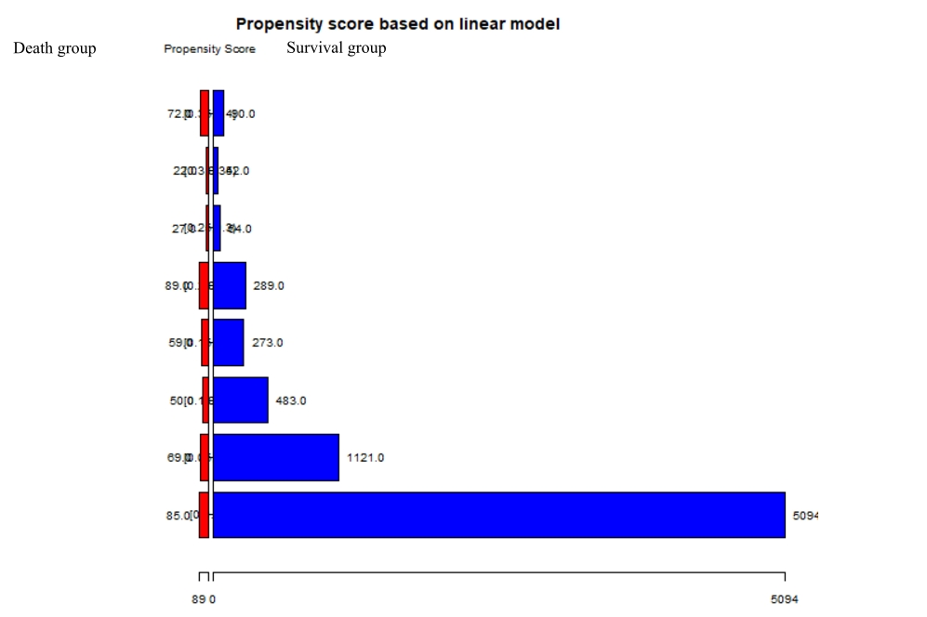
Figure S1: Propensity score based on linear model

Additional file1: Table S4.
Multivariate cox regression analysis of the association between NLR with all-cause and cardiovascular mortality in the propensity score matched cohort.
Exposure | Model 1 | Model 2 | Model 3
 | HR (95%CI) P-value | HR (95%CI) P-value | HR (95%CI) P-value
All-cause mortality
NLR | 1.32 (1.22, 1.43) <0.0001 | 1.15 (1.06, 1.24) 0.0006 | 1.18 (1.09, 1.29) 0.0001
NLR tertile
T1 | Reference | Reference | Reference
T2 | 1.12 (0.84, 1.49) 0.4475 | 0.98 (0.71, 1.36) 0.9253 | 0.94 (0.68, 1.30) 0.7088
T3 | 2.18 (1.65, 2.86) <0.0001 | 1.58 (1.39, 1.77) 0.0025 | 1.29 (1.17, 1.78) 0.0094
Cardiovascular mortality
NLR | 1.15 (1.07, 1.24) <0.0001 | 1.10 (1.02, 1.18) 0.0170 | 1.12 (1.03, 1.22) 0.0063
NLR tertile
T1 | Reference | Reference | Reference
T2 | 4.66 (2.23, 7.09) 0.0002 | 1.70 (0.17, 3.57) 0.0757 | 1.49 (1.03, 2.01) 0.5265
T3 | 12.05 (9.62, 14.47) <0.0001 | 3.74 (1.78, 5.70) 0.0002 | 1.92 (0.32, 3.53) 0.0190
NLR tertile: (T1: NLR <1.57; T2: 1.57≤NLR <2.27; T3: NLR≥2.27). HR: hazard ratios; CI: confidence
Model 1: Non-adjusted.
Model 2：adjust for age, sex, BMI, ethnicity status, education level, smoke status, alcohol consumption, hypertension, diabetes.
Mode 3：adjust for age, sex, BMI, ethnicity status, education level, smoke status, alcohol consumption, hypertension, diabetes, CVD, TG, TC, HDL, LDL, HBA1C, eGFR.

