SUPPLEMENTARY MATERIALS
Supplementary Table 1: Cocktail of antibodies for flow cytometry
Antibody | Dilution | Reference
Anti-CD3e-BUV615 | 1:40 | BD Biosciences 560804
Anti-CD4-APCH7 | 1:40 | BD Biosciences 560246
Anti-CD8 alpha-PO | 1:50 | Invitrogen MCD0830TR
Anti-CD11b-PeCy7 | 1:50 | BD Biosciences 561098
Anti-CD19-PERCPCy5.5 | 1:40 | BD Biosciences 561098
Anti-CD45-PE | 1:40 | BD Biosciences 553081
Anti-Gr1-APC | 1:50 | BD Biosciences 561083
Anti-NK1.1-FITC | 1:100 | BD Biosciences 561082

Supplementary Table 2: Antibodies used for immunohistochemistry
Antibody | Dilution | Reference
Anti-CD8α | 1:100 | Thermo Fisher Scientific 14-0808-80
Anti-Foxp3 | 1:50 | Cell Signaling 12653
Anti-rat IgG | 1:200 | Sigma Aldrich SAB3700596
Anti-rabbit IgG | 1:200 | Bio-Rad 170-6515

Supplementary Table 3: Antibodies used for immunofluorescence
Antibody | Dilution | Reference
Anti-CD3 | 1:100 | Agilent GA50361-2
Anti-CD206 | 1:100 | Abcam ab64693
Anti-endomucin | 1:200 | Santa Cruz sc-65495
Anti-Glut1 | 1:100 | Novus NB110-39113
Anti-podoplanin | 1:100 | Sigma‒Aldrich MABT1512
Anti-αSMA | 1:100 | Abcam ab5694
Anti-rat IgG-Alexa Fluor (AF)488 | 1:200 | Thermo Fisher Scientific A11006
Anti-syrian hamster IgG-AF488 | 1:200 | Thermo Fisher Scientific A21110
Anti-rabbit IgG-AF568 | 1:200 | Thermo Fisher Scientific A10042
Anti-rat IgG-AF568 | 1:200 | Thermo Fisher Scientific A11077

Supplementary Table 4: Primers for qRT‒PCR
Genes | Sequence (5’ to 3’) | Reference
Actb | TCTACAAATGTGGCTGAGGACT | -
Actb | GAGGGACTTCCTGTAACCACTT | -
Cox2 | TGC TGG TGG AAA AAC CTC GT | -
Cox2 | AAA ACC CAC TTC GCC TCC AA | -
Cxcl12 | CCA GAG CCA ACG TCA AGC AT | -
Cxcl12 | CAG CCG TGC AAC AAT CTG AA | -
Ifng | - | Bio-Rad  qMmuCID0006268
Il1b | GCC TGT GTT TTC CTC CTT GC | -
Il1b | TGC TGC CTA ATG TCC CCT TG | -
Il2 | - | Bio-Rad  qMmuCID0015786
Il6 | GCC TGT GTT TTC CTC CTT GC | -
Il6 | GCC TGT GTT TTC CTC CTT GC | -
Il10 | - | Bio-Rad  qMmuCED0044967
Il12a | - | Bio-Rad  qMmuCID001668
Tnf | - | Bio-Rad  qMmuCED0004141
Rps13 | GATGCTAAATTCCGCCTGAT | -
Rps13 | TAGAGCAGAGGCTGTGGATG | -

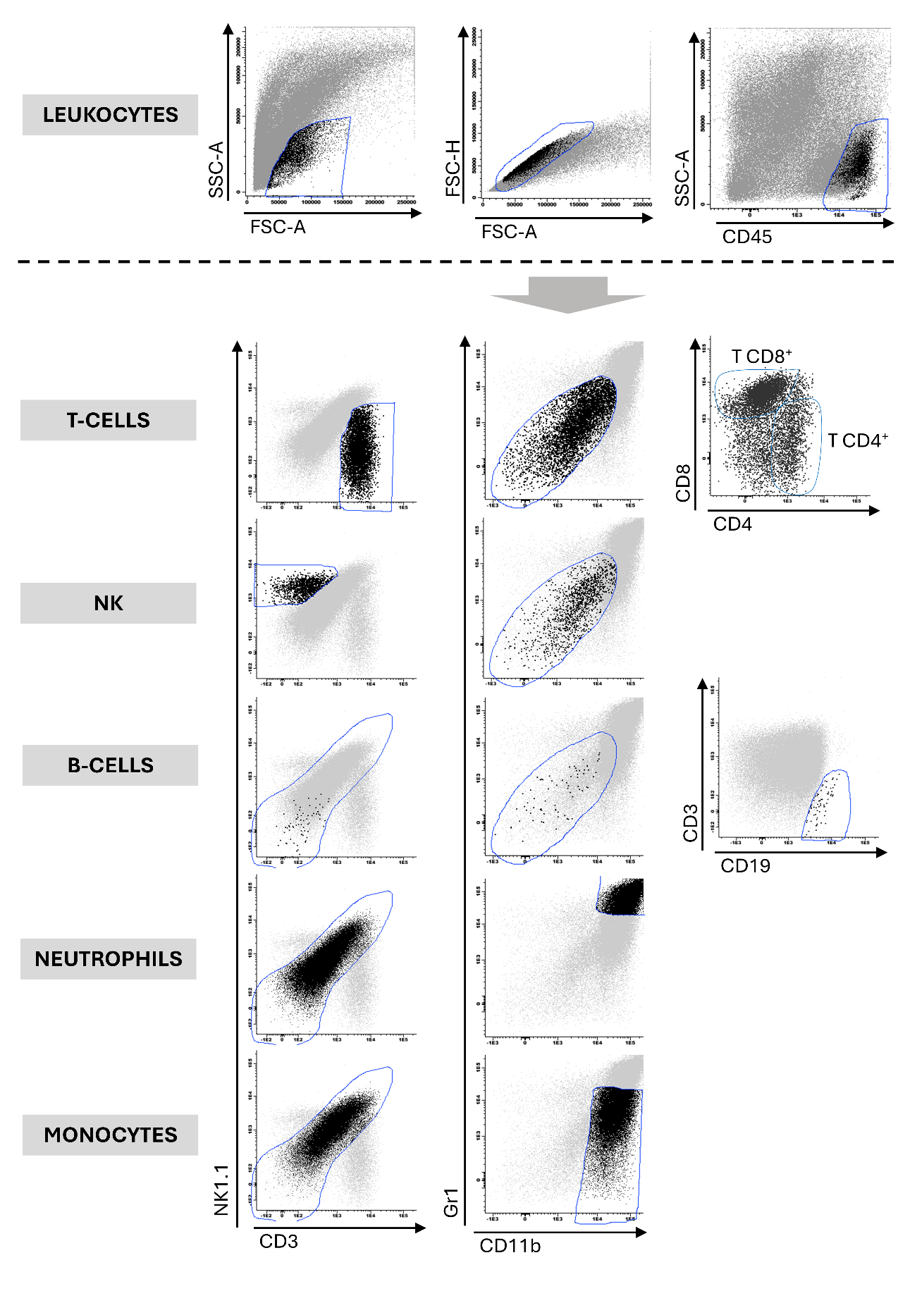
Supplementary figure 1. Gating strategy for the selection of different cell populations. The total leukocyte population was selected by selecting CD45^{hi} cells and excluding doublets. FSC/SSC gate selection was performed by comparing with peripheral blood leukocytes. The different cell populations were subsequently selected according to the markers and regions explained in the figure and in supplementary table 5.
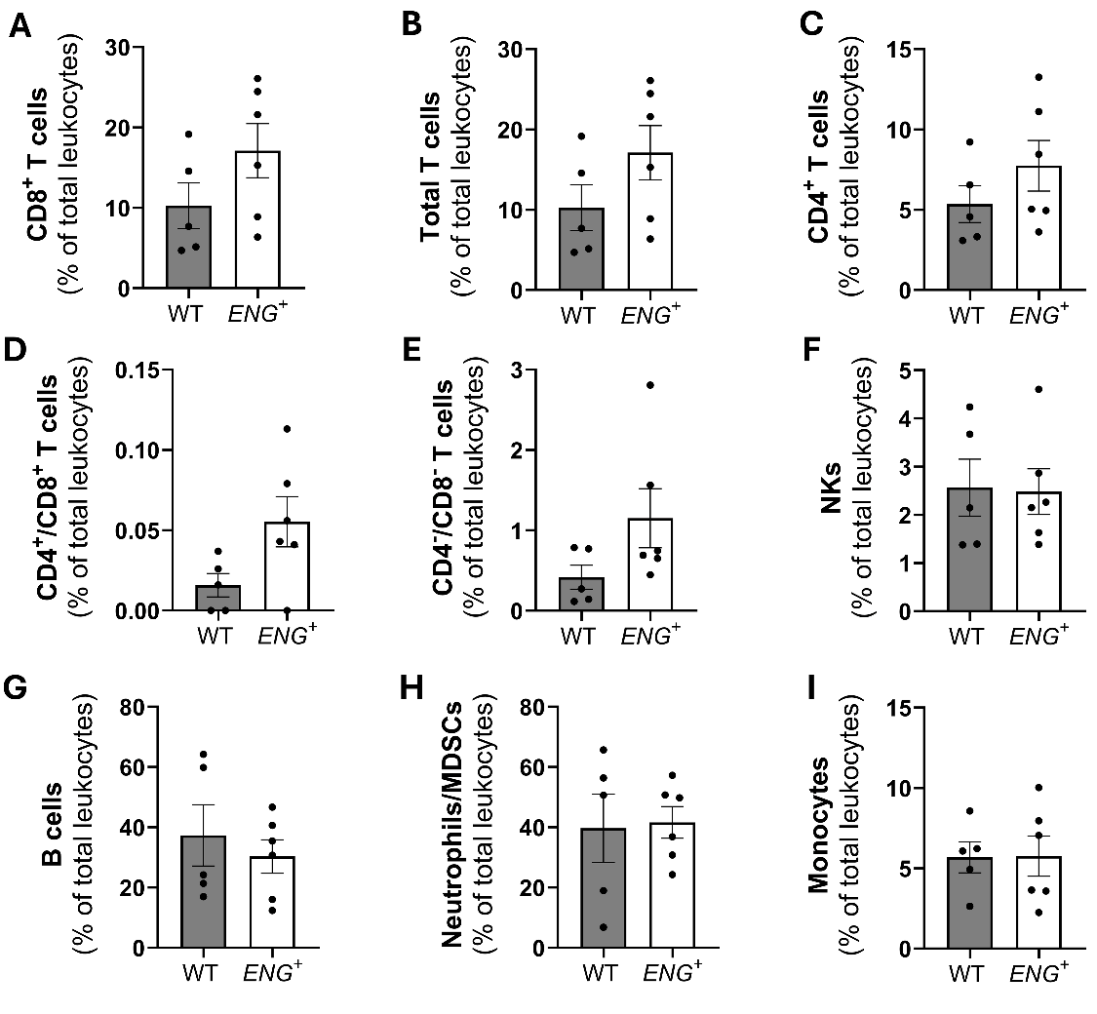
Supplementary figure 2. Continuous endoglin overexpression does not alter the immune profile in the peripheral blood. (A) Percentages of CD8+ T cells (p=0,1633), (B) total T cells (p=0, 1633), (C) CD4+ T cells (p=0,2674), (D) CD4+/CD8+ lymphocyte maturation stage (p=0,0608), (E) CD4-/CD8- lymphocyte maturation stage (p=0,2468), (F) NK cells (p=0,9152), (G) B lymphocytes (p=0,5426), (I) neutrophils and MDSCs (p=0,8735), and (H) monocytes (p=0,9676) of total leukocytes (CD45+) [n(WT)=5; n(ENG+)=6].
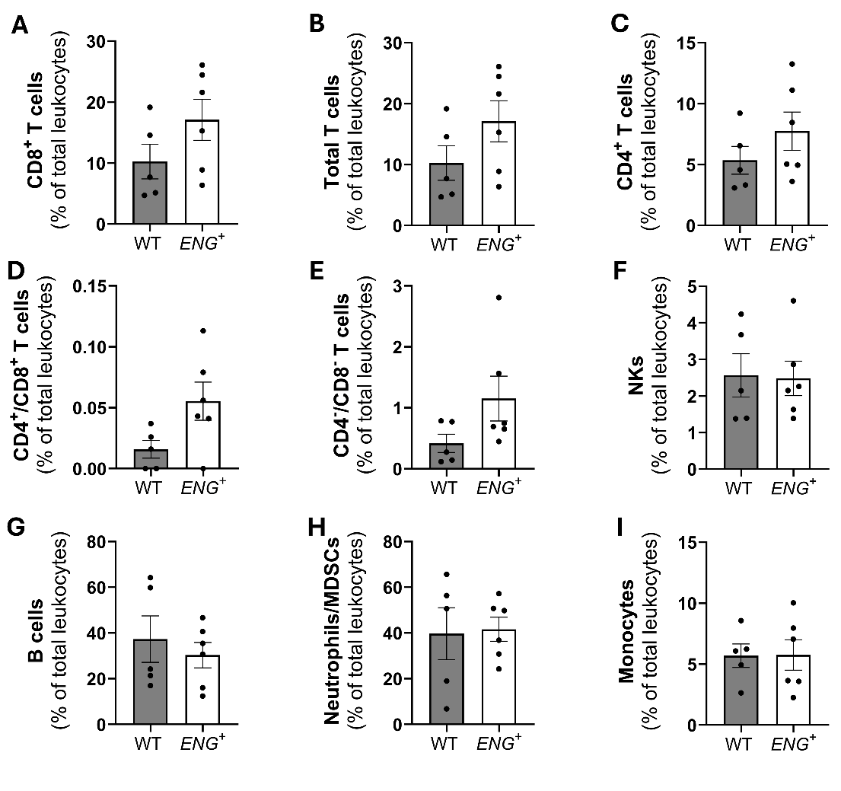
Supplementary figure 3. Continuous endoglin overexpression alters the immune profile of subcutaneous tumors. (A) Percentages of CD8⁺ T cells (p=0,1178), (B) total T cells (p=0,7032), (C) CD4⁺ T cells (p=0,9216), (D) CD4⁻/CD8⁻ lymphocyte maturation stage (p=0,8786), (E) CD4⁺/CD8⁺ lymphocyte maturation stage (p=0,3643), (F) NK cells (*p-value < 0,05), (G) B lymphocytes (p=0,0833), (H) neutrophils and MDSCs (p=0,8237), and (I) monocytes (p=0,2533) of total leukocytes (CD45⁺) [n(WT)=8; n(ENG⁺)=9].
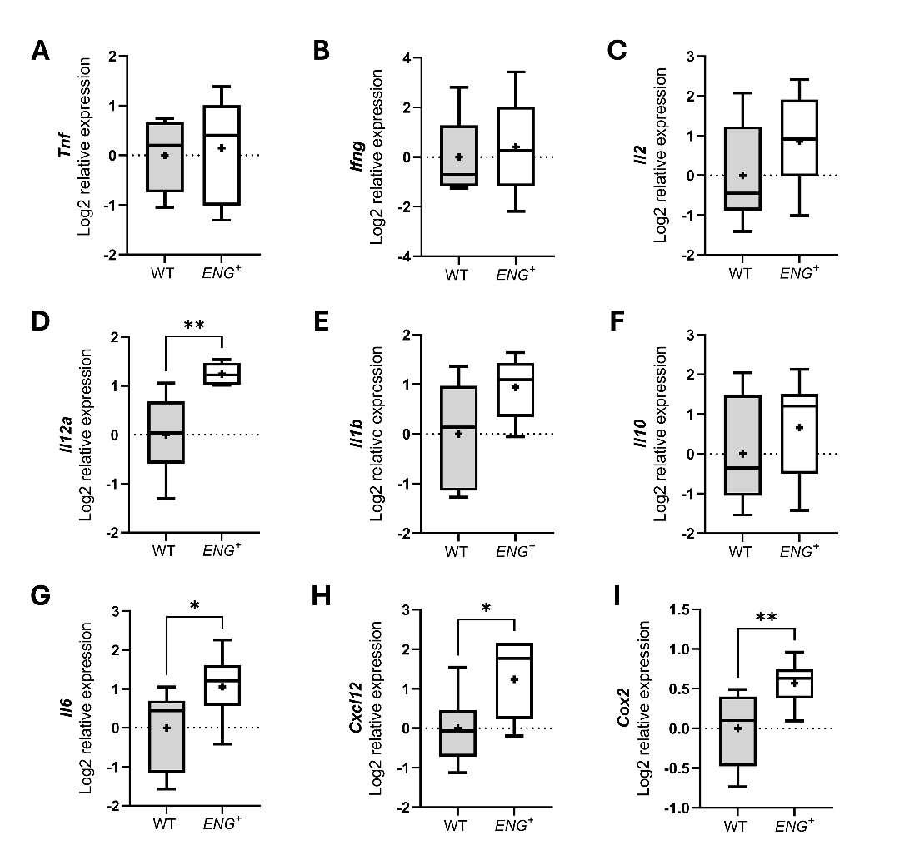
Supplementary figure 4. Expression of different cytokines present in the tumor microenvironment. (A) qPCR analysis of the expression of antitumor cytokines, such as Tnf (p=0,7423), (B) Ifng (p=0,6419), (C) Il2 (p=0,1719), and (D) Il12a (**p-value < 0,01) [n(WT)=8; n(ENG⁺)=8]. (E) qPCR analysis of protumor cytokines, such as Il1b (p=0,0572), (F) Il10 (p=0,3240), (G) Il6 (*p-value < 0,05), (H) Cxcl12 (*p-value < 0,05), and (I) Cox2 (**p-value < 0,01) [n(WT)=8; n(ENG⁺)=8].

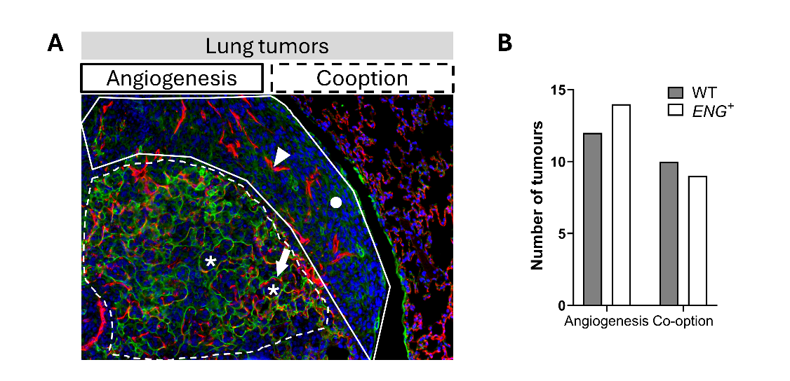
Supplementary figure 5. Characterization of tumor vascularization in lung tumors. (A) Immunofluorescence of the pneumocyte marker Podoplanin (green) and the vessel marker Endomucin (red). In the co-option areas, cancer cells fill the alveolar air spaces (asterisk), preserving the alveolar walls and the associated alveolar capillaries (arrow). On the other hand, in the angiogenic area, we observed neovascularization (triangle) and destruction of the lung parenchyma (circle). (B) Angiogenic and co-option areas were analyzed with respect to the total tumor area. Endoglin overexpression does not determine the generation of a predominant angiogenic or co-option vascular profile [n(WT)=22 (from 5 mice); n(ENG⁺)=23 (from 5 mice), p=0,6677].

