SUPPLEMENTAL MATERIAL

Coagulation Factor XII protects neurons from apoptosis by triggering a crosstalk between HGFR/c-Met and EGFR/ErbB1 signaling pathways

Short title: Factor XII protects neurons from apoptosis

Eugénie Garnier1*, Damien Levard1*, Carine Ali1, Yannick Hommet1, Tiziana Crepaldi2,3, Paolo Comoglio2, Marina Rubio1, Denis Vivien1,4, Sara Martinez de Lizarrondo1* & Fabian Docagne1*#

* Equal contributions.

This supplemental material contains 4 Supplemental Figures and 4 Figure legends

Supplemental Figure 1

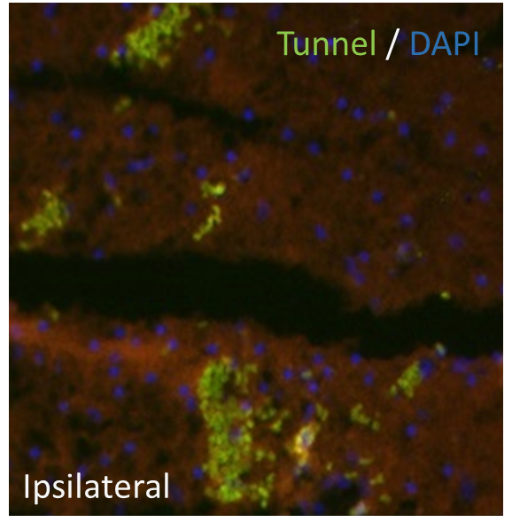

Supplemental Figure 1. NMDA-injection induces neuronal apoptosis. Low magnification representative fluorescence image of NMDA-injected mice, showing TUNNEL labelling (in green) in the ipsilateral of brain mice at 24 hours. DAPI was used as a cellular marker.
Supplemental Figure 2
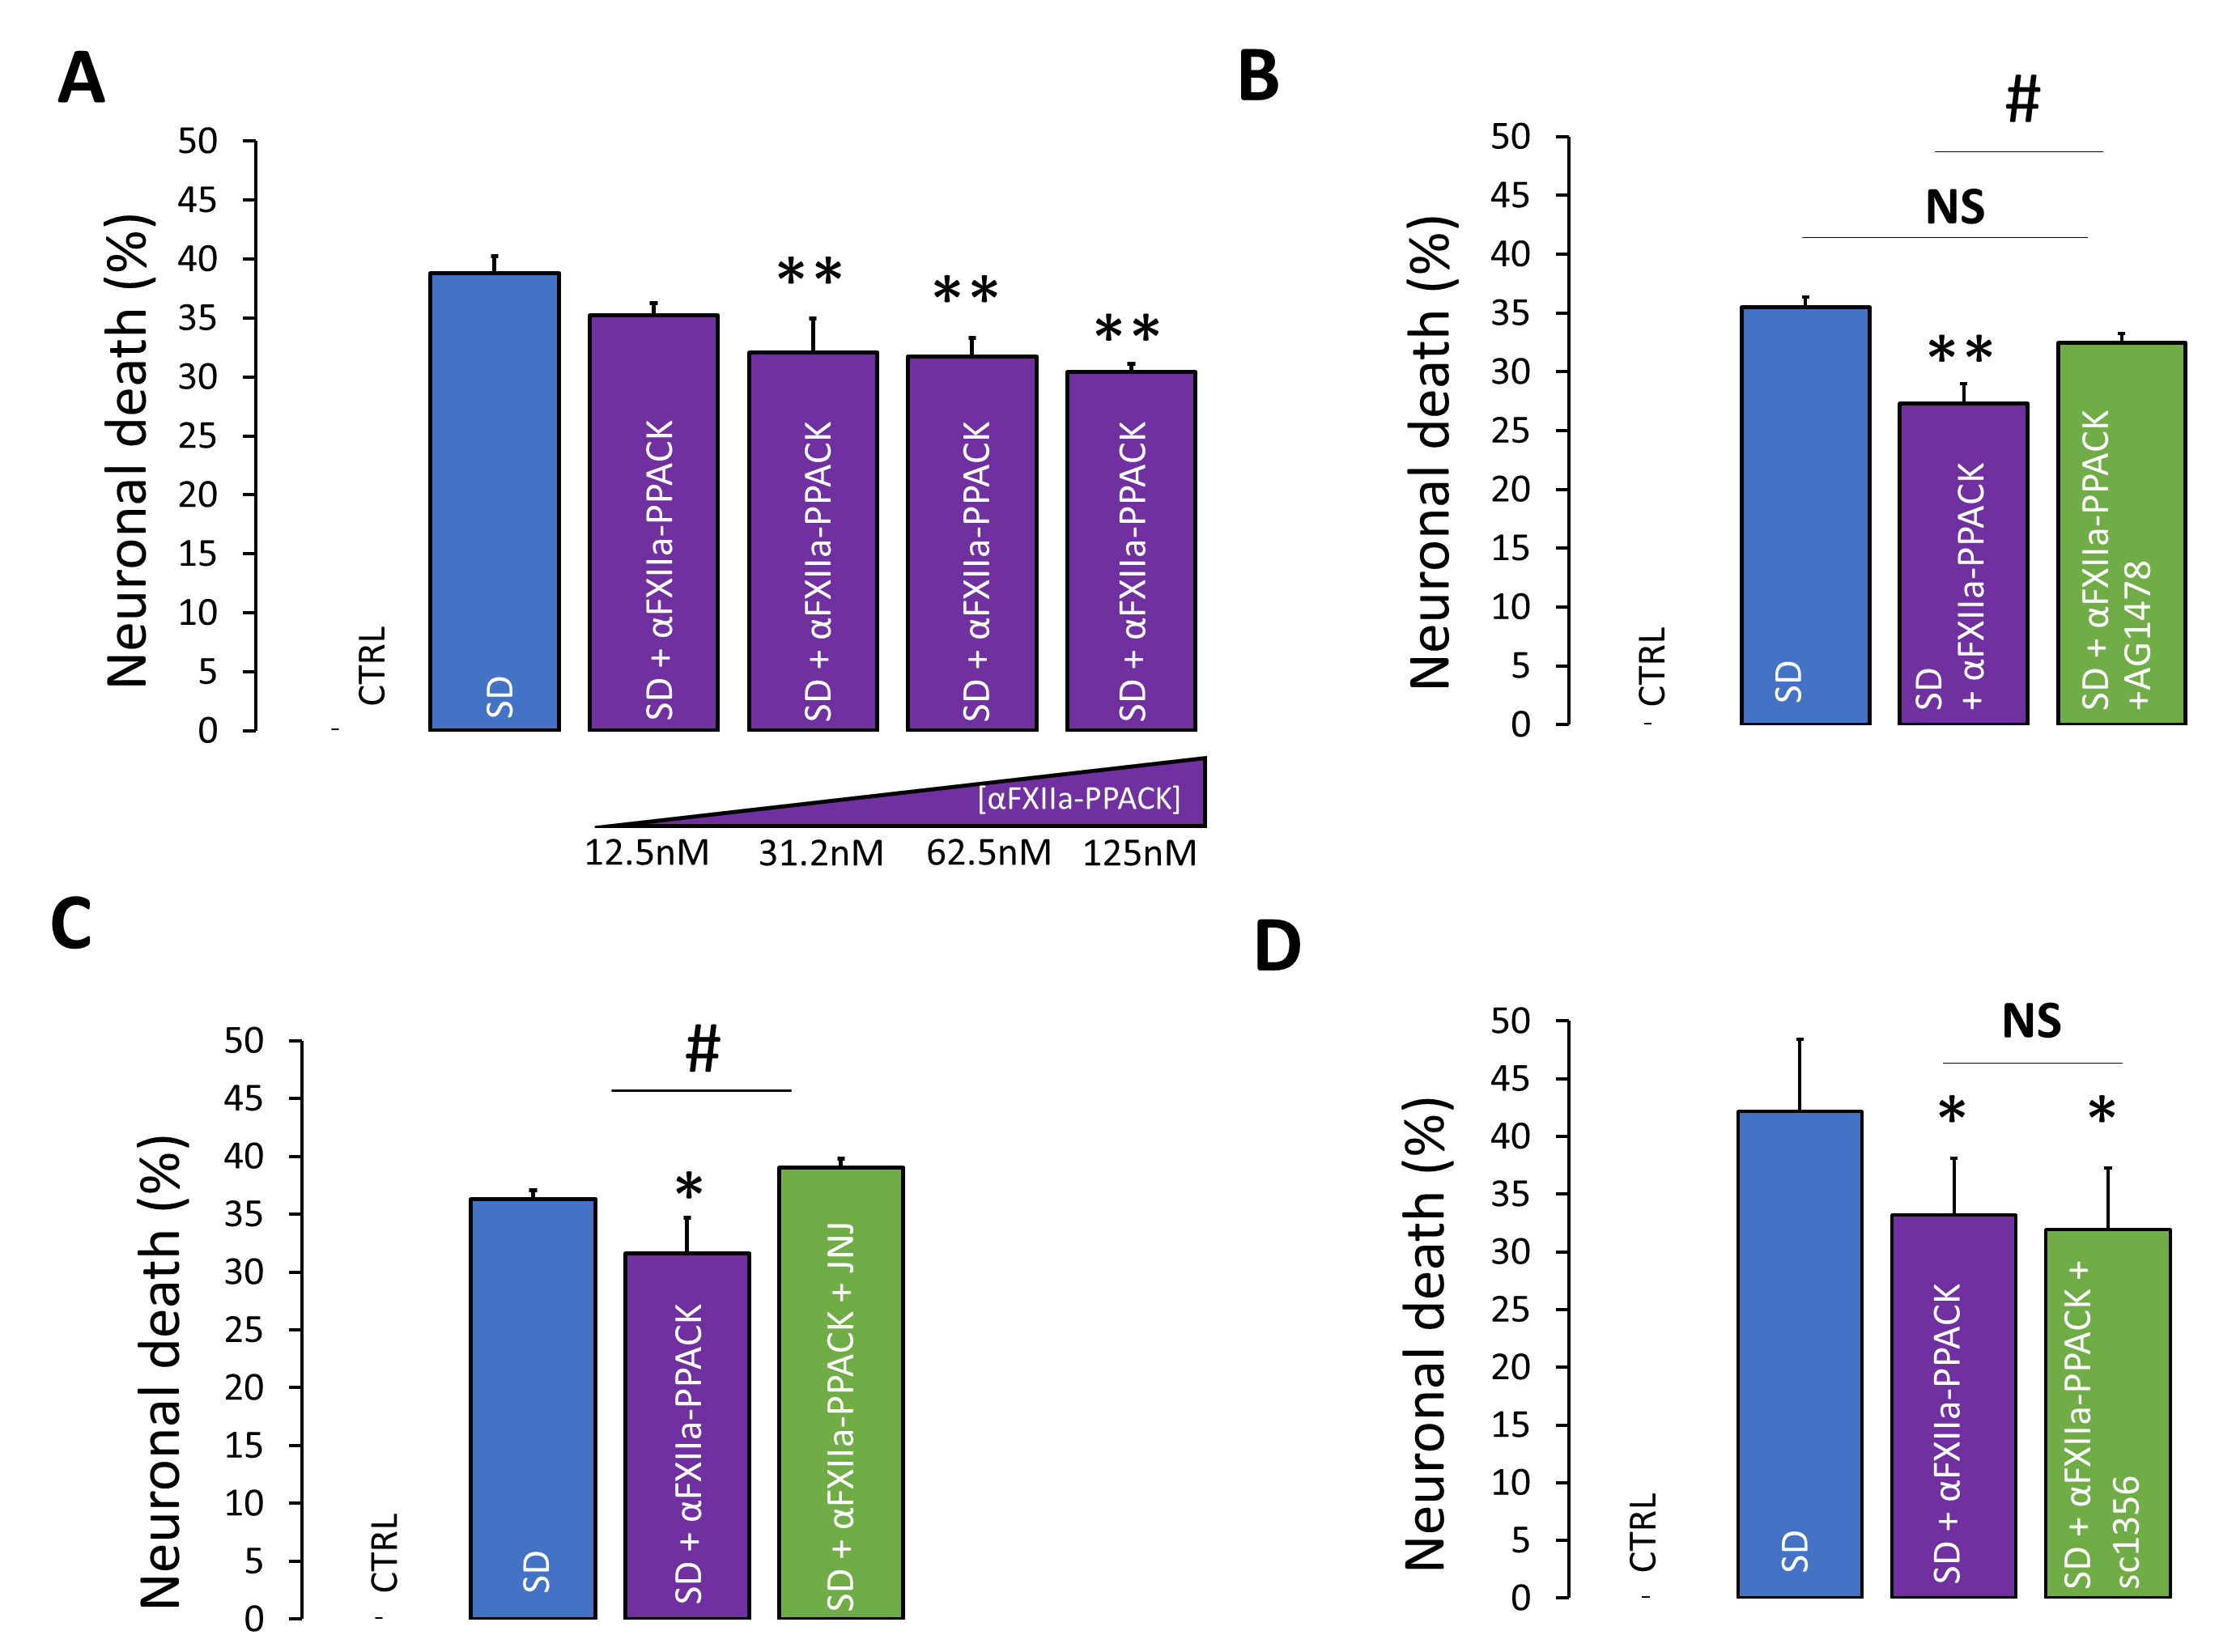

Supplemental Figure 2. Proteolytically inactive alpha-Factor XII (αFXIIa-PPACK) retains an antiapoptotic capacity dependent on EGFR activation and HGFR(c-MET) activation by transphosphorylation. (A) Quantification of neuronal death following 24h of either SD alone or SD in the presence of recombinant αFXIIa-PPACK (12,5–125 nM). Error bars represent the mean ± SEM. Symbols indicate significantly different from SD by Mann Whitney (** p < 0.01, n = 16 in 4 different experiments). (B) Quantification of neuronal death following 24 h of either SD alone or SD in the presence of 125 nM αFXIIa-PPACK (purple) with or without 5 µM EFGR kinase inhibitor, AG1478 (green; mean + SEM; n = 16 in 4 different experiments). **, p < 0,01; #, p < 0.05 and no significantly different from SD and αFXIIa respectively. (C) Quantification of neuronal death following 24 h of either SD alone or SD in the presence of 125 nM αFXIIa-PPACK (purple) with 500 nM JNJ, an inhibitor of c-MET phosphorylation (green; mean ± SEM; n = 16 in 4 different experiments). *, p < 0,05 and #, p < 0.05 significantly different from SD and FXII respectively. (D) Quantification of neuronal death following 24 h of either SD alone or SD in the presence of 125 nM αFXIIa-PPACK (purple) with 50 ng/mL sc1356, a blocking antibody of HGF (green; mean ± SEM; n = 16 in 4 different experiments). *, p < 0,05 significantly different from SD .

Supplemental Figure 3

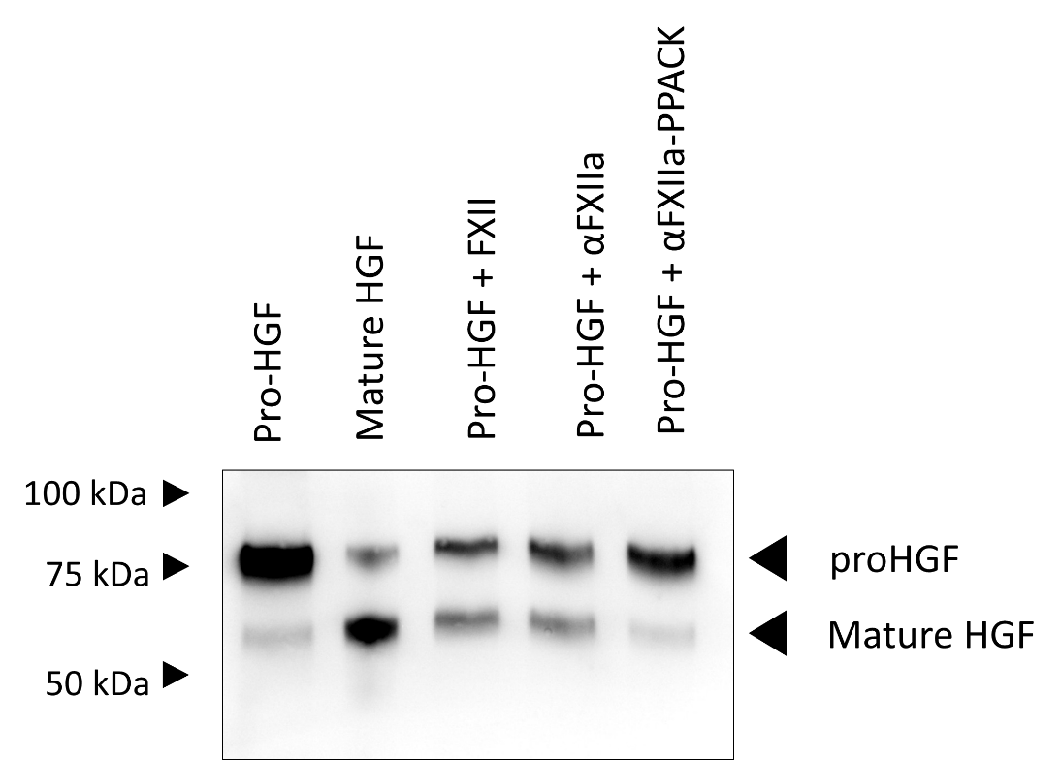
Supplemental Figure 3. FXII, αFXIIa convert ProHGF in mature HGF in purified conditions. Pro-HGF (52 nM) was incubated at 37°C for 4 h without proteases (lane 1) or with 5,2 nM FXII, αFXIIa, and αFXIIa-PPACK. Immunodetection of αHGF after incubation. Representative images of four independent experiments are presented.

Supplemental Figure 4

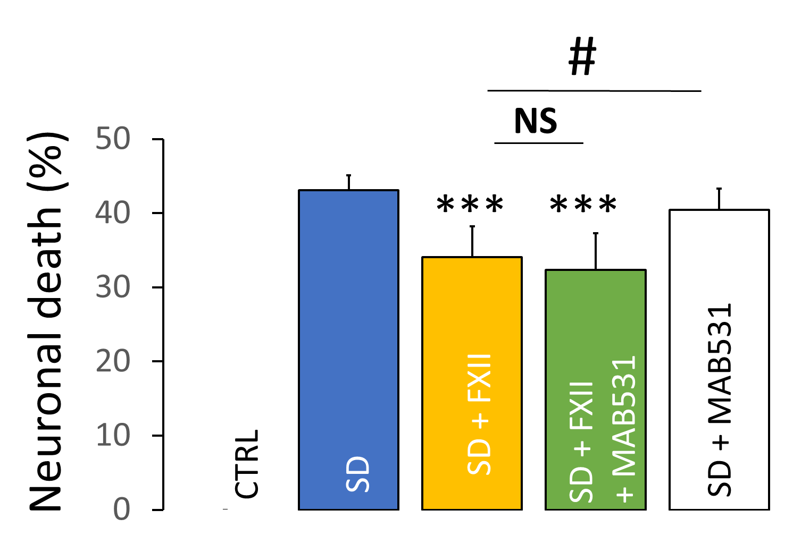

Supplemental Figure 4. Blocking antibody of uPAR MAB531 does not reverse anti-apoptotic effect of FXII. Quantification of neuronal death following 24 h of either SD alone or SD in the presence of 125 nM FXII (yellow) with or without 25 µg/mL uPAR blocking antibody, MAB531 (green ; mean + SEM; n = 16 in 4 different experiments). *** and #, p < 0.05 significantly different from SD and FXII respectively. CRTL: control; NS: non significant

