Supplementary Figure 1. The prognostic value of MCM10 expression in different types of cancers (GEPIA). Overall survival and disease free survival curves comparing the high and low expression of CCL14 in Adrenocortical carcinoma (ACC) (A-B), Bladder Urothelial Carcinoma (BLCA) (C-D), Breast invasive carcinoma (BRCA) (E-F), Cervical squamous cell carcinoma and endocervical adenocarcinoma (CESC) (G-H), Cholangiocarcinoma (CHOL) (I-J), Colon adenocarcinoma (COAD) (K-L), Lymphoid Neoplasm Diffuse Large B-cell Lymphoma (DLBC) (M-N), Esophageal carcinoma (ESCA) (O-P), Glioblastoma multiforme (GBM) (Q-R), Head and Neck squamous cell carcinoma (HNSC) (S-T), Kidney Chromophobe (KICH) (U-V), Kidney renal clear cell carcinoma (KIRC) (W-X), Kidney renal papillary cell carcinoma (KIRP) (Y-Z), Acute Myeloid Leukemia (LAML) (AA-AB), Brain Lower Grade Glioma (LGG) (AC-AD), Liver hepatocellular carcinoma (LIHC (HCC)) (AE-AF), Lung adenocarcinoma (LUAD) (AG-AH), Lung squamous cell carcinoma (LUSC) (AI-AJ), Mesothelioma (MESO) (AK-AL), Ovarian serous cystadenocarcinoma (OV) (AM-AN), Pancreatic adenocarcinoma (PAAD) (AO-AP), Pheochromocytoma and Paraganglioma (PCPG) (AQ-AR), Prostate adenocarcinoma (PRAD) (AS-AT), Rectum adenocarcinoma (READ) (AU-AV), Sarcoma (SARC) (AW-AX), Skin Cutaneous Melanoma (SKCM) (AY-AZ), Stomach adenocarcinoma (STAD) (BA-BB), Testicular Germ Cell Tumors (TGCT) (BC-BD), Thyroid carcinoma (THCA) (BE-BF), Thymoma (THYM) (BG-BH), Uterine Corpus Endometrial Carcinoma (UCEC) (BI-BJ), Uterine Carcinosarcoma (UCS) (BK-BL), Uveal Melanoma (UVM) (BM-BN).
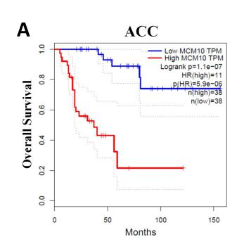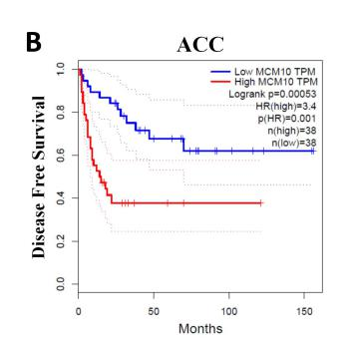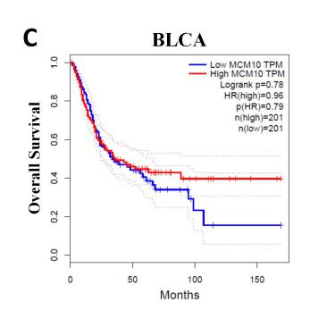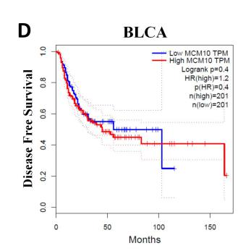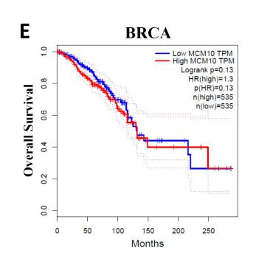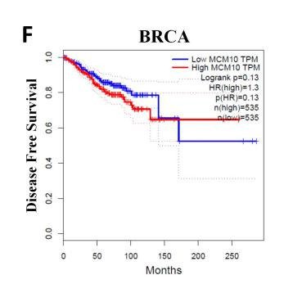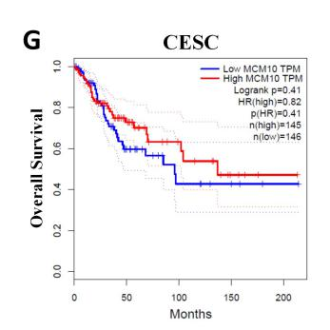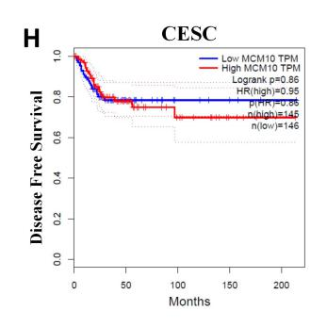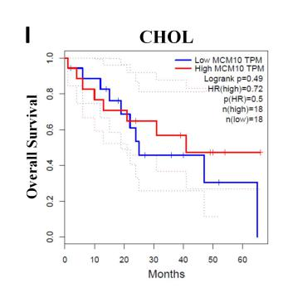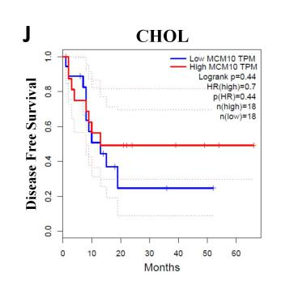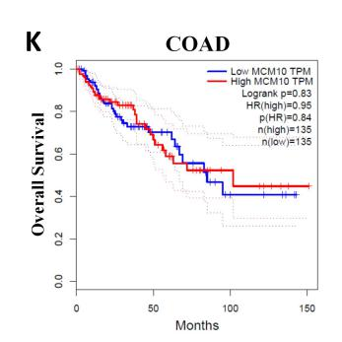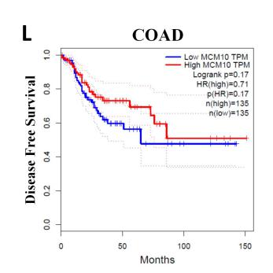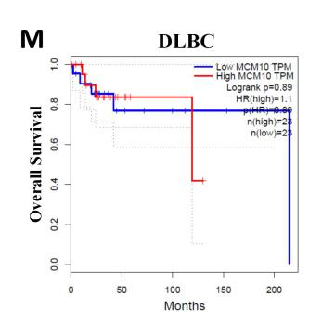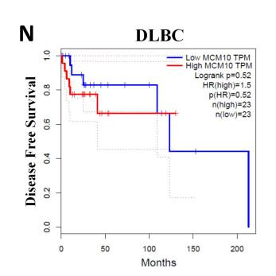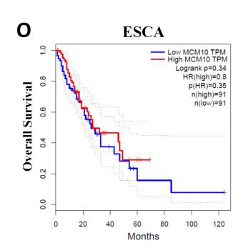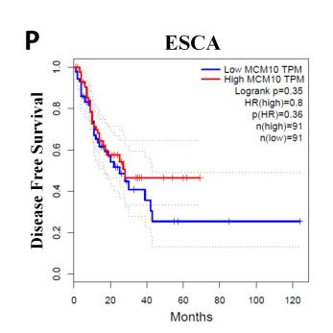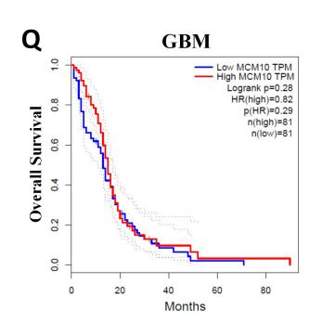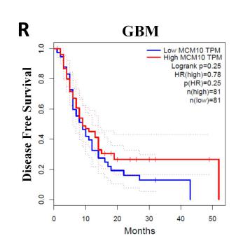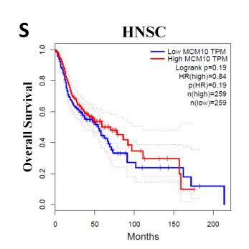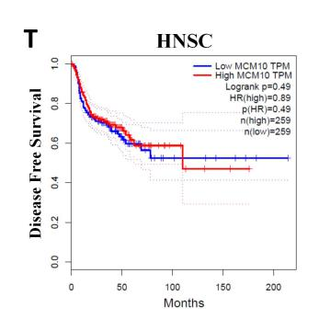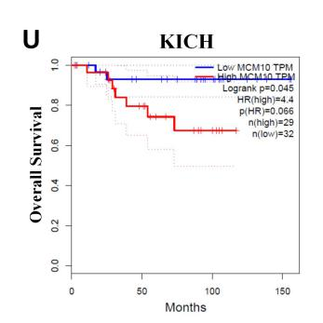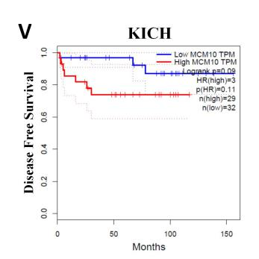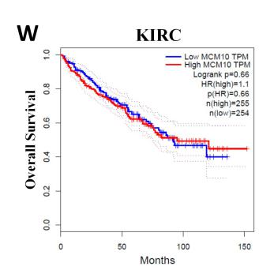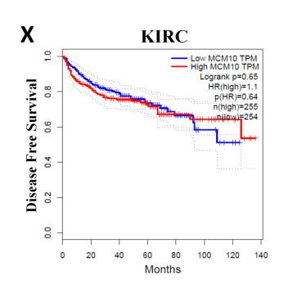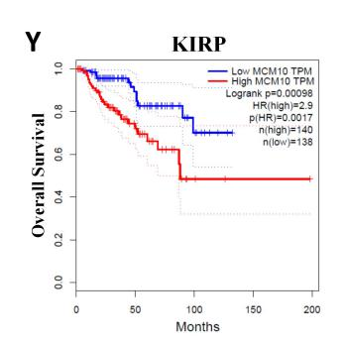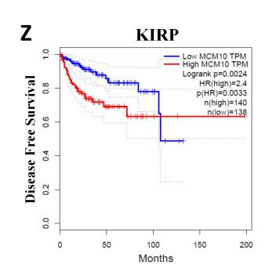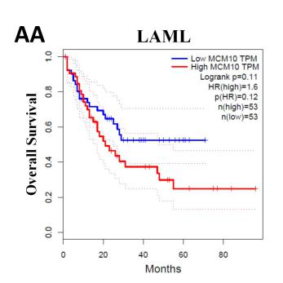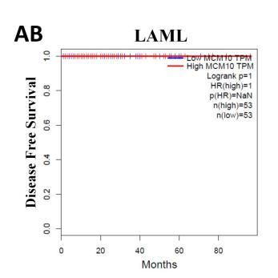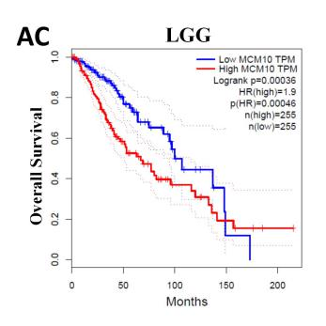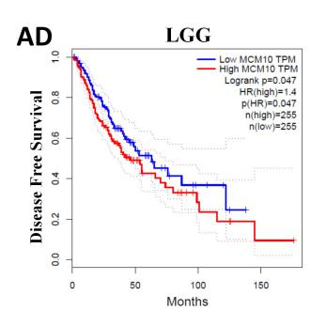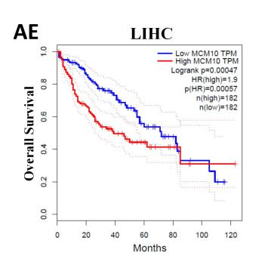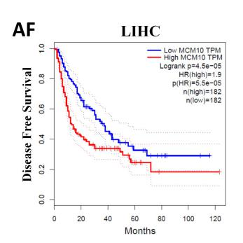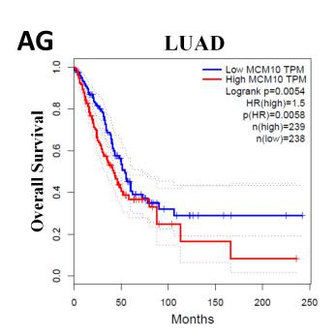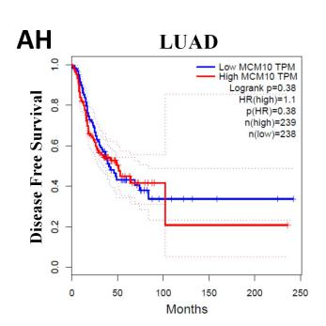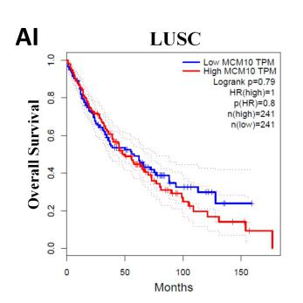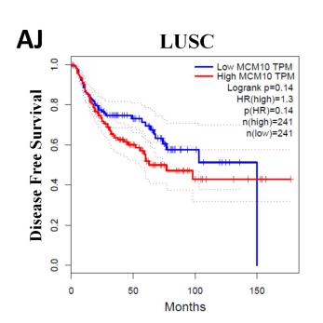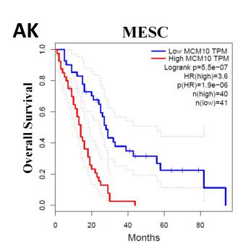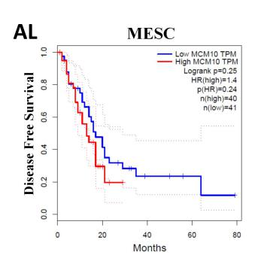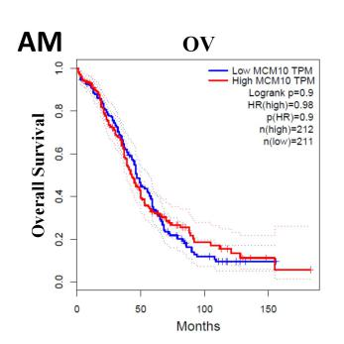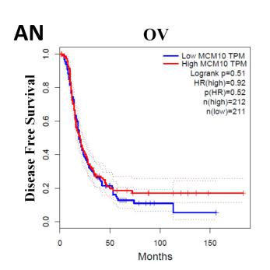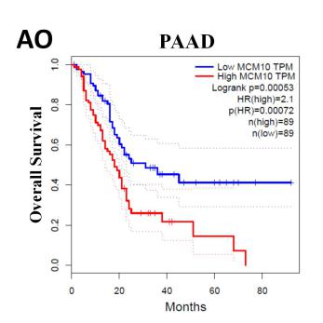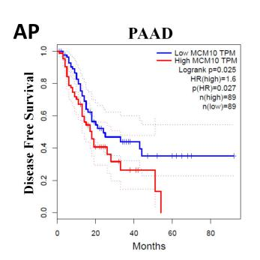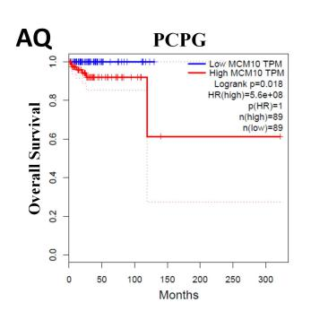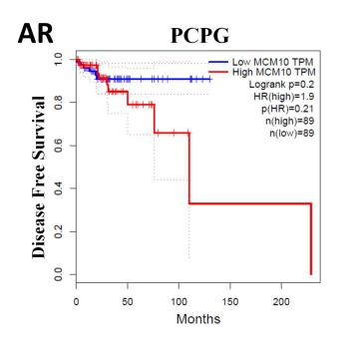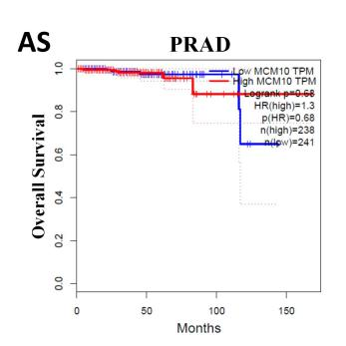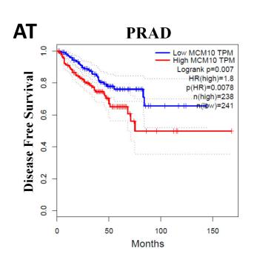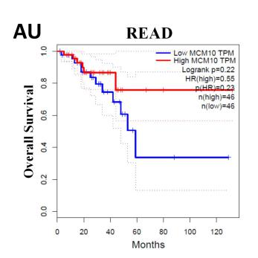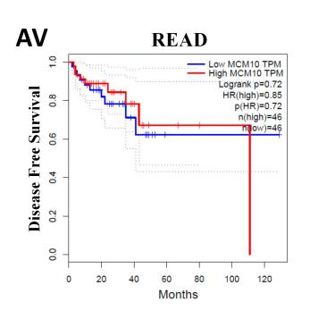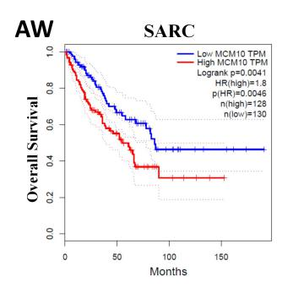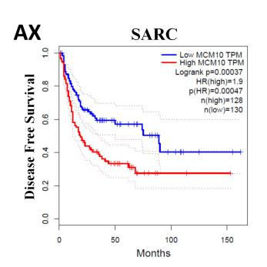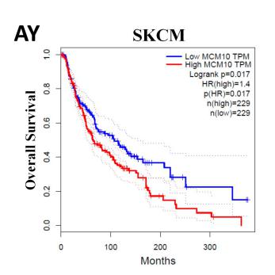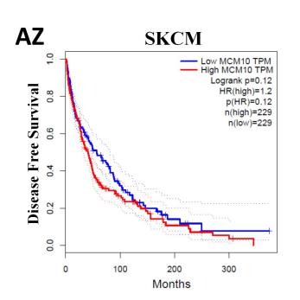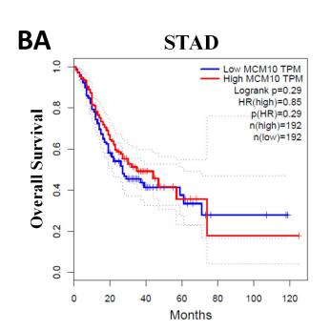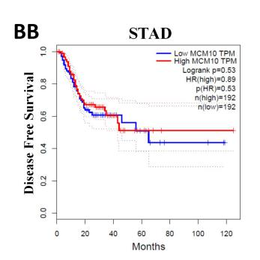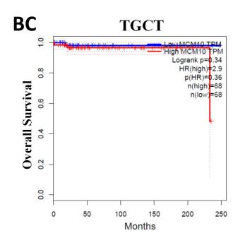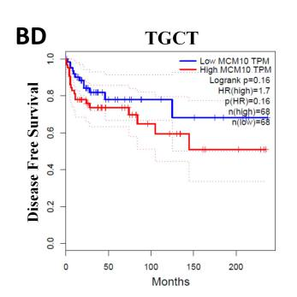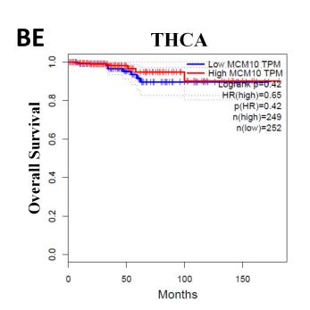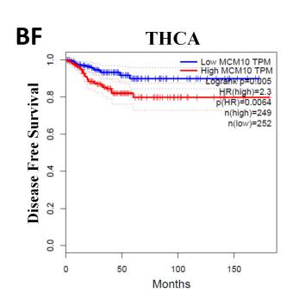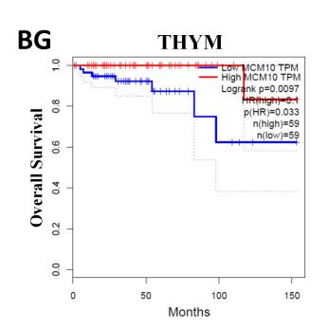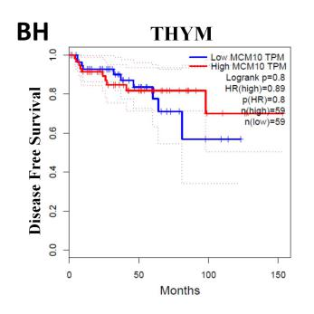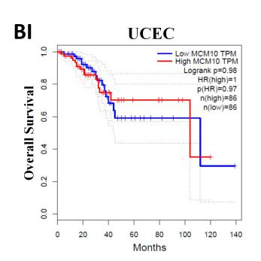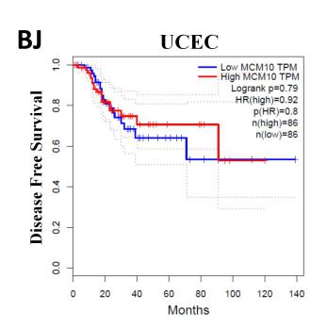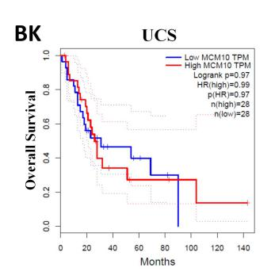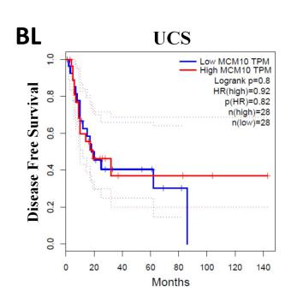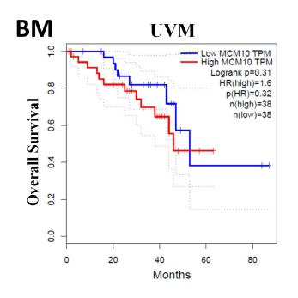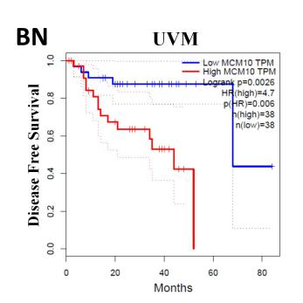

Supplementary Figure 2. Correlation of MCM10 expression with immune infiltration levels in different types of cancers (TIMER). (A) Adrenocortical carcinoma (ACC), (B) Bladder Urothelial Carcinoma (BLCA), (C) Breast Invasive Carcinoma (BRCA), (D) Breast Invasive Carcinoma-Basal (BRCA-Basal), (E) Breast Invasive Carcinoma-Her2 (BRCA-Her2), (F) Breast Invasive Carcinoma-Luminal (BRCA-Luminal), (G) Cervical and Endocervical Cancer (CESC), (H) Cholangiocarcinoma (CHOL), (I) Colon Adenocarcinoma (COAD), (J) Diffuse Large B-cell Lymphoma (DLBC), (K) Esophageal Carcinoma (ESCA), (L) Glioblastoma Multiforme (GBM), (M) Head and Neck Cancer (HNSC), (N) Head and Neck Cancer-HPVpos (HNSC-HPVpos), (O) Head and Neck Cancer-HPVneg (HNSC-HPVneg), (P) Kidney Chromophobe (KICH), (Q) Kidney Renal Clear Cell Carcinoma (KIRC), (R) Kidney Renal Papillary Cell Carcinoma (KIRP), (S) Lower Grade Glioma (LGG), (T) Lung Adenocarcinoma (LUAD), (U) Lung Squamous Cell Carcinoma (LUSC), (V) Mesothelioma (MESO), (W) Ovarian Serous Cystadenocarcinoma (OV), (X) Pancreatic Adenocarcinoma (PAAD), (Y) Pheochromocytoma and Paraganglioma (PCPG), (Z) Prostate Adenocarcinoma (PRAD), (AA) Rectum Adenocarcinoma (READ), (AB) Sarcoma (SARC), (AC) Skin Cutaneous Melanoma (SKCM), (AD) Skin Cutaneous Melanoma-Primary (SKCM-Primary), (AE) Skin Cutaneous Melanoma-Metastasis (SKCM-Metastasis), (AF) Stomach Adenocarcinoma (STAD), (AG) Testicular Germ Cell Tumors (TGCT), (AH) Thyroid Carcinoma (THCA), (AI) Thymoma (THYM), (AJ) Uterine Corpus Endometrial Carcinoma (UCEC), (AK) Uterine Carcinosarcoma (UCS), (AL) Uveal Melanoma (UVM).

Supplementary Table 1. MCM10 expression in cancers versus normal tissue in Oncomine database.
Cancer | Cancer type | P value | Fold change | Rank  (%) | Sample | Reference  (PMID)
Bladder | Infiltrating Bladder Urothelial Carcinoma | 2.54E-11 | 2.013 | 1% | 130 | 20421545
Brain and CNS | Oligodendroglioma | 9.61E-09 | 1.801 | 4% | 73 | 16616334
 | Anaplastic Astrocytoma | 9.69E-06 | 4.490 | 6% | 42 | 16616334
 | Brain Glioblastoma | 7.69E-09 | 1.694 | 7% | 552 | TCGA
Breast | Male Breast Carcinoma | 5.49E-26 | 4.716 | 1% | 64 | TCGA
 | Invasive Lobular Breast Carcinoma | 4.92E-11 | 2.510 | 5% | 97 | TCGA
 | Intraductal Cribriform Breast Adenocarcinoma | 3.00E-03 | 4.758 | 8% | 64 | TCGA
 | Invasive Ductal Breast Carcinoma | 2.99E-92 | 2.077 | 2% | 1700 | 22522925
 | Medullary Breast Carcinoma | 3.90E-13 | 3.802 | 2% | 176 | 22522925
Cervical | Cervical Squamous Cell Carcinoma Epithelia | 3.67E-06 | 2.287 | 3% | 31 | 17974957
 | Cervical Squamous Cell Carcinoma | 1.47E-06 | 4.046 | 5% | 56 | 18506748
 | Cervical Cancer | 2.74E-08 | 2.176 | 4% | 42 | 17510386
Colorectal | Colon Carcinoma Epithelia | 2.65E-09 | 3.118 | 2% | 15 | 20957034
 | Colorectal Carcinoma | 3.38E-10 | 3.167 | 3% | 60 | 20957034
 | Cecum Adenocarcinoma | 1.37E-14 | 3.787 | 1% | 44 | TCGA
 | Colon Mucinous Adenocarcinoma | 8.46E-12 | 3.636 | 2% | 44 | TCGA
 | Rectal Mucinous Adenocarcinoma | 4.38E-06 | 3.534 | 3% | 28 | TCGA
 | Rectal Adenocarcinoma | 4.28E-30 | 2.779 | 2% | 130 | 20725992
 | Rectal Adenoma | 8.16E-07 | 4.230 | 3% | 39 | 18171984
 | Colon Adenoma | 1.41E-11 | 3.947 | 5% | 57 | 18171984
Esophageal | Esophageal Squamous Cell Carcinoma | 2.18E-17 | 1.930 | 2% | 106 | 21385931
Gastric | Diffuse Gastric Adenocarcinoma | 2.03E-10 | 2.072 | 1% | 50 | 21447720
 | Gastric Mixed Adenocarcinoma | 6.43E-04 | 2.163 | 5% | 29 | 21447720
 | Gastric Intestinal Type Adenocarcinoma | 1.97E-11 | 4.990 | 2% | 57 | 19081245
Head and neck | Nasopharyngeal Carcinoma | 2.83E-11 | 2.241 | 1% | 41 | 16912175
 | Tonsillar Carcinoma | 8.74E-05 | 1.605 | 1% | 28 | 17510386
 | Floor of the Mouth Carcinoma | 1.08E-06 | 3.983 | 2% | 27 | 17510386
 | Oropharyngeal Carcinoma | 2.00E-03 | 2.718 | 10% | 28 | 17510386
 | Oral Cavity Squamous Cell Carcinoma Epithelia | 8.62E-04 | 1.538 | 5% | 20 | 15381369
 | Tongue Squamous Cell Carcinoma | 3.03E-04 | 1.675 | 5% | 38 | 18254958
Kidney | Renal Wilms Tumor | 1.20E-03 | 1.668 | 10% | 21 | 16299227
Leukemia | Chronic Lymphocytic Leukemia | 2.20E-41 | -2.766 | 4% | 522 | 20406941
Liver | Hepatocellular Carcinoma | 4.39E-05 | 2.116 | 6% | 45 | 17393520
Lung | Squamous Cell Lung Carcinoma | 4.06E-16 | 4.099 | 2% | 92 | 20421987
 | Large Cell Lung Carcinoma | 7.96E-08 | 6.446 | 2% | 84 | 20421987
 | Lung Adenocarcinoma | 1.92E-09 | 1.792 | 9% | 246 | 22080568
Lymphoma | Unspecified Peripheral T-Cell Lymphoma | 4.30E-11 | 4.232 | 5% | 48 | 17304354
 | Angioimmunoblastic T-Cell Lymphoma | 7.91E-05 | 4.592 | 10% | 26 | 17304354
Melanoma | Benign Melanocytic Skin Nevus | 1.98E-05 | 3.361 | 3% | 25 | 16243793
 | Cutaneous Melanoma | 8.99E-05 | 2.721 | 10% | 52 | 16243793
Ovarian | Ovarian Serous Cystadenocarcinoma | 1.28E-07 | 2.718 | 3% | 594 | TCGA
Pancreatic | Pancreatic Ductal Adenocarcinoma Epithelia | 2.50E-03 | 2.355 | 6% | 22 | 15548371
 | Pancreatic Carcinoma | 2.01E-04 | 1.507 | 10% | 52 | 19732725
Sarcoma | Round Cell Liposarcoma | 2.81E-07 | 7.893 | 1% | 19 | 15994966
 | Malignant Fibrous Histiocytoma | 5.16E-08 | 7.758 | 1% | 24 | 15994966
 | Synovial Sarcoma | 7.40E-06 | 5.892 | 2% | 19 | 15994966
 | Fibrosarcoma | 1.26E-05 | 9.258 | 2% | 23 | 15994966
 | Myxofibrosarcoma | 3.30E-09 | 1.523 | 5% | 40 | 20601955
Others | Mixed Germ Cell Tumor, NOS | 8.17E-16 | 1.932 | 1% | 47 | 16424014
 | Yolk Sac Tumor, NOS | 2.68E-08 | 1.982 | 1% | 15 | 16424014
 | Seminoma, NOS | 4.94E-07 | 2.057 | 6% | 18 | 16414014
 | Embryonal Carcinoma, NOS | 5.28E-07 | 1.799 | 7% | 21 | 16414014
 | Vulvar Intraepithelial Neoplasia | 1.91E-05 | 2.768 | 3% | 19 | 17471573
 | Uterine Corpus Leiomyoma | 1.90E-04 | 2.333 | 6% | 77 | 19622772

Supplementary Table 2. Clinicopathological characteristics of 364 HCC patients.
Variables | HCC patients (N = 363)
Age (years), median (IQR) | 61 (52-69)
Gender (male/female) | 247/117
Weight (kg), median (IQR) | 69 (59-82)
PLT (10^9/L), median (IQR) | 211 (160.75-299)
Creatinine (mg/dl), median (IQR) | 0.9 (0.7-1.1)
Albumin (g/L), median (IQR) | 4 (3.5-4.3)
TB (μmol/L), median (IQR) | 0.7 (0.5-1.0)
PT (s), median (IQR) | 1.1 (1.0-9.25)
AFP (ng/ml), median (IQR) | 15 (4-266.25)
Child-Pugh stage
A | N = 217
B | N = 21
C | N = 1
Adjacent hepatic tissue inflammation
None | N = 117
Mild | N = 98
Severe | N = 17
Liver fibrosis ishak score category
No fibrosis | N = 74
Portal fibrosis | N = 31
Fibrous speta | N = 27
Nodular formation and incomplete cirrhosis | N = 9
Established cirrhosis | N = 69
Vascular invasion
None | N = 204
Micro | N = 90
Macro | N = 16
Histologic grade
1 | N = 54
2 | N = 174
3 | N = 119
4 | N = 12
Pathologic stage
1 | N = 170
2 | N = 84
3 | N = 83
4 | N = 4
IQR: interquartile range; PT: prothrombin time; TB: total bilirubin

