The microbiome and metabolome of patients with acute or severe and enduring anorexia nervosa influence gamma-aminobutyric acid (GABA) metabolism and microbial fermentation
Petra Prochazkovaª*, Janet Jezkova^{a,b}, Radka Roubalovaª, Katerina Zadakovaª Kristyna Coufalovaª, Gabriela Kubisovaª, Jakub Kreisinger^{c}, Jaroslav Semerad^{a,d}, Alena Nehasilovaª, Tomas Cajthaml^{a,d}, Helena Tlaskalova-Hogenovaª, Petra Holanova^{e}, Alena Lambertova^{e}, and Hana Papezova^{e}

ªInstitute of Microbiology of the Czech Academy of Sciences, Prague, Czech Republic
^{b}First Faculty of Medicine, Charles University, Prague, Czech Republic
^{c}Faculty of Science, Department of Zoology, Charles University, Prague, Czech Republic
^{d}Institute for Environmental Studies, Faculty of Science, Charles University, Czech Republic
^{e}Department of Psychiatry, First Faculty of Medicine, Charles University and General University Hospital in Prague, Czech Republic

Supplementary data
Table S1. The original microbial community standards' compositions (ZymoBIOMICSTM) compared to the obtained sequencing data.

Microbial community standard I | gDNA % | 16S % | obtained 16S %
Pseudomonas aeruginosa | 12 | 4.2 | 4.0
Escherichia coli | 12 | 10.1 | 18.8
Salmonella enterica | 12 | 10.4 | 8.8
Lactobacillus fermentum | 12 | 18.4 | 9.2
Enterococcus faecalis | 12 | 9.9 | 8.9
Staphylococcus aureus | 12 | 15.5 | 9.5
Listeria monocytogenes | 12 | 14.1 | 16.6
Bacillus subtilis | 12 | 17.4 | 23.8
Saccharomyces cerevisiae | 2 | NA | NA
Cryptococcus neoformans | 2 | NA | NA

Microbial community standard II | gDNA % | 16S % | obtained 16S %
Listeria monocytogenes | 89.1 | 95.9 | 89.5
Pseudomonas aeruginosa | 8.9 | 2.8 | 7.9
Bacillus subtilis | 0.89 | 1.2 | 2.3
Saccharomyces cerevisiae | 0.89 | NA | NA
Escherichia coli | 0.089 | 0.069 | 0.00
Salmonella enterica | 0.089 | 0.07 | 0.00
Lactobacillus fermentum | 0.0089 | 0.012 | 0.00
Enterococcus faecalis | 0.0089 | 0.00067 | 0.00
Cryptococcus neoformans | 0.00089 | NA | NA
Staphylococcus aureus | 0.00089 | 0.0001 | 0.00

Microbial community DNA standard I | gDNA % | 16S % | obtained 16S %
Pseudomonas aeruginosa | 12 | 4.2 | 4.8
Escherichia coli | 12 | 10.1 | 12.0
Salmonella enterica | 12 | 10.4 | 11.1
Lactobacillus fermentum | 12 | 18.4 | 11.1
Enterococcus faecalis | 12 | 9.9 | 4.8
Staphylococcus aureus | 12 | 15.5 | 13.8
Listeria monocytogenes | 12 | 14.1 | 18.4
Bacillus subtilis | 12 | 17.4 | 20.6
Saccharomyces cerevisiae | 2 | NA | NA
Cryptococcus neoformans | 2 | NA | NA

Microbial community DNA standard II | gDNA % | 16S % | obtained 16S %
Listeria monocytogenes | 89.1 | 95.9 | 95.8
Pseudomonas aeruginosa | 8.9 | 2.8 | 3.6
Bacillus subtilis | 0.89 | 1.2 | 0.6
Saccharomyces cerevisiae | 0.89 | NA | NA
Escherichia coli | 0.089 | 0.069 | 0.00
Salmonella enterica | 0.089 | 0.07 | 0.00
Lactobacillus fermentum | 0.0089 | 0.012 | 0.00
Enterococcus faecalis | 0.0089 | 0.00067 | 0.00
Cryptococcus neoformans | 0.00089 | NA | NA
Staphylococcus aureus | 0.00089 | 0.0001 | 0.00

Table S2. The LC-MS/MS parameters.

Compound | Precursor ion | Quantifier ion | Qualifier ion | Polarity | Cell accelerator voltage (V) | Fragmentor (eV) | Quantifier collision energy (eV) | Qualifier collision energy (eV) | Standard addition (ppb)
Dopamine | 154.1 | 90.9 | 136.8 | pos | 4 | 72 | 26 | 10 | 50, 250, 1250
GABA | 104.1 | 45.2 | 87.1 | pos | 4 | 50 | 30 | 10 | 5, 25, 125
Hydroxy-tryptophan | 221.1 | 204 | 162 | pos | 4 | 90 | 10 | 18 | 10, 50, 250
Kynurenine | 209.2 | 94.1 | 146 | pos | 4 | 70 | 14 | 26 | 10, 50, 250
Serotonin | 177.1 | 160 | 115 | pos | 4 | 50 | 10 | 34 | 50, 250, 1250
GABA – gamma aminobutyric acid; pos – positive.

Table S3. Full names of predicted metabolites.

Names generated by PICTRUSt2 | Names used in publication
[1] "3-dehydro-L-gulonate 2-dehydrogenase" | 3-dehydro-L-gulonate 2-dehydrogenase
[2] "Dihydrokaempferol 4-reductase" | Dihydrokaempferol 4-reductase
[3] "EC:1.1.1.26 Glyoxylate reductase" | Glyoxylate reductase
[4] "EC:1.1.1.287 D-arabinitol dehydrogenase (NADP(+))" | D-arabinitol dehydrogenase
[5] "EC:1.1.1.289 Sorbose reductase" | Sorbose reductase
[6] "EC:1.1.1.304 Diacetyl reductase ((S)-acetoin forming)" | Diacetyl reductase
[7] "EC:1.1.1.310 (S)-sulfolactate dehydrogenase" | Sulfolactate dehydrogenase
[8] "EC:1.1.1.350 Ureidoglycolate dehydrogenase (NAD(+))" | Ureidoglycolate dehydrogenase
[9] "EC:1.1.1.47 Glucose 1-dehydrogenase (NAD(P)(+))" | Glucose 1-dehydrogenase
[10] "EC:1.1.1.76 (S,S)-butanediol dehydrogenase" | Butanediol dehydrogenase
[11] "EC:1.1.1.88 Hydroxymethylglutaryl-CoA reductase" | Hydroxymethylglutaryl-CoA reductase
[12] "EC:1.1.3.21 Glycerol-3-phosphate oxidase" | Glycerol-3-phosphate oxidase
[13] "EC:1.13.11.2 Catechol 2,3-dioxygenase" | Catechol 2,3-dioxygenase
[14] "EC:1.16.1.1 Mercury(II) reductase" | Mercury(II) reductase
[15] "EC:1.2.1.58 Phenylglyoxylate dehydrogenase (acylating)" | Phenylglyoxylate dehydrogenase
[16] "EC:1.2.1.76 Succinate-semialdehyde dehydrogenase (acetylating)" | Succinate-semialdehyde dehydrogenase
[17] "EC:1.2.1.8 Betaine-aldehyde dehydrogenase" | Betaine-aldehyde dehydrogenase
[18] "EC:1.3.1.31 2-enoate reductase" | 2-enoate reductase
[19] "EC:1.3.1.33 Protochlorophyllide reductase" | Protochlorophyllide reductase
[20] "EC:1.5.1.28 Opine dehydrogenase" | Opine dehydrogenase
[21] "EC:1.5.3.1 Sarcosine oxidase" | Sarcosine oxidase
[22] "EC:1.6.99.1 NADPH dehydrogenase" | NADPH dehydrogenase
[23] "EC:2.1.1.265 Tellurite methyltransferase" | Tellurite methyltransferase
[24] "EC:2.3.1.118 N-hydroxyarylamine O-acetyltransferase" | N-hydroxyarylamine O-acetyltransferase
[25] "EC:2.3.1.12 Dihydrolipoyllysine-residue acetyltransferase" | Dihydrolipoyllysine-res. acetyltransferase
[26] "EC:2.3.1.203 UDP-N-acetylbacillosamine N-acetyltransferase" | UDP-N-acetylbacillosamine N-acetyltrans.
[27] "EC:2.3.1.82 Aminoglycoside 6-N-acetyltransferase" | Aminoglycoside 6-N-acetyltransferase
[28] "EC:2.3.2.18 glycyltransferase" | Glycyltransferase
[29] "EC:2.4.1.144 Beta-1,4-mannosyl-glycoprotein 4-beta-N-acetylglucosaminyltransferase" | β-mann-gp-4-β-N-acetylglucosaminyltrans.
[30] "EC:2.4.1.208 Diglucosyl diacylglycerol synthase (1,2-linking)" | Diglucosyl diacylglycerol synthase
[31] "EC:2.4.1.216 Trehalose 6-phosphate phosphorylase" | Trehalose 6-phosphate phosphorylase
[32] "EC:2.4.1.247 Beta-D-galactosyl-(1->4)-L-rhamnose phosphorylase" | β-D-galactosyl-L-rhamnose phosphorylase
[33] "EC:2.4.1.64 Alpha,alpha-trehalose phosphorylase" | α-trehalose phosphorylase
[34] "EC:2.5.1.26 Alkylglycerone-phosphate synthase" | Alkylglycerone-phosphate synthase
[35] "EC:2.7.1.100 S-methyl-5-thioribose kinase" | S-methyl-5-thioribose kinase
[36] "EC:2.7.1.146 ADP-specific phosphofructokinase" | ADP-specific phosphofructokinase
[37] "EC:2.7.1.147 ADP-specific glucokinase" | ADP-specific glucokinase
[38] "EC:2.7.1.184 Sulfofructose kinase" | Sulfofructose kinase
[39] "EC:2.7.1.55 Allose kinase" | Allose kinase
[40] "EC:2.7.1.58 2-dehydro-3-deoxygalactonokinase" | 2-dehydro-3-deoxygalactonokinase
[41] "EC:2.7.1.95 Kanamycin kinase" | Kanamycin kinase
[42] "EC:2.7.7.83 UDP-N-acetylgalactosamine diphosphorylase" | UDP-N-acetylgalactosamine diphos.
[43] "EC:3.1.1.17 Gluconolactonase" | Gluconolactonase
[44] "EC:3.2.1.11 Dextranase" | Dextranase
[45] "EC:3.2.1.170 Mannosylglycerate hydrolase" | Mannosylglycerate hydrolase
[46] "EC:3.2.1.31 Beta-glucuronidase" | β-glucuronidase
[47] "EC:3.2.1.40 Alpha-L-rhamnosidase" | α-L-rhamnosidase
[48] "EC:3.2.1.64 2,6-beta-fructan 6-levanbiohydrolase" | 2,6-β-fructan 6-levanbiohydrolase
[49] "EC:3.3.1.1 Adenosylhomocysteinase" | Adenosylhomocysteinase
[50] "EC:3.4.11.19 D-stereospecific aminopeptidase" | D-stereospecific aminopeptidase
[51] "EC:3.4.11.7 Glutamyl aminopeptidase" | Glutamyl aminopeptidase
[52] "EC:3.4.14.11 Xaa-Pro dipeptidyl-peptidase" | Pro-dipeptidyl-peptidase
[53] "EC:3.5.1.49 Formamidase" | Formamidase
[54] "EC:3.5.1.68 N-formylglutamate deformylase" | N-formylglutamate deformylase
[55] "EC:3.5.2.14 N-methylhydantoinase (ATP-hydrolyzing)" | N-methylhydantoinase
[56] "EC:3.5.3.26 (S)-ureidoglycine aminohydrolase" | Ureidoglycine aminohydrolase
[57] "EC:3.5.99.3 Hydroxydechloroatrazine ethylaminohydrolase" | Hydroxydechloroatrazine ethylaminohydr.
[58] "EC:3.5.99.7 1-aminocyclopropane-1-carboxylate deaminase" | 1-aminocycloprop.-1-carboxylate deam.
[59] "EC:4.1.2.52 4-hydroxy-2-oxoheptanedioate aldolase" | 4-hydroxy-2-oxoheptanedioate aldolase
[60] "EC:4.2.1.144 3-amino-5-hydroxybenzoate synthase" | 3-amino-5-hydroxybenzoate synthase
[61] "EC:4.2.1.28 Propanediol dehydratase" | Propanediol dehydratase
[62] "EC:4.2.1.5 Arabinonate dehydratase" | Arabinonate dehydratase
[63] "EC:4.2.1.83 4-oxalmesaconate hydratase" | 4-oxalmesaconate hydratase
[64] "EC:4.2.2.17 Inulin fructotransferase (DFA-I-forming)" | Inulin fructotransferase
[65] "EC:4.4.1.15 D-cysteine desulfhydrase" | D-cysteine desulfhydrase
[66] "EC:4.4.1.25 L-cysteate sulfo-lyase" | L-cysteate sulfo-lyase
[67] "EC:5.1.3.7 UDP-N-acetylglucosamine 4-epimerase" | UDP-N-acetylglucosamine 4-epimerase
[68] "EC:5.1.99.3 Allantoin racemase" | Allantoin racemase
[69] "EC:5.2.1.1 Maleate isomerase" | Maleate isomerase
[70] "EC:5.3.1.29 Ribose 1,5-bisphosphate isomerase" | Ribose 1,5-bisphosphate isomerase
[71] "EC:5.3.2.5 2,3-diketo-5-methylthiopentyl-1-phosphate enolase" | Methylthiopentyl-1-phosphate enolase
[72] "EC:5.3.3.14 Trans-2-decenoyl-[acyl-carrier-protein] isomerase" | Trans-2-decenoyl-isomerase
[73] "EC:6.1.2.1 D-alanine--(R)-lactate ligase" | D-alanine-lactate ligase
[74] "EC:6.3.2.7 UDP-N-acetylmuramoyl-L-alanyl-D-glutamate--L-lysine ligase" | UDP-acetylm.-D-glutamate-L-lysine ligase
[75] EC:3.2.2.23 DNA-formamidopyrimidine glycosylase | DNA-formamidopyrimidine glycosylase
[76] EC:3.2.2.20 DNA-3-methyladenine glycosylase I | DNA-3-methyladenine glycosylase I

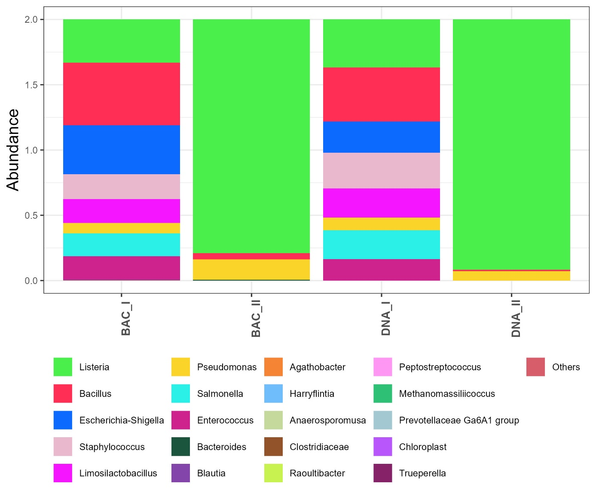
Fig S1. Microbiome analysis of microbial community standards. Bar plots show relative abundances of microbial community standards (ZymoBIOMICSTM). BAC_I – microbial community standard I, BAC_II – microbial community standard II, DNA_I – microbial community DNA standard I, DNA_II – microbial community DNA standard II.

Fig. S2. Proportions of the dominant A) bacterial classes and B) genera (represented by >
1% of reads) in the three groups studied. HC – healthy controls; SEAN – severe and enduring AN.

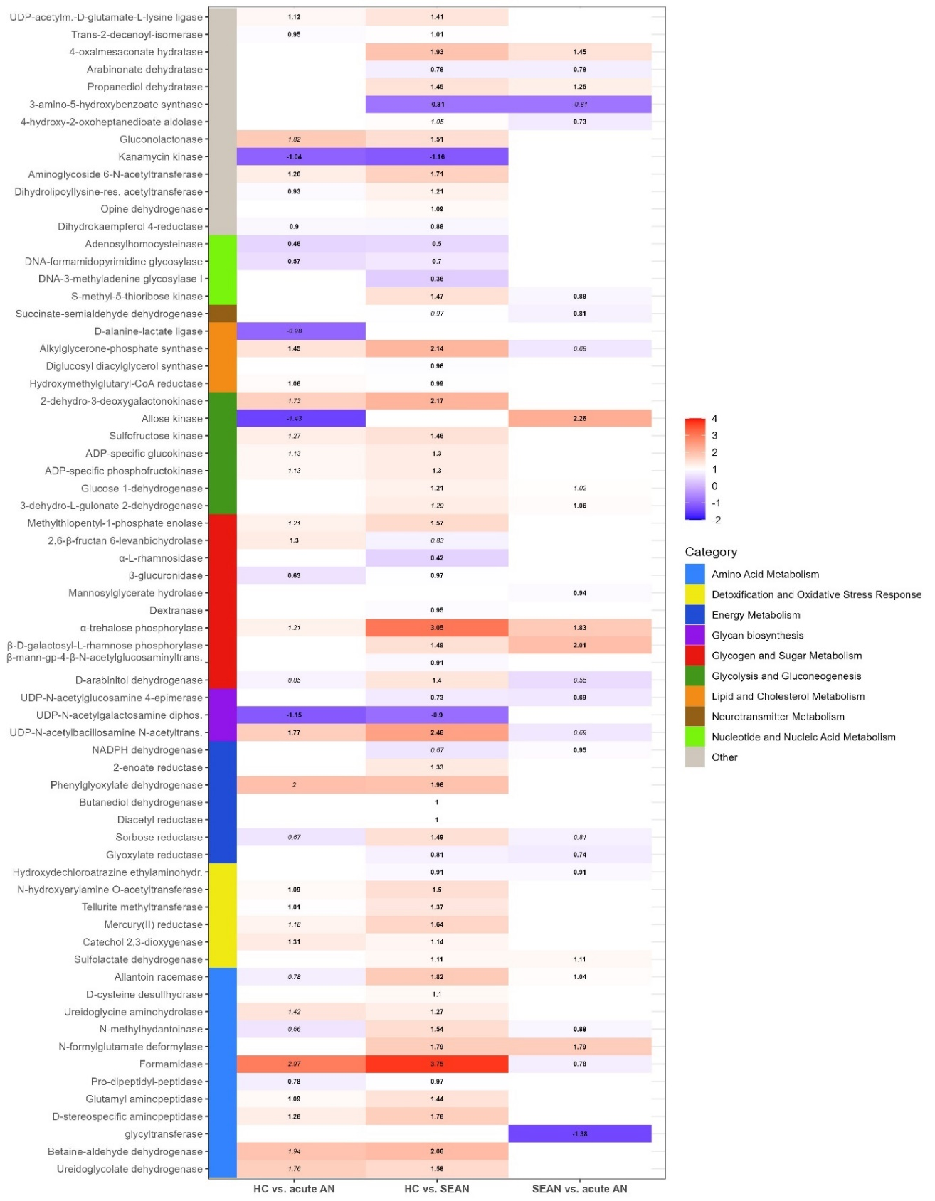
Fig. S3. Differences in the relative abundances of the predicted metabolites between the studied groups based on ANCOM-BC2 analyses (FDR < 0.05). The predicted metabolites are grouped into categories based on hypothetical metabolic pathways. White indicates non-significant corresponding pairwise tests. Italics indicate that the pairwise test did not pass the ANCOM-BC2 sensitivity test, otherwise, numbers are shown in bold type. HC – healthy controls; SEAN – severe and enduring AN. Metabolites were ordered relative to their biological function. The full names of metabolites are listed in Table S3.

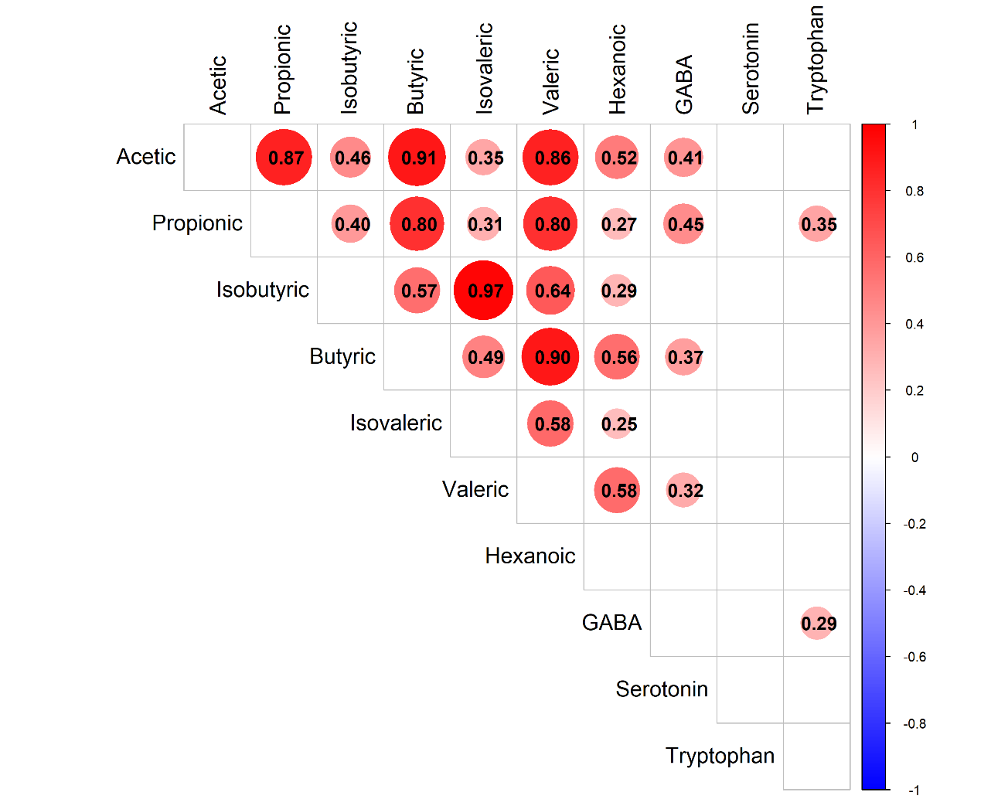
Fig. S4. Correlations between SCFAs and neurotransmitter levels, were analyzed with the Spearman correlation coefficient. Only significant correlations are shown.

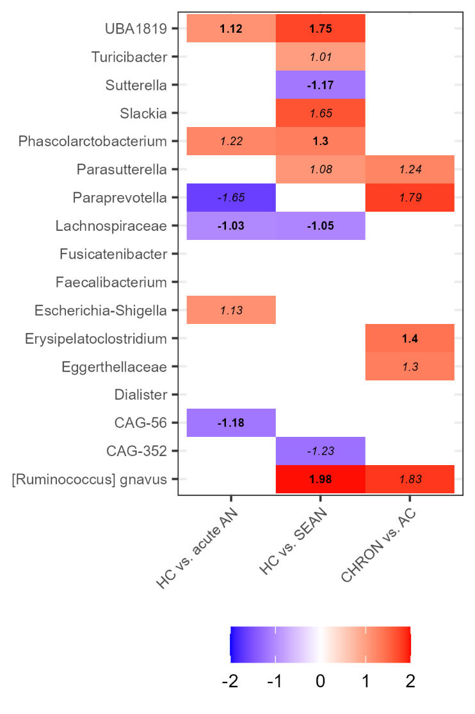
Fig. S5. Differential abundance analysis at the genus level. The heatmap shows the bacterial genera whose abundance varied between the study groups based on ANCOM-BC2. All genera identified by the global test are shown. Pairwise post-hoc comparisons were performed and the resulting log-fold changes are indicated by the color scale and numerical values within the cells. The color is white if the corresponding pairwise test was not significant. The numbers are printed in italics if the pairwise test did not pass the sensitivity analysis, otherwise, they are printed in bold.

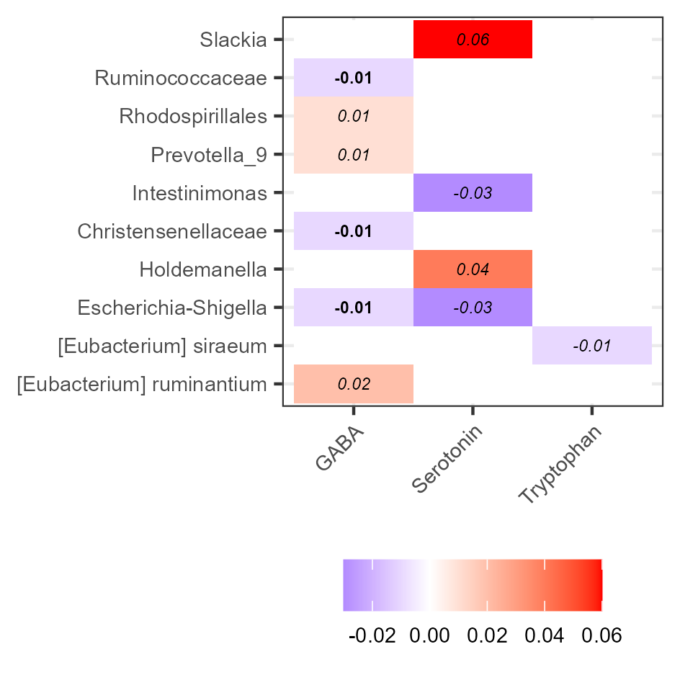
Fig. S6. Relationship between the concentrations of neurotransmitters and the abundances of microbial taxa. The log-fold changes are indicated by a color scale and numerical values within the cells. The color is white if the corresponding pairwise test was not significant. Numbers are in italics if the coefficient did not pass the sensitivity test in the differential abundance analysis, otherwise, they are in bold.

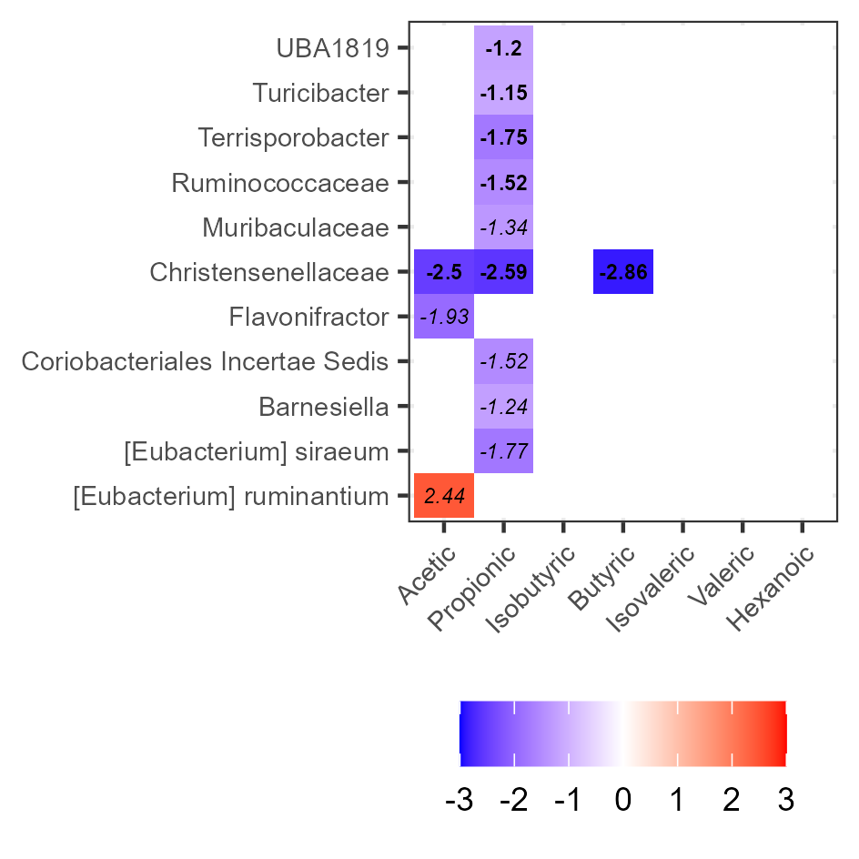
Fig. S7. Relationship between the concentrations of SCFAs and the abundance of microbial taxa. The log-fold changes are indicated by a color scale and numerical values within the cells. The color is white if the corresponding pairwise test was not significant. The numerical value is in italics if the coefficient did not pass the sensitivity test in the differential abundance analysis, otherwise, it is in bold.

