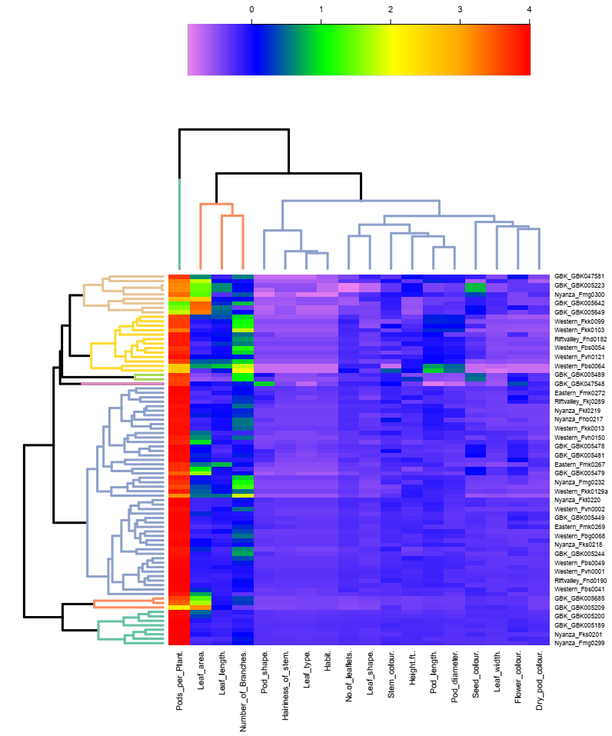
Supplementary figure 1 Sample clustering of 83 Crotalaria accessions from Kenya based on their agro-ecological regions using both quantitative and qualitative characters.

