Supplementary file
Appendix 1. Searching words
Update April 2024
PubMed (64)

ALL ( "Sleep" ) OR ( "sleep quality" OR "sleep enhance" OR "sleep promotion" OR "sleep hygiene" OR "Sleepefficiency" ) OR ( "prevention" )OR ( "Insonmia" ) OR ( "insomnia" ) AND ( "digital" OR "digital health intervention" OR "Digital health" OR "e-health" OR "electronic-health" OR "e-intervention" OR "mobile phone" OR "smartphone" OR "internet" OR "internet intervention" OR "web-based" OR "app" OR "application" OR "technology assisted" ) AND ( "Randomized control trial" OR "RCT" OR "trial" OR "randomized clinical trial" OR "randomallocation" ) AND ( "youth" OR "adolescents" OR "Teen" OR "teenager" OR "school-Age" OR "Pupil" )

Embase (13)

ALL ( "Sleep" ) OR ( "sleep quality" OR "sleep enhance" OR "sleep promotion" OR "sleep hygiene" OR "Sleep efficiency" ) OR ( "prevention" ) OR ( "insomnia" ) AND ( "digital" OR "digital health intervention" OR "Digital health" OR "e-health" OR "electronic-health" OR "e-intervention" OR "mobile phone" OR "smartphone" OR "internet" OR "internet intervention" OR "web-based" OR "app" OR "application" OR "technology assisted" ) AND ( "Randomized control trial" OR "RCT" OR "trial" OR "randomized clinical trial" OR "random allocation" ) AND ( "youth" OR "adolescents" OR "Teen" OR "teenager" OR "school-Age" OR "Pupil" )

Scopus (336)

ALL ( "Sleep" ) OR ( "sleep quality" OR "sleep enhance" OR "sleep promotion" OR "sleep hygiene" OR "Sleep efficiency" ) OR ( "insomnia" ) AND ( "digital" OR "digital health intervention" OR "Digital health" OR "e-health" OR "electronic-health" OR "e-intervention" OR "mobile phone" OR "smartphone" OR "internet" OR "internet intervention" OR "web-based" OR "app" OR "application" OR "technology-assisted" ) AND ( "Randomized control trial" OR "RCT" OR "trial" OR "randomized clinical trial" OR "random allocation" ) AND ( "youth" OR "adolescents" OR "Teen" OR "teenager" OR "school-Age" OR "Pupil" )

OVID MEDLINE 13
(Sleep* OR "sleep quality*" OR "sleep enhance*" OR "sleep promotion*" OR "sleep hygiene*" OR "sleep hygiene*" OR ‘prevention’ OR "insomnia*" AND ("digital*" OR "digital health intervention*" OR "digital health*" OR "e-health*" OR "electronic-health*" OR "e-intervention*" OR "mobile phone*" OR "smartphone*" OR "internet*" OR "internet intervention*") AND (Randomized control trial* OR "RCT*" OR "trial*" OR "randomized clinical trial*" OR "random allocation*") AND "(youth* OR “adolescents*" OR "Teen*" OR "teenager*" OR "school-Age*" OR "Pupil*").

CINAHL (30)
(SU Subject terms) Sleep OR sleep quality OR sleep enhance OR sleep promotion OR sleep hygiene OR sleep hygiene OR prevention OR insomnia or sleep deprivation or sleep disturbance or reduced sleep or sleep loss or lack of sleep, AND(TX all) digital OR digital health intervention OR digital health OR e-health OR electronic-health OR e-intervention OR mobile phone OR smartphone OR internet OR internet intervention OR online AND (TI Title) Randomized control trial OR RCT OR trial OR randomized clinical trial OR random allocation AND (TXT all) (youth OR young adult OR adolescents OR Teen OR teenager OR school-Age OR Pupil).
PSYINFO (22) April 4.2024
((Sleep* OR "sleep quality*" OR "sleep enhance*" OR "sleep promotion*" OR "sleep hygiene*" OR "sleep hygiene*" OR “prevention” OR “treatment” OR "insomnia*")) AND ((digital* OR "digital health intervention*" OR "digital health*" OR "e-health*" OR "electronic-health*" OR "e-intervention*" OR "mobile phone*" OR "smartphone*" OR "internet*" OR "internet intervention*")) AND ((Randomized control trial* OR "RCT*" OR "trial*" OR "randomized clinical trial*" OR "random allocation*")) AND ((youth* OR "adolescents*" OR "Teen*" OR "teenager*" OR "school-Age*" OR "Pupil*"))
Web of Science (80) - 124
(((((((((((((((((((((((((((((TS=(sleep)) OR TS=(sleep quality)) OR TS=(sleep enhance)) OR TS=(Sleep hygiene)) OR TS=(sleep promotion)) OR TS=(insomnia)) AND TS=(digital)) OR TS=(digital health intervention)) OR TS=(digital health)) OR TS=(e-health)) OR TS=(electronic-health)) OR TS=(e-intervention)) OR TS=(mobile phone)) OR TS=(mHealth)) OR TS=(smartphone)) OR TS=(internet)) OR TS=(internet intervention)) OR TS=(online)) AND TS=(Randomized control trial)) OR TS=(RCT)) OR TS=(trial))) OR TS=(randomized clinical trial)) OR TS=(random allocation)) AND TS=(youth)) OR TS=(adolescents)) OR TS=(teen)) OR TS=(teenager)) OR TS=(school-Age)) OR TS=(Pupil)

Appendix 2: Data extraction form
GENERAL INFORMATION
Title of the paper:
First author name:
Year:
Lead author's contact details:
Journal name:

CHARACTERISTICS OF INCLUDED STUDIES
Health domain (e.g., insomnia, healthy lifestyle):
Country in which the study was conducted (Select the options):
Australia

China

The Netherlands

U.S
U.K

Other:

Type of intervention (Select the options)
mHealth (Mobile health intervention)

eHealth (Website intervention/ internet intervention)

both (Include both types of interventions described above)

Other (e.g. MSM, chat, VR) (describe):

METHOD
Aim of the study:

Study design (e.g., RCT 2 arms, cluster RCT):

Type of control group (e.g., active control group, treatment as usual, face-to-face, waiting list, mixed) – Please describe.

Primary Measures (including questionnaires for sleep or objective trackers reported [e.g. actigraphy]):

Secondary Measures (e.g., Questionnaires or objective trackers reported for sleep or mental health)

Other measures (e.g., Questionnaires or objective trackers reported for other health conditions)

- Participants [Sociodemographic characteristics and target population)

Age (mean age, (SD) range)

Gender (Female= n, %, male=n, %, binary/ others)

Other sociodemographic characteristics:

Type of sample (e.g., general population, school-based, specific clinical)

Method of recruitment (Select the options)
Phone

Mail

Clinic patients

Voluntary
Other (e.g. school-based) describe.

Inclusion criteria

Exclusion criteria

Total number of participants recruited.

Analytical sample (Number of participants included for the final analysis)

Interventions
Characteristics (e.g., website+ mobile phone+ face-to-face)

Frequency (Select the options):
Daily

Weekly

Monthly

Other, describe.

Context intervention (e.g., healthcare, school-based, general population

- Intervention and comparisons
Active components (e.g., component description of Cognitive Behavioral Therapy (CBT) for insomnia [behavioural and cognitive components] [e.g., SH: Sleep Hygiene SC: Stimulus Control, SR: sleep restriction, RT: relaxation techniques PE: psychoeducation, CT: cognitive technique]
Other active components
(positive psychology/ Behavioral Change Techniques [BCT](taxonomy)/ healthy lifestyle components] (components reported in the paper)

Level of guidance (select)
Unguided (Automatic intervention, including chatbot, app, website)

Provide a description.
Guided (Human support, including live chat, asynchrony message, videoconference, face-to-face)

Provide a description.
Both

Provide a description.

No reported

RESULTS
Analytical strategy (select)
Per-protocol

Intention to treat.

Both

Others: Describe

Digital literacy participants (Reports on digital literacy participants (if any, are provided by the authors)

Effectiveness (Main results concerning overall effectiveness)
Outcome table (time point sleep) Quantitative outcomes on sleep only
Intervention | Mean (SD) pre-test | Mean (SD) post-test | Effect size (Within groups) (e.g., Cohen's d, Pearson's r) | Effect size (Between groups) (e.g., Cohen's d, Pearson's r)
Intervention 1
Intervention 2
Intervention 3
Notes (other analysis, statistical reports):
Std. Mean Difference

Drop-out and/or attrition (report from the paper)
Dose definition and report by the authors (Intention to use).
Clinically significant analysis (sleep and other measures, if any)
Main results concerning active components linked to adherence/intended use (RQ2)
Main results concerning the effect of intervention adherence/intended use on sleep (RQ3)
LIMITATIONS
Main limitations reported.

Study funding sources.
Possible conflicts of interest for study authors

Appendix 3: Quality Assessment Tool for Quantitative Studies
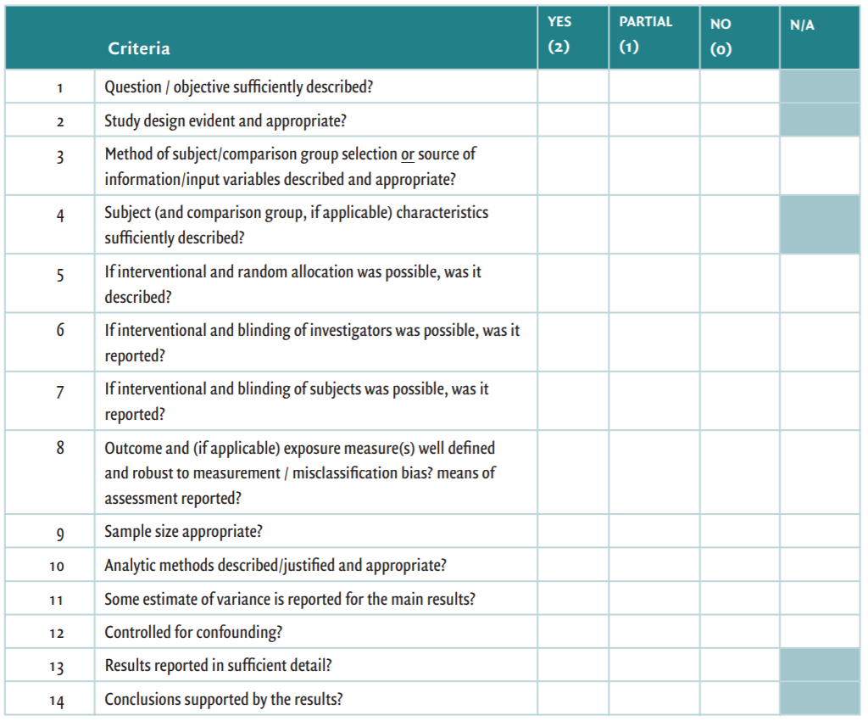
Leanne M. Kmet, R. C. L. L. S. C. (2004). STANDARD QUALITY ASSESSMENT CRITERIA for Evaluating Primary Research Papers from a Variety of Fields. from Alberta Heritage Foundation for Medical Research

Appendix 4. Study quality scores

 | Random Sequence Generation (Selection Bias) | Allocation Concealment (Selection Bias) | Blinding of Participants | Blinding of Outcome Assessment (Detection Bias) | Incomplete Outcome Data (Attrition Bias) | Selective Reporting (Reporting Bias)
Morris et al. 2015 | + | + | + | + | + | ?
Freeman et al. 2017 | + | + | + | + | ? | +
De Bruin et al. 2018 | + | + | + | + | + | +
Chan, et al. 2022 | + | + | ? | + | + | +
Champion, et al 2023 | + | + | + | + | + | +
Werner‐Seidler, et al 2023 | + | + | + | + | + | +

(+), (−), and (?) indicate that the study presented low, high, or unclear bias in their applied method, respectively.

