a
Traversianal（ppm）
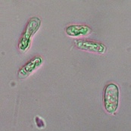
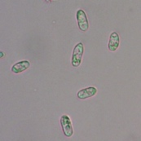
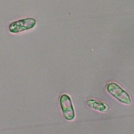
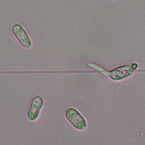
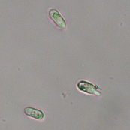
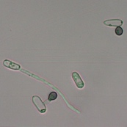
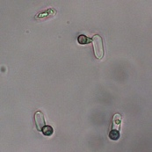
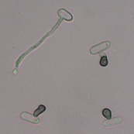
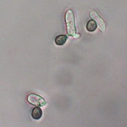
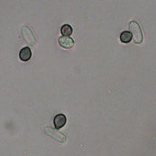
A
10
5
2
1
0
C
Control

G
Lecithin (200 ppm)

ns
Traversianal + Lecithin (200 ppm)
Traversianal (control)
b
＊
＊
100
80
60
40
20
0

Conidial germination (%)

＊
ns
0
2
1
5
10
Traversianal（ppm）
Fig. S1 Antagonistic effect of lecithin on inhibiting conidial germination by traversianal
Conidia of Colletotrichum orbiculare (1.0 × 10⁵ conidia/ml) were suspended in a mixture of equal parts lecithin (400 ppm) and traversianal (0, 2, 4, 10 and 20 ppm). The mixtures of sterile distilled water and traversianal (0, 2, 4, 10 and 20 ppm) in equal amounts were used as a control. After 24 h, (a) the conidia were observed and (b) conidial germination (%) was determined by counting the germinated conidia among 300 conidia in each treatment. The bar at the top of each column represents the standard deviation of the mean. Asterisks indicate a significant difference among treatments, while ns indicates no significant difference in a t-test (P < 0.05). C: conidia, G: germ tube, A: appressorium.

a
DOPE (ppm)
DOPC (ppm)
150
Control
100
50
150
50
100
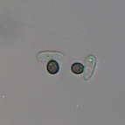
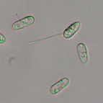
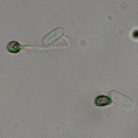
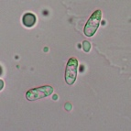
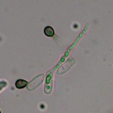
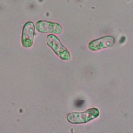
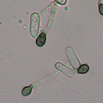
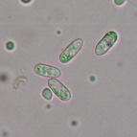
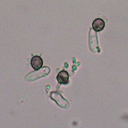
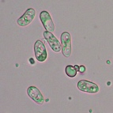
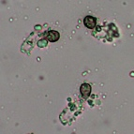
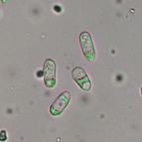
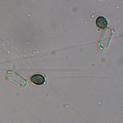
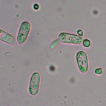
C
DMSO
(0.05%)
G
A
Traversianal
（5 ppm）

b
Traversianal (5 ppm)
DMSO (0.05%)
a
a
a
100
80
60
40
20
0
a
a
a
a

Conidial germination (%)

b
c
c
c
c
c
c
DOPC (ppm)
Control
50
100
150
50
100
150
DOPE (ppm)

Fig. S2 Antagonistic effect of DOPC and DOPE on inhibiting conidial germination by traversianal
Conidia of Colletotrichum orbiculare (1.0 × 10⁵ conidia/ml) were suspended in mixtures of equal parts DOPC or DOPE (100, 200 and 300 ppm) and traversianal (10 ppm). The mixtures of sterile distilled water and DMSO (0.1%) or traversianal (10 ppm) in equal volumes were used as a control. After 24 h, (a) the conidia were observed and (b) conidial germination (%) was determined by counting the germinated conidia among 300 conidia in each treatment. The bar at the top of each column represents the standard deviation of the mean. Different letters after means indicate a significant difference between treatments (Tukey–Kramer test, P < 0.05). C: conidia, G: germ tube, A: appressorium.

