Fully Stretchable Hydrovoltaic Cells Based on Winding-Locked Double-Helical Carbon Nanotube Fibers
Wonkyeong Son^{1†}, Jae Myeong Lee^{1†}, Hyunji Seo¹, Sung Beom Cho², Sungwoo Chun³, Changsoon Choi¹*

¹ Department of Electronic Engineering and Biomedical Engineering, Hanyang University, Seoul 04763, Republic of Korea
² Department of Materials Science and Engineering, Ajou University, Suwon 16499, Republic of Korea
³ Department of Electronics and Information Engineering, Korea University, Sejong 30019, Republic of Korea

*Corresponding author: Changsoon Choi
E-mail addresses: pccs2004@hanyang.ac.kr
†These authors equally contributed to this work.
Supplementary Figures

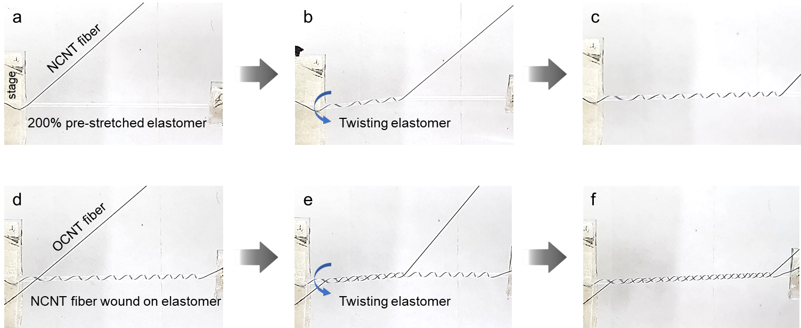
Supplementary Figure S1. Sequential photographic images showing the winding process of (a–c) NCNT and (d–f) OCNT fibers onto a 200% pre-stretched elastomeric core mandrel to create a winding-locked double-helix structure.

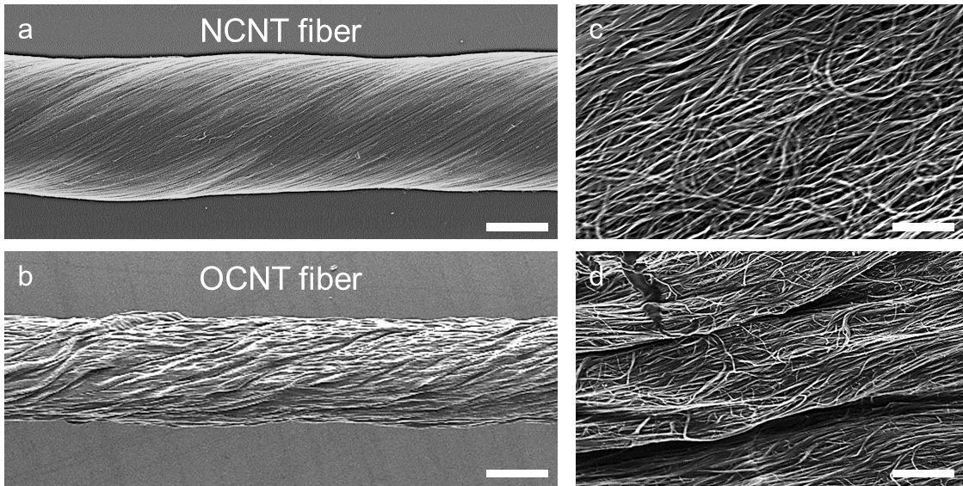
Supplementary Figure S2. Low-resolution (a and b) and high-resolution (c and d) SEM images of the NCNT (a and c) and OCNT (b and d) fibers. Scale bars: (a and b) 100 µm, (c and d) 2 µm.

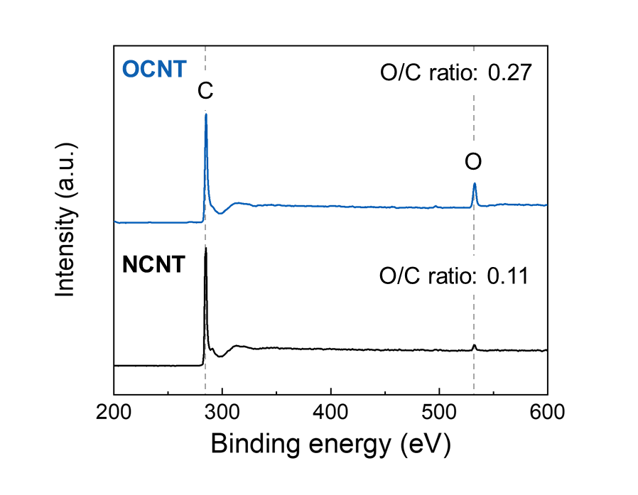
Supplementary Figure S3. The XPS spectra of the OCNT (top) and NCNT (bottom) fibers. The increased O/C ratio in the OCNT confirms the incorporation of oxygen-containing functional groups after electrochemical oxidation.

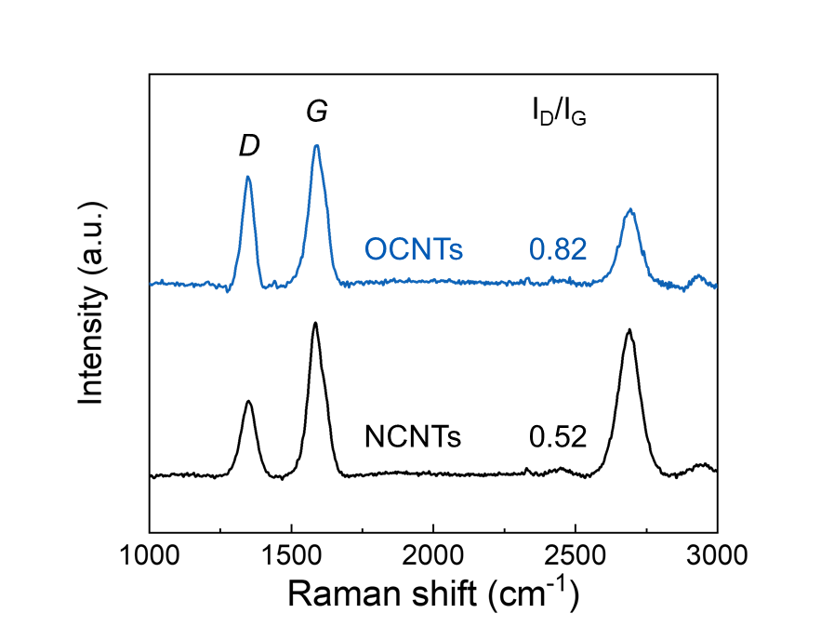
Supplementary Figure S4. The Raman spectra of the NCNT and OCNT fibers, showing an increase in the intensity ratio of the D to G bands from 0.52 before to 0.82 after oxidation. This indicates that the OCNTs have more defects than the NCNTs.

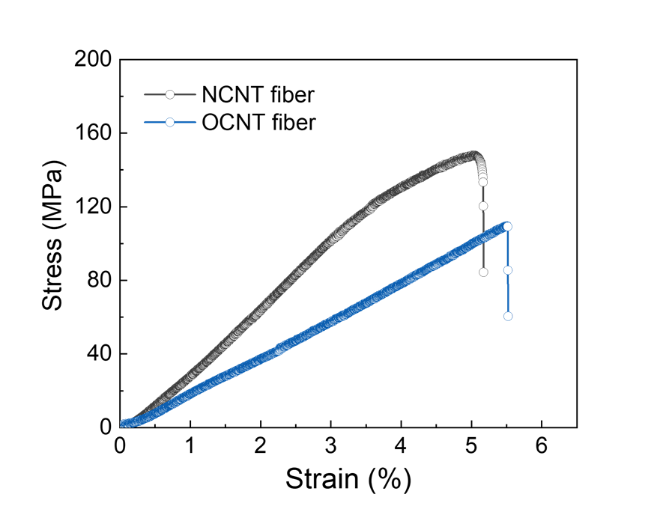
Supplementary Figure S5. The stress-strain curves of the NCNT and OCNT fibers.

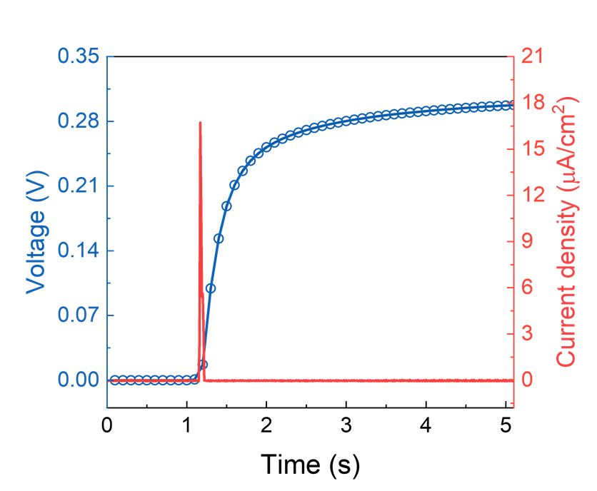
Supplementary Figure S6. The time-dependent voltage (left hand axis) and current density (right hand axis) of the SHC in deionized water.

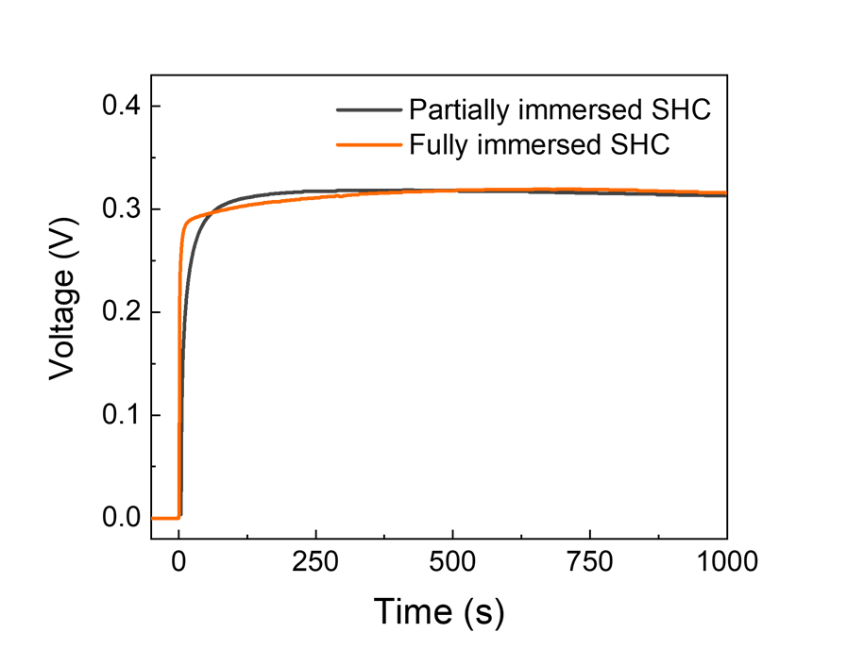
Supplementary Figure S7. The time-dependent voltage of the SHC when fully and partially immersed in deionized water, indicating that evaporation has no influence on electricity generation.

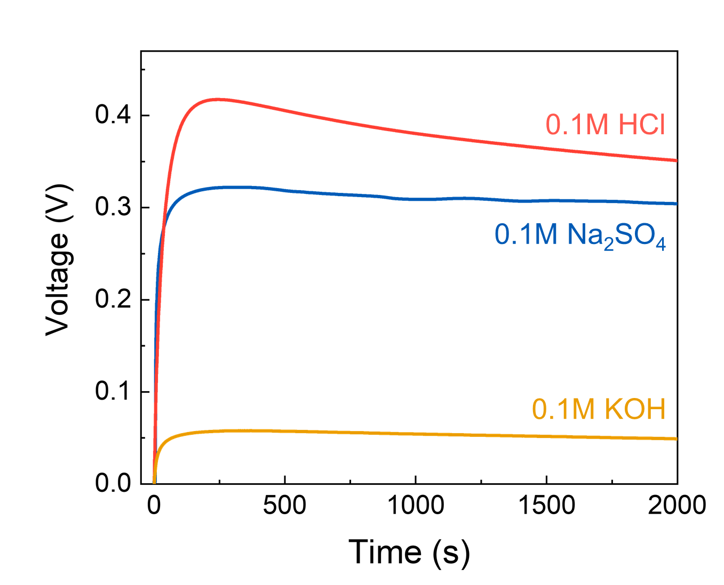
Supplementary Figure S8. The time-dependent voltage output of the SHC in various electrolytes (0.1 M HCl, 0.1 M Na₂SO₄, and 0.1 M KOH).

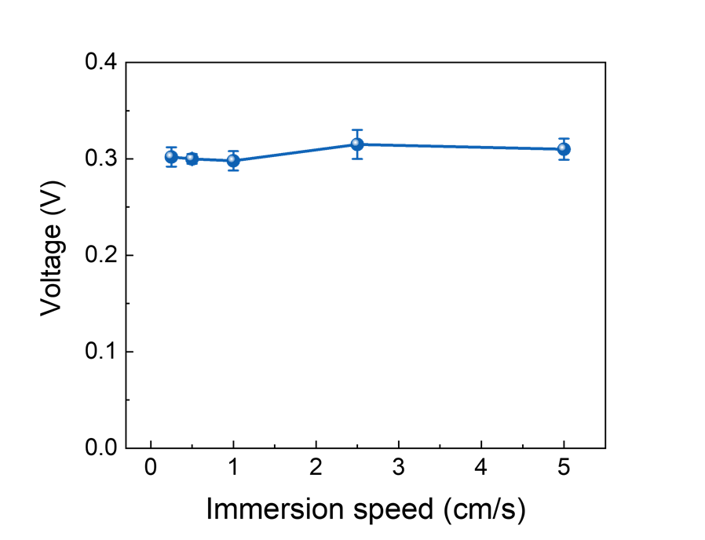
Supplementary Figure S9. The dependence of SHC voltage on the immersion speed in deionized water. The voltage remains essentially unchanged with increasing immersion speed, which suggests that the working mechanism is distinct from that of conventional fluidic devices.

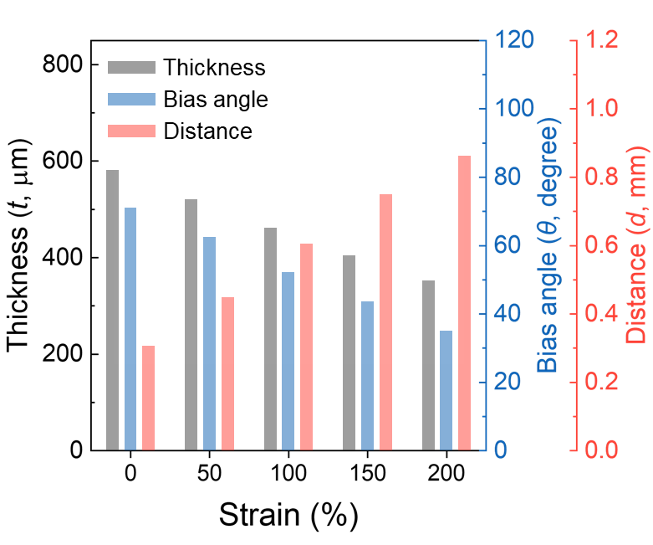
Supplementary Figure S10. The changes in elastomeric core thickness (t) with the distance (d) between the wound CNT fibers and the bias angle (θ) as a function of strain for the SHC.

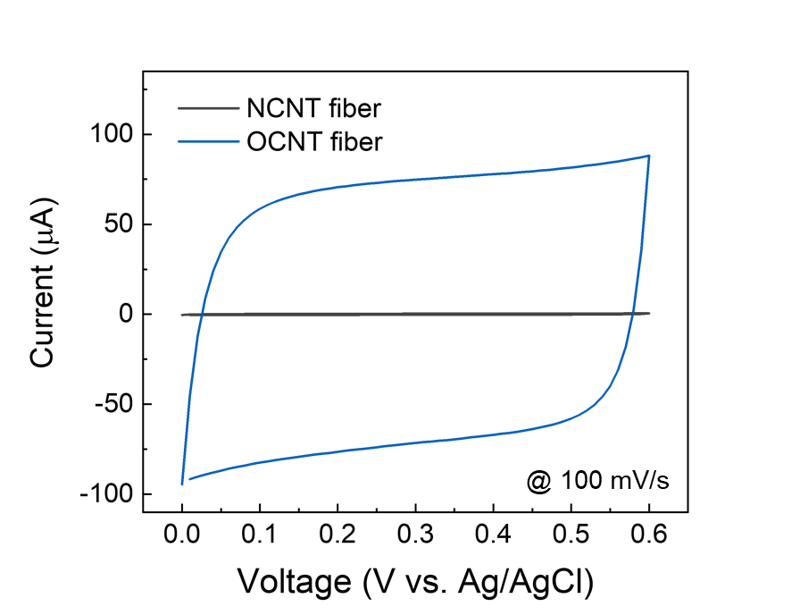
Supplementary Figure S11. The CV curves measured at 100 mV/s in a three-electrode system for the NCNT and OCNT fibers. The introduction of oxygen-containing functional groups increases the area under the CV curve by a factor of 226.1.

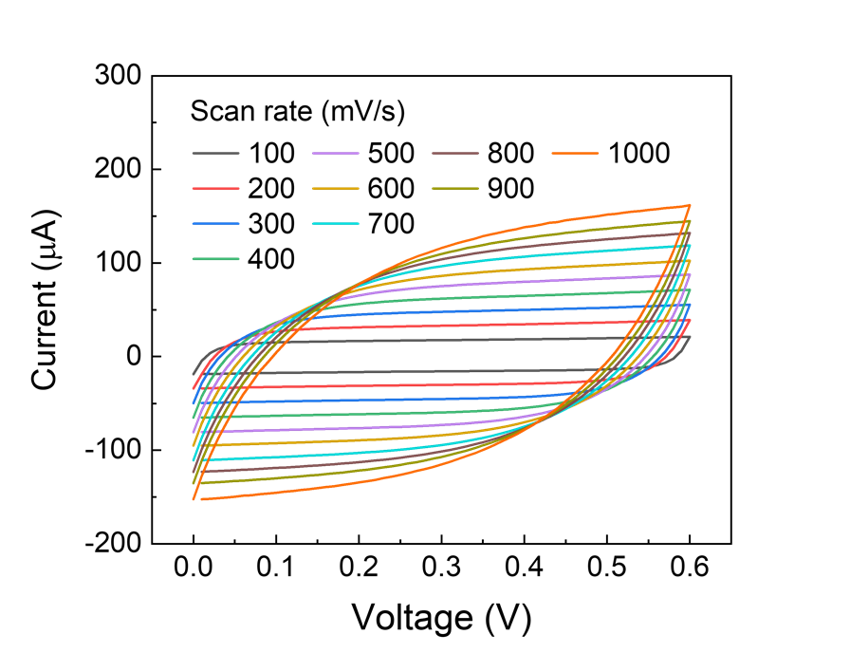
Supplementary Figure S12. The CV curves of the SHC at scan rates of 100–1000 mV/s.

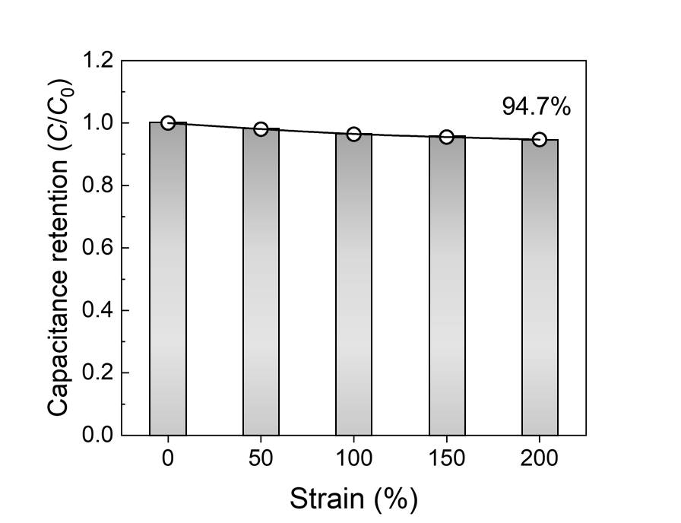
Supplementary Figure S13. The capacitance retention of the SHC under various tensile strains, showing consistent performance across all conditions.

