Supplementary table 1: Results of Shapiro-Wilks test for normality in the acoustic signals of each R. imitator color morph. W is the Shapiro-Wilks test statistic and P is the p-value for each color morph.
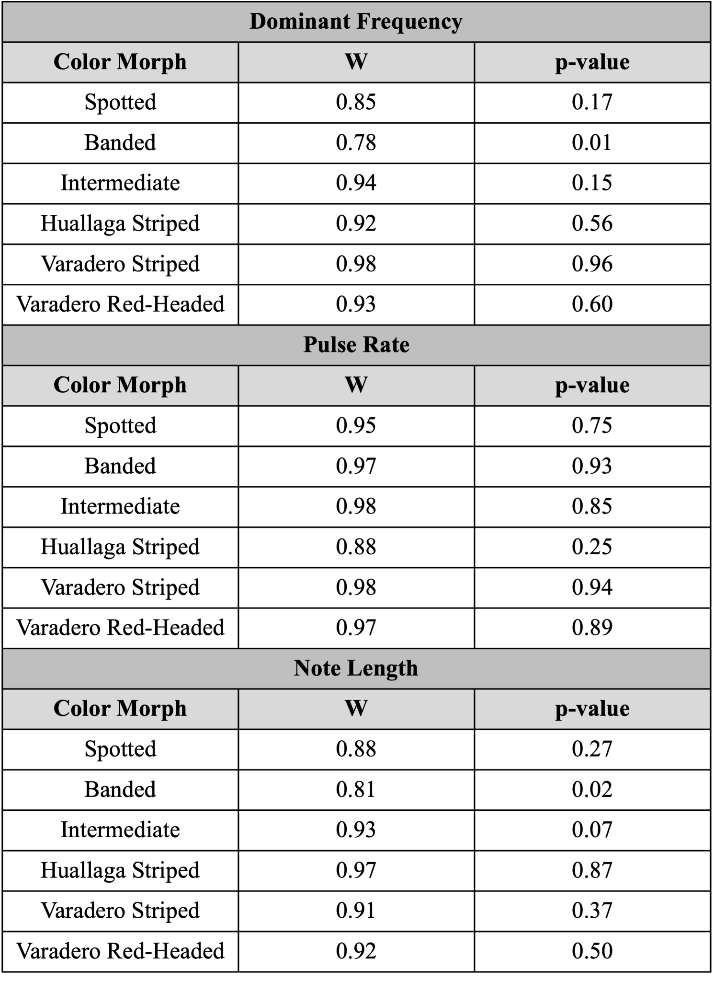
Supplementary table 2: Primers and motif regions used for each candidate gene.
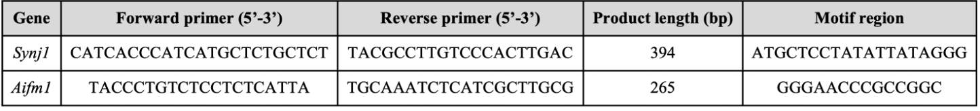

Supplementary table 3: PCR protocol used for amplifying the genes Synaptojanin 1 (synj1) and Apoptosis Inducing Factor Mitochondria Associated 1 (aifm1). Annealing temperature and number of cycles were adjusted if amplification failed using the original protocol.
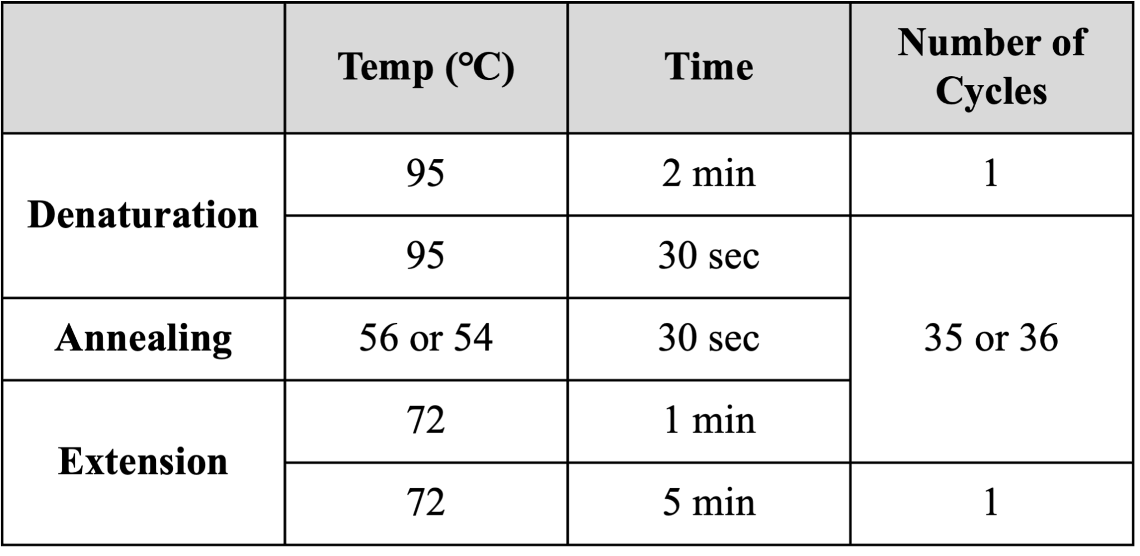

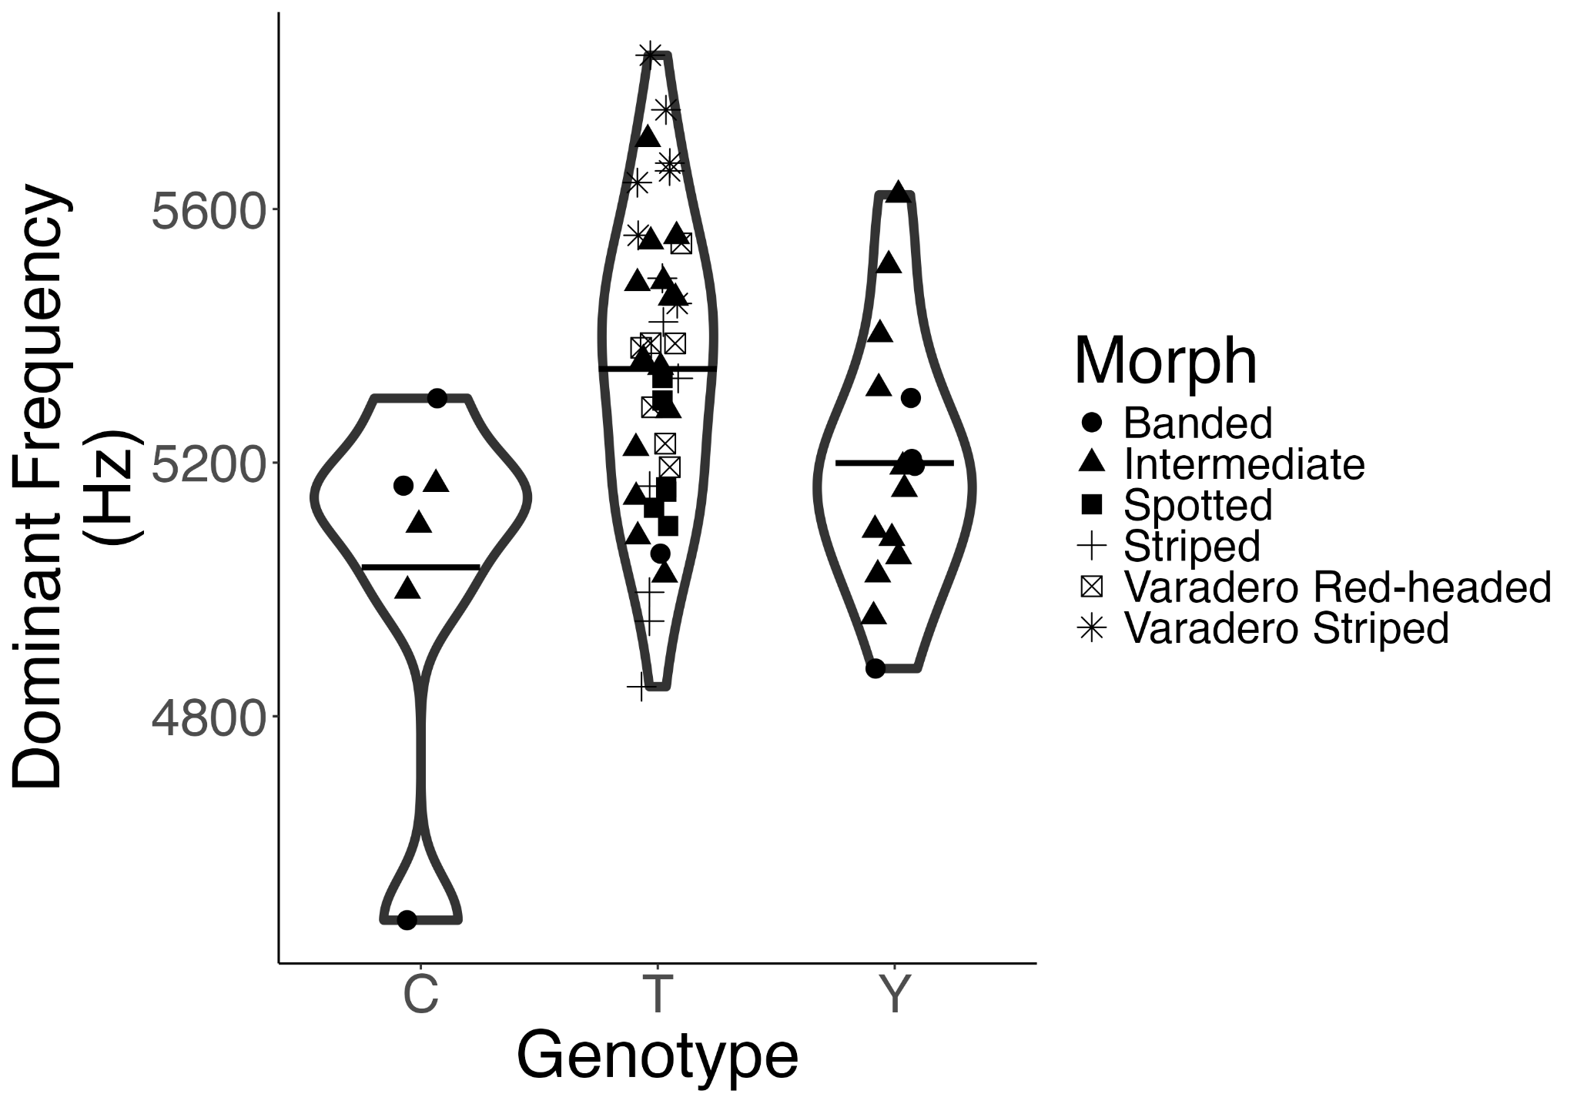
Supplementary figure 1: Relationship between dominant frequency and aifm1 genotype plotted by color morph. Variation in aifm1 is seen in the banded and intermediate color morphs.

