Supporting information

Chejuenolide D, a 17-Membered macrocyclic polyketide with anti-inflammatory from an iChip-Domesticated Marine Bacterium Hahella sp. NBU794

Fangjian Feng,¹ Ziran Ju,² Guobao Huang,¹ Dengquan Su,¹ Bin Wu,³ Weiyan Zhang,¹ Shan He,^{1,4,*} and Lijian Ding^{1,*}

¹ School of Pharmacy, Health Science Center, Ningbo University, Ningbo 315211, China;
² Collaborative Innovation Center of Yangtze River Delta Region Green Pharmaceuticals, Zhejiang University of Technology, Hangzhou 310014, China;
³ Ocean College, Zhejiang University, Zhoushan 316000, China;
⁴ Ningbo Institute of Marine Medicine, Peking University, Ningbo 315800, China.

*Corresponding Author: heshan@nbu.edu.cn (S.H); dinglijian@nbu.edu.cn (L. D)
Contents
Fig. S1 The HRESIMS spectrum of chejuenolide D (1).
Fig. S2 The UV spectrum of chejuenolide D (1) in MeOH.
Fig. S3 The IR spectrum of chejuenolide D (1).
Fig. S4 The ¹H spectrum of chejuenolide D (1) in DMSO-d₆.
Fig. S5 The ¹³C spectrum of chejuenolide D (1) in DMSO-d₆.
Fig. S6 The HSQC spectrum of chejuenolide D (1) in DMSO-d₆.
Fig. S7 The COSY spectrum of chejuenolide D (1) in DMSO-d₆.
Fig. S8 The DEPT spectrum of chejuenolide D (1) in DMSO-d₆.
Fig. S9 The HMBC spectrum of chejuenolide D (1) in DMSO-d₆.
Fig. S10 The NOESY spectrum of chejuenolide D (1) in DMSO-d₆.
Fig. S11 The ¹H Spectrum of Chejuenolide D (S)-MTPA ester (1a) in DMSO-d₆.
Fig. S12 The COSY Spectrum of Chejuenolide D (S)-MTPA ester (1a) in DMSO-d₆.
Fig. S13 The ¹H Spectrum of Chejuenolide D (R)-MTPA ester (1b) in DMSO-d₆.
Fig. S14 The COSY Spectrum of Chejuenolide D (R)-MTPA ester (1b) in DMSO-d₆.
Table S1 Boltzmann weight of calculated conformers at B3LYP/6-31G (d) level in the gas phase using Shermo.
SⅠ. Cartesian coordinates of low-energy conformers optimized at B3LYP/6-31G (d) level in the gas phase.
Reference

Fig. S1 The HRESIMS spectrum of chejuenolide D (1).

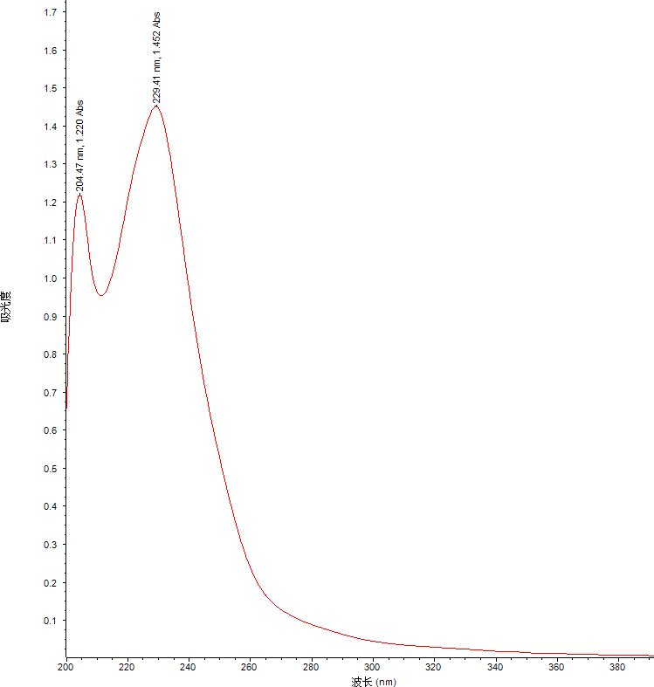
Fig. S2 The UV spectrum of chejuenolide D (1) in MeOH.

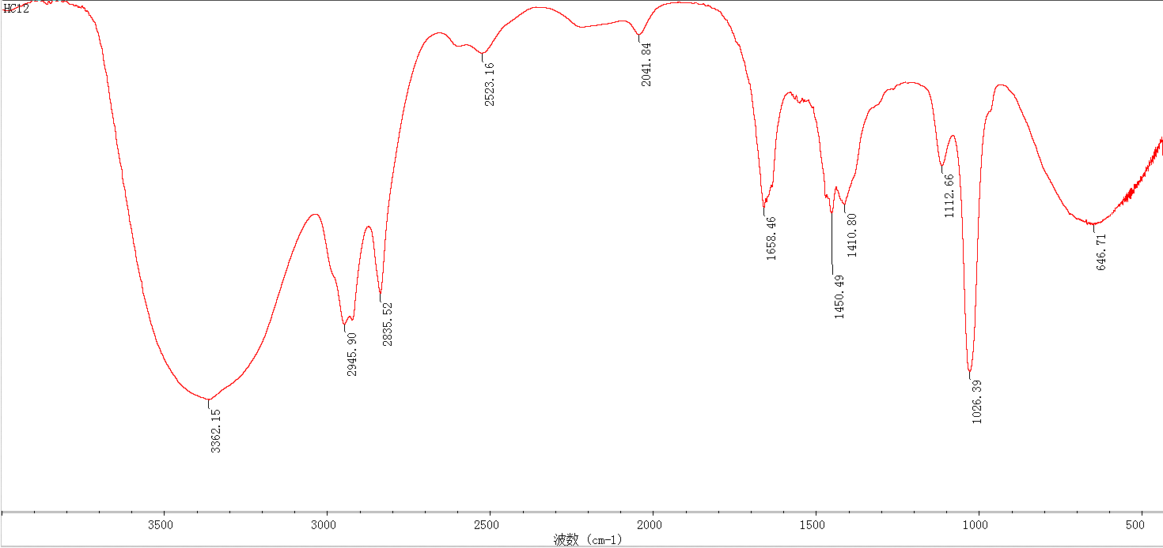
Fig. S3 The IR spectrum of chejuenolide D (1).

Fig. S4 The ¹H spectrum of chejuenolide D (1) in DMSO-d₆.

Fig. S5 The ¹³C spectrum of chejuenolide D (1) in DMSO-d₆.

Fig. S6 The HSQC spectrum of chejuenolide D (1) in DMSO-d₆.

Fig. S7 The COSY spectrum of chejuenolide D (1) in DMSO-d₆.

Fig. S8 The DEPT spectrum of chejuenolide D (1) in DMSO-d₆.

Fig. S9 The HMBC spectrum of chejuenolide D (1) in DMSO-d₆.

Fig. S10 The NOESY spectrum of chejuenolide D (1) in DMSO-d₆.

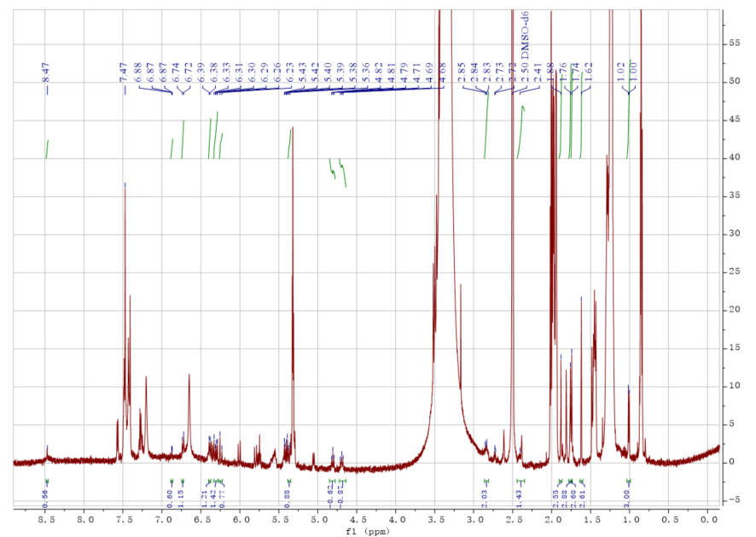
Fig. S11 ¹H NMR Spectrum of Chejuenolide D (S)-MTPA ester (1a) in DMSO-d₆.

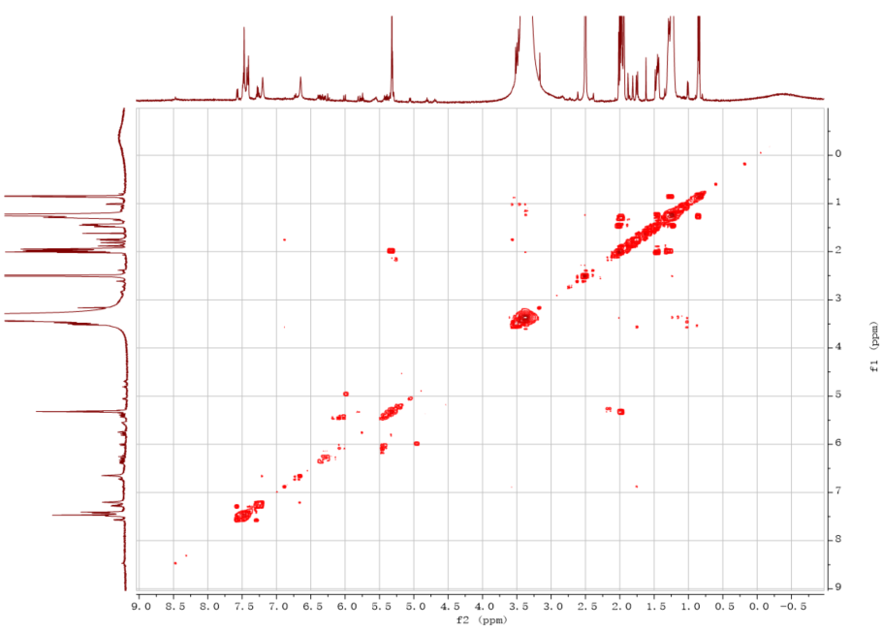
Fig. S12 The COSY Spectrum of Chejuenolide D (S)-MTPA ester (1a) in DMSO-d₆.

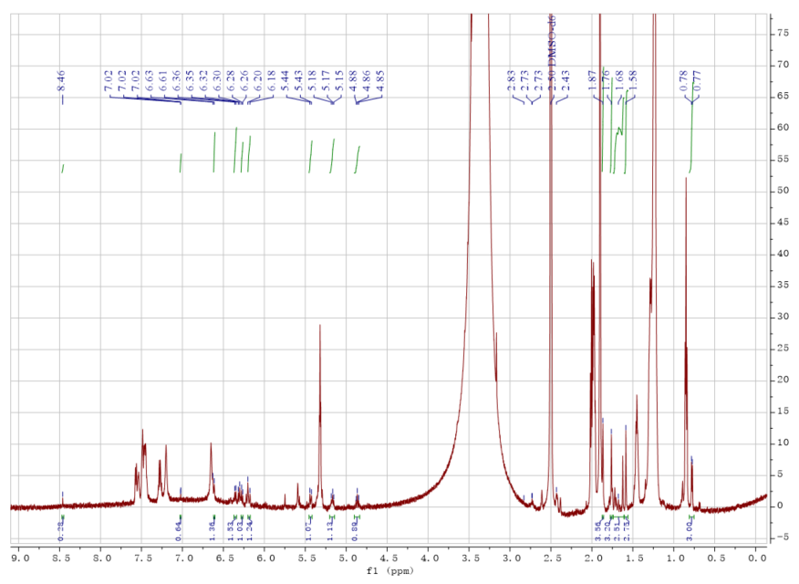
Fig. S13 ¹H NMR Spectrum of Chejuenolide D (R)-MTPA ester (1b) in DMSO-d₆.

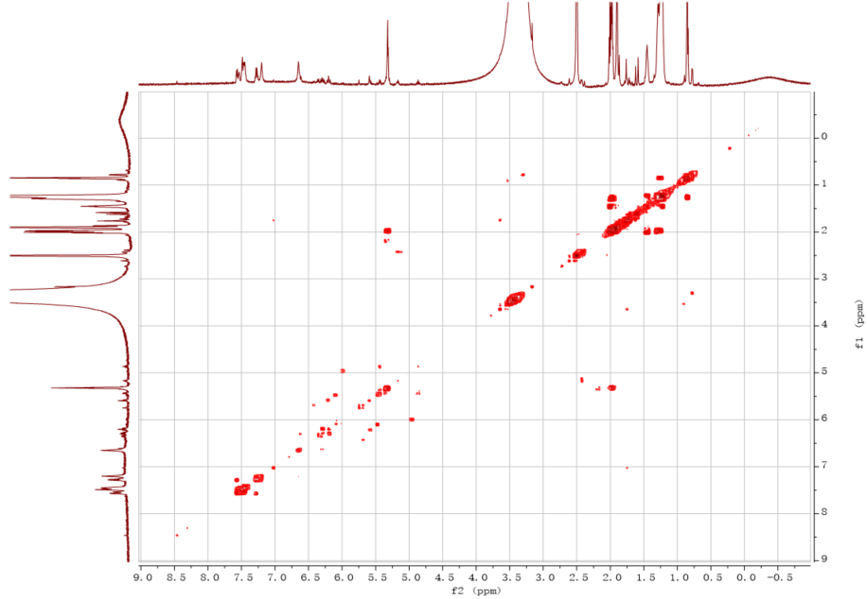
Fig. S14 The COSY Spectrum of Chejuenolide D (R)-MTPA ester (1b) in DMSO-d₆.

Table S1. Boltzmann weight of calculated conformers at B3LYP/6-31G (d) level in the gas phase using Shermo¹.
Conformer | Relative G | Boltzmann weight
1 | 0.000 kJ/mol | 78.689 %
2 | 5.328 kJ/mol | 9.372 %
3 | 6.596 kJ/mol | 5.647 %
4 | 8.641 kJ/mol | 2.496 %
5 | 9.107 kJ/mol | 2.072 %
6 | 10.433 kJ/mol | 1.220 %
7 | 12.642 kJ/mol | 0.505 %

SⅠ. Cartesian coordinates of low-energy conformers optimized at B3LYP/6-31G (d) level in the gas phase.
Conformer 1
0 1
O -2.46770000 -1.84298000 1.52191400
O 3.09915100 4.66051500 -0.62233900
O 3.68639800 -3.42878500 -1.63604100
O -5.63298100 1.40340100 1.65169000
N -3.95865800 0.36728400 0.53514800
C -1.88554200 -1.90379900 0.43991000
C -2.49457100 -1.17367500 -0.76528300
C -2.86399000 0.30478400 -0.42709100
C -1.64991900 1.08094700 0.04837000
C -0.71386900 1.69262800 -0.70871000
C 0.41371800 2.34935300 -0.03714700
C 1.50583200 2.85142700 -0.63650900
C 2.67320100 3.48153500 0.07159000
C 3.90957200 2.54908400 0.11504500
C 3.88784000 1.59543200 1.27722200
C 3.62692700 0.26979600 1.29813100
C 3.25079700 -0.48153200 0.09727600
C 3.03386000 -1.80785400 0.03877900
C 2.64095200 -2.54341500 -1.21179000
C 1.41370300 -3.45596900 -1.00859500
C 0.14411000 -2.69908100 -0.75342400
C -0.65391300 -2.74660700 0.33421900
C -0.39004500 -3.58459500 1.56237700
C -3.70802400 -1.97933300 -1.26985000
C -0.74279500 1.71691600 -2.21997600
C 3.70710700 -0.48927500 2.60428800
C -4.87267900 1.38039800 0.69234200
C -4.91436300 2.44898600 -0.39297400
H 2.32037200 5.23073700 -0.72403500
H 4.51051000 -2.91637600 -1.62967600
H -3.88978000 -0.27953000 1.31563400
H -1.76844200 -1.11169800 -1.57853000
H -3.22916300 0.73340100 -1.36606700
H -1.53181300 1.10325900 1.13099500
H 0.34678100 2.40124400 1.05012100
H 1.62216700 2.79988200 -1.71908100
H 2.38928600 3.73214400 1.10664300
H 4.01376300 2.04139900 -0.84930700
H 4.78179200 3.20769500 0.21828500
H 4.11817700 2.06352200 2.23518200
H 3.11031200 0.09738800 -0.81398600
H 3.16521700 -2.43329100 0.92056200
H 2.41821000 -1.81231800 -2.00784000
H 1.64603700 -4.16780800 -0.21228800
H 1.30262800 -4.04002600 -1.93346400
H -0.13055900 -2.02982100 -1.56561600
H -1.24862100 -4.22864000 1.78145700
H 0.49606400 -4.21214000 1.45670800
H -0.26164700 -2.94138200 2.43950100
H -4.16520200 -1.47965300 -2.13150500
H -3.40244700 -2.98369000 -1.58341400
H -4.46520800 -2.07567900 -0.48794500
H -0.62608500 2.74028600 -2.59615900
H 0.08530800 1.13040400 -2.63915600
H -1.67151700 1.31367600 -2.63019100
H 3.96711300 0.17589200 3.43250600
H 2.75288700 -0.97544600 2.84371300
H 4.46595900 -1.28132300 2.56029200
H -5.17676100 2.01981700 -1.36766700
H -5.67400000 3.17958700 -0.11294500
H -3.94712100 2.95338700 -0.49975200
Conformer 2
0 1
O -2.53199600 -1.86938900 1.45904800
O 3.16455300 4.59405900 -0.76724400
O 3.66062000 -3.50087900 -1.55208200
O -5.50851600 1.53039200 1.68544100
N -3.89200700 0.44578000 0.53083900
C -1.93687300 -1.91554700 0.38335900
C -2.50618600 -1.13252100 -0.80758100
C -2.80783000 0.35471000 -0.44195500
C -1.56017500 1.07343500 0.03593500
C -0.63550700 1.71071900 -0.71410600
C 0.51355100 2.32969500 -0.04140100
C 1.56912800 2.88937700 -0.65182100
C 2.76157400 3.48553700 0.04064700
C 3.92905700 2.46149300 0.18026400
C 3.78104600 1.52946500 1.34973100
C 3.47646100 0.21294400 1.36622200
C 3.16887900 -0.54298000 0.14871400
C 2.94084000 -1.86699000 0.08493900
C 2.60635000 -2.60173700 -1.18325800
C 1.35859200 -3.49707000 -1.03958700
C 0.09852400 -2.72130900 -0.79286000
C -0.72933100 -2.79197500 0.27079000
C -0.52083400 -3.68621900 1.46972500
C -3.75527100 -1.87060200 -1.32884400
C -0.70490600 1.81561400 -2.22068100
C 3.43351500 -0.52990500 2.68327100
C -4.75474000 1.49732200 0.72096500
C -4.74906100 2.59598500 -0.33430000
H 3.92602900 5.01251200 -0.33603600
H 4.48834200 -2.99547200 -1.51861400
H -3.85324800 -0.22577800 1.29223800
H -1.77626300 -1.08956100 -1.61875800
H -3.16256200 0.81351900 -1.37032500
H -1.41353700 1.03973800 1.11494700
H 0.48582300 2.31048400 1.04816400
H 1.63715900 2.92078900 -1.73788400
H 2.47695500 3.82698800 1.04898900
H 4.05429900 1.93679000 -0.77197200
H 4.85114900 3.04460800 0.33247200
H 3.95138800 2.00367000 2.31736700
H 3.08862600 0.03141900 -0.77251000
H 3.01236600 -2.48910400 0.97591000
H 2.43334700 -1.86954700 -1.99038400
H 1.55826200 -4.23284400 -0.25631800
H 1.26129700 -4.05533900 -1.98174000
H -0.13616500 -2.01150700 -1.58282800
H 0.34529600 -4.34000300 1.35757200
H -0.39081300 -3.08313000 2.37469800
H -1.40542200 -4.30819600 1.64463000
H -4.18537500 -1.33406400 -2.18219900
H -3.49754200 -2.88275300 -1.66008600
H -4.51797500 -1.94438200 -0.54992100
H -1.63648400 1.41771900 -2.62936400
H -0.61429300 2.85968400 -2.54308300
H 0.12189300 1.26729900 -2.69088100
H 3.64363300 0.13939200 3.52229100
H 2.45165800 -0.99010300 2.85056400
H 4.17367800 -1.34022800 2.70858200
H -5.03439800 2.20668000 -1.31925400
H -5.47213300 3.35401300 -0.03127500
H -3.75906700 3.05612600 -0.43117300
Conformer 3
0 1
O -1.78937800 -1.80536000 1.76468200
O 1.62911900 4.76508100 -0.48818100
O 4.16167200 -2.84463000 -1.88657500
O -5.55045600 0.70632400 1.88067500
N -3.83727000 -0.16757900 0.68666100
C -1.34890700 -1.97306000 0.62854500
C -2.22352000 -1.58744700 -0.57228400
C -2.87184100 -0.17800400 -0.40924300
C -1.81872600 0.90078600 -0.24551400
C -1.23297200 1.63149800 -1.21517600
C -0.17581900 2.61874000 -0.91343000
C 0.69402900 2.58040700 0.10682600
C 1.75355500 3.62595400 0.35742400
C 3.18113900 3.07337800 0.12138800
C 3.64103000 2.13035900 1.19887000
C 3.75341500 0.78372800 1.16193900
C 3.37750800 -0.00510400 -0.01488600
C 3.46529200 -1.34274400 -0.12415500
C 3.05160300 -2.11916200 -1.34264300
C 1.98846200 -3.19570700 -1.03228300
C 0.64083700 -2.61910000 -0.71188300
C -0.01276800 -2.62872000 0.46859400
C 0.52579700 -3.22388800 1.74741500
C -3.27660100 -2.69459000 -0.78263000
C -1.58218400 1.53084600 -2.68538600
C 4.27001800 0.03919700 2.37295200
C -4.92485900 0.65847800 0.82896800
C -5.33145200 1.48289600 -0.38602100
H 0.74462200 5.13744900 -0.34189600
H 4.89522000 -2.21558700 -1.97647300
H -3.53139100 -0.62838500 1.53875100
H -1.61595400 -1.52340800 -1.47783800
H -3.42874800 -0.00995500 -1.33606900
H -1.52136000 1.07690100 0.78672400
H -0.07646900 3.43503200 -1.62965500
H 0.68358200 1.74969500 0.81063200
H 1.68826800 3.93658600 1.41594500
H 3.21836200 2.63004000 -0.87786100
H 3.84731100 3.94557000 0.10754400
H 3.91357400 2.62075900 2.13423200
H 2.96711300 0.54563900 -0.85941200
H 3.86760600 -1.94583000 0.68873900
H 2.64557500 -1.42404700 -2.09689100
H 2.37072800 -3.83974500 -0.23577600
H 1.90596600 -3.81794000 -1.93411400
H 0.17161900 -2.11909500 -1.55616600
H 0.65407400 -2.44188500 2.50344600
H -0.18614800 -3.94126400 2.16994100
H 1.48246600 -3.72771600 1.60159100
H -3.91288500 -2.45493400 -1.64216700
H -2.79323900 -3.65839400 -0.97697700
H -3.91530000 -2.79727800 0.09814700
H -1.78913200 2.52605900 -3.09979800
H -0.73895100 1.12545100 -3.26057900
H -2.45196200 0.89965600 -2.88332500
H 4.50385300 0.72740000 3.19004100
H 3.53398700 -0.68720800 2.74038900
H 5.18199500 -0.52387900 2.13606100
H -6.20023800 2.08077200 -0.10840900
H -4.52151500 2.14687400 -0.70921300
H -5.59761100 0.84195300 -1.23532900
Conformer 4
0 1
O -1.66924500 -1.89705400 1.68915200
O 1.55007600 4.84077500 -0.49046400
O 4.32696700 -2.73790700 -1.87418900
O -5.53802400 0.38678600 1.94849900
N -3.79149300 -0.32838800 0.69972300
C -1.23644600 -2.01939500 0.54452600
C -2.11914400 -1.60036600 -0.63922400
C -2.83860900 -0.23615400 -0.40491600
C -1.84004200 0.88481000 -0.20161600
C -1.43270900 1.80009700 -1.10336700
C -0.40449200 2.80816500 -0.76603800
C 0.65375300 2.62587300 0.03655900
C 1.69655200 3.68049100 0.32122000
C 3.13932600 3.11112800 0.19401100
C 3.52258900 2.15369600 1.28762800
C 3.65932900 0.80918100 1.23585200
C 3.39023900 0.03790100 0.01897400
C 3.50389500 -1.29584200 -0.11232300
C 3.17680600 -2.04549800 -1.37346800
C 2.11674900 -3.14713300 -1.15222700
C 0.75785500 -2.60157200 -0.82249200
C 0.10397100 -2.66022600 0.35638300
C 0.64820500 -3.29698000 1.61283000
C -3.11721300 -2.74237800 -0.92390200
C -1.95934500 1.90985100 -2.51927100
C 4.08540600 0.04796200 2.47127400
C -4.92423800 0.42461900 0.88949400
C -5.39448700 1.27839700 -0.28092000
H 1.62518900 4.55156000 -1.41514700
H 5.05327700 -2.09521800 -1.90893400
H -3.44819400 -0.80395400 1.52893900
H -1.50698100 -1.45519400 -1.53278300
H -3.41308200 -0.05582000 -1.31774100
H -1.42433500 0.93402600 0.80349900
H -0.52008100 3.78102000 -1.24497700
H 0.81964300 1.66039700 0.51135800
H 1.56873800 4.04932500 1.34842800
H 3.25229200 2.66765200 -0.80257100
H 3.81064500 3.97842500 0.23328200
H 3.70790300 2.63030500 2.25091700
H 3.03611900 0.59847300 -0.84459500
H 3.85528400 -1.91261000 0.71363400
H 2.80100400 -1.33559800 -2.12979500
H 2.49079700 -3.83047200 -0.38517500
H 2.06022500 -3.71842900 -2.08874800
H 0.28383100 -2.07832000 -1.64999800
H -0.07018800 -4.01399000 2.02427000
H 1.59524900 -3.81130400 1.44306400
H 0.79711900 -2.53765000 2.38824300
H -3.74996600 -2.48769900 -1.78168700
H -2.58807400 -3.67277800 -1.15728300
H -3.76468300 -2.91689300 -0.06083400
H -2.26862200 2.94138300 -2.73235100
H -1.17545200 1.66362100 -3.24827800
H -2.81366200 1.25890000 -2.71937100
H 4.24164300 0.72296500 3.31729700
H 3.33198300 -0.69454600 2.76352200
H 5.02166900 -0.49872700 2.29969100
H -5.61286000 0.66689300 -1.16480800
H -6.30485000 1.79410500 0.02663700
H -4.63703700 2.01833100 -0.56367900
Conformer 5
0 1
O -2.38278100 -1.84161700 1.53483200
O 3.05151500 4.70580700 -0.63719600
O 3.86496800 -3.33725300 -1.54553600
O -5.67328700 1.28490100 1.63258900
N -3.96267200 0.29677200 0.52771800
C -1.80973700 -1.90332000 0.44837100
C -2.44323600 -1.20100300 -0.76057800
C -2.86281600 0.26578700 -0.43019100
C -1.67458900 1.08068300 0.04476800
C -0.75213800 1.71096700 -0.71358600
C 0.36197100 2.39120400 -0.04333500
C 1.44956100 2.90274200 -0.64248900
C 2.61194400 3.53888500 0.06822400
C 3.84057300 2.59889700 0.13919600
C 3.78565400 1.64650500 1.30119100
C 3.54879500 0.31646000 1.31364400
C 3.23841100 -0.44559100 0.10026000
C 3.07814600 -1.77754000 0.03769900
C 2.73148000 -2.52829000 -1.21518400
C 1.48898000 -3.44085500 -1.02030300
C 0.21404400 -2.69339900 -0.76119700
C -0.56420100 -2.72693300 0.34116300
C -0.26859200 -3.53523000 1.58162000
C -3.62749700 -2.05073800 -1.26238100
C -0.77923000 1.72843800 -2.22500800
C 3.59643000 -0.43943300 2.62322200
C -4.91169900 1.27913100 0.67405300
C -4.98962800 2.33479000 -0.42177900
H 2.27806700 5.28100000 -0.75046700
H 3.64061100 -3.85248200 -2.33755100
H -3.86962700 -0.33547300 1.31744800
H -1.71818700 -1.11719200 -1.57302300
H -3.23880000 0.67775100 -1.37227100
H -1.55884500 1.11053500 1.12739500
H 0.29207400 2.44727900 1.04348600
H 1.57062400 2.84602200 -1.72425600
H 2.31822000 3.80546400 1.09663700
H 3.96339400 2.08976700 -0.82198800
H 4.71481800 3.25199100 0.26134300
H 3.97231900 2.11922000 2.26648100
H 3.11201700 0.12761100 -0.81599000
H 3.21150400 -2.39726100 0.92241100
H 2.52605100 -1.80814400 -2.02475000
H 1.72208100 -4.15894400 -0.22975100
H 1.35991700 -4.02158600 -1.94852600
H -0.08166700 -2.04350000 -1.58160200
H 0.62482000 -4.15232100 1.47551800
H -0.13378200 -2.87097600 2.44195900
H -1.11469600 -4.18512900 1.82968900
H -4.09954500 -1.57215000 -2.12797800
H -3.28794900 -3.04641600 -1.56873100
H -4.38290900 -2.16715700 -0.48144600
H -0.67983900 2.75230300 -2.60469400
H 0.06005500 1.15543000 -2.64061900
H -1.70029200 1.30770200 -2.63514400
H 3.80227600 0.23329100 3.46059500
H 2.64780300 -0.95364800 2.82350600
H 4.37979500 -1.20824400 2.61089800
H -5.77675500 3.03931800 -0.15102200
H -4.04143500 2.87384100 -0.53021300
H -5.23251000 1.88703400 -1.39315200
Conformer 6
0 1
O -1.71875200 -1.86651500 1.71778500
O 1.52742200 4.74379400 -0.57414800
O 4.25882400 -2.77712400 -1.87650700
O -5.52210300 0.54682300 1.93845800
N -3.80251100 -0.24940200 0.70062300
C -1.28671300 -2.00424500 0.57453900
C -2.16840200 -1.59411100 -0.61250500
C -2.84925300 -0.20591800 -0.40644500
C -1.82344400 0.89567400 -0.22944400
C -1.33376000 1.72327900 -1.17441800
C -0.29794200 2.73068200 -0.86248200
C 0.67581400 2.60902100 0.04990000
C 1.71688800 3.65797200 0.32671500
C 3.15860700 3.08662000 0.18693300
C 3.55092400 2.13064400 1.27906000
C 3.66915700 0.78459400 1.22866100
C 3.36917500 0.01433100 0.01821700
C 3.47361500 -1.32023400 -0.11111400
C 3.12063800 -2.07387200 -1.36274200
C 2.05671600 -3.16638800 -1.11790400
C 0.70332300 -2.60797400 -0.78768000
C 0.04984900 -2.65452500 0.39185700
C 0.59058700 -3.28561300 1.65259300
C -3.19713500 -2.71709100 -0.86003900
C -1.77763800 1.72772100 -2.62251900
C 4.10802500 0.02161100 2.45851500
C -4.90815200 0.54494300 0.87855800
C -5.34933700 1.39381600 -0.30680700
H 2.12915100 5.45499100 -0.30775400
H 4.98632500 -2.13733800 -1.93306900
H -3.47413700 -0.72273700 1.53716600
H -1.56121900 -1.48740600 -1.51454000
H -3.42131300 -0.03046900 -1.32218500
H -1.46412500 1.00930600 0.79199700
H -0.31883500 3.63908200 -1.46191900
H 0.77119500 1.70064900 0.64141100
H 1.59146300 4.00556300 1.36866400
H 3.25459900 2.65525800 -0.81364600
H 3.84764300 3.94438200 0.22444800
H 3.75950200 2.60623200 2.23824200
H 2.99922800 0.57648600 -0.83741200
H 3.83807300 -1.93629600 0.70978400
H 2.73828100 -1.36598600 -2.11732900
H 2.43175400 -3.84194700 -0.34438000
H 1.98996400 -3.74968500 -2.04642900
H 0.23287800 -2.08512400 -1.61732400
H 1.53753900 -3.80173500 1.48743500
H 0.73840600 -2.52228800 2.42424400
H -0.12931200 -3.99992400 2.06631900
H -3.83385000 -2.46578100 -1.71590400
H -2.69356300 -3.66515000 -1.07898300
H -3.83812800 -2.85709200 0.01402800
H -2.04763600 2.74452700 -2.93544100
H -0.95954200 1.40827500 -3.28197600
H -2.63469400 1.07882400 -2.81897000
H 4.28640800 0.69660000 3.30025200
H 3.35157100 -0.71185400 2.76518900
H 5.03501500 -0.53592200 2.27219200
H -6.23527800 1.95381400 -0.00537700
H -4.56296000 2.09411500 -0.61072000
H -5.59920100 0.77298700 -1.17576700
Conformer 7
0 1
O -2.36160600 -1.79279600 1.50449600
O 1.99737900 4.33000900 -1.46328100
O 3.88981100 -3.34706300 -1.58514900
O -5.51752900 1.32325500 1.29820800
N -3.86511700 0.20636300 0.23148300
C -1.75792800 -1.95286700 0.44342600
C -2.44773700 -1.52478800 -0.86133200
C -2.91083700 -0.03032900 -0.84228600
C -1.71735500 0.91253000 -0.93469300
C -0.98538900 1.54647600 0.00815200
C 0.14731800 2.36113100 -0.45794700
C 1.10093500 2.90365700 0.31616300
C 2.27341000 3.69449200 -0.21617700
C 3.51118900 2.80500400 -0.48629900
C 3.96270400 2.01016900 0.70581500
C 3.91979800 0.67048600 0.88604700
C 3.40223300 -0.24300800 -0.13700800
C 3.32108200 -1.58219400 -0.04241000
C 2.83934300 -2.46799000 -1.15834100
C 1.68473400 -3.40649700 -0.75265900
C 0.36074500 -2.71561800 -0.61149600
C -0.43368400 -2.64671900 0.47728300
C -0.09064700 -3.22203900 1.83090400
C -3.62549900 -2.48728000 -1.11891200
C -1.20967000 1.46849600 1.49991100
C 4.42604700 0.06532700 2.17623300
C -4.81957100 1.18997900 0.30042000
C -4.97680300 2.08587600 -0.92065800
H 1.17667000 4.83572100 -1.34936000
H 4.67887500 -2.79880400 -1.72214500
H -3.76513000 -0.36776200 1.06283400
H -1.75745100 -1.60745100 -1.70390500
H -3.45236200 0.09485700 -1.78976900
H -1.39269900 1.05464600 -1.96753700
H 0.21890000 2.51332300 -1.53491400
H 1.08733800 2.75522700 1.39330800
H 2.55116300 4.45077900 0.53858100
H 3.25914000 2.17051900 -1.33985000
H 4.32055000 3.47188000 -0.81456200
H 4.36477700 2.60694900 1.52601800
H 3.05041200 0.21183500 -1.06031100
H 3.65493700 -2.10624000 0.85232300
H 2.50711600 -1.83893400 -2.00160700
H 1.97428300 -3.95195100 0.14922400
H 1.60256400 -4.15016800 -1.55872600
H 0.02717000 -2.22757800 -1.52481600
H -0.84459200 -3.95284500 2.14426100
H 0.88698600 -3.70587100 1.84205900
H -0.09968200 -2.43242700 2.58910700
H -4.13444100 -2.22241300 -2.05247000
H -3.27127900 -3.52023300 -1.20805400
H -4.35168700 -2.44263500 -0.30345200
H -1.29828900 2.47509500 1.92646900
H -2.10008000 0.90486200 1.76538100
H -0.35041700 0.99043900 1.98740700
H 4.79109600 0.83749000 2.85941800
H 3.63548800 -0.49590400 2.69079500
H 5.24746700 -0.63918600 1.99245900
H -5.31344200 1.51246700 -1.79336300
H -5.72593800 2.84321800 -0.68710500
H -4.03257500 2.57355500 -1.18709300

Reference
(1) Lu, T.; Chen, Q. Shermo: A general code for calculating molecular thermochemistry properties. Computational and Theoretical Chemistry 2021, 1200, 113249. DOI: https://doi.org/10.1016/j.comptc.2021.113249.

