Supplemental Data
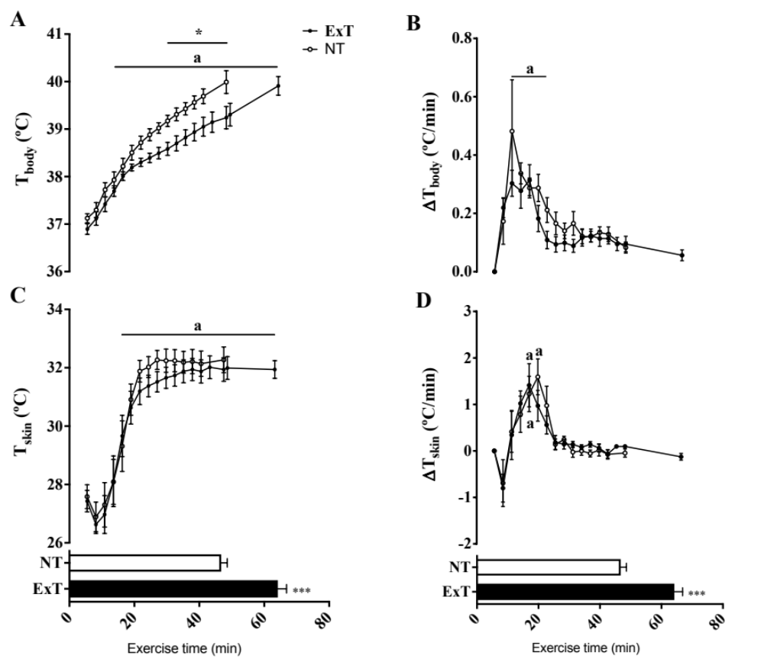
Figure 1: Results of test day showing the effect of regularly scheduled exercise training on running capacity and thermal balance. A) Abdominal body temperature (Tbody) during running. B) Tbody gain per minute of running. C) Temperature of tail skin (Tskin) during running. D) Tskin gain per minute of running. Physical exercise training attenuated hyperthermia due to the reduction in body heat rate calculated for each stage of the test (p<0.01). T_{skin} was similar in the trained and untrained animals (p=0.068), despite an anticipation of the maximum rate of tail vasodilation (p<0.0001). Two-way ANOVA followed by Tukey’s test. The bar graphs (duplicated in the panel) show the time of exercise. Physical exercise training increase (p<0.05) the time of running as indicated by unpaired t-test.

