Simulation of a ‘suicidal mind’: Using the Integrated Motivational Volitional model of suicide to demonstrate dynamic suicidal states.

SUPPLEMENTARY MATERIALS
Parameter Sweep Results
Figure 1: Parameter sweep results for the 'Ability to Assess' parameter, which is the probability of a correct health service risk assessment.
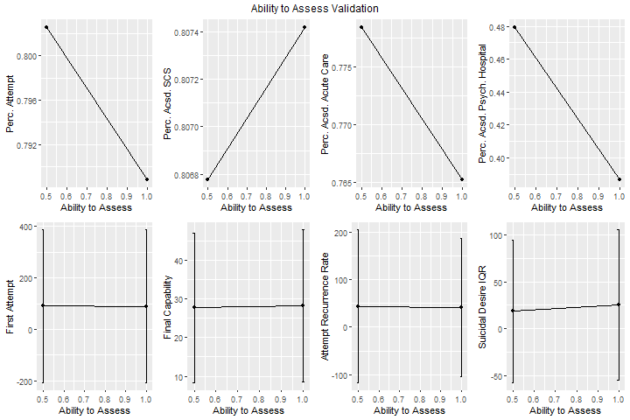
Figure 2: Parameter sweep results for the 'Assessment Frequency' parameter, which is the frequency in days of primary care risk assessments.
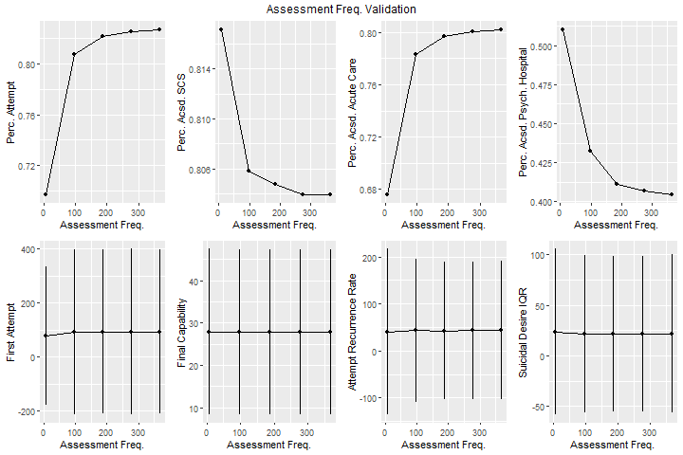

Figure 3: Parameter sweep results for the 'Coping' parameter, which affects the individual's response to triggering life events and moderates the relationship between Defeat/Humiliation and Entrapment.
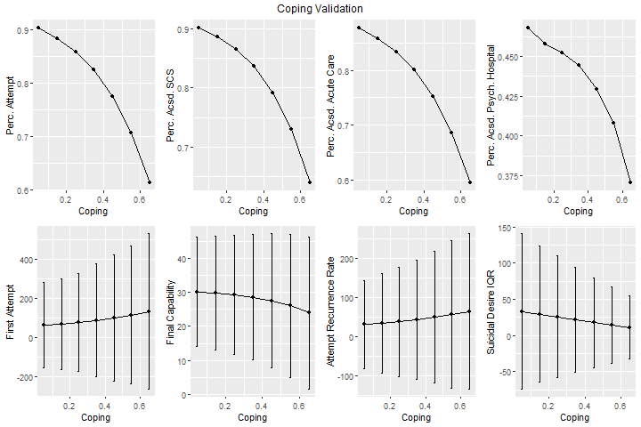

Figure 4: Parameter sweep results for the 'Diathesis' parameter, which represents the individual's medical condition.
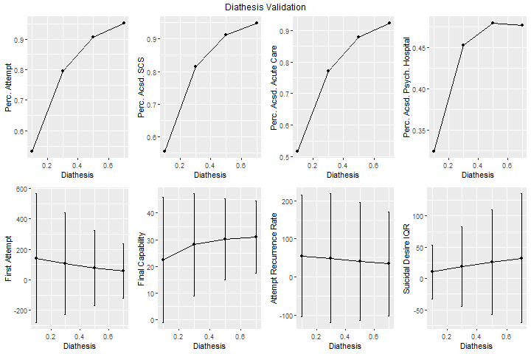

Figure 5: Parameter sweep results for the 'Environment' parameter, which represents the level of triggering factors in the individual's environment.
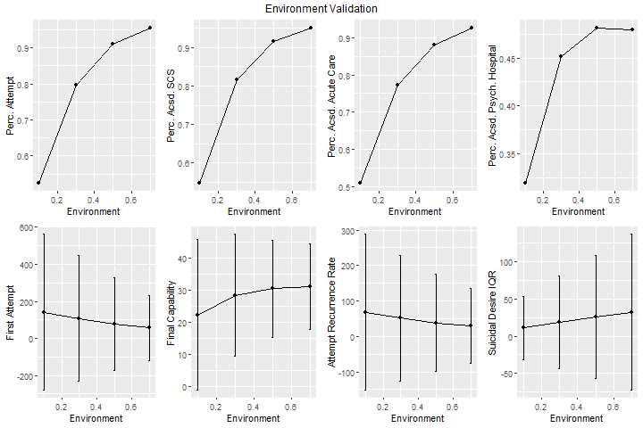

Figure 6: Parameter sweep results for the 'Personal Motivational Characteristics' parameter, which represents the strength of the individual's motivational characteristics. A smaller value is more protective.
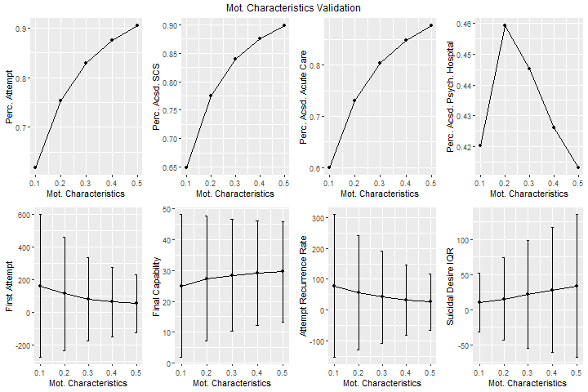

Figure 7: Parameter sweep results for the 'Normal Event Tolerance' parameter, which represents the individual's sensitivity to 'normal' triggering life events.
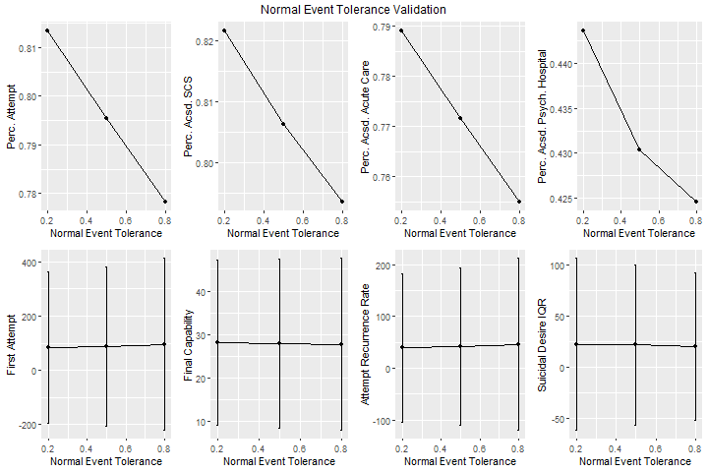

Figure 8: Parameter sweep results for the 'Personal Threat-to-Self Characteristics’ parameter, which represents the strength of the individual’s threat-to-self moderators. A smaller value is more protective.
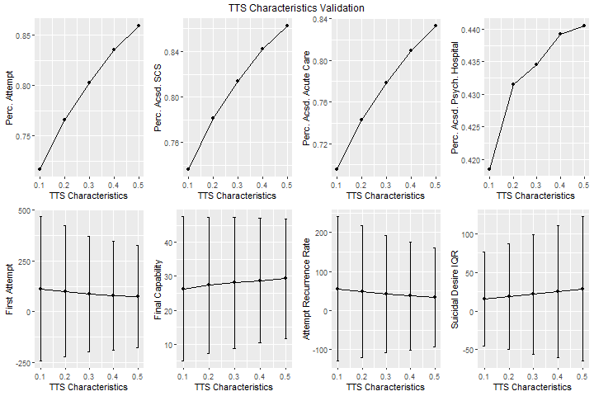

Figure 9: Parameter sweep results for the 'Use Primary Care' parameter, which determines whether or not the individual attends primary care visits.
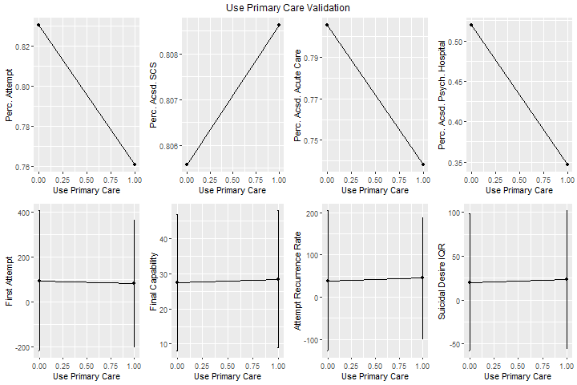

Figure 10: Parameter sweep results for the 'Personal Volitional Characteristics' parameter, which represents the strength of the individual’s volitional moderators. A smaller value is more protective.
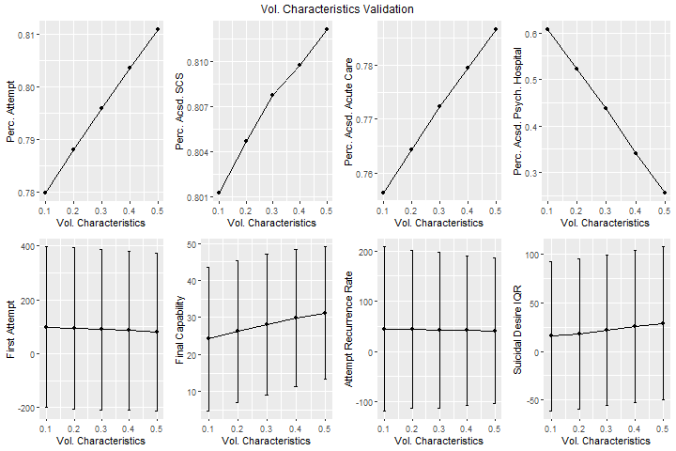

Clustering Results

Figure 11: Clustering results for Scenario ‘A’ show generally low desire and risk with only 1% of runs resulting in death.
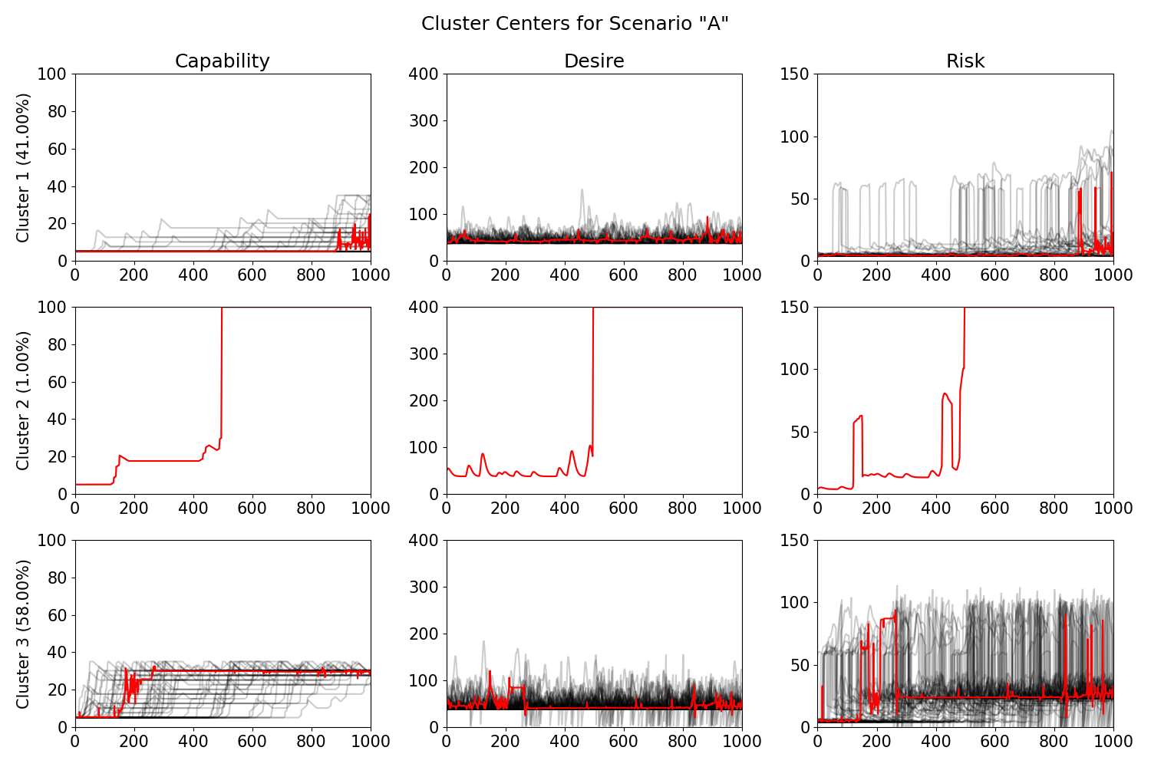

Figure 12: Clustering results for Scenario 'B' show very large desire and risk fluctuations and many runs resulting in death.
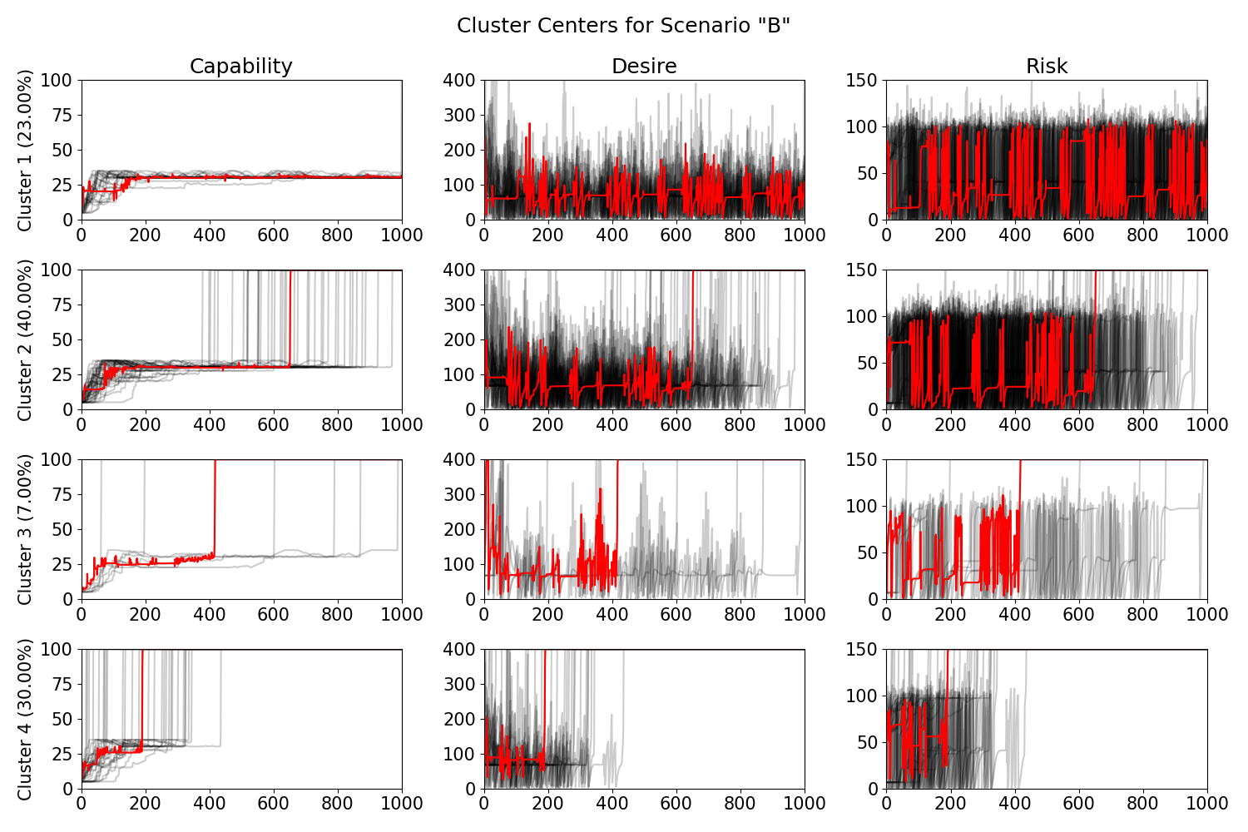

Figure 13: Clustering results for Scenario 'C' show large fluctuations in desire and risk with most simulations ending in death, many very early in the simulation.
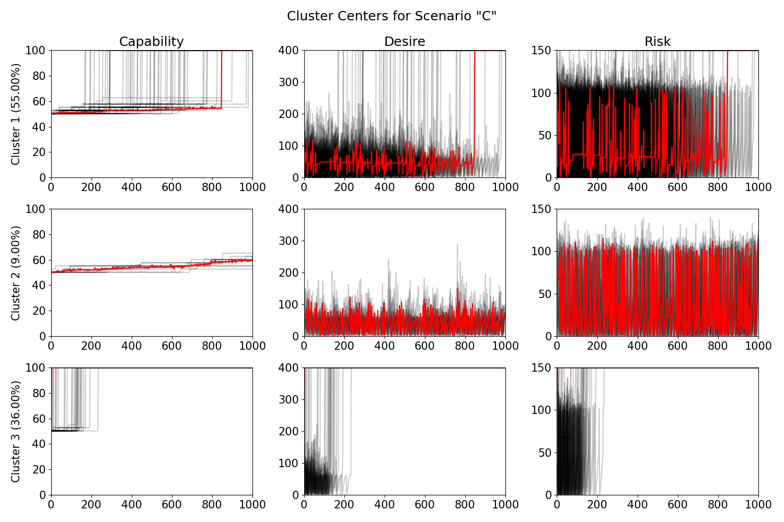

Figure 14: Clustering results for the health service scenario with an assessment frequency of 7 days. Most simulations show large early fluctuations that are then stabilized by health services.
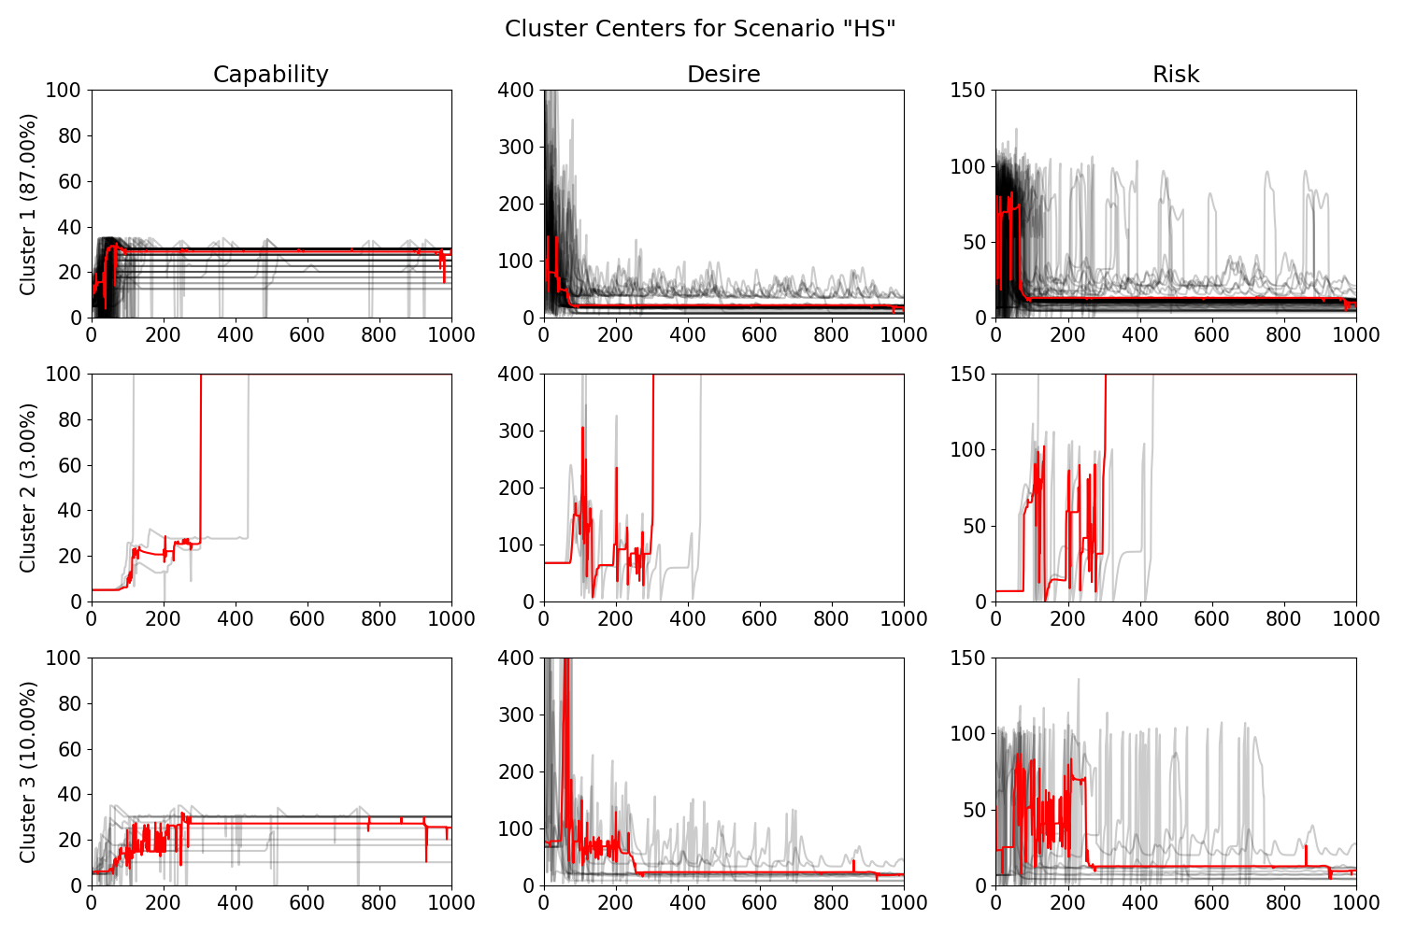

Figure 15: Clustering results for the combined simulations of the scenarios.
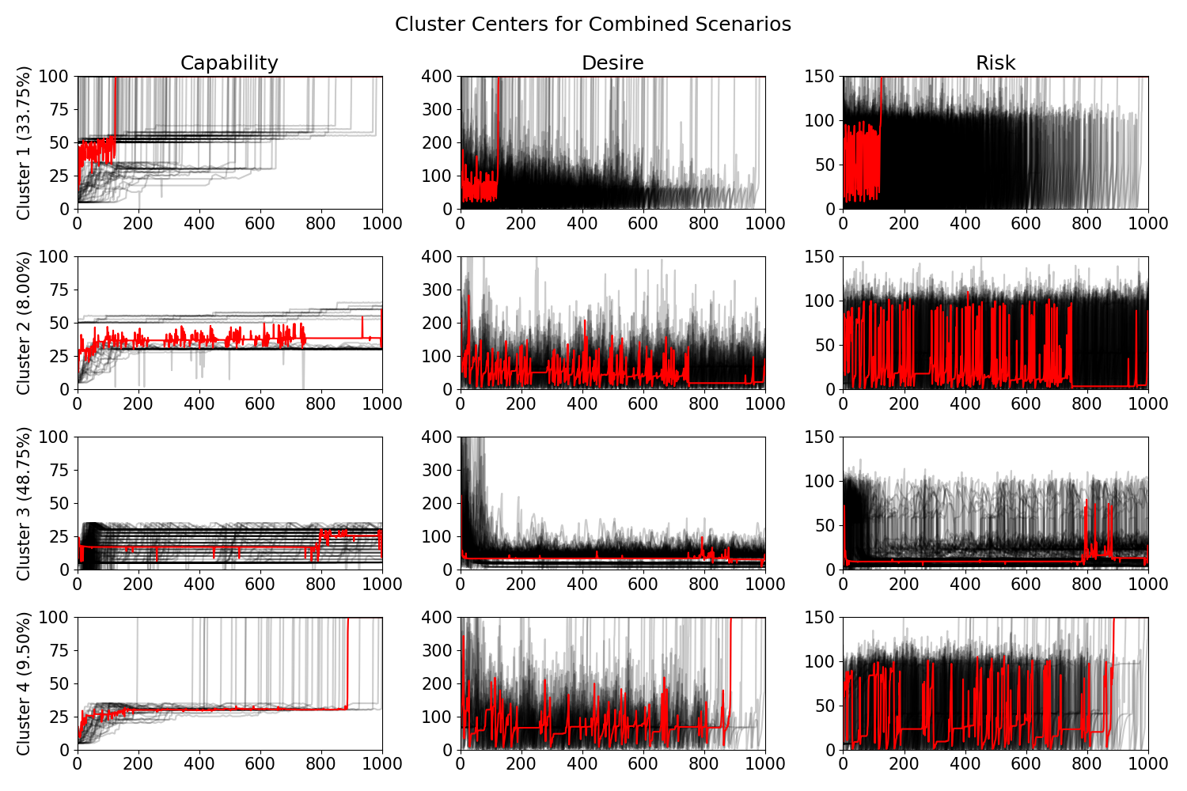
ODD
This model description follows the ODD (Overview, Design concepts, Details) protocol for describing individual- and agent-based models in general structure. [1-2] However, the Suicidal Mind is a systems-dynamics model (SDM), rather than an agent-based model, so some sections are removed or modified.
1. Purpose
Question: What is the purpose of the model?
Answer:
The Suicidal Mind is a simulation of an individual’s mind as they are experiencing suicidal ideation. It aims to quantify and synthesize three different theories, the Motivational-Volitional Theory of Suicide, the Fluid Vulnerability Theory of Suicide, and the Cusp Catastrophe model. The model allows researchers and health service practitioners to experiment with theoretical scenarios and case studies in a controlled environment.

Entities, state variables, and scales
Questions: What kinds of entities are in the model? By what state variables, or attributes, are these entities characterized? What are the temporal and spatial resolutions and extents of the model?
Answer:
The overall model depicts an individual’s mind, according to our theoretical frameworks. Internally, the model is a hybrid SDM consisting of stocks and flows, a health services state chart, stochastic and deterministic events, and various parameters and variables.
Table 1 lists the stocks of the Suicidal Mind model, while Table 2 and Table 3 define the flows. The model describes cognitive mechanisms related to suicidal ideation and behavior, so the units of these elements are abstract levels of defeat/humiliation, entrapment, etc.
Table 1: Stocks
Name | Meaning | Units | Symbol
Defeat_Humiliation | The individual's amount of defeat and humiliation. | Abstract level of defeat and humiliation | $$DH$$
Entrapment | The individual's amount of entrapment. | Abstract level of entrapment | $$E$$
Suicidal_Ideation | The individual's amount of suicidal ideation. | Abstract level of suicidal ideation | $$SI$$
Suicidal_Behavior | The individual's amount of suicidal behavior, which contributes directly to their risk of making a suicide attempt. | Abstract level of suicidal behavior | $$SB$$

Table 2: Flow Descriptions
Input | Output | Description
Exo | $$DH$$ | The incoming flow into Defeat_Humiliation comes from triggering life events, diathesis, and negative environment pressures, as well as feedback from the other stocks. It is reduced by universal-relief moderators present in the environment.
Exo | $$E$$ | The incoming flow into Entrapment comes from the quantity of Defeat_Humiliation, which is scaled by threat to self moderators.
Exo | $$SI$$ | The incoming flow into Suicidal_Ideation comes from the quantity of Entrapment, which is scaled by motivational moderators.
Exo | $$SB$$ | The incoming flow into Suicidal_Behavior comes from the quantity of Suicidal_Ideation, which is scaled by volitional moderators.
$$DH$$ | Exo | The outgoing flow from Defeat_Humiliation comes from the healing process of time flowing as well as any interventions targeted at the feelings of defeat and humiliation (which are currently unused in the model).
$$E$$ | Exo | The outgoing flow from Entrapment comes from the healing process of time flowing as well as any interventions targeted at the feelings of entrapment (which are currently unused in the model).
$$SI$$ | Exo | The outgoing flow from Suicidal_Ideation comes from the healing process of time flowing as well as any interventions targeted at suicidal ideation (which are currently unused in the model).
$$SB$$ | Exo | The outgoing flow from Suicidal_Behavior comes from the healing process of time flowing as well as any interventions targeted at suicidal behavior (which are currently unused in the model).

Table 3: Flow definitions
Input | Output | Definition
Exo | $$DH$$ | $$\left(0.4*life_{events}*diathesis*environment*\left(1+avg\left(E, SI, SB\right)\right)+diathesis_weight*diathesis+environment_weight*environment\right)*(1-universal_relief)$$
Exo | $$E$$ | $$DH*threat_to_self_mod$$
Exo | $$SI$$ | $$E*motivational_mod$$
Exo | $$SB$$ | $$SI*volitional_mod$$
$$DH$$ | Exo | $$DH*min⁡(time_reduction+defeat_humiliation_intervention, 1)$$
$$E$$ | Exo | $$E*min⁡(time_reduction+entrapment_intervention, 1)$$
$$SI$$ | Exo | $$SI*min⁡(time_reduction+suicidal_ideation_intervention), 1)$$
$$SB$$ | Exo | $$SB*min⁡(time_reduction+suicidal_behavior_intervention, 1)$$

Table 4, Table 5, and Table 6 define the dynamic variables, mutable variables, and parameters respectively. Dynamic variables are defined with an equation, similarly to flows, and are updated automatically while the simulation is running. Mutable variables do not get updated automatically but can be changed by other simulation processes. Finally, parameters are used to simulate different scenarios and do not change during a single simulation run.
Table 4: Dynamic Variables
Name | Definition
environment | $$max⁡(environment_init, 0)$$
diathesis | $$max(diathesis_init-ph_diathesis_intervention, 0)$$
threat_to_self_mod | $$avg(personal_threat_to_self_characteristics, 1-coping)$$
motivational_mod | $$avg(personal_motivational_characteristics, belonging_burdensomeness, social_support)$$
volitional_mod | $$avg\left(high_risk_volitional_weight *time_at_high_risk/ high_risk_day_window, capability_from_planning / 10, personal_volitional_characteristics, access_to_means\right)*(1-capability_intervention)$$
normal_event_effect | $$event_max⁡_effect*\left(1-normal_event_tolerance\right)*(1-coping)$$
severe_event_effect | $$event_max_effect*(1-coping)$$
CAPABILITY | $$volitional_mod*100$$
DESIRE | $$SI$$
RISK | $\left(0.4*SB\right)+$𝟙$\left(isHighRisk\right)*0.5*attempt_threshold$

Table 5: Mutable Variables
Name | Default Init Value | Meaning
access_to_means | $$0.1$$ | Access to means for a suicide attempt
belonging_burdensomeness | $$0.05$$ | The feeling of thwarted belonging and burdensomeness (currently unused)
capability_from_planning | $$0$$ | Capability to die through suicidal planning
capability_intervention | $$0$$ | External reduction in capability for a suicide attempt (e.g. removing firearms from the home)
coping | $$coping_init$$ | Ability to cope with negative triggers
isHighRisk | $$false$$ | Whether the individual is in a high suicidal risk state (True/False)
life_event_hold | $$false$$ | External stop of triggering life events (e.g. from admitting to an inpatient program at a psych. hospital)
life_events_effect | $$0$$ | Negative effect from triggering life events
ph_diathesis_intervention | $$0$$ | Pharmaceutical reduction in diathesis from a psych. hospital
should_enter_ph | $$0$$ | Flag that the individual should enter the psych. hospital health service state
should_enter_specialist | $$0$$ | Flag that the individual should enter the specialist care health service state
social_support | $$0.05$$ | Amount of social support the individual is receiving
time_at_high_risk | $$0$$ | Number of days the individual has been at a high suicidal risk state

Table 6: Parameters
Name | Default Value | Meaning
ability_to_assess | 1 | Probability of a health service correctly assessing the individual's suicidal risk (0-1)
assessment_window | 5 | Number of risk assessments to use when triaging health service state changes
attempt_threshold | 100 | Suicidal risk threshold after which the individual may make a suicide attempt
choose_to_enter_pc | 1 | Whether the individual chooses to use primary care health services (0 or 1)
coping_init | 0.1 | Initial level of coping (0-1)
defeat_humiliation_intervention | NA | Interventions directly targeting the individual's feelings of defeat and humiliation (currently unused)
diathesis_init | 0.5 | Initial level of diathesis (0-1)
diathesis_weight | 20 | Relative weight of diathesis' effect on negative cognitions
disable_health_services | 0 | Flag to disable health services during a particular simulation run
entrapment_intervention | NA | Interventions directly targeting the individual's feelings of entrapment (currently unused)
environment_init | 0.5 | Initial level of environmental stress (0-1)
environment_weight | 20 | Relative weight of environmental stress' effect on negative cognitions
event_decay_rate | 0.5 | Decay rate per day of negative effects from life events
event_max_effect | 50 | Maximum effect of a life event
events_per_month | 1 | Average number of life events per month
high_risk_day_window | 50 | Number of days to track high suicidal risk status
high_risk_volitional_weight | 0.2 | Relative weight of time spent at a high risk state on volitional moderators (0-1)
normal_event_tolerance | 0.5 | The individual's tolerance to "normal" triggering life events. Higher is more protective. (0-1)
pc_assessment_freq | 180 | Number of days in between primary care risk assessments
personal_motivational_characteristics | 0.1 | Personal characteristics affecting motivational moderators (0-1)
personal_threat_to_self_characteristics | 0.1 | Personal characteristics affecting threat to self moderators (0-1)
personal_volitional_characteristics | 0.1 | Personal characteristics affecting volitional moderators (0-1)
ph_coping_effectiveness | 0.2 | Effectiveness of psych. hospital treatment on coping (0-1)
ph_diathesis_effectiveness | 0.2 | Effectiveness of psych. hospital treatment on diathesis (0-1)
severe_event_proportion | 0.3 | Proportion of life events that are severe instead of normal (0-1)
specialist_coping_effect | 0.01 | Effectiveness of specialist health services on coping (0-1)
suicidal_behavior_intervention | NA | Interventions directly targeting the individual's suicidal behavior (currently unused)
suicidal_ideation_intervention | NA | Interventions directly targeting the individual's suicidal ideation (currently unused)
suicide_completion_rate | 0.03 | Probability of the individual dying by suicide after an attempt (0-1)
time_reduction | 0.2 | Proportion of stock values that are reduced each day by the healing properties of time passing (0-1)
universal_relief | 0.1 | Universal relief against negative cognitions experienced even by someone who does not see a primary care service (0-1)

Besides standard systems dynamics entities, the Suicidal Mind model also uses a statechart for health service use (Figure 1). The states are described in Table 7, and the transitions in Table 8.
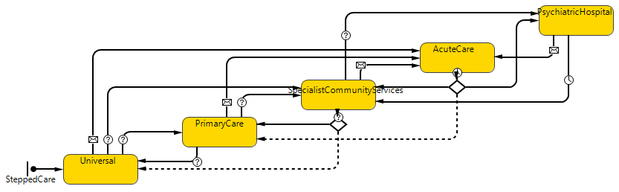
Figure 16: Health Services Statechart

Table 7: Health Services States
Name | Description
Universal | Universal services are ones present in the environment even if the individual does not choose to directly interact with health services. An example would be community building programs.
PrimaryCare | In the context of the Suicidal Mind model, Primary Care services provide regular suicidal risk assessments and can direct the individual to other services as needed.
SpecialistCommunityServices (SCS) | Specialist community services are health services targeted directly at mental health, substance use, suicidal risk, etc. (e.g. psychologists). These services provide more frequent risk assessments and improve the individual's coping abilities.
AcuteCare | Acute care services include hospital emergency rooms and services like the suicide helpline. They provide immediate stabilization for imminent or recent suicidal behavior and help determine where the individual should go next.
PsychiatricHospital | Psychiatric hospitals provide stabilization and pharmaceutical interventions for individuals at critical risk. The medication can directly target symptoms, increase coping abilities, and decrease diathesis.

Table 8: Health Services State Transitions
Transition | Type | Description
Universal to PrimaryCare | Conditional | The individual decides to enter PrimaryCare.
Universal to SCS | Conditional | The individual is assessed to need specialist services.
Universal to AcuteCare | On Event | The individual makes a suicide attempt.
PrimaryCare to Universal | Conditional | The individual decides not to use primary care services.
PrimaryCare to SCS | Conditional | The individual is assessed to need specialist services.
PrimaryCare to AcuteCare | On Event | The individual makes a suicide attempt.
SCS to Universal | Conditional | The individual is assessed to no longer need specialist services and do not want primary care services.
SCS to PrimaryCare | Conditional | The individual is assessed to no longer need specialist services and do want primary care services.
SCS to AcuteCare | On Event | The individual makes a suicide attempt.
SCS to PsychiatricHospital | Conditional | The individual is assessed to need psychiatric hospital services.
AcuteCare to PrimaryCare | Timeout, Conditional | After one day, the individual is assessed to need only primary care services.
AcuteCare to SCS | Timeout, Conditional | After one day, the individual is assessed to need specialist services.
AcuteCare to PsychiatricHospital | Timeout, Conditional | After one day, the individual is assessed to need psychiatric hospital services.
PsychiatricHospital to SCS | Timeout | The individual is discharged after one week.
PsychiatricHospital to AcuteCare | On Event | The individual makes a suicide attempt.

Finally, the Suicidal Mind model also uses both deterministic and stochastic events, which will be described in Section 3. For the sake of these events and value ranges of the variables/parameters, the model uses a daily temporal scale (1 simulation step = 1 day). The simulation will continue to run until the individual dies by suicide, but the parameter variation experimental runs were stopped after 1,500 days.

Process overview and scheduling
Questions: Who (i.e., what entity) does what, and in what order? When are state variables updated? How is time modeled, as discrete steps or as a continuum over which both continuous processes and discrete events can occur? Except for very simple schedules, one should use pseudo-code to describe the schedule in every detail, so that the model can be reimplemented from this code. Ideally, the pseudo-code corresponds fully to the actual code used in the program implementing the ABM.
Answer: ...
In a systems dynamics model, dynamic variables and flow values are calculated using parameters, variables, stock values, etc. (see Table 3 and Table 4). Then, stock values are updated by adding the value of incoming flows and subtracting the values of outgoing flows. The Suicidal Mind model also uses events to trigger or respond to changes in the model’s state (Table 9). Due to the nature of the Anylogic system, it is unclear if there is a fixed order of operation for events and flow/variable updates.
Table 9: Events
Name | Rate | Description
AssessRiskEvent | $pc_assessment_freq$ days, starting at day 20 | As long as the individual is not in the Universal care state, the individual's suicide risk will be assessed according to the health system's ability to assess.
AttemptTrigger | 1 day | Checks if the individual is in a state to make an attempt, whether they make an attempt, and the results of the attempt.
CheckRisk | 1 day | Sets the individual's suicidal risk state (high/low) and adjusts time spent at high risk.
EndEvent | 1 day | Reduces the negative effect from life events according to $ev_{decay}$.
EventTrigger | $events_per_month$ per month on average (stochastic) | Triggers a negative life event that is randomly either a 'normal' event or a 'severe' event.
SpecialistService | 1 week | If the individual is in the SCS health services state, this will assess their suicide risk and increase their coping.
SuicidalPlanning | 1 day | If the individual is in a high risk state, this will sometimes increase their capability from suicidal planning.
UpdateStateTransitions | 1 day | Updates the flags that indicate if the individual should enter the SCS or PsychiatricHospital states.

The following is pseudocode for these events:
AssessRiskEvent
if in state Universal: return

assessRisk(assessment_ability)
AttemptTrigger
if CAPABILITY > 0 and RISK > attempt_threshold:
attempt_rate = min((DESIRE+(3*CAPABILITY))/400, 1)

if randomdouble > attempt_rate: return

record attempt

if randomdouble < suicide_completion_rate:
record death
stop simulation
else:
assessRisk(1.0)
transition state to AcuteCare

Entrapment = 0
Suicidal_Ideation = 0
Suicidal_Behavior = 0
CheckRisk
if not isHighRisk:
if DESIRE > 80:
isHighRisk = true
if CAPABILITY > 50 and DESIRE > 60:
isHighRisk = true
else:
isHighRisk = DESIRE > 40

if isHighRisk and time_at_high_risk < high_risk_day_window:
time_at_high_risk = time_at_high_risk + 1
else if not isHighRisk and time_at_high_risk > 1:
time_at_high_risk = time_at_high_risk - 1
EndEvent
if life_events_effect > 0.5:
life_events_effect = life_events_effect * event_decay_rate
else:
life_events_effect = 0
EventTrigger
if life_event_hold: return

event_type = NORMAL
if randomdouble < severe_event_proportion:
event_type = SEVERE

if event_type is SEVERE:
life_events_effect = life_events_effect+severe_event_effect
else:
life_events_effect = life_events_effect+normal_event_effect
SpecialistService
if not in state SpecialistCommunityServices: return

if coping < 1:
coping = coping + specialist_coping_effect
if coping > 1:
coping = 1

assessRisk(assessment_ability)
SuicidalPlanning
if isHighRisk:
plan_chance = high_risk_volitional_weight *
time_at_high_risk / high_risk_day_window

if randomdouble < plan_chance and
capability_from_planning < 10:
capability_from_planning = capability_from_planning + 1
UpdateStateTransitions
if assessedRiskState() is true or
assessedRisk() > 0.5*attempt_threshold:
should_enter_specialist = 1
else:
should_enter_specialist = 0

if assessedRisk() > 0.8*attempt_threshold and
time_at_high_risk/high_risk_day_window > 0.75:
should_enter_ph = 1
else:
should_enter_ph = 0

In addition to the event functions, the model also uses some helper functions:
assessRisk – Arguments: assessment_ability
if randomdouble < assessment_ability:
add isHighRisk to end of assessed_risk_state
add RISK to end of assessed_risk

if sizeof assessed_risk > assessment_window:
remove first of assessed_risk_state
remove first of assessed_risk
enterAcuteCare
capability_intervention = 1 // reduce capability to 0

UpdateStateTransitions()
enterPH
capability_intervention = 1 // reduce capability to 0
life_event_hold = true // stop life events
exitAcuteCare
capability_intervention = 0 // return capability to
// previous levels
assessedRisk
return avg(assessed_risk)
assessedRiskState
counter = 0
for assessment in assessed_risk_state:
if assessment is true:
counter = counter + 1

num_assessments = size of assessed_risk_state
if counter > 0 and counter/num_assessments >= 0.5:
return true
else:
return false
resolvePH
capability_intervention = 0 // return capability to
// previous levels

assessRisk(1.0)
ph_diathesis_intervention = ph_diathesis_interventions +
ph_diathesis_effectiveness
coping = coping + ph_coping_effectiveness
life_event_hold = false

Design concepts
Questions: There are eleven design concepts. Most of these were discussed extensively by Railsback [3] and Grimm and Railsback [4; Chapter 5], and are summarized here via the following questions. Some questions are skipped because they do not apply to system dynamics models.
Basic principles. Which general concepts, theories, hypotheses, or modeling approaches are underlying the model’s design? Explain the relationship between these basic principles, the complexity expanded in this model, and the purpose of the study. How were they taken into account? Are they used at the level of submodels (e.g., decisions on land use, or foraging theory), or is their scope the system level (e.g., intermediate disturbance hypotheses)? Will the model provide insights about the basic principles themselves, i.e. their scope, their usefulness in real-world scenarios, validation, or modification? [5] Does the model use new, or previously developed, theory for agent traits from which system dynamics emerge (e.g.,
‘individual-based theory’ as described by Grimm and Railsback [4])? Answer: ...
The basic principles of the model are derived from O’Connor et al.’s Integrated Motivational-Volitional Model of suicide (IMV) [6], Rudd’s Fluid Vulnerability Theory (FVT) [7], and the Cusp Catastrophe model (CC) as integrated by Bryan et al. [8]
IMV:
- External pressures are from diathesis, environment, and life events.
- External pressures cause negative cognitions that increase levels of defeat and humiliation.
- Feelings of defeat/humiliation increase feelings of entrapment (via threat to self moderators), feelings of entrapment increase suicidal ideation (via motivational moderators), and suicidal ideation increases suicidal behavior (via volitional moderators).
FVT:
- The individual has unique vulnerabilities and process life events as being normal or severe, depending on the type of event.
- The individual’s risk changes over time as they experience life events (and interact with the health services system).
- The individual can be in a high or low suicidal risk state (analogous to FVT’s “suicidal mode”.
CC + FVT:
- The individual only exhibits suicidal behavior while in a high risk state.
- If the individual has a high capability to die, they may enter a high risk state very easily, even if their suicidal desire is low.
- Returning to a low risk state may require lower levels of desire and capability than it took to enter the high risk state in the first place.
Other principles:
- The individual may choose to interact with health services when they are low risk.
- In the health services system, primary care provides regular risk assessments, specialist care provides risk assessments and improves coping abilities, acute care stabilizes after an attempt and performs triage, and psychiatric hospitalization stabilizes and improves coping abilities and diathesis through pharmaceutical interventions.
The model has many purposes and uses. It aims to show the power of synthesis between different theories of suicide, and to demonstrate a quantitative implementation of the three theories. It can be used to experiment with case studies and “what if” scenarios. It is also a helpful thinking tool, to break down elements of an individual’s situation into the different components that might affect suicidality.

Emergence. What key results or outputs of the model are modeled as emerging from the adaptive traits, or behaviors, of individuals? In other words, what model results are expected to vary in complex and perhaps unpredictable ways when particular characteristics of individuals or their environment change? Are there other results that are more tightly imposed by model rules and hence less dependent on what individuals do, and hence ‘built in’ rather than emergent results? Answer: ...
Our model does not have emergent behaviors resulting in interactions between individuals, as is common in agent-based models. However, we do see emergent behaviors in the form of the different scenarios described by Bryan et al.

Adaptation. What adaptive traits do the individuals have? What rules do they have for making decisions or changing behavior in response to changes in themselves or their environment? Do these traits explicitly seek to increase some measure of individual success regarding its objectives (e.g., “move to the cell providing fastest growth rate”, where growth is assumed to be an indicator of success; see the next concept)? Or do they instead simply cause individuals to reproduce observed behaviors (e.g., “go uphill 70% of the time”) that are implicitly assumed to indirectly convey success or fitness? Answer: ...
The individual modelled in the Suicidal Mind does not currently have any decision-making capabilities, so adaptation over time comes from health services. In the real world, an individual feeling stress from life events, for example, may proactively try to reduce the number or intensity of those events. This behavior could be the subject of future research.

Objectives. If adaptive traits explicitly act to increase some measure of the individual's success at meeting some objective, what exactly is that objective and how is it measured? When individuals make decisions by ranking alternatives, what criteria do they use? Some synonyms for ‘objectives’ are ‘fitness’ for organisms assumed to have adaptive traits evolved to provide reproductive success, ‘utility’ for economic reward in social models or simply ‘success criteria’. (Note that the objective of such agents as members of a team, social insects, organs—e.g., leaves—of an organism, or cells in a tissue, may not refer to themselves but to the team, colony or organism of which they are a part.) Answer: ...
The adaptability given by the health services sector aims to reduce suicidal risk over time.

Learning. Many individuals or agents (but also organizations and institutions) change their adaptive traits over time as a consequence of their experience? If so, how? Answer: ...
The Suicidal Mind model does not have elements of learning.

Prediction. Prediction is fundamental to successful decision-making; if an agent’s adaptive traits or learning procedures are based on estimating future consequences of decisions, how do agents predict the future conditions (either environmental or internal) they will experience? If appropriate, what internal models are agents assumed to use to estimate future conditions or consequences of their decisions? What tacit or hidden predictions are implied in these internal model assumptions? Answer: ...
The Suicidal Mind model does not have elements of prediction.

Sensing. What internal and environmental state variables are individuals assumed to sense and consider in their decisions? What state variables of which other individuals and entities can an individual perceive; for example, signals that another individual may intentionally or unintentionally send? Sensing is often assumed to be local, but can happen through networks or can even be assumed to be global (e.g., a forager on one site sensing the resource levels of all other sites it could move to). If agents sense each other through social networks, is the structure of the network imposed or emergent? Are the mechanisms by which agents obtain information modeled explicitly, or are individuals simply assumed to know these variables? Answer: ...
In the Suicidal Mind model, the individual senses signals from the outside world in the form of environment pressures, diathesis, and life events effects. Each of these are variables in the system dynamics model and can change over time. The health services sector also senses the individual’s suicidal risk through risk assessments, which change in frequency and accuracy when the individual is in different health service states.

Interaction. What kinds of interactions among agents are assumed? Are there direct interactions in which individuals encounter and affect others, or are interactions indirect, e.g., via competition for a mediating resource? If the interactions involve communication, how are such communications represented? Answer: ...
The Suicidal Mind model does not have interactions between agents.

Stochasticity. What processes are modeled by assuming they are random or partly random? Is stochasticity used, for example, to reproduce variability in processes for which it is unimportant to model the actual causes of the variability? Is it used to cause model events or behaviors to occur with a specified frequency? Answer: ...
There are several elements of stochasticity in the Suicidal Mind Model including life events, suicide attempts, suicidal planning, and risk assessment.
Life events: Life events are triggered on average events_per_month times per month according to a Poisson distribution. When they are triggered, they are assigned to be a “severe” event with probability severe_event_proportion.
Suicide attempts: When the threshold has been passed for a suicide attempt, an attempt rate is calculated (see the Attempt_Trigger function above), and the individual makes an attempt with probability of the attempt rate. If the individual makes an attempt, they die by suicide with probability suicide_completion_rate.
Suicidal planning: If the individual is in a high suicidal risk state, a planning chance is calculated (see the SuicidalPlanning function above) and the individual makes suicidal plans with probability of the planning chance.
Risk assessment: When the health service system performs a risk assessment, they get a reading with probability ability_to_assess, which may change when performing risk assessments in different settings.

Collectives. Do the individuals form or belong to aggregations that affect, and are affected by, the individuals? Such collectives can be an important intermediate level of organization in an ABM; examples include social groups, fish schools and bird flocks, and human networks and organizations. How are collectives represented? Is a particular collective an emergent property of the individuals, such as a flock of birds that assembles as a result of individual behaviors, or is the collective simply a definition by the modeler, such as the set of individuals with certain properties, defined as a separate kind of entity with its own state variables and traits? Answer: ...
There are no collectives in the Suicidal Mind model.

Observation. What data are collected from the ABM for testing, understanding, and analyzing it, and how and when are they collected? Are all output data freely used, or are only certain data sampled and used, to imitate what can be observed in an empirical study (“Virtual Ecologist” approach; Zurell et al., 2010)? Answer: ...
There are three main data that are collected at every step of the simulation, capability, desire, and risk. Capability is calculated as 100 times the volitional moderator, so that the value ranges between 0 and 100. Desire is a direct measure of the Suicidal Ideation stock. Its range in only bounded to the positive domain, but it tends to fall in a similar 0-100 range with the default parameter values. Finally, Risk is calculated using the following equation:
$$risk=\left(0.4*SuicidalBehavior\right)+(isHighRisk? *0.5*attemptthreshold)$$
In other words, risk is proportional to suicidal behavior, and being in a high suicidal risk state jumps the risk value much closer to the suicidal attempt threshold.
These values help understand single simulation runs, but there are some other outputs that are helpful to compare runs. These outputs can be calculated by keeping track of stock values and suicide attempt events:
- Made an attempt: whether the individual has made a suicide attempt this simulation run
- First attempt date
- Final capability: Capability value at the end of the run
- Average attempt recurrence rate: If the individual makes multiple suicide attempts, the average time between attempts
- Desire IQR: The inter-quartile range of the suicidal desire stock. Measures fluctuation amplitude/volatility. To calculate this, disregard the first 40 days of simulation states.
- Health service access: For each health service state, track whether the individual has accessed that state this run.

Explanation: The ‘Design concepts’ element of the ODD protocol does not describe the model per se; i.e., it is not needed to replicate a model. However, these design concepts tend to be characteristic of ABMs, though certainly not exclusively. They may also be crucial to interpreting the output of a model, and they are not described well via traditional model description techniques such as equations and flow charts. Therefore, they are included in ODD as a kind of checklist to make sure that important model design decisions are made consciously and that readers are aware of these decisions. [3-4] For example, almost all ABMs include some kinds of adaptive traits, but if these traits do not use an explicit objective measure the ‘Objectives’ and perhaps ‘Prediction’ concepts are not relevant (though many ABMs include hidden or implicit predictions). Also, many ABMs do not include learning or collectives. Unused concepts can be omitted in the ODD description.
There might be important concepts underlying the design of an ABM that are not included in the ODD protocol. If authors feel that it is important to understand a certain new concept to understand the design of their model, they should give it a short name, clearly announce it as a design concept not included in the ODD protocol, and present it at the end of the Design concepts element.

Initialization
Questions: What is the initial state of the model world, i.e., at time t = 0 of a simulation run? In detail, how many entities of what type are there initially, and what are the exact values of their state variables (or how were they set stochastically)? Is initialization always the same, or is it allowed to vary among simulations? Are the initial values chosen arbitrarily or based on data? References to those data should be provided.
Answer: ...
There is no initialization besides setting parameters and mutable variables to their initial values (see above). These values were chosen relatively arbitrarily to keep the capability, desire, and risk values near the range of 0-100. Parameters used in rates or probabilities are set to values between 0 and 1, while parameters representing duration or anything similar are set to reasonable values (e.g. high_risk_day_window is initialized to 50 days).
Explanation: Model results cannot be accurately replicated unless the initial conditions are known. Different models, and different analyses using the same model, can of course depend quite differently on initial conditions. Sometimes the purpose of a model is to analyze consequences of its initial state, and other times modelers try hard to minimize the effect of initial conditions on results.

Input data
Question: Does the model use input from external sources such as data files or other models to represent processes that change over time?
Answer: ...
The model does not use input from external sources.
Explanation: In models of real systems, dynamics are often driven in part by a time series of environmental variables, sometimes called external forcings; for example annual rainfall in semi-arid savannas (Jeltsch et al., 1996). “Driven” means that one or more state variables or processes are affected by how these environmental variables change over time, but these environmental variables are not themselves affected by the internal variables of the model. For example, rainfall may affect the soil moisture variable of grid cells and, therefore, how the recruitment and growth of trees change. Often it makes sense to use observed time series of environmental variables so that their statistical qualities (mean, variability, temporal autocorrelation, etc.) are realistic. Alternatively, external models can be used to generate input, e.g. a rainfall time series (Eisinger and Wiegand, 2008). Obviously, to replicate an ABM, any such input has to be specified and the data or models provided, if possible. (Publication of input data for some social simulations can be constrained by confidentiality considerations.) If a model does not use external data, this element should nevertheless be included, using the statement: “The model does not use input data to represent time-varying processes.” Note that ‘Input data’ does not refer to parameter values or initial values of state variables.

Supplemental Material References
[1] V. Grimm et al., “A standard protocol for describing individual-based and agent-based models,” Ecol. Model., vol. 198, no. 1, pp. 115–126, Sep. 2006, doi: 10.1016/j.ecolmodel.2006.04.023.
[2] V. Grimm, U. Berger, D. L. DeAngelis, J. G. Polhill, J. Giske, and S. F. Railsback, “The ODD protocol: A review and first update,” Ecol. Model., vol. 221, no. 23, pp. 2760–2768, Nov. 2010, doi: 10.1016/j.ecolmodel.2010.08.019.
[3] S. F. Railsback, “Concepts from complex adaptive systems as a framework for individual-based modelling,” Ecol. Model., vol. 139, no. 1, pp. 47–62, Mar. 2001, doi: 10.1016/S0304-3800(01)00228-9.
[4] V. Grimm and S. F. Railsback, Individual-based Modeling and Ecology:, STU-Student edition. Princeton University Press, 2005. Accessed: Apr. 01, 2025. [Online]. Available: https://www.jstor.org/stable/j.ctt5hhnk8
[5] V. Grimm, “Ten years of individual-based modelling in ecology: what have we learned and what could we learn in the future?,” Ecol. Model., vol. 115, no. 2, pp. 129–148, Feb. 1999, doi: 10.1016/S0304-3800(98)00188-4.
[6] R. C. O’Connor and O. J. Kirtley, “The integrated motivational–volitional model of suicidal behaviour,” Philos. Trans. R. Soc. B Biol. Sci., vol. 373, no. 1754, p. 20170268, Jul. 2018, doi: 10.1098/rstb.2017.0268.
[7] M. D. Rudd, “Fluid Vulnerability Theory: A Cognitive Approach to Understanding the Process of Acute and Chronic Suicide Risk.,” in Cognition and suicide: Theory, research, and therapy., T. E. Ellis, Ed., Washington: American Psychological Association, 2006, pp. 355–368. doi: 10.1037/11377-016.
[8] C. J. Bryan et al., “Nonlinear change processes and the emergence of suicidal behavior: A conceptual model based on the fluid vulnerability theory of suicide,” New Ideas Psychol., vol. 57, p. 100758, Apr. 2020, doi: 10.1016/j.newideapsych.2019.100758.

