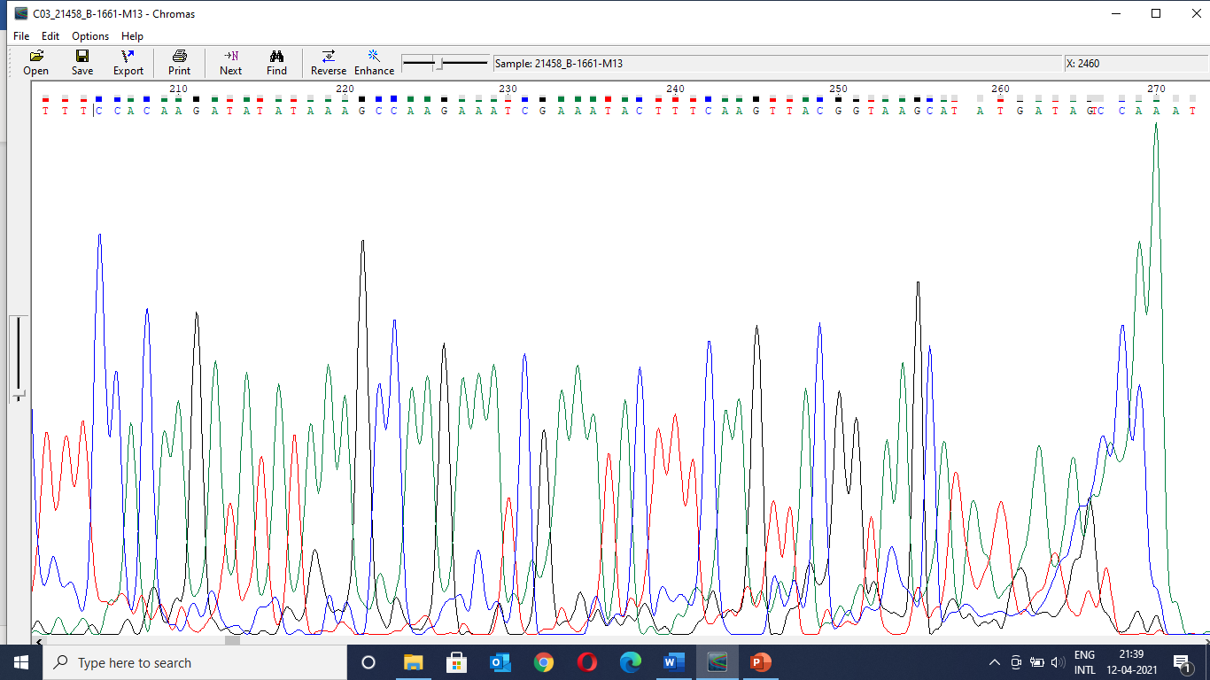
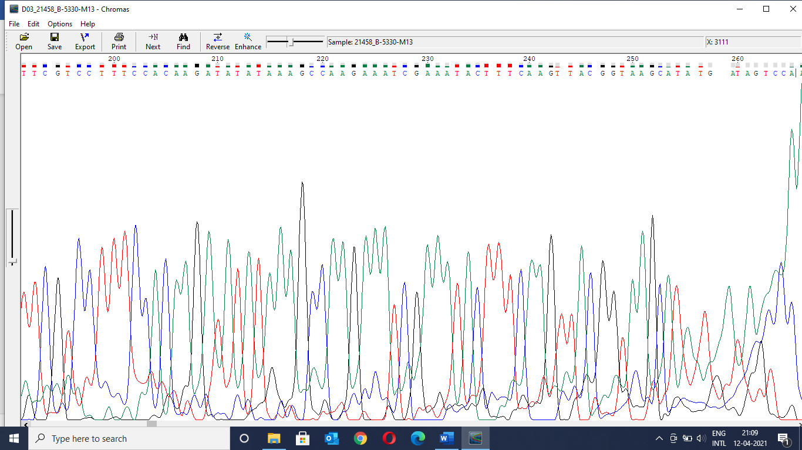
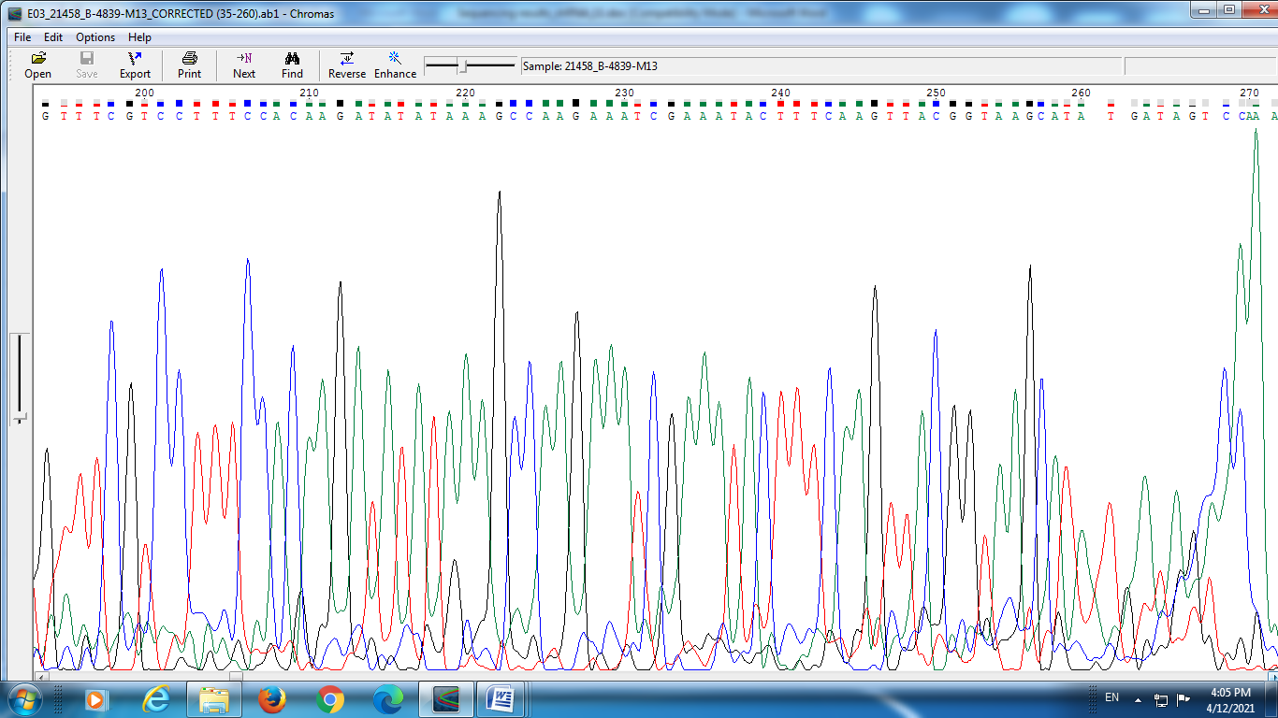
Vector sequence: TTTCGTCCTTTCCACAAGATATATAAAGCCAAGAAATCGAAATACTTTCAAGTTACGGTAAGCATATGATAGTCCA
Bird No. 1661
Bird No. 5330
Bird No. 4839

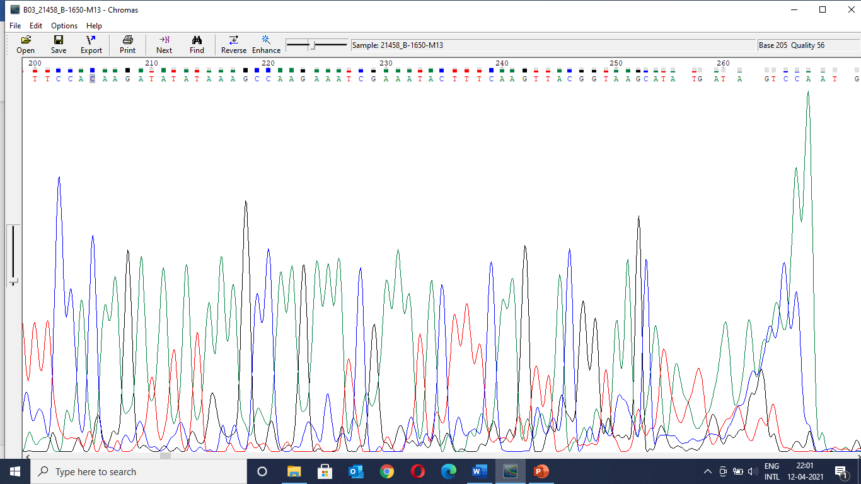
Bird No. 1650

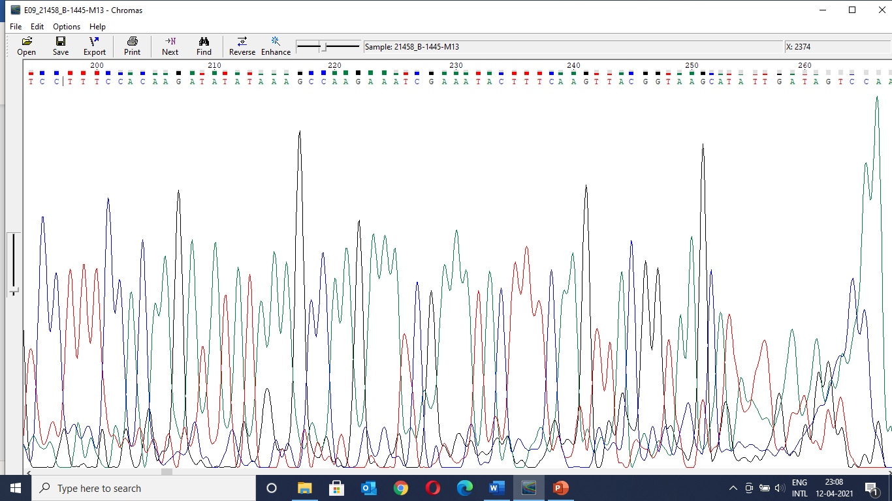
Bird No. 1445

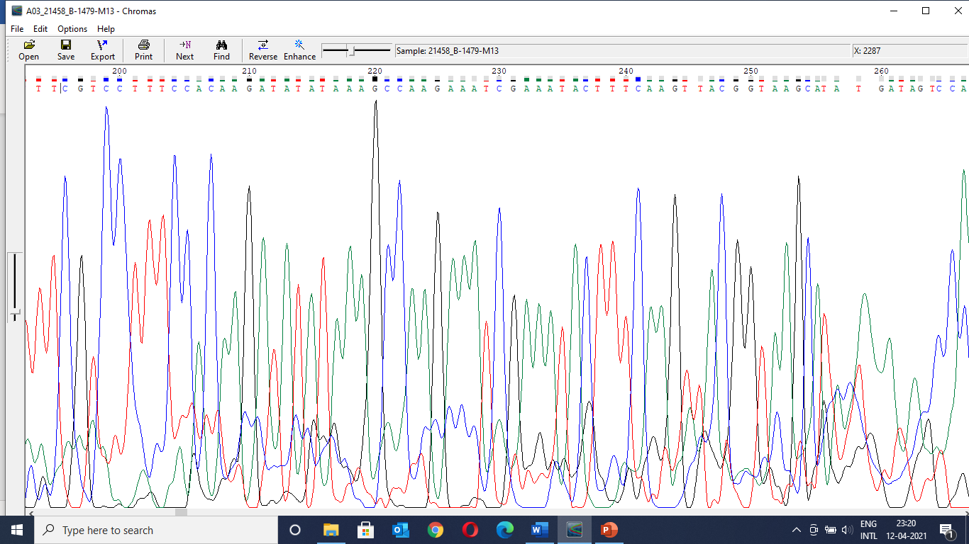
Bird No. 1479

Supplementary Figure 1. DNA sequence of entry vector fragment amplified from transgenic birds. Primer sequence has been under lined. Entry vector fragment sequence has been mentioned on top of chromatogram of Bird No. 4839. Presence of vector sequence in the bird indicates integration of entry vector in the genome of the transgenic birds.

