Process based management and computerized decision support systems in the complex treatment of patients with spinal cord injury and pressure injury stage III and IV: a quality improvement project

Appendix figure 2: CDSS overview of treatment elements (3a), of consultations (3b) and milestones in the six-week mobilisation scheme (3c) do you want to translate this?
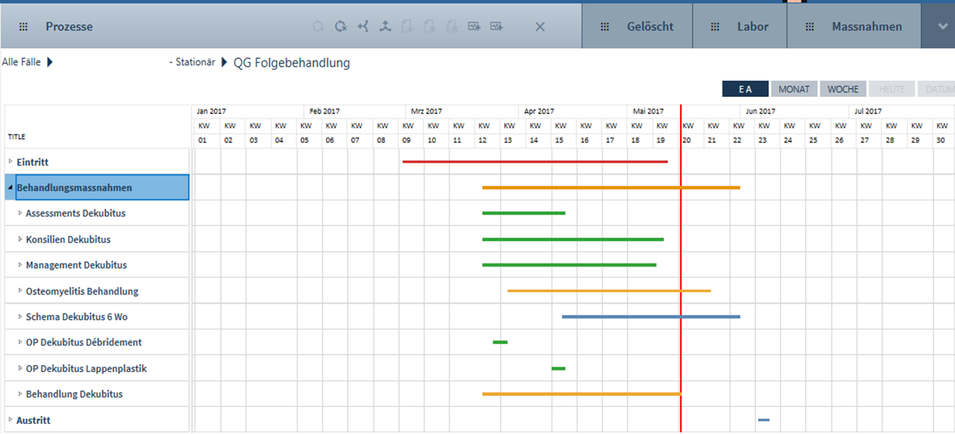
3a) Treatment elements

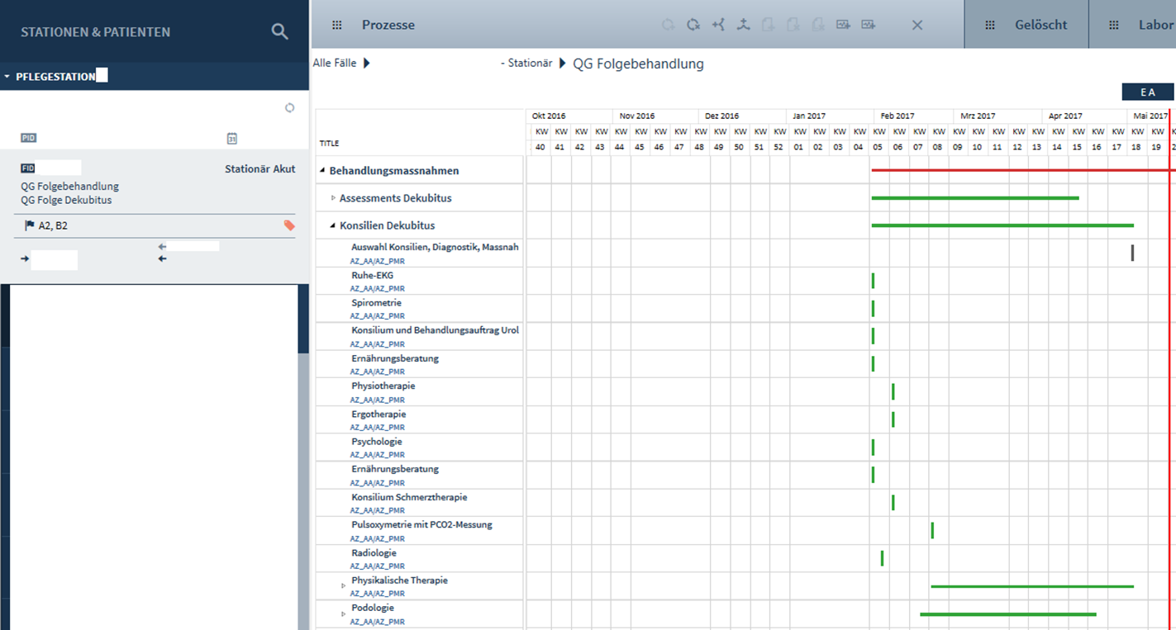
3b) consultation
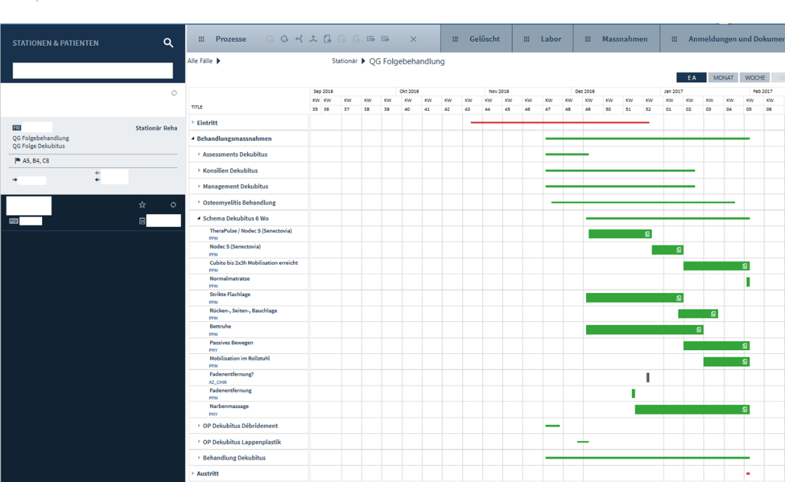
3c) milestones in the six-week mobilisation scheme

