Appendix A. Supplementary data
Electricity generation and pollutants removal of landfill leachate by osmotic microbial fuel cells with different forward osmosis membranes

Nan Jiang ª, Li Huangª, Teng Cai^{c}, Jialing Songª, Shengyang Zhengª, Jili Guoª, Zhuang Kongª, Manhong Huang^{a,b,}*

ªCollege of Environmental Science and Engineering, State Environmental Protection Engineering Center for Pollution Treatment and Control in Textile Industry, Donghua University, Shanghai 201620, China. E-mail: huangmanhong@dhu.edu.cn
^{b}Shanghai Institute of Pollution Control and Ecological Security, Shanghai 200092, China
^{c}Shanghai Key Lab for Urban Ecological Processes and Eco-Restoration, School of Ecological and Environmental Sciences, East China Normal University, Shanghai, 200241, China

----------------------------------
* Corresponding author. E-mail: huangmanhong@dhu.edu.cn (Manhong Huang)

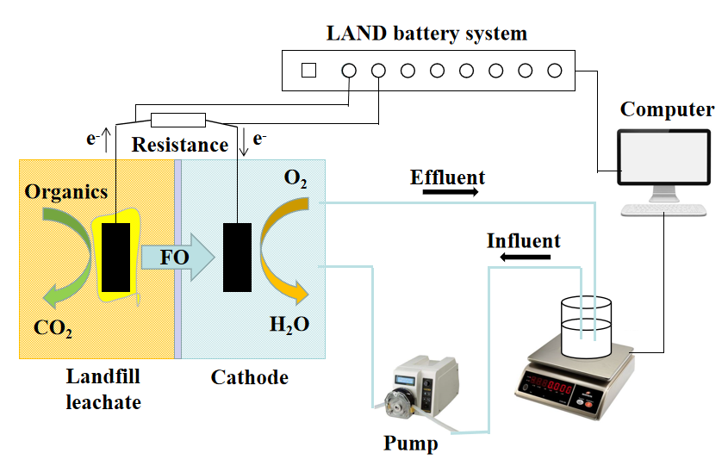
Fig. S1 Schematic of the experimental design for the OsMFC

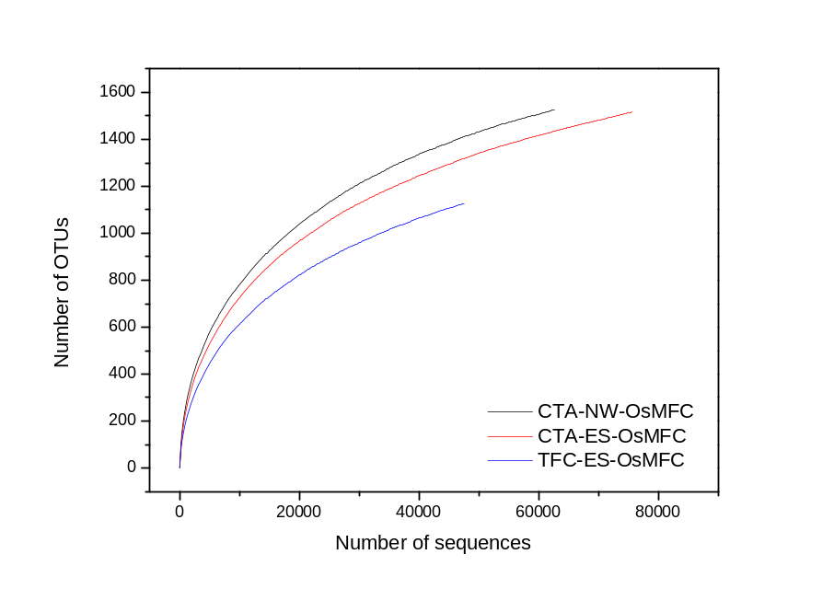
Fig. S2 Rarefaction curves of different membranes

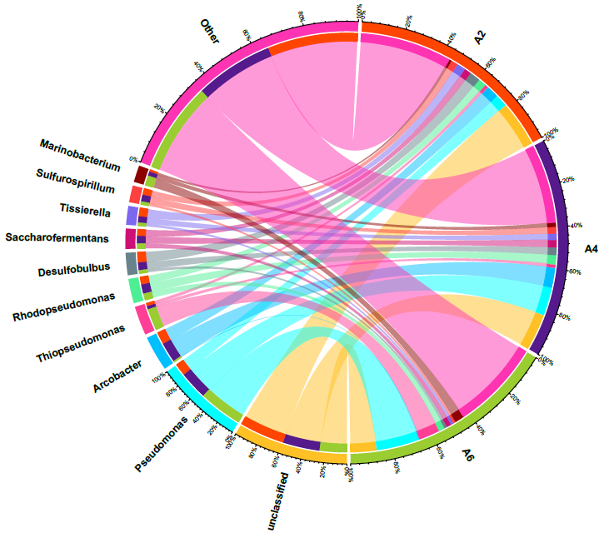
Fig. S3 Genus level relationship between the sample and the species（A2：CTA-NW-OsMFC、A4：CTA-ES-OsMFC、 A6：TFC-ES-OsMFC）

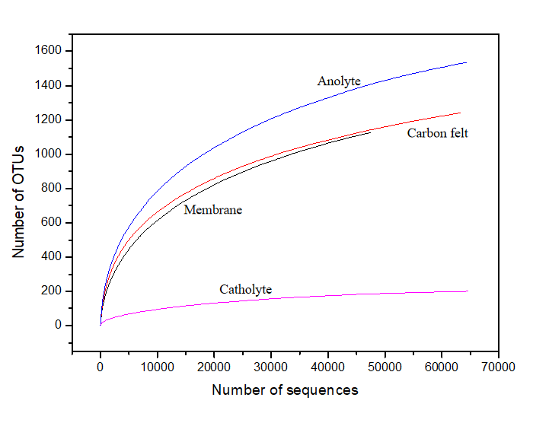
Fig. S4 Rarefaction curves of different OsMFCs sites

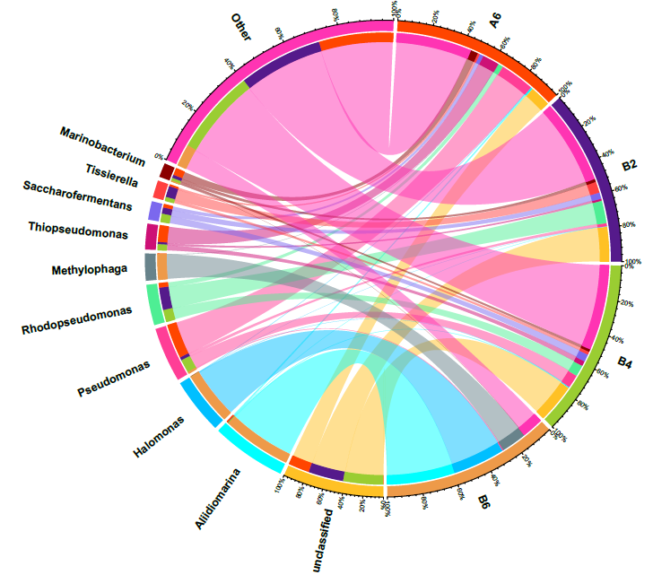

Fig. S5 Genus level relationship between the sample and the species（A6: membrane; B2: carbon felt; B4: anolyte; B6: catholyte）

