Figures
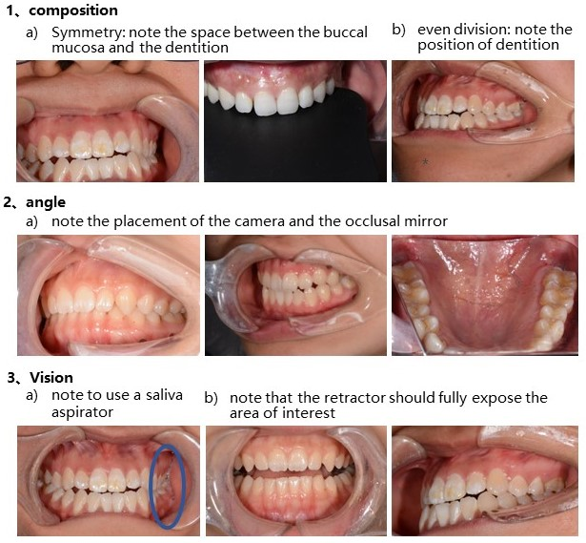
Figure S1. Snapshot of the pre-trial multimedia presentation on intra-oral photography fundamentals

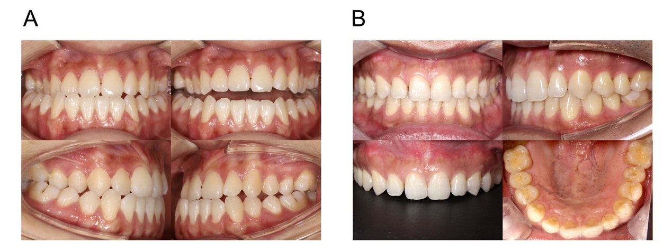
Figure S2. Thumbnails of the standard intra-oral dental portfolio. A, Set 1. B, Set 2.

Tables
Table S1. The scoring criteria of dental photography
Scoring criterion
Composition
- The horizontal axis and vertical axis are not tilted.
- The dentition is in the center of the image.
- The lips and buccal mucosa are not in contact with the teeth.
- For intraoral frontal view in maximum intercuspation (MI), occlusal full-arch maxillary view and frontal view against a black background, the dentition is symmetrical.
Content
- The teeth are clearly visible.
- The teeth is not in contact with buccal mucosa.
- For intraoral frontal view with separated teeth, the incisal edges, occlusal plane inclination, curves of Spee and Wilson are shown clearly.
- For intraoral lateral view in MI, the Angle's molar, canine and incisal relationships are shown clearly.
- For intraoral occlusal full-arch maxillary view, the palatal side of maxillary front teeth is visualized.
*For each photo, one point will be added for each scoring criterion met.
Table S2. The questionnaire for participants
Category
Improvement of photography technique
- The workshop has enhanced my proficiency in clinical photography.
- The workshop has enhanced my proficiency in doctor-patient communication.
Establishment of professional identity
- I notice that through ongoing practice, I am on track to achieve full mastery in dental photography.
- I believe that I am potent of becoming a qualified dentist in the future.

