Food Practices of Ancient South Indians: Insights from Biomolecular Analyses of Potteries
Prakash V S¹, Manivannan Kokarneswaran^{1,2}, Thennarasan Ashokan¹, Deepa Sathish³,
T Sreelakshmi⁴, Sivanantham Ramalingam⁵, Vijayanand Chandrasekaran^{1*}
¹Department of Chemistry, School of Advanced Sciences, Vellore Institute of Technology, Vellore, India
²Archaeological Survey of India, Science Branch, Chennai, India
²Department of Food Processing Technology and Management, PSGR Krishnammal College for Women, Peelamadu, Coimbatore, India
³Archaeological Survey of India, Western Zone, Mumbai, India
⁴Department of Archaeology, Government of Tamil Nadu, Chennai, India
* Corresponding author: vijayanand.c@vit.ac.in

This pdf contains:
Supplementary Discussion
Supplementary Figures:
Supplementary Figure 1: The method development of representative UPLC-Q-ToF-MS total ion current (TIC) chromatograms of the YA3 lipid extract, acquired using positive ion mode unispray ionization (USI+) at different run times.
Supplementary Figure 2: Elemental composition analysis and product ion spectrum (MS/MS) of the precursor ion (m/z 1153) procyanidin tetramer A-type eluting at 18.69 min of the YC5/Q2 lipid extract.
Supplementary Figure 3: Elemental composition analysis and UPLC-Q-ToF-MS spectrum showing the precursor ion (m/z 1153) procyanidin tetramer A-type eluting at 19.94 min of the YA3 lipid extract.
Supplementary Figure 4: Elemental composition analysis and product ion spectrum (MS/MS) of the precursor ion (m/z 1153) procyanidin tetramer A-type eluting at 25.11 min of the A2/1 lipid extract.
Supplementary Figure 5: Elemental composition analysis and UPLC-Q-ToF-MS spectrum showing the precursor ion (m/z 561.1938) procyanidin dimer B-type eluting at 7.45 min of the YA3 lipid extract.
Supplementary Figure 6: Elemental composition analysis and UPLC-Q-ToF-MS spectrum showing the precursor ion (m/z 381.2967) monoacylglycerol (MG 18:0) eluting at 8.47 min of the YA3 lipid extract.
Supplementary Figure 7: UPLC-Q-ToF-MS spectrum of (epi)catechin detected in lipid extracts from Gottiprolu samples.
Supplementary Figure 8: UPLC-Q-ToF-MS spectrum of (epi)catechin detected in lipid extracts from Keeladi samples
Supplementary Figure 9: Total ion current chromatogram (TIC) from UPLC-Q-ToF-MS/MS analysis showing the detection of (epi)catechin in lipid extracts from Keeladi samples
Supplementary Figure 10: Product ion (MS/MS) spectrum of the precursor ion at m/z 290 obtained from the lipid extracts of Keeladi samples.
Supplementary Figure 11: UPLC-Q-ToF-MS spectrum of the B-type procyanidin dimer (m/z 561) detected in lipid extracts from Keeladi samples, eluting at 7.6 minutes
Supplementary Figure 12: UPLC-Q-ToF-MS spectrum of the B-type procyanidin dimer (m/z 561) detected in lipid extracts from Gottiprolu samples, eluting at 7.4 minutes
Supplementary Figure 13: UPLC-Q-ToF-MS spectrum of the A-type procyanidin dimer
(m/z 559) detected in lipid extracts from Keeladi samples, eluting at 19 minutes.
Supplementary Figure 14: UPLC-Q-ToF-MS/MS chromatogram of the Keeladi lipid extract acquired at a collision energy of 40 eV, showing the separation of procyanidin dimers (A-type and B-type)
Supplementary Figure 15: Product ion (MS/MS) spectrum of the precursor ion at m/z 561 (procyanidin dimer B-type) obtained via UPLC-Q-ToF-MS/MS using a collision energy of 40 eV from the lipid extracts of Keeladi samples.
Supplementary Figure 16: Product ion (MS/MS) spectrum of the precursor ion at m/z 559 (procyanidin dimer A-type) obtained via UPLC-Q-ToF-MS/MS using a collision energy of 40 eV from the lipid extracts of Keeladi samples.
Supplementary Figure 17: UPLC-Q-ToF-MS spectrum showing representative degradation products (m/z 437, 409, 450 and 1003) identified in the YA3 lipid extract
Supplementary Figure 18: UPLC-Q-ToF-MS spectrum of the A-type procyanidin dimer (m/z 559) detected in lipid extracts from Gottiprolu samples.
Supplementary Figure 19: UPLC-Q-ToF-MS spectrum showing representative degradation products (m/z 409, 437, 712) identified in the YC5/Q2 lipid extract
Supplementary Figure 20: UPLC-Q-ToF-MS spectrum showing representative degradation product (m/z 712) identified in the Keeladi lipid extracts
Supplementary Figure 21: UPLC-Q-ToF-MS spectrum of the linear A-type procyanidin tetramer (m/z 1153) detected in lipid extracts from Keeladi samples, eluting at 23 minutes.
Supplementary Figure 22: UPLC-Q-ToF-MS/MS chromatogram of a linear A-type procyanidin tetramer (m/z 1153) detected with a collision energy of 40 eV in the Keeladi lipid extracts.
Supplementary Figure 23: UPLC-Q-ToF-MS/MS spectrum of a linear A-type procyanidin tetramer (m/z 1153) detected with a collision energy of 40 eV in the Keeladi lipid extracts.
Supplementary Figure 24: UPLC-Q-ToF-MS spectrum showing the distribution of triacylglycerol (TAGs) molecular ions detected in the lipid extracts of the Gottiprolu samples.
Supplementary Figure 25: UPLC-Q-ToF-MS/MS chromatogram of selected TAGs (m/z 855, 857, 877 and 879) detected with a collision energy of 40 eV in the YA3 lipid extract.
Supplementary Figure 26: UPLC-Q-ToF-MS/MS mass spectrum of selected TAGs (m/z 855, 857, 877 and 879) detected with a collision energy of 40 eV in the YA3 lipid extract.
Supplementary Figure 27: UPLC-Q-ToF-MS/MS chromatogram of selected TAGs (m/z 855, 857, and 929) detected with a collision energy of 40 eV in the YC5/Q2 lipid extract.
Supplementary Figure 28: UPLC-Q-ToF-MS/MS mass spectrum of selected TAGs (m/z 855, 857, and 929) detected with a collision energy of 40 eV in the YC5/Q2 lipid extract.
Supplementary Figure 29: UPLC-Q-ToF-MS spectrum highlighting the signal m/z 929 corresponding to the triolein molecule observed as a [M+2Na-H] + adduct in the lipid extracts obtained from the Gottiprolu samples
Supplementary Figure 30: UPLC-Q-ToF-MS spectrum of MG 18:0 (monoacylglycerol) m/z 381 detected in the Gottiprolu lipid extracts, eluting at 8.4 minutes
Supplementary Figure 31: UPLC-Q-ToF-MS spectrum of MG 18:0 (monoacylglycerol) m/z 381 detected in the Keeladi lipid extracts, eluting at 8.4 minutes
Supplementary Figure 32: UPLC-Q-ToF-MS spectrum of DG 30:0 (diacylglycerol) m/z 541 detected in the Gottiprolu lipid extracts, eluting at 17.4 minutes
Supplementary Figure 33: UPLC-Q-ToF-MS spectrum of Glycerophospholipid (PA(O-18:0/16:0)) m/z 685 detected in the Gottiprolu lipid extracts, eluting at 20 minutes.
Supplementary Figure 34: UPLC-Q-ToF-MS/MS chromatogram of selected Glycerophospholipid (PA(O-18:0/16:0)) m/z 685 detected with a collision energy of 40 eV in the YC5/Q2 lipid extract
Supplementary Figure 35: UPLC-Q-ToF-MS/MS spectrum of selected Glycerophospholipid (PA(O-18:0/16:0)) m/z 685 detected with a collision energy of 40 eV in the YC5/Q2 lipid extract
Supplementary Figure 36: UPLC-Q-ToF-MS spectrum of Glycerophospholipid (PA(O-18:0/16:0)) m/z 685 detected in the Keeladi lipid extracts, eluting at 20 minutes
Supplementary Figure 37: UPLC-Q-ToF-MS spectrum of Glycerophospholipid PA(O-18:0/16:0) m/z 707 detected in the Gottiprolu lipid extracts, eluting at 13.3 minutes
Supplementary Figure 38: UPLC-Q-ToF-MS spectrum of Glycerophospholipid PS (16:0/18:1) m/z 784 detected in the Gottiprolu lipid extracts, eluting at 15.8 minutes.
Supplementary Figure 39: UPLC-Q-ToF-MS spectrum of Glycerophospholipid PA(P-16:0/17:0) detected in the Gottiprolu lipid extracts, eluting at 16 minutes
Supplementary Figure 40: UPLC-Q-ToF-MS Analysis of Glycerophospholipids PA(P-16:0/16:0) m/z 633 and PA(P-16:0/18:0) m/z 683 in Gottiprolu Lipid Extracts
Supplementary Figure 41: UPLC-Q-ToF-MS analysis of glycerophospholipids (PA (12:0/12:0) and PI (18:0/20:4)) and sphingolipid (M(IP)2C(t18:0/18:0)) in YA3 Lipid Extracts.
Supplementary Figure 42: UPLC-Q-ToF-MS analysis of Fatty Acyl (Hexacosanoyl-CoA) m/z 1190 in Gottiprolu lipid extracts.
Supplementary Figure 43: UPLC-Q-ToF-MS analysis of sphingolipid (M(IP)2C(t18:0/16:0)) m/z 1246 in Gottiprolu lipid extracts.
Supplementary Figure 44: UPLC-Q-ToF-MS analysis of plant sterols stigmasterol (m/z 412) and beta-sitosterol (m/z 414) in Gottiprolu lipid extracts.
Supplementary Figure 45: UPLC-Q-ToF-MS analysis of Beta-sitosterol (m/z 414) in Keeladi lipid extracts.
Supplementary Figure 46: UPLC-Q-ToF-MS analysis of resveratrol (m/z 290) in Gottiprolu lipid extracts
Supplementary Figure 47: UPLC-Q-ToF-MS analysis of chlorogenic acid (m/z 355) in YA3 lipid extract

Supplementary Discussion
X-ray Micro-Computed Tomography:
In this work, X-ray micro-computed tomography (μCT) was performed for all the samples using BRUKER SKYSCAN 1273. μCT is a non-destructive imaging technique that uses X-rays to create cross-sectional images of an object^{1,2}. It provides a detailed view of the internal structures of the pottery. Along with ORA, it synergistically enhances archaeological investigations of ancient pottery by bridging structural and molecular insights. The cross-sections obtained from the μCT can then be reconstructed into a 3D model, revealing the internal structure based on differences in X-ray attenuation (which relates primarily to material density and atomic number). µCT is not sensitive to the organic residues found in the pores of the pottery. Organic molecules comprise light elements (Carbon, Hydrogen, Oxygen, Nitrogen). These elements have very low X-ray attenuation compared to the heavier elements composing the ceramic matrix (Silicon, Aluminium, Oxygen, Iron, Calcium, Potassium, etc.). µCT excels at characterizing the 3D pore structure³ (Ext. Data Fig. 2). This is highly relevant for ORA because the porosity (total porosity, pore size distribution, connectivity) dictates: 1. How much residue could potentially be absorbed? 2. Where are residues likely to be concentrated? 3.How accessible these residues might be to degradation or, conversely, how well they might be protected.
µCT analysis of the archaeological pottery sherd revealed critical insights into its internal fabric structure and implications for organic residue preservation. The quantitative morphometric results for the selected pottery sherds are provided in (S. Table: 2-5). The analyzed volume of interest (VOI) and surface-to-volume ratios for all samples indicate minimal surface area relative to volume. Porosity analysis demonstrated exceptionally low total porosity, dominated by closed pores rather than open pores. The pore network exhibited limited connectivity, evidenced by a high Euler number and negligible connectivity density, suggesting isolation of most voids. Of all the measured potteries in this work, the pore sizes ranged widely between 20–1190 μm. These structural characteristics have significant implications for organic residue analysis. In particular, the predominance of closed pores could enhance preservation by physically isolating organic residues from external factors such as water, oxygen, and microbial activity. This isolation minimizes oxidative degradation and microbial decomposition, which are primary pathways for organic matter loss.

Method Development:
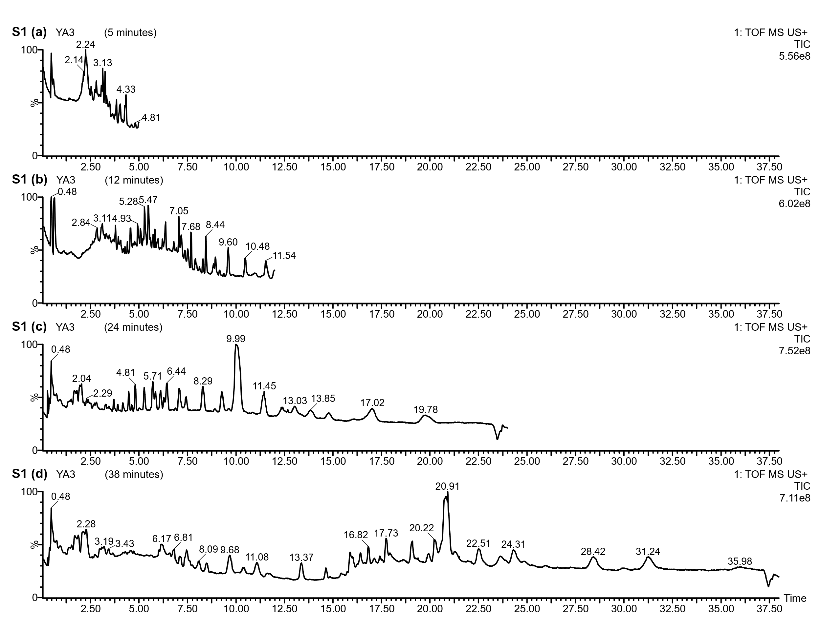
Supplementary Figure 1: The method development of representative UPLC-Q-ToF-MS total ion current (TIC) chromatogram of the YA3 lipid extract, acquired using positive ion mode unispray ionization (USI+). Elution times at 5 min (a), 12 min (b), 24 min (c), and 38 min (d) are highlighted on the chromatogram from a single run. This demonstrates the separation achieved for diverse lipid classes, with particularly high resolution observed for compounds eluting at 38 minutes (d).
Ultra-pressure liquid chromatography, which offers increased sensitivity, ease of use, decreased solvent consumption, and a lower injection volume, has opened up new possibilities for improving analytical methods for complex sample matrices. Waters Corporation invented the novel atmospheric ionisation method known as UniSpray (US), which ionises analytes using a high-velocity spray produced by a grounded nebulizer. It enhances droplet break-up and desolvation via Coanda and vortex effects. This method is an excellent tool for a variety of applications because it has been demonstrated to increase sensitivity and decrease matrix effects in mass spectrometry analysis. The method we developed for analysing total lipid extracts employs UPLC-Q-TOF-MS and MS/MS, which allow for short chromatographic runs in under 40 minutes. Chromatographic separation was optimized using a Waters ACQUITY UPLC BEH C18 Column, 130Å, 2.1mm X 50mm, 1.7µm with a water (0.1% formic acid) and Acetonitrile (0.1% formic acid) gradient system. The 38-minute method (50% A at 0–1.5 min, 50–20% A at 1.5–15 min, 5% A at 15–36.10 min, 5-50% A at 36.10-38 min) operated at 0.4 mL/min and 40°C, paired with a 10 µL injection volume, enabled comprehensive detection of diverse lipid classes (glycerophospholipids, sphingolipids) and high-molecular-weight polar compounds like procyanidin tetramers. UniSpray parameters, including a 2 kV impactor pin voltage, 1000 L/hr nebulizer gas flow, and 500°C desolvation temperature, significantly boosted sensitivity, achieving a very low detection limit. Compared to initial shorter runs (5–12 min), which detected only very few compounds (e.g., plant sterols, dimeric procyanidin and its degradation products) with poor resolution, the optimized method covers various class of lipids, plant sterols, and polyphenols with greater resolution. This balance of speed, sensitivity, and robustness makes the approach particularly suited for complex archaeological matrices requiring high-resolution profiling of both polar and nonpolar constituents.

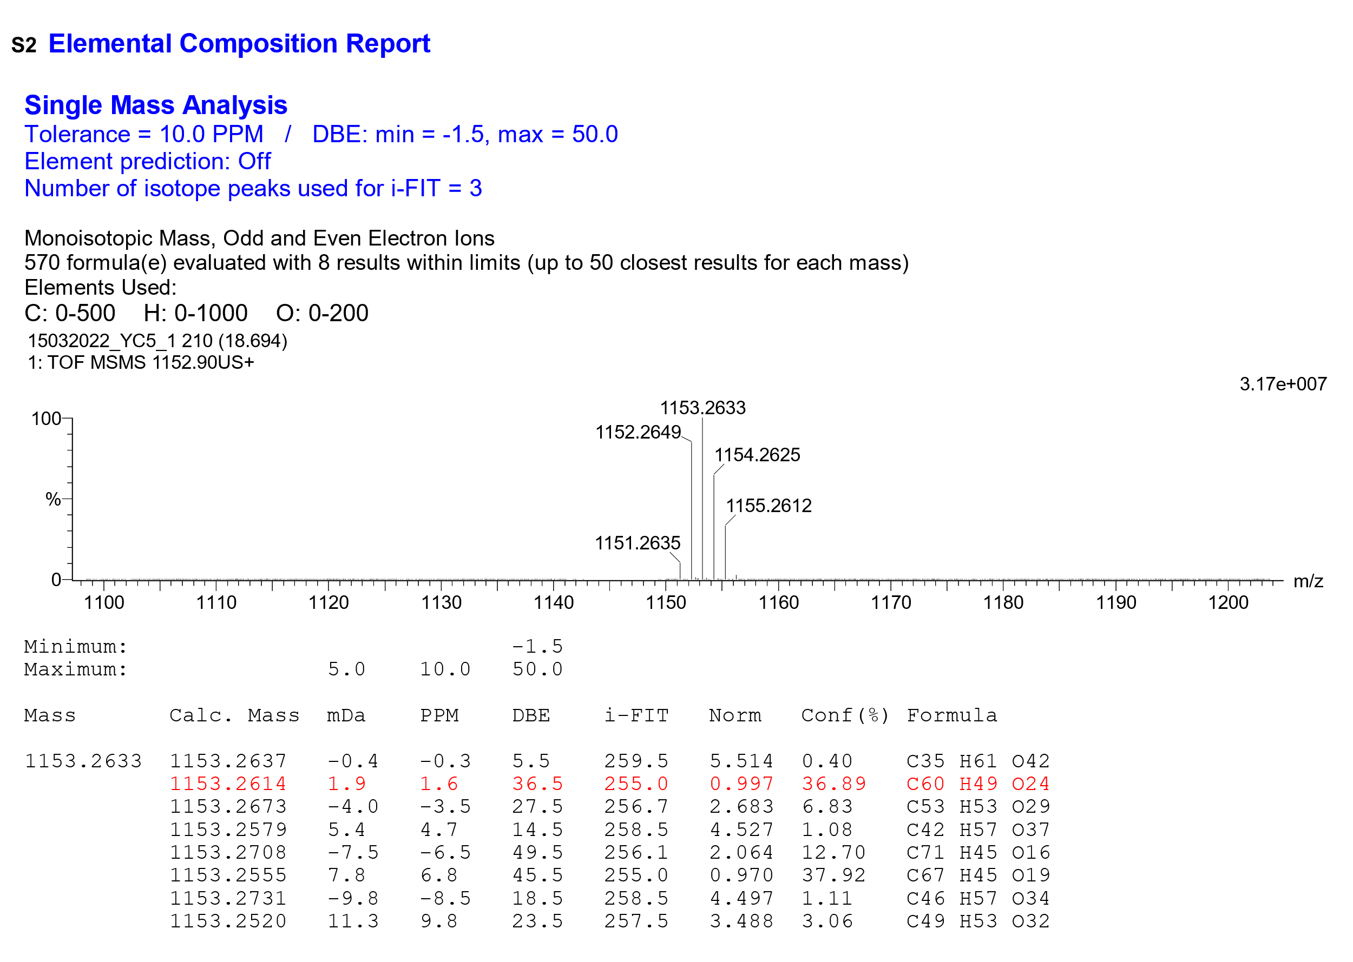
Supplementary Figure 2: Product ion spectrum (MS/MS) of the precursor ion eluting at 18.69 min of the YC5/Q2 lipid extract. Fragmentation was acquired via UPLC-Q-ToF-MS/MS using a collision energy of 40 eV. The accurate mass of the precursor ion (m/z 1153.2614) matched the predicted elemental composition for the protonated molecule ([M+H] ⁺) of a linear A-type procyanidin tetramer within 1.6 ppm mass accuracy.
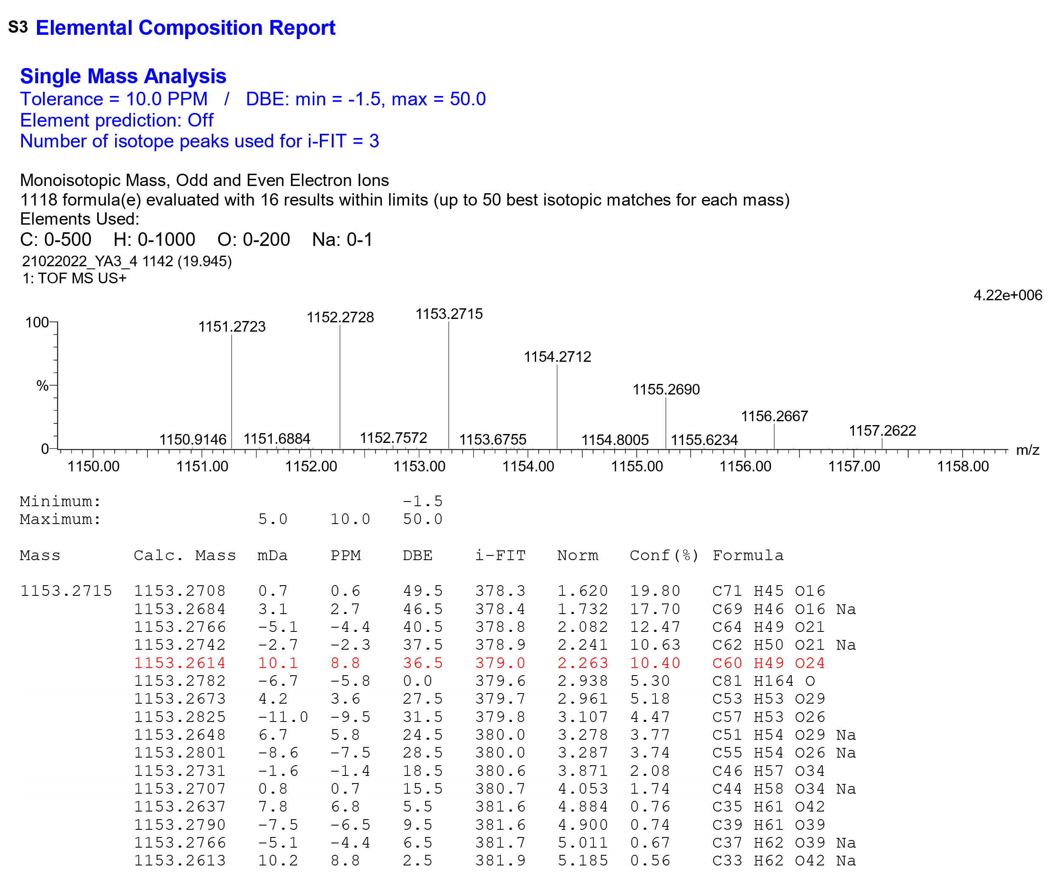
Supplementary Figure 3: UPLC-Q-ToF-MS spectrum showing the precursor ion eluting at 19.94 min of the YA3 lipid extract. The measured accurate mass (m/z 1153.2715) corresponds to the protonated molecule ([M+H] ⁺) of a linear A-type procyanidin tetramer, matching its predicted elemental composition with 8.8 ppm mass accuracy.

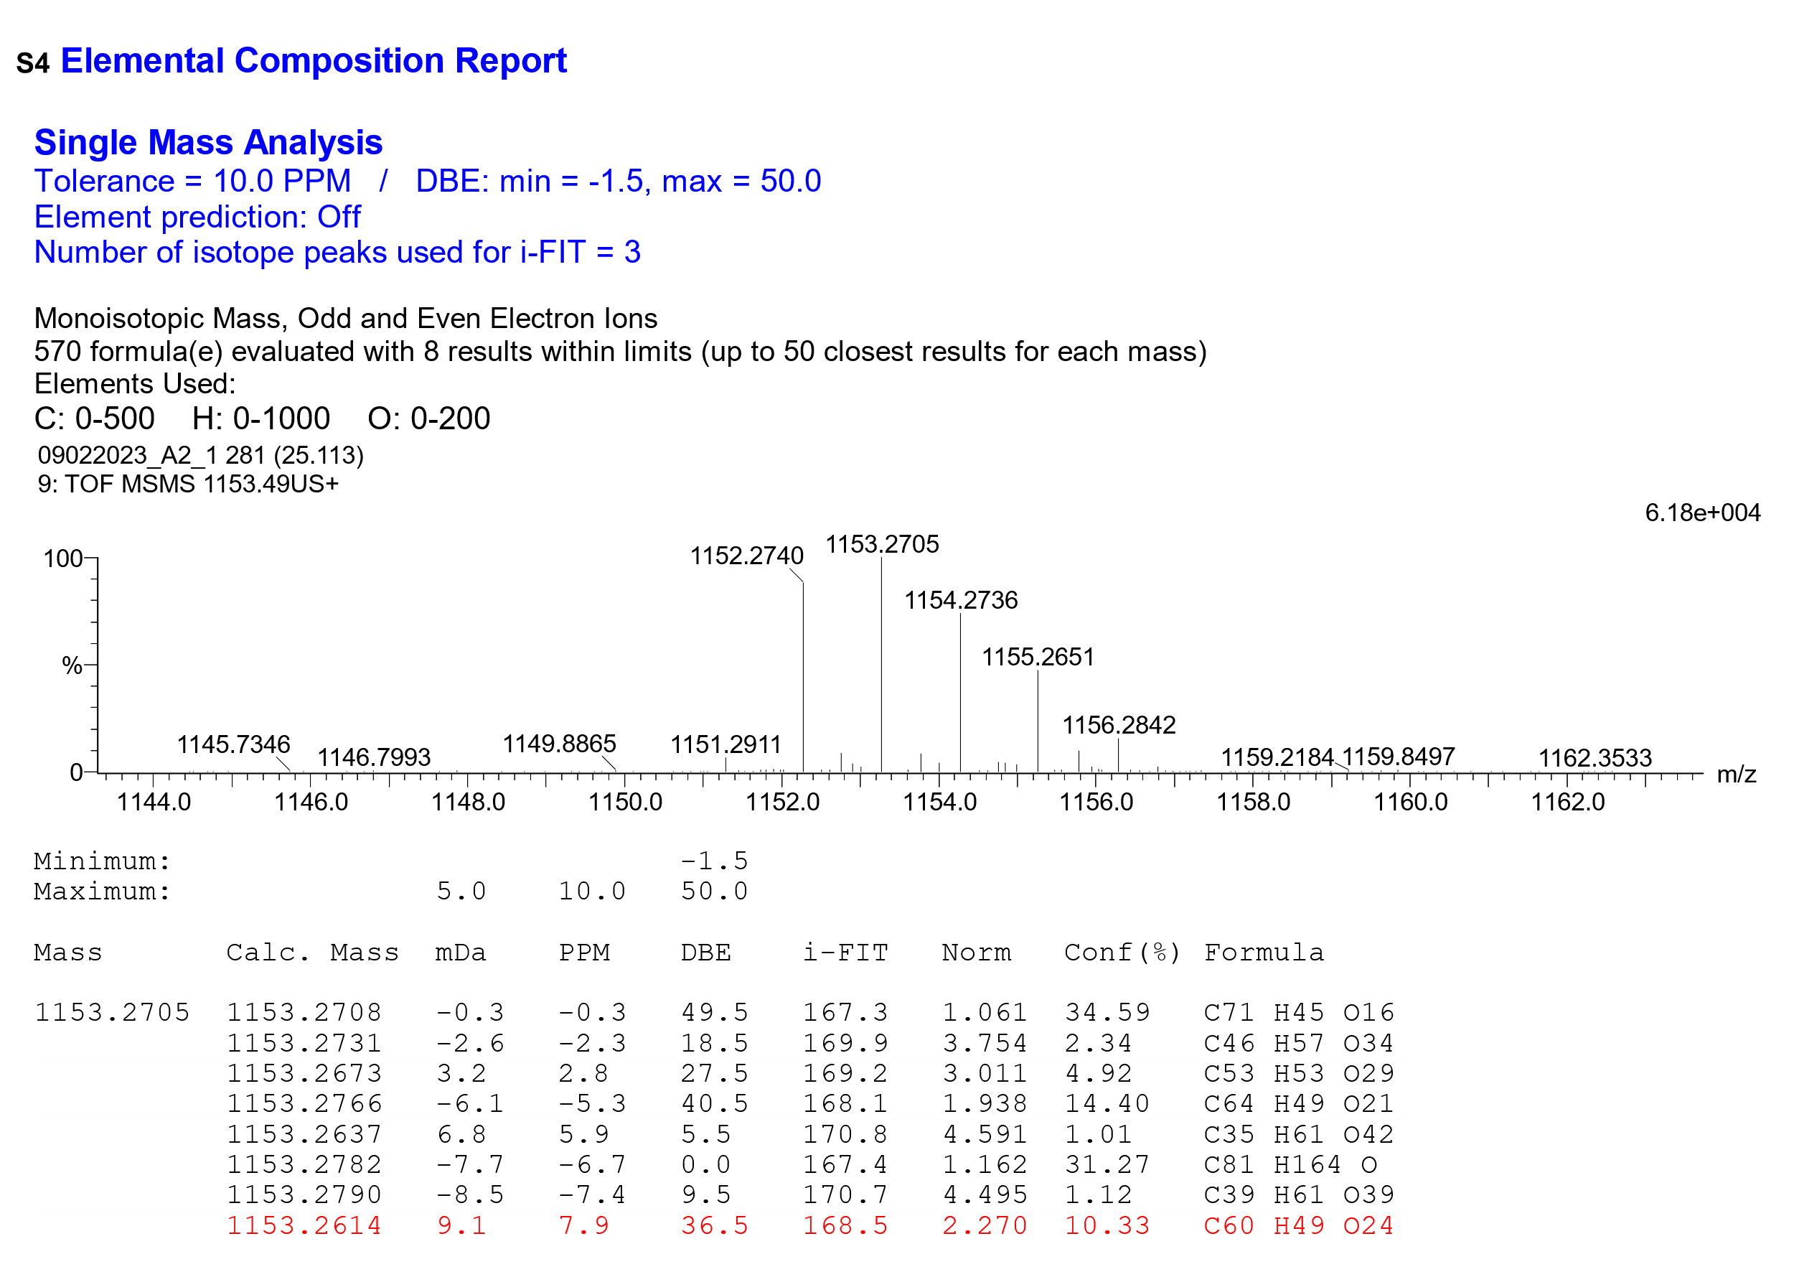
Supplementary Figure 4: Product ion spectrum (MS/MS) of the precursor ion eluting at 25.11 min of the A2/1 lipid extract. Fragmentation was acquired via UPLC-Q-ToF-MS/MS using a collision energy of 40 eV. The accurate mass of the precursor ion (m/z 1153.2705) matched the predicted elemental composition for the protonated molecule ([M+H] ⁺) of a linear A-type procyanidin tetramer within 7.9 ppm mass accuracy.

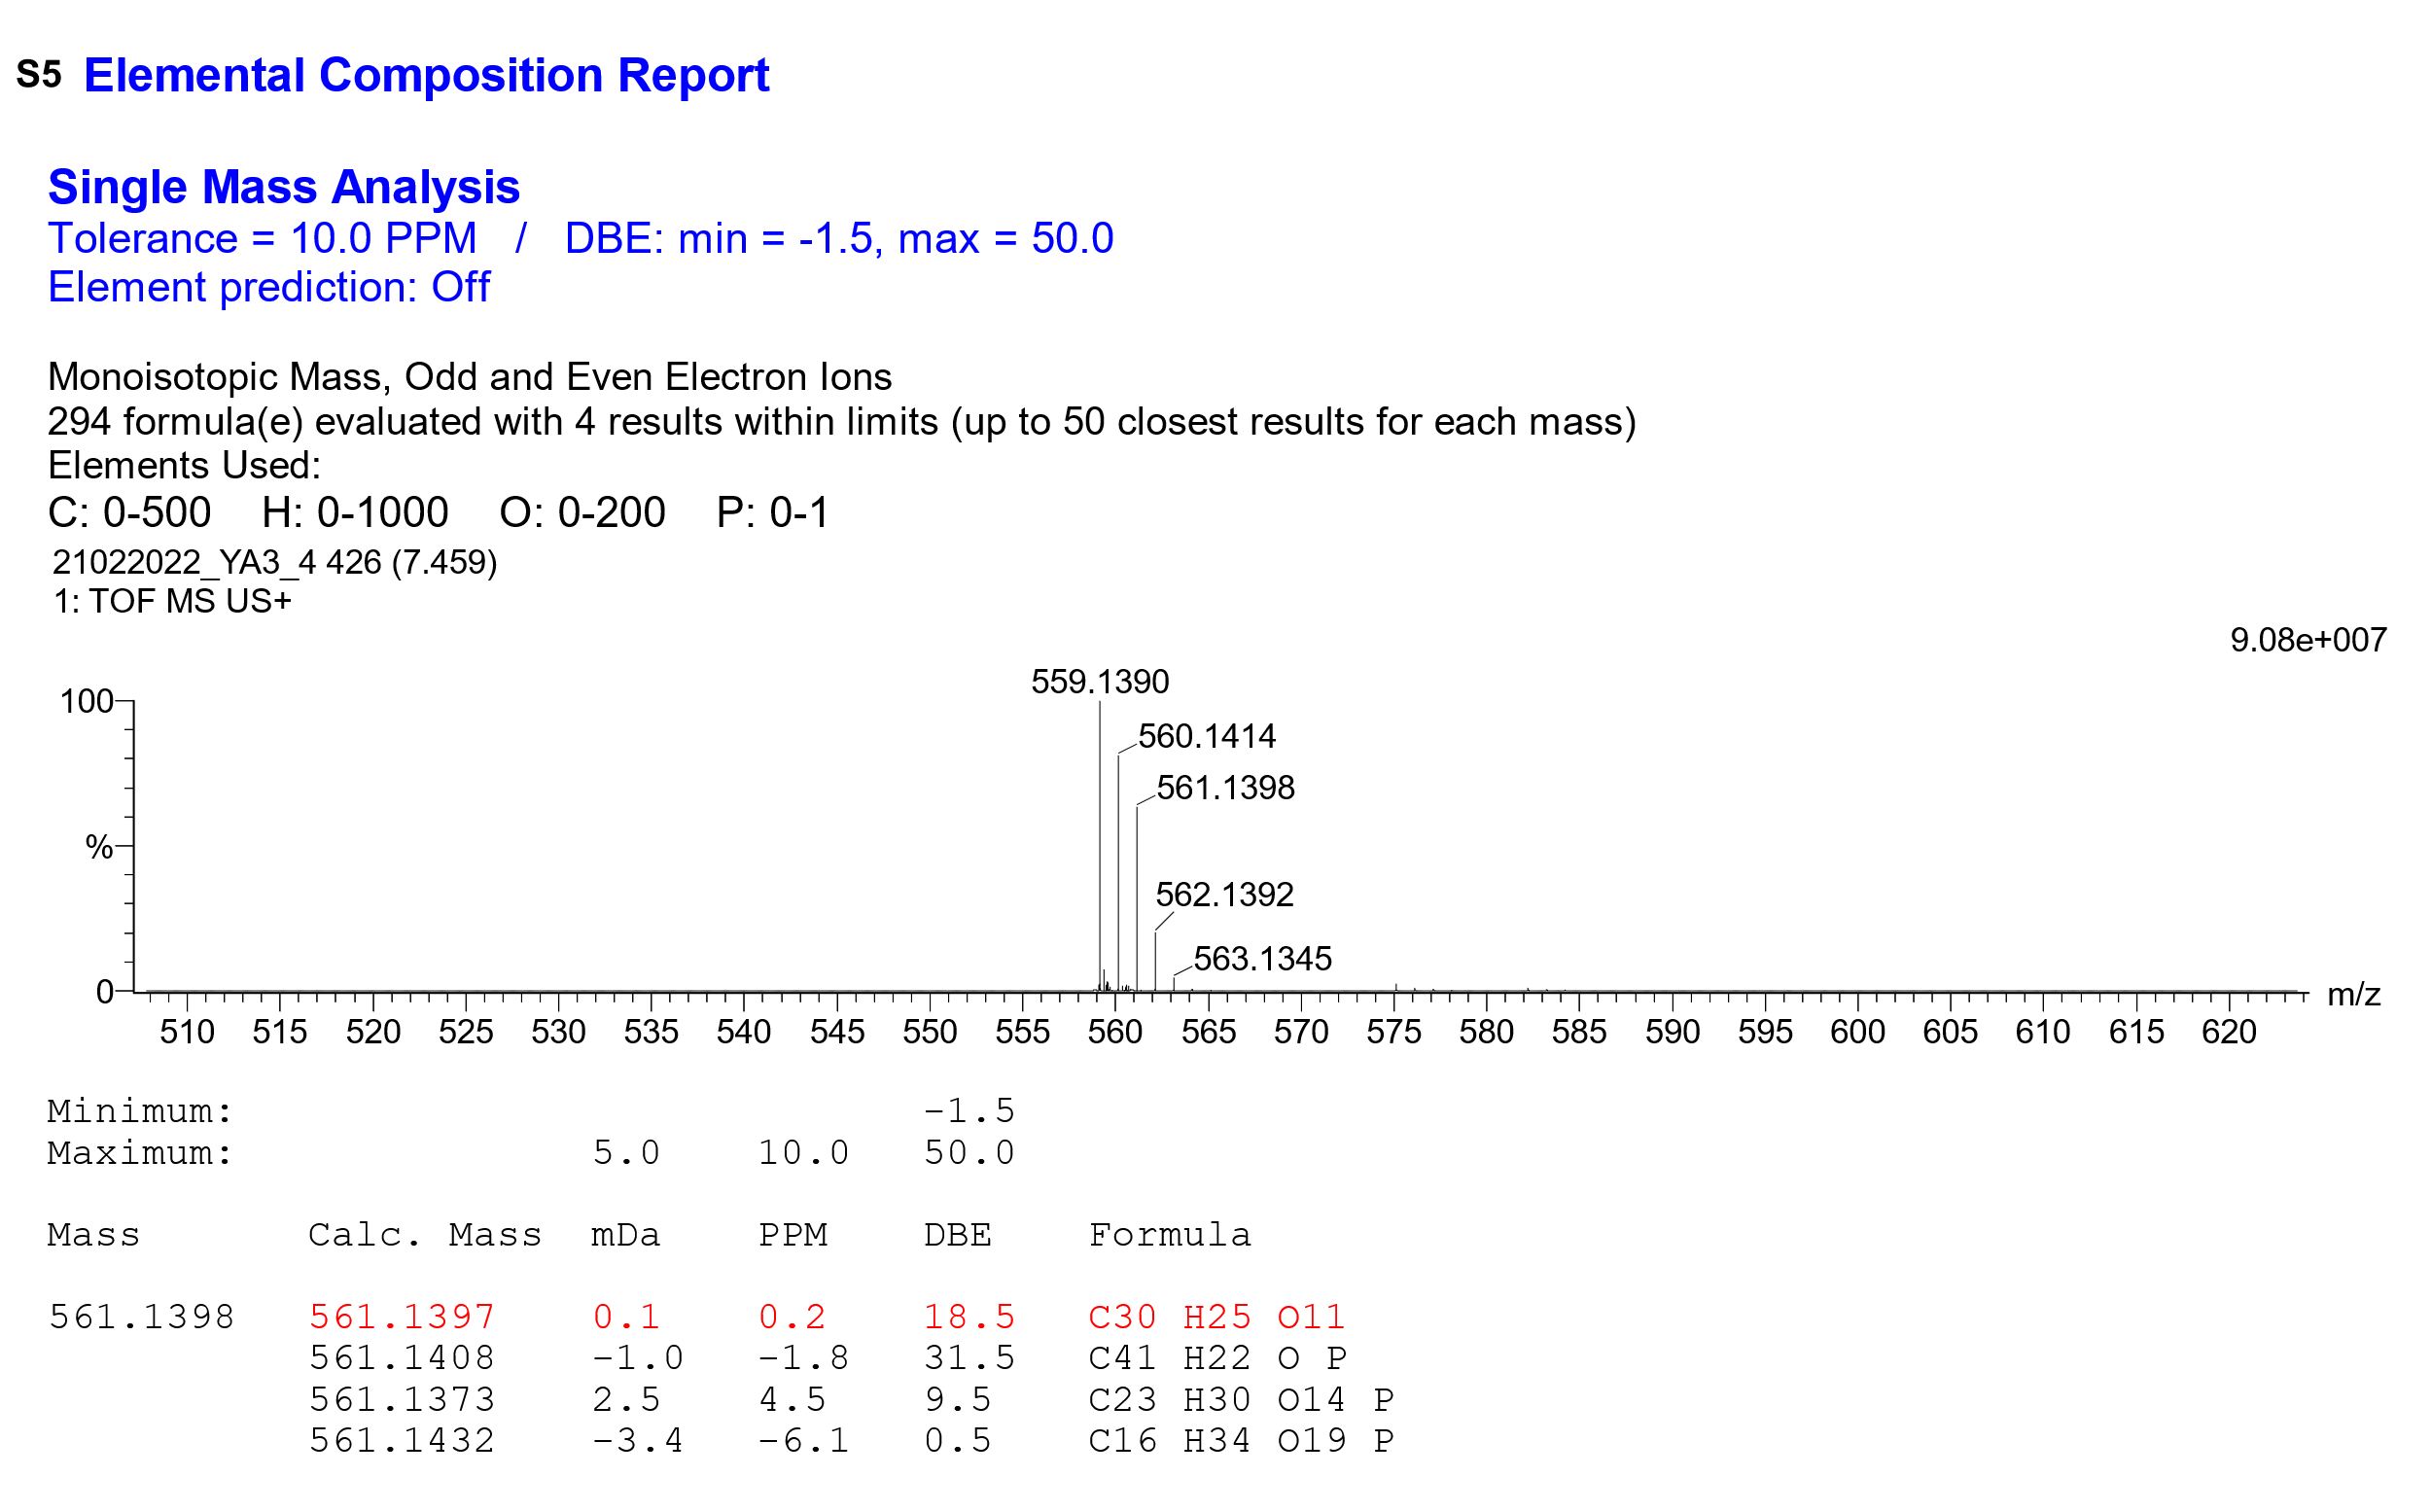
Supplementary Figure 5: UPLC-Q-ToF-MS spectrum showing the precursor ion eluting at 7.45 min of the YA3 lipid extract. The measured accurate mass (m/z 561.1938) corresponds to the protonation followed by dehydrated molecule ([M+H-H₂O] ⁺) of a procyanidin dimer B-type, matching its predicted elemental composition with 0.1 ppm mass accuracy.

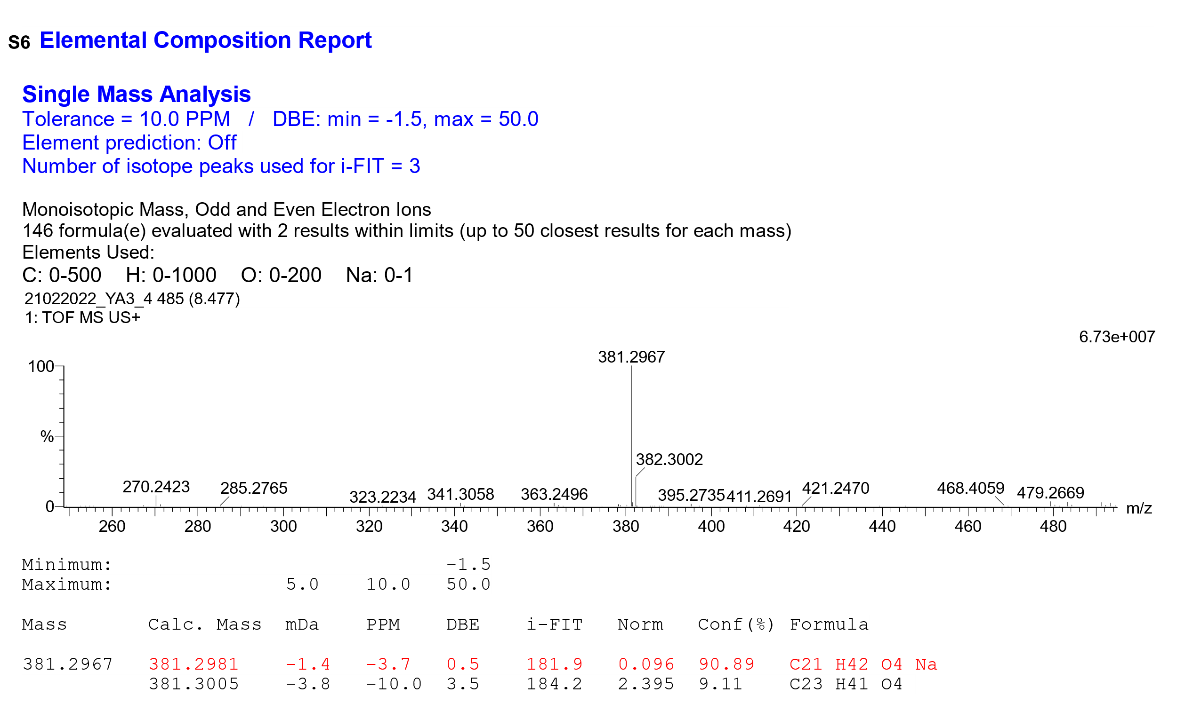
Supplementary Figure 6: UPLC-Q-ToF-MS spectrum showing the precursor ion eluting at 8.47 min of the YA3 lipid extract. The measured accurate mass (m/z 381.2967) corresponds to the sodiated molecule ([M+Na] ⁺) of a monoacylglycerol (MG 18:0), matching its predicted elemental composition with 0.1 ppm mass accuracy.

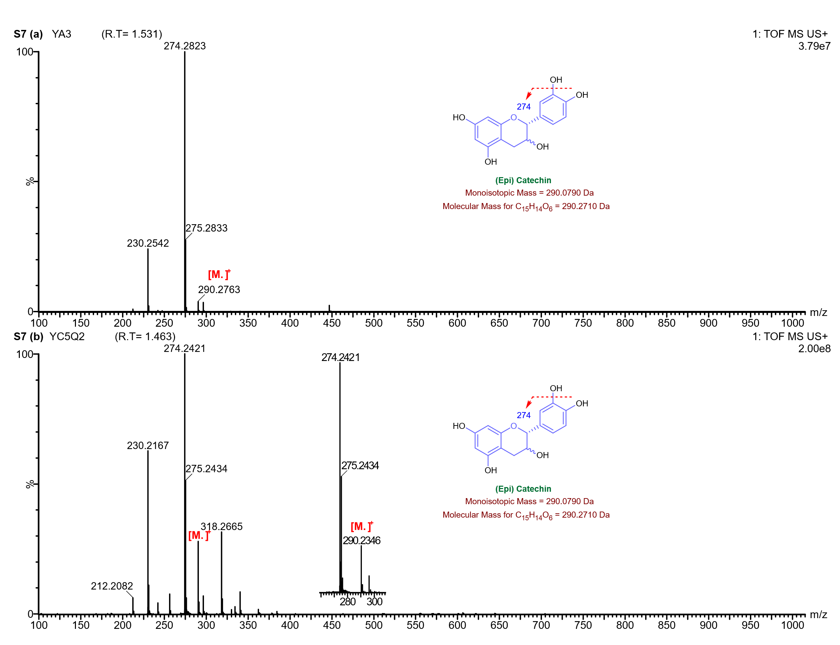
Supplementary Figure 7: UPLC-Q-ToF-MS spectrum of (epi)catechin detected in lipid extracts from Gottiprolu samples.

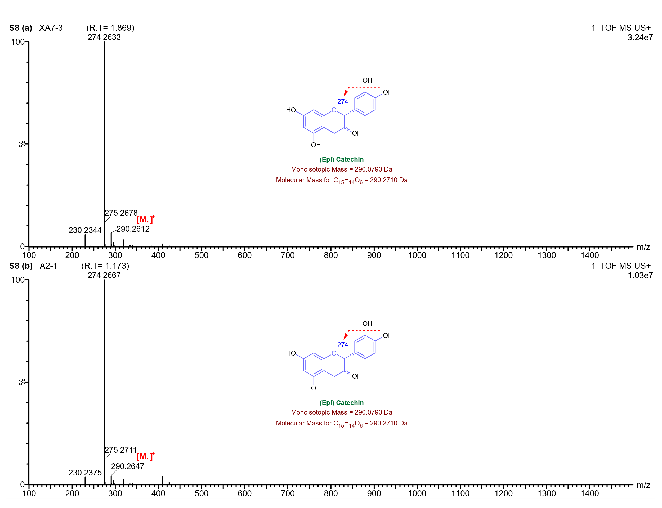
Supplementary Figure 8: UPLC-Q-ToF-MS spectrum of (epi)catechin detected in lipid extracts from Keeladi samples.

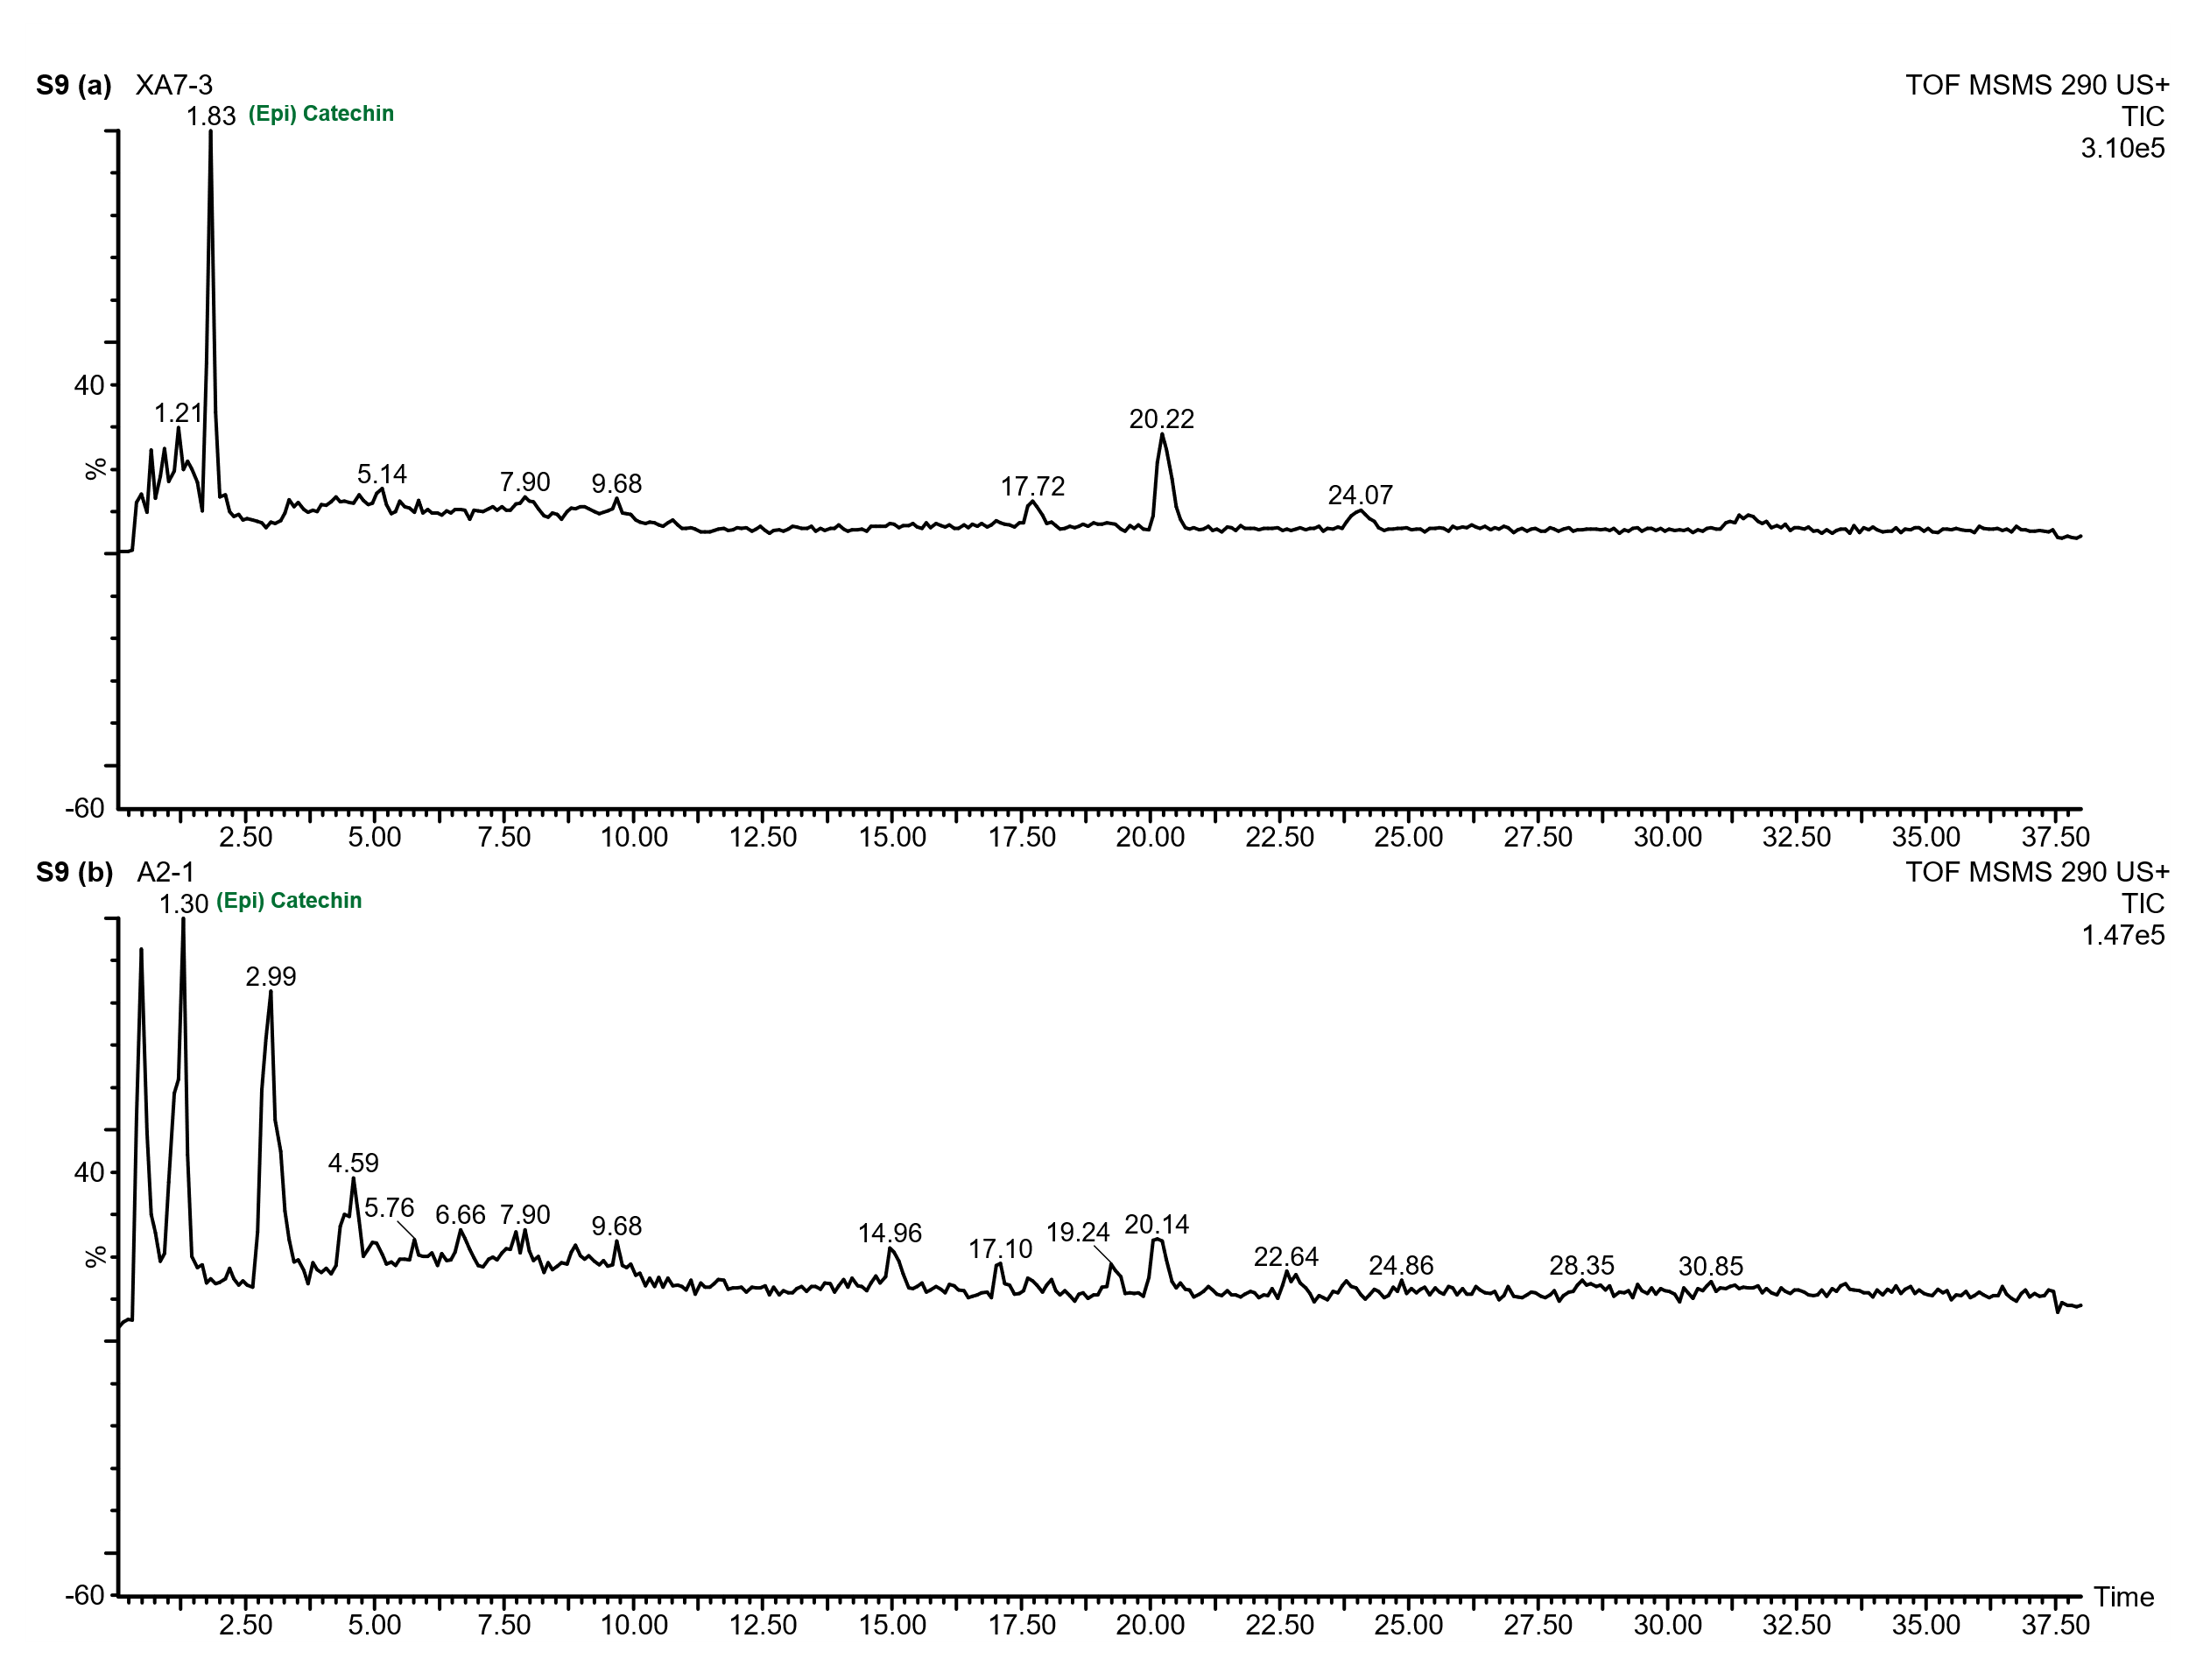
Supplementary Figure 9: Total ion current chromatogram (TIC) from UPLC-Q-ToF-MS/MS analysis showing the detection of (epi)catechin in lipid extracts from Keeladi samples
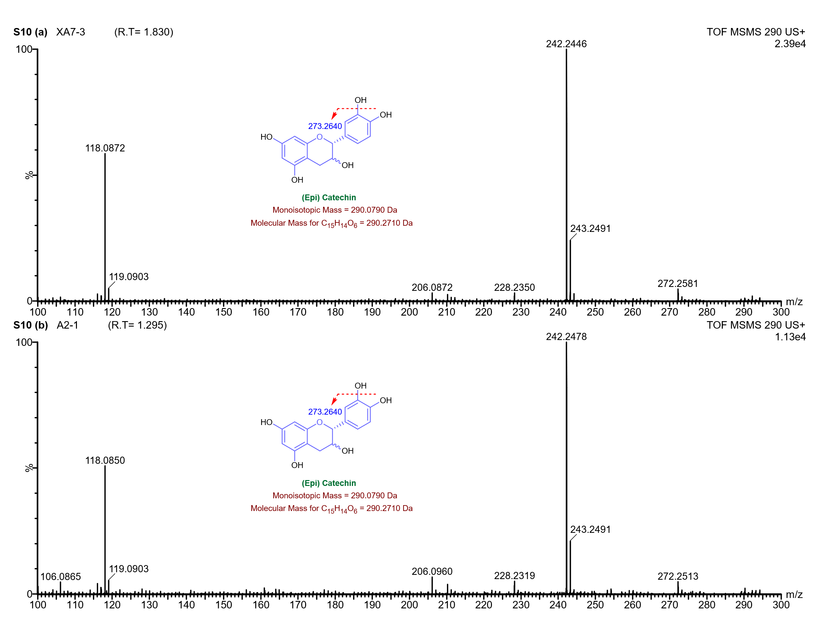
Supplementary Figure 10: Product ion (MS/MS) spectrum of the precursor ion at m/z 290 obtained from the lipid extracts of Keeladi samples. Fragmentation was acquired via UPLC-Q-ToF-MS/MS using a collision energy of 40 eV.
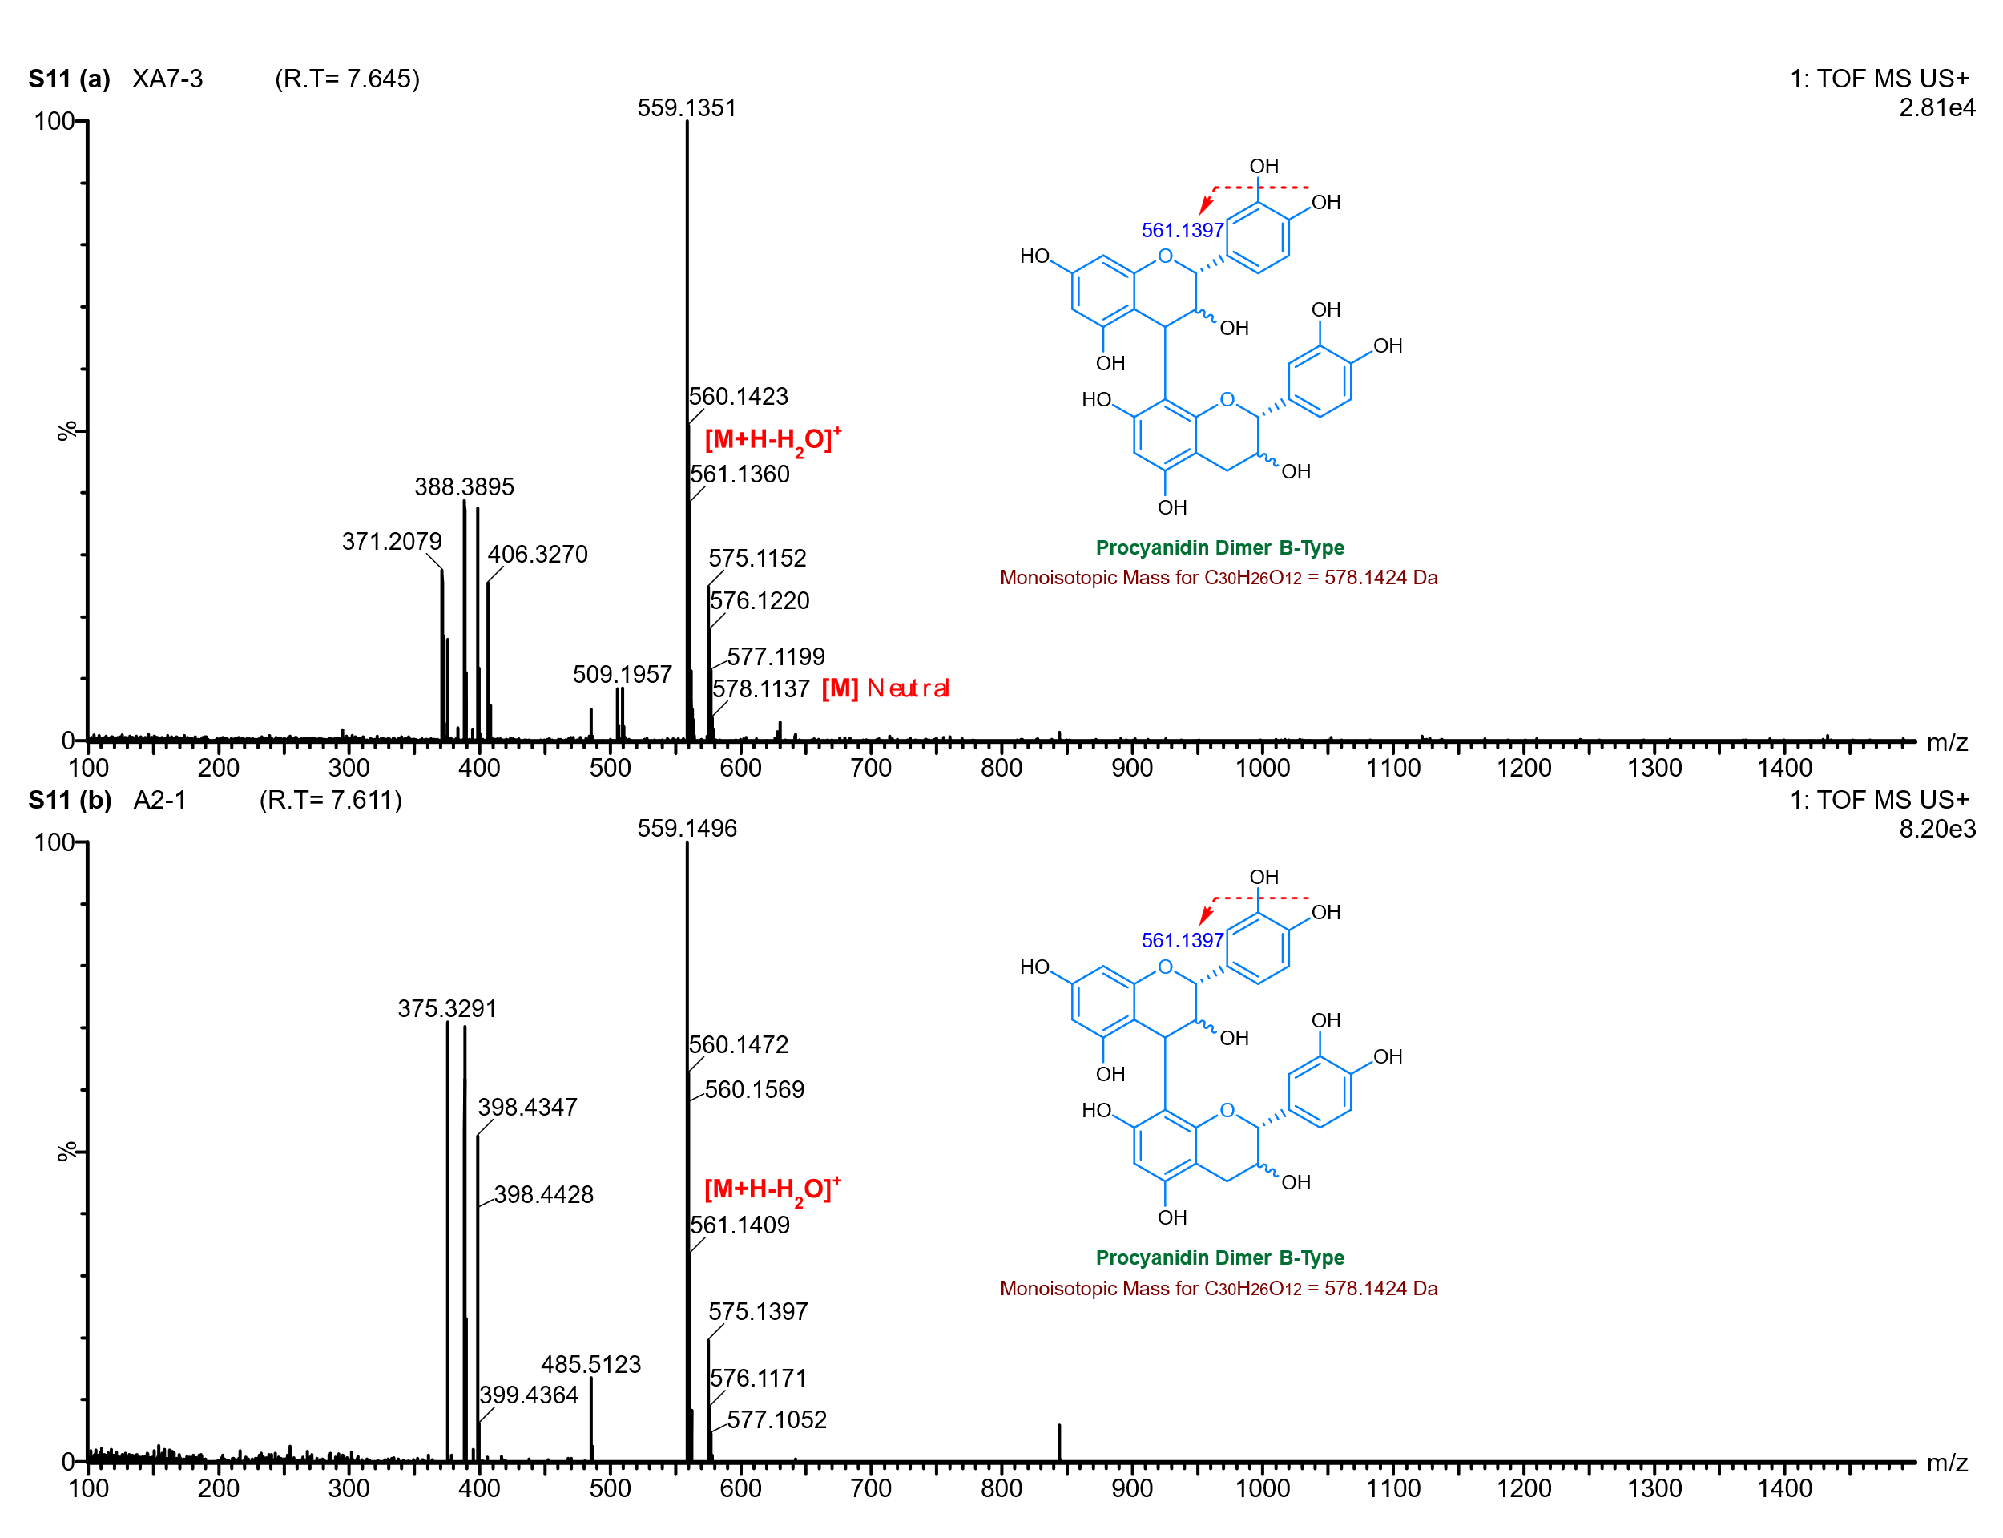
Supplementary Figure 11: UPLC-Q-ToF-MS spectrum of the B-type procyanidin dimer detected in lipid extracts from Keeladi samples, eluting at 7.6 minutes.
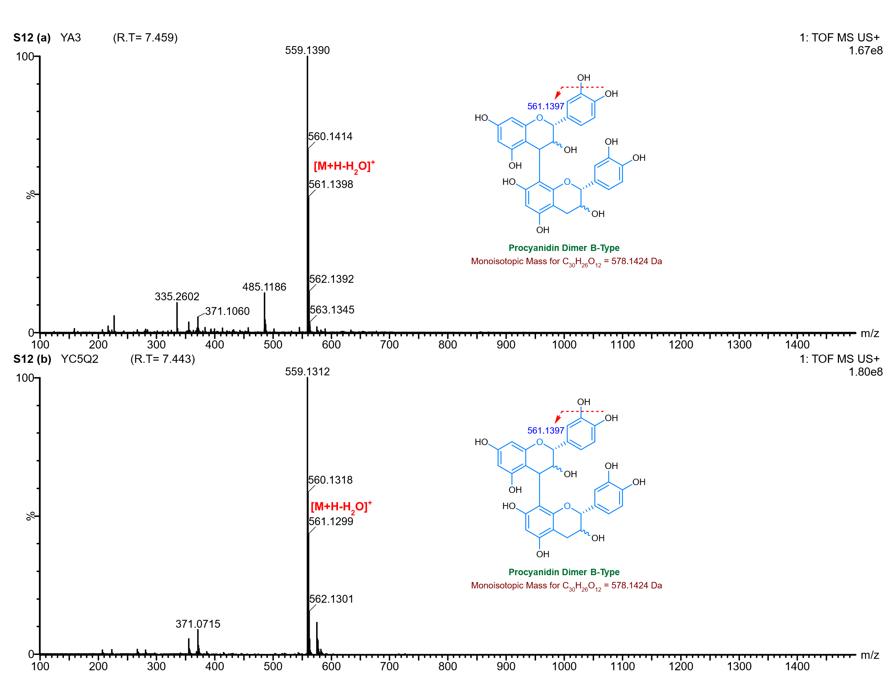
Supplementary Figure 12: UPLC-Q-ToF-MS spectrum of the B-type procyanidin dimer detected in lipid extracts from Gottiprolu samples, eluting at 7.4 minutes.

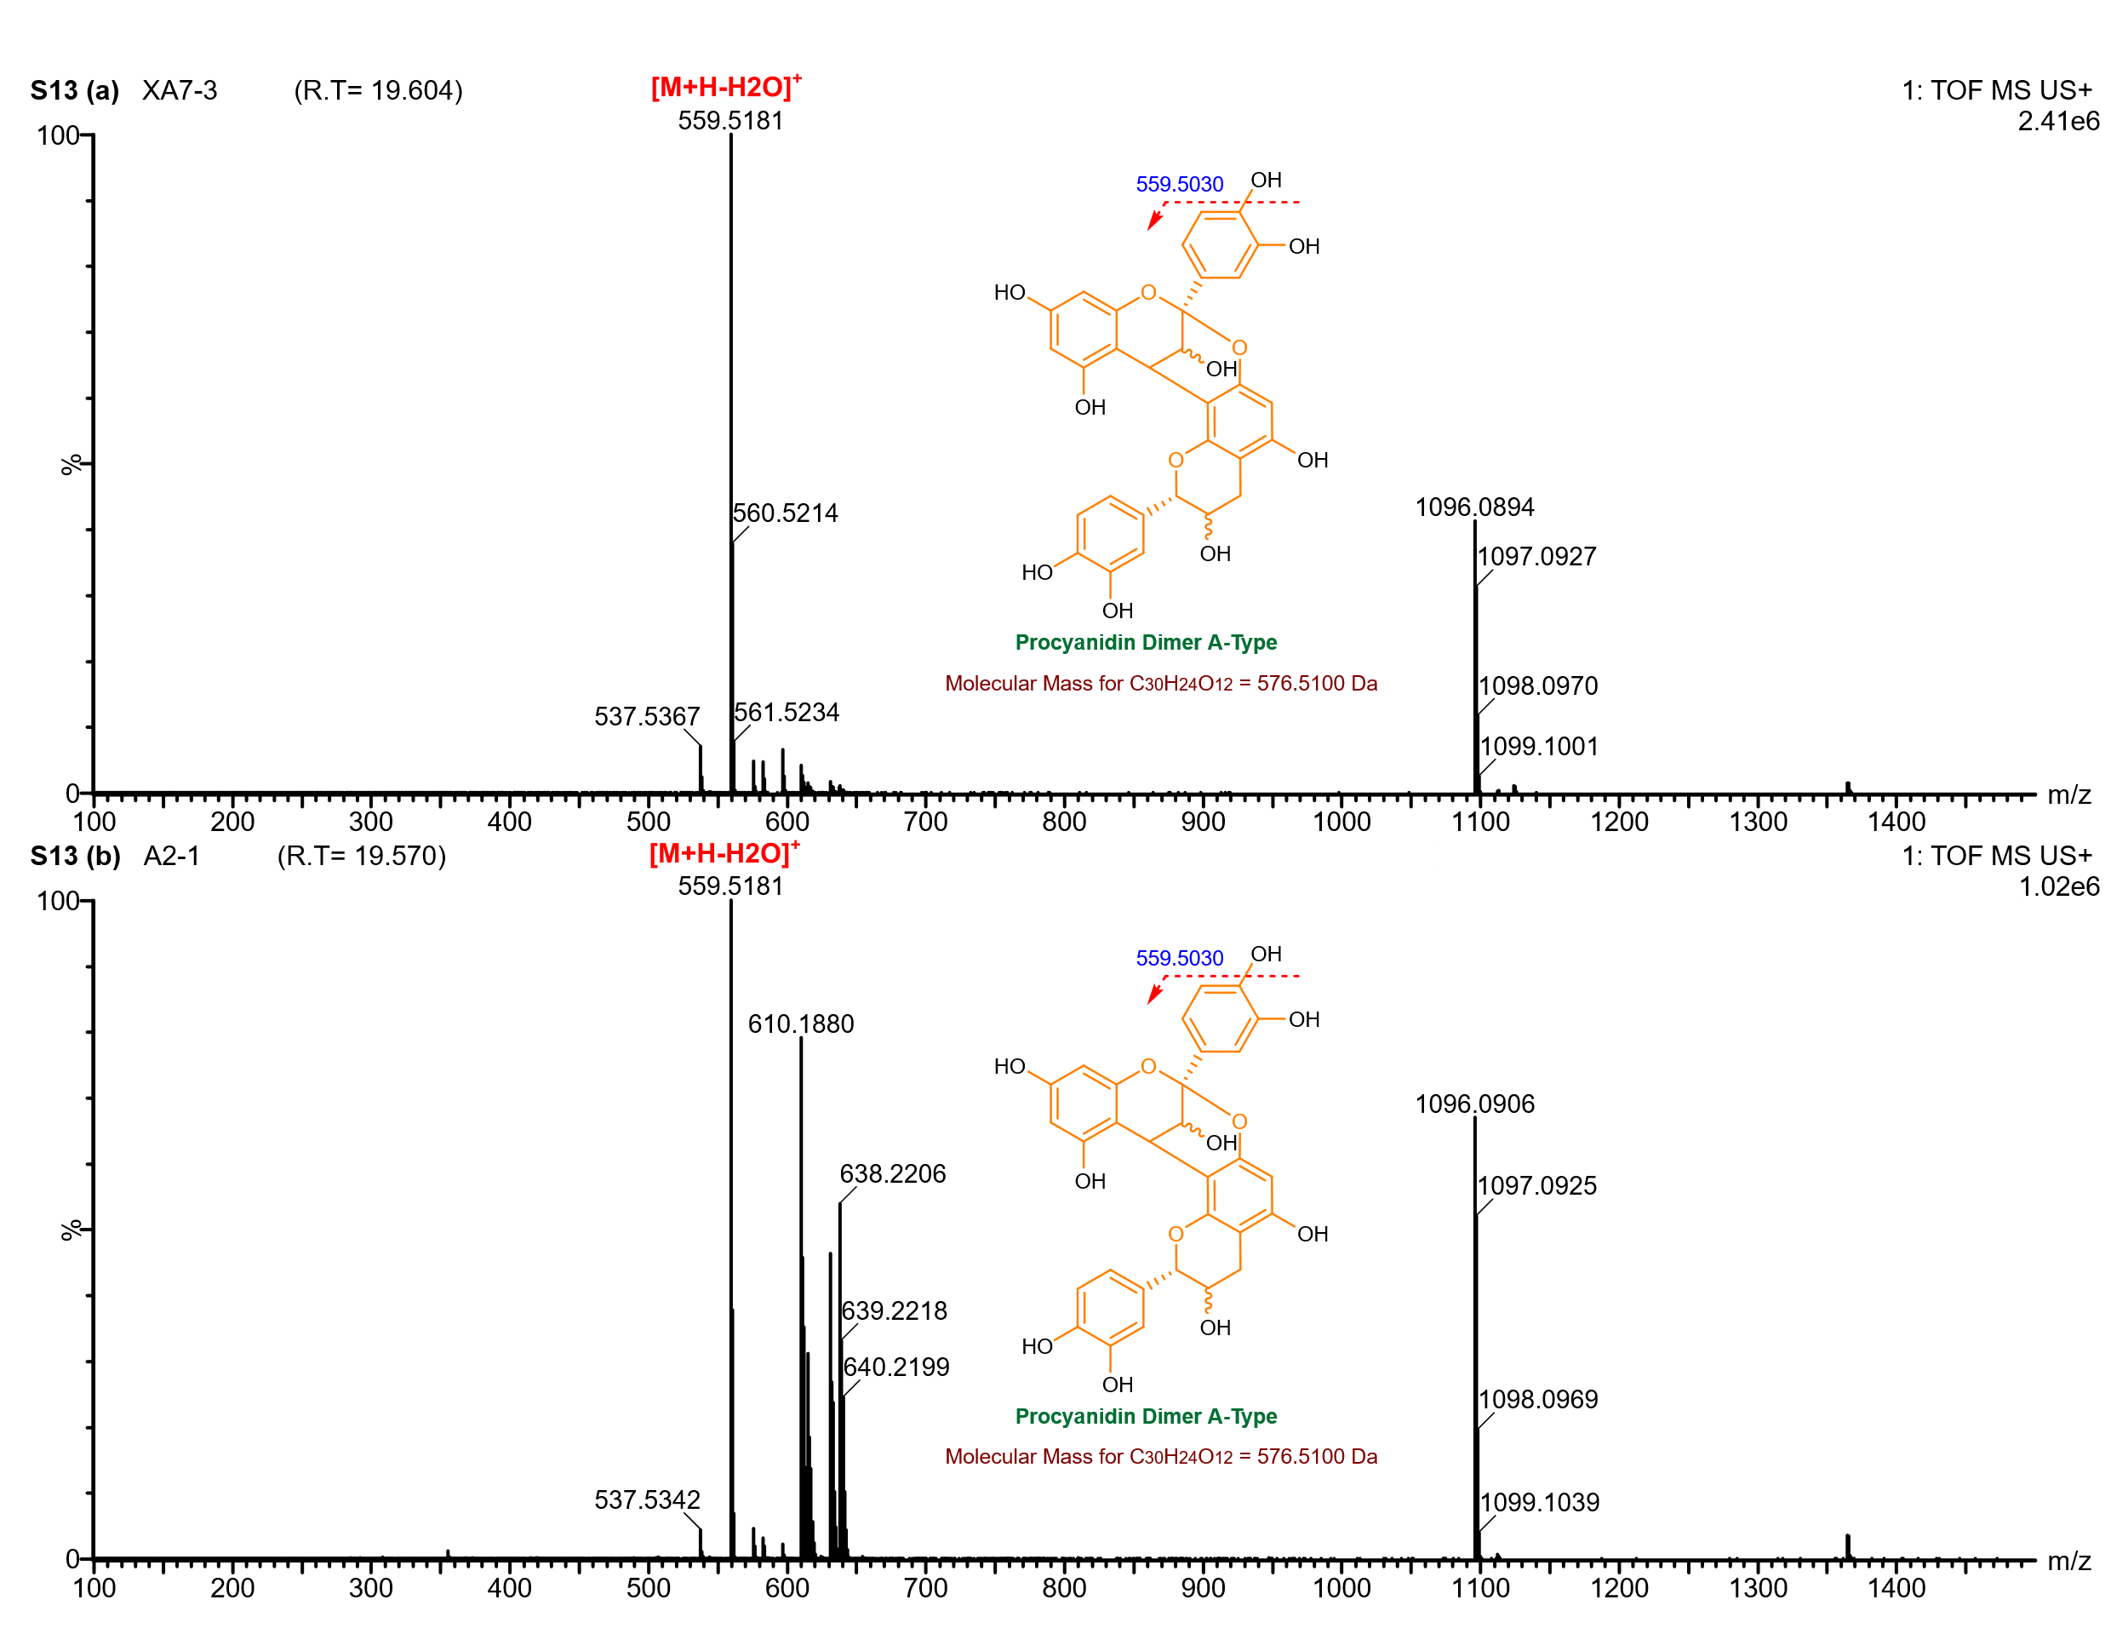
Supplementary Figure 13: UPLC-Q-ToF-MS spectrum of the A-type procyanidin dimer detected in lipid extracts from Keeladi samples, eluting at 19 minutes.

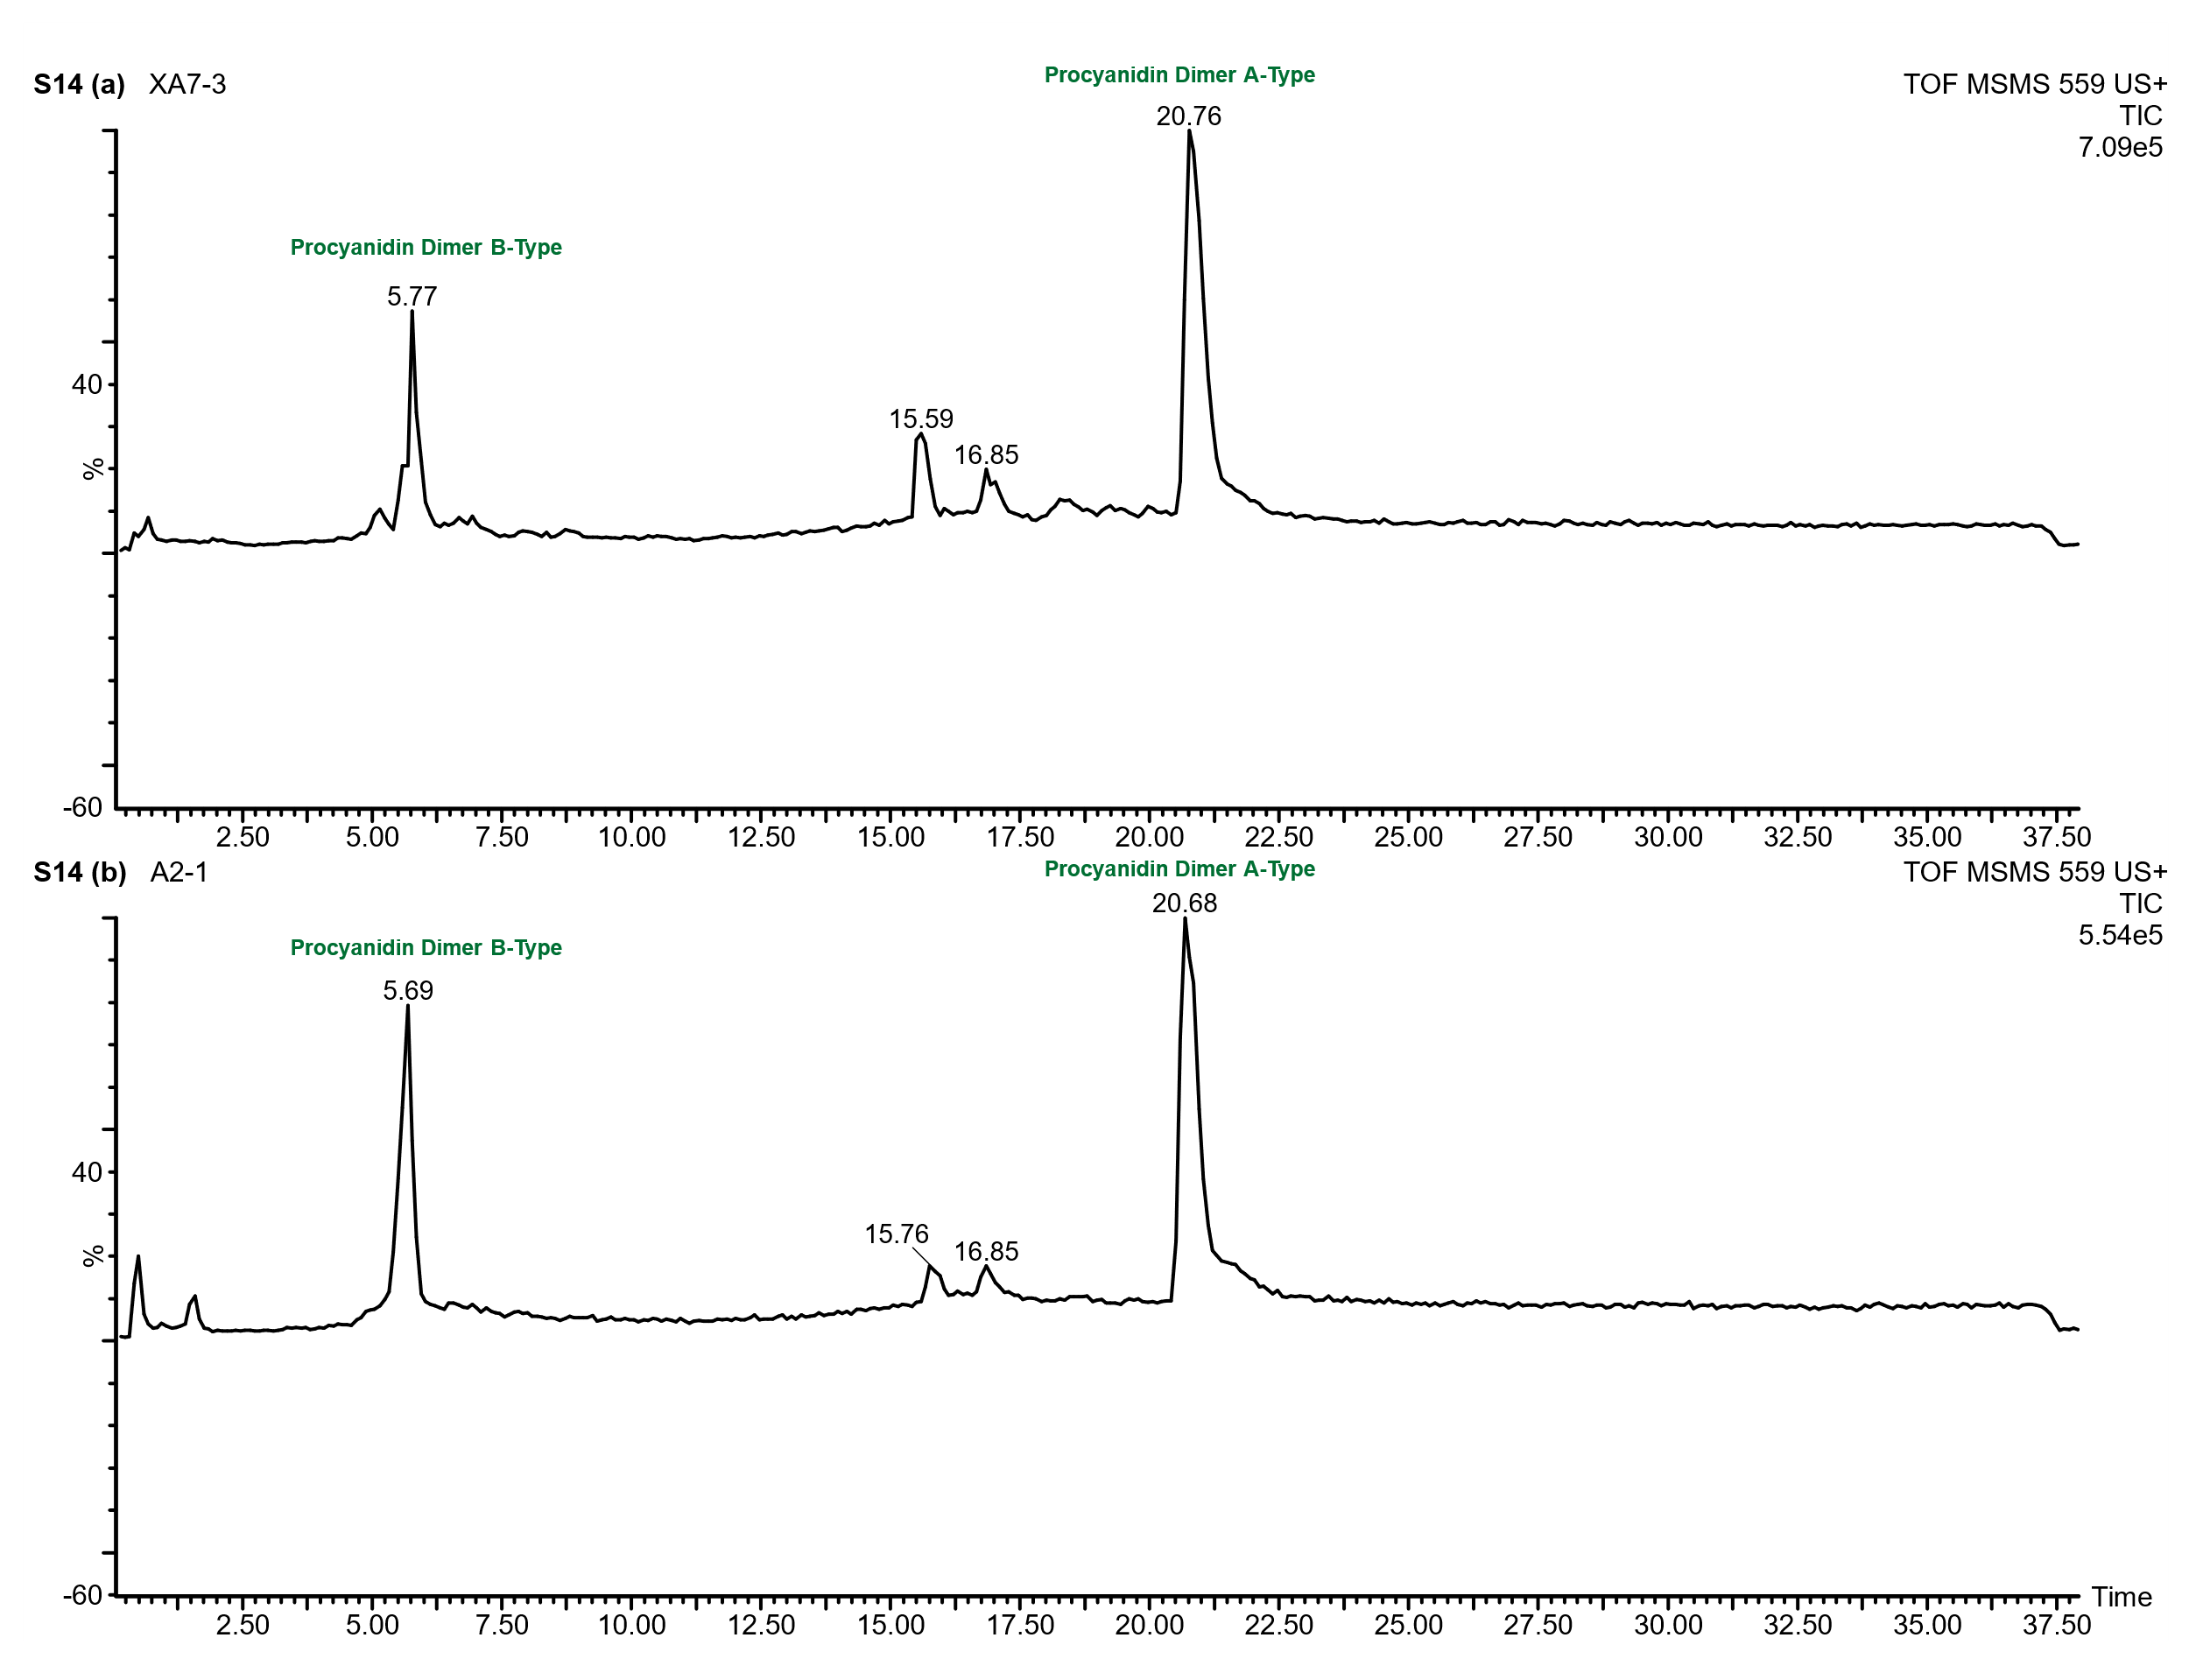
Supplementary Figure 14: UPLC-Q-ToF-MS/MS chromatogram of the Keeladi lipid extract acquired at a collision energy of 40 eV, showing the separation of procyanidin dimers. The chromatogram clearly distinguishes A-type and B-type procyanidin dimers, which elute at different retention times.

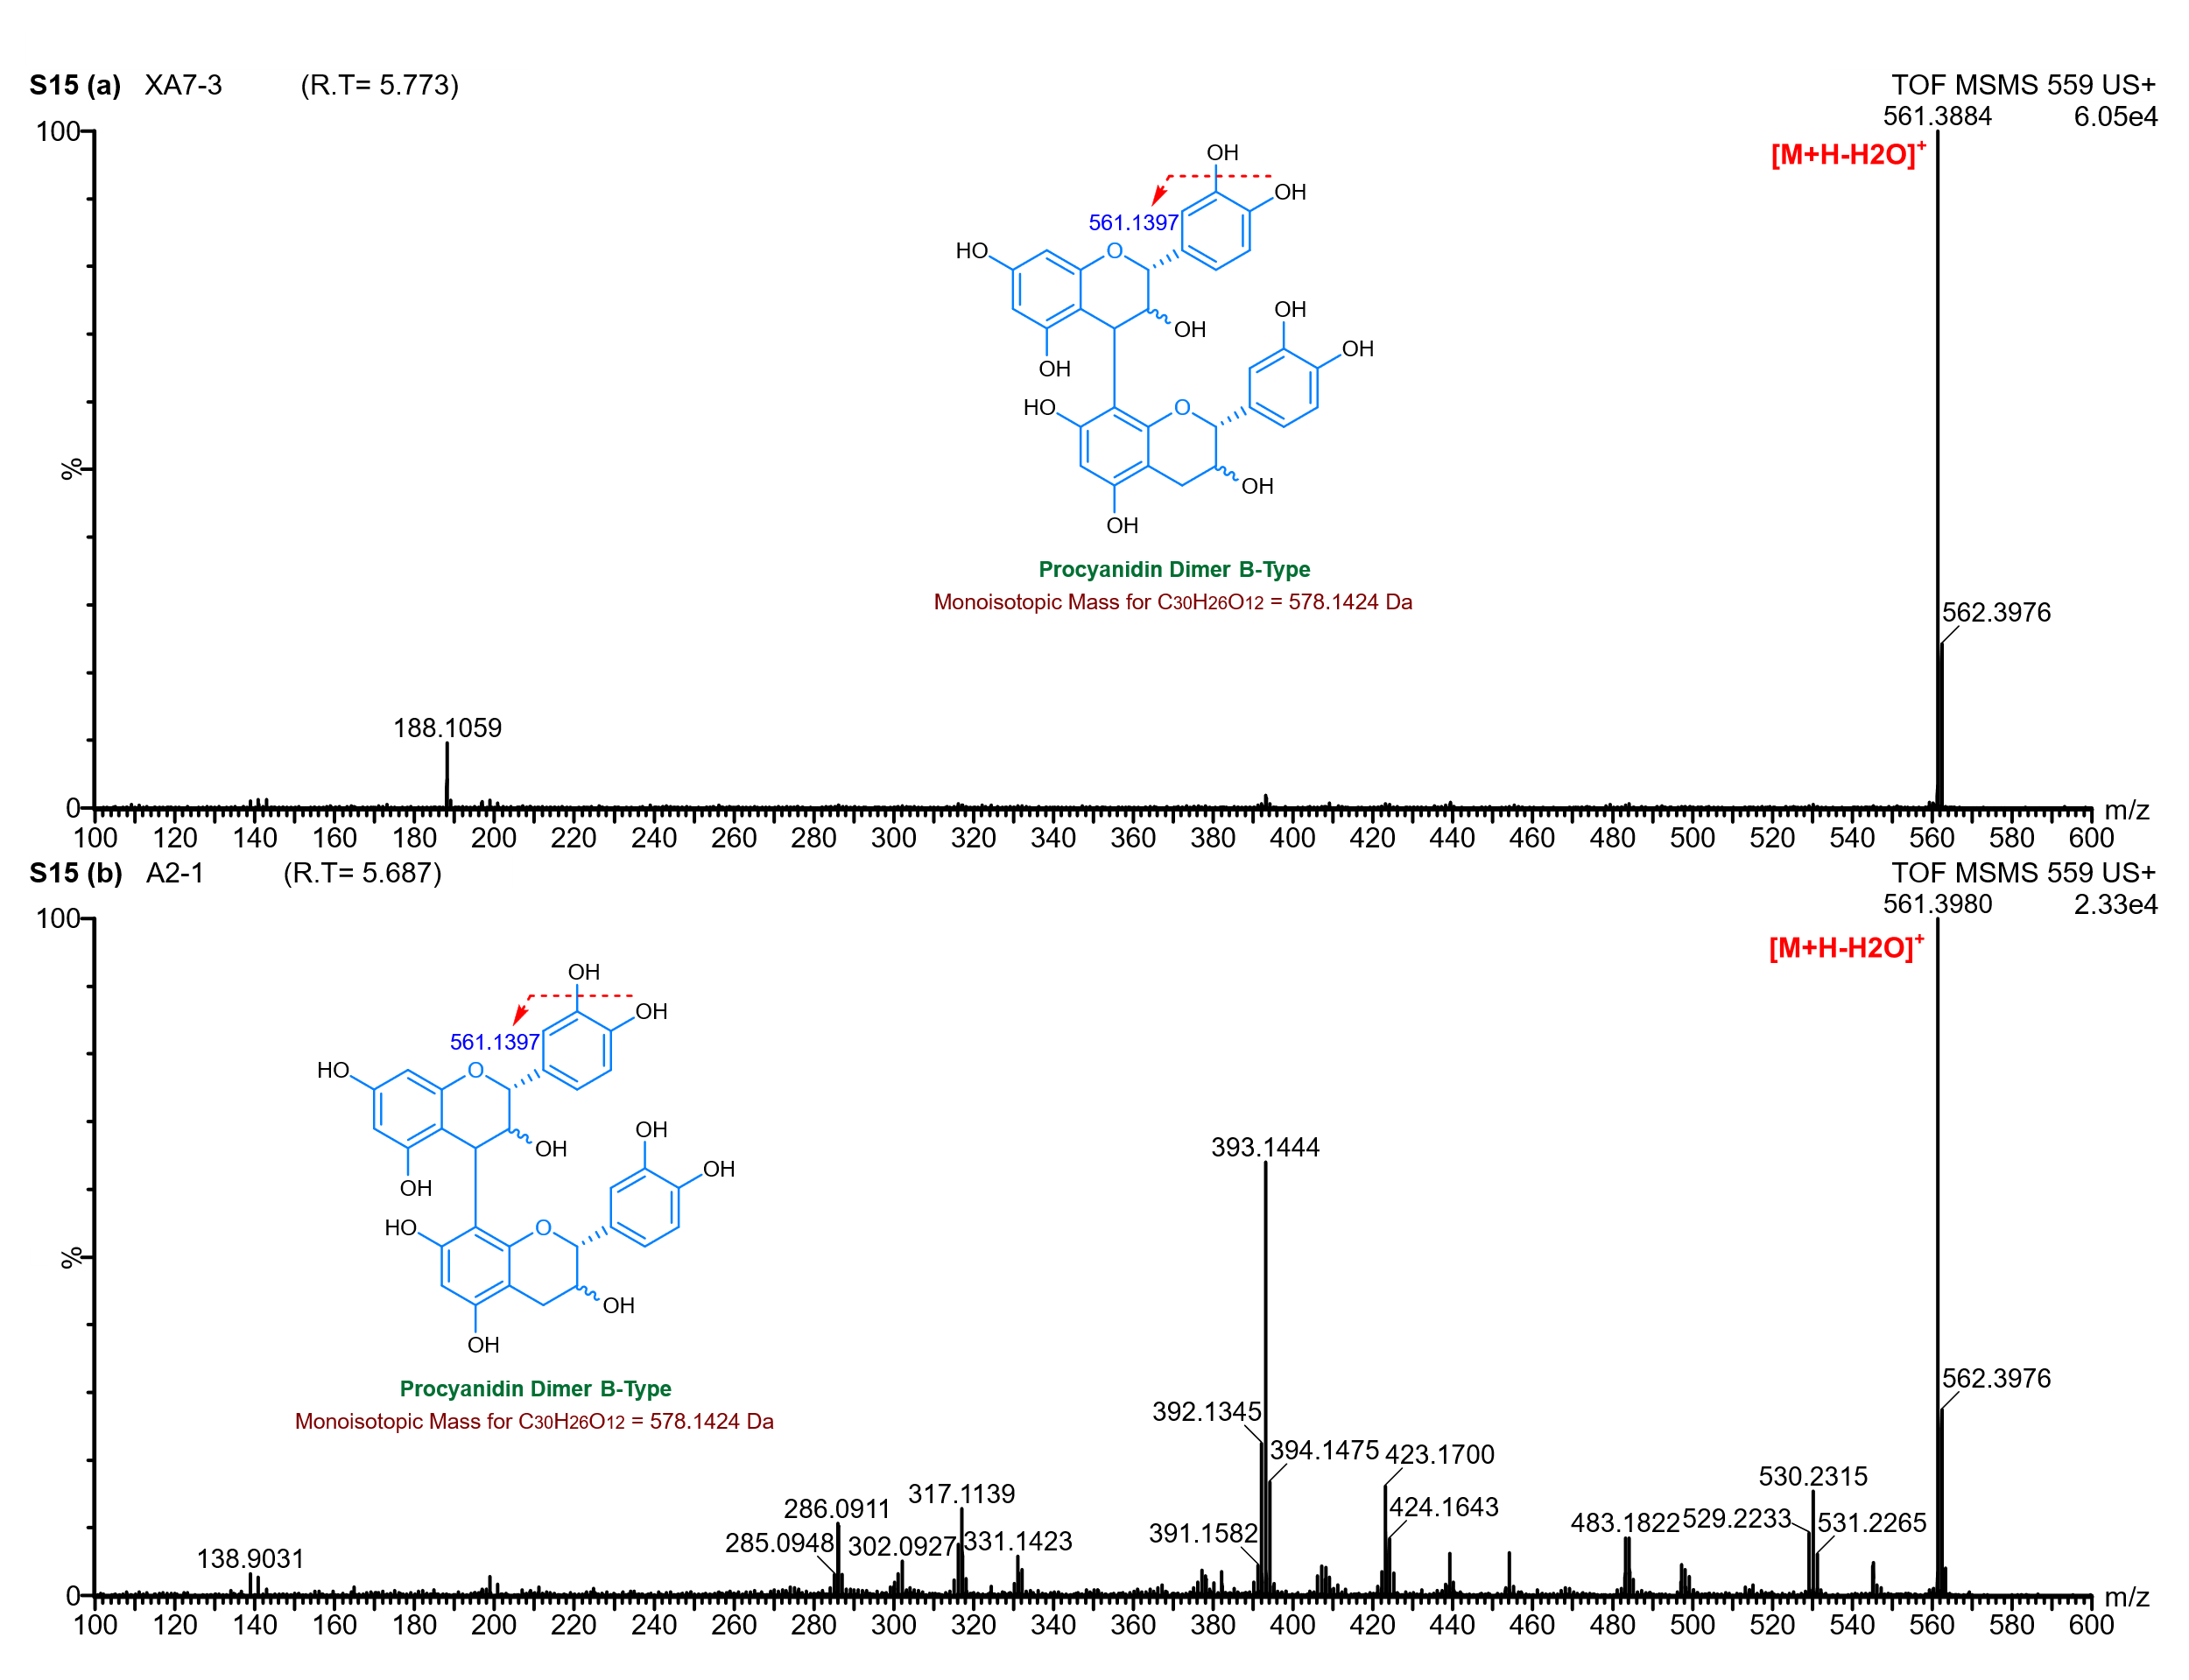
Supplementary Figure 15: Product ion (MS/MS) spectrum of the precursor ion at m/z 559 obtained from the lipid extracts of Keeladi samples. Fragmentation was acquired via UPLC-Q-ToF-MS/MS using a collision energy of 40 eV.

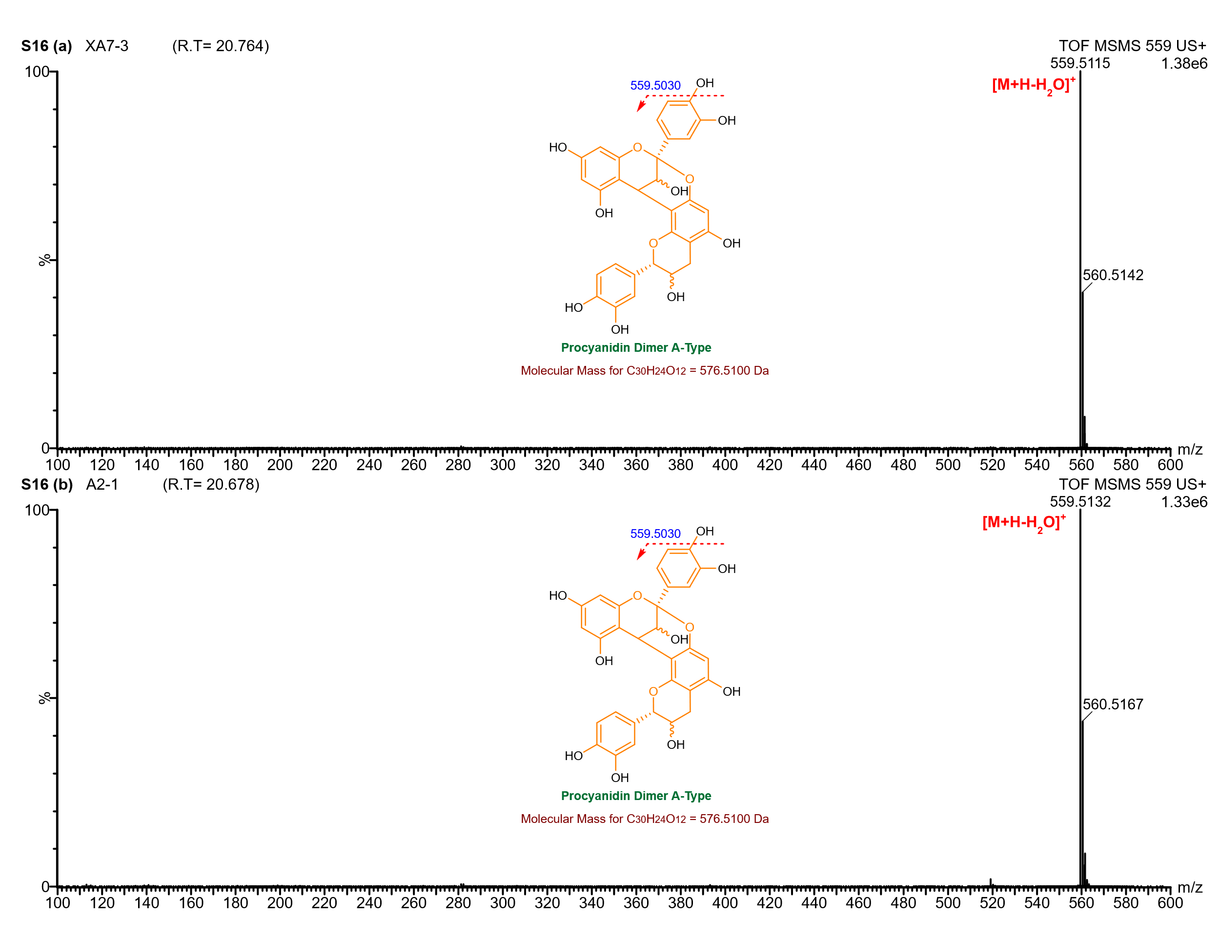
Supplementary Figure 16: Product ion (MS/MS) spectrum of the precursor ion at m/z 559 obtained from the lipid extracts of Keeladi samples. Fragmentation was acquired via UPLC-Q-ToF-MS/MS using a collision energy of 40 eV.

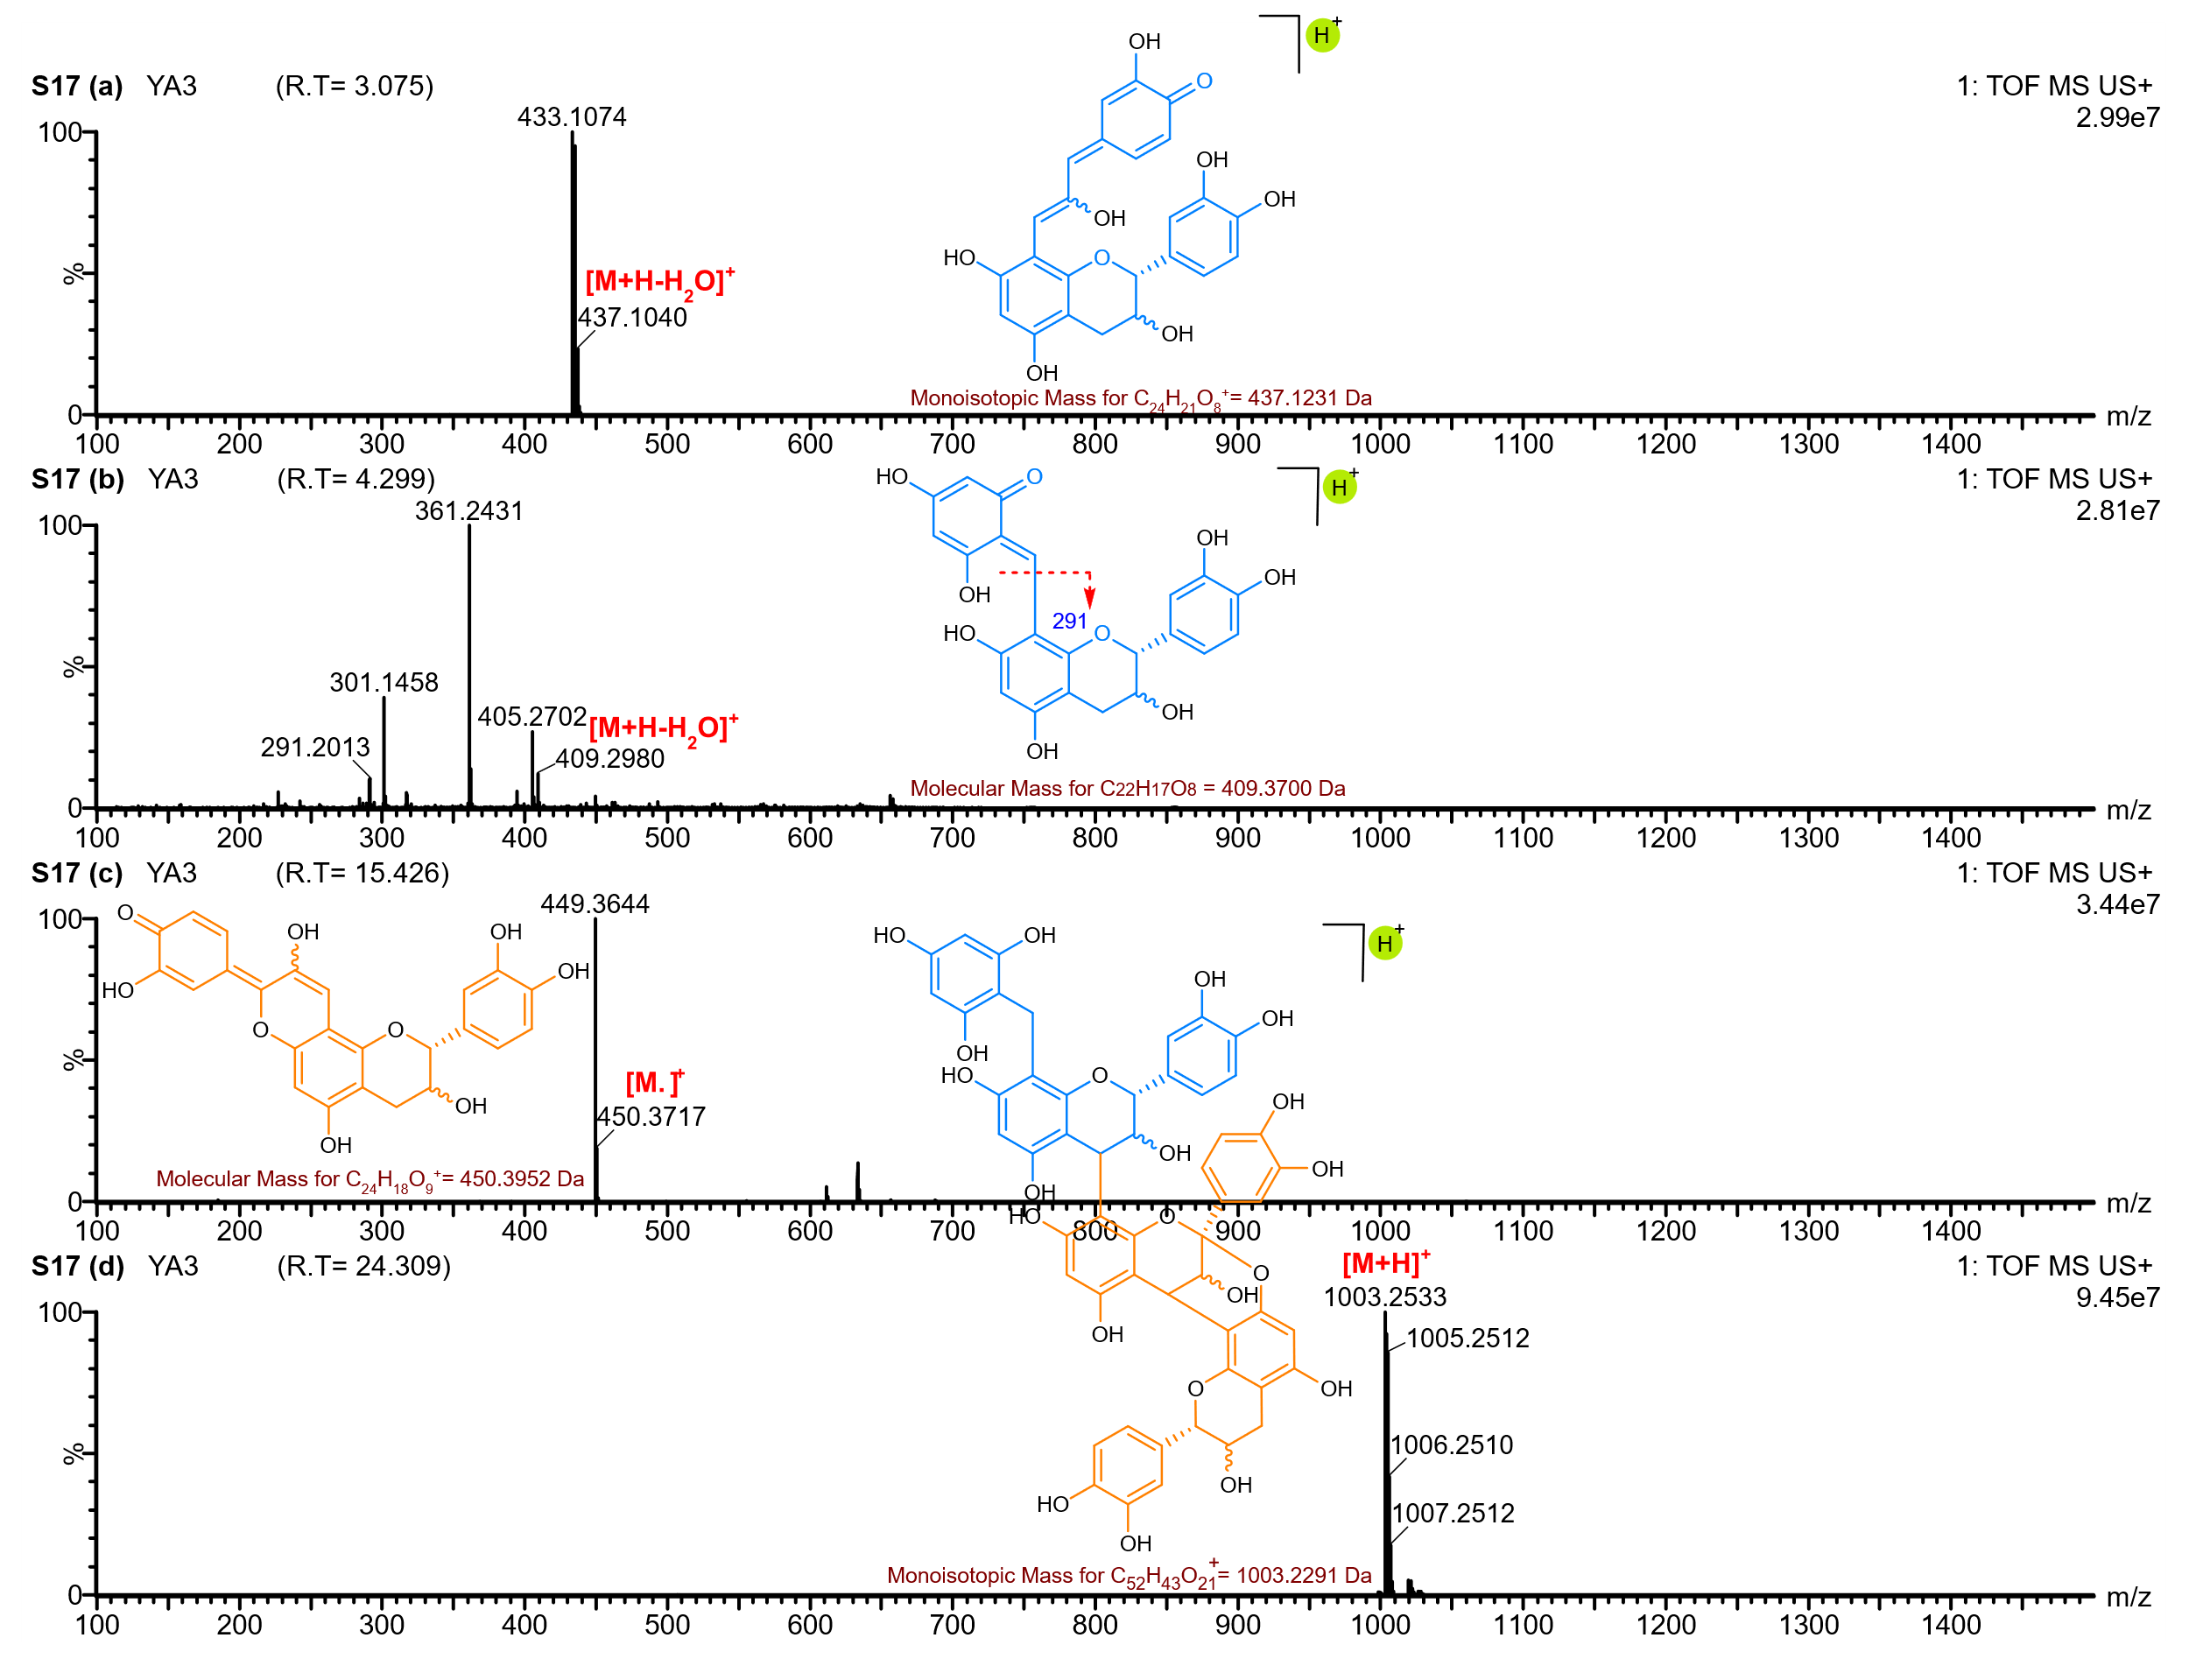
Supplementary Figure 17: UPLC-Q-ToF-MS spectrum showing representative degradation products identified in the YA3 lipid extract.
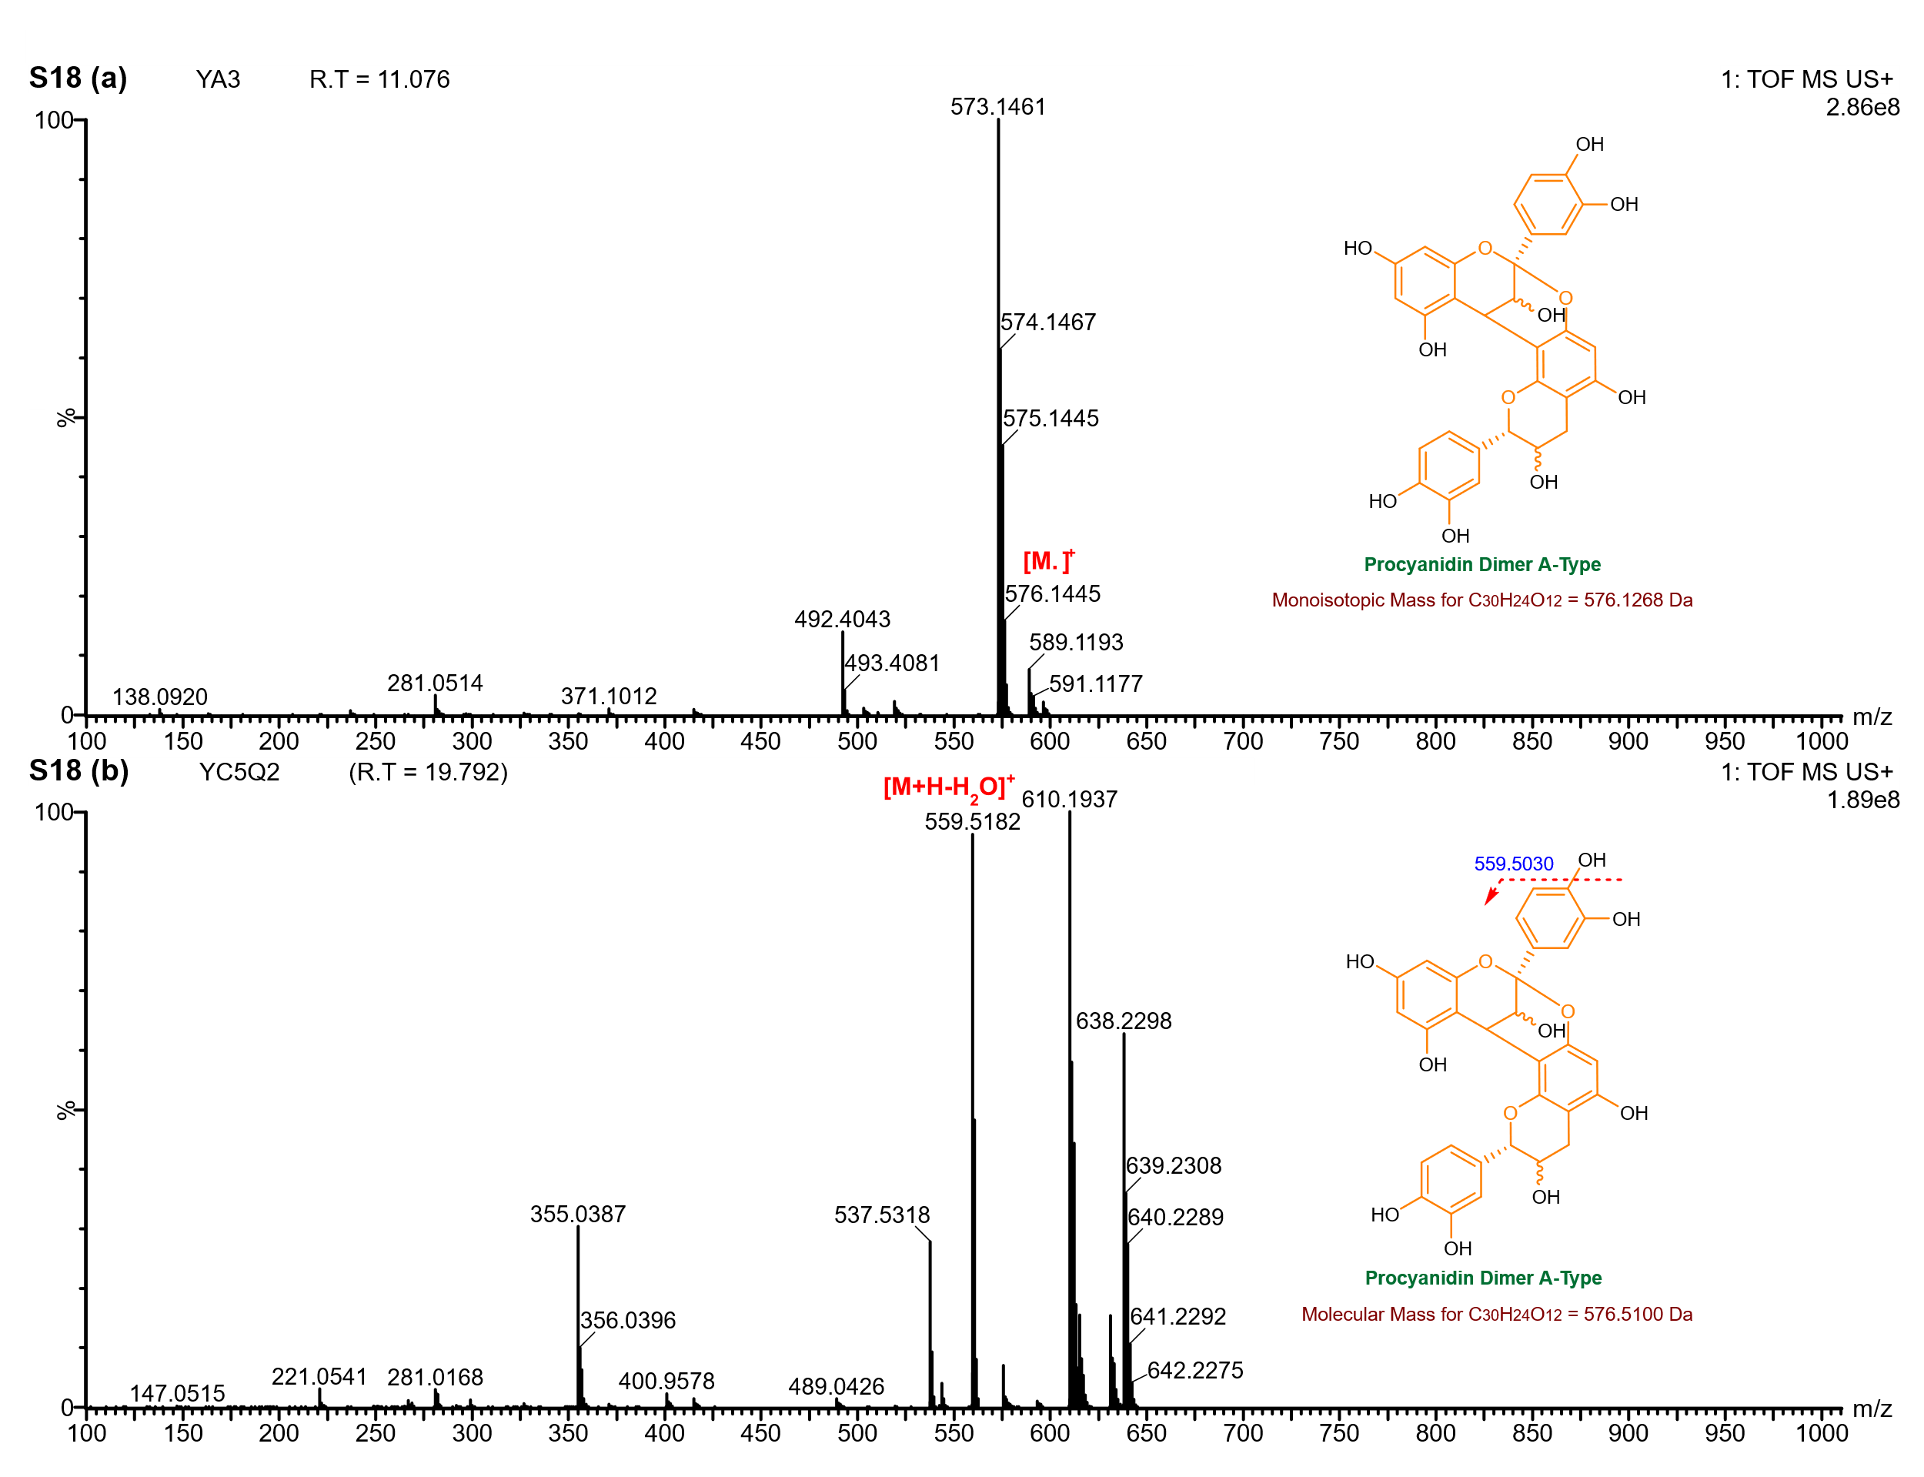
Supplementary Figure 18: UPLC-Q-ToF-MS spectrum of the A-type procyanidin dimer detected in lipid extracts from Gottiprolu samples.

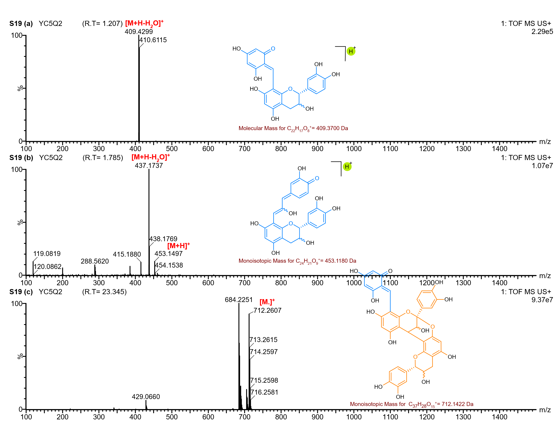
Supplementary Figure 19: UPLC-Q-ToF-MS spectrum showing representative degradation products identified in the YC5/Q2 lipid extract.

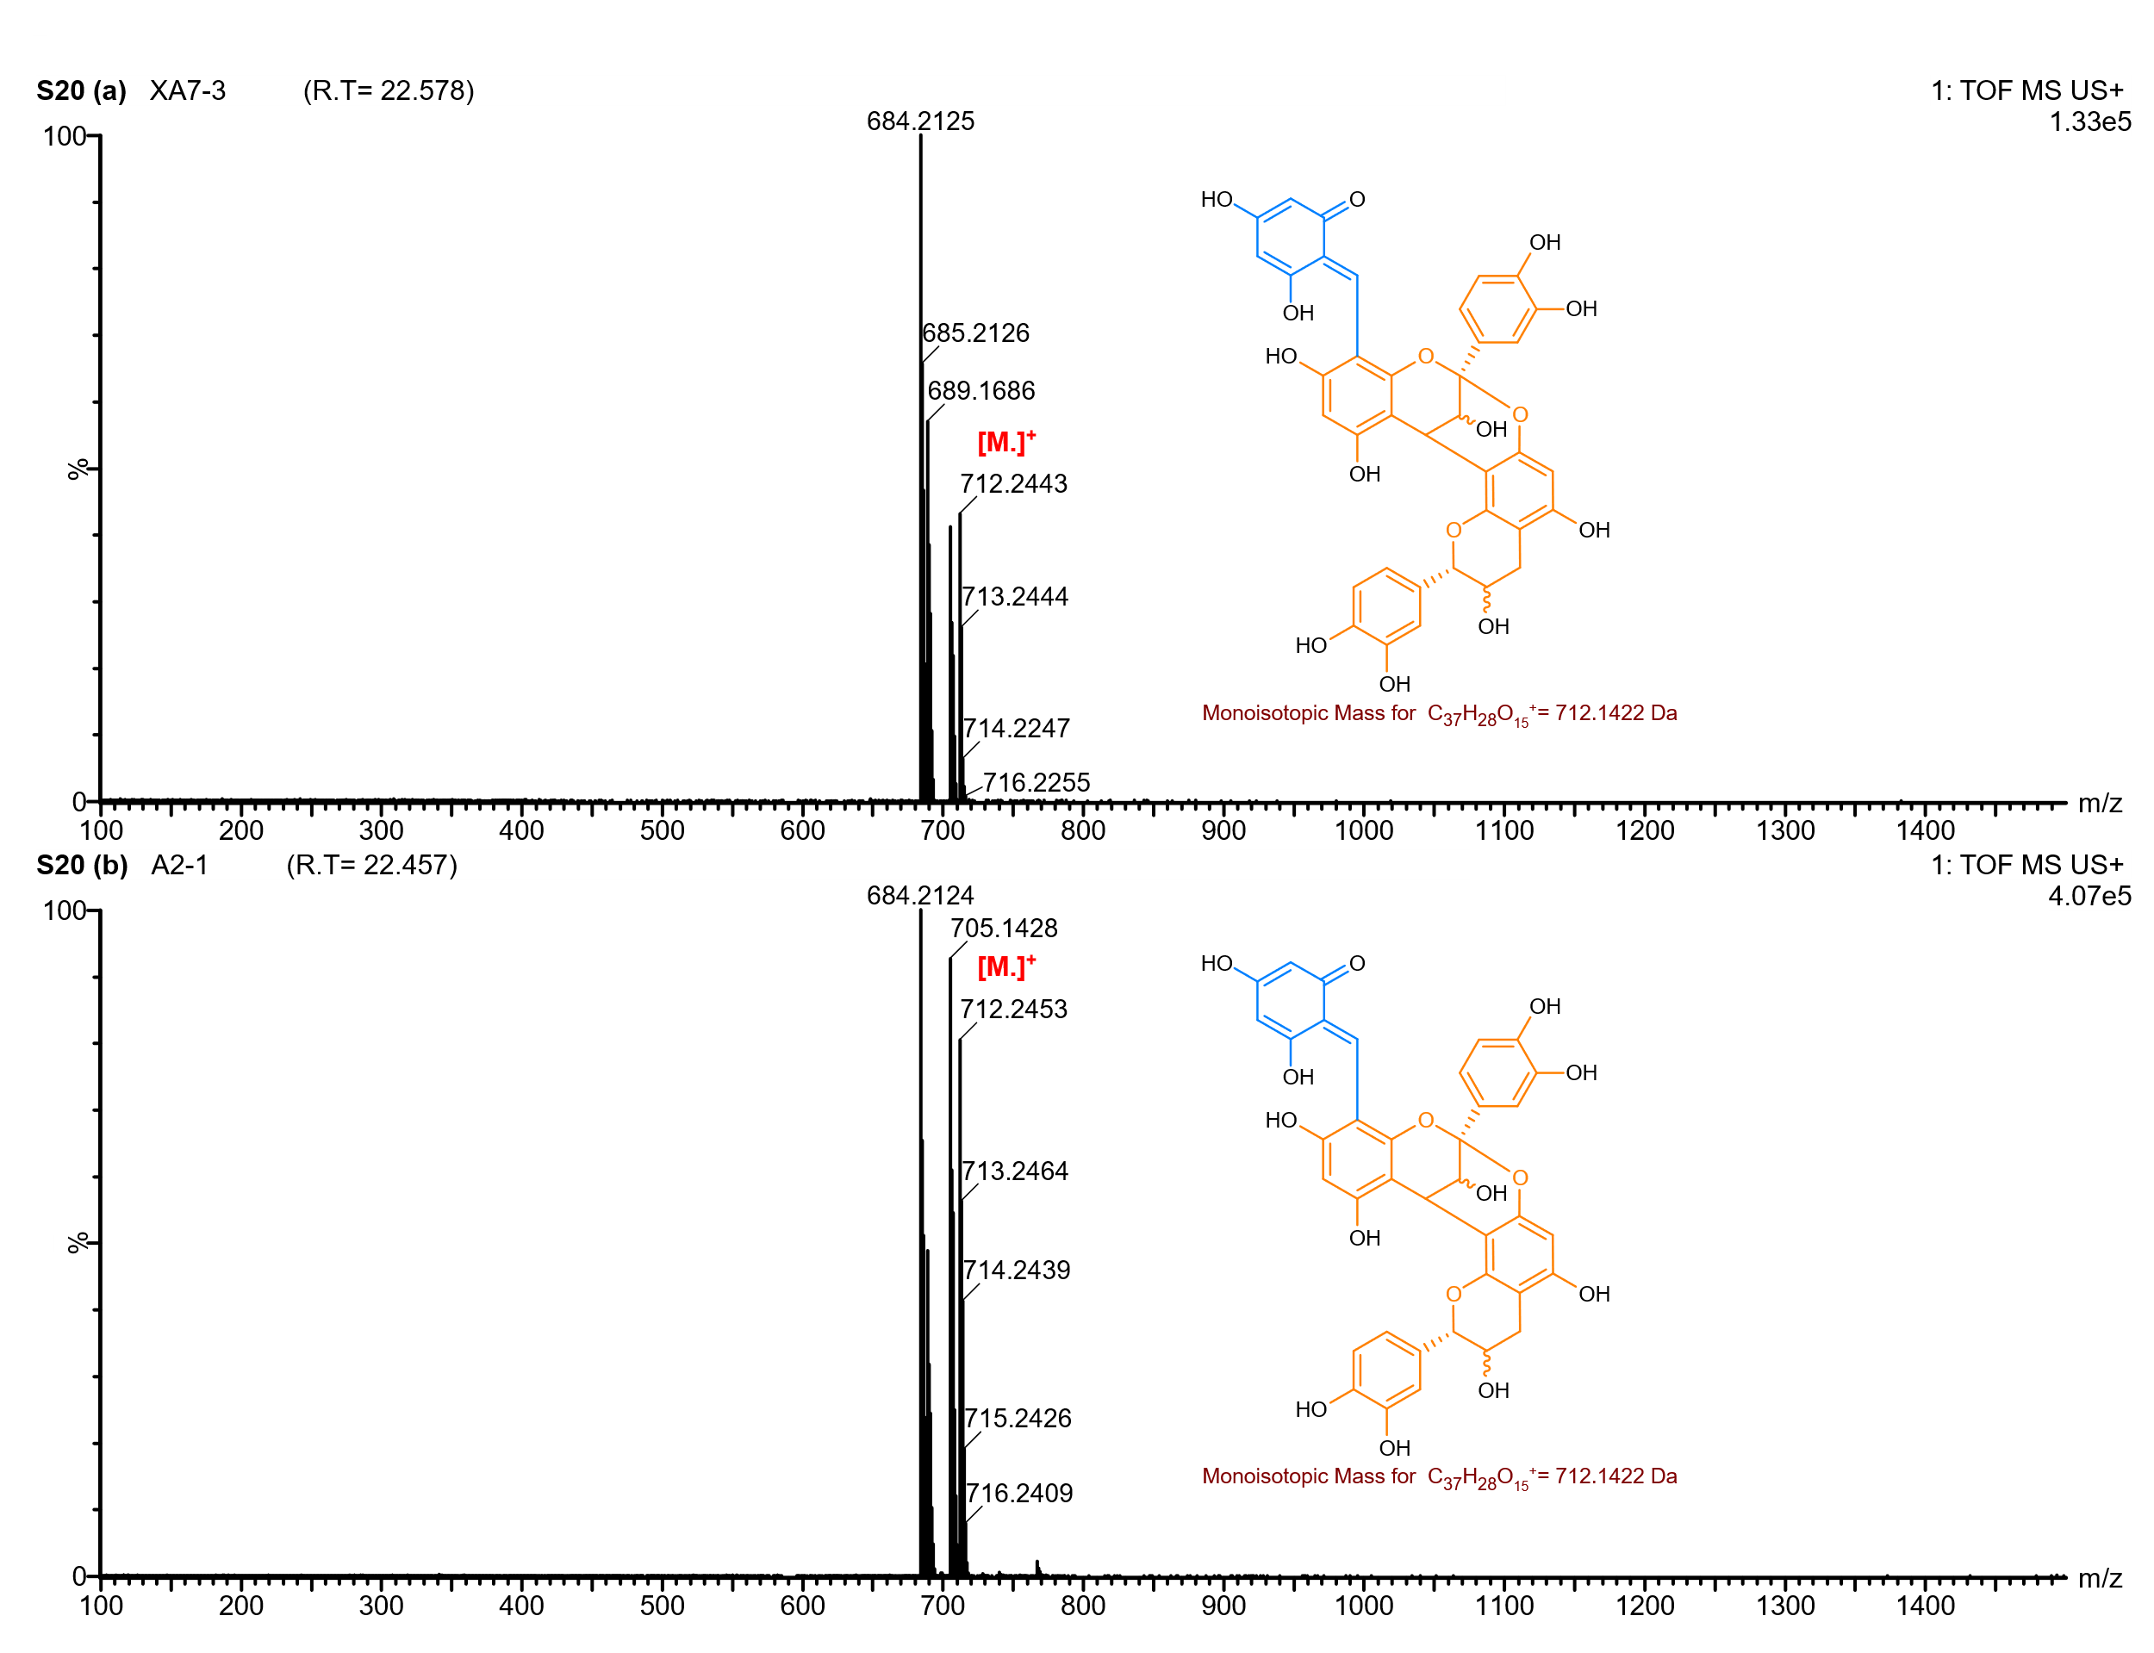
Supplementary Figure 20: UPLC-Q-ToF-MS spectrum showing representative degradation product (m/z 712) identified in the Keeladi lipid extracts.

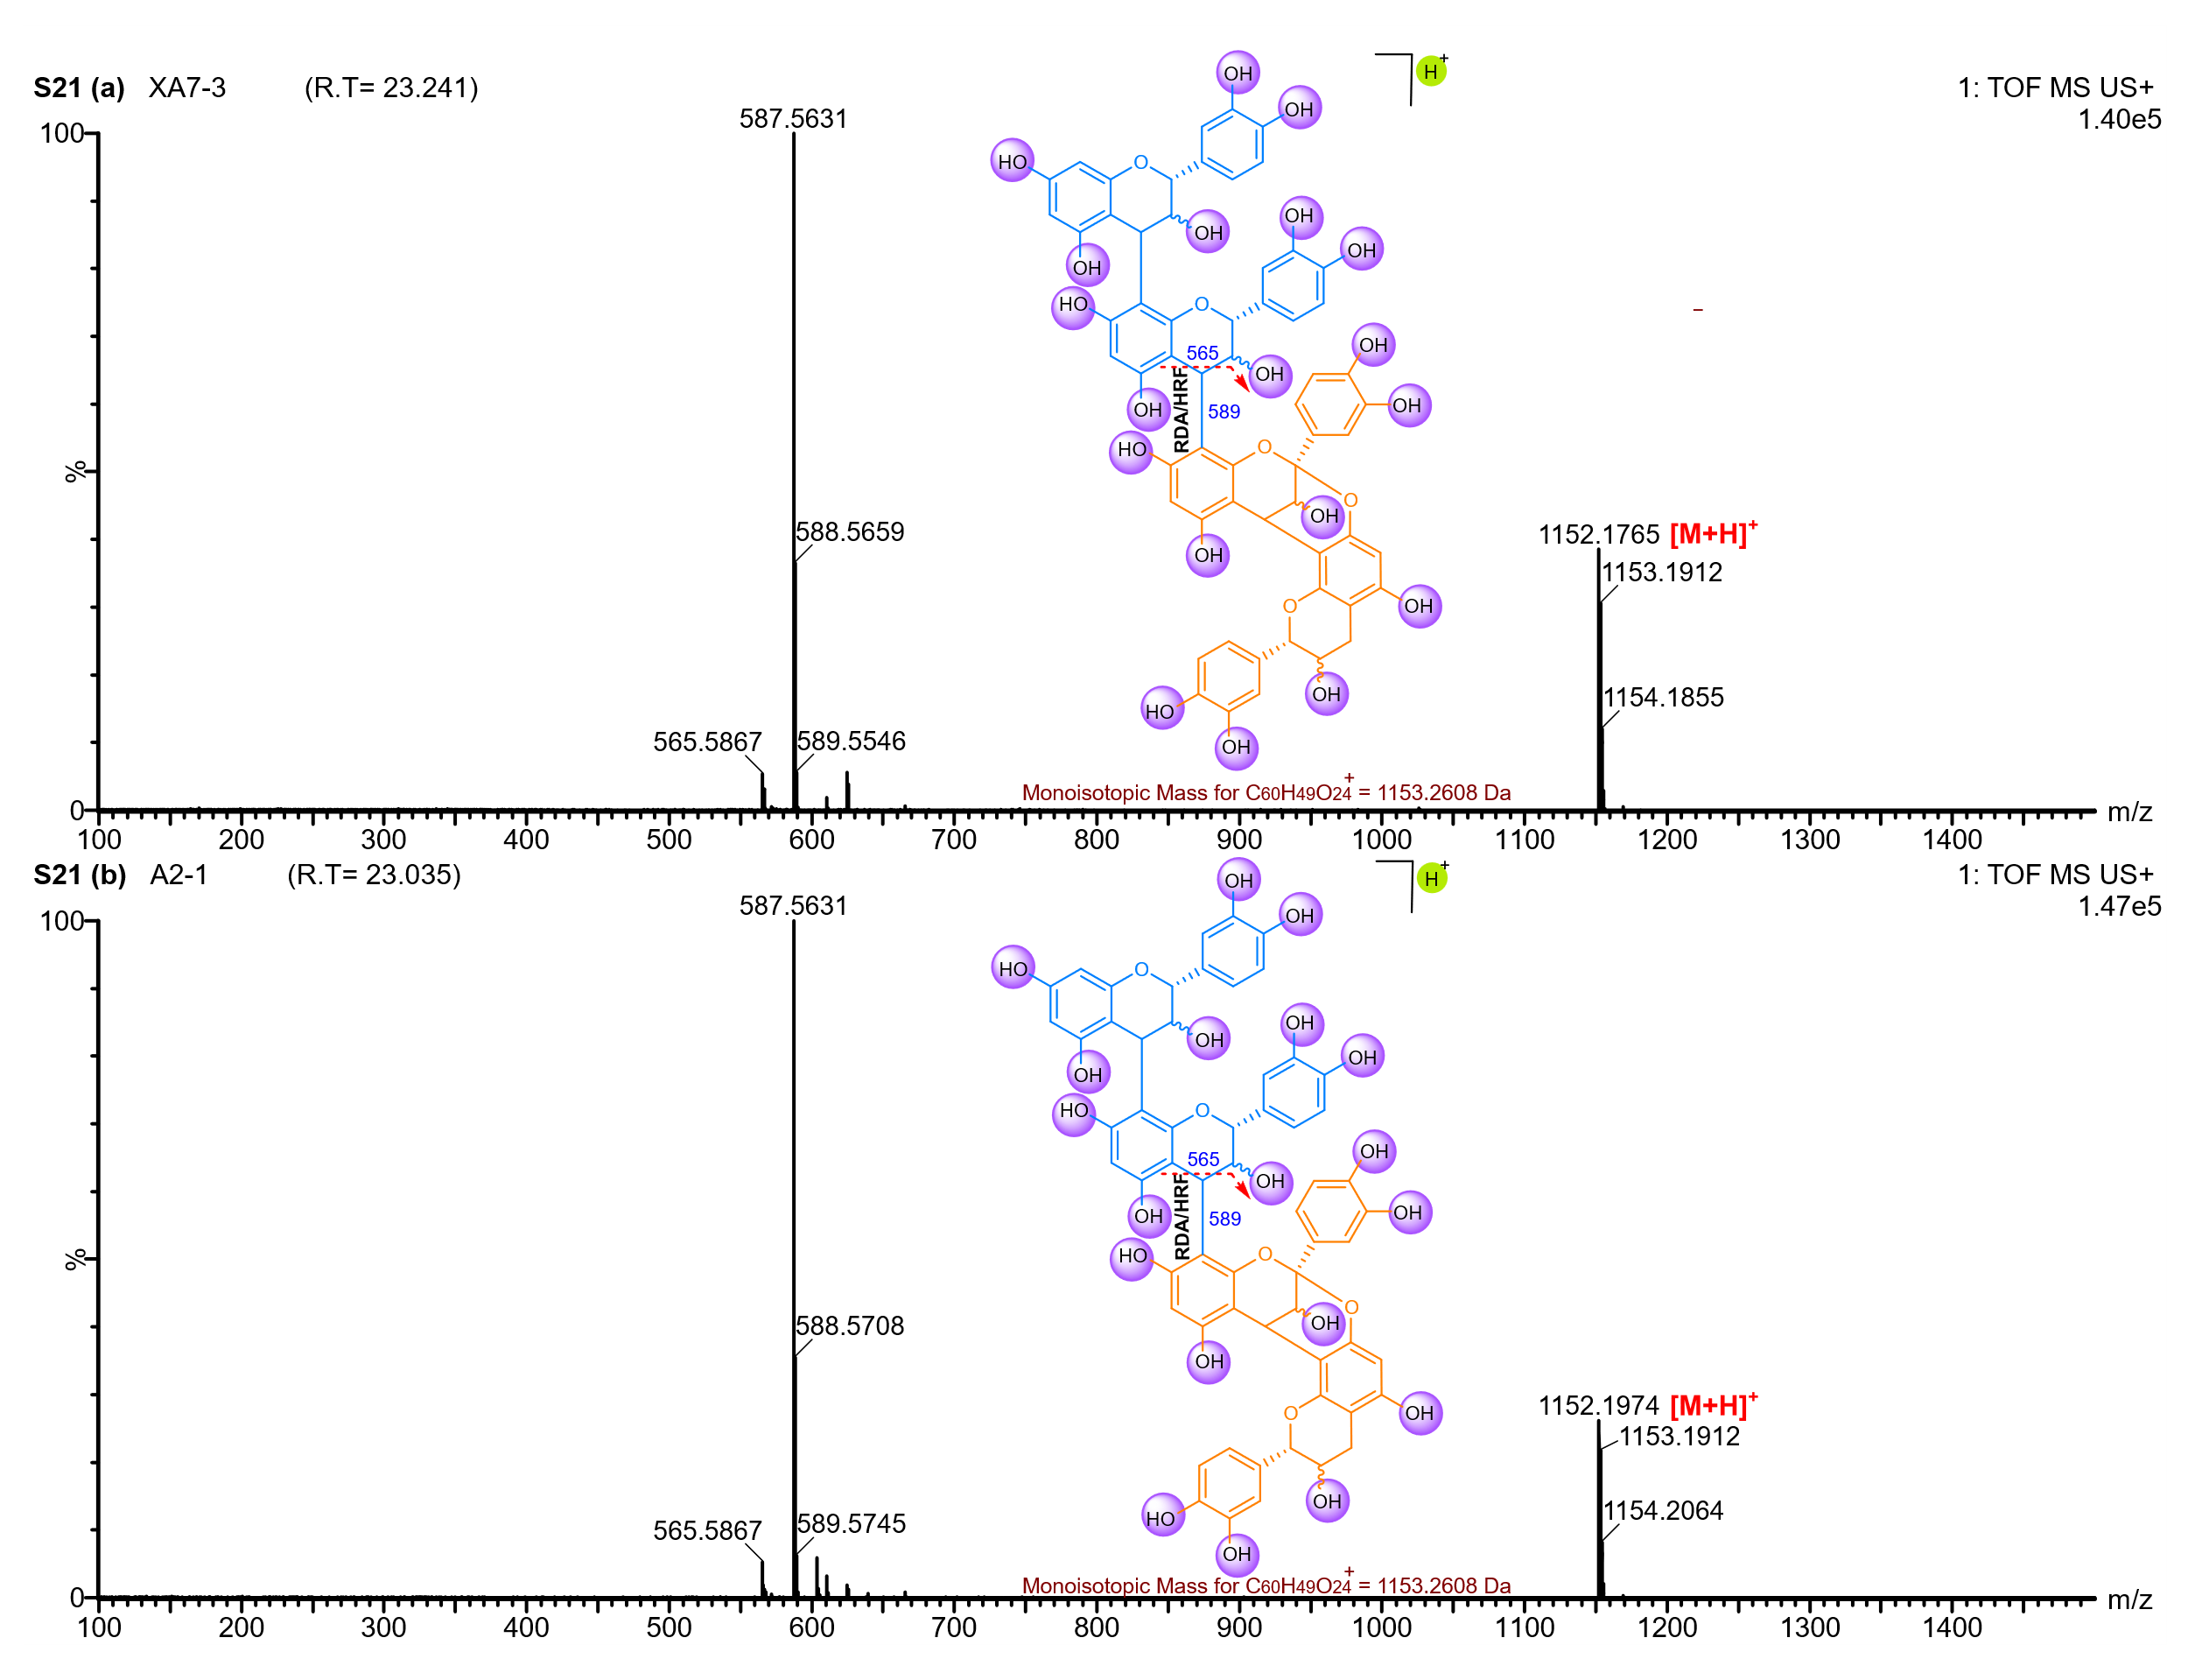
Supplementary Figure 21: UPLC-Q-ToF-MS spectrum of the linear A-type procyanidin tetramer detected in lipid extracts from Keeladi samples, eluting at 23 minutes.

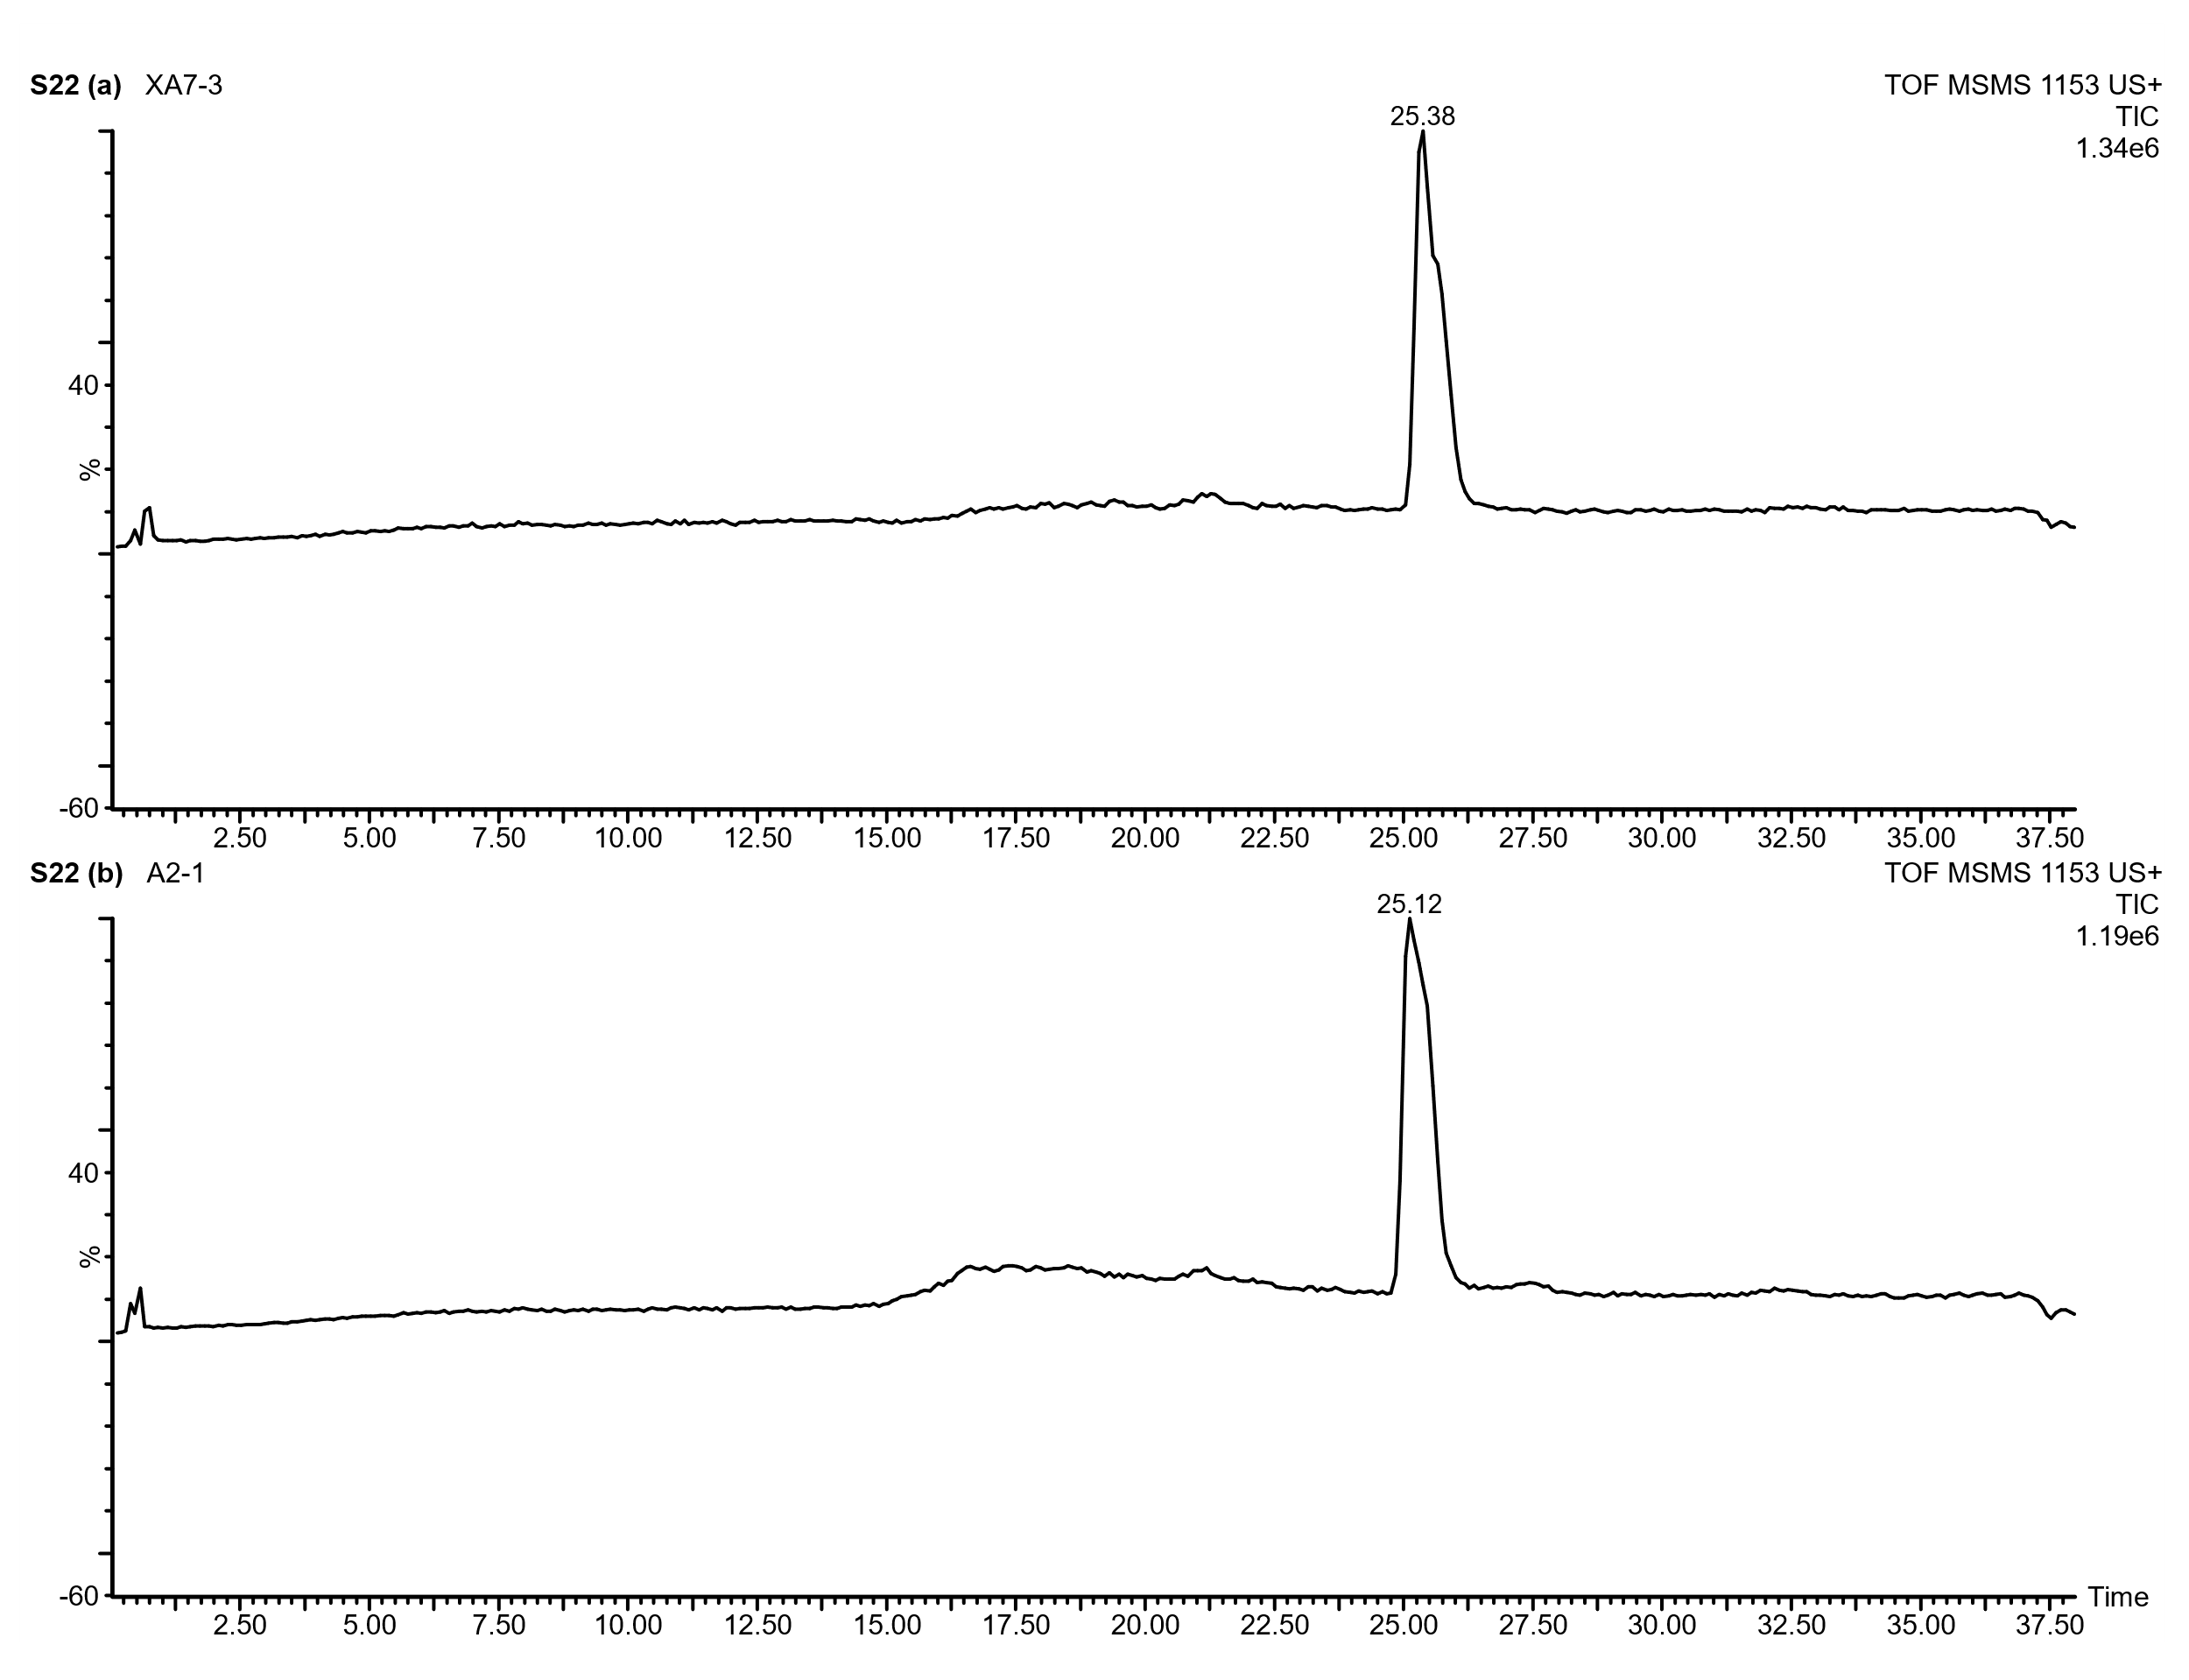
Supplementary Figure 22: UPLC-Q-ToF-MS/MS chromatogram of a linear A-type procyanidin tetramer detected in the Keeladi lipid extracts. The mass spectrum was acquired with a collision energy of 40 eV.

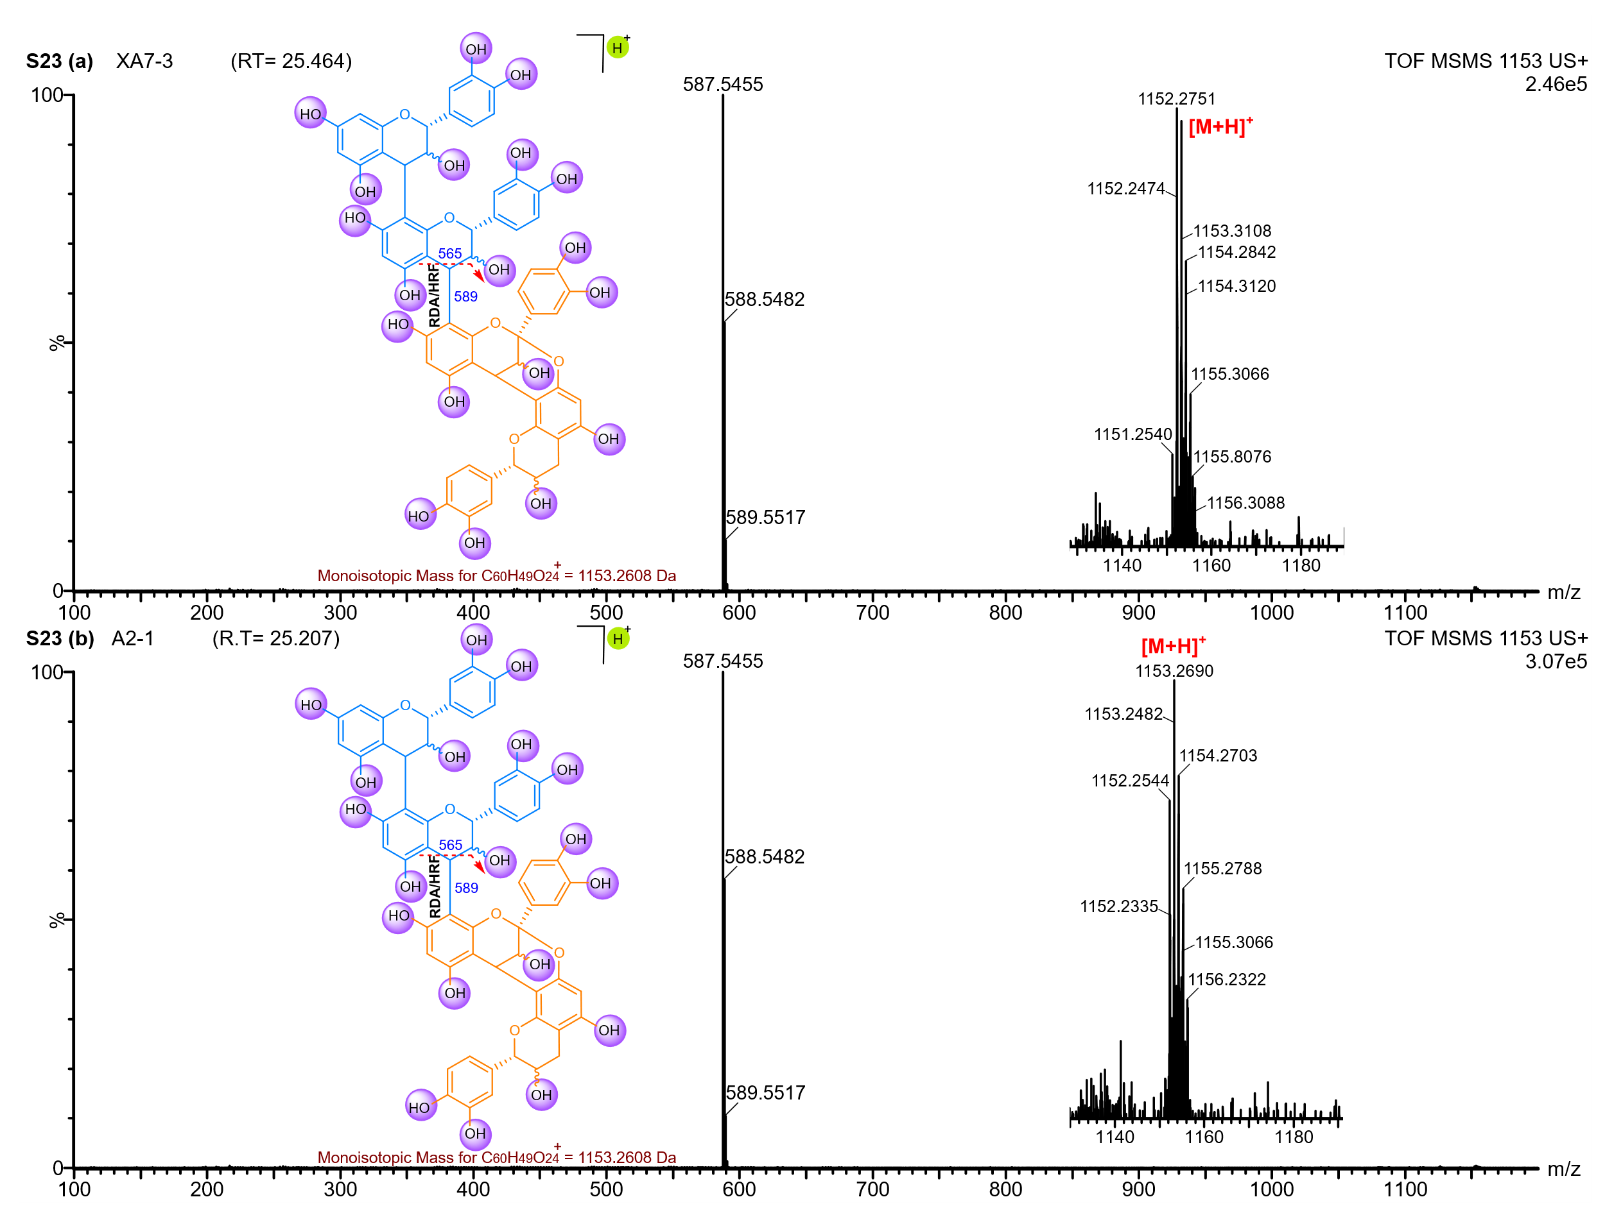
Supplementary Figure 23: UPLC-Q-ToF-MS/MS spectrum of a linear A-type procyanidin tetramer detected in the Keeladi lipid extracts. The mass spectrum was acquired with a collision energy of 40 eV.

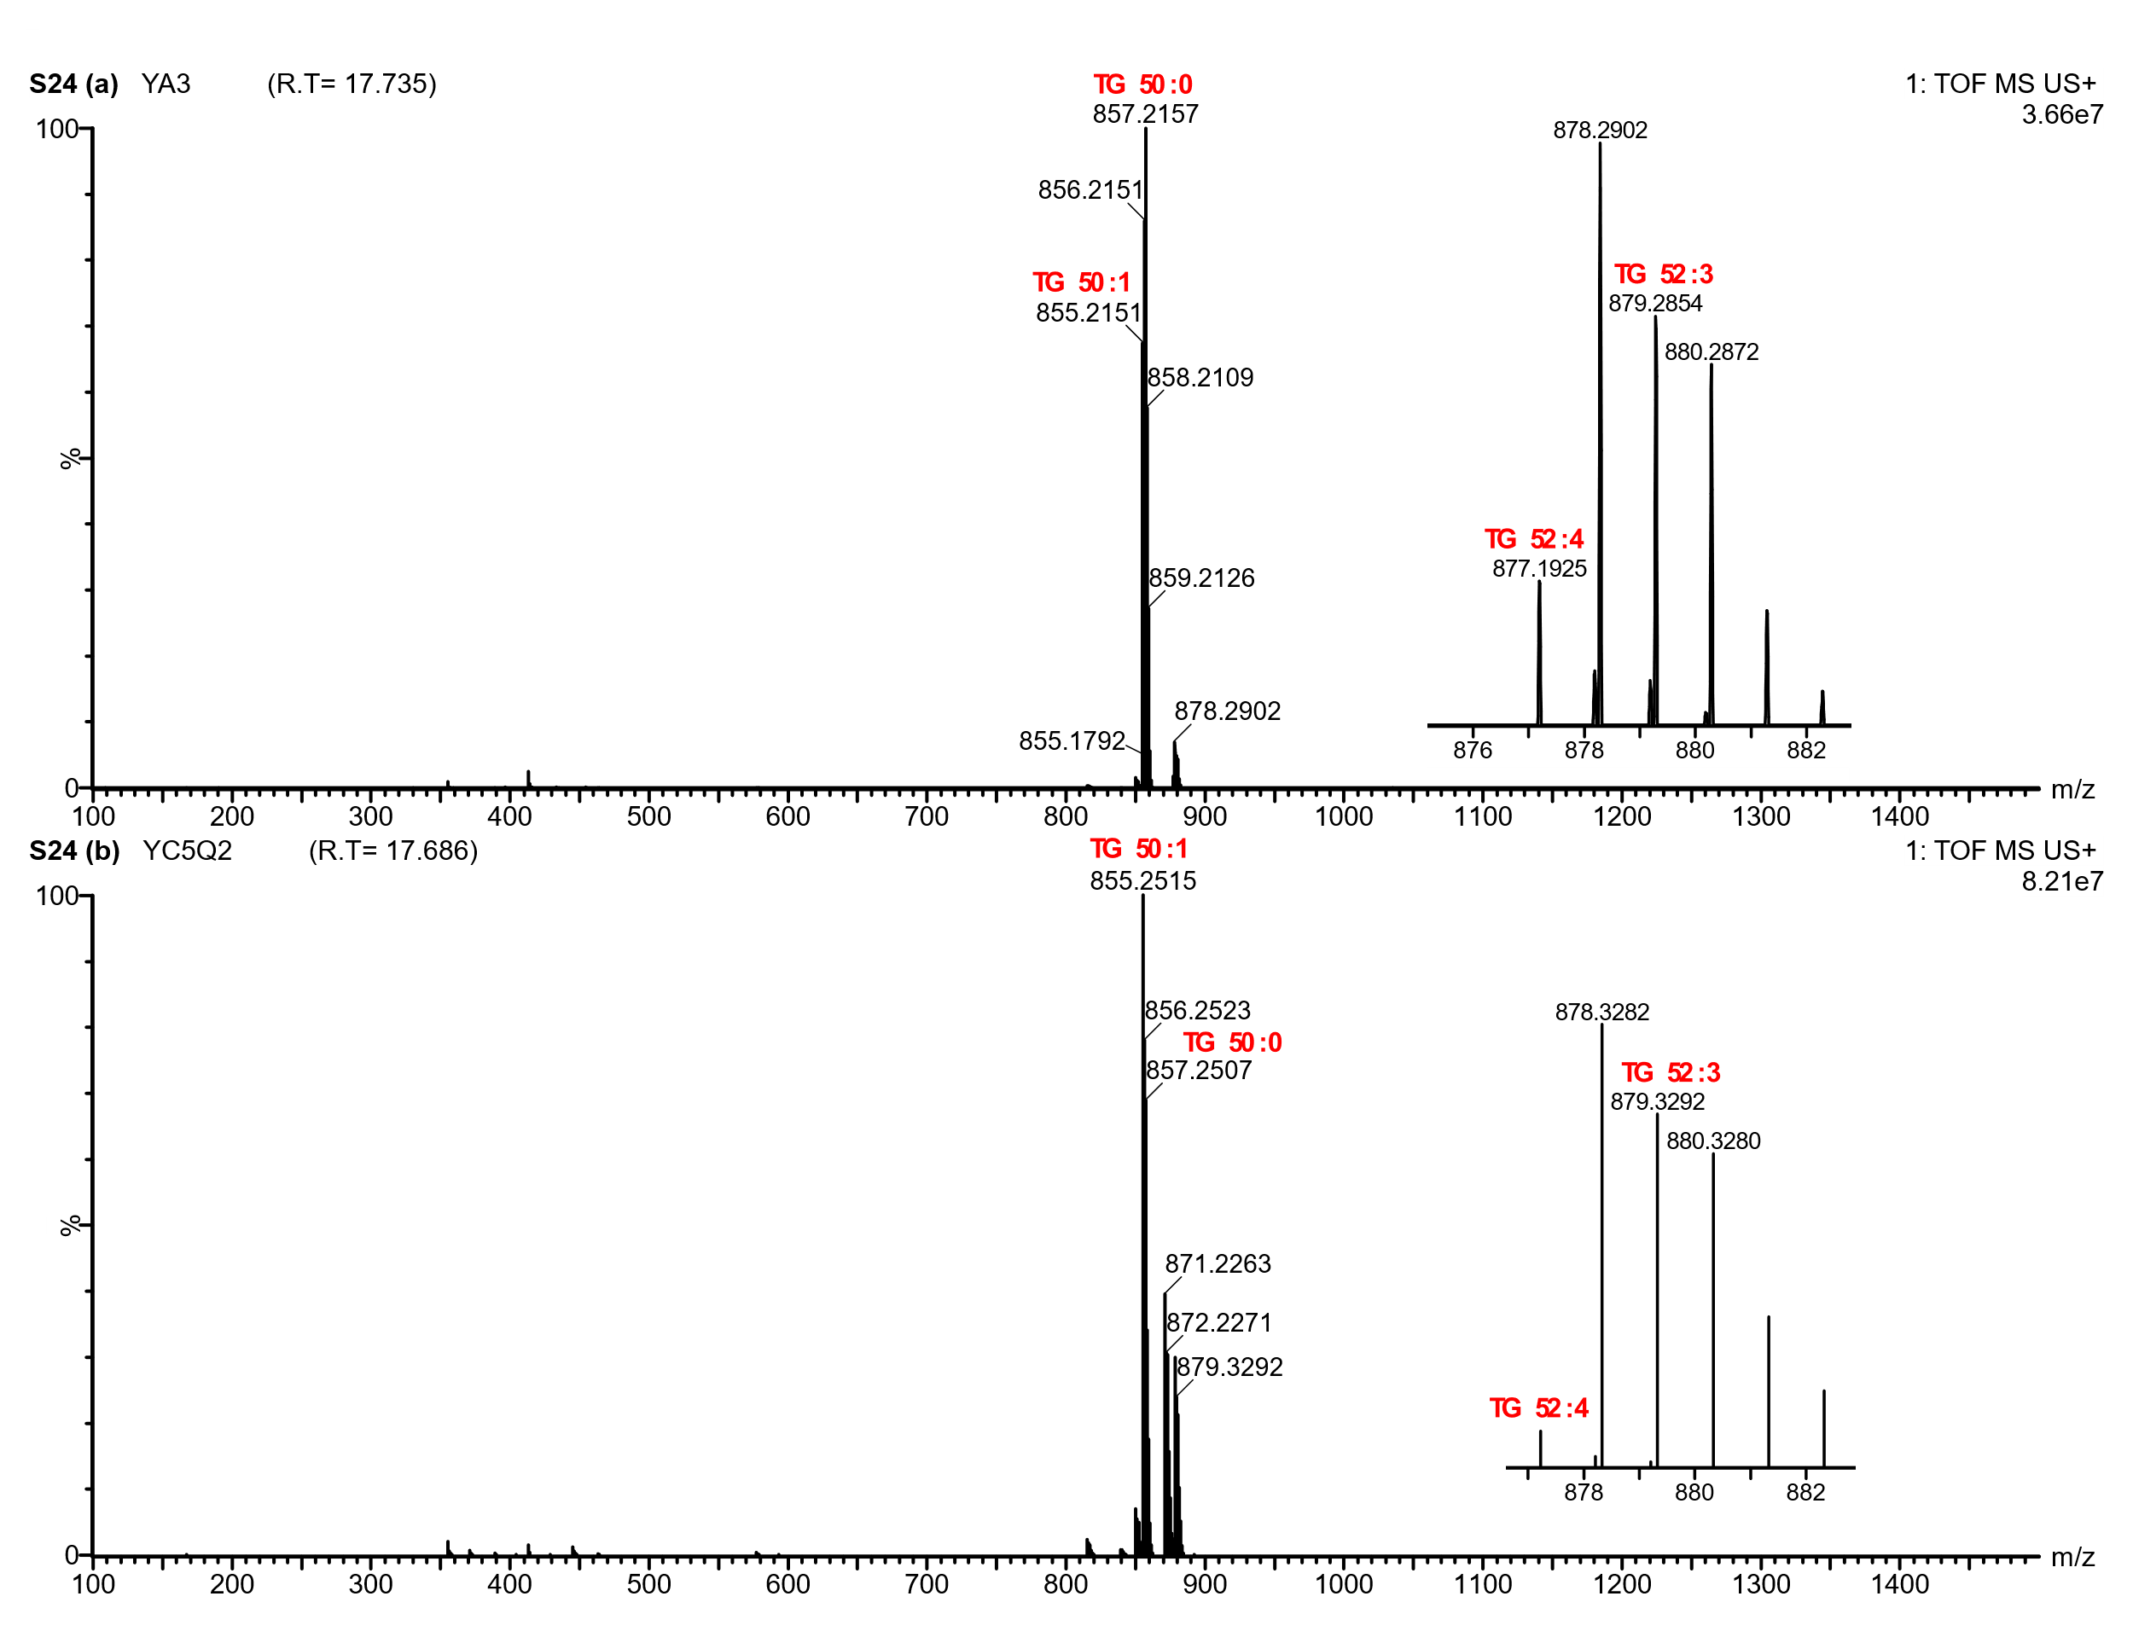
Supplementary Figure 24: UPLC-Q-ToF-MS spectrum showing the distribution of triacylglycerol (TAGs) molecular ions detected in the lipid extracts of the Gottiprolu samples.

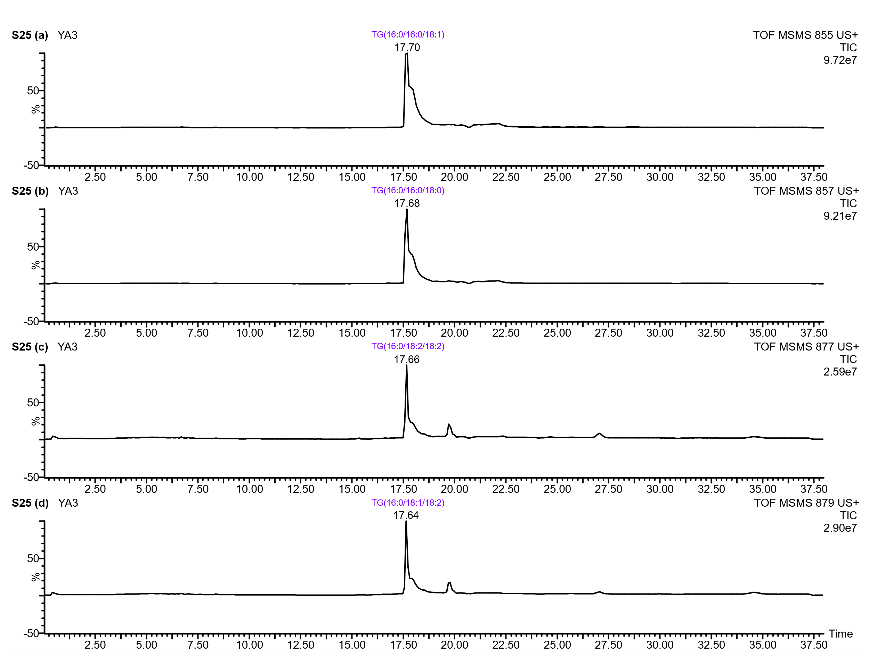
Supplementary Figure 25: UPLC-Q-ToF-MS/MS chromatogram of selected triacylglycerols (TAGs) detected in the YA3 lipid extract. The mass spectrum was acquired with a collision energy of 40 eV.

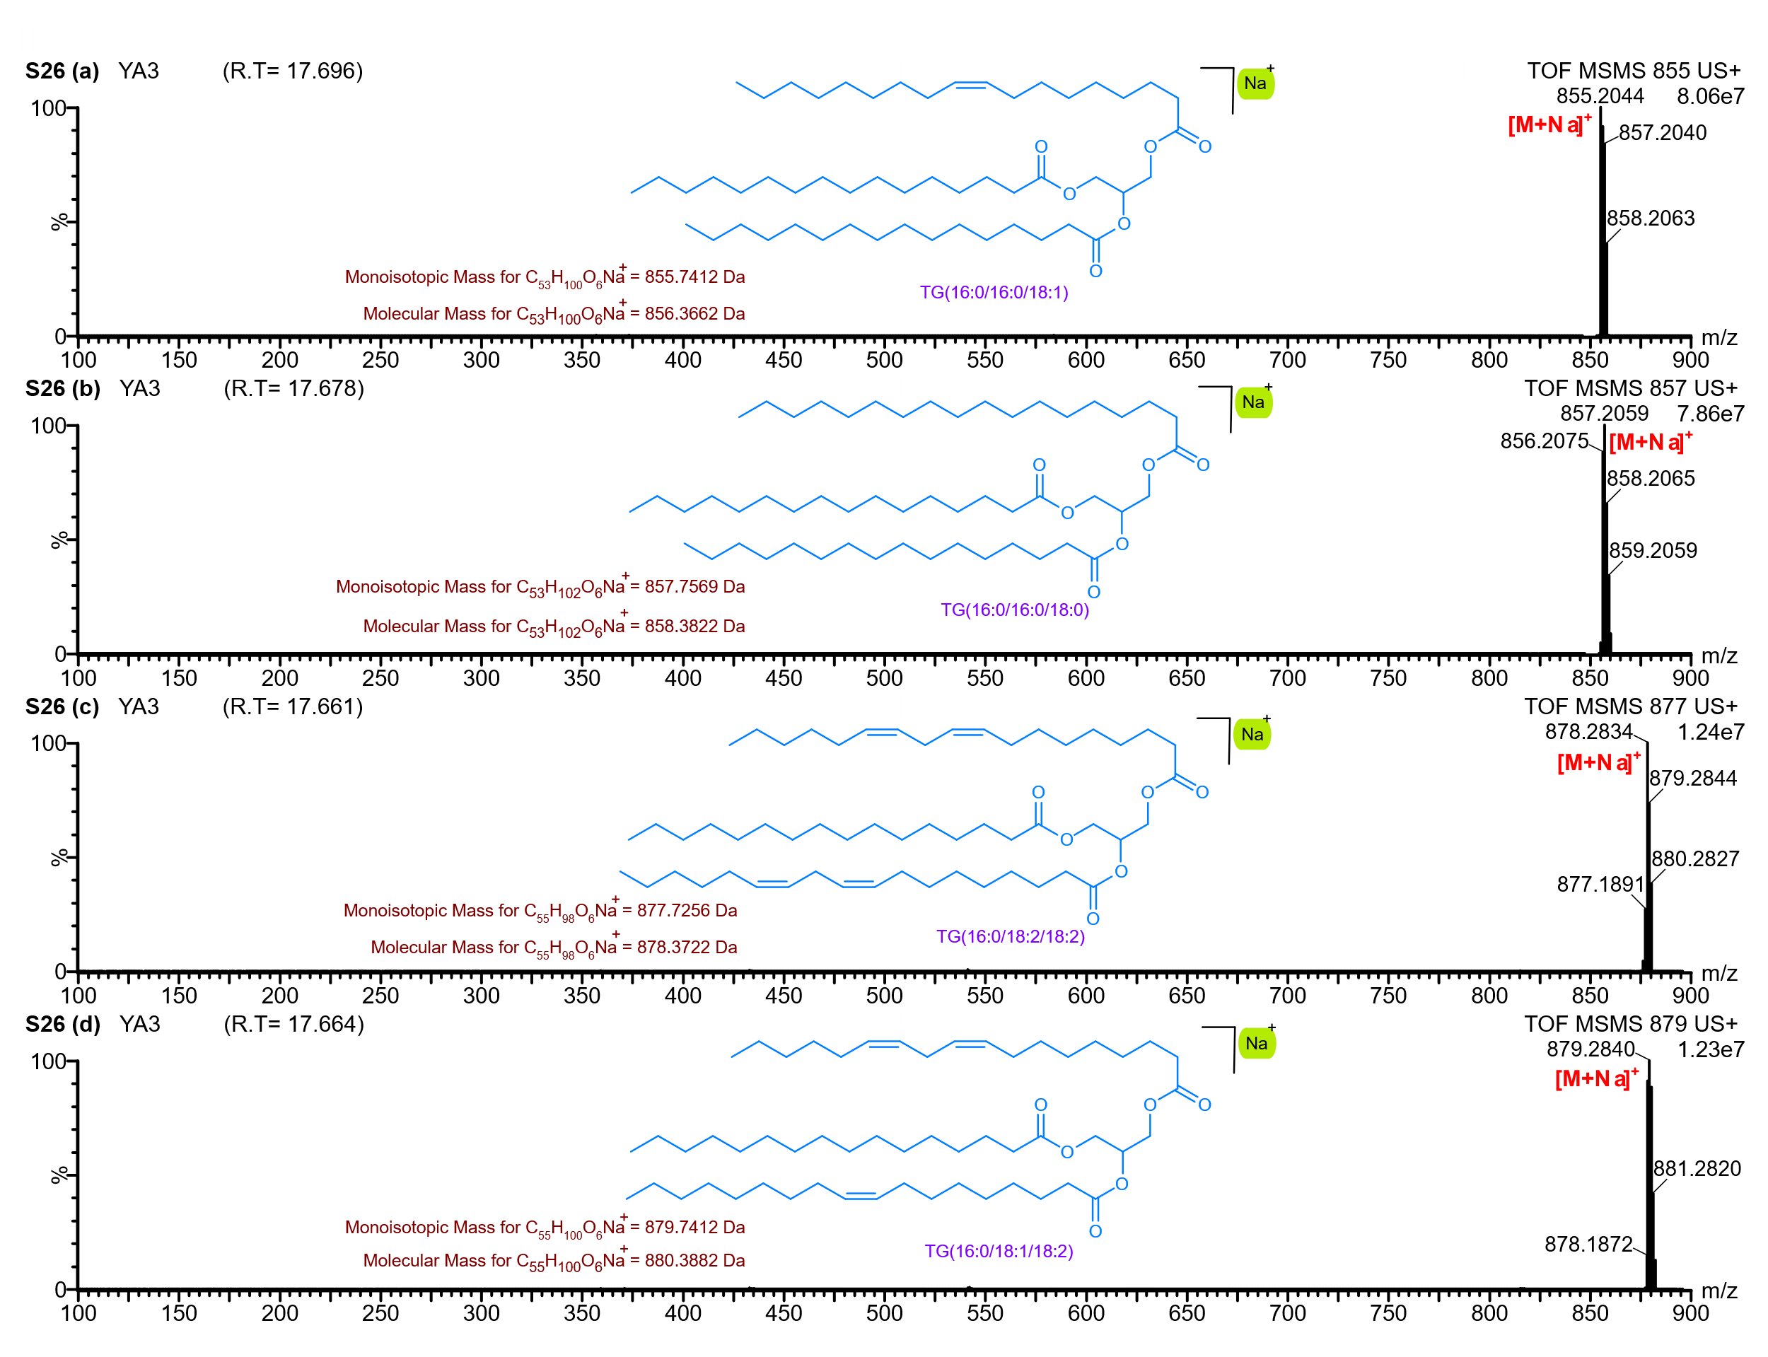
Supplementary Figure 26: UPLC-Q-ToF-MS/MS Spectrum of selected triacylglycerols (TAGs) detected in the YA3 lipid extract. The mass spectrum was acquired with a collision energy of 40 eV.

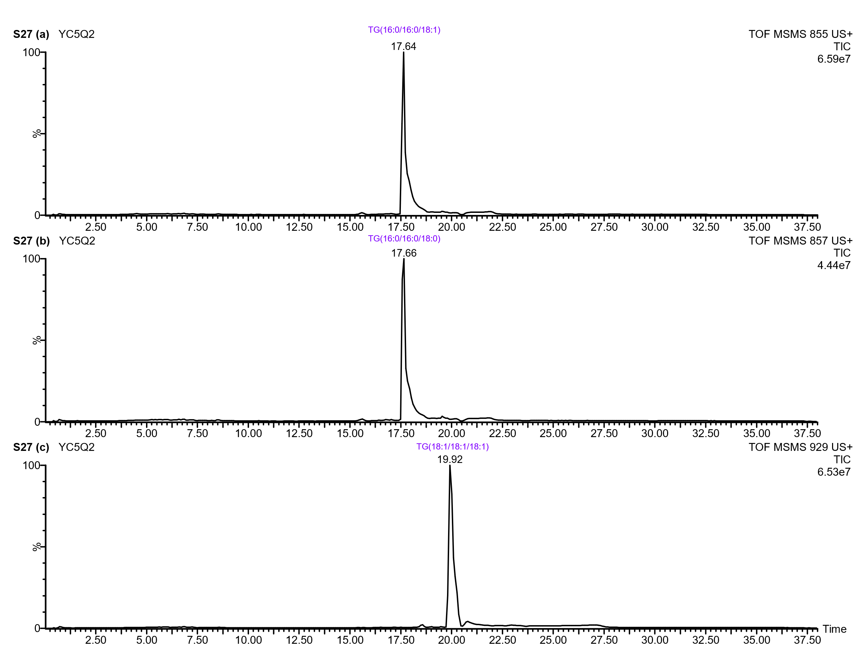
Supplementary Figure 27: UPLC-Q-ToF-MS/MS chromatogram of selected triacylglycerols (TAGs) detected in the YC5/Q2 lipid extract. The mass spectrum was acquired with a collision energy of 40 eV.

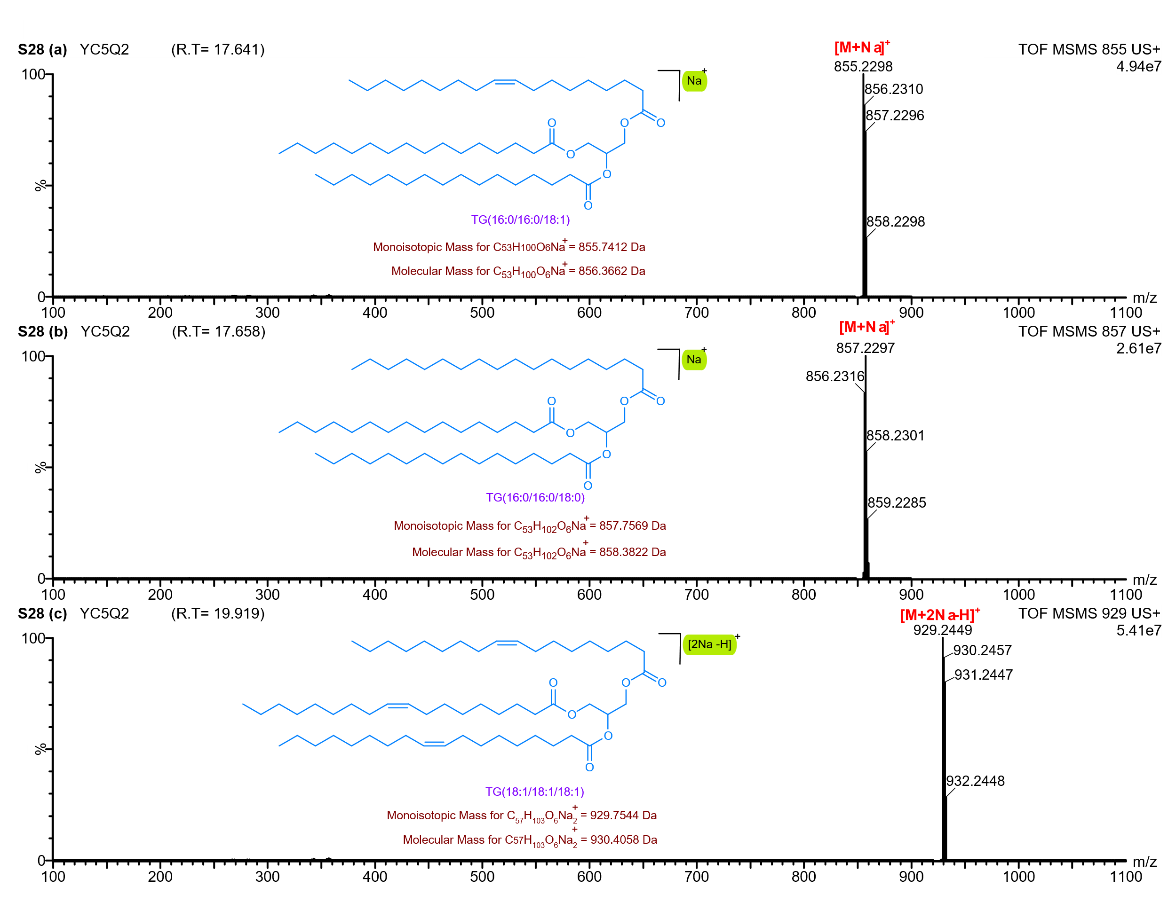
Supplementary Figure 28: UPLC-Q-ToF-MS/MS spectrum of selected triacylglycerols (TAGs) detected in the YC5/Q2 lipid extract. The mass spectrum was acquired with a collision energy of 40 eV.

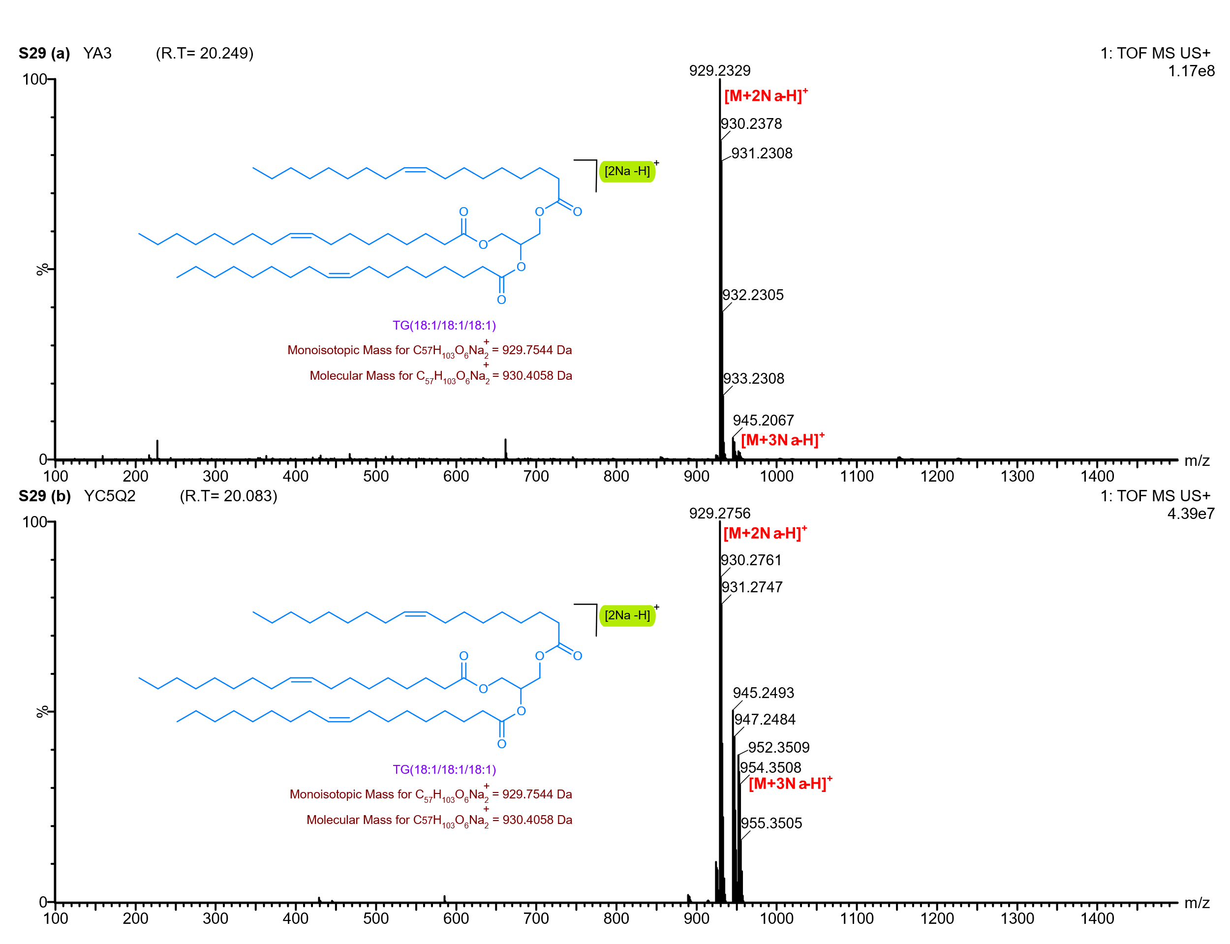
Supplementary Figure 29: UPLC-Q-ToF-MS spectrum highlighting the signal m/z 929 corresponding to the triolein molecule observed as a [M+2Na-H] ⁺ adduct in the lipid extracts obtained from the Gottiprolu samples.
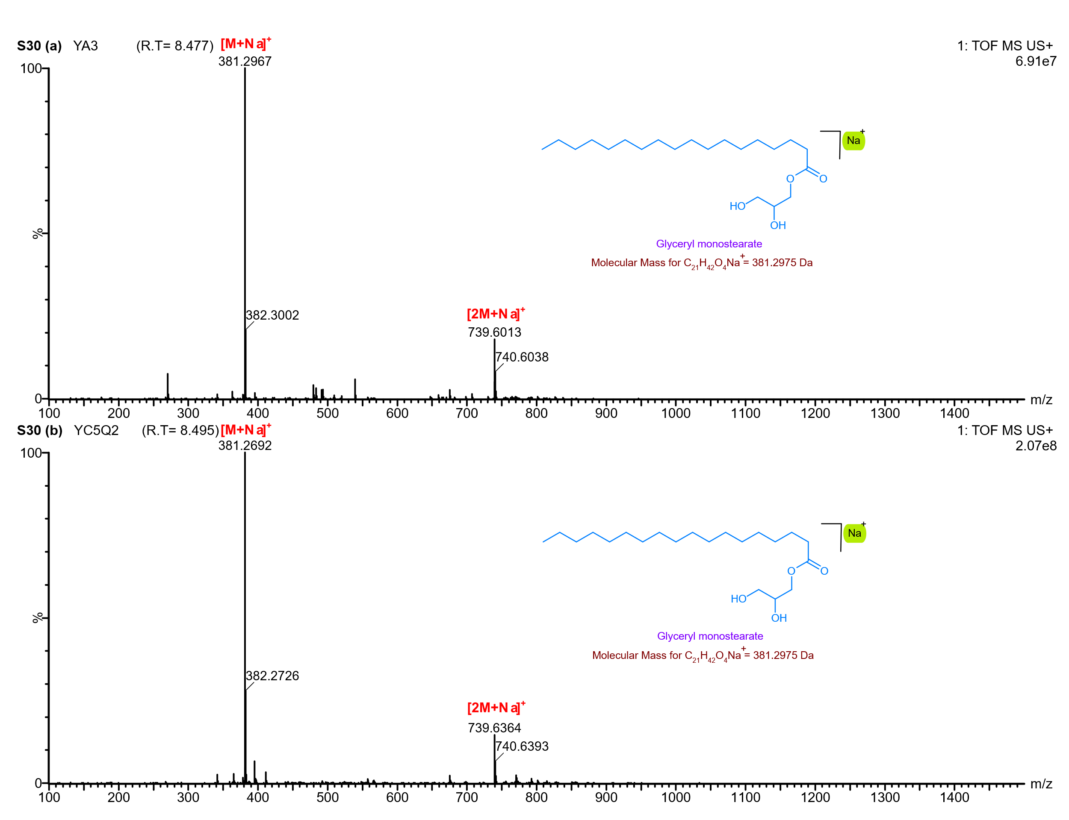
Supplementary Figure 30: UPLC-Q-ToF-MS spectrum of MG 18:0 (monoacylglycerol) detected in the Gottiprolu lipid extracts, eluting at 8.4 minutes.
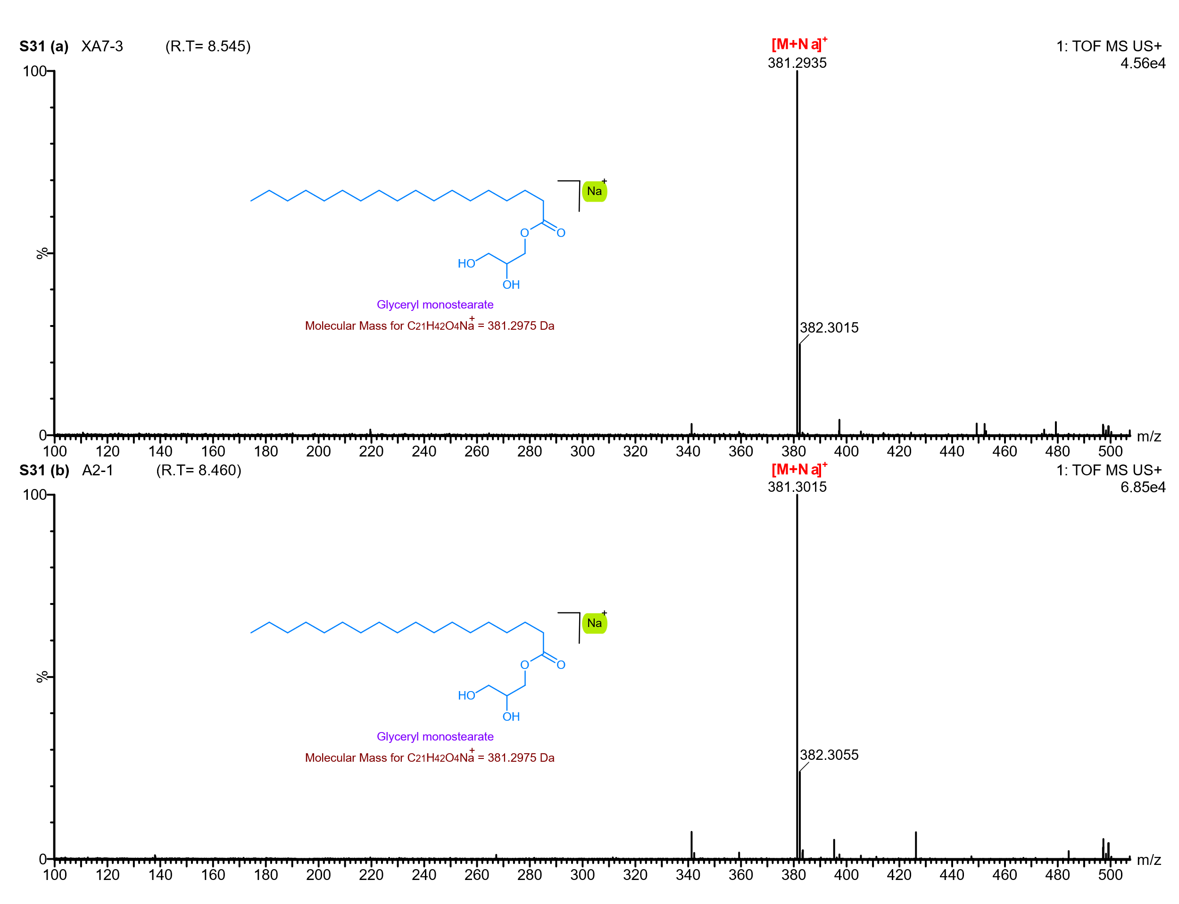
Supplementary Figure 31: UPLC-Q-ToF-MS spectrum of MG 18:0 (monoacylglycerol) detected in the Keeladi lipid extracts, eluting at 8.4 minutes.

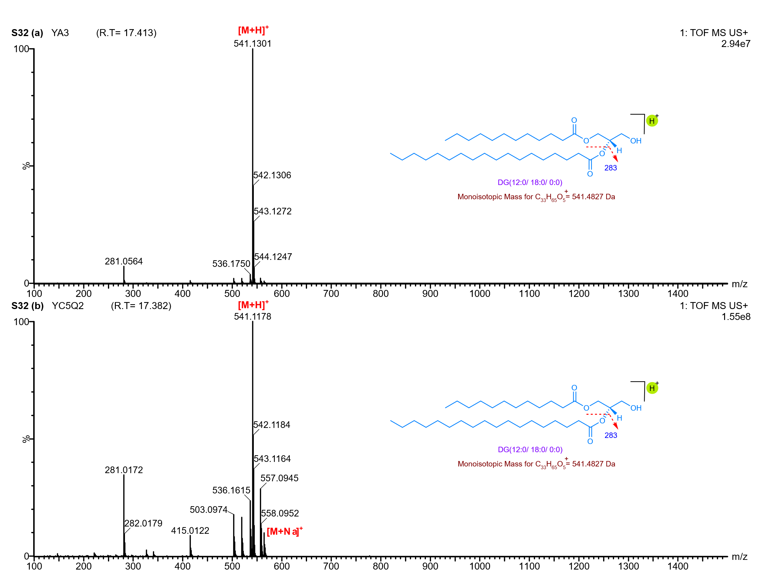
Supplementary Figure 32: UPLC-Q-ToF-MS spectrum of DG 30:0 (diacylglycerol) detected in the Gottiprolu lipid extracts, eluting at 17.4 minutes.

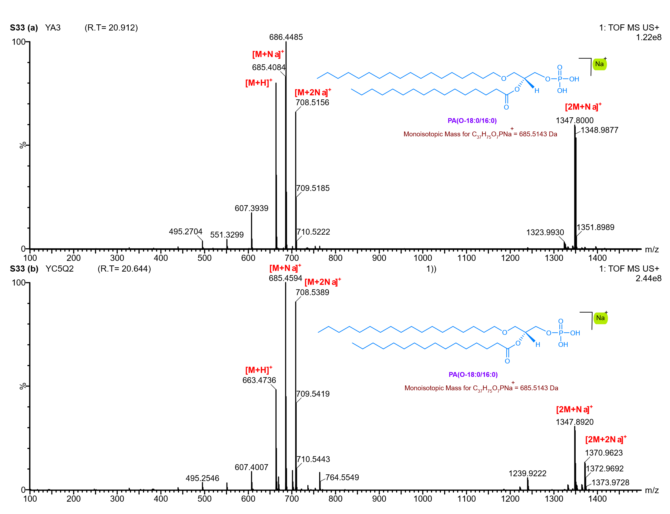
Supplementary Figure 33: UPLC-Q-ToF-MS spectrum of Glycerophospholipid (PA(O-18:0/16:0)) detected in the Gottiprolu lipid extracts, eluting at 20 minutes.

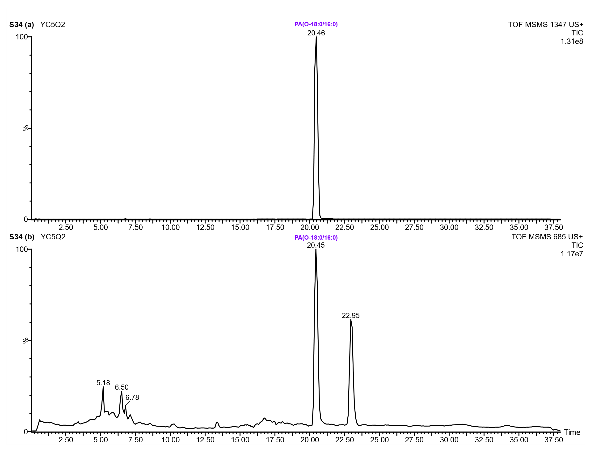
Supplementary Figure 34: UPLC-Q-ToF-MS/MS chromatogram of selected Glycerophospholipid (PA(O-18:0/16:0)) detected in the YC5/Q2 lipid extract. The mass spectrum was acquired with a collision energy of 40 eV.

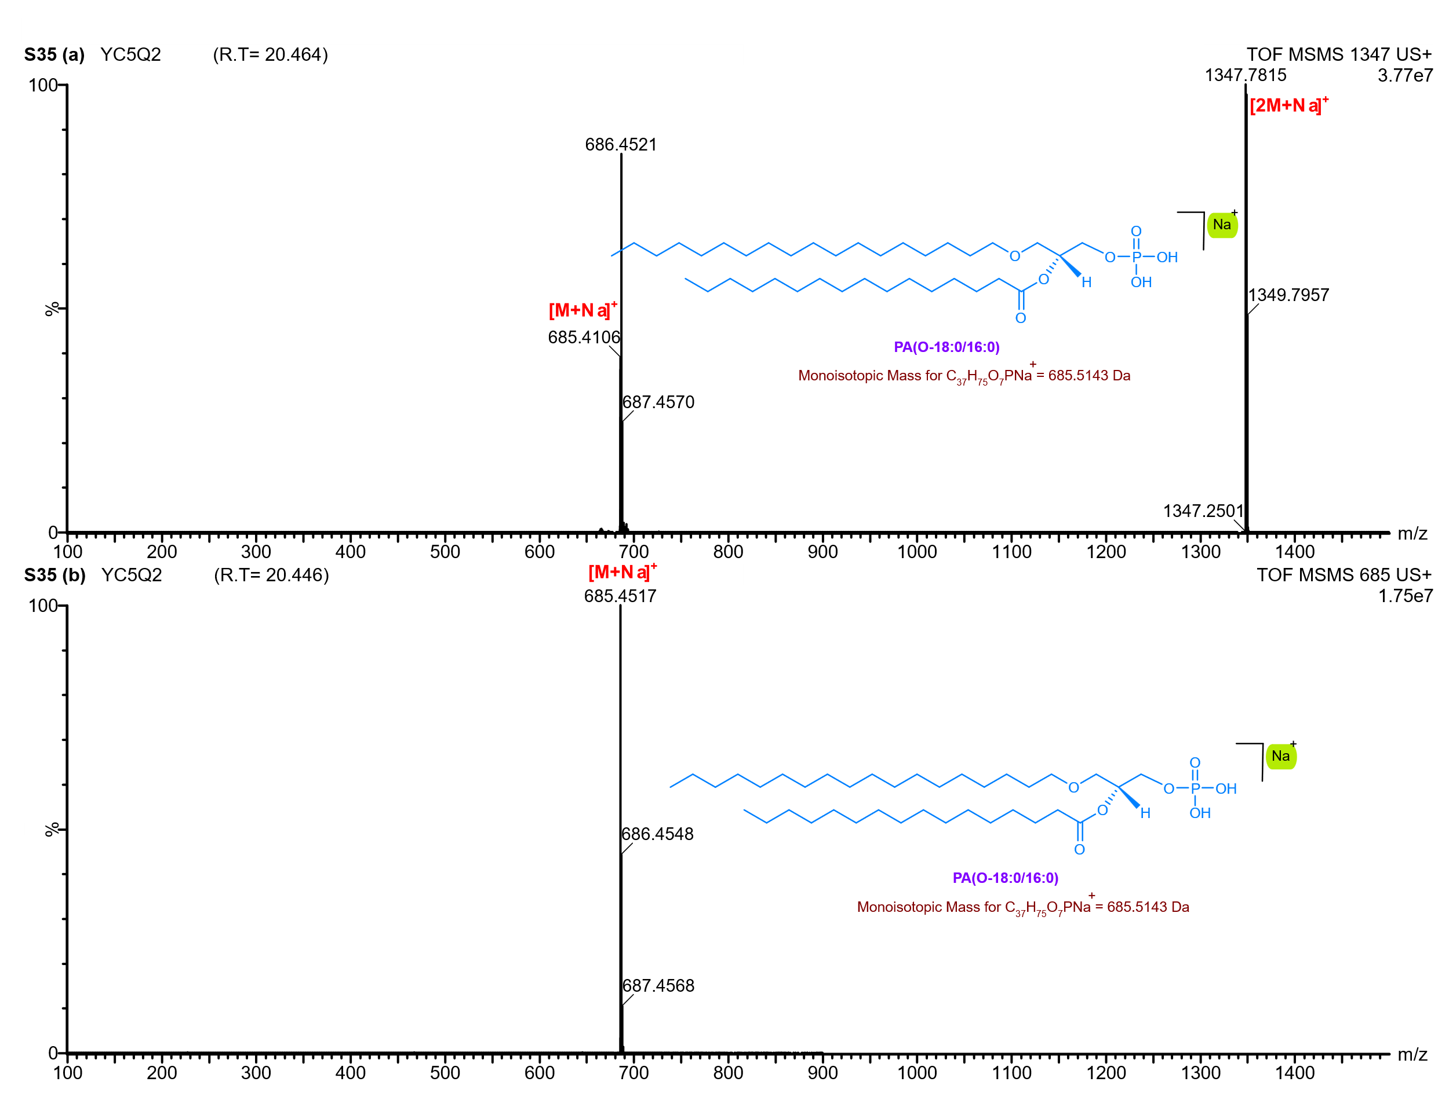
Supplementary Figure 35: UPLC-Q-ToF-MS/MS spectrum of selected Glycerophospholipid (PA(O-18:0/16:0)) detected in the YC5/Q2 lipid extract. The mass spectrum was acquired with a collision energy of 40 eV.

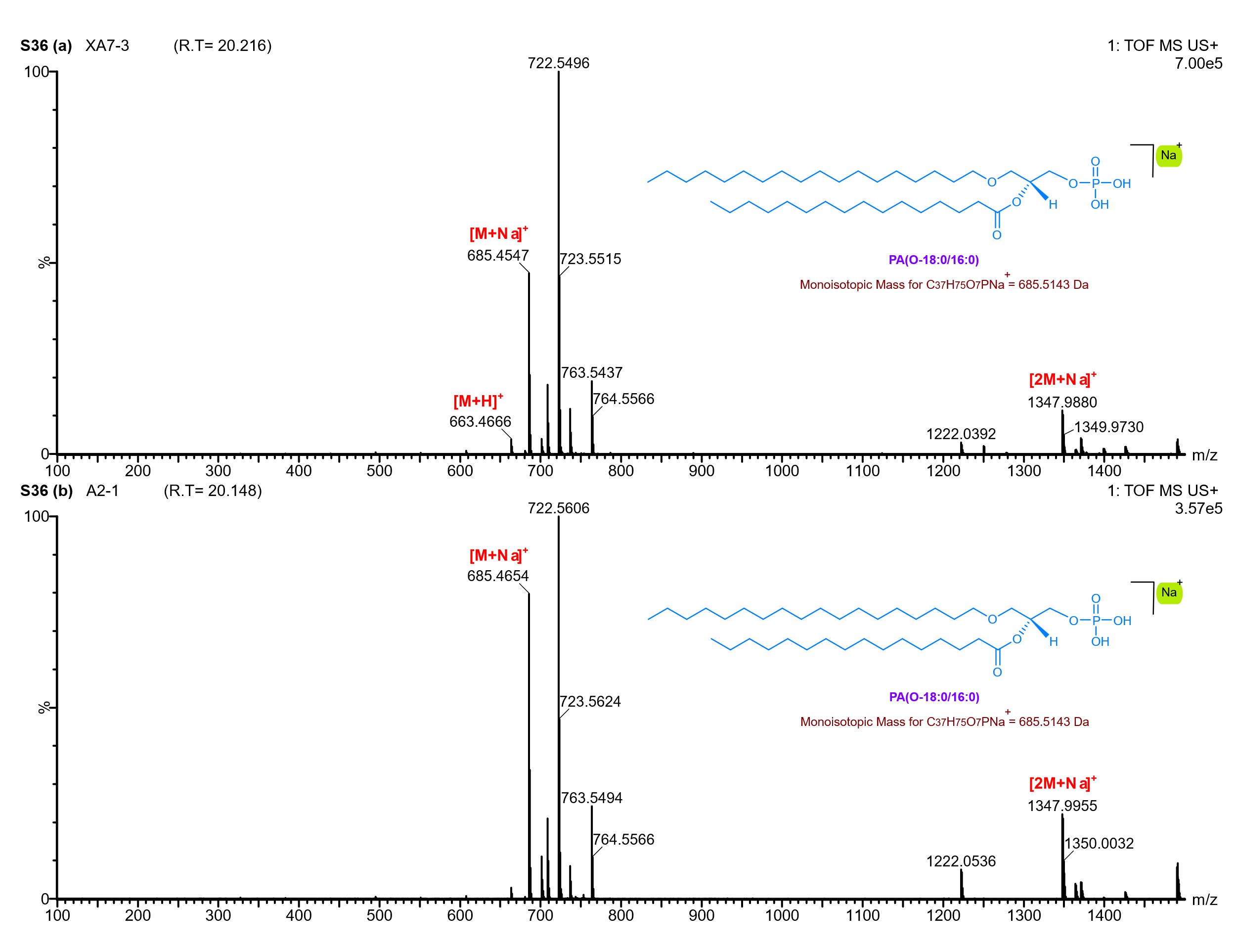
Supplementary Figure 36: UPLC-Q-ToF-MS spectrum of Glycerophospholipid (PA(O-18:0/16:0)) detected in the Keeladi lipid extracts, eluting at 20 minutes.

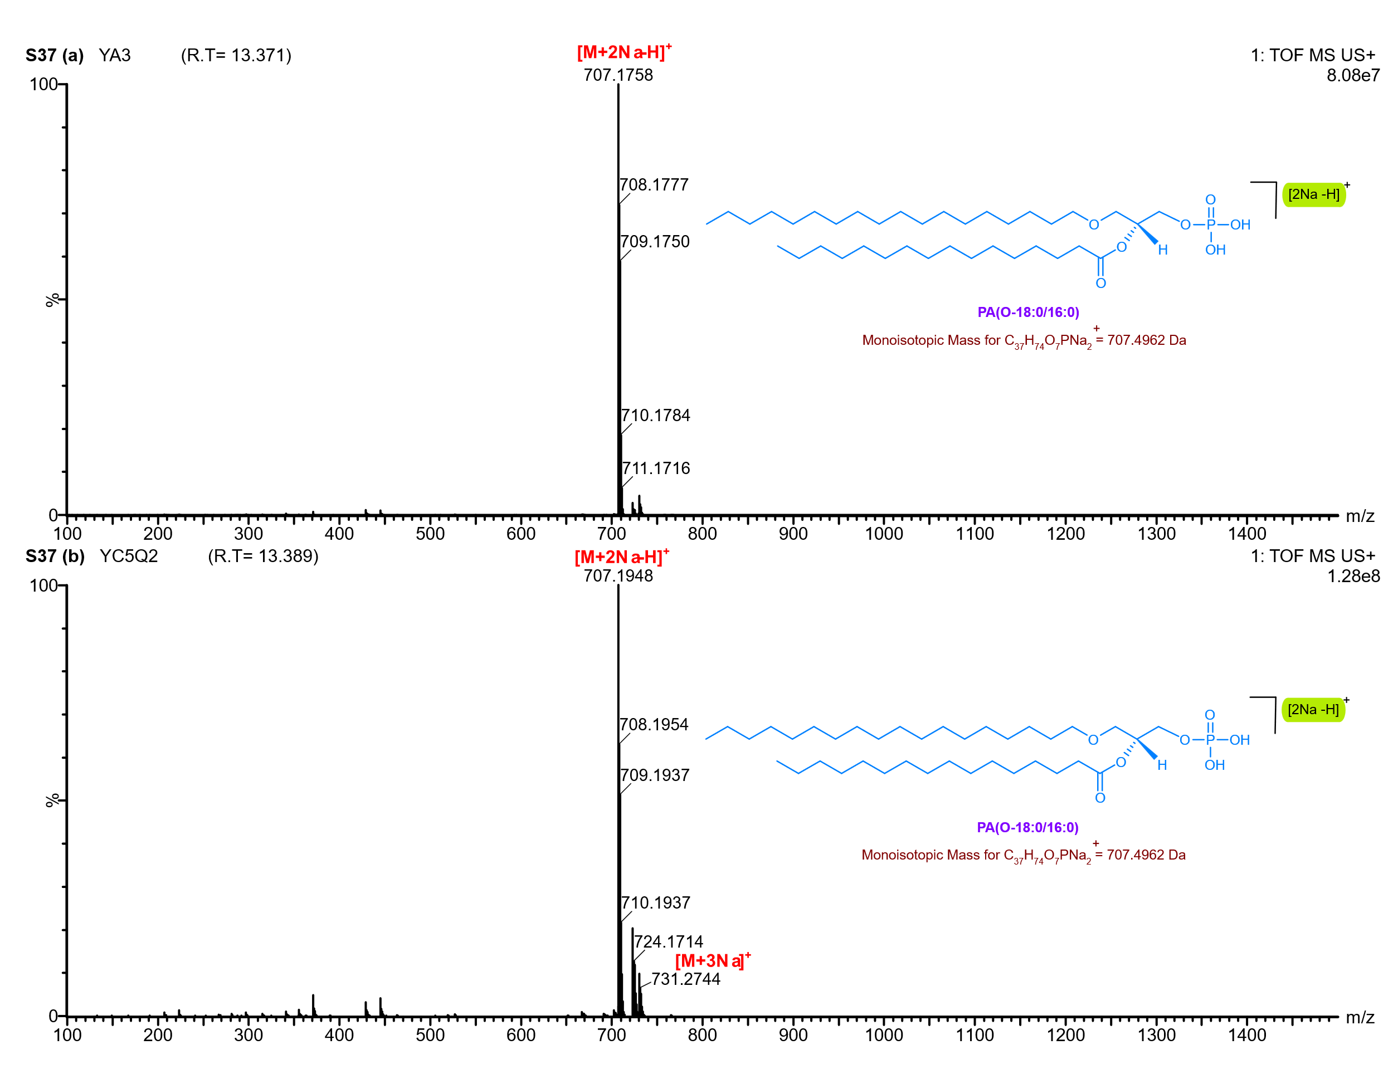
Supplementary Figure 37: UPLC-Q-ToF-MS spectrum of Glycerophospholipid PA(O-18:0/16:0) detected in the Gottiprolu lipid extracts, eluting at 13.3 minutes.

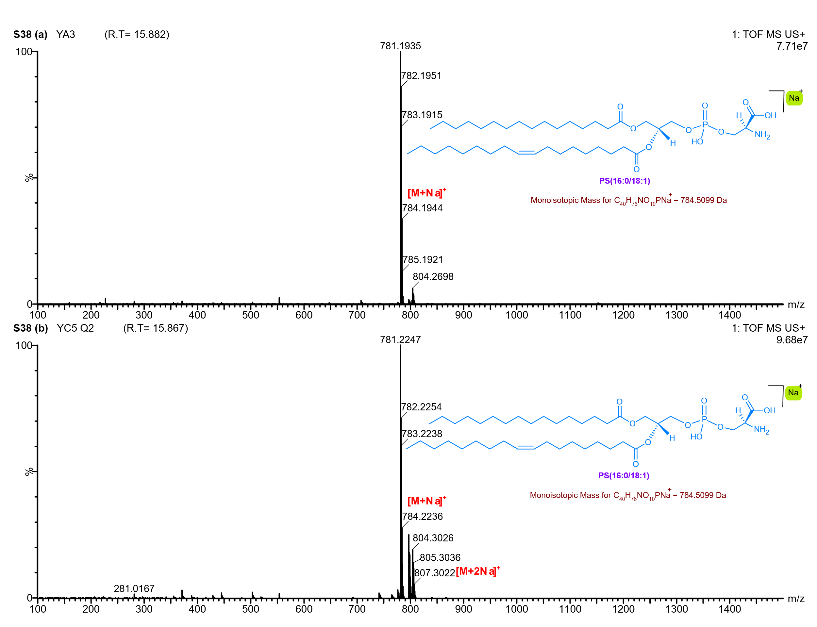
Supplementary Figure 38: UPLC-Q-ToF-MS spectrum of Glycerophospholipid PS(16:0/18:1) detected in the Gottiprolu lipid extracts, eluting at 15.8 minutes.

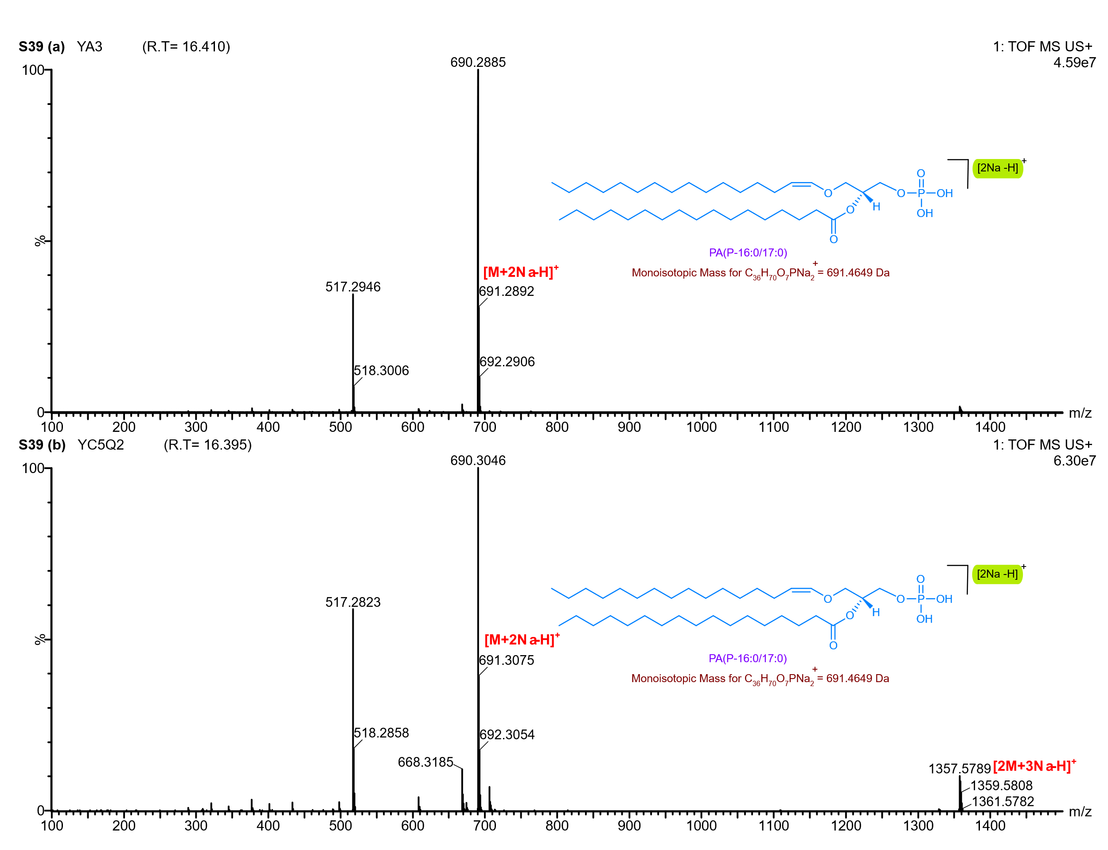
Supplementary Figure 39: UPLC-Q-ToF-MS spectrum of Glycerophospholipid PA(P-16:0/17:0) detected in the Gottiprolu lipid extracts, eluting at 16 minutes.

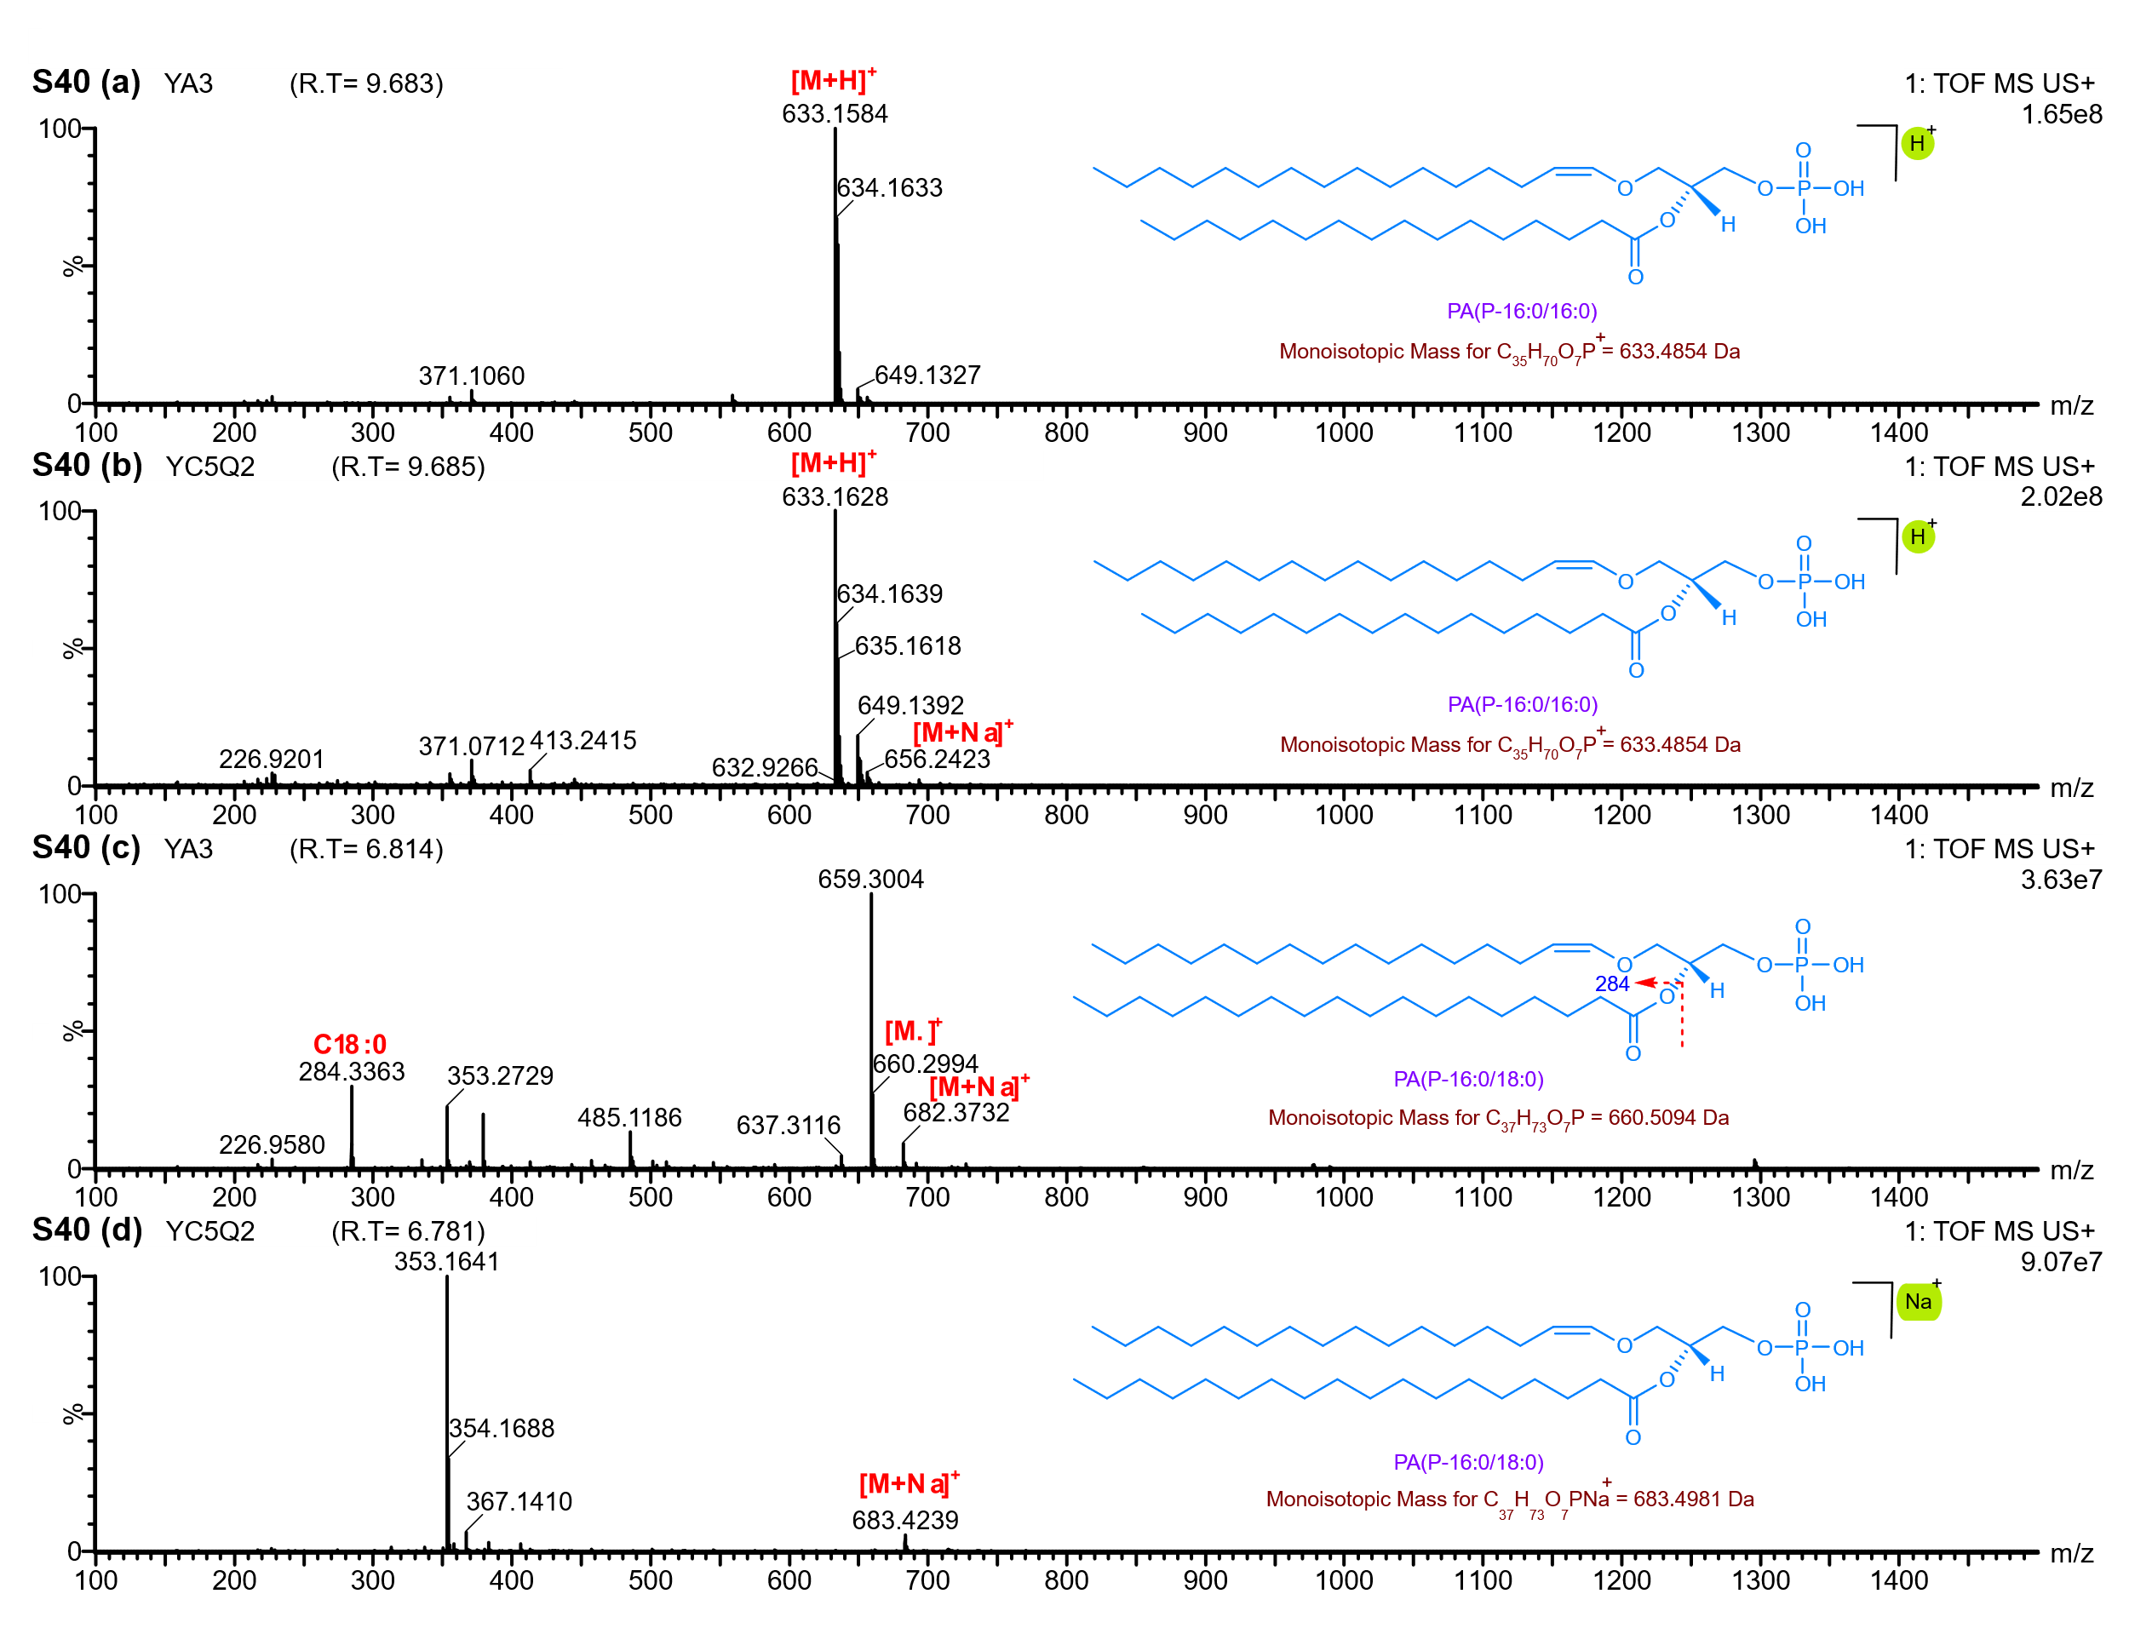
Supplementary Figure 40: UPLC-Q-ToF-MS Analysis of Glycerophospholipids in Gottiprolu Lipid Extracts. a–b: Mass spectrum and structural representation of PA (P-16:0/16:0) eluting at 9.6 min (RT). c–d: Mass spectrum and structural representation of PA (P-16:0/18:0) eluting at 6.8 min (RT).

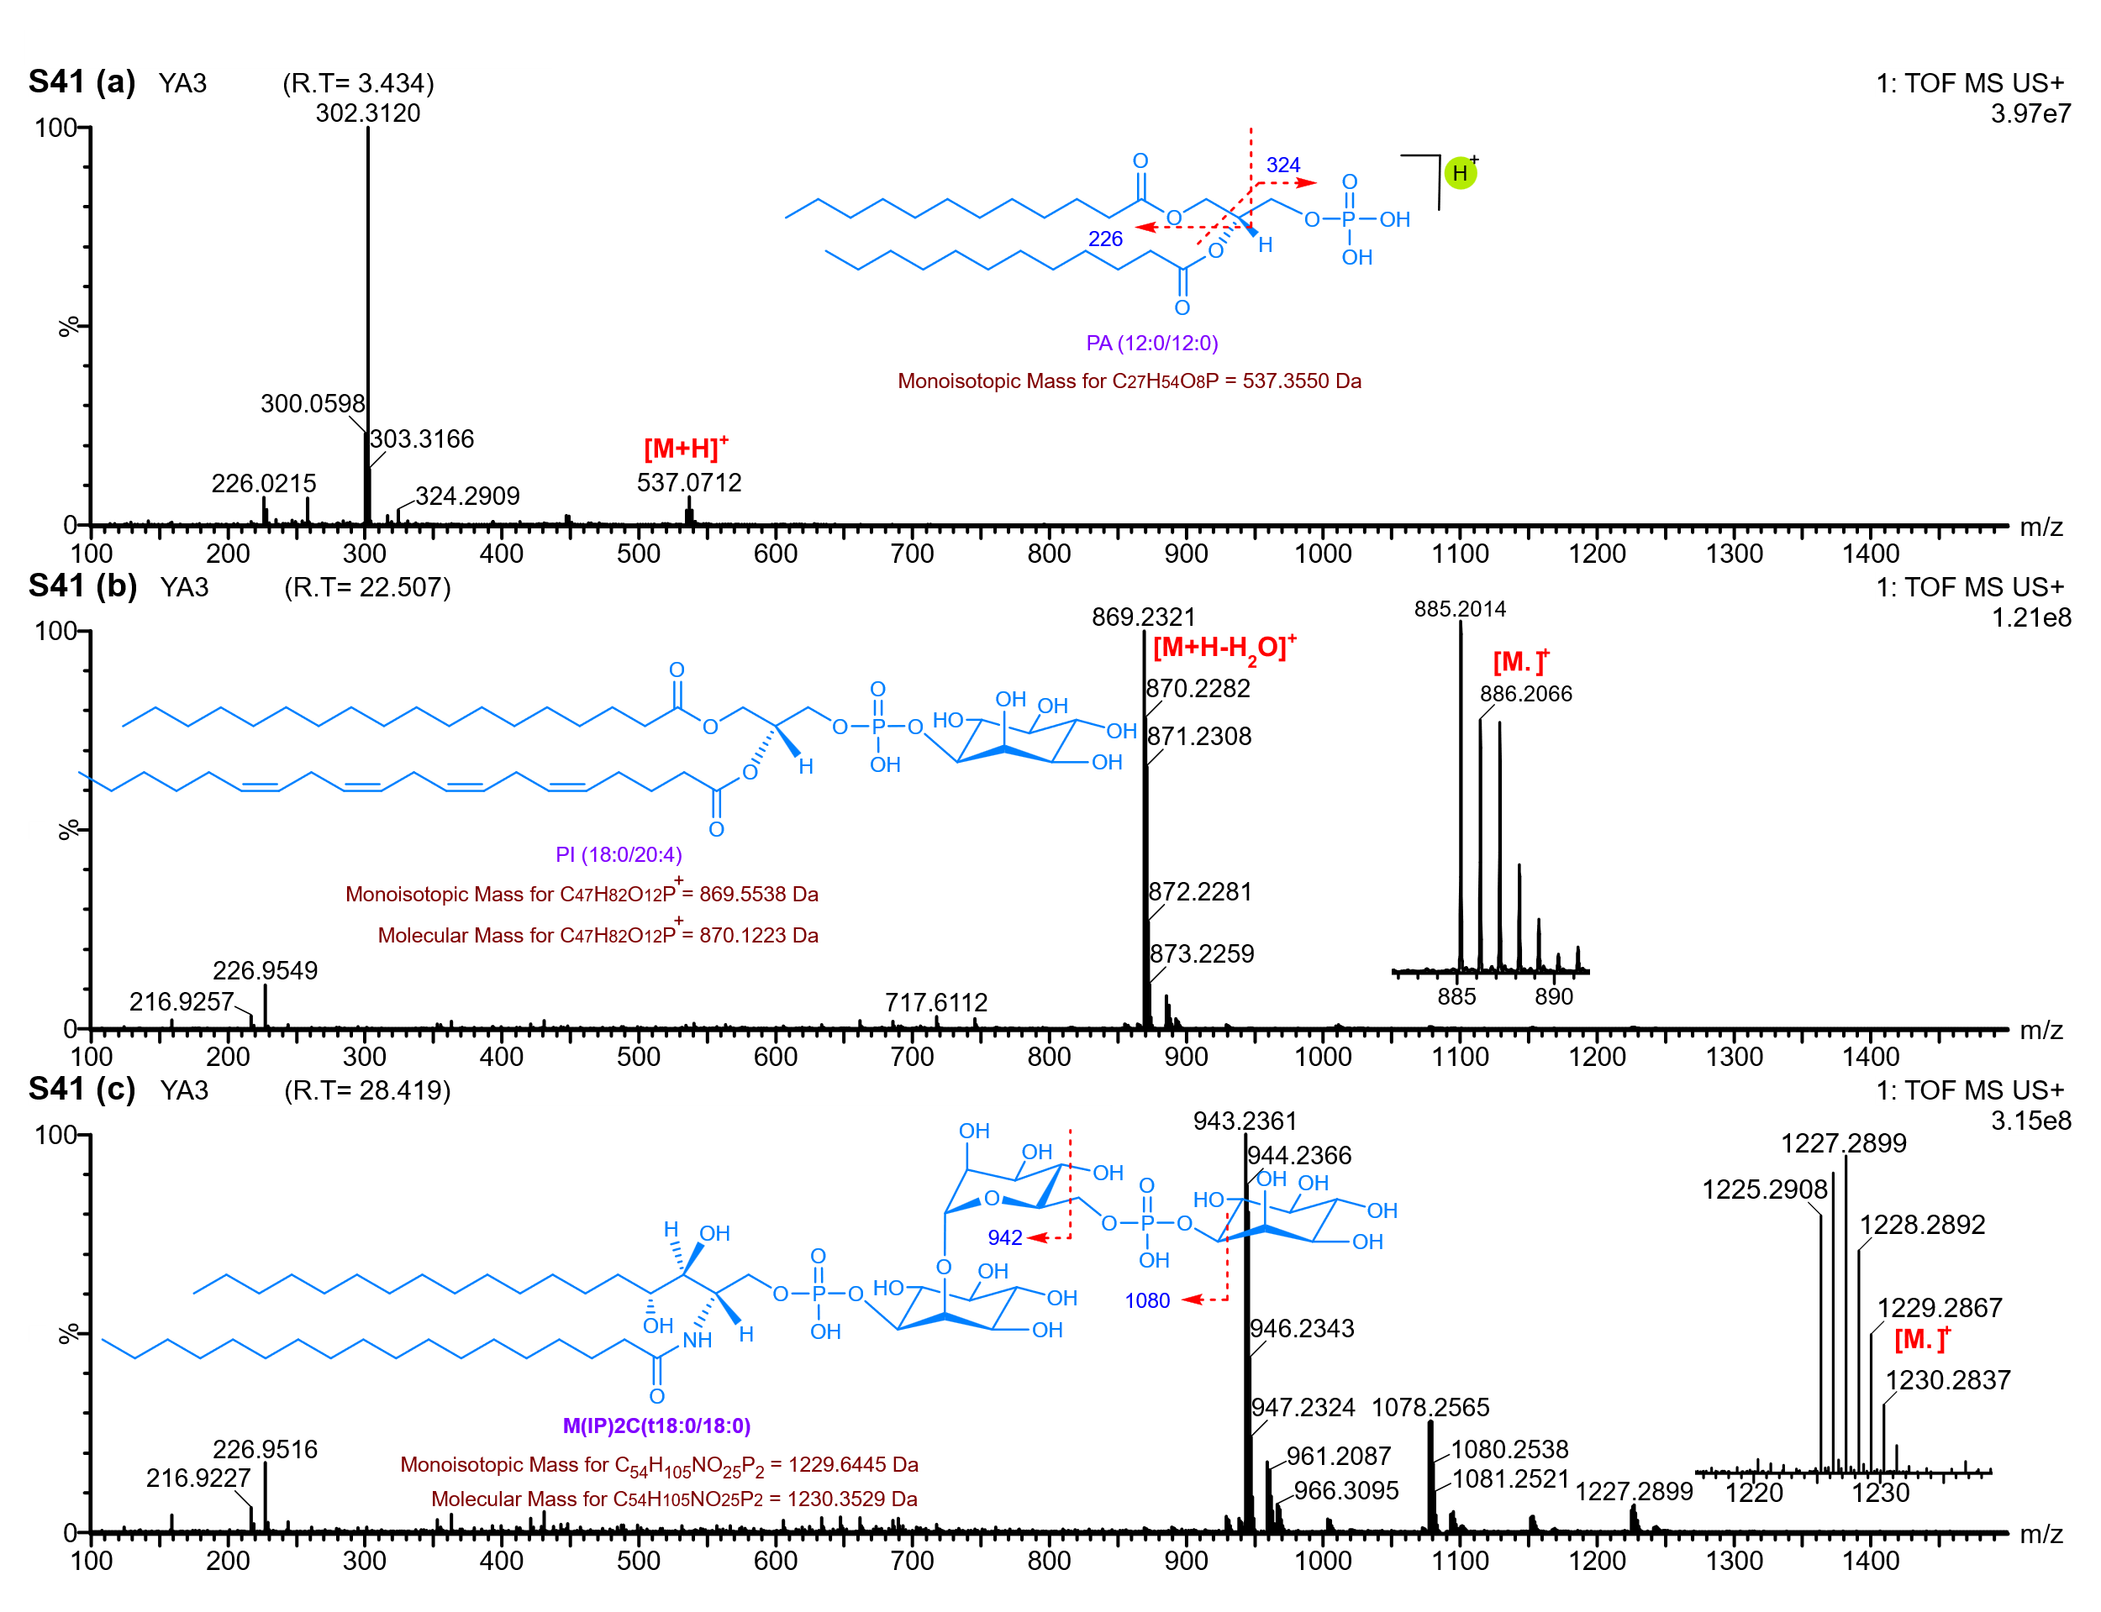
Supplementary Figure 41: UPLC-Q-ToF-MS analysis of glycerophospholipids and sphingolipid in YA3 Lipid Extracts. a: Mass spectrum and structural representation of PA (12:0/12:0) eluting at 3.4 min (RT). b: Mass spectrum and structural representation of
PI (18:0/20:4) eluting at 22.5 min (RT). c: Mass spectrum and structural representation of
sphingolipid (M(IP)2C(t18:0/18:0)) eluting at 22.5 min (RT).

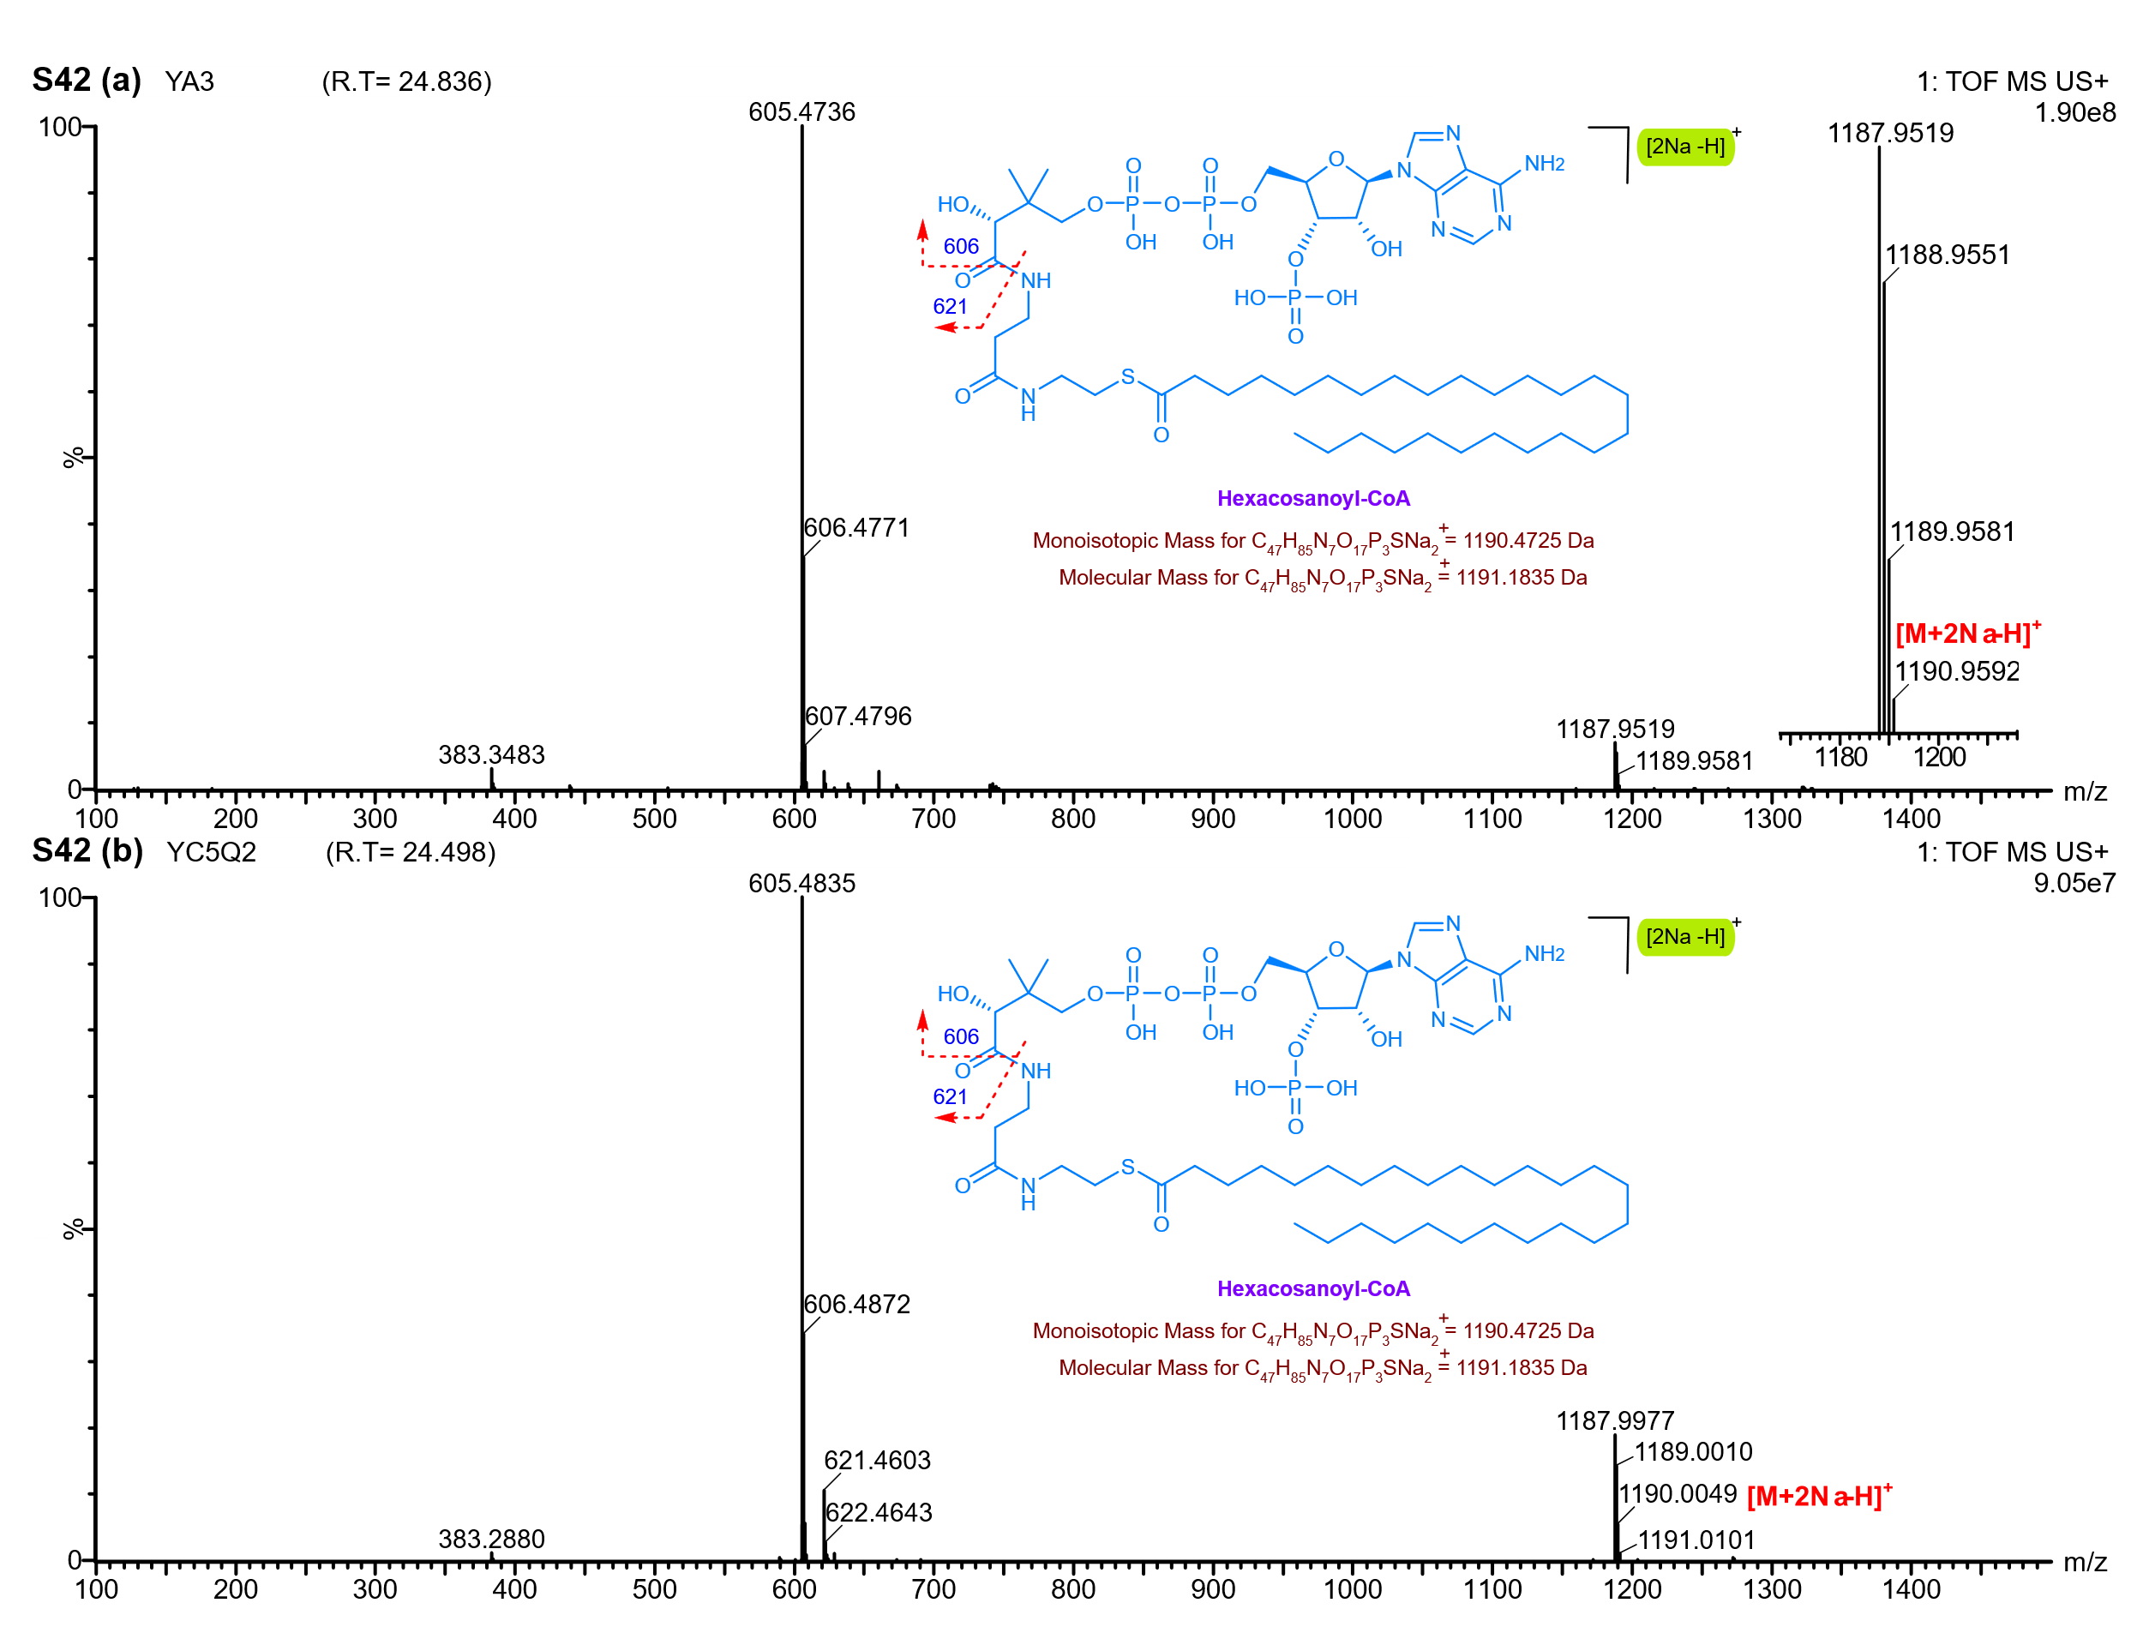
Supplementary Figure 42: UPLC-Q-ToF-MS analysis of Fatty Acyl in Gottiprolu lipid extracts. a&b: Mass spectrum and structural representation of Fatty Acyl (Hexacosanoyl-CoA) eluting at 24 min (RT).
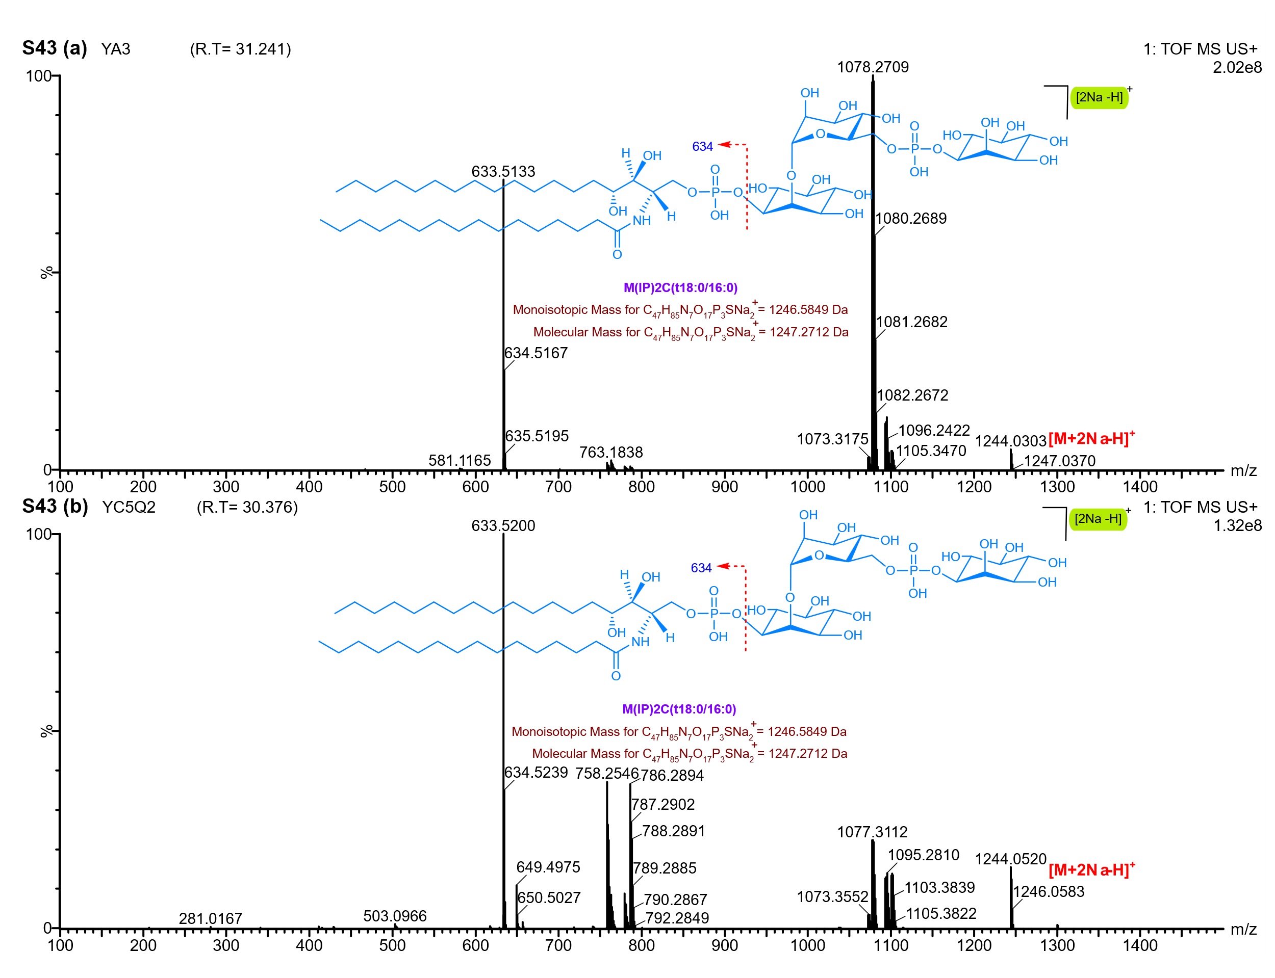
Supplementary Figure 43: UPLC-Q-ToF-MS analysis of sphingolipid in Gottiprolu lipid extracts. a: Mass spectrum and structural representation of M(IP)2C(t18:0/16:0) eluting at 31.2 min (RT) in YA3 sample b: Mass spectrum and structural representation of
M(IP)2C(t18:0/16:0) eluting at 30.3 min (RT) in YC5/Q2 sample.

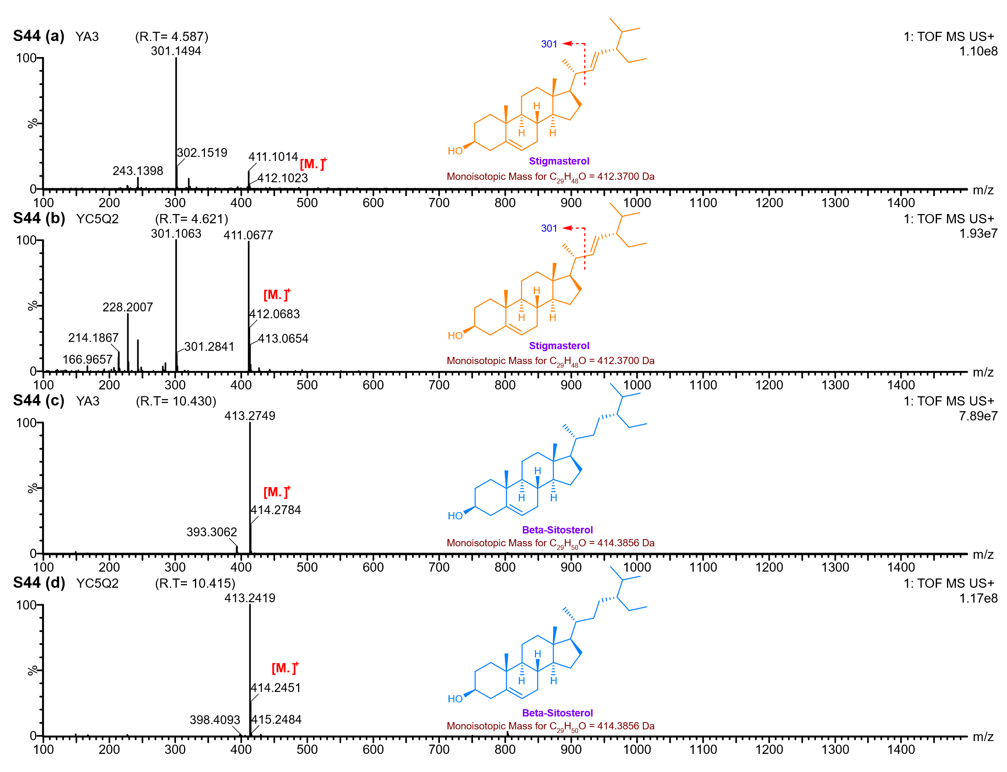
Supplementary Figure 44: UPLC-Q-ToF-MS analysis of plant sterols in Gottiprolu lipid extracts. a&b: Mass spectrum and structural representation of stigmasterol eluting at 4.6 min (RT) in YA3 and YC5/Q2 sample. c&d: Mass spectrum and structural representation of
Beta-sitosterol eluting at 10.4 min (RT) in YA3 and YC5/Q2 sample.

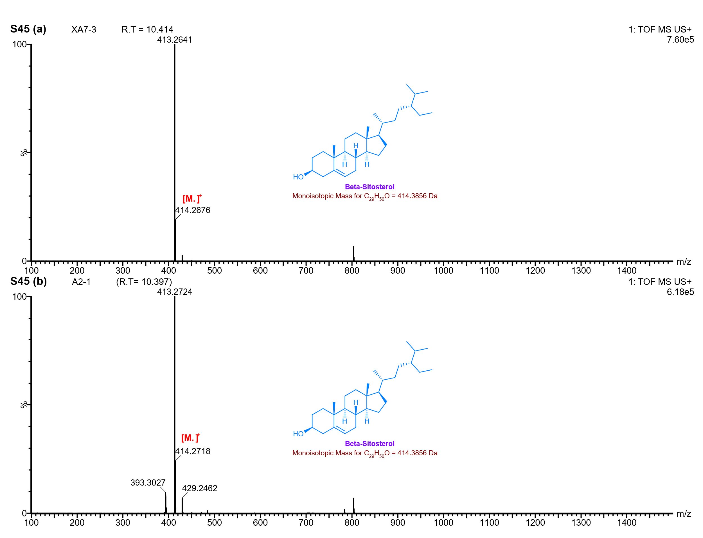
Supplementary Figure 45: UPLC-Q-ToF-MS analysis of Beta-sitosterol in Keeladi lipid extracts. a&b: Mass spectrum and structural representation of Beta-sitosterol eluting at 10.4 min (RT) in XA7/3 and A2/1 sample.
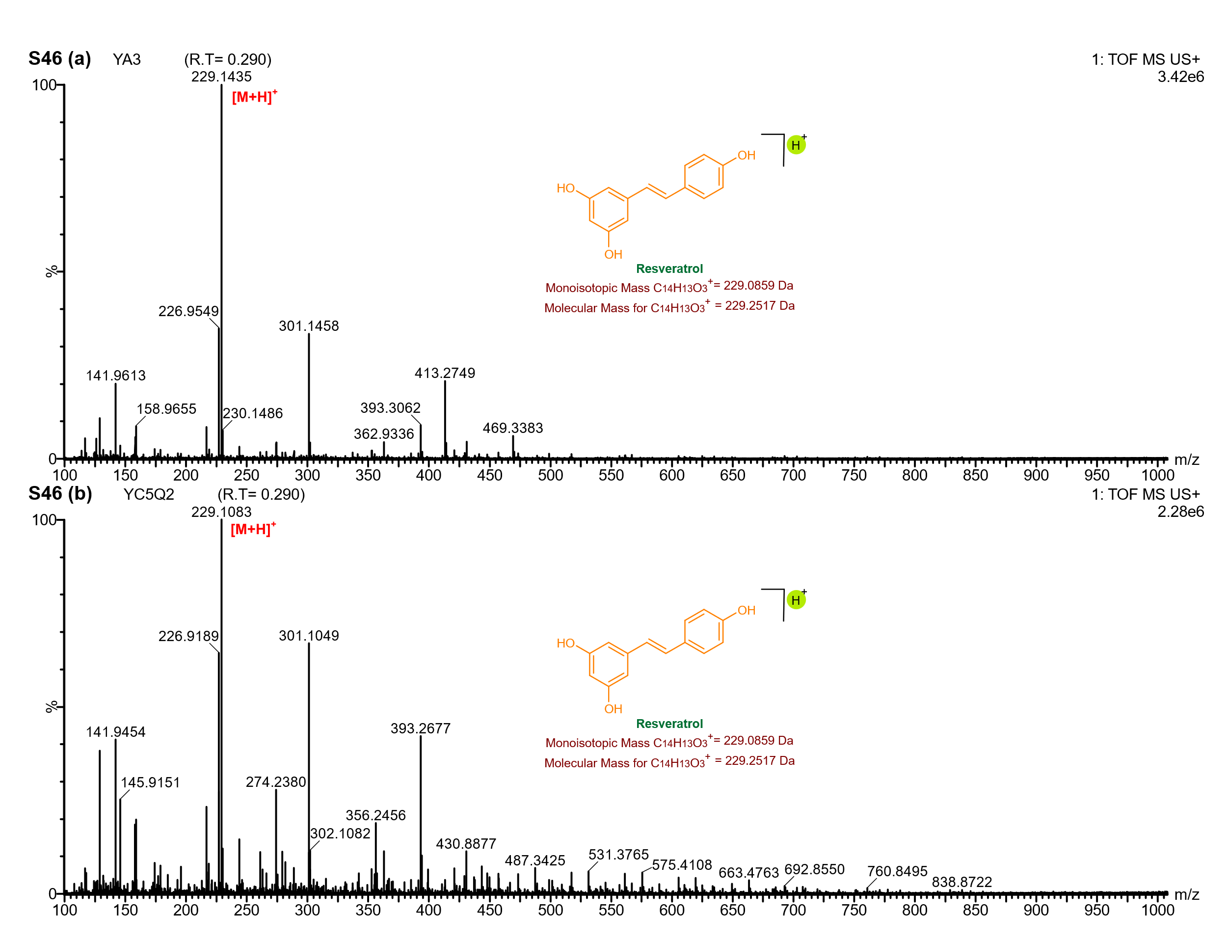
Supplementary Figure 46: UPLC-Q-ToF-MS analysis of resveratrol in Gottiprolu lipid extracts. a&b: Mass spectrum and structural representation of resveratrol eluting at 0.29 min (RT) in YA3 and YC5/Q2 samples.

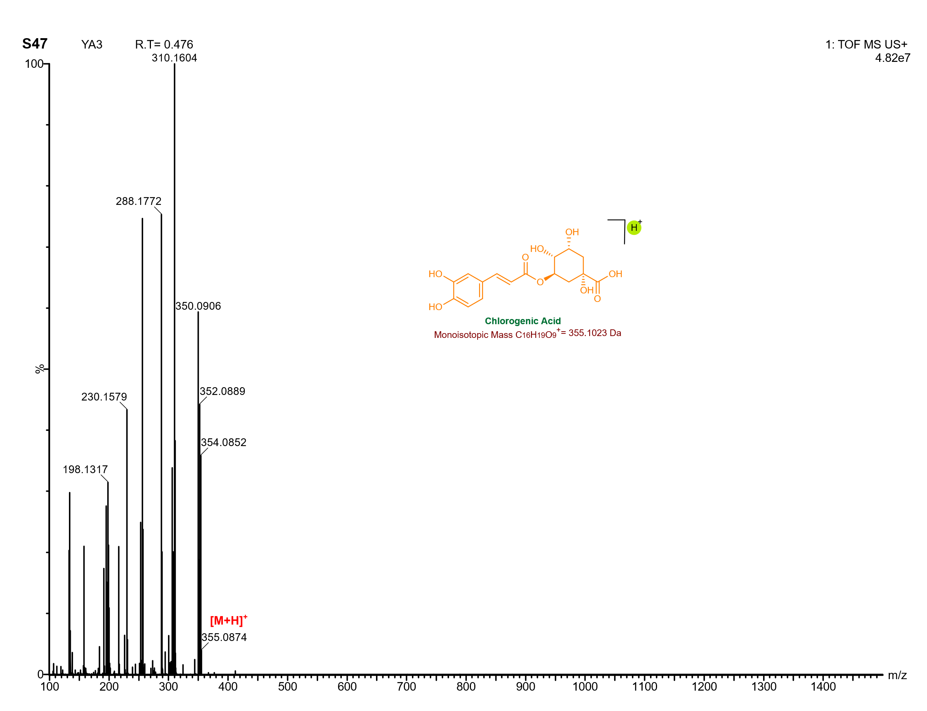
Supplementary Figure 47: UPLC-Q-ToF-MS analysis of chlorogenic acid in YA3 lipid extract. Mass spectrum and structural representation of chlorogenic acid eluting at 0.47 min (RT) in YA3 sample.

