Table 1. Effective indicators on the morphological types of residential complexes to reduce urban heat islands (theoretical framework)
Dimensions | Criteria | Indicators
Cultural-social | Optimal population density | population density
Environmental | Environmental sustainability | green space (-total area) ratio
Environmental | Environmental sustainability | topography (slope percentage)
Environmental | Environmental sustainability | wind speed
Environmental | Environmental sustainability | air pollution
Physical | Optimal use of land | lot coverage
Physical | Optimal use of land | building height
Physical | Optimal use of land | floor area ratio
Physical | Optimal use of land | polluting and heat-generating land use surface (-total area) ratio
Physical | Optimum urban configuration and geometry | block orientation desirability (-total area) ratio
Physical | Optimum urban configuration and geometry | grain size (-total area) ratio
Physical | Appropriate network access | street width-building height ratio
Table 2. Morphological types in the case study
Type | Figure | Google Earth map of case study | Image of case study
Regular low-rise blocks (villas) | 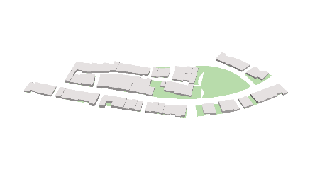 | 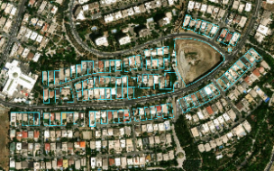 | 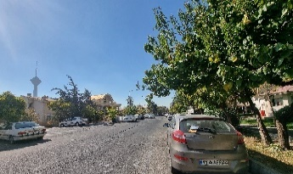
High-rise residential complexes (towns) | 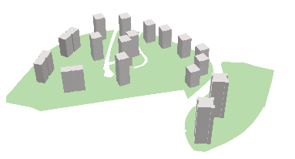 | 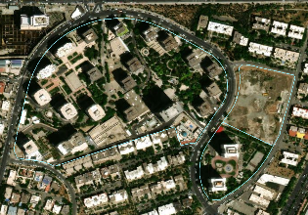 | 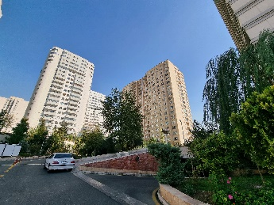
Regular blocks of various heights (apartments) | 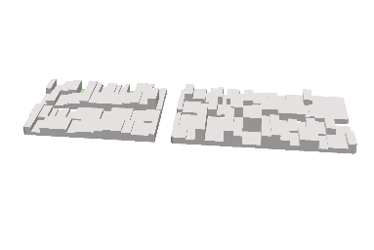 | 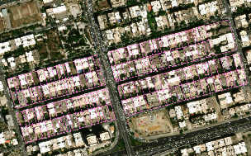 | 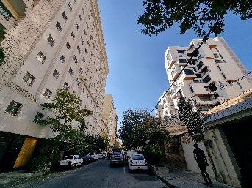
Irregular blocks (organic) | 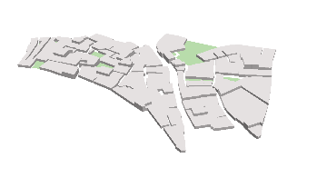 | 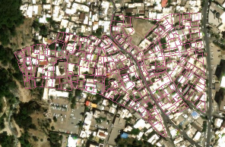 | 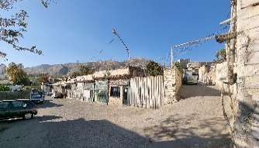
Table 3. Analysis of spatial factor indicators in a case study
Type |  | Population Density | Green space Ratio | Lot Coverage | Street width-building Height ratio
Villas | )V₁( | 39.0909 | 0.1994 | 41.4324 | 4.9681
Villas | )V₂( | 398.3 | 0.0758 | 60.9960 | 1.4287
Villas | )V₃( | 102 | 0.2367 | 44.5955 | 3.5014
Villas | )V₄( | 257 | 0.3972 | 65.6133 | 1.7984
Villas | )V₅( | 328.6923 | 0.0705 | 55.5826 | 1.5055
Towns | )T₁( | 199.5 | 0.3762 | 21.3333 | 2.0056
Towns | )T₂( | 252.5960 | 0.3418 | 16 | 2.5192
Towns | )T₃( | 110 | 0.4101 | 17.25 | 2.2913
Towns | )T₄( | 207.1489 | 0.3635 | 19 | 1.5645
Towns | )T₅( | 265.0488 | 0.2983 | 41 | 1.19339
Apartments | )A₁( | 357.25 | 0.0274 | 49.7888 | 1.1109
Apartments | )A₂( | 502.25 | 0.0234 | 65.9408 | 1.0135
Apartments | )A₃( | 601.5833 | 0.0169 | 67.6071 | 1.0679
Apartments | )A₄( | 494.875 | 0.0151 | 66.1324 | 0.9826
Apartments | )A₅( | 526 | 0.0267 | 62.0146 | 1.3272
Apartments | )A₆( | 472 | 0.0212 | 60.5330 | 1.0901
Organic | )O₁( | 585.8571 | 0.0609 | 72.2889 | 0.7404
Organic | )O₂( | 176.9091 | 0.2413 | 54.935 | 1.2866
Organic | )O₃( | 331.6364 | 0.0573 | 74.8050 | 0.7614
Organic | )O₄( | 383.3636 | 0.0985 | 66.9747 | 0.8526
Table 4. Analysis of physical factor indicators in a case study
Type |  | Floor Area ratio | Block Orientation desirability ratio | Grain Size ratio | Building height
Villas | )V₁( | 92.6628 | 401.7 | 0.0016 | 6.0385
Villas | )V₂( | 205.5610 | 300 | 0.2349 | 9.0992
Villas | )V₃( | 117.9320 | 279.6 | 0.0006 | 7.1401
Villas | )V₄( | 229.7122 | 400 | 0.0759 | 9.4527
Villas | )V₅( | 191.4306 | 600 | 0.0017 | 9.2990
Towns | )T₁( | 393.9636 | 348.4 | 0.0389 | 49.8611
Towns | )T₂( | 235.2267 | 464.6 | 0.0843 | 39.6945
Towns | )T₃( | 105.9546 | 331.12 | 0.0524 | 16.5842
Towns | )T₄( | 157.4284 | 400 | 0.0170 | 22.3714
Towns | )T₅( | 457.8819 | 400 | 0.0830 | 30.1532
Apartments | )A₁( | 248.9938 | 500 | 0.0012 | 13.5027
Apartments | )A₂( | 277.1272 | 400 | 0.0606 | 11.3472
Apartments | )A₃( | 351.7022 | 500 | 0.0450 | 14.0458
Apartments | )A₄( | 274.2094 | 400 | 0.0165 | 11.1952
Apartments | )A₅( | 286.7929 | 500 | 0.0629 | 12.0554
Apartments | )A₆( | 246.8043 | 200 | 0.0474 | 11.0084
Organic | )O₁( | 108.4762 | 78.38 | 0.7071 | 4.0516
Organic | )O₂( | 158.1457 | 195.44 | 0.1586 | 7.7727
Organic | )O₃( | 200.1255 | 147.81 | 0.6950 | 7.2233
Organic | )O₄( | 174.5683 | 302.68 | 0.4191 | 7.0375
Table 5. Analysis of environmental factor indicators in a case study
Type |  | Air Pollution | Wind Speed | Topography (Slope)
Villas | )V₁( | 21.8170 | 0.0744 | 5%
Villas | )V₂( | 23.0932 | 0.4569 | 9%
Villas | )V₃( | 23.0710 | 0.3500 | 3%
Villas | )V₄( | 27.1964 | 0.2012 | 4%
Villas | )V₅( | 27.2486 | 0.6405 | 1%
Towns | )T₁( | 23.2416 | 0.1931 | 2%
Towns | )T₂( | 21.5598 | 0.3818 | 6%
Towns | )T₃( | 23.1026 | 0.1750 | 4%
Towns | )T₄( | 24.8495 | 0.1669 | 9%
Towns | )T₅( | 27.0887 | 0.3216 | 3%
Apartments | )A₁( | 23.6677 | 0.3242 | 1%
Apartments | )A₂( | 22.2139 | 0.5030 | 4%
Apartments | )A₃( | 23.1535 | 0.3728 | 3%
Apartments | )A₄( | 24.6655 | 0.0728 | 5%
Apartments | )A₅( | 29.6589 | 1.0155 | 1%
Apartments | )A₆( | 29.8153 | 0.6134 | 2%
Organic | )O₁( | 22.9714 | 0.5182 | 8%
Organic | )O₂( | 23.0419 | 0.2553 | 4%
Organic | )O₃( | 32.5500 | 1.0783 | 1%
Organic | )O₄( | 32.5043 | 1.2082 | 2%
Table 6. Relative importance of indicators using F'ANP
Indicators | Relative Importance
Population density | 0.098
Green space ratio | 0.100
Lot coverage | 0.114
Street width-building height ratio | 0.097
Floor area ratio | 0.071
Block orientation desirability ratio | 0.068
Grain size ratio | 0.098
Building height | 0.088
Air pollution | 0.094
Wind speed | 0.105
Topography (slope) | 0.067
Table 7. Scores of 20 residential complex samples based on indicators
Type |  | PD | GR | LC | WH | FA | BO | GS | BH | AP | WS | TS | Total
Villas | 1 | 0.000 | 0.046 | -0.049 | 0.097 | 0.000 | 0.042 | 0.000 | -0.004 | -0.002 | 0.000 | 0.034 | 0.163 | 0.0229
Villas | 2 | -0.063 | 0.015 | -0.087 | 0.016 | -0.022 | 0.029 | -0.032 | -0.010 | -0.013 | 0.036 | 0.067 | -0.063 | 0.0229
Villas | 3 | -0.011 | 0.056 | -0.055 | 0.063 | -0.005 | 0.026 | 0.000 | -0.006 | -0.013 | 0.026 | 0.017 | 0.098 | 0.0229
Villas | 4 | -0.038 | 0.097 | -0.096 | 0.024 | -0.027 | 0.042 | -0.011 | -0.010 | -0.048 | 0.012 | 0.025 | -0.030 | 0.0229
Villas | 5 | -0.050 | 0.013 | -0.077 | 0.018 | -0.019 | 0.068 | 0.000 | -0.010 | -0.049 | 0.053 | 0.000 | -0.054 | 0.0229
Towns | 1 | -0.028 | 0.092 | -0.010 | 0.029 | -0.059 | 0.035 | -0.006 | -0.088 | -0.014 | 0.011 | 0.008 | -0.029 | 0.0439
Towns | 2 | -0.037 | 0.082 | 0.000 | 0.041 | -0.028 | 0.050 | -0.011 | -0.068 | 0.000 | 0.029 | 0.042 | 0.099 | 0.0439
Towns | 3 | -0.012 | 0.100 | -0.002 | 0.036 | -0.003 | 0.033 | -0.007 | -0.024 | -0.013 | 0.010 | 0.025 | 0.142 | 0.0439
Towns | 4 | -0.029 | 0.087 | -0.006 | 0.019 | -0.013 | 0.042 | -0.003 | -0.035 | -0.028 | 0.009 | 0.067 | 0.110 | 0.0439
Towns | 5 | -0.039 | 0.072 | -0.048 | 0.010 | -0.071 | 0.042 | -0.011 | -0.050 | -0.047 | 0.023 | 0.017 | -0.103 | 0.0439
Apartments | 1 | -0.055 | 0.003 | -0.066 | 0.008 | -0.030 | 0.055 | 0.000 | -0.018 | -0.018 | 0.023 | 0.000 | -0.098 | -0.1548
Apartments | 2 | -0.081 | 0.000 | -0.097 | 0.006 | -0.036 | 0.042 | -0.008 | -0.014 | -0.006 | 0.040 | 0.025 | -0.128 | -0.1548
Apartments | 3 | -0.098 | 0.000 | -0.100 | 0.008 | -0.050 | 0.055 | -0.007 | -0.019 | -0.014 | 0.028 | 0.017 | -0.181 | -0.1548
Apartments | 4 | -0.079 | 0.000 | -0.097 | 0.006 | -0.035 | 0.042 | -0.003 | -0.014 | -0.027 | 0.000 | 0.034 | -0.174 | -0.1548
Apartments | 5 | -0.085 | 0.003 | -0.089 | 0.014 | -0.038 | 0.055 | -0.008 | -0.015 | -0.069 | 0.088 | 0.000 | -0.146 | -0.1548
Apartments | 6 | -0.075 | 0.000 | -0.086 | 0.008 | -0.030 | 0.016 | -0.007 | -0.013 | -0.071 | 0.050 | 0.008 | -0.201 | -0.1548
Organic | 1 | -0.095 | 0.010 | -0.109 | 0.000 | -0.003 | 0.000 | -0.098 | 0.000 | -0.012 | 0.041 | 0.059 | -0.207 | -0.1676
Organic | 2 | -0.024 | 0.056 | -0.075 | 0.013 | -0.013 | 0.015 | -0.022 | -0.007 | -0.013 | 0.018 | 0.025 | -0.027 | -0.1676
Organic | 3 | -0.051 | 0.010 | -0.114 | 0.000 | -0.021 | 0.009 | -0.097 | -0.006 | -0.094 | 0.093 | 0.000 | -0.270 | -0.1676
Organic | 4 | -0.060 | 0.021 | -0.099 | 0.003 | -0.016 | 0.029 | -0.058 | -0.006 | -0.094 | 0.105 | 0.008 | -0.166 | -0.1676
 | TV | -1.012 | 0.764 | -1.364 | 0.418 | -0.517 | 0.728 | -0.388 | -0.419 | -0.644 | 0.693 | 0.477
Table 8. F'ANP score of MTRC based on indicators affecting UHI
Date | Villas | Towns | Apartments | Organic
Oct 22 | 13.40 | 13.51 | 13.99 | 13.32
Nov 22 | 7.71 | 7.67 | 8.48 | 7.92
Dec 22 | 1.87 | 1.63 | 2.60 | 1.06
Jan 22 | 1.52- | 1.37- | 0.72- | 1.20-
Feb 23 | 3.00 | 3.11 | 3.85 | 2.63
Mar 23 | 10.39 | 10.40 | 11.11 | 10.32
Apr 23 | 14.59 | 14.37 | 15.42 | 14.23
May 23 | 16.59 | 16.59 | 17.50 | 17.23
Jun 23 | 25.42 | 25.37 | 26.20 | 25.40
Jul 23 | 25.84 | 25.72 | 26.41 | 25.51
Aug 23 | 24.03 | 23.94 | 24.71 | 24.08
Sep 23 | 21.11 | 21.03 | 21.70 | 21.00
Table 9. F'ANP score of MTRC based on indicators affecting UHI
Factors | Indicators | Relative Importance | Villas | Towns | Apartments | Organic
Spatial | Population density | 0.098 | 0.032- | 0.029- | 0.079- | 0.058-
Spatial | Green space ratio | 0.100 | 0.046 | 0.087 | 0.001 | 0.024
Spatial | Lot coverage | 0.114 | 0.073- | 0.013- | 0.089- | 0.044-
Spatial | Width- height ratio | 0.097 | 0.044 | 0.027 | 0.008 | 0.004
Physical | Floor area ratio | 0.071 | 0.015- | 0.034- | 0.037- | 0.013-
Physical | Block orientation ratio | 0.068 | 0.041 | 0.040 | 0.044 | 0.013
Physical | Grain size ratio | 0.098 | 0.009- | 0.007- | 0.006- | 0.069-
Physical | Building height | 0.088 | 0.008- | 0.053- | 0.016- | 0.005-
Environmental | Air pollution | 0.094 | 0.025- | 0.021- | 0.034- | 0.053-
Environmental | Wind speed | 0.105 | 0.025 | 0.016 | 0.038 | 0.064
Environmental | Topography (slope) | 0.067 | 0.028 | 0.032 | 0.014 | 0.023
 | Total | - | 0.023 | 0.044 | 0.155- | 0.168-
 | Scores of types with F’ANP | - | 0.0229 | 0.0439 | 0.1548- | 0.01676-

