Supporting Information
Optimizing Electron Transport in Crystalline Silicon Solar Cells with Oxygen-Doped Titanium Carbide Layers
Lei He¹, Kuiwen Guan¹, Biao Sun⁴, Zhiping Huang^{2,3}, Ying Xu⁴, Huaidong Yin²*, Deyuan Wei⁵*, Yang Ding^{,2,4}*

To investigate the structural characteristics of ultra-thin TiC_{x}O_{y} films, a 5 nm TiC_{x}O_{y} layer was deposited on monocrystalline silicon substrates with a resistivity of 1–5 Ω·cm and (100) orientation for transmission electron microscopy (TEM) analysis. As shown in Figure S1a, the TiC_{x}O_{y} film forms a continuous, relatively uniform layer approximately 6 nm thick, slightly exceeding the expected thickness by about 1 nm. Small protruding particles, measuring 0.9–2.4 nm in width and 0.8–1.2 nm in height, were observed on the film surface, indicating a surface roughness of around 1–2 nm.
Figure S1b shows a TEM image of the TiC_{x}O_{y} film, with dark regions representing the silicon substrate, revealing a clear lattice structure. The intermediate dark band represents the TiC_{x}O_{y} film, which displays a mixed amorphous and microcrystalline structure. As highlighted by the orange contour in Figure S1c, nano-crystalline grains are embedded within the continuous amorphous phase, confirming the presence of nanocrystallites in an overall amorphous matrix. Figure S1c provides a magnified view of these nanocrystallites, showing partially ordered atomic arrangements in polygonal structures. Red circles highlight the irregular distribution of carbon vacancies.
The TEM findings corroborate the crystallization observed in X-ray diffraction (XRD) analysis and the carbon vacancies indicated in Raman spectra, demonstrating that TiC_{x}O_{y} films consist of coexisting crystalline and amorphous phases with abundant defect sites.
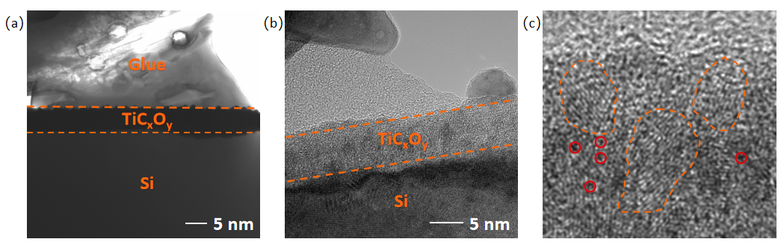
Figure S1. Cross-Sectional TEM Images of EBE-TiC_{x}O_{y} Thin Film; (a) Cross-sectional TEM image; (b) High-resolution TEM image; (c) Grain distribution map.

Figure S2. a) device structure diagram of TLM test. b) calculation principle for contact resistivity using TLM method.

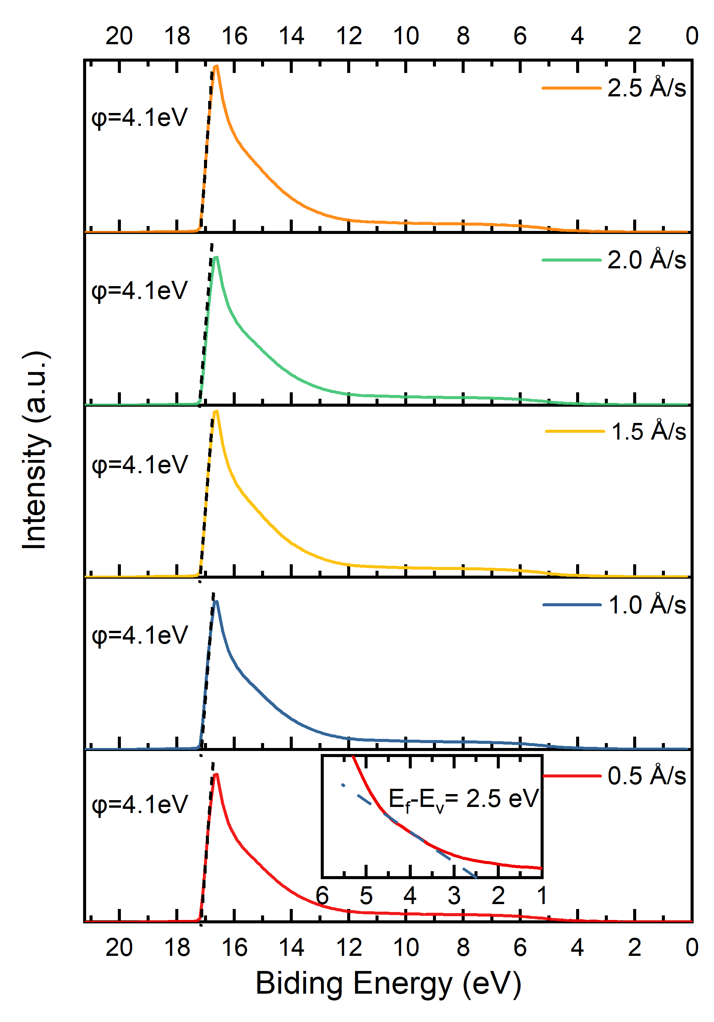
Figure S3. UPS Spectra of TiC_{x}O_{y} Films at Different Evaporation Rates.

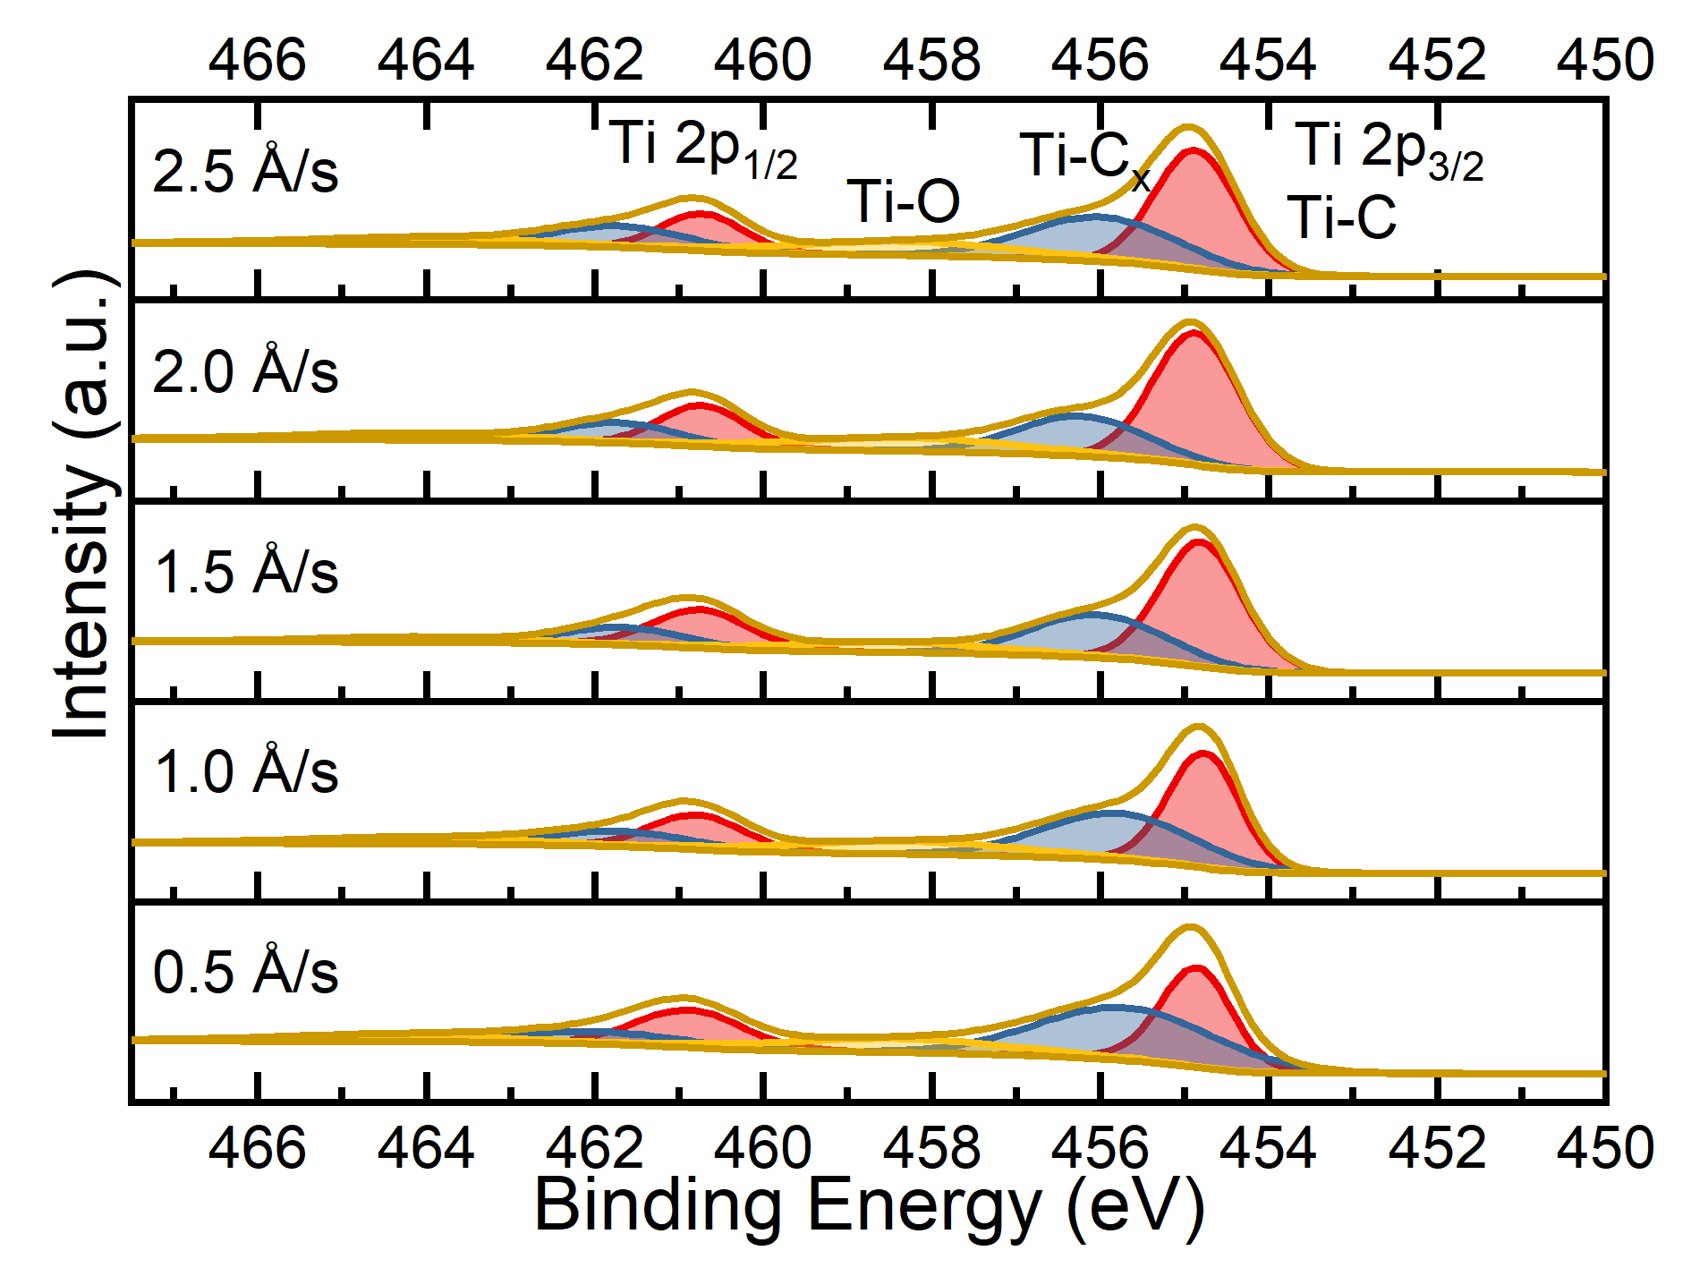
Figure S4. XPS Spectra of TiC_{x}O_{y} Films at Different Evaporation Rates.

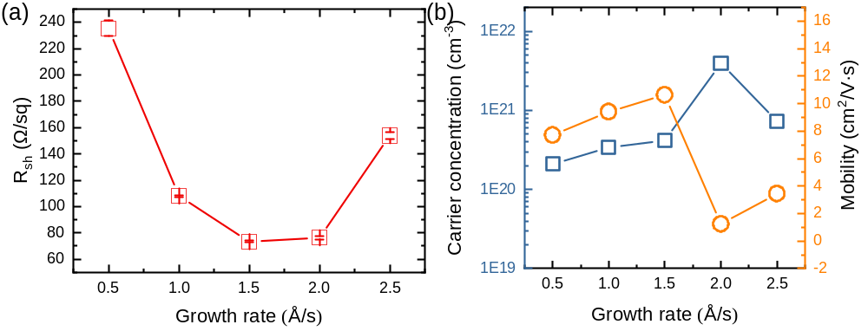
Figure S5. Correspondence between Growth Rate and (a) Carrier Concentration; (b) Mobility.

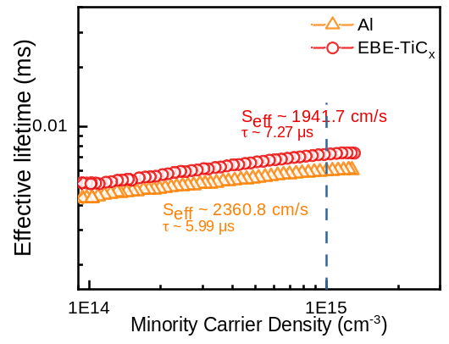
Figure S6. Minority Carrier Lifetime of 50 nm EBE-TiC_{x}O_{y} prepared at Evaporation Rate of 1.0 Å/s.

