Table S1. Differential analysis table of secondary metabolic pathways in phyllosphere bacterial communities based on the KEGG database. The horizontal axis, logFC (log₂(fold change)), represents upregulation with positive values and downregulation with negative values relative to the control group; the upregulated group is SS, and the control group is SE.
pathway | logFC | P values
Isoflavonoid biosynthesis  Flavonoid biosynthesis  Arachidonic acid metabolism  Sesquiterpenoid biosynthesis  Photosynthesis - antenna proteins  Steroid hormone biosynthesis  Carotenoid biosynthesis  Lipoic acid metabolism  Biosynthesis of ansamycins  Vibrio cholerae pathogenic cycle  Plant-pathogen interaction  Naphthalene degradation  Other glycan degradation  Geraniol degradation  Caprolactam degradation  Nitrotoluene degradation  Caprolactam degradation | 5.068  0.6407  4.343  2.668  0.6729  1.347  1.124  0.4001  -0.4241  -1.394  -0.5398  -3.82  -1.546  -0.6228  -1.147  -0.9313  -1.147 | <0.001  0.046  <0.001  4.57E-11  0.03748  1.02E-06  3.69E-14  4.28E-06  2.68E-09  0.000  2.67E-15  0.006085  <0.001  1.26E-07  1.02E-09  1.51E-05  1.02E-09

Table S2. Differential analysis table of secondary metabolic pathways in phyllosphere fungal communities based on the KEGG database. The horizontal axis, logFC (log₂(fold change)), represents upregulation with positive values and downregulation with negative values relative to the control group; the upregulated group is SS, and the control group is SE.
Pathway | logFC | P values
Phospholipid remodeling  NAD/NADP-NADH/NADPH  Glucose and glucose-1-phosphate degradation  Sulfate reduction I (assimilatory)  Palmitate biosynthesis I (animals and fungi)  Phospholipases  Superpathway of purine nucleotide salvage  Superpathway of pyrimidine ribonucleosides salvage | 3.229  2.637  2.614  0.6543  0.3277  0.3277  -3.759  -4.019 | 0.006  0.011  0.008  0.071  0.02578  0.02578  1.07E-07  1.29E-06

Table S3. Mantel test analysis of the relationship between plant physiological and biochemical characteristics and phyllospheric bacterial community βNTI values. All plant physiological and biochemical variables were converted into Euclidean distance matrices. Mantel tests were conducted to assess the correlation between the two distance matrices, with significance determined based on 999 random permutations to ensure the robustness of the p-values.
‌Plant indicators-bacteria |  | R² | P values
SOD  CAT  POD  MDA  TC  TN  TP  TK  Pro  SP  SUG | 0.7159  0.5406  0.3711  0.1557  0.7804  0.3796  0.6812  -0.0143  0.5863  -0.0580  0.3327 |  |  | 0.001  0.003  0.009  0.113  0.001  0.013  0.001  0.502  0.002  0.657  0.019

Table S4. Mantel test analysis of the relationship between plant physiological and biochemical characteristics and phyllospheric fungi community βNTI values. All plant physiological and biochemical variables were converted into Euclidean distance matrices. Mantel tests were conducted to assess the correlation between the two distance matrices, with significance determined based on 999 random permutations to ensure the robustness of the p-values.
‌Plant indicators-Fungi |  | R² | P values
SOD  CAT  POD  MDA  TC  TN  TP  TK  Pro  SP  SUG | 0.3509  0.3721  0.2807  0.2054  0.3298  0.3170  0.2453  -0.2461  0.4790  0.1457  -0.4278 |  |  | 0.005  0.002  0.003  0.114  0.007  0.013  0.038  0.907  0.001  0.220  0.998

Figure Captions
Figure S1. Soil influencing factors in the multivariate regression tree analysis include NN, AN, pH, SOC, EC, Na⁺, and Cl⁻, while plant physiological and biochemical characteristics include TN, TC, TP, TK, MDA, POD, CAT, SOD, SUG, SP, and Pro. For meanings of acronyms, see the description in the fig 2.
Figure S2. Differential analysis of bacterial ((a) and (c)) and fungal ((b) and (d)) communities in the phyllosphere of three halophytes at the phylum level ((c) and (d)) and genus level ((a) and (b)). The genus-level analysis includes the top 24 most abundant genera.
Figure S3. Pearson correlation analysis between alpha diversity of phyllosphere bacterial and fungal communities and plant physiological-biochemical traits. Alpha diversity indices for bacterial and fungal communities include Simpson index, Shannon index, Pielou’s evenness index, observed species (Obs), Good’s coverage, and Chao index. For meanings of acronyms, see the description in the fig 2.
Figure S4. Key bacterial (a) and fungal (b) genera identified through Zi-Pi analysis. The genera were selected based on node degree and ranked within the top 24, with genera ranked beyond 25 classified as "others."
Figure S5. Assembly processes of phyllosphere bacterial and fungal communities of three different halophytic plants. (a) the contributions of different ecological processes to bacterial community assembly; (b) the contributions of different ecological processes to fungal community assembly.
Figure S6. The figure presents the results of random forest analyses examining the relationships between plant physiological and biochemical traits and phyllosphere bacterial and fungal community compositions. In the figure, "bacteria" and "fungi" represent the respective community compositions, as characterized by the first principal coordinate (PC1) from redundancy analysis (RDA). The R² values indicate the proportion of variance explained by each trait. Due to the relatively low R² values obtained from the random forest analysis of plant traits and the Shannon diversity indices of phyllosphere bacterial and fungal communities, these results were not further considered.
Figure S7. MetagenomeSeq analysis of leaf-associated fungal communities in the SS and SE groups. ASV data were filtered based on a frequency threshold of ≥ 0.3 (default value) in either the SS or SE group. In the figure, the x-axis represents the ASV sorted by fungal genera, while the y-axis denotes the -log10(adjusted P-value), with higher y-axis positions indicating greater statistical significance. Each dot or circle in the coordinate system represents an individual ASV, with its size proportional to the relative abundance (expressed as log2(CPM/n), where CPM = copies per million and n = sample number). A dashed line separates significantly different (above the line) from non-significant genera. Significantly different ASVs are marked with colored dots or rings, while non-significant ones are indicated by gray rings. Within each group, significantly upregulated ASVs are highlighted with colored solid dots. The color of each dot corresponds to its phylum-level classification, labeled at the bottom of the figure (representing the top five phyla with the highest number of significantly upregulated ASVs). For the top 10 genera (default value) with the greatest number of significantly upregulated ASVs, a grayscale background is added, and their names are annotated at the top of the figure.
Figure S8. The figure presents pie charts illustrating the species composition contributions to the top eight secondary metabolic pathways in the phyllosphere fungal communities of SE and SS. The top eight secondary metabolic pathways, listed in descending order as shown in the table, are as follows: phospholipid remodeling (phosphatidylethanolamine, yeast), L-tryptophan degradation to 2-amino-3-carboxymuconate semialdehyde, monoacylglycerol metabolism (yeast), NAD/NADP-NADH/NADPH mitochondrial interconversion (yeast), glucose and glucose-1-phosphate degradation, NAD/NADP-NADH/NADPH cytosolic interconversion (yeast), sucrose degradation III (sucrose invertase), and stearate biosynthesis III (fungi).
Figure S9. Linear regression analyses were performed to evaluate the relationships among plant CAT, POD, SOD and plant TC, TN. (a,b) Linear regression analyses were performed to evaluate the relationships among soil salinity, soil moisture content, phyllosphere bacterial diversity, and the relative abundances of Vibrio, Planococcus, and Kocuria. (c-e) Phyllosphere bacterial diversity was represented by the Shannon diversity index of the phyllosphere bacterial community, while soil salinity was indicated by EC values. the coefficient of determination (R²) and statistical significance (P) are also shown. For meanings of acronyms, see the description in the fig 2.

Figure S1

Figure S2

Figure S3

Figure S4
Figure S5

Figure S6

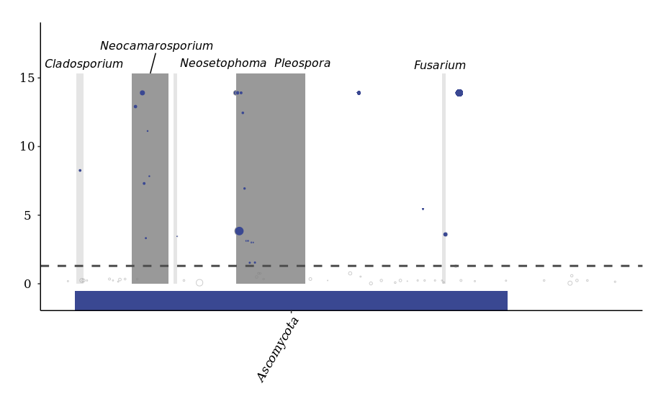
Figure S7

Figure S8
Figure S9

