Supplementary materials for:
Se-methylselenocysteine, D-α-tocopheryl succinate, β-carotene
and L-lysine combined can prevent cancer metastases as an adjuvant
therapy
Shuhui Li^{1#}, Yunlong Cheng^{1#}, Yusheng Lu², Shu Lian¹, Jie Wang¹, Xiaoxiao Deng¹, Shengyi Zhai¹, Lee Jia^{1, 2*}
- Cancer Metastasis Alert and Prevention Center, and Fujian Provincial Key Laboratory of Cancer Metastasis Chemoprevention, College of Chemistry, Fuzhou University, Fuzhou 350002, China.
- Institute of Oceanography, Minjiang University, Fuzhou, Fujian 350108, China.

Correspondence should be addressed to Dr. Lee Jia.
Email: cmapcjia1234@163.com or jiali@fzu.edu.cn

#These authors contributed equally to this paper

Table of contents
- Figure S1. Chemical structure of drugs
- Table S1. Cell cycle and apoptosis and ROS experiments concentrations
- Table S2. Migration and invasion assays concentrations
- Table S3. Dosing in mice

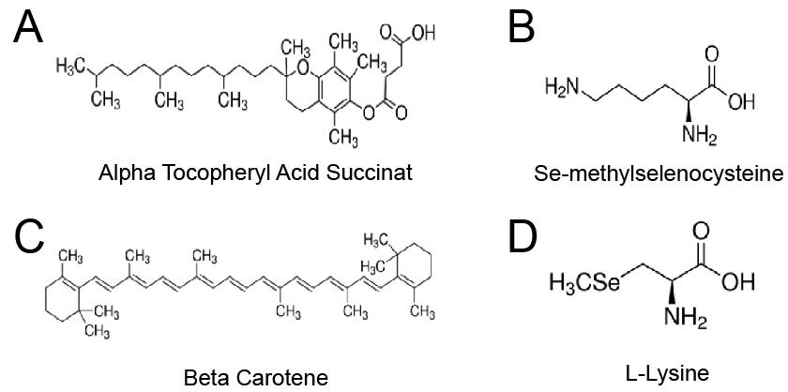

Fig.S1.Chemical structure (A) VES. (B) MSC. (C) β-Ca. (D) Lys.

Groop  Drug (μM) | Control | MSC | VES | β-Ca | Lys | Low | Medium | High
MSC | 0 | 10 | \ | \ | \ | 2 | 5 | 10
VES | 0 | \ | 20 | \ | \ | 4 | 10 | 20
β-Ca | 0 | \ | \ | 20 | \ | 4 | 10 | 20
Lys | 0 | \ | \ | \ | 200 | 40 | 100 | 200
Table S1 Cell cycle and apoptosis and ROS experiments concentrations

Table S2 migration and invasion assays concentrations
Drug (μM) | Control | Low | High
MSC | 0 | 2 | 5
VES | 0 | 4 | 10
β-Ca | 0 | 4 | 10
Lys | 0 | 40 | 100

dosage：mg/kg | Control | Low | Medium | High
MSC | 0 | 0.008 | 0.04 | 0.2
VES | 0 | 18 | 90 | 450
β-Ca | 0 | 0.24 | 1.2 | 6
Lys | 0 | 8 | 40 | 200
Table S3 Dosing in mice

