Appendix I: Interviewees List
Expert Interviewees:
- Dr. Sarah Carter, Ph.D.—science policy consulting, synthetic biology, biosecurity, and engineering biology, Principal, Science Policy Consulting LLC.
- Dr. Manuel Gonzalo Claros—Molecular biology and biochemistry; professor at the University of Malaga
- Mr. Mauricio Chicas Romero —bioremediation, environmental research, and molecular biology; experience in public and private sectors, Professor at the Costa Rica Institute of Technology, President, National Committee on ISO Standards for Wastewater Treatment (CTN66), International Consultant.
- Master. Jorge Benavides—bio-based innovation, hazardous waste management certifications, and techno-economic analyses; background as a chemical engineer. Innovation Lead at Vela. Senior Innovation Engineer at Consorzio Italbiotec, Bioengineering Consultant.
- Dr. Adish Shankar Walvekar—synthetic biology, sustainability, project management, agriculture, human & animal nutrition; Scientist-I at StringBio Pvt. Ltd.
- Dr. Rajeev Kumar—Synthetic Biology, Sustainability, Agriculture, Human & Animal Nutrition, Metabolism, Biotechnology; Scientist at StringBio Pvt. Ltd.
- Dr. Indranil Ganil, Ph.D.—Molecular Biology, Zoology, Environmental Studies; A SERB senior research scholar currently focused on Molecular Immunology.

Appendix II: Additional Suvery Results

Supplimentary data can be found at here: https://drive.google.com/drive/folders/1v0lveDgrAOW3Ymnmpa0Tqjd8LNirFxPm in addition to the results prevented in the article. Interviewee summary are also available https://drive.google.com/drive/folders/1Gy4aAtoik-XK2dIGeFX5UryIxhNLLgsC.
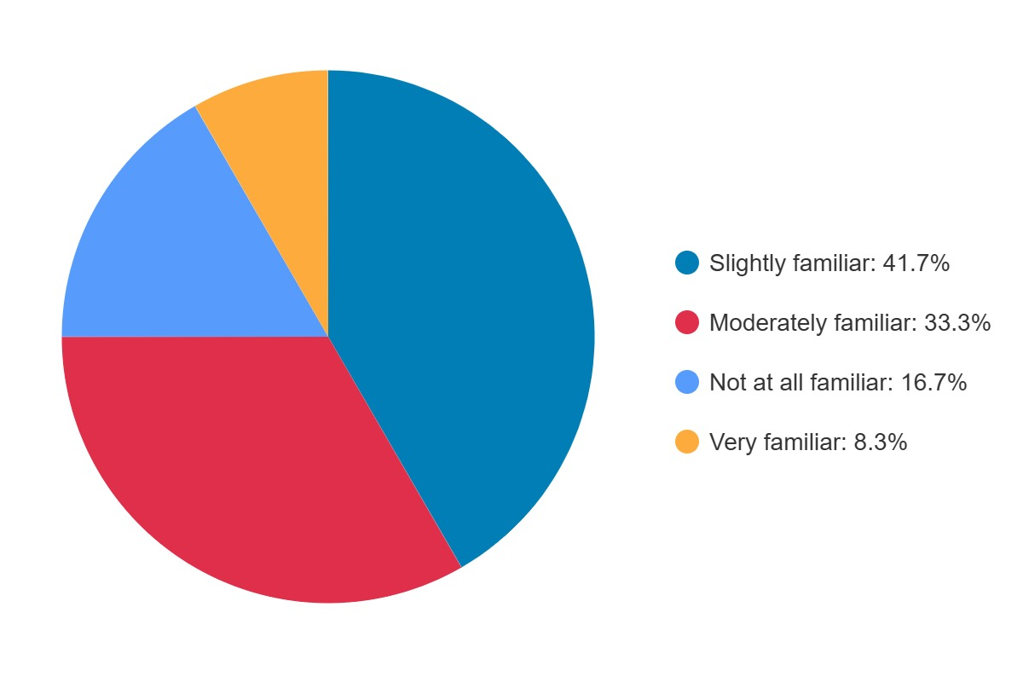
Figure 5: Participants familiarity with Environmental bioremediation.
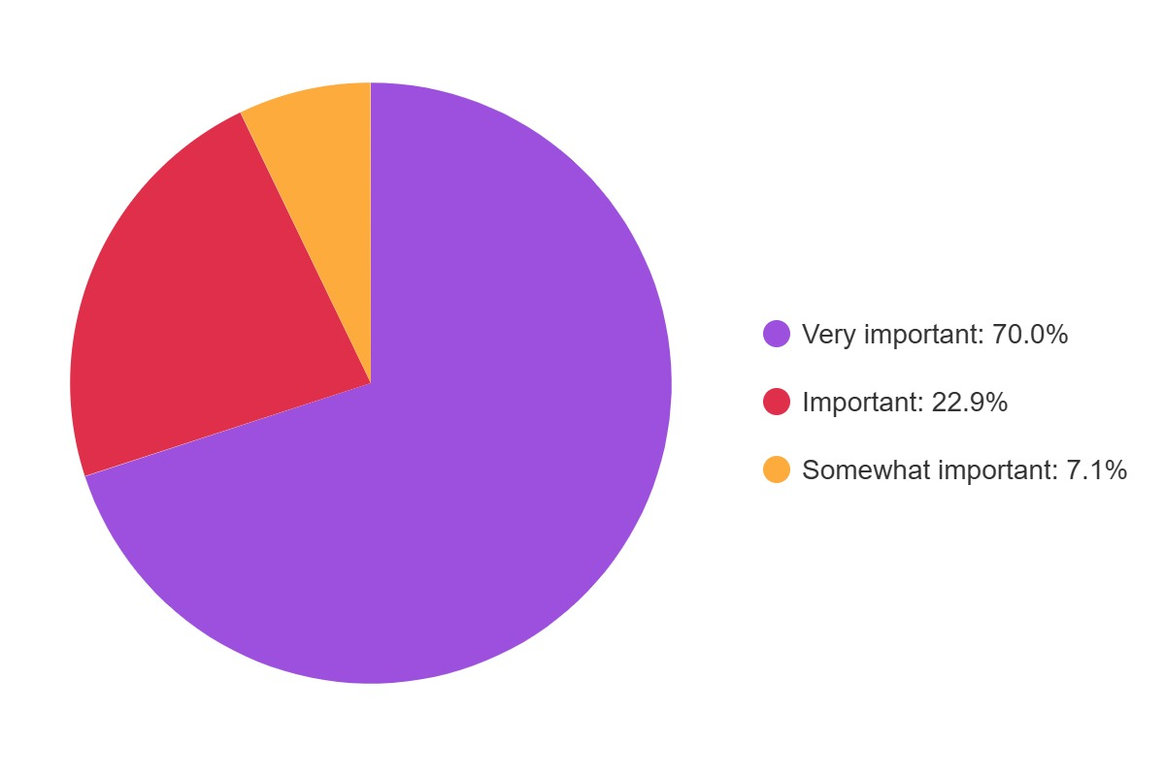
Figure 6: Particpants response to the need for public engagement in policy developments

