APPENDICES
Appendix 1:
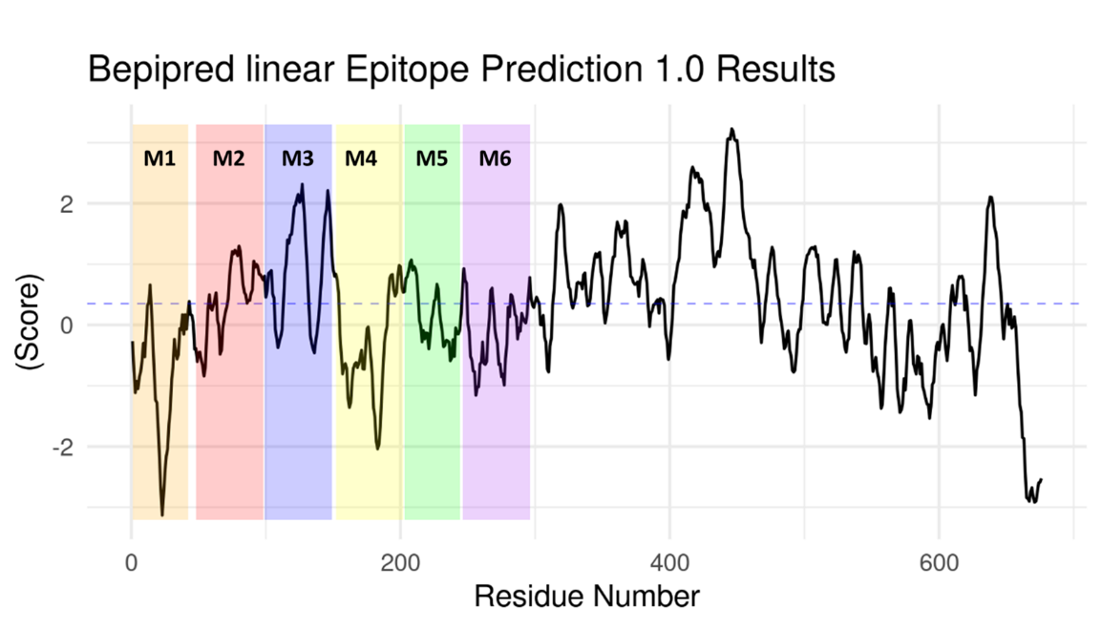
Figure 15: BepiPred 1.0 linear epitope prediction method. Residues with scores above this threshold were considered to have a high probability of being part of an epitope.
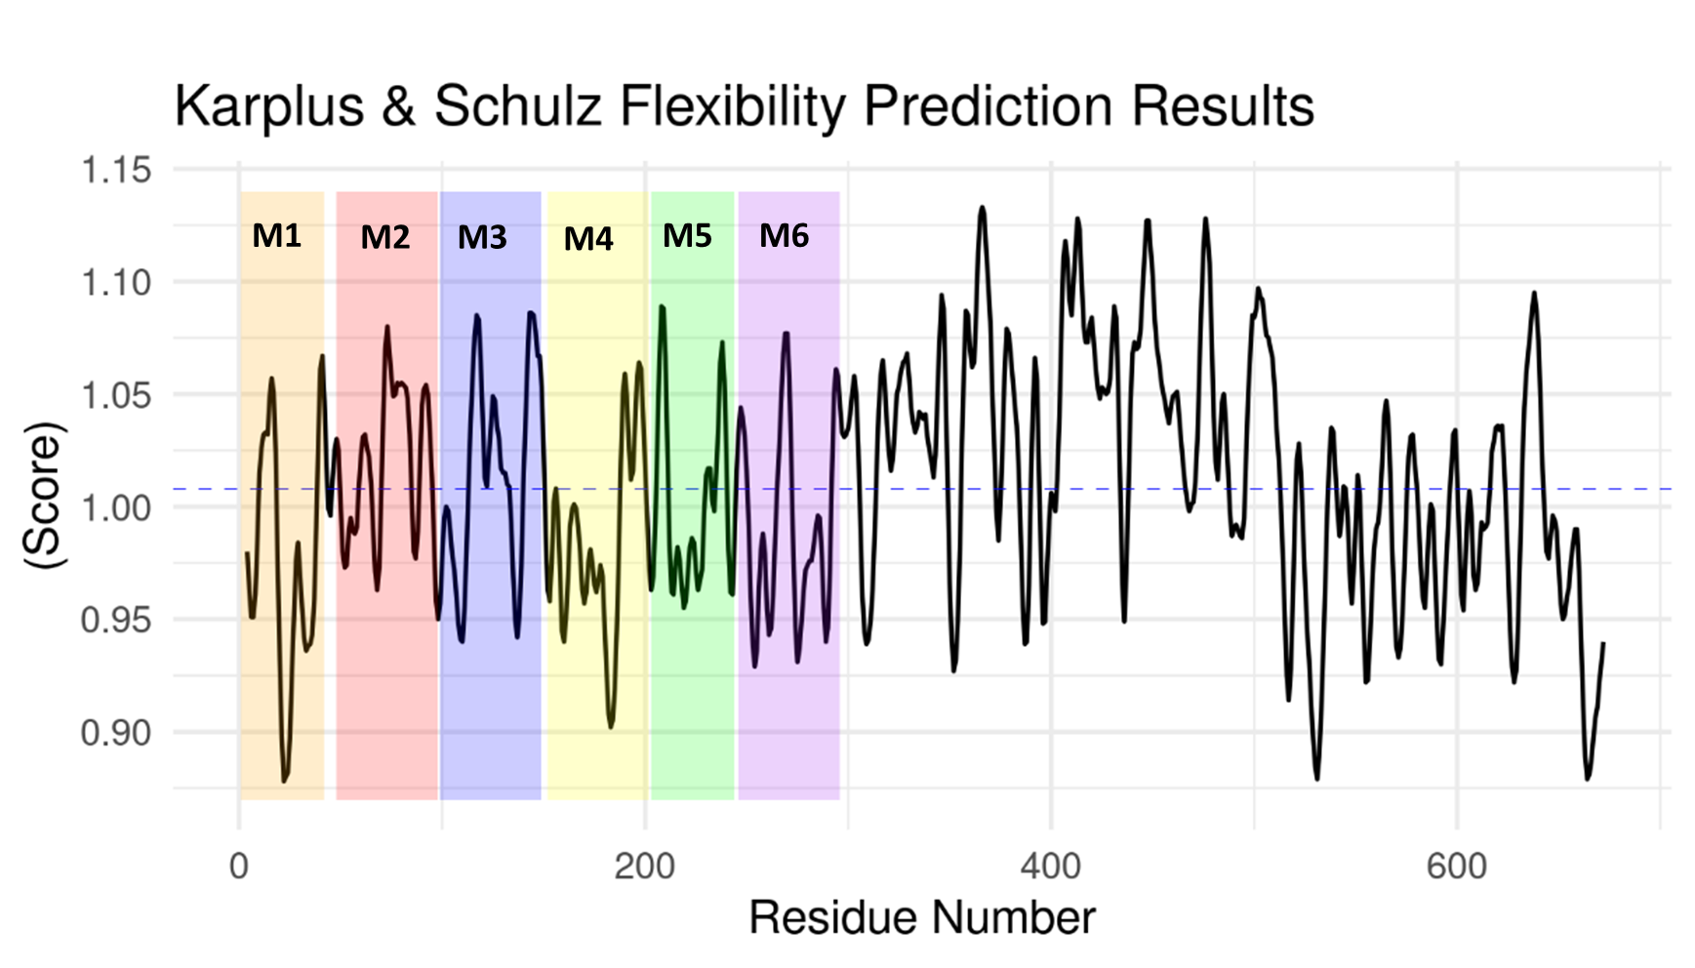
Figure 16: Karplus & Schulz Flexibility Prediction method. Residues with scores above this threshold were considered to have a high probability of being part of an epitope.

Appendix II:
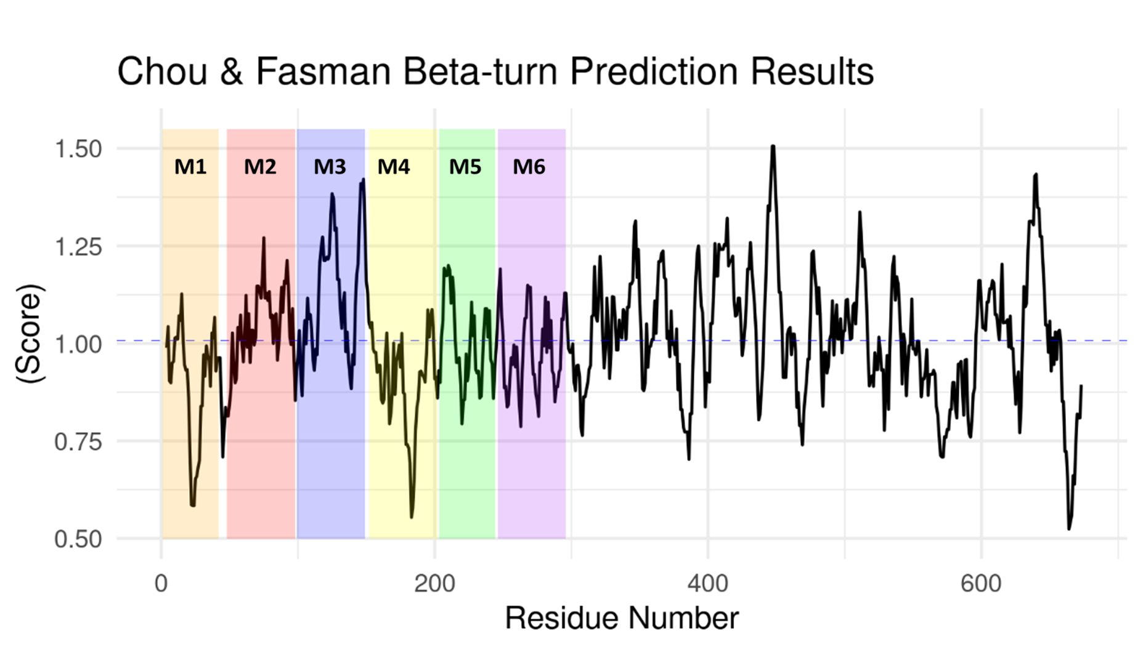
Figure 17: Chou & Fasman Beta-turn Prediction method. Residues with scores above this threshold were considered to have a high probability of being part of an epitope with Beta-turns.

Appendix: VI

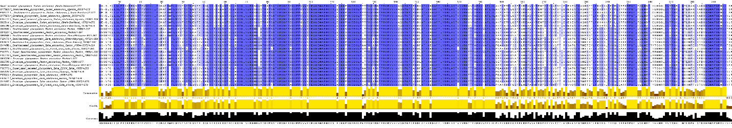
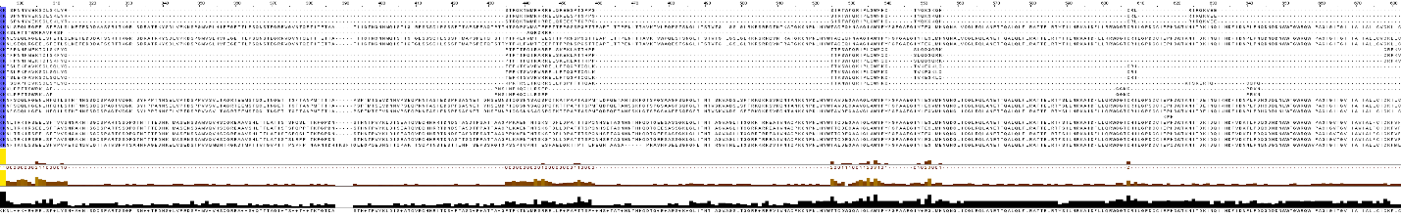
Figure 18: Multiple sequence alignment of ebolavirus glycoprotein sequences showing regions of conservation, mainly at the sGPS.

