Supplement figure
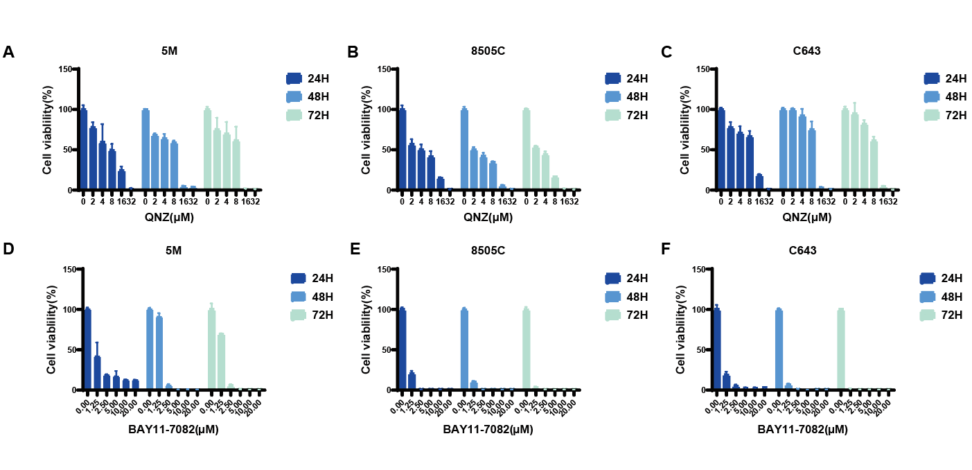
Figure S1 (A)-(C) ATC cell lines (KHM-5M, 8505C, C643), were treated with a series of concentrations of anlotinib (0, 2, 4, 8, 16, and 32 μM) for 24 hours. (D)-(F) ATC cell lines (KHM-5M, 8505C, C643), were treated with a series of concentrations of anlotinib (0, 1.25, 2.5, 5, 10, and 20 μM) for 24 hours. Cell viability was evaluated by CCK-8 assa. All data comes from independent experiments.* P < 0.05;** P < 0.01。
Figure S2. (A)-(D) Under the treatment of anlotinib alone in combination with anlotinib and NF - κB inhibitor (BAY11-7082 or QNZ), the levels of lipid ROS in KHM-5M, 8505C, and C643 cells were measured by flow cytometry using H2DCFDA probe. All data comes from three independent experiments.* P < 0.05;** P < 0.01。

