Supplementary Figures
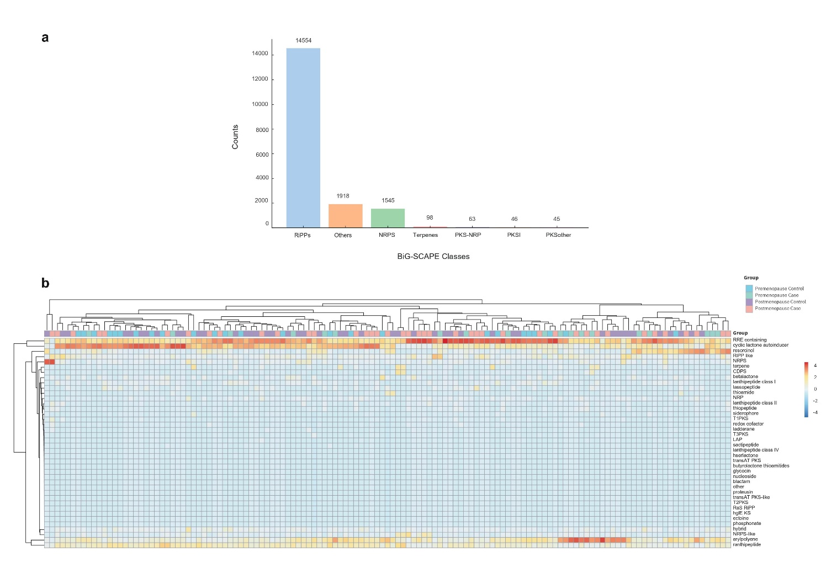
Supplementary Figure 1: (a) Distribution of BGCs among BiG-SCAPE classes. (b) Abundance of BGCs across pre- and postmenopausal cases and controls.

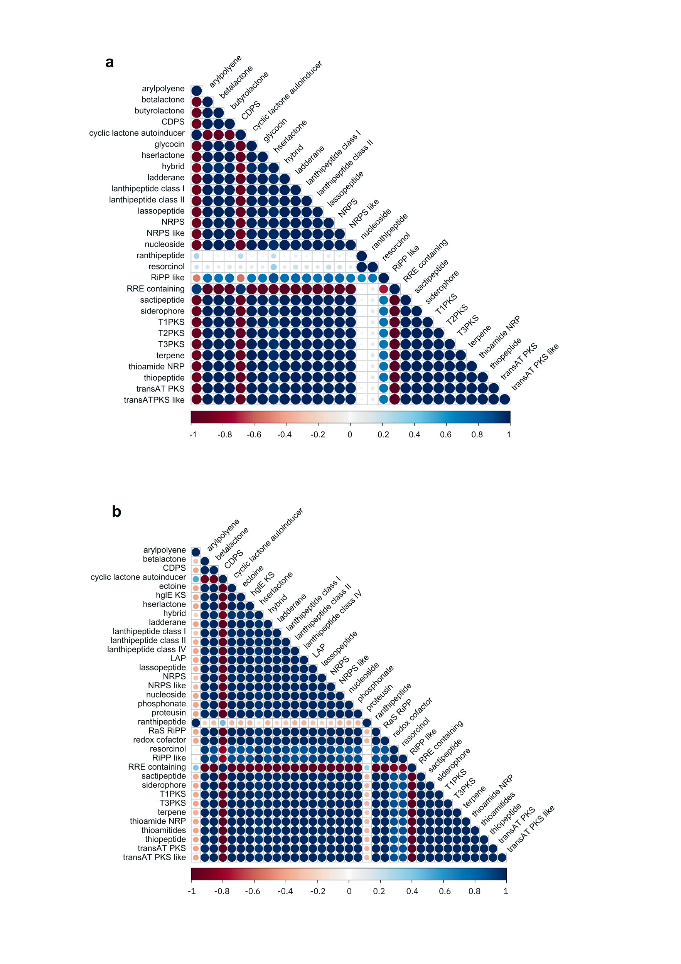
Supplementary Figure 2: Metabolite-metabolite correlation analysis. (a) Metabolite-metabolite correlation in premenopausal controls. (b) Metabolite-metabolite correlation in premenopausal cases. Positive correlations are in blue; negative correlations are in red; the bar represents the Pearson correlation coefficient value.
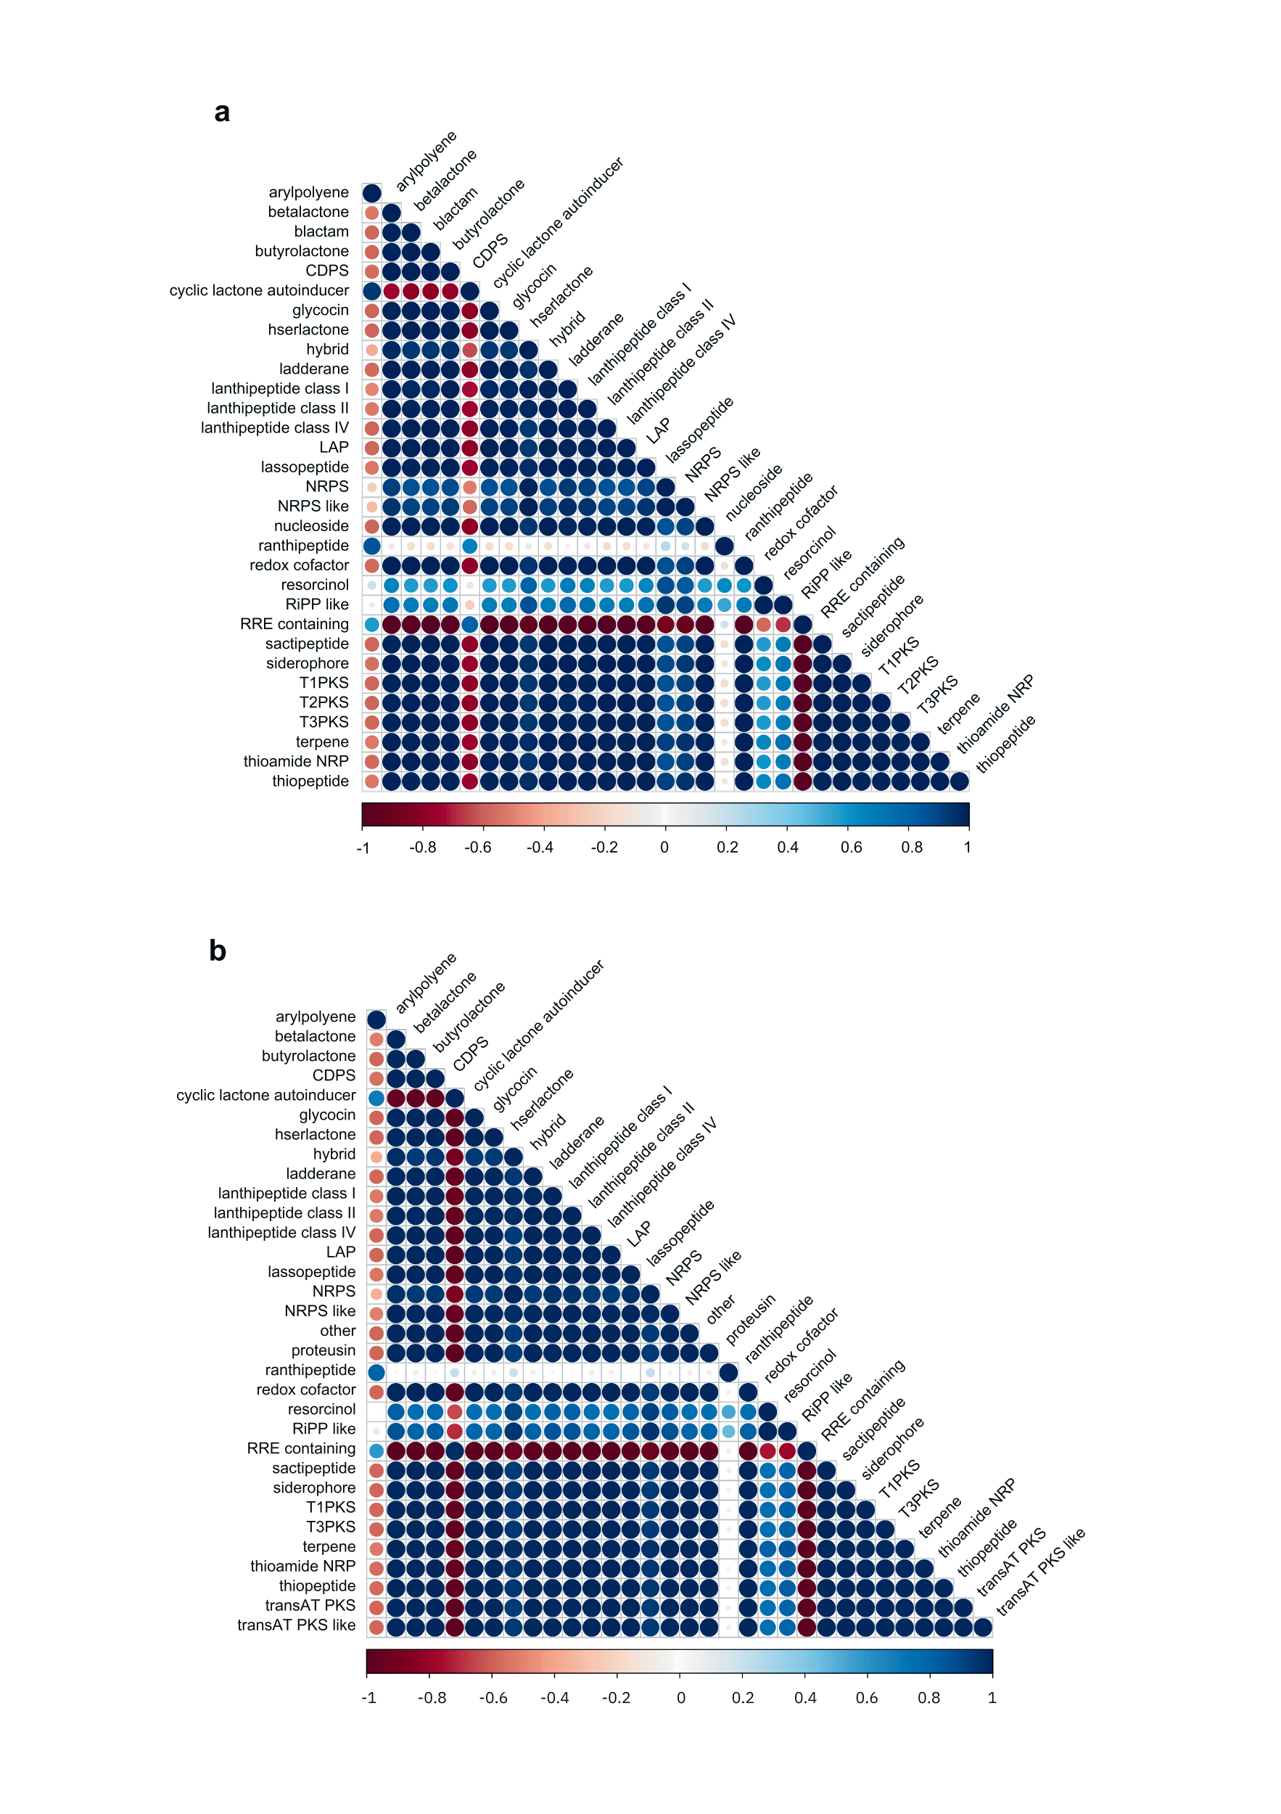
Supplementary Figure 3: Metabolite-metabolite correlation analysis. (a) Metabolite-metabolite correlation in postmenopausal controls. (b) Metabolite-metabolite correlation in postmenopausal cases. Positive correlations are in blue; negative correlations are in red; the bar represents the Pearson correlation coefficient value.

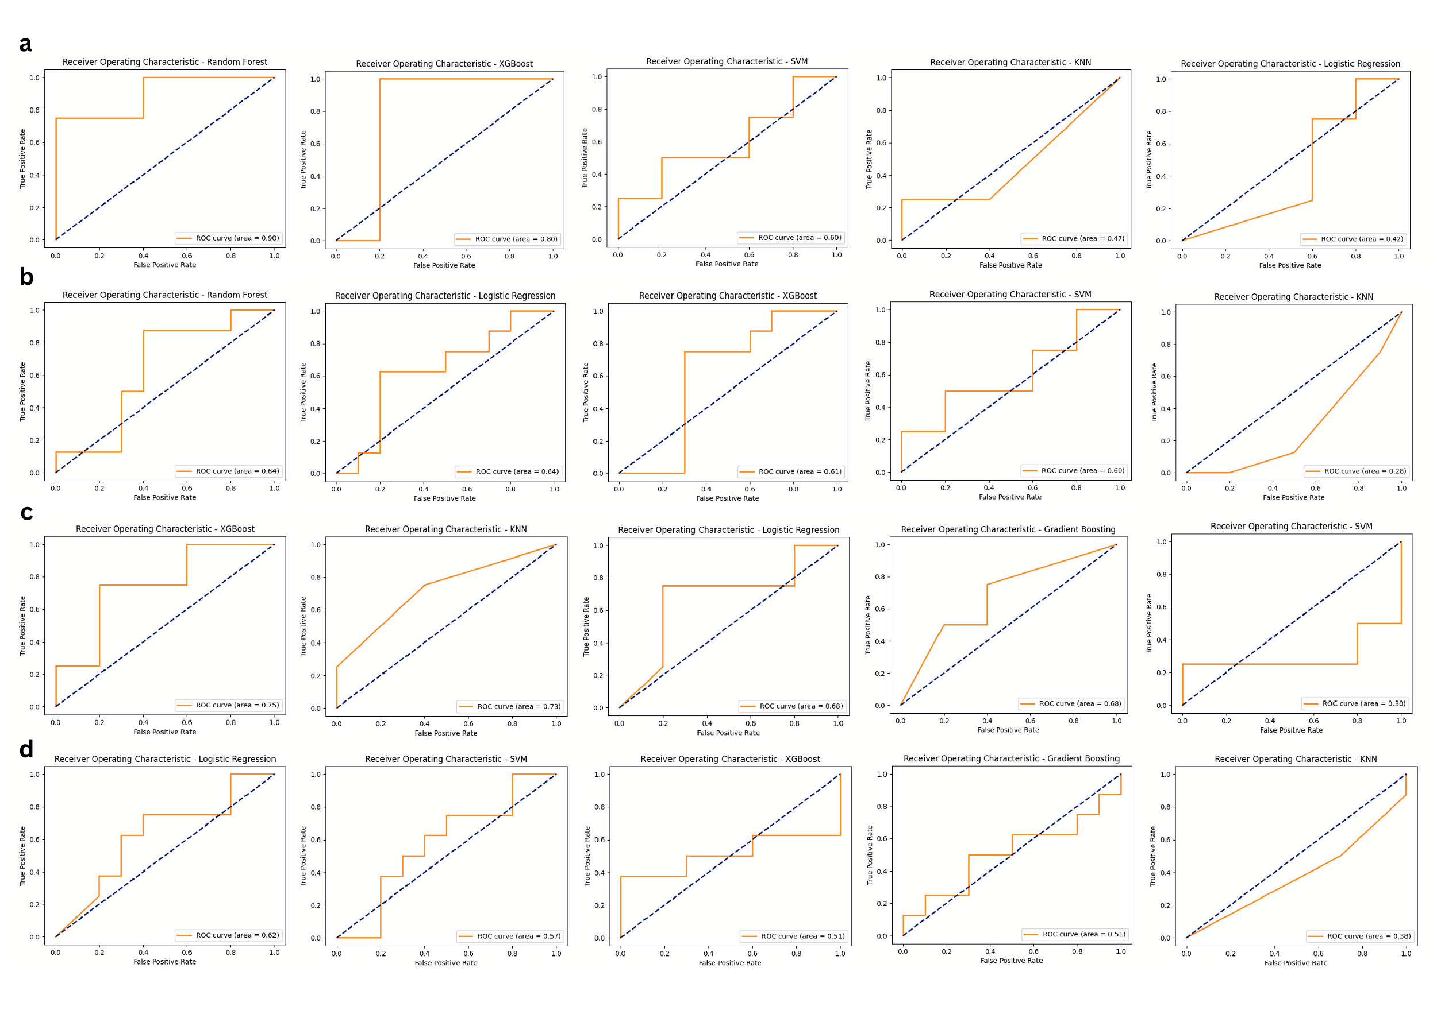
Supplementary Figure 4: AUCROC curves of classical ML classifiers. (a) AUCROC curves of classifiers for premenopausal cases vs controls using metabolite features. (b) AUCROC curves of classifiers for postmenopausal cases vs controls using metabolite features. (c) AUCROC curves of classifiers for premenopausal cases vs controls using taxa features. (d) AUCROC curves of classifiers for postmenopausal cases vs controls using taxa features.

